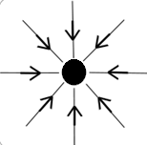
Basic
(1): Is the central charge in the diagram positive or negative? How can you tell? __________________ ______________________ ______________________
(2): Are the charges shown below equal in magnitude? Explain why.
A B
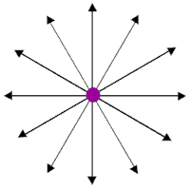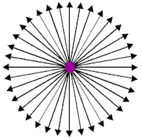
_____________________________________________
(3): Which charge, A or B, is larger? Why?
_____________________________________________
(4): What is the type of charge in diagrams A and B? How can you tell?
_____________________________________________
(5): What would happen if charges A and B were placed close to one another?
_____________________________________________
Medium
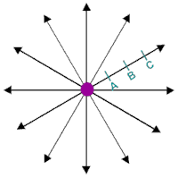
Figure 1:
(6): Looking at Figure 1, how do the field strengths compare at points A and B? ____________________ ____________________ ____________________
(7): Looking at Figure 1, how do the field strengths compare at points B and C? ______________________ _____________________________________________
(8): Looking at Figure 1, complete the following sentence:
As the distance to the charge increases the electric field _________________________________________
(9): Looking at Figure 1, would a positively charged particle placed at point B move towards A or towards C? ___________________________________________
(10): How do field lines indicate where the strength of a field is greatest? ______________________________ _____________________________________________
Hard (complete these in your book)
(11): True or false? Copy down true sentences and copy and correct false sentences by changing only one word.
-An electric field is created by a charged object.
-The neutral object creates an electric field around itself.
-If another neutral object is in the field, it will experience a force.
-If it is the same charge it will attract.
-If it is a different charge it will repel
-The further away the charges the smaller the force.
(12): What does the direction of the electric field line represent?
(13): In terms of field lines, explain why an electric field is stronger nearer an object.
(14): In terms of field lines, explain why the force of two objects repelling each other decreases as the distance increases.
(15): In terms of field lines, explain why the force on an electron increases as it approaches the nucleus of an atom.
Stretch: Copy and explain all of the diagrams on the whiteboard.

Basic
(1): Is the central charge in the diagram positive or negative? How can you tell? __________________ ______________________ ______________________
(2): Are the charges shown below equal in magnitude? Explain why.
A B
_____________________________________________
(3): Which charge, A or B, is larger? Why?
_____________________________________________
(4): What is the type of charge in diagrams A and B? How can you tell?
_____________________________________________
(5): What would happen if charges A and B were placed close to one another?
_____________________________________________
Medium
Figure 1:
(6): Looking at Figure 1, how do the field strengths compare at points A and B? ____________________ ____________________ ____________________
(7): Looking at Figure 1, how do the field strengths compare at points B and C? ______________________ _____________________________________________
(8): Looking at Figure 1, complete the following sentence:
As the distance to the charge increases the electric field _________________________________________
(9): Looking at Figure 1, would a positively charged particle placed at point B move towards A or towards C? ___________________________________________
(10): How do field lines indicate where the strength of a field is greatest? ______________________________ _____________________________________________
Hard (complete these in your book)
(11): True or false? Copy down true sentences and copy and correct false sentences by changing only one word.
-An electric field is created by a charged object.
-The neutral object creates an electric field around itself.
-If another neutral object is in the field, it will experience a force.
-If it is the same charge it will attract.
-If it is a different charge it will repel
-The further away the charges the smaller the force.
(12): What does the direction of the electric field line represent?
(13): In terms of field lines, explain why an electric field is stronger nearer an object.
(14): In terms of field lines, explain why the force of two objects repelling each other decreases as the distance increases.
(15): In terms of field lines, explain why the force on an electron increases as it approaches the nucleus of an atom.
Stretch: Copy and explain all of the diagrams on the whiteboard.

