Mains electricity
Basic
- a) How does alternating current differ to direct current?
b) What is the frequency of the a.c. mains electricity supply in the UK?
c) What is the voltage of UK mains electricity?
- What are the names and colours of the three pins in a plug?
- a) Why are pins in a plug made of brass?
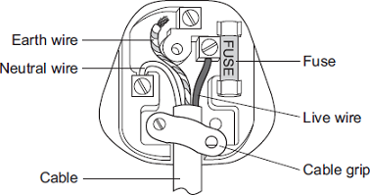
b) Why is the outer casing of a plug made of plastic?
- a) What is the purpose of a fuse?
b) What causes a fuse to break the circuit?
c) Give one advantage of a circuit breaker over a fuse?
Medium
- The diagram shows the inside of an incorrectly wired three-pin plug.
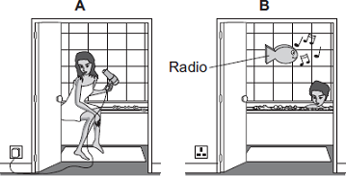
- What two changes need to be made so that the plug is wired correctly?
- The fuse inside a plug is a safety device. Explain what happens when too much current passes through a fuse.
- Using the hairdryer in picture A is dangerous. However, it is safe to use the battery-operated radio in picture B. Explain why.
- The diagram to the below shows someone accidentally touching a live wire inside a dismantled 230 V mains electricity socket.
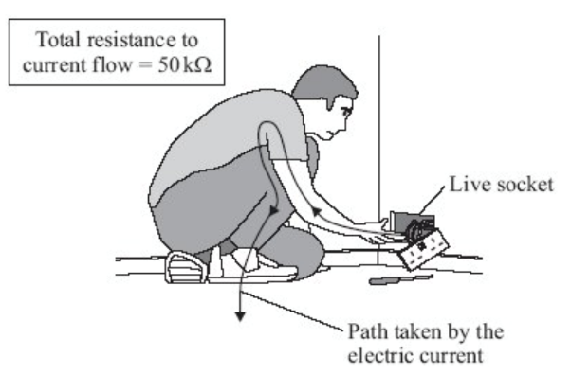
- The total resistance to current flow is 50 kΩ. Calculate the current that will flow through the person. (Hint: you need to use Ohm’s law and rearrange the equation).
- Rubber is a good insulator. Explain why it is a good idea for electricians to wear rubber soled boots when working.
To go from kΩ to Ω → × 1000

Hard
- A hairdryer designed to be used with the UK mains supply has a plastic cover. The cable connecting the hairdryer to the plug does not have an Earth wire. Why does the hairdryer not need a cable with an Earth wire?
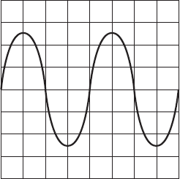
- An oscilloscope (this is a device used for measuring and showing voltage over time) is connected to an alternating current (ac) supply. The diagram shows the trace produced on the oscilloscope screen. Each horizontal division on the oscilloscope screen represents 0.002 s. Calculate the frequency of the alternating current supply. Hint: frequency is a measure of how many cycles the current makes every second.

Mains electricity
Basic
- a) How does alternating current differ to direct current?
b) What is the frequency of the a.c. mains electricity supply in the UK?
c) What is the voltage of UK mains electricity?
- What are the names and colours of the three pins in a plug?
- a) Why are pins in a plug made of brass?
b) Why is the outer casing of a plug made of plastic?
- a) What is the purpose of a fuse?
b) What causes a fuse to break the circuit?
c) Give one advantage of a circuit breaker over a fuse?
Medium
- The diagram shows the inside of an incorrectly wired three-pin plug.
- What two changes need to be made so that the plug is wired correctly?
- The fuse inside a plug is a safety device. Explain what happens when too much current passes through a fuse.
- Using the hairdryer in picture A is dangerous. However, it is safe to use the battery-operated radio in picture B. Explain why.
- The diagram to the below shows someone accidentally touching a live wire inside a dismantled 230 V mains electricity socket.
- The total resistance to current flow is 50 kΩ. Calculate the current that will flow through the person. (Hint: you need to use Ohm’s law and rearrange the equation).
- Rubber is a good insulator. Explain why it is a good idea for electricians to wear rubber soled boots when working.
To go from kΩ to Ω → × 1000

Hard
- A hairdryer designed to be used with the UK mains supply has a plastic cover. The cable connecting the hairdryer to the plug does not have an Earth wire. Why does the hairdryer not need a cable with an Earth wire?
- An oscilloscope (this is a device used for measuring and showing voltage over time) is connected to an alternating current (ac) supply. The diagram shows the trace produced on the oscilloscope screen. Each horizontal division on the oscilloscope screen represents 0.002 s. Calculate the frequency of the alternating current supply. Hint: frequency is a measure of how many cycles the current makes every second.

