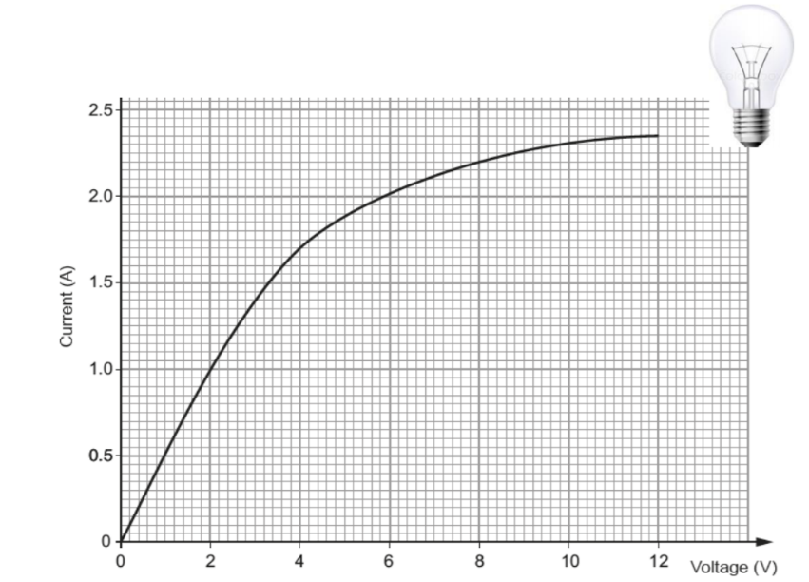
Resistors worksheet:
- Draw the symbols for the following components
- Resistor b) Lamp c) LED
d) Thermistor e) LDR
- The voltage across a bulb is measured for various different currents, with the results plotted opposite.
- At what voltage does the lamp stop acting like an Ohmic conductor (i.e. when does it stop following Ohm’s law and being a straight line)?
- What is the current when the Voltage is:
- 2V. ii) 6V. iii) 12V.
- Calculate the resistance of the lamp at:
- 2V. ii) 6V. iii) 12V.
- What do you notice happens to the resistance of the lamp as the voltage increases?
- Why does this happen to the resistance of the lamp?
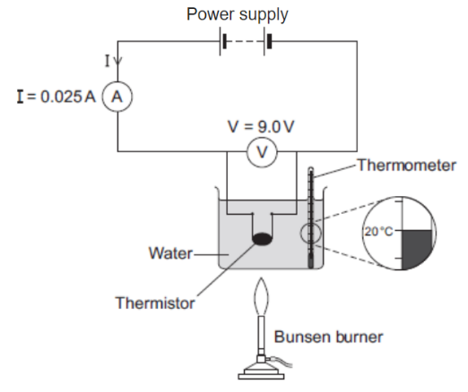
- The figure opposite shows the apparatus used to obtain the data needed to calculate the resistance of a thermistor at different temperatures.
- Use the data given in the figure to calculate the resistance of the thermistor at 20 °C.
- Using a ruler and pencil for the axes, sketch a graph that shows how the resistance of the thermistor would change as the temperature increases from 20 °C to 100 °C.
- Give an example of a circuit that is likely to contain a thermistor.
- The ammeter used in the circuit has a very low resistance. Why is it important that ammeters have a very low resistance?
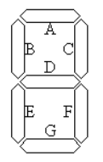
- A student plans to investigate how the resistance of an LDR changes with light intensity. The student starts with the apparatus show in the figure but makes three changes to the apparatus. One of the changes is to replace the thermistor with an LDR. Describe what other changes the student should make to the apparatus.
- Draw a circuit diagram of the new apparatus (with LDR instead of thermistor).
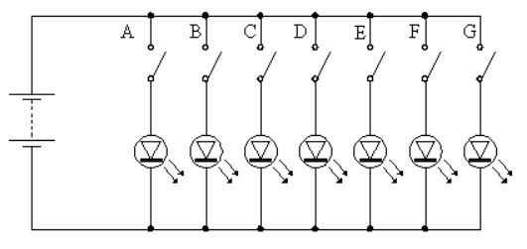
- Some electronic calculators use light emitting diodes (LEDs) to display numbers. Each number in a display consists of up to seven LEDs. The LEDs are arranged as shown in the diagram below. The different numbers are formed by switching different LEDs on at the same time. The LEDs are labelled A to G. A simplified circuit to provide power to the LEDs is shown.
- Explain why each LED has its own switch.
- What number is displayed when all switches except E are closed?
- Which switches would be open if the number 3 is to be displayed?
- Which of the numbers from 0 to 9 draws the least current from the battery? Explain your answer.

Resistors worksheet:
- Draw the symbols for the following components
- Resistor b) Lamp c) LED
d) Thermistor e) LDR
- The voltage across a bulb is measured for various different currents, with the results plotted opposite.
- At what voltage does the lamp stop acting like an Ohmic conductor (i.e. when does it stop following Ohm’s law and being a straight line)?
- What is the current when the Voltage is:
- 2V. ii) 6V. iii) 12V.
- Calculate the resistance of the lamp at:
- 2V. ii) 6V. iii) 12V.
- What do you notice happens to the resistance of the lamp as the voltage increases?
- Why does this happen to the resistance of the lamp?
- The figure opposite shows the apparatus used to obtain the data needed to calculate the resistance of a thermistor at different temperatures.
- Use the data given in the figure to calculate the resistance of the thermistor at 20 °C.
- Using a ruler and pencil for the axes, sketch a graph that shows how the resistance of the thermistor would change as the temperature increases from 20 °C to 100 °C.
- Give an example of a circuit that is likely to contain a thermistor.
- The ammeter used in the circuit has a very low resistance. Why is it important that ammeters have a very low resistance?
- A student plans to investigate how the resistance of an LDR changes with light intensity. The student starts with the apparatus show in the figure but makes three changes to the apparatus. One of the changes is to replace the thermistor with an LDR. Describe what other changes the student should make to the apparatus.
- Draw a circuit diagram of the new apparatus (with LDR instead of thermistor).
- Some electronic calculators use light emitting diodes (LEDs) to display numbers. Each number in a display consists of up to seven LEDs. The LEDs are arranged as shown in the diagram below. The different numbers are formed by switching different LEDs on at the same time. The LEDs are labelled A to G. A simplified circuit to provide power to the LEDs is shown.
- Explain why each LED has its own switch.
- What number is displayed when all switches except E are closed?
- Which switches would be open if the number 3 is to be displayed?
- Which of the numbers from 0 to 9 draws the least current from the battery? Explain your answer.

