Ripple tank practical worksheet.
Basic
Q1. How do we measure the wavelength of a wave in a ripple tank?
Q2. How do we measure the frequency of a wave in a ripple tank?
Q3. Once we’ve measured the frequency and the wavelength of a wave in a ripple tank, how do we find out the wave speed?
Medium
Q4. Why is it a benefit to measure the length of ten wavelengths and then take an average?
Q5. Calculate the frequency if: a) 50 waves pass a point in 10 seconds.
b) 20 waves pass a point in 2 seconds.
c) 100 waves pass a point in 20 seconds.
Q6. The measured frequency of a wave is 5 Hz. Calculate the wave speed for each of the wavelengths:
- 0.1 m
- 20 cm
- 2 mm
Q7. The measured wavelength is 0.02m. Calculate the wave speed for each of the frequencies:
- 10 Hz
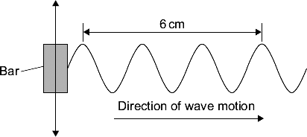
- 0.2 kHz
- 5 kHz
Hard
A ripple tank is used to investigate the behaviour of water waves. A bar moves up and down to make the waves.
Q8. What is the wavelength of each wave in the diagram?
Q9. The ripple tank produces 10 waves in 2 seconds. What is the frequency of the waves?
Q10. The bar is made to move faster. It now produces waves with a frequency of 20 Hz and a wavelength of 0.5 cm. Calculate the speed of the waves in units of cm/s.
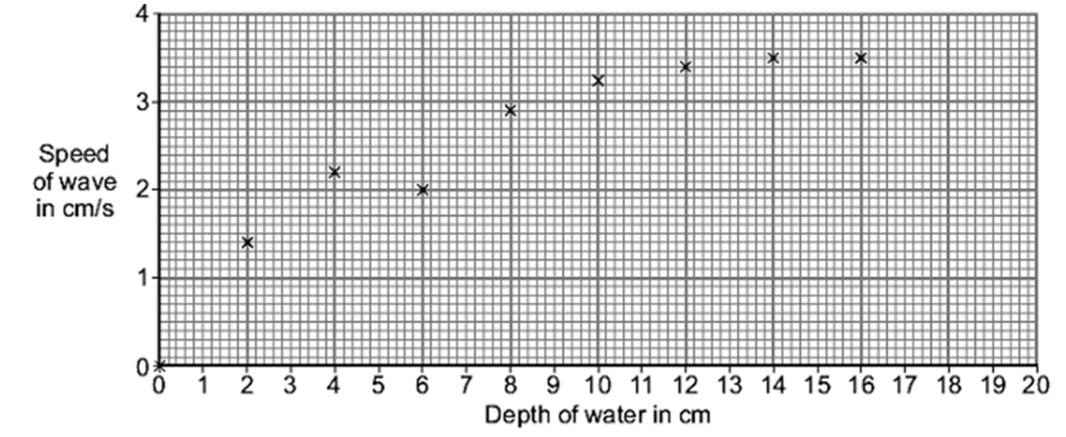
Q11. A student uses the ripple tank to investigate the relationship between depth of water and speed of waves. The graph shows the student’s results.
There is one anomalous result. On the graph, draw a ring around the anomalous result.
Q12. On the graph, draw a line of best fit.
Q13. Use your line of best fit to find the speed of a wave at a depth of 20cm.

