Structure of the atom
Basic
- Complete the following sentences using words from the list below.
equal negative opposite positive zero
- A proton has …………….. charge.
- A neutron has …………….. charge.
- An electron has …………….. charge.
- A proton and an electron have …………….. and …………….. charge.
- What is the size of the radius of an atom?
- What is most of the atom made up of?
- What is the name of an atom that has lost an electron?
Medium
- Complete the following sentences using words from the list below.
electron(s) ion(s) neutron(s) nucleus (nuclei) proton(s)
- Every atom contains a …………….. which is positively charged.
- The nucleus of an atom is composed of …………….. and ……………...
- The …………….. in an atom move about in the space surrounding the nucleus.
- An uncharged atom has equal numbers of …………….. and ……………...
- A charged atom is called an ……………...
- An uncharged atom becomes charged as a result of transferring …………….. to or from it.
- An Oxygen atom contains 8 protons. How many electrons does it contain?
- A Nitrogen atom contains 7 protons. How many electrons does it contain?
Hard
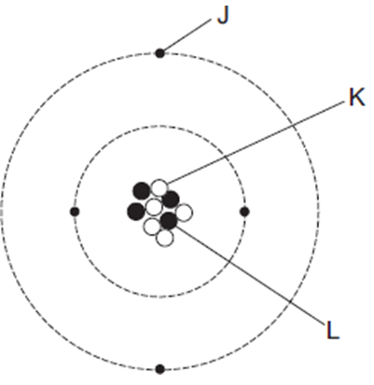
- Explain why atoms are usually neutral.
- The diagram represents an atom of beryllium.
- The particle with a positive charge is ……...
- The particle with the smallest mas is ……...
- The particle with no charge is ……...
- Some electromagnetic radiation (e.g. light) is being shone on some rubidium atoms. What happens to the electrons of the rubidium atoms?
- The electromagnetic radiation now stops being shone on the rubidium atoms. What happens now?

