Basic
Q1: Write the equation that links time period and frequency.
Q2: What are the units of time period and frequency?
Q3: Calculate the time period when the frequency is:
- 10 Hz b) 5 Hz c) 0.2 Hz d) 1200 Hz e) 0.006 Hz
Q4: What is the definition of frequency?
Medium
Q5: Rearrange the equation to give an equation for frequency.
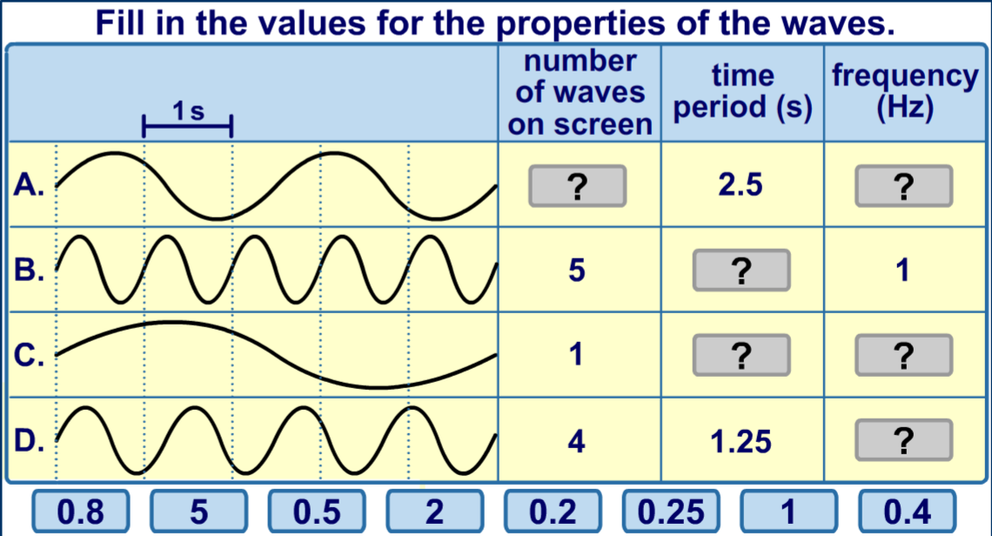
Q6:

Hard
Q7: A note is played on an electric keyboard. The frequency of the note was 440 Hz. What does a frequency of 440 Hz mean?
Q8: Calculate the time period when the frequency is:
To go from kHz to Hz → × 1000
a) 2 kHz. b) 0.5 kHz c) 150 kHz d) 0.2 kHz e) 0.01 kHz
Q9: Calculate the frequency when the time period is:
- 0.5 seconds b) 0.01 seconds b) 5 milliseconds c) 2 milliseconds
- 1 minute e) 30 minutes f) 1 hour g) 1 year.
To go from milliseconds to seconds → ÷ 1000

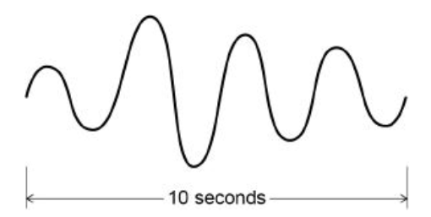
Q10: What is the time period of the wave opposite?
Q11 Using the answer to Q10, what is the frequency of the wave opposite?

