Basic: Look at your teacher’s notes if you’re not sure.
- What do waves transfer?
- What are the two types of wave?
- Cross out the wrong one:
- Transverse waves vibrate parallel / at right angles to the direction of energy transfer
- Longitudinal waves vibrate parallel / at right angles to the direction of energy transfer
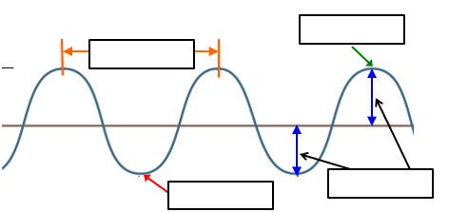
- The wave below is transverse / longitudinal. Label the wave.

- The wave below is transverse / longitudinal. Label the wave.
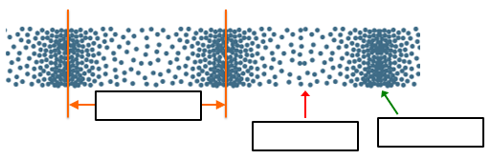

Height of a wave
Bottom of a wave
Top of a wave
Distance between two waves
Where particles are closest together
Where particles are furthest apart
Medium: Draw a line from the word to the correct definition.
Wavelength
Amplitude
Crest
Trough
Compression
Rarefaction

For each wave described below, identify the wave as a transverse or longitudinal wave.
- The wave created by moving the end of a spring toy up and down.
- The wave created by moving the end of a spring toy back and forth parallel to the length of the spring.
- A sound wave.
- An ocean wave.
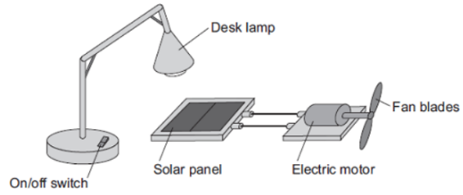
- An electromagnetic wave.
Hard: Use complete sentences. Look at the number of marks available.
- Describe the differences between longitudinal waves and transverse waves (3).
- Radio waves are electromagnetic waves. Describe how radio waves are different from sound waves. (4)
- Describe how switching the desk lamp on and off shows that light waves transfer energy. (2)

