Basic
- What are the three types of radiation?
- What are alpha particles made of?
- What are beta particles made of?
- What is gamma radiation made of?
- What is ionisation?
- Why is radiation dangerous?
- What do we use to detect radiation?
- Complete the following sentences. Use the words in the box.
Gains ions unstable decay random loses

Ionising radiation is emitted from ___________ nuclei. The process is __________. This means you cannot predict when the nucleus will ___________ and emit radiation. This radiation can cause atoms to become __________. Ionisation occurs when an atom _________ or __________ electrons.

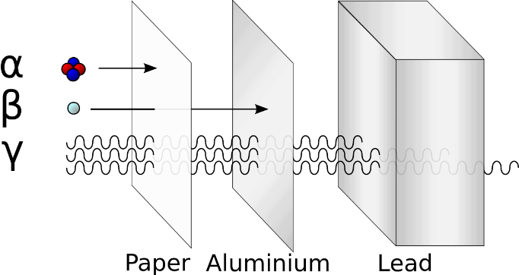
Medium
- Complete the table of radioactive penetration using the diagram. For the last two columns use the words “strongly”, “partly” or “weakly”.

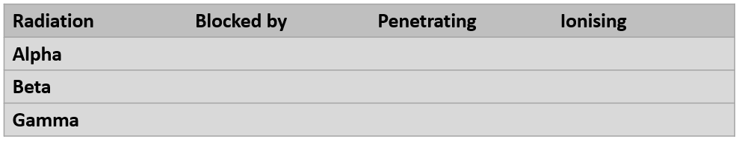

- Which of the three types of radiation:
- Has the greatest mass?
- Has the greatest charge?
- Does not have any mass?
- Has the same mass as an electron?
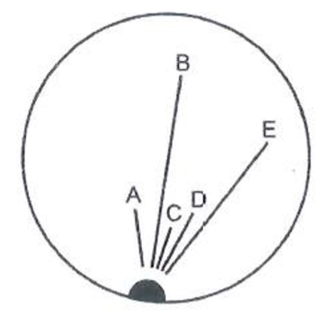
- Is equivalent to a helium nucleus.
- Is a type of electromagnetic radiation.
- What are the charges of alpha, beta and gamma radiation?
Hard
- Look at the diagram, which shows trails in a cloud chamber. The radioactive source is emitting both alpha and beta particles.
- Which trails are caused by alpha particles?
- Which trails are caused by beta particles?
- Explain how you can tell.
- Can you predict when alpha or beta particles will be emitted? Explain your answer?
- What happens when the alpha particles collide with the particles in the cloud chamber?
- When radioactive sources are stored in boxes in schools, the boxes are always lined with lead on the inside. Why is this necessary?
- A student said: “If I were to wear a lead suit, I would be completely protected from radiation!” Explain why this statement is not true.

