Basic: Match up the following parts of the EM spectrum with their uses
Gamma rays Allow us to see
Radio waves Remote Controls
Ultra Violet ‘See’ broken bones
Visible Carry TV signals
Microwaves Mobile phones
X rays Sterilise equipment
Infra Red Causes sun burn
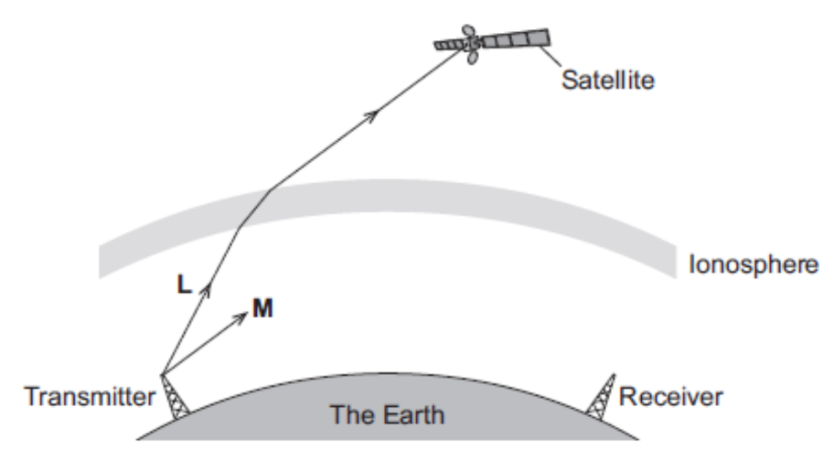
Medium
- What is the danger of:
- Visible light
- Infra-red
- Microwaves
- Which three EM waves are ionising? What does ionising mean and what is it dangerous?
- What does sterilisation mean? What property of gamma waves makes it suitable for sterilising food/medical equipment?
- What does sun-screen do to UV light?
- Different parts of the EM spectrum are useful for different methods of communication. The diagram shows a transmitter emitting two electromagnetic waves L and M.
- i) Wave L is used to send a signal to a satellite. Which part of the electromagnetic spectrum does wave L belong to?
ii) What name is given to the process that occurs as wave L passes into the ionosphere?
- I) Wave M is reflected by the ionosphere. On the diagram above, draw the path of wave M until it reaches the receiver.
ii) On the diagram above, draw a line to show the normal where wave M meets the ionosphere. Label the line N.
- Give two properties of all electromagnetic waves.
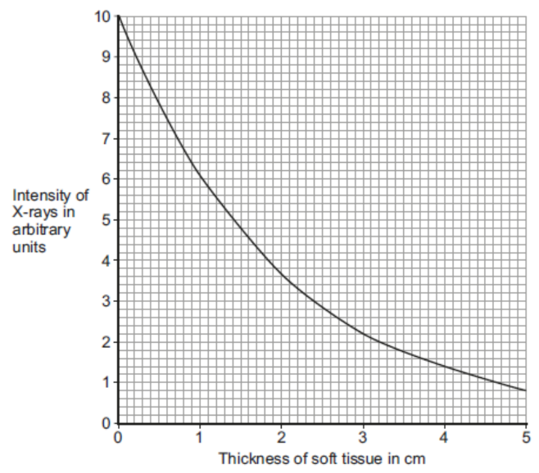
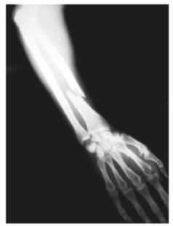
Hard
- The photo shows an X-ray of an arm with a broken bone.
- Complete the following sentence. X-rays are part of the ________________ spectrum.
- The graph shows how the intensity of the X-rays changes as they pass through soft tissue and reach a detector.
- Use the graph to determine the intensity of X-rays reaching the detector for a 3cm thickness of soft tissue.
- Describe how the thickness of soft tissue affects the intensity of the X-rays.
- The data in the graph is shown as a line graph and not as a bar chart. Explain why.
- What happens to X-rays when they enter a bone?
- How are images formed electronically in a modern X-ray machine?
- Radiographers who take X-ray photographs may be exposed to X-rays. X-rays can increase the risk of the radiographer getting cancer. Why can X-rays increase the risk of getting cancer?
- What should the radiographer do to reduce the risk from X-rays?

