Density = Mass ÷ Volume
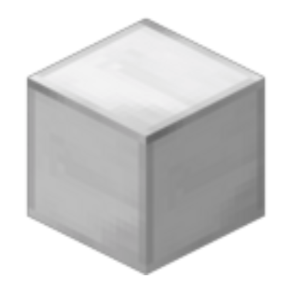
- What is the density of a 5 cm³ concrete block that has a mass of 10 g?
Density = Mass ÷ Volume
= 10 g ÷ 5 cm³
= ____________ g/ cm³
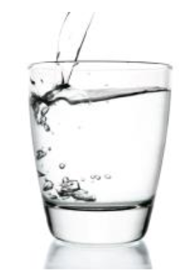
- What is the density of a 10 cm³ volume of water that has a mass of 10 g?
Density = Mass ÷ Volume
= __________ g ÷ __________cm³
= ____________ g/ cm³
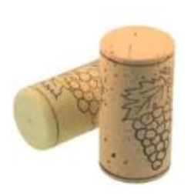
- What is the density of a 6 cm³ cork that has a mass of 3 g?
Density = M_____ ÷ V______
= __________ ___ ÷ _________ ___
= ____________ g/ cm³
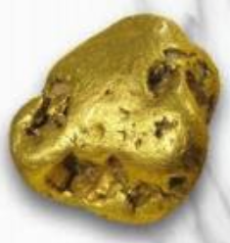
- What is the density of a 0.5 cm³ nugget of gold that has a mass of 10 g?
Density = _______ ÷ ________
= __________ ___ ÷ _________ ___
= ____________ g/ cm³
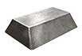
- What is the density of a 15 cm³ iron bar that has a mass of 120 g?
Density = _______ ÷ ________
= __________ ___ ÷ _________ ___

= ____________ _____
- What is the density of a 500 cm³ iPhone that has a mass of 200 g?
Density = _______ ÷ ________
= __________ ___ ÷ _________ ___
= ____________ _____

