Feynman diagram worksheet
Basic
- Give an example of an exchange particle other than a W⁺ or W⁻ particle, and state the fundamental force involved when it is produced.
- State what roles exchange particles can play in the interaction.
- What force do charged particles feel?
- What force do quarks feel?
- What force do particles with mass feel?
- Which is the only stable baryon.
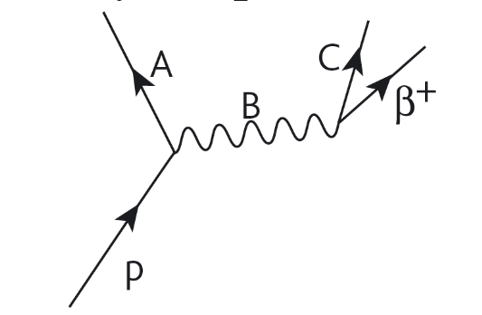
Medium
- Beta-plus decay may be represented by the Feynman diagram to the right. Name the particles represented by A, B and C.
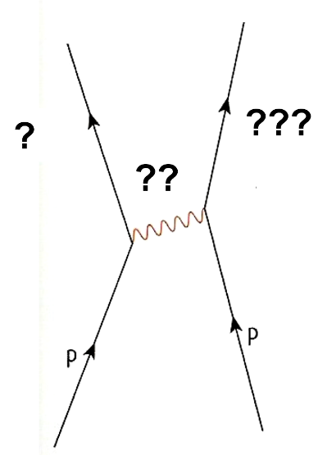
- Complete the labels on the Feynman diagram to the left.
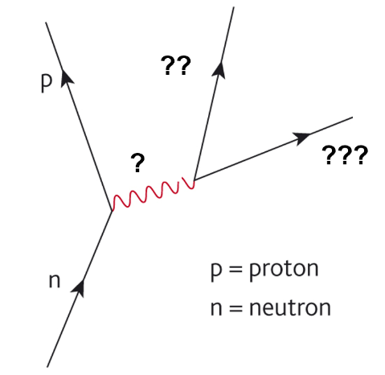
- Complete the labels on the Feynman diagram below.

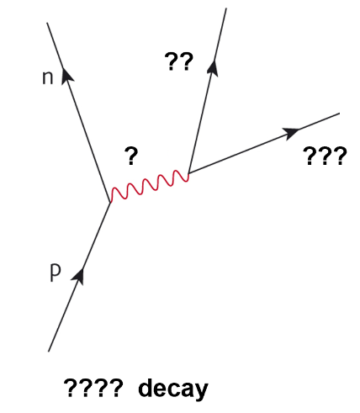
- Complete the labels on the Feynman diagram to the left.

Hard
- Draw a Feynman diagram for electron-positron pair production.
- Beryllium-7 is a proton rich nucleus. It is unstable because it has more protons than neutrons. One of the protons will have to ‘capture’ an electron from the inner shell and change into a neutron!
- Draw a Feynman diagram for the electron capture.
- What changes will happen to the nucleus after the capture?
- Neutrinos very rarely interact with other particles.
- Draw a Feynman diagram of an interaction between a neutrino and a neutron.
- State a property that is conserved in the interaction.
- Draw a Feynman diagram for electron capture.
- Draw a Feynman diagram for an electron-proton collision.

