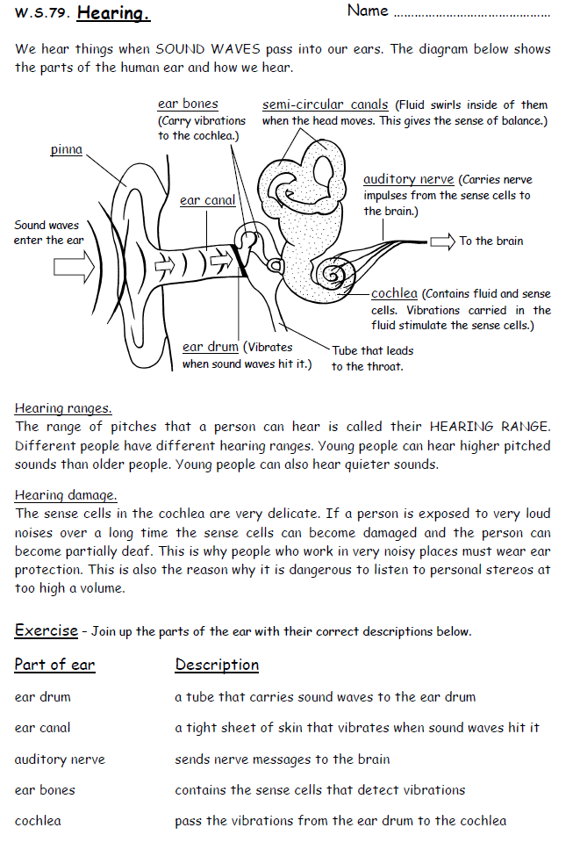
Basic
- What produces a radio wave?
- How is an electronic signal produced from an antenna?
- What happens when a sound wave reaches the ear drum?
- What is the auditory range of humans?
- Join up parts of the ear with their correct description below.

Medium
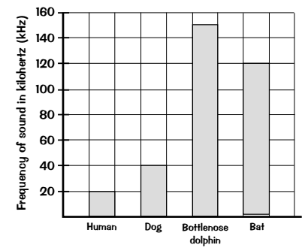
- What is the name for the range of frequencies that an animal can hear?
- Use the graph to the right to find the answers to these questions.
- What’s the highest frequency that a dog can hear?
- Which animal can hear the highest pitch sounds?
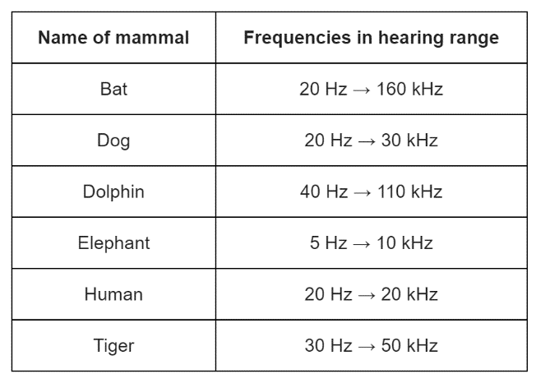
- Which animal can hear the widest range of frequencies.

- a) Which mammal in the table can hear the highest frequency?
b) Which mammal in the table, apart from humans, cannot hear ultrasound?
c) Give one example of a frequency which an elephant can heat but which a tiger cannot.
Hard
- a) What makes microwaves suitable for sending communications to a satellite in space?
b) Scientists have detected short bursts of radio waves emitted from a distant galaxy. The scientists think that the radio waves may have been emitted from a neutron star. What even leads to a neutron star forming?
c) Some of the radio waves from the distance galaxy have a frequency of 1.2 GHz. Convert 1.2 GHz into Hz.
d) Radio waves travel through space at the speed of light. Calculate the wavelength of the 1.2 GHz radio waves emitted from the distant galaxy.
e) When radio waves are absorbed by an aerial they may create an alternating current in an electrical circuit. If an alternating current is created what frequency would it have?

