Selective Breeding Worksheet

Basic:
- Fill in the gaps:

Selective breeding is the process by which humans …………… plants and animals for desired ……………………….
- Label the steps of selective breeding in the correct order: 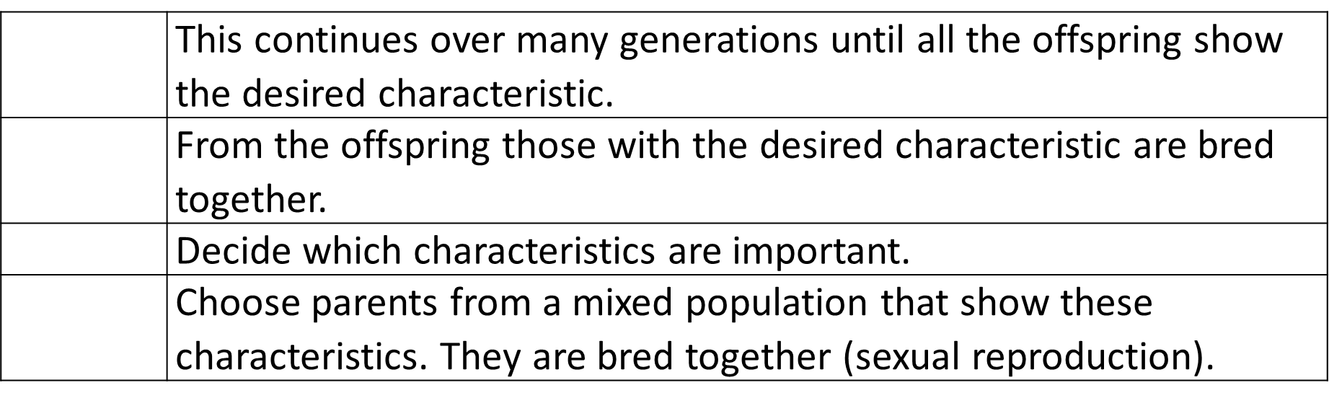

- What are the advantages of selective breeding?
- Give two desirable characteristics in crop plants
- Give a disadvantage of selective breeding.

Medium:

6. Explain how selective breeding has been used to produce docile pets.

7. Explain the reason for two desired characteristics farmers have bread into cows.

8. Describe one problem inbreeding causes

9. Many people have breathing problems because they are allergic to cats. The allergy is caused by a chemical called Fel D1. Different cats produce different amounts of Fel D1. A cat has been bred so that it does not produce Fel D1. The cat does not cause an allergic reaction. Explain how the cat has been produced using selective breeding.

Hard:

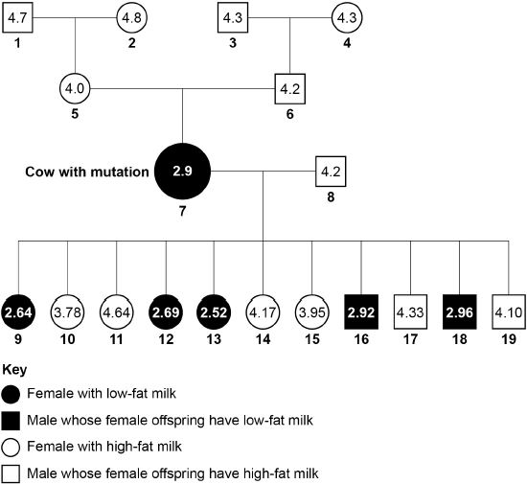
The family tree shows a family of cows and the % of fat in their milk. Cow number 7 had a mutation which caused it to produce low fat milk.

10. The low-fat allele is dominant. Cow 8 is homozygous, explain why cow 7 must be heterozygous.

11. Identify how many offspring from cows 7 and 8 would produce low fat milk. Use a Punnett square to help you.

D = dominant allele for making low-fat milk

d = recessive allele for making high-fat milk

12. The scientists want to produce a type of cattle that makes large volumes of low-fat milk. The scientists will need to use some of the cows shown in the family tree for selective breeding.
Describe how the scientists would do this.

Selective Breeding Worksheet

Basic:
- Fill in the gaps:

Selective breeding is the process by which humans …………… plants and animals for desired ……………………….
- Label the steps of selective breeding in the correct order:

- What are the advantages of selective breeding?
- Give two desirable characteristics in crop plants
- Give a disadvantage of selective breeding.

Medium:

6. Explain how selective breeding has been used to produce docile pets.

7. Explain the reason for two desired characteristics farmers have bread into cows.

8. Describe one problem inbreeding causes

9. Many people have breathing problems because they are allergic to cats. The allergy is caused by a chemical called Fel D1. Different cats produce different amounts of Fel D1. A cat has been bred so that it does not produce Fel D1. The cat does not cause an allergic reaction. Explain how the cat has been produced using selective breeding.

Hard:

The family tree shows a family of cows and the % of fat in their milk. Cow number 7 had a mutation which caused it to produce low fat milk.

10. The low-fat allele is dominant. Cow 8 is homozygous, explain why cow 7 must be heterozygous.

11. Identify how many offspring from cows 7 and 8 would produce low fat milk. Use a Punnett square to help you.

D = dominant allele for making low-fat milk

d = recessive allele for making high-fat milk

12. The scientists want to produce a type of cattle that makes large volumes of low-fat milk. The scientists will need to use some of the cows shown in the family tree for selective breeding.
Describe how the scientists would do this.

