Speed = Distance ÷ Time
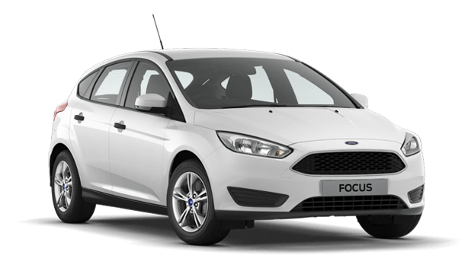
- A car travels a distance of 400 m in a time of 8 seconds. What is the speed of the car?
Speed = Distance ÷ Time
= 400 m ÷ 8 s
= ____________ m/s
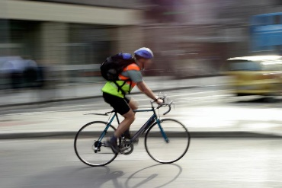
- A cyclist travels a distance of 120 m in a time of 20 seconds. What is the speed of the cyclist?
Speed = Distance ÷ Time
= _____ m ÷ _____ s
= ____________ m/s

- A runner travels a distance of 1,200 m in a time of 400 seconds. What is the speed of the runner?
Speed = Distance ÷ Time
= _____ ___ ÷ _____ ___
= ____________ m/s
- Someone walking their dog travels a distance of 1,500 m in a time of 1,000 seconds. What is the speed of the walker?

Speed = D_________ ÷ T______
= _____ ___ ÷ _____ ___
= ____________ m/s

- A sound wave travels a distance of 686 m in a time of 2 seconds. What is the speed of sound?
Speed = ____________ ÷ _____________
= _____ ___ ÷ _____ ___
= ____________ ____
- Light travels a distance of 4,500,000,000 m in a time of 15 seconds. What is the speed of light?

Speed = ____________ ÷ _____________
= _____ ___ ÷ _____ ___
= ____________ ____

