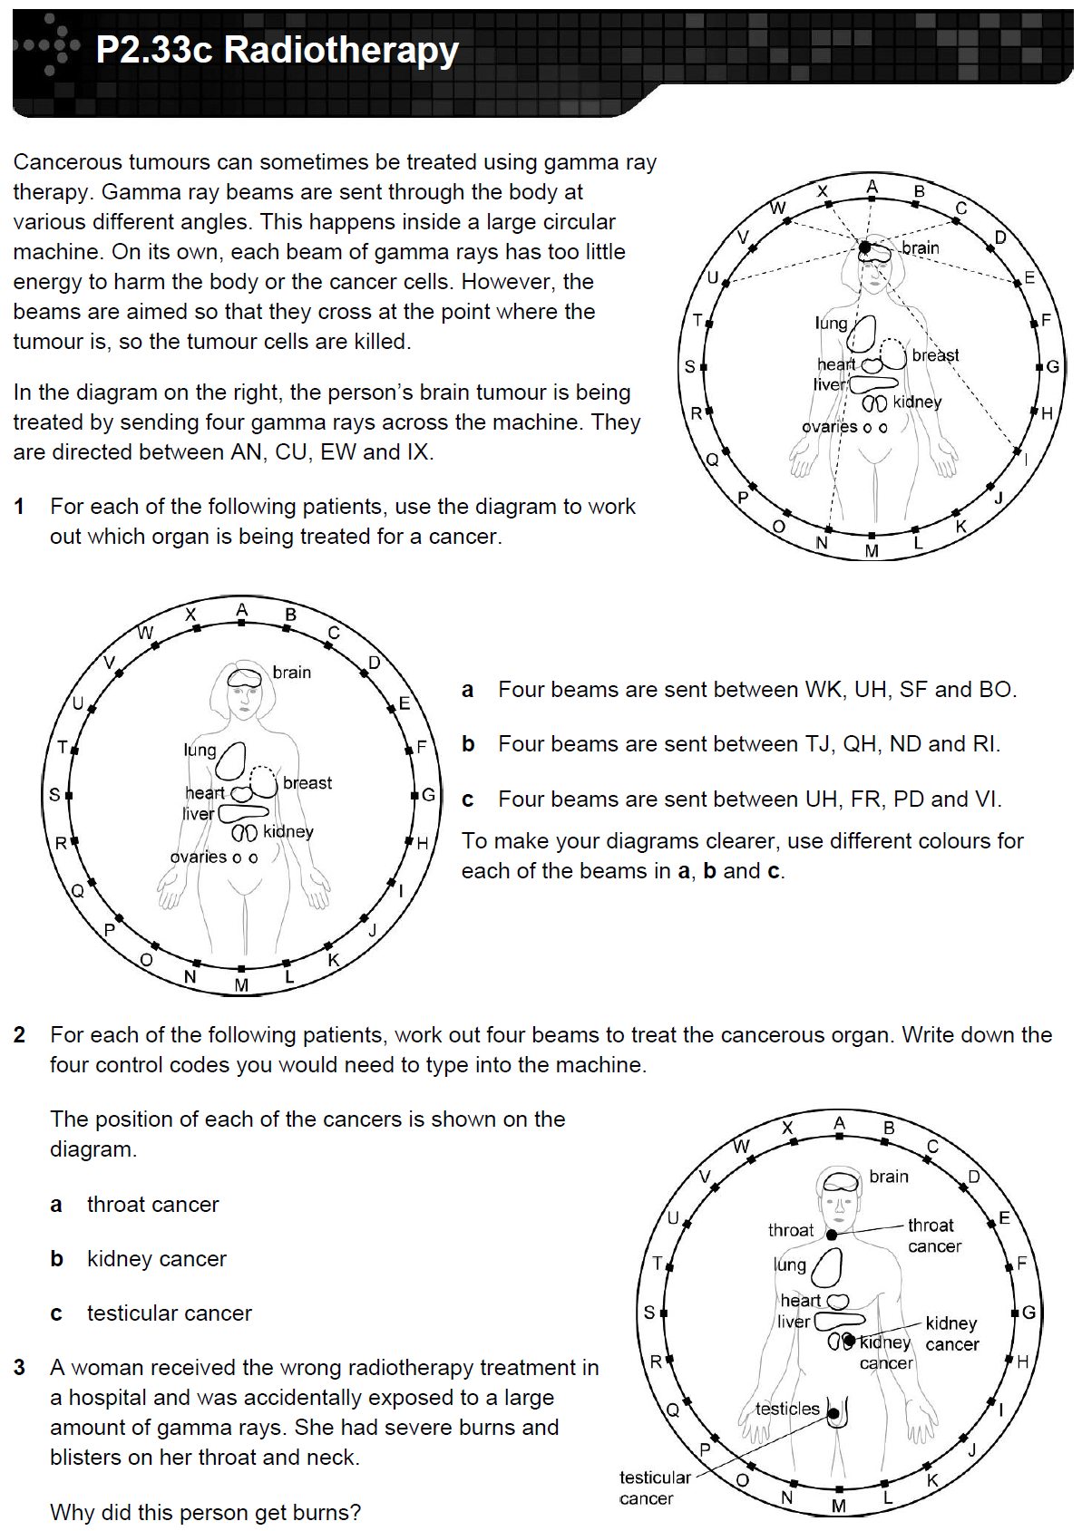
Uses of radiation
Basic
- Name two uses of nuclear radiation in medicine.
- What type of radiation is used in radiotherapy?
- Why is it important that medical tracers have a short half life?
- Where in the body does the person opposite have a tumour?
- What is done to protect healthy tissue?
Medium
6. For each of the following patients, use the diagram to work out which organ is being treated for a cancer. Using different colours for each of the questions will help.
a) Four beams are sent between WK, UH, SF and BO.
b) Four beams are sent between TJ, QH, ND and RI.
c) Four beams are sent between UH, FR, PD and VI.
7. For each of the following patients, work out four beams to treat the cancerous organ. Write down the four control codes you would need to type into the machine.
a) Throat cancer.
b) Kidney cancer.
c) Ovarian cancer.
Hard
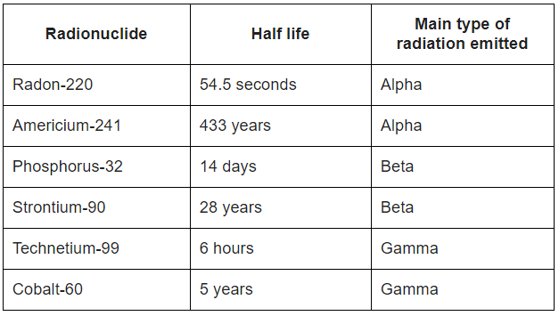
8. The table gives the properties of some radionuclides (radioactive isotopes).
a) Which radionuclide would be best for monitoring the thickness of aluminium foil? Explain the reason for your answer.
b) Which radionuclide would be best for acting as a tracer inside the human body? Explain the reason for your answer.
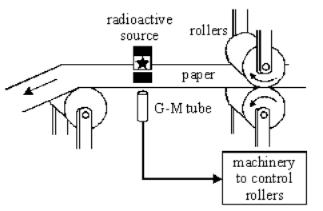
9. The diagram shows a method of controlling the thickness of paper produced at a paper mill. A radioactive source which emits beta radiation is placed on one side of the paper and a radiation detector is placed on the other.
a) How will the amount of radiation reaching the detector change as the paper gets thicker?
b) Explain why a radioactive source which emits alpha radiation could not be used for this application.
c) Explain why a radioactive source which emits gamma radiation could not be used for this application.
d) Explain why a radioactive source which emits beta radiation can be used for this application.
e) Americium-241 is a radioisotope used in smoke detectors. It has a proton number of 95, and a mass number of 241. Americium-241 has a half life of 433 years. How long would it take the americium-241 in a smoke detector to decrease to one eighth of its original number of radioactive atoms?

