Weight = mass × gravitational field strength

- A car of mass 1,200 kg is on Earth, g = 9.8 N/kg on Earth. Calculate the weight of the car.
Weight = mass × gravitational field strength
= 1,200 kg × 9.8 N/kg
= ____________ N
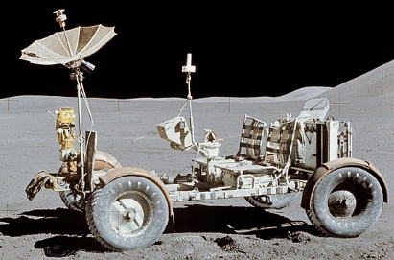
- A lunar rover of mass 210 kg is on the Moon, g = 1.6 N/kg on the moon. Calculate the weight of the rover.
Weight = mass × gravitational field strength
= _______ kg × _______ N/kg
= ____________ N
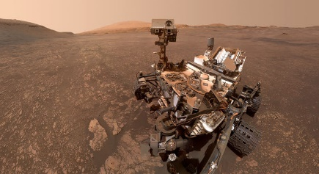
- A mars rover of mass 210 kg is on Mars, g = 3.7 N/kg on Mars. Calculate the weight of the mars rover.
Weight = m____ × g_____________________
= _______ kg × _______ N/kg
= ____________ N
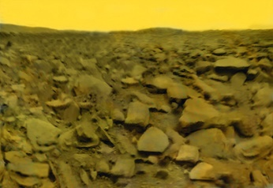
- A rock of mass 0.8 kg is on Venus, g = 8.8 N/kg on Venus. Calculate the weight of the rock.
Weight = _____ × ______________________
= _______ __ × _______ ___
= ____________ N
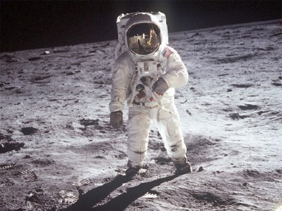
- Neil Armstrong had a mass of 100kg with his suit on. On the moon, g = 1.6 N/kg. Calculate his weight.
Weight = _____ × ______________________
= _______ __ × _______ ___
= ____________ ___
- A satellite drifts into outer space. The satellite has a mass of 500kg. In outer space, g = 0 N/kg. Calculate the satellite’s weight.
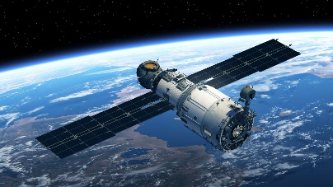
Weight = _____ × ______________________
= _______ __ × _______ ___
= ____________ ___

