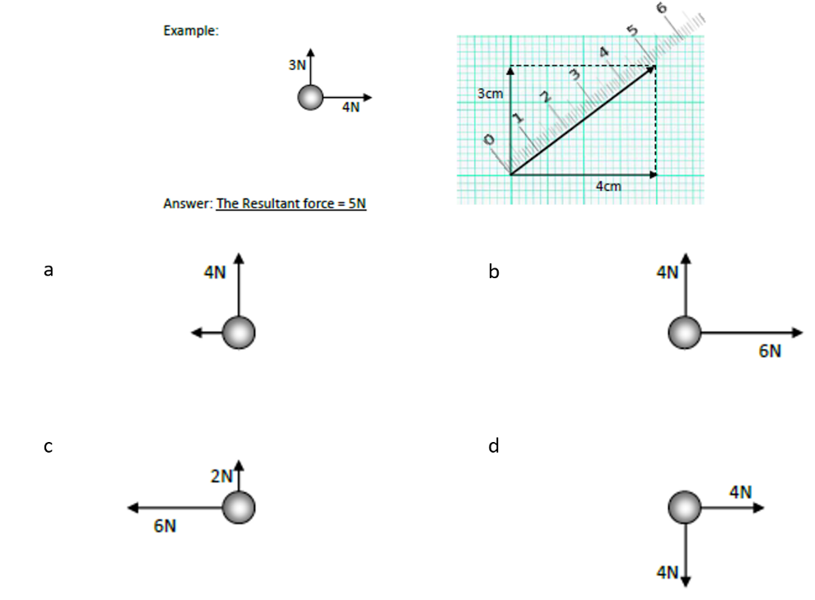
Introduction to forces
Basic
- What is a force?
- What is the unit of a force?
- What do we use to measure forces?
- What is the definition of a scalar? Give three examples of scalars.
- What is the definition of a vector? Give three examples of vectors.
- What is the equation for Pythagoras’ theorem?
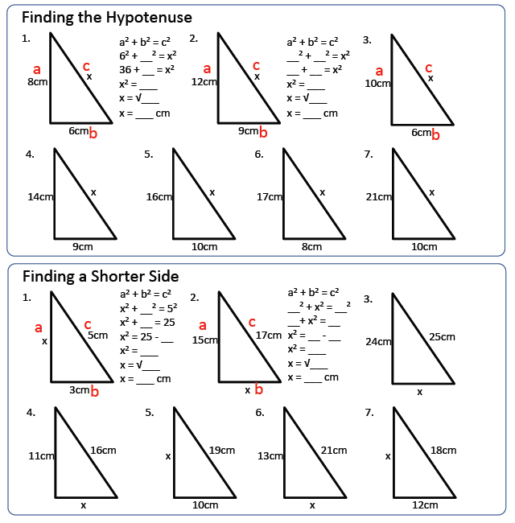
- Draw scale diagrams (1cm = 1N) to work out the resultant force in each of the cases to the right.

Medium
- Describe the difference between distance and displacement.
- Use Pythagoras’ theorem to calculate the missing lengths of each triangle to the right.

Hard
- A woman walks 200m east and then 100m south.
- Find the total distance travelled.
- Now find the resultant displacement.
- Dr. Edmunds’ cat Lola runs after a squirrel 40m North and 30m West.
- What is the distance that Lola has run?
- What is Lola’s resultant displacement?
- An aeroplane travels with a speed of 100 m/s North, and a speed of 20 m/s East. What is the plane’s overall velocity?

