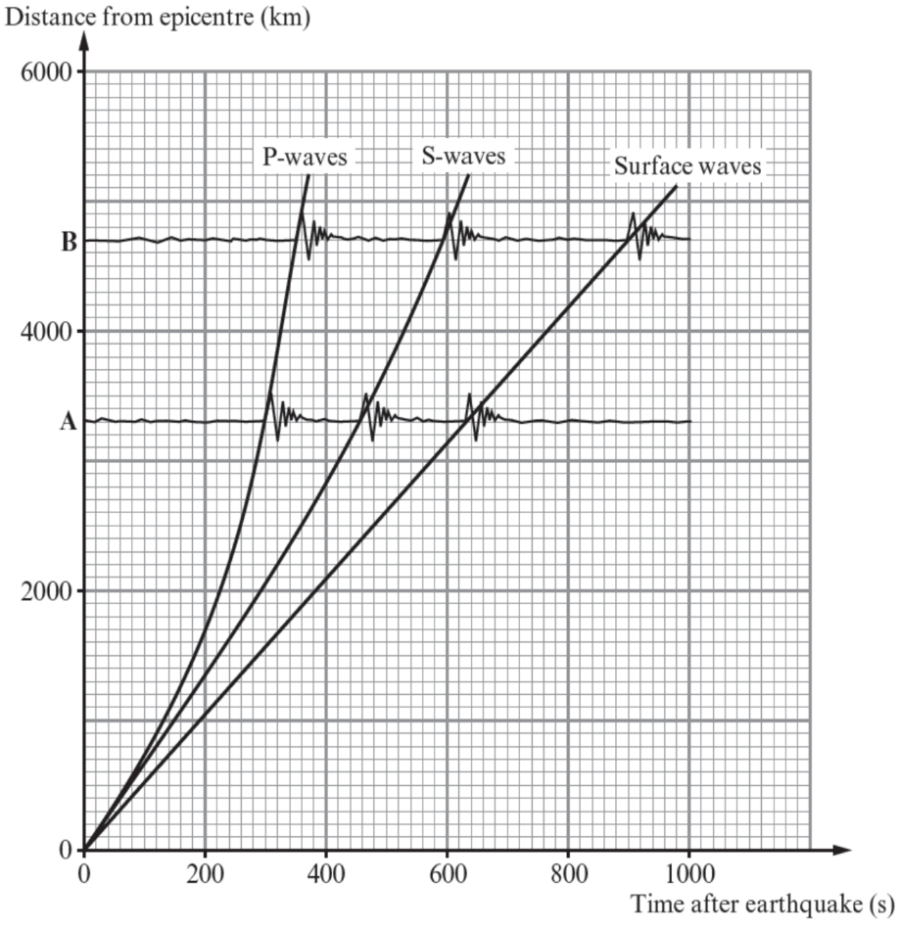
Basic
- What are the names of the four layers of Earth?
- Which type of earthquake wave can travel through liquids and which cannot?
- Which type of earthquake wave travels faster?
- The graph shows how the P, S and surface waves spread out from the epicentre of an earthquake. A and B are seismic stations.
- Use the graph to find the time delay between the arrival of P and S waves at station A.
- Explain why there is a time delay between the arrival of the P and S waves at station A.
- Explain how the graph shows that the speed of surface waves is constant.
- Using the graph, explain why P and S waves change speed as they travel from the epicentre to stations A and B.
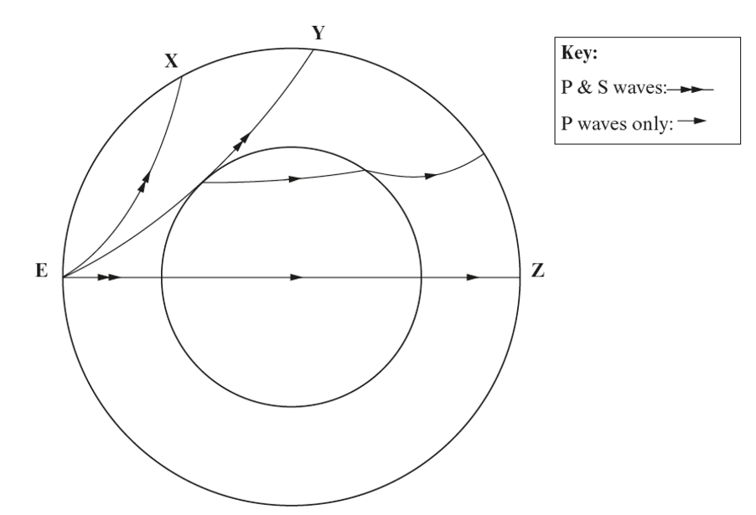
Medium
- State the difference between surface waves and P and S waves.
Z, Y and Z are stations that detect seismic waves.
- Explain why no S waves are detection at station Z.
- Explain why P waves change direction when they enter the outer core.
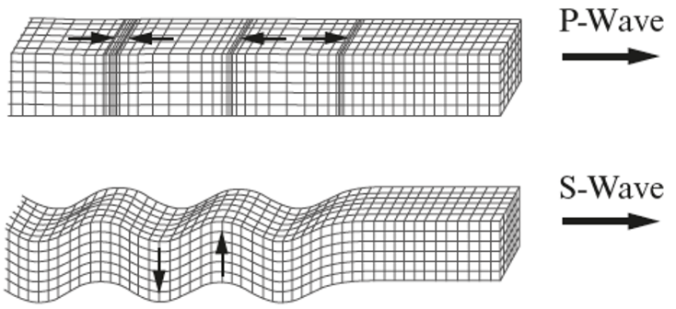
- Use the diagram below to help you explain the difference between how the particles move in P and S waves.
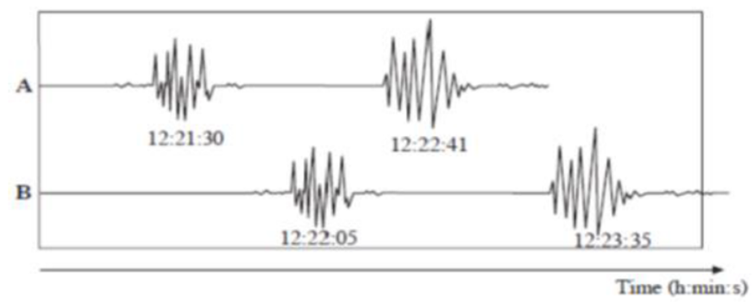

Hard
The diagram shows the first seismic signals received from an earthquake at two monitoring stations A and B.
- What evidence is shown by the seismic data that suggests A is nearer the epicentre than B.
- What evidence suggests P and S waves have travelled with different speeds from the earthquake?
- The time lag between the arrival of the P and S waves for a seismic station which is 100km from the epicentre of an earthquake is 12s. Calculate the distance of the monitoring station A from the epicentre of this earthquake.

