Basic
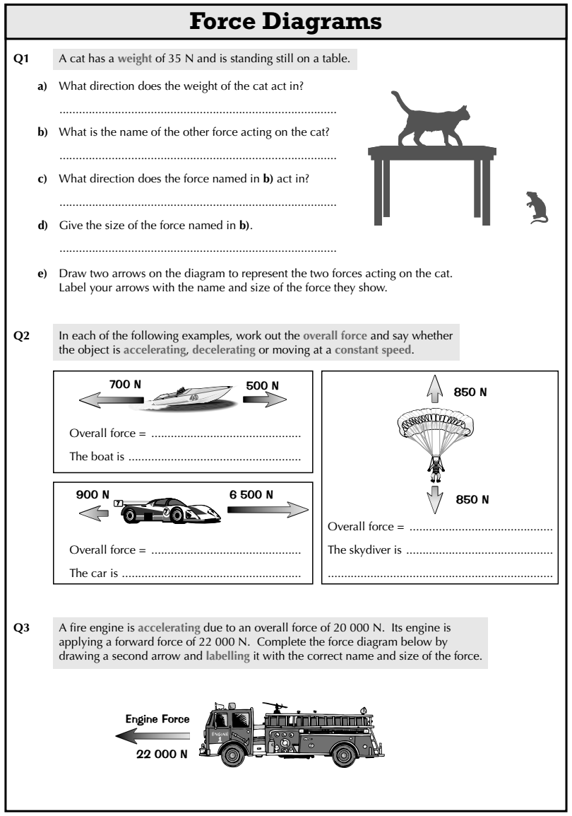
- What does the length of an arrow in a force diagram show?
- What does the direction of an arrow in a force diagram show?
- A cat has a weight of 35N and is standing still on a table.
- What direction does the weight of the cat act in?
- What is the name of the other force acting on the cat?
- What direction does the force named in b) act in?
- Give the size of the force named in b).
- Draw two arrows on the diagram to represent the two forces acting on the cat. Label your arrows with the name and size of the force they show.
- In each of the examples to the right, work out the overall force and say whether the object is accelerating, decelerating or moving at a constant speed.

Medium
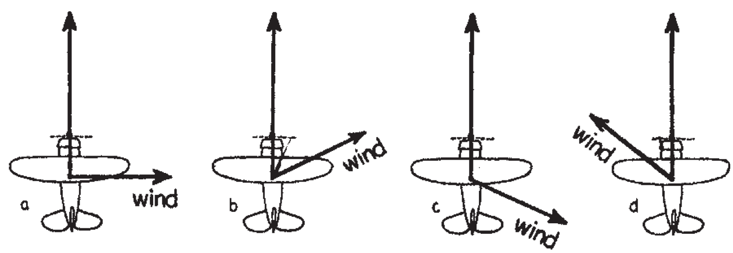
- Below we see a top view of an airplane being blown off course by wind in various directions. Draw the resultant speed and direction of travel for each case. In which case does the airplane travel fastest & slowest?
Hard
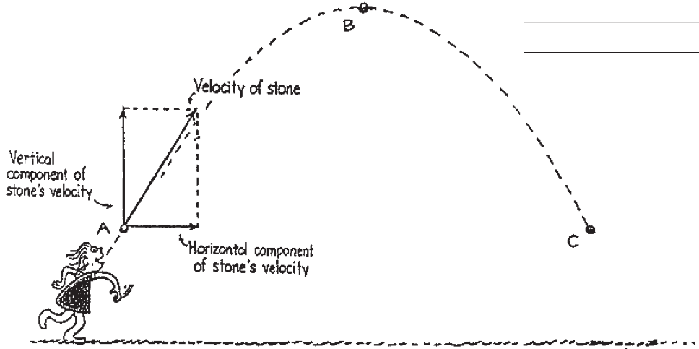
- If we ignore air resistance, we can assume that the horizontal velocity of an object does not change.
- Since there is no acceleration in the horizontal direction, how does the horizontal component of velocity compare for positions A, B and C?
- What is the value of the vertical component of velocity at position B?
- How does the vertical component at position C position with that of position A?
- Draw the resultant velocities at positions B and C.

