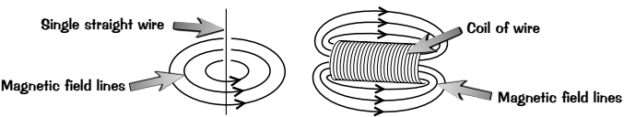
Basic:
- What causes a wire to produce a magnetic field?
- What kind of magnet has the same magnetic field as the long coil of wire?
- What is the scientific name for a long coil of wire?
- What is the main advantage of using an electromagnet vs a permanent magnet?
- Why would steel be bad to use as the core of an electromagnet?
- Name a metal that would be more suitable to use as the core of an electromagnet.
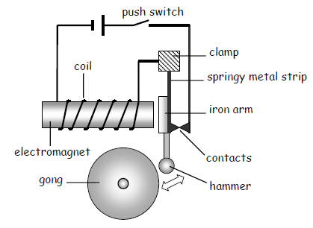
- Suggest two other ways of increasing the strength of an electromagnet.
Medium: Describe how some electromagnetic devices work
- An electric bell:
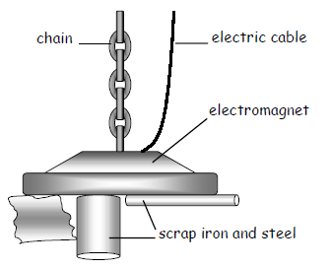
When the push switch is closed the current flows through the ___________. The electromagnet then attracts the iron ______. The hammer moves and strikes the _________. As this happens the contacts separate and the circuit is broken. The electromagnet is switched ______ and the hammer springs back.
- Sorting scrap metal:
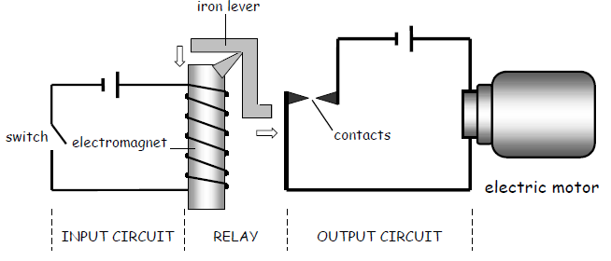
In a scrap yard electromagnets can be used to separate iron and ________ objects from other materials. A thick __________ supplies current to the electromagnet. The current is switched on to pick the metals up and then switched _____ to put them down.

- Electromagnetic switches – relays.
Sometimes it is dangerous to switch on a circuit directly. For example, a car starting motor needs a current of over 100 amps. An electromagnetic switch called a _________ can be used to switch the circuit on safely. When the switch in the _________ circuit is closed the magnet is switched on. This pulls the iron __________ towards it and the ____________ are closed. The motor in the circuit is now switched on.
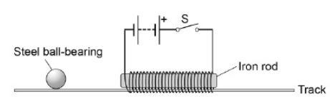
Hard:
- Explain how a relay similar to one in the diagram above could be used to turn an electric motor off.
- Explain how you could use a plotting compass to draw the direction of magnetic field lines around an electromagnet?
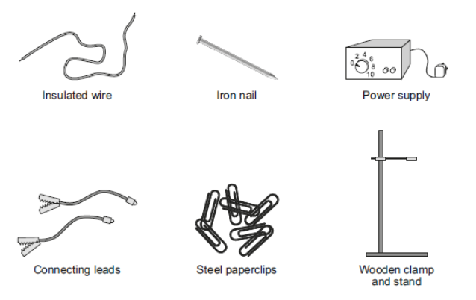
- A student gives a steel ball bearing a gentle push in the direction of the iron rod. At the same time the student closes the switch S. Explain the effect on the motion of the ball bearing when the switch S is closed.
- Using the equipment shown to the left, describe how students could build an electromagnet. Include in your answer how the students should vary and test the strength of their electromagnet (6).

