Basic:
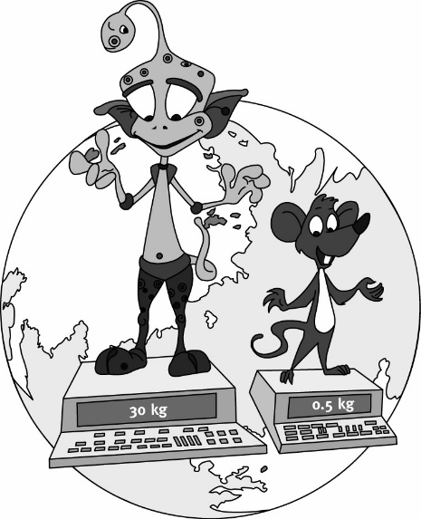
Arnie and Markey have been travelling the Solar
System on a mission to find out about weight on
all the planets. They came to Earth and found out
their mass in kilograms (shown in the picture).
Complete the tables for Arnie and Markey and fill in the missing numbers. Hint – information from elsewhere in the table could be useful!

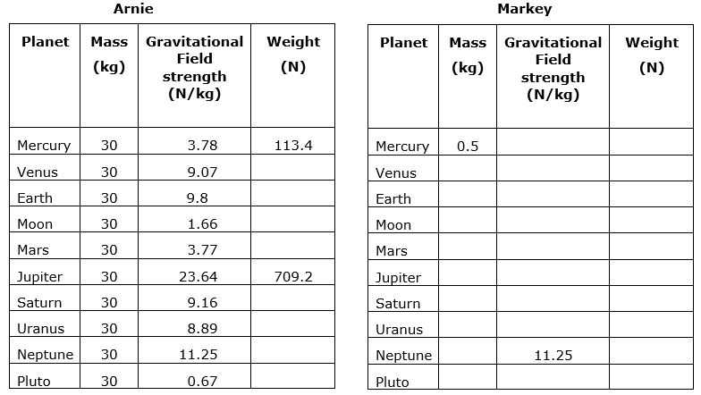
Medium: For these questions you need to re-arrange the formula. (g = 9.8 N/kg for questions 1-5).
- A Formula 1 car weighs 7150N, calculate its mass.
- A cat weighs 42 N, calculate its mass.
- A dog weighs 180 N, calculate its mass.
- An iPad weighs 2.2 N, calculate its mass in.
- A Boeing 747 aeroplane weighs 1.9 × 10⁶ N, calculate its mass.
- A man of mass 70 kg is standing on a planet where he weighs 1750 N. Calculate the planet’s gravitational field strength.
- The curiosity Rover was sent to search Mars. It has a mass of 900 kg weighs 3400 N while on Mars. Calculate Mars’ gravitational field strength.
Hard: Rearranging and unit conversion.
- An iphone has a weight of 1.2N on Earth. Calculate its mass in grams.
- A bottle of water has a weight of 10N on Earth. Calculate its mass in grams.
- A car has a weight of 12 kN on Earth. Calculate its mass in kg.
- A rocket of mass 133,000 kg has a weight of 500 kN on Mars. Calculate the gravitational field strength on Mars.

