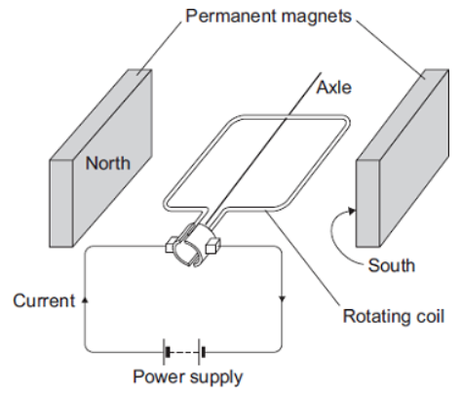
Basic
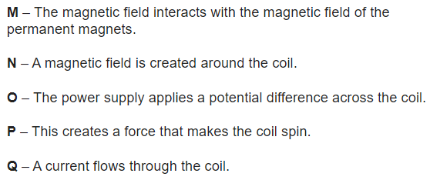
The diagram shows a simple electric motor. The following statements explain how the motor creates a turning force. The statements are in the wrong order.

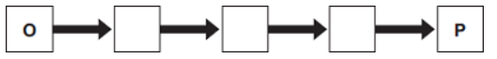
Q1. Arrange the statements in the correct order. Two of them have been done for you.

Q2. Why do the opposite sides of the coil in a dc motor feel forces in opposite directions?
Q3. In what direction will the motor spin?
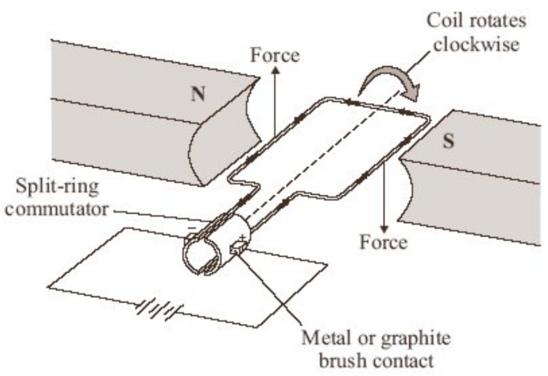
Medium
Q4. What does a split ring commutator do?
Q5. In a dc motor, the commutator disconnects the current every half turn. Why doesn’t the motor stop?
Q6. The electric motor produces a turning force. Give two ways of increasing the turning force.
Q7. Suggest two changes to the electric motor, each one of which would make the coil spin in the opposite direction.
Q8. When there is a current in the coil, the coil rotates continuously. Explain why.
Q9. The battery has been used for a long time and the potential difference across it has decreased from 3V to 2V. What effect does this have on the turning force of the electric motor? Explain your answer.
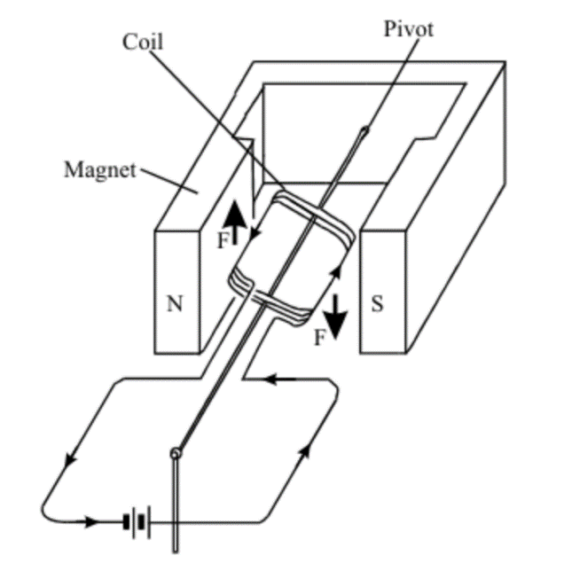
Hard
Q10. The diagram to the left shows an electric motor, without a split ring commutator. What is the purpose of a split ring commutator?
Q11. The arrows labelled F show the direction of the forces acting on the sides of the coil. Describe the motion of the coil until it comes to rest.
Q12. A resistor is placed in series with the battery and coil. What effect, if any, does this have on the force F? Explain why.
Q13. Most electric motors use electromagnets instead of permanent magnets. State three of the features of an electromagnet which control the strength of the magnetic field obtained.

