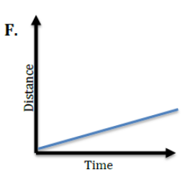
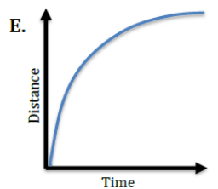
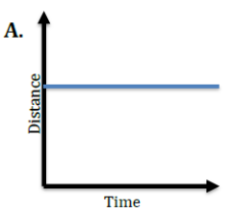
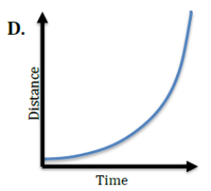
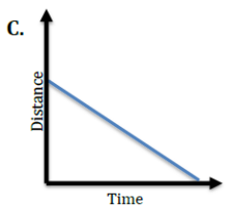
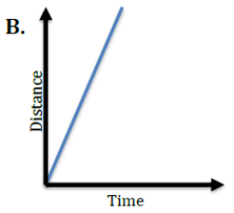
Basic: For each graph below, match the description of the object’s motion.

- _____ Speeding Up (acceleration) 6. _____ No Motion (stopped)
- _____ Constant Speed (high rate of speed) 7. _____ Slowing Down (deceleration)
- _____ Constant Speed (low rate of speed) 8. _____ Moving Backwards (constant velocity
in reverse)
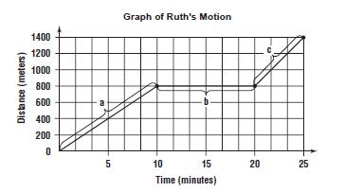
Medium:
- _____ Ruth stops for 10 minutes to speak to a friend.

- _____ She walks at a constant speed of 80 m/min.

- _____ She jogs 600 m in 5 minutes.

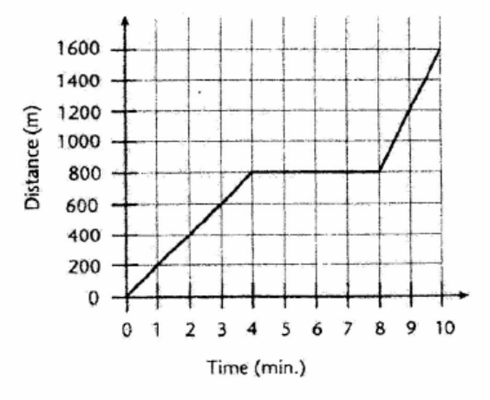
Hard: On Saturday, Erin rode her bicycle to visit Caroline. Caroline’s house is directly east of Erin’s. The graph shows how far Erin was from her house after each minute of the trip.

- Erin rode at a constant speed for the first 4 minutes of the trip. What was her constant speed? ___________________________________________
___________________________________________
___________________________________________

- What was Erin’s average speed for the entire trip? _____________________________________________________________________________________________________________________________________________________________________________________________________________________________________________

- Erin stopped to talk with another friend during the trip. How far was she from home when she stopped? _____________________How long was she stopped? ____________________

- How does Erin’s speed before she stopped compare to after she’s stopped?
_____________________________________________________________________________________________________________________________________________________________________________________________________________________________________________

