Basic:
- Use the words in the box to label the diagram.
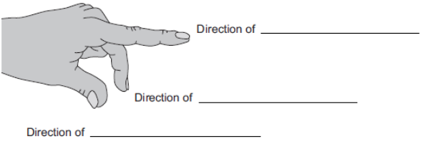
- A current carrying wire is at right angles to a magnetic field. What is the name of the effect that causes the wire to experience a force?
- Draw the circuit symbol for a cell. Mark which end is positive and which end is negative.
- In which direction does current flow?
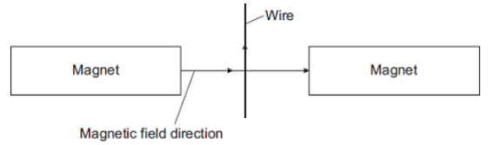
Medium:
- In which direction does the force on the wire act?
- Suggest three changes that would decrease the force acting on the wire.

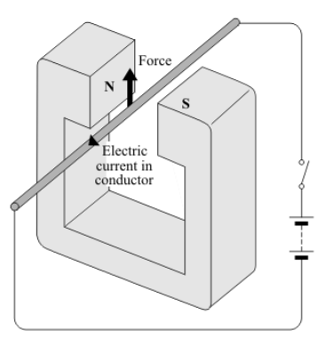

- State two ways in which this force can be increased.

- State two ways in which this force can be made to act in the opposite direction.

- In what circumstance will no force act on a conductor carrying an electric current in a magnetic field.

Hard:
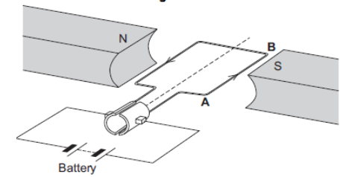
- In which direction does the force on the wire AB act?
- Suggest two changes that would reverse the direction of the force acting on the wire AB.

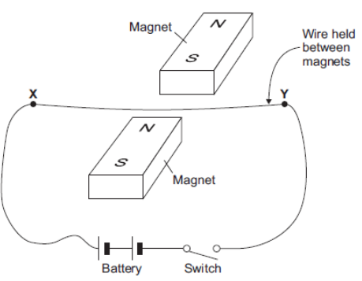
- Closing the switch creates a force that acts on the wire XY. Explain why a force acts on the wire XY when the switch is closed.
- The force causes the wire XY to move. In what direction does the wire XY move?
- The student replaced the battery with a low frequency alternating current (AC) power supply. The student closed the switch. Describe the movement of the wire & explain why the wire moves this way.

