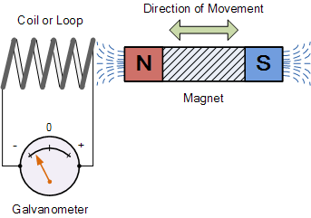
Basic:
- What is required to make an electric current flow in a circuit?
- Name two ways of causing electromagnetic induction.
- How can an induced current be produced?
- What happens if you move a magnet into a coil of wire?
- What happens when a magnet is stationary inside a coil of wire?
- What happens if you move a magnet out of a coil of wire?
- What happens if you move magnet in and out of the coil repeatedly?
Medium:
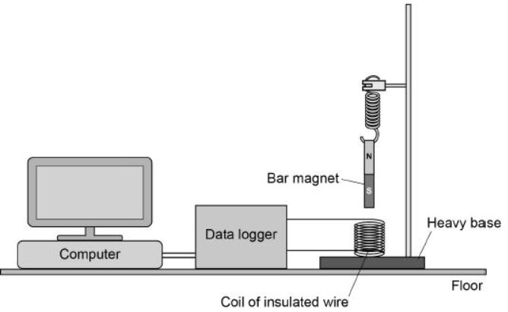
- What are the four ways you can increase the current from an AC generator?

The diagram shows a simple seismometer made by a student. To test that the seismometer works, the student pushes the bar magnet into the coil and then releases the bar magnet.
- Why does the movement of the bar magnet induce a potential difference across the coil?
- Why is the induced potential difference across the coil alternating?
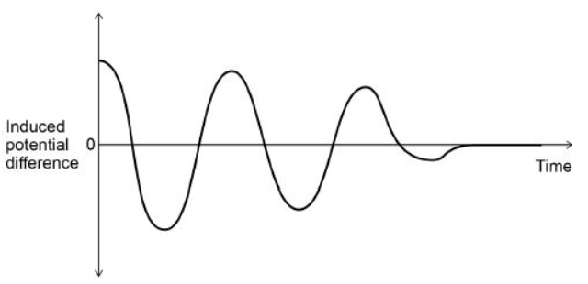
The graph shows how the potential difference induced across the coil varies after the bar magnet has been released.
- What is the movement of the magnet when the induced potential difference is zero?
Hard:
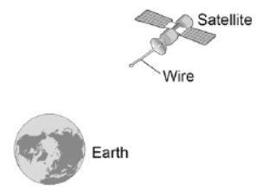
Scientists have used a satellite system to investigate the idea of generating electricity in space. As the system orbited the Earth a 20 km copper wire was reeled out. Before the wire snapped a current of 1 amp was induced in the wire.
- What provides the force needed to keep a satellite in orbit around the Earth?
- Explain how a current is induced in the wire.

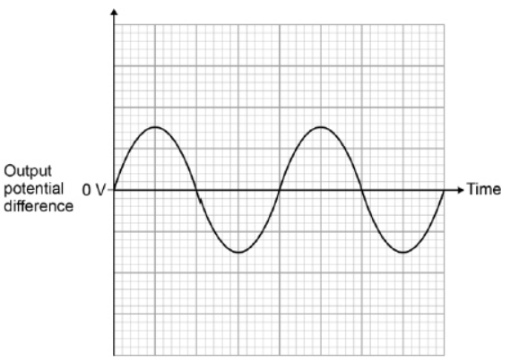
An alternator is connected to a data logger. The data logger is connected to a computer. The graph shows how the output potential difference of the alternator varies with time.
- The coil inside the alternator now rotates at twice the frequency. Draw on the graph to show how the output potential difference varies with time at this new frequency.

