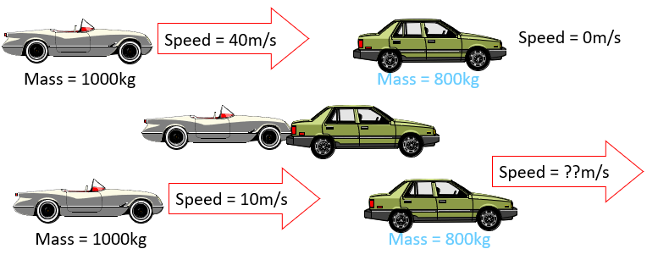
- Calculate the change in momentum of the first car.
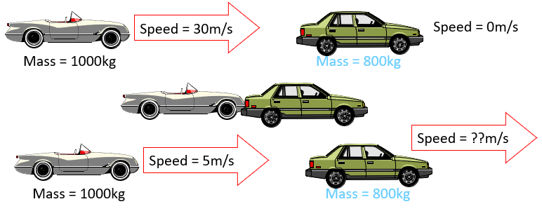
- Calculate the velocity after the collision of the second car.
- Calculate the change in momentum of the first car.
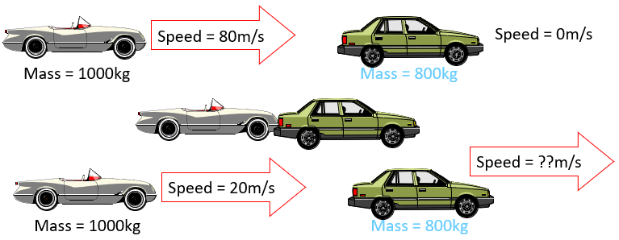
- Calculate the velocity after the collision of the second car.
- Calculate the change in momentum of the first car.
- Calculate the velocity after the collision of the second car.

