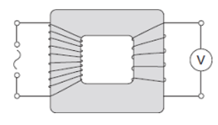
Basic:
V_{p} ÷ V_{s} = N_{p} ÷ N_{s}
V_{s} × I_{s} = V_{p} × I_{p}
Q1. What is a transformer made of?
Q2. Why is iron a suitable material for the core of a transformer?
Q3. What does a step-up transformer do? Explain why this is useful in the National Grid.
Q4. What does a step-down transformer do? Explain why this is useful in the National Grid.
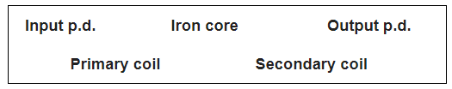
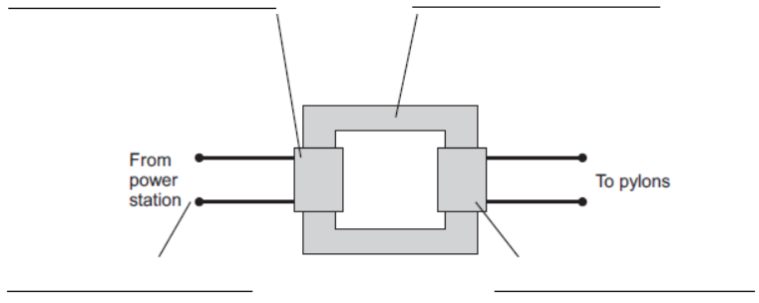
Q5. Use the words from the box to label the diagram.

Medium:
Q5. Complete the table below:
Primary coil potential difference, V_{p} (V) | Secondary coil potential difference, V_{s} (V) | Primary coil current, I_{p} (A) | Secondary coil current, I_{s} (A)
10 | 40 | 20
400,000 | 230 |  | 13
230 |  | 5 | 15
 | 120 | 2 | 8
Q6. Complete the table below:
Primary coil potential difference, V_{p} (V) | Secondary coil potential difference, V_{s} (V) | No. of turns on primary coil, N_{p} | No. of turns on secondary coil, N_{s}
230 | 2300 | 10
400,000 | 230 |  | 460
230 |  | 15 | 1,500
 | 115 | 500 | 800

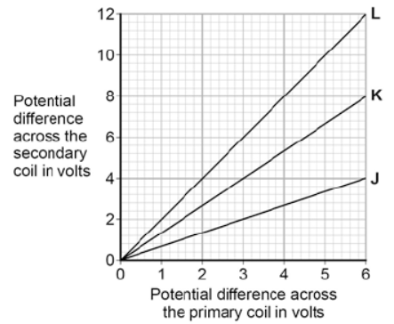
Hard:
A student makes three simple transformers, J, K and L. The graph shows how the potential difference across the secondary coil of each transformer varies ad the potential difference across the primary coil of each transformer is changed.
Q7. How can you tell that transformer J is a step-down transformer?
Q8. Each of the transformers has 50 turns on the primary coil. Calculate the number of turns on the secondary coil of:
- Transformer L
- Transformer K
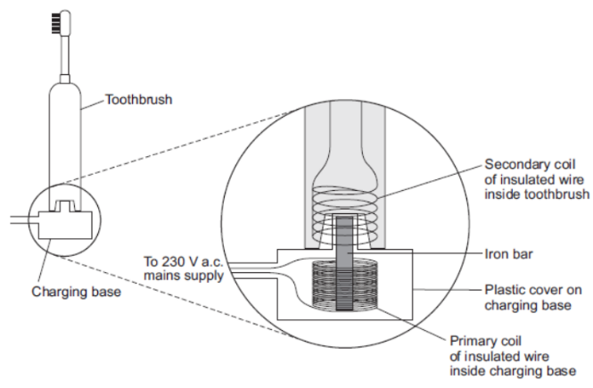
- Transformer J
Q9. When a toothbrush is being charged, the p.d. across the primary coil in the charging base is 230V. The charging p.d. across the secondary coil is 7.2V. The primary coil in the charging base has 575 turns of wire on its coil. Calculate the number of turns on the secondary coil inside the toothbrush.

