Uses of electrostatics worksheet
Basic
- Like charges ________, unlike charges _________.
- Which charged particle is negatively charged?
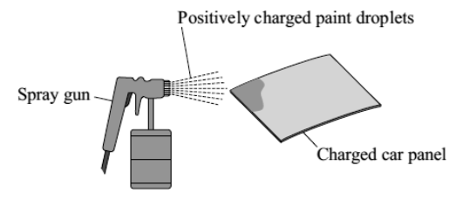
- Name three devices that use electrostatics.
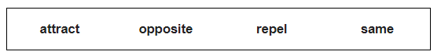
- The diagram to the right shows how static electricity is used to paint a metal car panel. Use words from the box to complete the following sentences.

All the paint droplets have the same type of charge. This makes the paint droplets __________ each other and spread out. The car panel and the paint droplets have the _____________ type of charge. This causes the car panel to __________ the paint droplets. The car panel is covered by an even layer of paint.
Medium
- Name a situation in which static electricity is dangerous and not useful. Give a reason for your answer.
- Describe how an electrostatic precipitator works (3).
- Describe how a photocopier works (4).
- Describe how an ink-jet printer works (2).
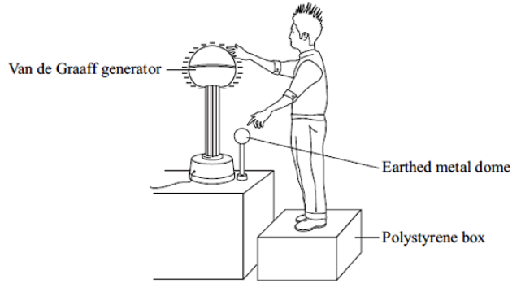
- The diagram to the left shows a student touching the metal dome of a Van de Graaf generator. When the generator is switched on, the metal dome becomes negatively charged.
Explain why the student’s hair stands on end when the generator is switched on. (2)

Hard
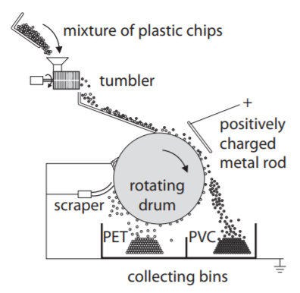
- Polyethylene terephthalate (PET) and polyvinyl chloride (PVC) are two common types of plastic that can be recycled from household waste. They need to be separated in the recycling plant. The waste plastics are crushed into small chips and tumbled together. The PET chips become positively charged. The PVC chips become negatively charged.
- Explain how the PET chips become positively charged and the PVC chips become negatively charged. (2)
- The mixture is dropped onto a rotating drum.
The mixture sticks to the outside of the drum.
The mixture goes past a metal rod that has a positive charge. PVC chips leave the drum and fall into the collecting bin on the right.
Explain why the PVC chips leave the drum. (2)
- The PET chips are carried round until they reach the scraper.
They fall into the collecting bin on the left.
Both of the bins and the scraper are connected to earth.
Suggest why the bins are the scraper are connected to earth. (1)

