Basic: Write what each graph shows: constant velocity, stationary, positive constant acceleration, negative constant acceleration, increasing acceleration or decreasing acceleration.
For example; graph a) shows ___________________.
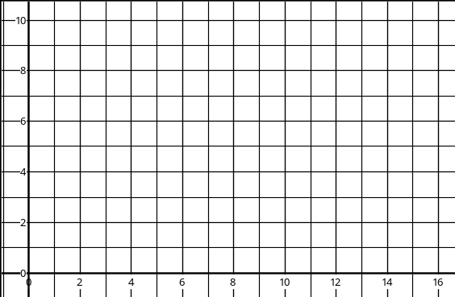
f)
Time (s)
Velocity (m/s)
Velocity (m/s)
Time (s)
e)
Velocity (m/s)
Time (s)
d)
Velocity (m/s)
Time (s)
b)
c)
Time (s)
Velocity (m/s)
a)
Time (s)
Velocity (m/s)

Medium: Calculate: 1) The acceleration for each of the graphs below (using the gradient).
2) The distance travelled for each of the graphs below (using the area under the graph).
f)
Time (s)
Velocity (m/s)
Velocity (m/s)
Time (s)
e)
Velocity (m/s)
Time (s)
d)
Velocity (m/s)
Time (s)
b)
c)
Time (s)
Velocity (m/s)
a)
Time (s)
Velocity (m/s)

Hard: Calculate the distance travelled for each of the graphs below (you will have to divide the area under the graph into different shapes and add up the areas of each shape to give a total area).
f)
Time (s)
Velocity (m/s)
Velocity (m/s)
Time (s)
e)
Velocity (m/s)
Time (s)
d)
Velocity (m/s)
Time (s)
b)
c)
Time (s)
Velocity (m/s)
a)
Time (s)
Velocity (m/s)

The graph below shows the speed of a runner during an indoor 60 metres race.
- Calculate the acceleration of the runner during the first four seconds.
- How far does the runner travel during the first four seconds?
- How long does the runner take to decelerate after the end of the race?
- What is the total distance travelled by the runner?
