
model
Particle
Combined Science
Name ______________________________
Class ______________________________
Teacher ______________________________

Particle model facts
- ρ = m ÷ V
- density – kg/m³, mass – kg, volume - m³

- The particles are touching and vibrate around a fixed pattern.
- Particles are touching but not in fixed positions. They are free to flow around.
- Particles are far apart and move around quickly and randomly.
- Solid.
- Melting (solid → liquid), evaporating (liquid → gas), freezing (liquid → solid), condensing (gas → liquid), sublimating (solid → gas/gas → solid).
- Measure the length of the three sides and multiply together.
- Place the irregular solid in water in a measuring cylinder. Measure how much the water level has gone up by.
- Internal energy is the total kinetic energy and potential energy of all the particles that make up a system.
- The energy needed to heat up 1kg of a material by a temperature of 1°C.
- The energy needed to change state of 1kg of a substance without changing temperature.
- Energy goes into breaking/making bonds.

- In random motion.
- The speed of the particles increases as the gas is heated.
- The pressure would increase as particles would hit the walls of the container more often.
- From solid to liquid.

- From liquid to gas.

- ΔE = m × c × Δθ

- E = m × L

Fold page here
- What is the equation for density?
- What are the units for density, mass and volume?
- How are the particles in a solid arranged?

- How are the particles in a liquid arranged?

- How are the particles in a gas arranged?

- Which state of matter is most dense?
- What are the names of the five state changes?

- How do you measure the volume of a regular solid.
- How do you measure the volume of an irregular solid.

- What is internal energy?

- What is the definition of specific heat capacity?
- What is the definition of latent heat?

- Why doesn’t the temperature of a material change as it’s changing state?
- How do the molecules in a gas move?
- What happens to the speed of particles in a gas as the gas is heated?
- What happens to pressure if the size of a container is reduced?
- The specific latent heat of fusion gives what state change?
- The specific latent heat of vaporisation gives what state change?
- What is the equation to calculate energy change from specific heat capacity?
- What is the equation to calculate energy needed for a state change?

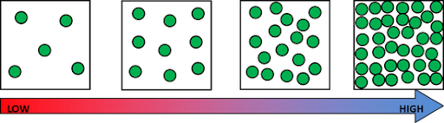
The word means how much mass (particles) there are in a given volume (space). The more particles in a volume, the higher the density.
Density

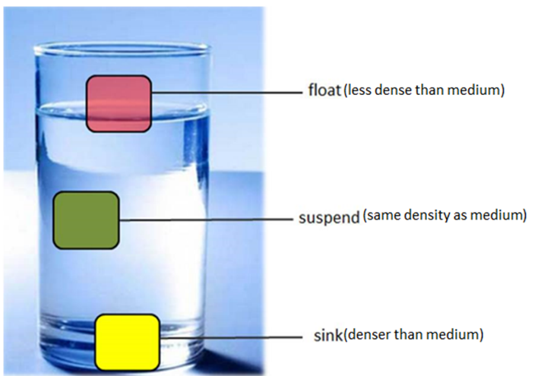
The density of a substance is defined as its mass per unit volume.
Objects float if they are less dense than water. This is because they weigh less than the same volume of water.
Density ρ can be calculated as follows:
Density = Mass ÷ Volume
ρ = m ÷ V
Where:
- ρ is density in kilograms per
cubic metre (kg/m³)
- m is mass in kilograms (kg)
- V is volume in cubic metres (m³)

BASIC
- Calculate the density ρ (in kg/m³) for each of the following:

  - m = 10 kg and V = 10 m³

  - m = 15.5 kg and V = 0.1 m³

  - m = 20.20 kg and V = 0.01 m³

- Calculate the mass m (in kg) for each of the following:

  - ρ = 10 kg/m³ and V = 15 m³
  - ρ = 0.15 kg/m³ and V = 12.20 m³

  - ρ = 0.006 kg/m³ and V = 1.005 m³

- Calculate the volume V (in m³) for each of the following:
  - m = 20 kg and ρ = 10 kg/m³

  - m = 0.22 kg and ρ = 0.05 kg/m³

  - m = 6.60 kg and ρ = 0.003 kg/m³

MEDIUM

- Calculate the density ρ (in kg/m³) for each of the following:
  - m = 10 g and V = 10 cm³

You need to change g into kg and cm³ into m³

m = 10 g = ______ kg and V = 10 cm³ = ______ m³ Now you can calculate the density in kg/m³
To go from cm³ to m³ → ÷ 1,000,000
To go from g to kg → ÷ 1,000

    - = ______ kg/m³

  - m = 12.2 g and V = 200 cm³

  - m = 300.3 g and V = 600.6 cm³

- Calculate the density ρ (in g/cm³) for each of the following:
  - m = 10 kg and V = 10 m³

You need to change kg into g and m³ into cm³

m = 10 kg = ______ g and V = 10 m³ = ______ cm³ Now you can calculate the density in g/cm³

    - = ______ g/cm³

  - m = 0.001 kg and V = 0.002 m³
To go from m³ to cm³ → × 1,000,000
To go from kg to g → × 1,000

  - m = 0.015 kg and V = 0.050 m³

HARD
- A wooden post has a volume of 0.025 m³ and a mass of 20 kg. Calculate its density in kg/m³.

- An object has a mass of 100 g and a volume of 20 cm³. Calculate its density in kg/m³.

- An object has a volume of 3 m³ and a density of 6 000 kg/m³. Calculate its mass in kg.

- An object has a mass of 20 000 kg and a density of 4 000 kg/m³. Calculate its volume in m³.

- The density of air is 1.3 kg /m³. What mass of air is contained in a room measuring 2.5 m x 4 m x 10 m?

- The density of water is 1 000 kg/m³. A water tank measures 2 m x 4 m x 5 m. What mass of water (in g) will it contain?

- A rectangular concrete slab is 0.80 m long, 0.60 m wide and 0.05 m thick.
a. Calculate its volume in m³. b. The mass of the concrete slab is 60 kg.
Calculate its density in kg/m³.
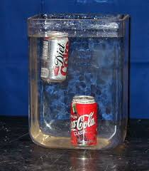
When a can of regular coke is put into water it sinks. However, when a can of diet coke is put into water it floats. Using the keywords below, explain why.

Keywords: Less, water (x2), more, volume, sugar, sinks, floats.

Both diet coke and regular coke are in cans of the same _________ [1].
However regular coke weighs ______ [1]
Because it contains a lot of ________ [1].
The density of the regular coke is ______ than _________. [1]
But the density of diet coke is _______ than _________. [1]
Therefore diet coke _________, but regular coke _______. [1]

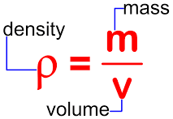
Density – Regular Objects:
Density practical
Object 1 :
Mass of object = ____________ g
Length = ___________ cm, Width = __________ cm, Height = __________ cm
Volume = length × width × height = _________________ cm³
Density = mass ÷ volume = _____________ g/cm³
Compare with the table at the top of the sheet to predict what the object is made of.
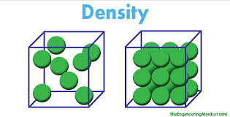
Object is made of ____________________.
Object 2:
Mass of object = ____________ g
Length = ___________ cm, Width = __________ cm, Height = __________ cm
Volume = length × width × height = _________________ cm³
Density = mass ÷ volume = _____________ g/cm³
Compare with the table at the top of the sheet to predict what the object is made of.
Object is made of ____________________.
Object 3:
Mass of object = ____________ g
Length = ___________ cm, Width = __________ cm, Height = __________ cm
Volume = length × width × height = _________________ cm³
Density = mass ÷ volume = _____________ g/cm³
Compare with the table at the top of the sheet to predict what the object is made of.
Substance | Wood | Aluminium | Zinc | Iron | Copper | Gold
Density in g/cm³ | 0.4 | 2.7 | 7.1 | 7.9 | 8.9 | 19.3
Object is made of ____________________.

Density – Irregular Objects

Method:
- Measure the mass of a piece of plasticine in grams.

- Note the level of the water before and after the plasticine is added.

- Work out the volume of the plasticine by using the calculation –

Volume of water before object added – volume of water after object added.

4. Work out the density in g/cm³ of plasticine.

Results table:

Object | Mass  (g) | Volume of water before object added (cm³) | Volume of water after object added (cm³) | Volume of object  (cm³) | Density of object  (g/cm³)
1

2

3

Questions:

Circle the correct words in each sentence.

- Density is how much (mass / volume) there is in 1cm³ of a material.

- A material with a high density feels (lighter / heavier) than a material with a low density.

- Materials with a high density (float / sink) when you put them in water.

- Materials with a (high / low) density float.

- The density of water is 1g/cm³. If a material has a density (less / greater) than the density of water, it will float.

Density – Liquids
Mass of measuring cylinder without water = ____________ g
Mass of measuring cylinder with 50 cm³ of water = _____________ g
Mass of water = __________ g
Volume of water = 50 cm³
Density = Mass ÷ Volume = _________ g/cm³
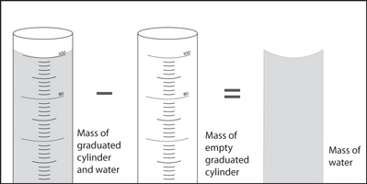

A student wanted to determine the density of a small piece of rock.
(a) Describe how the student could measure the volume of the piece of rock. (4)
___________________________________________________________________
___________________________________________________________________
___________________________________________________________________
___________________________________________________________________
___________________________________________________________________
___________________________________________________________________
___________________________________________________________________
___________________________________________________________________
(b) The volume of the piece of rock was 18.0 cm³.
The student measured the mass of the piece of rock as 48.6 g.
Calculate the density of the rock in g/cm³. (2)
Use the equation:
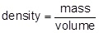
___________________________________________________________________
___________________________________________________________________
Density = _______________________ g/cm³
The graph below shows the densities of different types of rock.
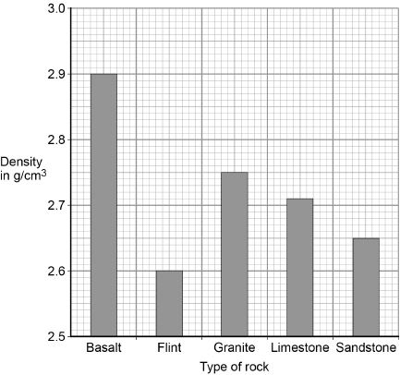
(c) What is the most likely type of rock that the student had? Tick one box.

Basalt | 
Flint
Granite
Limestone
Sandstone

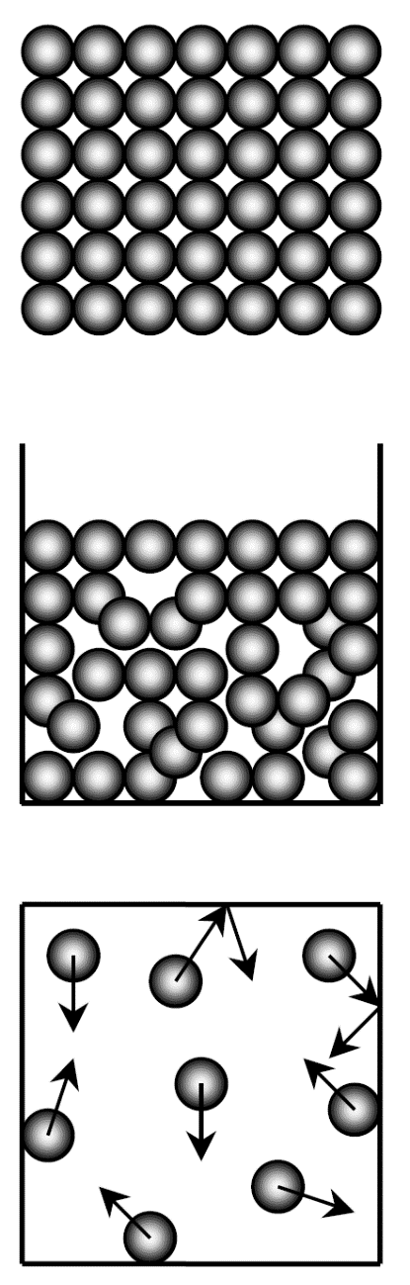
Everything is made up of particles. The three states of matter are solid, liquid, and gas. They all have different properties due to the arrangement and movement of their particles.
Particle model
Solids have particles that are held tightly together by strong forces. The particles vibrate around their fixed positions. Solids have a definite shape and volume. Solids are dense and they can not be compressed easily because the particles are already packed closely together. Solids have the least amount of energy.

A liquid can flow because the particles can move past each other. The particles are still held closely together by strong forces. Liquids are dense and they can not be compressed easily (hydraulics make use of this). A liquid can change its shape but not its volume.

There are only very weak forces between gas particles, which are far apart. Because of this gases can be compressed, and so they have no fixed volume. The particles move around quickly, at a range of speeds. They cause pressure when they collide with the walls of a container. Gases have a low density and they do not have a definite shape or volume. Gases have the most energy. As you heat a gas, the particles move more quickly.
Energy is stored inside a system by the particles (atoms and molecules) that
make up the system. This is called internal energy.

Internal energy is the total kinetic energy and potential energy of all the particles (atoms and molecules) that make up a system.
Task: Complete in exercise book

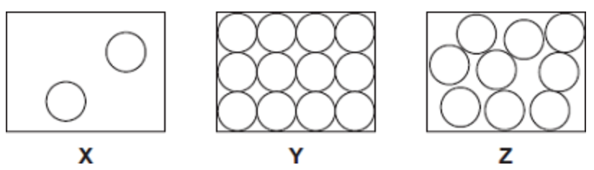
Basic
The diagrams X, Y and Z show how the particles are arranged in the three states of matter.
- Which one of the diagrams shows the arrangement of particles in a solid?
- Which one of the diagrams shows the arrangement of particles in a liquid?
- Which one of the diagrams shows the arrangement of particles in a gas?
- Which state of matter:
- Can be compressed.
- Takes up the shape of the container
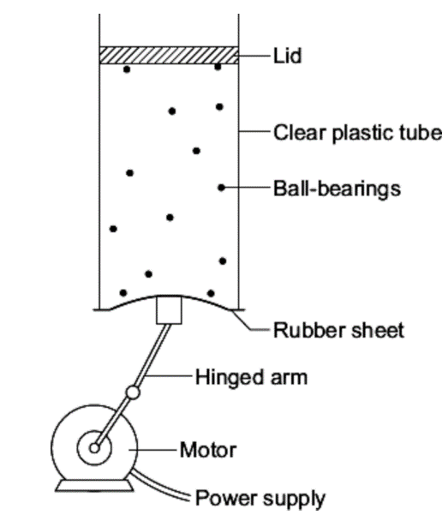
- Has no fixed volume
- Has no fixed shape.
- Has a low density.
- Causes pressure.
Medium
- The diagram shows the model that a science teacher used to show her students that there is a link between the temperature of a gas and the speed of the gas particles.

The ball-bearings represent the gas particles. Switching the motor on makes the ball-bearings move around in all directions.

- Explain, in terms of the particles, why gases are easy to compress.
- How is the motion of the ball bearings similar to the motion of the gas particles?
- The faster the motor runs, the faster the ball-bearings move. Increasing the speed of the motor is like increasing the temperature of a gas. Use the model to predict what happens to the speed of the gas particles when the temperature of a gas is increased.

Hard
- Describe the difference between the solid and gas states, in terms of the arrangement and movement of their particles (4).
- One kilogram of a gas has a much larger volume than one kilogram of a solid. Explain why (4).
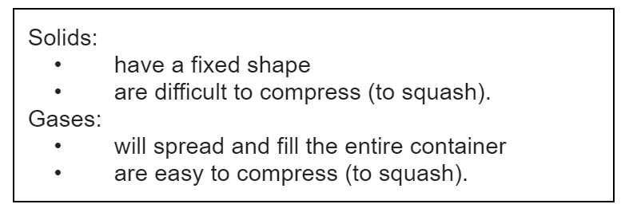
- The information in the box is about the properties of solids and gases.

Use your knowledge of kinetic theory to explain the information given in the box. You should consider:
- The spacing between the particles.
- The movement of individual particles.
- The forces between the particles. (6)

The figure below shows a balloon filled with helium gas.
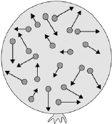
(a) Describe the movement of the particles of helium gas inside the balloon. (2)
___________________________________________________________________
___________________________________________________________________
___________________________________________________________________
___________________________________________________________________
(b) What name is given to the total kinetic energy and potential energy of all the particles of helium gas in the balloon? (1)

Tick one box.
External energy |  | 
Internal energy
Movement energy
(c) Write down the equation which links density, mass and volume. (1)
___________________________________________________________________
(d) The helium in the balloon has a mass of 0.00254 kg.
The balloon has a volume of 0.0141 m³.
Calculate the density of helium. Choose the correct unit from the box. (3)

m³ / kg kg / m³ kg m³
___________________________________________________________________
___________________________________________________________________
___________________________________________________________________
___________________________________________________________________
Density = __________________ Unit _________
A substance is solid at temperatures below its melting point.
State changes
A substance is liquid at temperatures between its melting and boiling point.
A substance is gas at temperatures above its boiling point.
Metal | Melting point in °C
Gold | 1064
Mercury | -37
Sodium | 98
Iron | 1540
Mini-task:
- Which metal has the highest melting point?
- Which metal has the lowest melting point?
- Which metal is a liquid at room temperature (25°C)?
- Which 2 metals would be liquid at 100°C?
- What state would Iron be at a temperature of 900°C?
The boiling point of water is 100°C, while the melting point is 0°C.
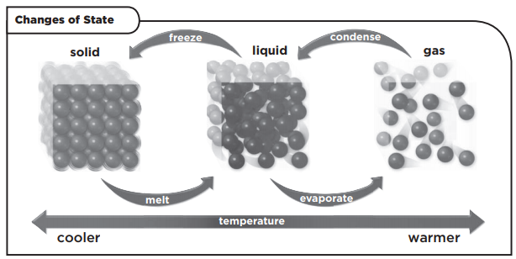

The state changes are shown in the diagram above.
Solid → Liquid Melting
Liquid → Gas Evaporation
Gas → Liquid Condensation
Liquid → Solid Freezing
Solid → Gas Sublimation
Gas → Solid Deposition

Before a state change, energy goes into raising the temperature of the material.

While the state is changing, the temperature of the material stays constant. This is because energy goes into breaking the bonds (forces between particles).
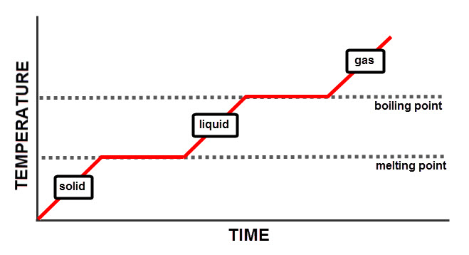

Task: Complete in your exercise book
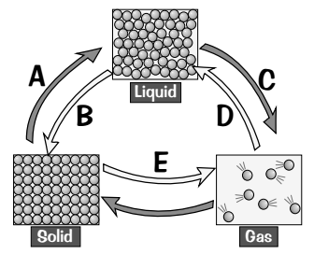
Basic
- A, B, C, D and E represent changes from one state to another. Name each of these changes.
- What is happening to the particles in the substance when change C happens?
- These sentences are wrong. Rewrite them so that they are correct.
- When the state of a substance changes, the energy of the particles doesn’t change.
- A change of state involves a change in mass.
- Condensing is the opposite of melting.
Medium
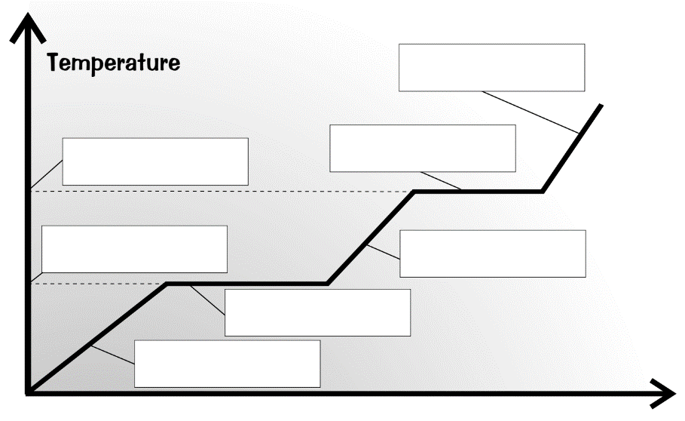
- Which state must be supplied with the most energy to turn it into a gas? Explain your answer.
- When energy is supplied to a solid, what happens to the particles within it. Answer in terms of the energies of the particles and how they are moving?
- Fill in the blanks on the heating curve by using the words given in the word box.
boiling point melting point solid melting liquid boiling gas
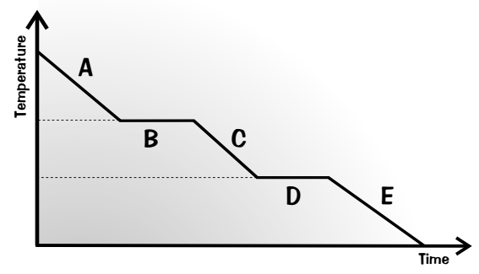
Hard
A scientist measured the temperature of water as it was cooled from 150°C to -20°C. She used her results to make the graph.
- What state is the water in at points A, C and E?
- Name the processes that are happening at points B and D.
- Explain why the graph is flat at points B and D. Use the words forces, energy and particles in your answer.
- Describe what happens to the arrangement of particles as it goes through state change D.

Solid, liquid and gas are three different states of matter.
(a) Describe the difference between the solid and gas states, in terms of the arrangement and movement of their particles. (4)
___________________________________________________________________
___________________________________________________________________
___________________________________________________________________
___________________________________________________________________
___________________________________________________________________
___________________________________________________________________
___________________________________________________________________
___________________________________________________________________
___________________________________________________________________
___________________________________________________________________
___________________________________________________________________
(b) The graph shows how temperature varies with time for a substance as it is heated.
The graph is not drawn to scale.
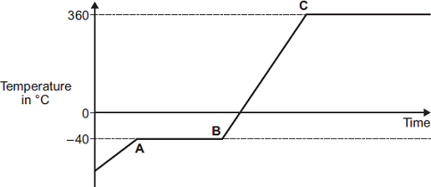
Explain what is happening to the substance in sections AB and BC of the graph. (4)
Section AB _________________________________________________________
___________________________________________________________________
___________________________________________________________________
___________________________________________________________________
Section BC _________________________________________________________
___________________________________________________________________
___________________________________________________________________
___________________________________________________________________
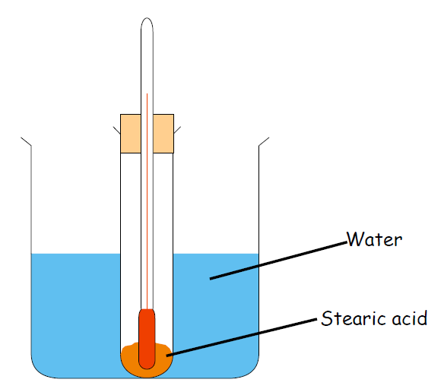
Aim
State changes practical
To heat and melt stearic acid, and then to obtain a cooling curve as it cools down.

Method

- Put a boiling tube with 3cm³ of Stearic Acid into a beaker half full of water.
- Heat this on a Bunsen burner until the stearic acid has melted.
- Turn the Bunsen burner off and put thermometer into stearic acid.
- Use the tongs to put boiling tube into rack.
- Record the temperature immediately and then after every 1 minute until the stearic acid has been a solid again for 2 minutes.

Record your results in the table below:

Time (mins) | Temperature (°C)
0
1
2
3
4
5
6
7
8

Mini-task

Q1 What is the independent variable?
Q2 What is the dependent variable?

Using the graph paper on the next page, plot a graph of temperature (on the y axis) against time (on the x axis).


Two students investigated the change of state of stearic acid from liquid to solid.
They measured how the temperature of stearic acid changed over 5 minutes as it changed from liquid to solid.
The diagram below shows the different apparatus the two students used.
Student A’s apparatus Student B’s apparatus
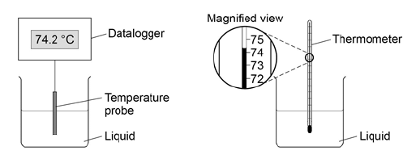
(a) Choose two advantages of using student A’s apparatus. Tick two boxes. (2)
Student A’s apparatus made sure the test was fair.
Student B’s apparatus only measured categoric variables.
Student A’s measurements had a higher resolution.
Student B was more likely to misread the temperature.
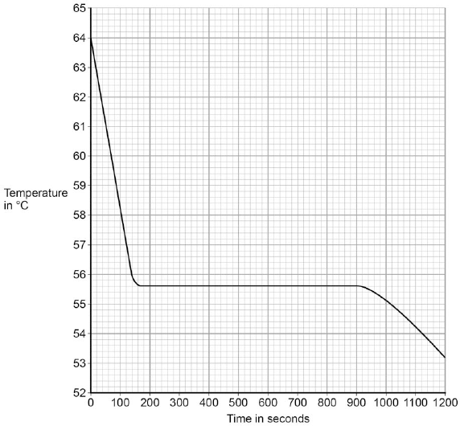
(b) Student A’s results are shown in the graph.

What was the decrease in temperature between 0 and 160 seconds? Tick one box. (1)
8.2 °C
8.4 °C
53.2 °C
55.6 °C
(c) Use the graph to determine the time taken for the stearic acid to change from a liquid to a solid. (1)
Time = ____________ seconds
(d) Use the graph to obtain the melting point of stearic acid. (1)
Melting point = ____________ ˚C
(e) Why doesn’t the temperature change when the stearic acid is melting? (1)
___________________________________________________________________
___________________________________________________________________

(f) After 1200 seconds the temperature of the stearic acid continued to decrease.
Explain why. (2)
___________________________________________________________________
___________________________________________________________________
___________________________________________________________________
___________________________________________________________________

Specific heat capacity
Putting the same amount of heat energy into some materials gives a bigger temperature rise than in other materials. This is due to specific heat capacity.

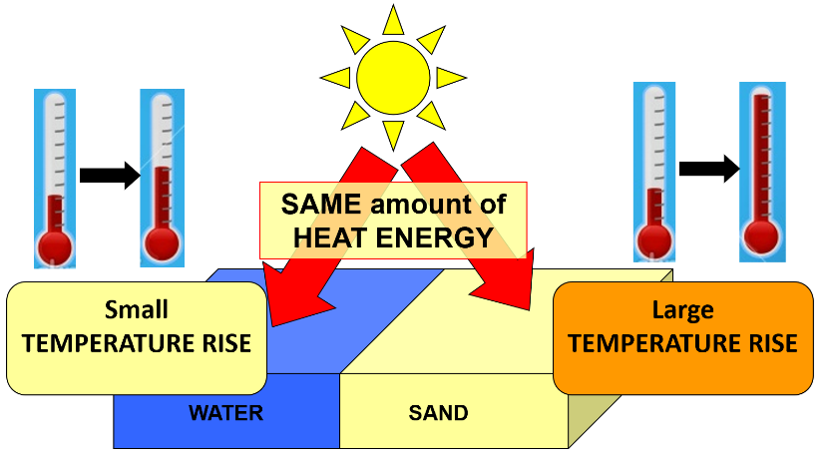
An example of this is on a sandy beach on a sunny day. The water in the sea will be relatively cool, but the sand will be much hotter. This is because water has a higher specific heat capacity than air, and therefore takes more energy to increase in temperature.

The specific heat capacity (c) is the amount of energy needed to increase the temperature of 1 kg of a substance by 1 °C.

A material with a higher specific heat capacity takes more energy to heat up 1 kg by 1 °C than a material with a lower specific heat capacity.

Energy can be calculated using the following:
ΔE = m x c x Δθ
Where:
- ΔE = change in thermal energy (J)
- m = mass (kg)
- c = specific heat capacity (J/kg°C)
- Δθ = change in temperature (°C)

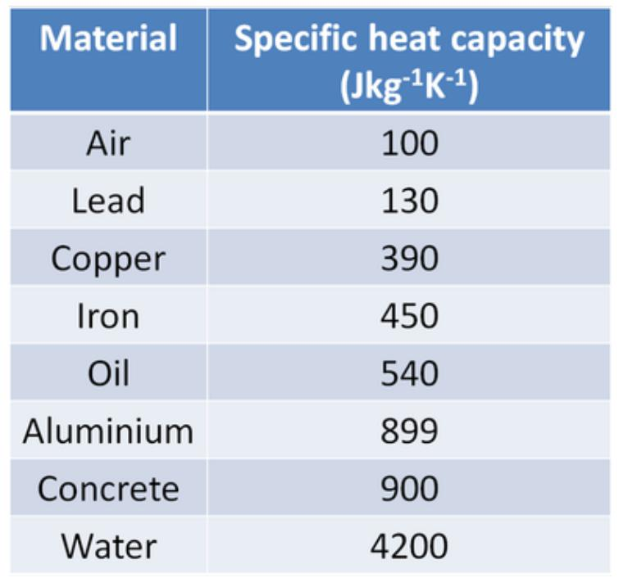
BASIC

1. Calculate the energy ΔE (in J) for each of the following:

- m = 10 kg and Δθ = 4 °C (for water)

- m = 15.5 kg and Δθ = 0.5 °C (for aluminium)
- m = 0.5 kg and Δθ = 20 °C (for copper)
- m = 2 kg and Δθ = 60 °C (for oil)
- m = 800 kg and Δθ = 7.5 °C (for concrete)
- m = 1.2 kg and Δθ = 0.5 °C (for air)
- m = 2 kg and Δθ = 8 °C (for lead)
- m = 1500 kg and Δθ = 0.2 °C (for iron)

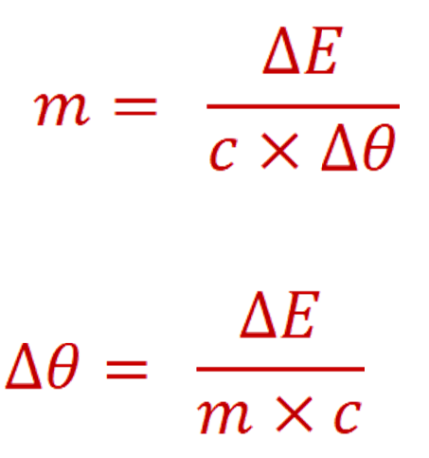
MEDIUM (have to use rearranged equations)

- Calculate the mass m (in kg) for each of the following.

  - ΔE = 1 000 J and Δθ = 2.5 °C (for oil)

  - ΔE = 2 500 J and Δθ = 0.2 °C (for lead)
  - ΔE = 200 J and Δθ = 1 °C (for concrete)
  - ΔE = 5,000,000 J and Δθ = 15 °C (for water)
- Calculate the temperature change Δθ (in °C) for each of the following:

  - ΔE = 3 000 J and m = 20 kg (for air)

  - ΔE = 6 600 J and m = 0.3 kg (for iron)
  - ΔE = 700 J and m = 0.1 kg (for aluminium)
  - ΔE = 20 J and m = 0.02 kg (for copper)

HARD (have to convert units)

4. Calculate the energy E (in J) for each of the following:
- m = 10 g and Δθ = 5 °C (for water) You need to change g into kg
m = 10 g = ______ kg

Now you can calculate the energy in J.
E = ______ J
- m = 12.2 g and Δθ = 10.1 °C (for concrete)
to go from g to kg → ÷ 1 000

- m = 300.3 g and Δθ = 0.8 °C (for copper)

- Calculate the mass m (in kg) for each of the following:

  - E = 10 kJ and Δθ = 20 °C (for aluminium) You need to change kJ into J
E = 10 kJ = ______ J
to go from kJ to J → × 1 000

Now you can calculate the mass in kg .
m = ______ kg
  - E = 0.6 kJ and Δθ = 2.2 °C (for lead)

  - E = 0.05 kJ and Δθ = 50 °C (for oil)

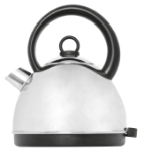
Q1. The electric kettle shown is used to boil water.
(a) After the water has boiled, the temperature of the water decreases by 22 °C.
The mass of water in the kettle is 0.50 kg.
The specific heat capacity of water is 4200 J/kg °C.
Calculate the energy transferred to the surroundings from the water.
___________________________________________________________________
___________________________________________________________________
___________________________________________________________________
Energy = ____________ joules
Tick (✔)
Energy is absorbed from the surroundings.
Energy is used to heat the kettle.
The kettle is more than 100% efficient.
(b) Why is the total energy input to the kettle higher than the energy used to heat the water?
Tick (✔) one box.

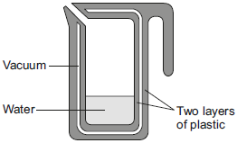
Q2. A new design for a kettle is made from two layers of plastic separated by a vacuum. After the water in the kettle has boiled, the water stays hot for at least 2 hours.
(a) The energy transferred from the water in the kettle to the surroundings in 2 hours is
46 200 J.
The mass of water in the kettle is 0.50 kg.
The specific heat capacity of water is 4200 J/kg °C.
The initial temperature of the water is 100 °C.
Calculate the temperature of the water in the kettle after 2 hours.
___________________________________________________________________
___________________________________________________________________
___________________________________________________________________
Temperature after 2 hours = ___________ °C
(b) Calculate the average power output from the water in the kettle to the surroundings in 2 hours.
___________________________________________________________________
___________________________________________________________________
Average power output = ______________ W

Latent heat
Heating a substance changes the internal energy (KE and GPE of the particles) of the substance by increasing the energy of its particles. As a result:
- The temperature of the substance increases
OR
- The substance changes its state (i.e. it melts or it boils)

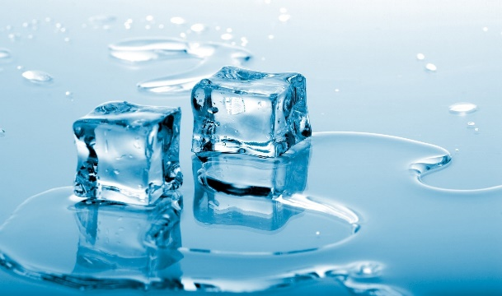
Before 1 kg of ice melts into 1 kg of water, it must be given 340 000 J of energy.
This is called latent heat (‘hidden heat’) because it does not increase the temperature - it is still at 0°C.

The specific latent heat L of a substance is the amount of energy required to change the state of 1 kg of the substance with no change in temperature.

We can calculate this energy by using the equation:

E = m x L

Where:
- E is energy in J
- m is mass in kg
- L is specific latent heat in J/kg

When a substance goes from solid to liquid (or vice versa) we talk about specific latent heat of fusion L_{F}.
When a substance goes from liquid to gas (or vice versa) we talk about specific latent heat of vaporisation L_{V}.

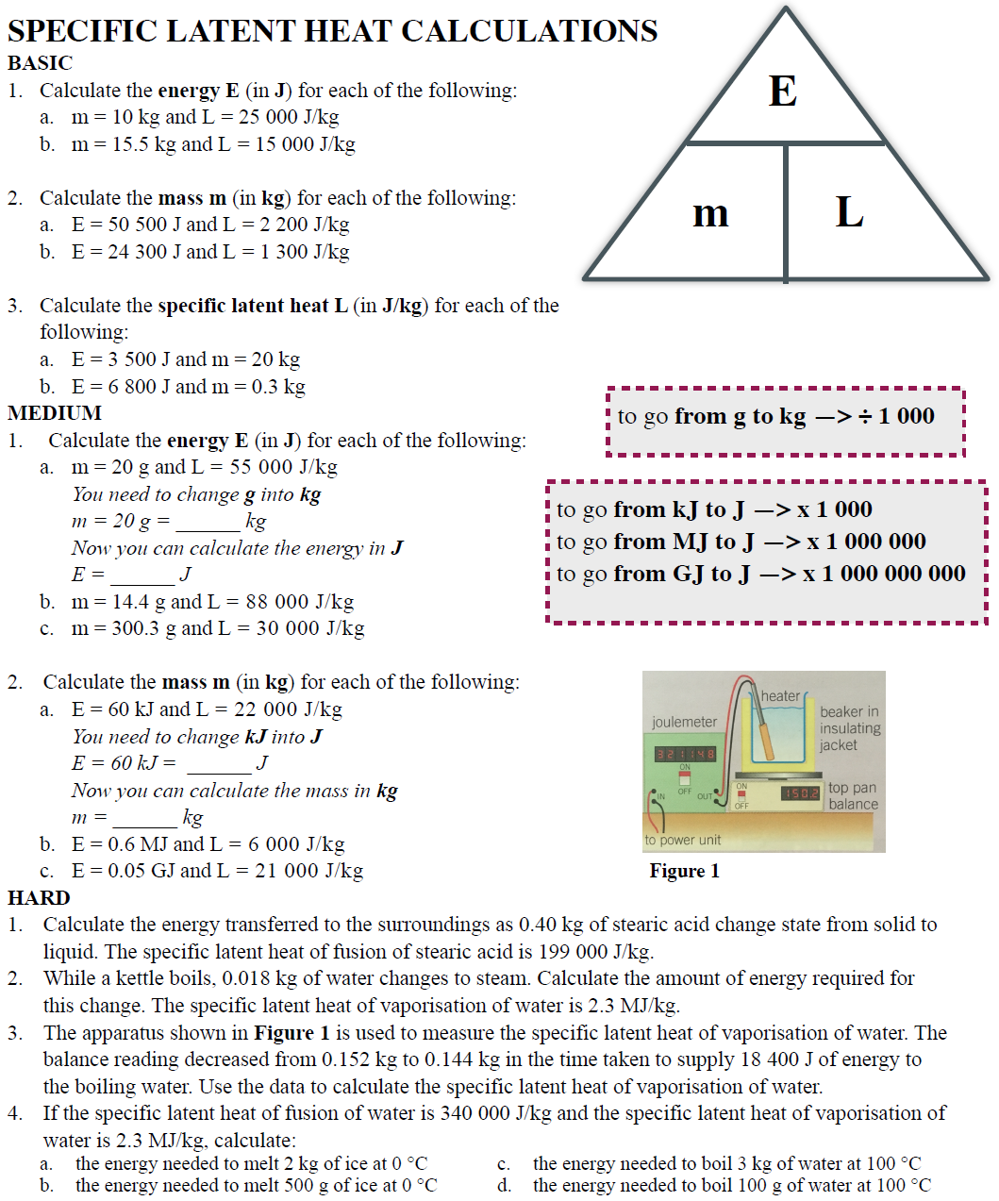

(a) (i) What is meant by specific latent heat of fusion? (2)
______________________________________________________________
______________________________________________________________
______________________________________________________________
(ii) Calculate the amount of energy required to melt 15 kg of ice at 0 °C.
Specific latent heat of fusion of ice = 340,000 J/kg. (2)
______________________________________________________________
______________________________________________________________
Energy = ___________________ J
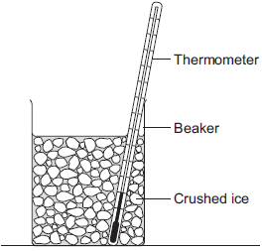
(b) A way to keep roads clear of ice in the winter is to spread salt on them.
When salt is added to ice, the melting point of the ice changes.
A student investigated how the melting point of ice varies with the mass of salt added.
The figure below shows the equipment that she used.

The student added salt to crushed ice and measured the temperature at which the ice melted.
(i) State one variable that the student should have controlled. (1)
______________________________________________________________
______________________________________________________________
(ii) The table below shows the data that the student obtained.

Mass of salt added in grams | 0 | 10 | 20
Melting point of ice in °C | 0 | -6 | -16
Describe the pattern shown in the table. (1)
______________________________________________________________
______________________________________________________________

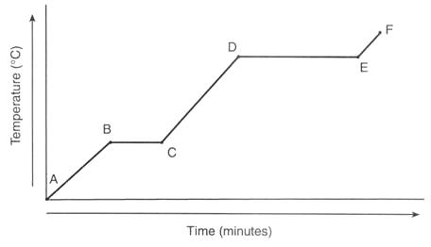
Specific heat: applies when the temperature of an object is increasing.
Specific and latent heat
ΔE = m × c × Δθ
Latent heat: applies when the state is changing. Temperature is constant as energy goes into breaking bonds.
E = m × L

Example question:
0.5kg of water is at a temperature of 20°C. Calculate how much energy is needed to evaporate all of the water.
Specific heat capacity of water = 4200 J/kg°C
Latent heat of vaporisation = 2.26 × 10⁶ J/kg

Copy the model answer in the space below:

Medium
- Calculate the energy for each of the following. ΔE = m × c × Δθ
- 0.5 kg of oil is heated by 5°C. Specific Heat capacity of oil = 540 J/kg°C.
- 4 kg of lead is heated by 20°C. Specific Heat capacity of lead = 130 J/kg°C.
- 0.3 kg of water is heated by 50°C. Specific Heat capacity of water = 4200 J/kg°C.
- Calculate the energy for each of the following. E = m × L
- 5 kg of water is evaporated at 100°C. Latent heat of vaporisation of water = 2,260,000 J/kg.
- 1 kg of ice is melting at 0°C. Latent heat of fusion of water = 334,000 J/kg.
- The boiling point of oxygen is at -183°C. Calculate the energy needed for 50g of Oxygen to evaporate at its boiling point. Latent heat of vaporisation of oxygen = 213,000 J/kg.
- Explain why the temperature of an object does not change while its state is changing.
Very hard
- 0.2 kg of water is at a temperature of 20°C. Calculate how much energy is needed to evaporate all of the water.
Specific heat capacity of water = 4200 J/kg°C
Latent heat of vaporisation = 2.26 × 10⁶ J/kg
- 2 kg of ethanol is at a temperature of 28°C. Calculate how much energy is needed to evaporate all of the ethanol.
Boiling point of ethanol = 78 °C
Specific heat capacity of ethanol = 2570 J/kg°C
Latent heat of vaporisation = 8.38 × 10⁵ J/kg
- Dr. Edmunds’ hard work for HAB is finally being recognised. The school decides to melt 300 kg of bronze to make a statue of him. If the bronze is originally at a temperature of 20°C, calculate the energy needed to melt all of the bronze.
Melting point of bronze = 950 °C
Specific heat capacity of bronze = 435 J/kg°C
Latent heat of fusion = 2.30 × 10⁵ J/kg
- Since spending too much money on the bronze statue, HAB has decided to sell ice-creams at break time to recoup the money. However, the ice creams are melting. Calculate the energy needed to melt a 200g ice cream at an initial temperature of -10°C.
Melting point of ice cream = -1°C
Specific heat capacity of ice cream = 3,100 J/kg°C
Latent heat of fusion = 1.5 × 10⁵ J/kg

(a) Which statement explains why energy is needed to melt ice at 0°C to water at 0°C?
Place a tick (✔) in the right-hand column to show the correct answer.

✔ if correct
It provides the water with energy for its molecules to move faster.
It breaks all the intermolecular bonds.
It allows the molecules to vibrate with more kinetic energy.
It breaks some intermolecular bonds.
(1)
(b) The diagram shows an experiment to measure the specific heat capacity of ice.
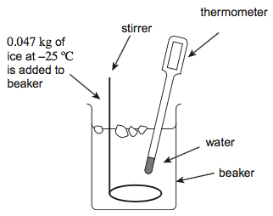
A student adds ice at a temperature of –25°C to water. The water is stirred continuously. The mass of ice added during the experiment is 0.047 kg.
(i) Calculate the total energy required to melt the ice.
The specific latent heat of fusion of water is 3.3 × 10⁵ J kg^{–1}.
The specific heat capacity of ice is 2100 J/kg°C

energy = ____________________ J
(3)

As a gas heats, it gains energy and the speed of the particles increases. Particles move randomly in all directions.
Particle motion
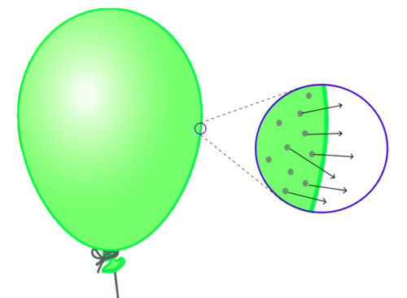
The pressure in a gas is caused by the random movement of particles hitting the walls of the container.
The reason balloons get bigger when you blow them us is because more air means more particles. More particles means more collisions with the walls of the balloon. More collisions means a higher force on the walls of the balloon, which means a higher pressure.
Increasing the temperature of a gas which is kept in a sealed container (i.e. constant volume) increases the kinetic energy of the particles, therefore the pressure increases.


Task: Watch the YouTube video where balloons are put into liquid nitrogen. Then use the words in the word bank to fill in the blanks below.
PRESSURE—DECREASES—INCREASES—QUICKLY—SLOWLY—PARTICLES—EXPAND—OFTEN

When a balloon is heated, its size __________. This is because the air ___________ inside the balloon are moving more ___________. The particles now hit the sides of the balloon more ________ and therefore exert more _________ on the side of the balloon. This causes the balloon to ________. Conversely if the balloon is cooled, its size _________ because the particles are moving more __________.

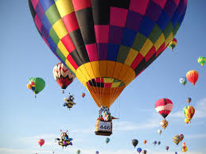
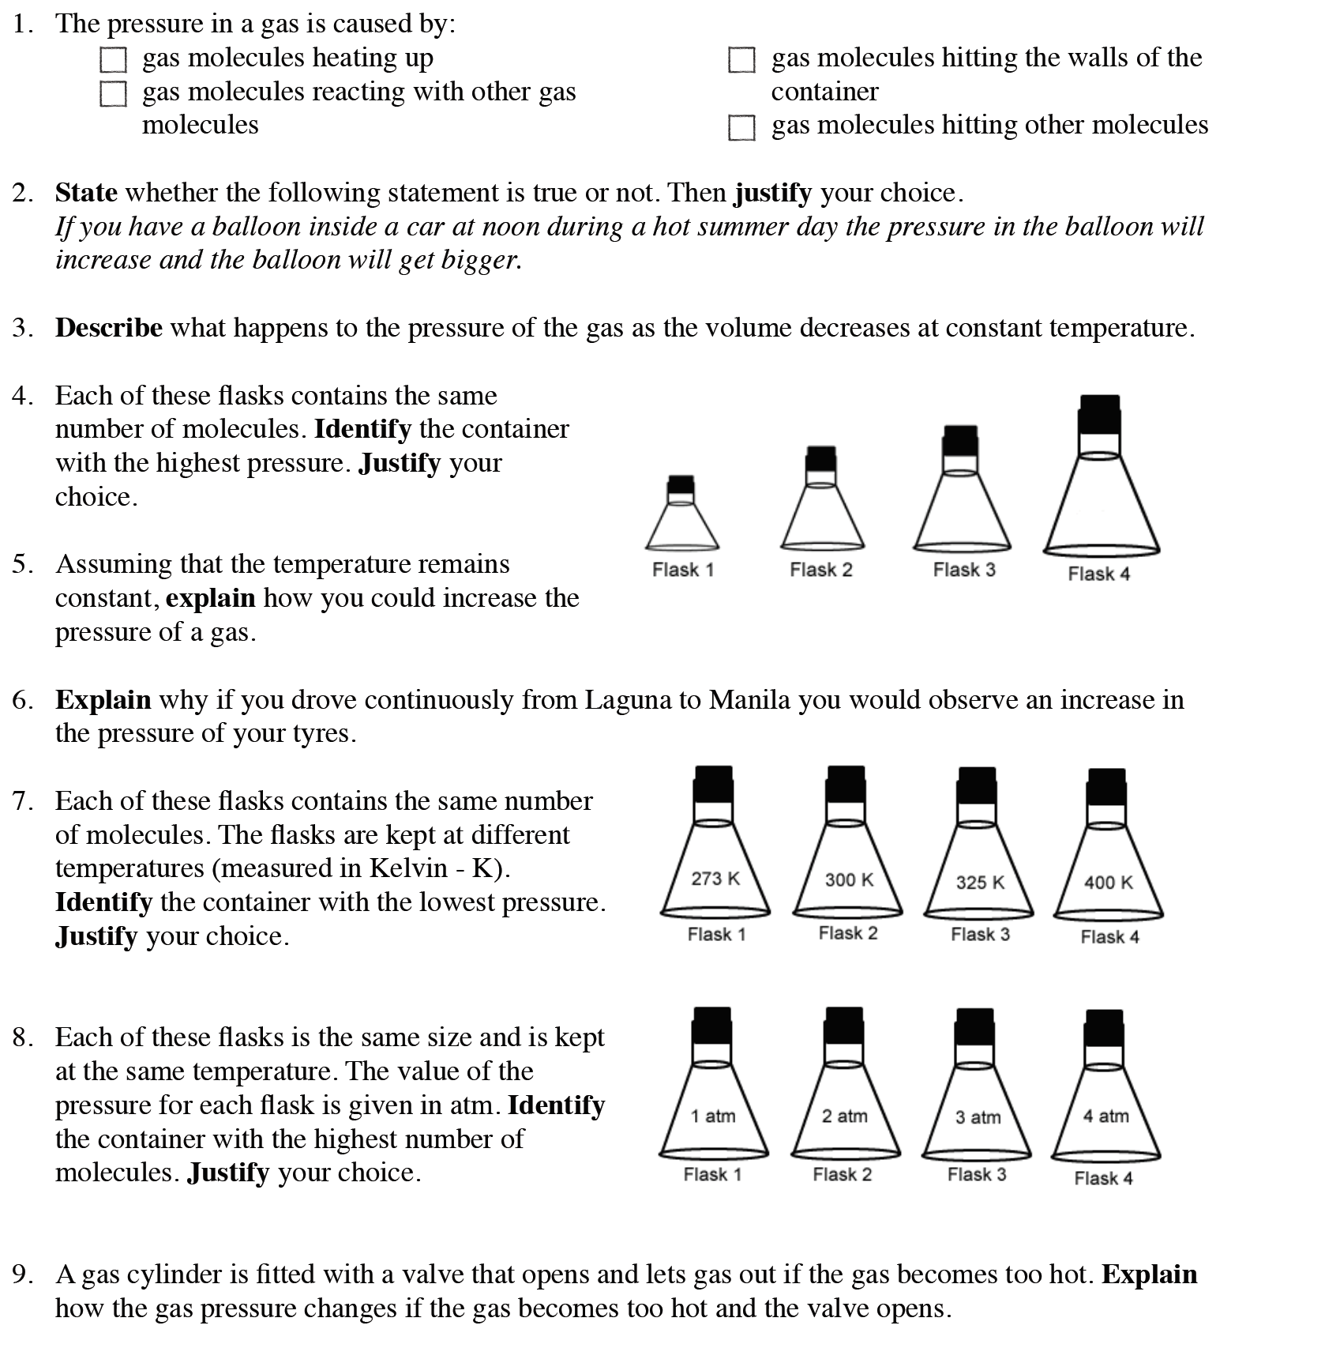
Task: Complete in exercise book
Stretch: John and Lisa are taking part in an air balloon
competition. They need to do the following:
- Rise to 500 m, move at that altitude for a while before moving up to 1000 m.
- After which they need to drift slowly down to the ground at the finishing line.
To accomplish this they have a flap at the top of the balloon, a heater in the basket of the
balloon, and weights on the side of the balloon.
Write a full account of what they have to do, and how it works according to the rules of density, pressure and temperature and kinetic theory of particles.

