
model
Particle
Separate Physics
Name ______________________________
Class ______________________________
Teacher ______________________________

Particle model facts
- ρ = m ÷ V
- density – kg/m³, mass – kg, volume - m³

- The particles are touching and vibrate around a fixed pattern.
- Particles are touching but not in fixed positions. They are free to flow around.
- Particles are far apart and move around quickly and randomly.
- Solid.
- Melting (solid → liquid), evaporating (liquid → gas), freezing (liquid → solid), condensing (gas → liquid), sublimating (solid → gas/gas → solid).
- Measure the length of the three sides and multiply together.
- Place the irregular solid in water in a measuring cylinder. Measure how much the water level has gone up by.
- Internal energy is the total kinetic energy and potential energy of all the particles that make up a system.
- The energy needed to heat up 1kg of a material by a temperature of 1°C.
- The energy needed to change state of 1kg of a substance without changing temperature.
- Energy goes into breaking/making bonds.

- In random motion.
- The speed of the particles increases as the gas is heated.
- The pressure would increase as particles would hit the walls of the container more often.
- From solid to liquid.

- From liquid to gas.

- ΔE = m × c × Δθ

- E = m × L

Fold page here
- What is the equation for density?
- What are the units for density, mass and volume?
- How are the particles in a solid arranged?

- How are the particles in a liquid arranged?

- How are the particles in a gas arranged?

- Which state of matter is most dense?
- What are the names of the five state changes?

- How do you measure the volume of a regular solid.
- How do you measure the volume of an irregular solid.

- What is internal energy?

- What is the definition of specific heat capacity?
- What is the definition of latent heat?

- Why doesn’t the temperature of a material change as it’s changing state?
- How do the molecules in a gas move?
- What happens to the speed of particles in a gas as the gas is heated?
- What happens to pressure if the size of a container is reduced?
- The specific latent heat of fusion gives what state change?
- The specific latent heat of vaporisation gives what state change?
- What is the equation to calculate energy change from specific heat capacity?
- What is the equation to calculate energy needed for a state change?

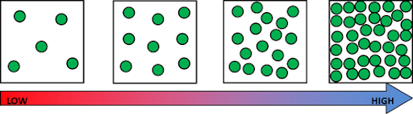
The word means how much mass (particles) there are in a given volume (space). The more particles in a volume, the higher the density.
Density

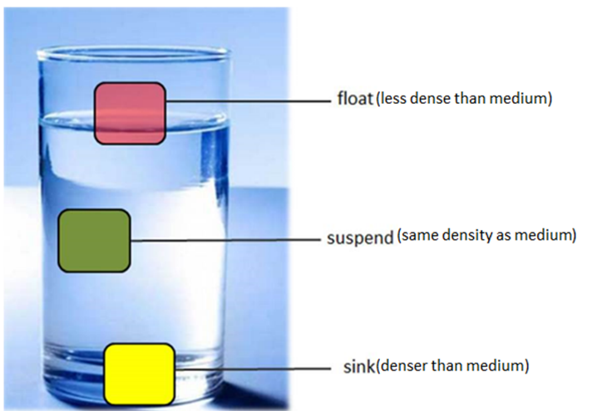
The density of a substance is defined as its mass per unit volume.
Objects float if they are less dense than water. This is because they weigh less than the same volume of water.
Density ρ can be calculated as follows:
Density = Mass ÷ Volume
ρ = m ÷ V
Where:
- ρ is density in kilograms per
cubic metre (kg/m³)
- m is mass in kilograms (kg)
- V is volume in cubic metres (m³)

BASIC
- Calculate the density ρ (in kg/m³) for each of the following:

  - m = 10 kg and V = 10 m³ m/v = 1kg/m³

  - m = 15.5 kg and V = 0.1 m³ m/v = 155kg/m³

  - m = 20.20 kg and V = 0.01 m³ m/v =2020kg/m³

- Calculate the mass m (in kg) for each of the following:

  - ρ = 10 kg/m³ and V = 15 m³ pv = 150kg
  - ρ = 0.15 kg/m³ and V = 12.20 m³ pv = 1.83kg

  - ρ = 0.006 kg/m³ and V = 1.005 m³ pv = 6.03x10⁻³kg

- Calculate the volume V (in m³) for each of the following:
  - m = 20 kg and ρ = 10 kg/m³ m/p =2m³

  - m = 0.22 kg and ρ = 0.05 kg/m³ m/p = 4.4m³

  - m = 6.60 kg and ρ = 0.003 kg/m³ m/p = 2200m³

MEDIUM

- Calculate the density ρ (in kg/m³) for each of the following:
  - m = 10 g and V = 10 cm³

You need to change g into kg and cm³ into m³

m = 10 g = 0.01 kg and V = 10 cm³ = 1x10⁻⁵ m³ Now you can calculate the density in kg/m³
To go from cm³ to m³ → ÷ 1,000,000
To go from g to kg → ÷ 1,000

    - = 1000 kg/m³

  - m = 12.2 g and V = 200 cm³ p = m/v = 61kg/m³

  - m = 300.3 g and V = 600.6 cm³ p = m/v = 500kg/m³

- Calculate the density ρ (in g/cm³) for each of the following:
  - m = 10 kg and V = 10 m³

You need to change kg into g and m³ into cm³

m = 10 kg = 10 000g g and V = 10 m³ = 10 000 000 cm³ Now you can calculate the density in g/cm³

    - = 1x10⁻³ g/cm³

  - m = 0.001 kg and V = 0.002 m³ p = m/v = 5x10⁻⁴g/cm³
To go from m³ to cm³ → × 1,000,000
To go from kg to g → × 1,000

  - m = 0.015 kg and V = 0.050 m³ p = m/v = 3x10⁻⁴g/cm³

HARD
- A wooden post has a volume of 0.025 m³ and a mass of 20 kg. Calculate its density in kg/m³. 20 / 0.025 = 800 kg/m³

- An object has a mass of 100 g and a volume of 20 cm³. Calculate its density in kg/m³. 0.1/2x10⁻⁵ = 5000 kg/m³

- An object has a volume of 3 m³ and a density of 6 000 kg/m³. Calculate its mass in kg.
6000 x 3 = 18 000kg

- An object has a mass of 20 000 kg and a density of 4 000 kg/m³. Calculate its volume in m³. 20000/4000 = 5 m³

- The density of air is 1.3 kg /m³. What mass of air is contained in a room measuring 2.5 m x 4 m x 10 m? 1.3 x (2.5 x 4 x 10) = 130 kg

- The density of water is 1 000 kg/m³. A water tank measures 2 m x 4 m x 5 m. What mass of water (in g) will it contain? 1000 x (2 x 4 x 5) = 40 000kg

- A rectangular concrete slab is 0.80 m long, 0.60 m wide and 0.05 m thick.
a. Calculate its volume in m³. (0.8 x 0.6 x 0.05) = 0.024m³ b. The mass of the concrete slab is 60 kg.
Calculate its density in kg/m³. 60 / 0.024 = 2500 kg/m³
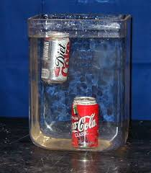
When a can of regular coke is put into water it sinks. However, when a can of diet coke is put into water it floats. Using the keywords below, explain why.

Keywords: Less, water (x2), more, volume, sugar, sinks, floats.

Both diet coke and regular coke are in cans of the same volume [1].
However regular coke weighs more [1]
Because it contains a lot of sugar [1].
The density of the regular coke is more than water. [1]
But the density of diet coke is less than water. [1]
Therefore diet coke floats, but regular coke sinks. [1]

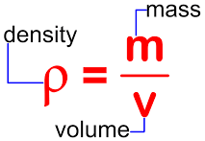
Density – Regular Objects:
Density practical
Object 1 :
Mass of object = ____________ g
Length = ___________ cm, Width = __________ cm, Height = __________ cm
Volume = length × width × height = _________________ cm³
Density = mass ÷ volume = _____________ g/cm³
Compare with the table at the top of the sheet to predict what the object is made of.
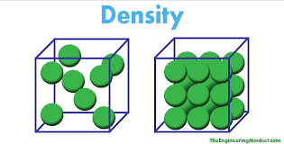
Object is made of ____________________.
Object 2:
Mass of object = ____________ g
Length = ___________ cm, Width = __________ cm, Height = __________ cm
Volume = length × width × height = _________________ cm³
Density = mass ÷ volume = _____________ g/cm³
Compare with the table at the top of the sheet to predict what the object is made of.
Object is made of ____________________.
Object 3:
Mass of object = ____________ g
Length = ___________ cm, Width = __________ cm, Height = __________ cm
Volume = length × width × height = _________________ cm³
Density = mass ÷ volume = _____________ g/cm³
Compare with the table at the top of the sheet to predict what the object is made of.
Substance | Wood | Aluminium | Zinc | Iron | Copper | Gold
Density in g/cm³ | 0.4 | 2.7 | 7.1 | 7.9 | 8.9 | 19.3
Object is made of ____________________.

Density – Irregular Objects

Method:
- Measure the mass of a piece of plasticine in grams.

- Note the level of the water before and after the plasticine is added.

- Work out the volume of the plasticine by using the calculation –

Volume of water before object added – volume of water after object added.

4. Work out the density in g/cm³ of plasticine.

Results table:

Object | Mass  (g) | Volume of water before object added (cm³) | Volume of water after object added (cm³) | Volume of object  (cm³) | Density of object  (g/cm³)
1

2

3

Questions:

Circle the correct words in each sentence.

- Density is how much (mass / volume) there is in 1cm³ of a material.

- A material with a high density feels (lighter / heavier) than a material with a low density.

- Materials with a high density (float / sink) when you put them in water.

- Materials with a (high / low) density float.

- The density of water is 1g/cm³. If a material has a density (less / greater) than the density of water, it will float.

Density – Liquids
Mass of measuring cylinder without water = ____________ g
Mass of measuring cylinder with 50 cm³ of water = _____________ g
Mass of water = __________ g
Volume of water = 50 cm³
Density = Mass ÷ Volume = _________ g/cm³
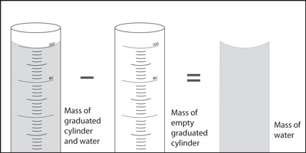

A student wanted to determine the density of a small piece of rock.
(a) Describe how the student could measure the volume of the piece of rock. (4)

Level 2: The method would lead to the production of a valid outcome. Key steps are identified and logically sequenced.

3−4

Level 1: The method would not necessarily lead to a valid outcome. Some relevant steps are identified, but links are not made clear.

1−2

No relevant content

0

Indicative content

• part fill a measuring cylinder with water

• measure initial volume

• place object in water

• measure final volume

• volume of object = final volume − initial volume

• fill a displacement / eureka can with water

• water level with spout

• place object in water

• collect displaced water

• measuring cylinder used to determine volume of displaced water
(b) The volume of the piece of rock was 18.0 cm³.
The student measured the mass of the piece of rock as 48.6 g.
Calculate the density of the rock in g/cm³. (2)
Use the equation:
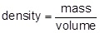

1

density = 2.70 (g/cm³)

1

an answer of 2.70 (g/cm³) scores 2 marks
The graph below shows the densities of different types of rock.
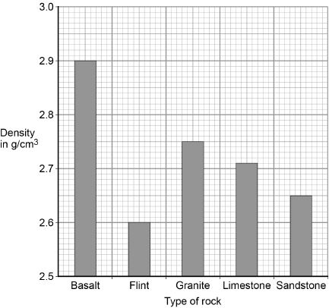
(c) What is the most likely type of rock that the student had? Tick one box.

Basalt | 
Flint
Granite
Limestone | x
Sandstone

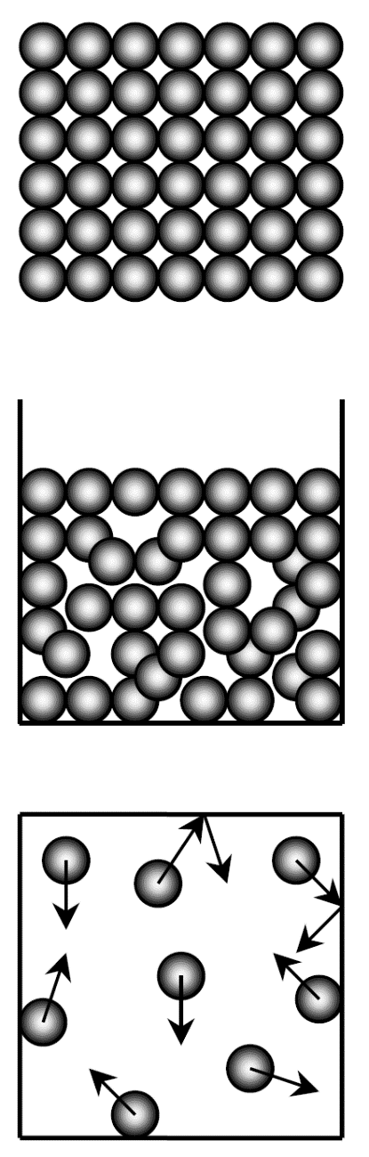
Everything is made up of particles. The three states of matter are solid, liquid, and gas. They all have different properties due to the arrangement and movement of their particles.
Particle model
Solids have particles that are held tightly together by strong forces. The particles vibrate around their fixed positions. Solids have a definite shape and volume. Solids are dense and they can not be compressed easily because the particles are already packed closely together. Solids have the least amount of energy.

A liquid can flow because the particles can move past each other. The particles are still held closely together by strong forces. Liquids are dense and they can not be compressed easily (hydraulics make use of this). A liquid can change its shape but not its volume.

There are only very weak forces between gas particles, which are far apart. Because of this gases can be compressed, and so they have no fixed volume. The particles move around quickly, at a range of speeds. They cause pressure when they collide with the walls of a container. Gases have a low density and they do not have a definite shape or volume. Gases have the most energy. As you heat a gas, the particles move more quickly.
Energy is stored inside a system by the particles (atoms and molecules) that
make up the system. This is called internal energy.

Internal energy is the total kinetic energy and potential energy of all the particles (atoms and molecules) that make up a system.

Task: Complete in exercise book

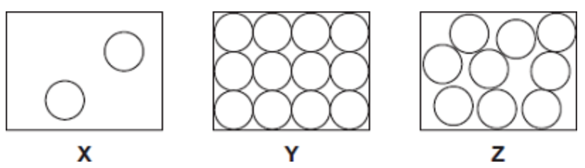
Basic
The diagrams X, Y and Z show how the particles are arranged in the three states of matter.
- Which one of the diagrams shows the arrangement of particles in a solid? Y
- Which one of the diagrams shows the arrangement of particles in a liquid? Z
- Which one of the diagrams shows the arrangement of particles in a gas? X
- Which state of matter:
- Can be compressed. Gas
- Takes up the shape of the container Liquid
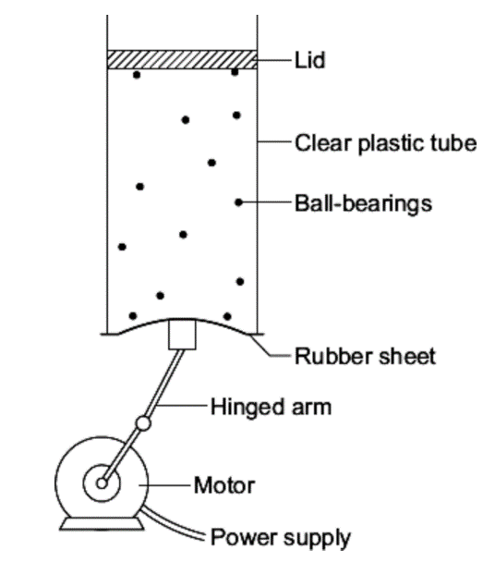
- Has no fixed volume Gas
- Has no fixed shape. Gas /Liquid
- Has a low density. Gas
- Causes pressure. Gas
Medium
- The diagram shows the model that a science teacher used to show her students that there is a link between the temperature of a gas and the speed of the gas particles.

The ball-bearings represent the gas particles. Switching the motor on makes the ball-bearings move around in all directions.

- Explain, in terms of the particles, why gases are easy to compress.
Particles far apart (less dense), very weak forces of attraction and hence free space for them to move into and no forces to be overcome
- How is the motion of the ball bearings similar to the motion of the gas particles?
Distribution of directions and speeds, no forces of attraction (like very weak), elastic collisions with each other and sides of container
- The faster the motor runs, the faster the ball-bearings move. Increasing the speed of the motor is like increasing the temperature of a gas. Use the model to predict what happens to the speed of the gas particles when the temperature of a gas is increased. It increases

Hard
- Describe the difference between the solid and gas states, in terms of the arrangement and movement of their particles (4).
Solid | Gas
Regular arrangement | Random arrangement
Strong forces of attraction | Very weak forces of attraction
Particles vibrate about a fixed point | Particles free to move
Incompressible | Compressible
Comparatively more dense | Comparatively less dense

- One kilogram of a gas has a much larger volume than one kilogram of a solid. Explain why (4).
In gas, particles are further apart (much less dense) moving in random directions
In solid, particles are much closer together (much more dense) and in a regular arrangement
Particles themselves are the same size for the same material (misconception well worth addressing!)
The same mass has the same number of particles for the same material.
Thus gas requires a much larger volume.
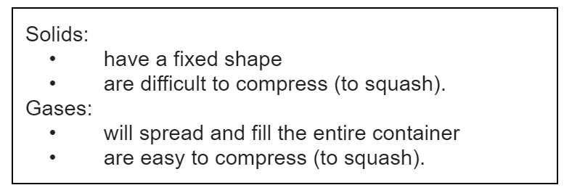
- The information in the box is about the properties of solids and gases.

Use your knowledge of kinetic theory to explain the information given in the box. You should consider:
- The spacing between the particles.
- The movement of individual particles.
- The forces between the particles. (6)

Marks awarded for this answer will be determined by the Quality of Written Communication (QWC) as well as the standard of the scientific response. Examiners should also apply a ‘best-fit’ approach to the marking.

0 marks

No relevant content.

Level 1 (1–2 marks)

Considers either solid or gas and describes at least one aspect of the particles.

or

Considers both solids and gases and describes an aspect of each.

Level 2 (3–4 marks)

Considers both solids and gases and describes aspects of the particles.

or

Considers one state and describes aspects of the particles and explains at least one of the properties.

or

Considers both states and describes an aspect of the particles for both and explains a property for solids or gases.

Level 3 (5–6 marks)

Considers both states of matter and describes the spacing and movement / forces between the particles. Explains a property of both solids and gases.

examples of the points made in the response

extra information

Solids

• (particles) close together

• (so) no room for particles to move closer (so hard to compress)

• vibrate about fixed point

• strong forces of attraction (at a distance)

• the forces become repulsive if the particles get closer

• particles strongly held together / not free to move around (shape is fixed)

any explanation of a property must match with the given aspect(s) of the particles.

Gases

• (particles) far apart

• space between particles (so easy to compress)

• move randomly

• negligible / no forces of attraction

• spread out in all directions (to fill the container)

The figure below shows a balloon filled with helium gas.
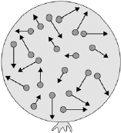
(a) Describe the movement of the particles of helium gas inside the balloon. (2)

range of speeds

1

moving in different directions

accept random motion

1
(b) What name is given to the total kinetic energy and potential energy of all the particles of helium gas in the balloon? (1)

Tick one box.
External energy |  | 
Internal energy |  | x
Movement energy
(c) Write down the equation which links density, mass and volume. (1)

density = mass / volume

1
(d) The helium in the balloon has a mass of 0.00254 kg.
The balloon has a volume of 0.0141 m³.
Calculate the density of helium. Choose the correct unit from the box. (3)

m³ / kg kg / m³ kg m³

0.00254 / 0.0141

1

0.18

1

accept 0.18 with no working shown for the 2 calculation marks

kg / m³

1

A substance is solid at temperatures below its melting point.
State changes
A substance is liquid at temperatures between its melting and boiling point.
A substance is gas at temperatures above its boiling point.
Metal | Melting point in °C
Gold | 1064
Mercury | -37
Sodium | 98
Iron | 1540
Mini-task:
- Which metal has the highest melting point? Iron
- Which metal has the lowest melting point? Mercury
- Which metal is a liquid at room temperature (25°C)? Mecury
- Which 2 metals would be liquid at 100°C? Mercury, Sodium
- What state would Iron be at a temperature of 900°C? Solid
The boiling point of water is 100°C, while the melting point is 0°C.
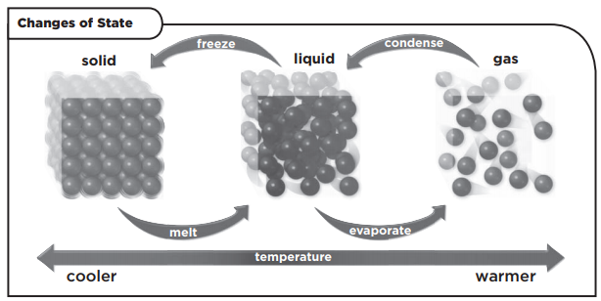

The state changes are shown in the diagram above.
Solid → Liquid Melting
Liquid → Gas Evaporation
Gas → Liquid Condensation
Liquid → Solid Freezing
Solid → Gas Sublimation
Gas → Solid Deposition

Before a state change, energy goes into raising the temperature of the material.

While the state is changing, the temperature of the material stays constant. This is because energy goes into breaking the bonds (forces between particles).
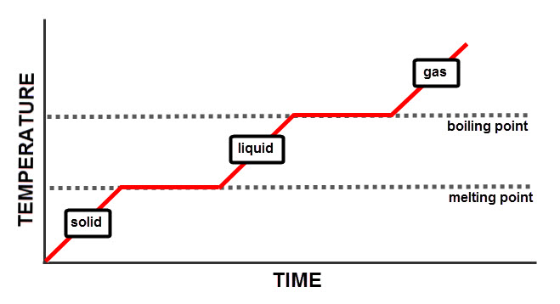

Task: Complete in your exercise book
State changes worksheet
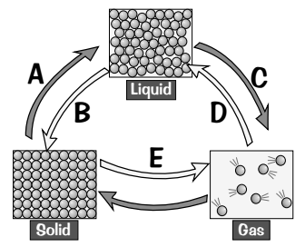
Basic
- A, B, C, D and E represent changes from one state to another. Name each of these changes.
A melting, B Freezing, C Evaporation, D Condensation, E Sublimation
- What is happening to the particles in the substance when change C happens? Forces of attraction are overcome, free to move in random directions, Spacing between particles increases.
- These sentences are wrong. Rewrite them so that they are correct.
- When the state of a substance changes, the energy of the particles increases during melting, evaporation and sublimation and decreases during freezing, condensing and desublimation.
- During a change of state the mass of a substance remains the same.
- Condensing is the opposite of evaporating
Medium
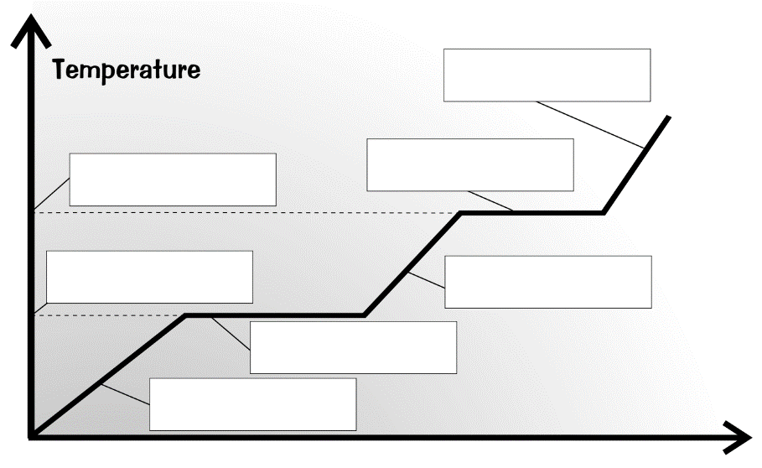
- Which state must be supplied with the most energy to turn it into a gas? Explain your answer. Solid, the temperature has to be increased by the largest amount and energy required to change state two times.
gas
boiling
Boiling point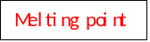
- When energy is supplied to a solid, what happens to the particles within it. Answer in terms of the energies of the particles and how they are moving? Internal energy increases, larger amplitude vibrations.
liquid
Melting
Melting point
- Fill in the blanks on the heating curve by using the words given in the word box.
solid
boiling point melting point solid melting liquid boiling gas
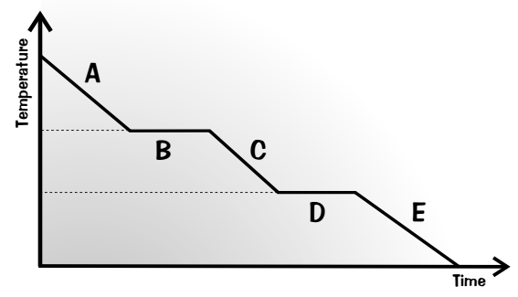
Hard
A scientist measured the temperature of water as it was cooled from 150°C to -20°C. She used her results to make the graph.
- What state is the water in at points A, C and E? C liquid, E solid
- Name the processes that are happening at points B and D.
B Condensing, D Freezing
- Explain why the graph is flat at points B and D. Use the words forces, energy and particles in your answer.
Energy is being used to form bonds (forces of attraction) between particles, this gives out energy and so the temperature does not fall.
- Describe what happens to the arrangement of particles as it goes through state change D.
Transition from a liquid to a solid. Forces of attraction between particles strengthen. Particles are arranged in a regular arrangement. Particles are no longer free to move and vibrate about a fixed position.

Solid, liquid and gas are three different states of matter.
(a) Describe the difference between the solid and gas states, in terms of the arrangement and movement of their particles. (4)

solid
particles vibrate about fixed positions

1

closely packed

accept regular

1

gas
particles move randomly

accept particles move faster

accept freely for randomly

1

far apart

1
(b) The graph shows how temperature varies with time for a substance as it is heated.
The graph is not drawn to scale.
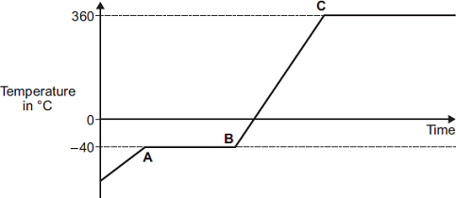
Explain what is happening to the substance in sections AB and BC of the graph. (4)

AB
changing state from solid to liquid / melting

1

at steady temperature

dependent on first AB mark

1

BC
temperature of liquid rises

1

until it reaches boiling point

dependent on first BC mark 1

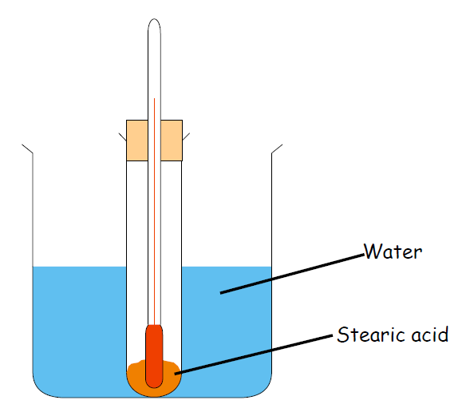
Aim
State changes practical
To heat and melt stearic acid, and then to obtain a cooling curve as it cools down.

Method

- Put a boiling tube with 3cm³ of Stearic Acid into a beaker half full of water.
- Heat this on a Bunsen burner until the stearic acid has melted.
- Turn the Bunsen burner off and put thermometer into stearic acid.
- Use the tongs to put boiling tube into rack.
- Record the temperature immediately and then after every 1 minute until the stearic acid has been a solid again for 2 minutes.

Record your results in the table below:

Time (mins) | Temperature (°C)
0
1
2
3
4
5
6
7
8

Mini-task

Q1 What is the independent variable? Time
Q2 What is the dependent variable? Temperature of stearic acid

Using the graph paper on the next page, plot a graph of temperature (on the y axis) against time (on the x axis).

Two students investigated the change of state of stearic acid from liquid to solid.
They measured how the temperature of stearic acid changed over 5 minutes as it changed from liquid to solid.
The diagram below shows the different apparatus the two students used.
Student A’s apparatus Student B’s apparatus
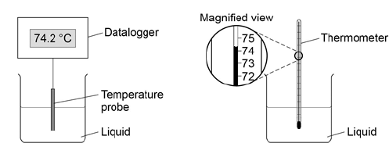
(a) Choose two advantages of using student A’s apparatus. Tick two boxes. (2)
Student A’s apparatus made sure the test was fair.
Student B’s apparatus only measured categoric variables.
Student A’s measurements had a higher resolution. | x
Student B was more likely to misread the temperature. | x
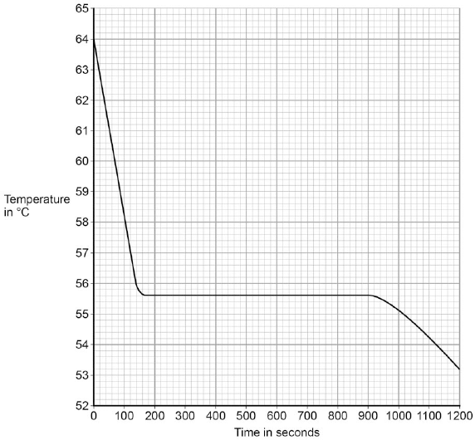
(b) Student A’s results are shown in the graph.

What was the decrease in temperature between 0 and 160 seconds? Tick one box. (1)
8.2 °C
8.4 °C | x
53.2 °C
55.6 °C
(c) Use the graph to determine the time taken for the stearic acid to change from a liquid to a solid. (1)
Time = 740 seconds
(d) Use the graph to obtain the melting point of stearic acid. (1)
Melting point = 55.6 ˚C
(e) Why doesn’t the temperature change when the stearic acid is melting? (1)
Energy which is put into the system is being used to overcome forces of attraction between particles
(f) After 1200 seconds the temperature of the stearic acid continued to decrease.
Explain why. (2)

stearic acid has a higher temperature than the surroundings

accept stearic acid is hotter than the surroundings

1

temperature will decrease until stearic acid is the same as the room temperature / surroundings

1

Specific heat capacity
Putting the same amount of heat energy into some materials gives a bigger temperature rise than in other materials. This is due to specific heat capacity.

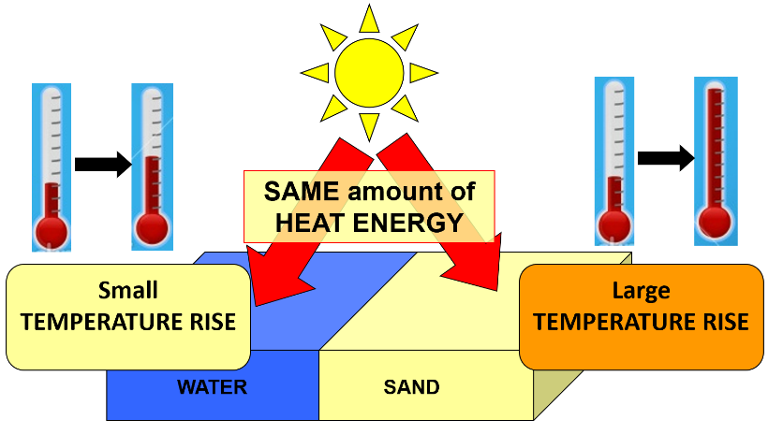
An example of this is on a sandy beach on a sunny day. The water in the sea will be relatively cool, but the sand will be much hotter. This is because water has a higher specific heat capacity than air, and therefore takes more energy to increase in temperature.

The specific heat capacity (c) is the amount of energy needed to increase the temperature of 1 kg of a substance by 1 °C.

A material with a higher specific heat capacity takes more energy to heat up 1 kg by 1 °C than a material with a lower specific heat capacity.

Energy can be calculated using the following:
ΔE = m x c x Δθ
Where:
- ΔE = change in thermal energy (J)
- m = mass (kg)
- c = specific heat capacity (J/kg°C)
- Δθ = change in temperature (°C)

BASIC

1. Calculate the energy ΔE (in J) for each of the following:

  - m = 10 kg and Δθ = 4 °C (for water) 168000J

  - m = 15.5 kg and Δθ = 0.5 °C (for aluminium) 6967.25J
  - m = 0.5 kg and Δθ = 20 °C (for copper) 3900J
  - m = 2 kg and Δθ = 60 °C (for oil) 64800J
  - m = 800 kg and Δθ = 7.5 °C (for concrete) 5400000J
  - m = 1.2 kg and Δθ = 0.5 °C (for air) 60J
  - m = 2 kg and Δθ = 8 °C (for lead) 2080J
  - m = 1500 kg and Δθ = 0.2 °C (for iron) 135000J
MEDIUM (have to use rearranged equations)

- Calculate the mass m (in kg) for each of the following.
$$m= \frac{∆E}{c×∆θ}$$

  - ΔE = 1 000 J and Δθ = 2.5 °C (for oil) 0.74kg

  - ΔE = 2 500 J and Δθ = 0.2 °C (for lead) 96.15kg
  - ΔE = 200 J and Δθ = 1 °C (for concrete) 0.22kg
  - ΔE = 5,000,000 J and Δθ = 15 °C (for water) 79.37kg

- Calculate the temperature change Δθ (in °C) for each of the following:

  - ΔE = 3 000 J and m = 20 kg (for air) 1.5°C

  - ΔE = 6 600 J and m = 0.3 kg (for iron) 48.89°C
  - ΔE = 700 J and m = 0.1 kg (for aluminium) 7.79°C
  - ΔE = 20 J and m = 0.02 kg (for copper) 2.56°C

HARD (have to convert units)

4. Calculate the energy E (in J) for each of the following:

  - m = 10 g and Δθ = 5 °C (for water) You need to change g into kg
to go from g to kg → ÷ 1 000

m = 10 g = 0.01 kg

Now you can calculate the energy in J E = 210 J
  - m = 12.2 g and Δθ = 10.1 °C (for concrete) 110.90J

  - m = 300.3 g and Δθ = 0.8 °C (for copper) 93.69J

- Calculate the mass m (in kg) for each of the following:

  - E = 10 kJ and Δθ = 20 °C (for aluminium) You need to change kJ into J
to go from kJ to J → × 1 000

E = 10 kJ = 10000 J

Now you can calculate the mass in kg m = 0.56 kg
  - E = 0.6 kJ and Δθ = 2.2 °C (for lead)2.10kg

  - E = 0.05 kJ and Δθ = 50 °C (for oil) 1.85x10⁻³ kg

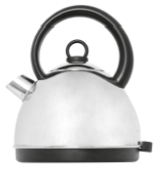
Q1. The electric kettle shown is used to boil water.
(a) After the water has boiled, the temperature of the water decreases by 22 °C.
The mass of water in the kettle is 0.50 kg.
The specific heat capacity of water is 4200 J/kg °C.
Calculate the energy transferred to the surroundings from the water.
ΔE = m x c x Δθ = 0.5 x 4200 x 22 = 46200J
 | Tick (✔)
Energy is absorbed from the surroundings.
Energy is used to heat the kettle. | Y
The kettle is more than 100% efficient.
(b) Why is the total energy input to the kettle higher than the energy used to heat the water?
Tick (✔) one box.

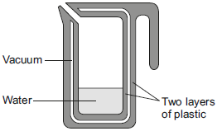
Q2. A new design for a kettle is made from two layers of plastic separated by a vacuum. After the water in the kettle has boiled, the water stays hot for at least 2 hours.
(a) The energy transferred from the water in the kettle to the surroundings in 2 hours is
46 200 J.
The mass of water in the kettle is 0.50 kg.
The specific heat capacity of water is 4200 J/kg °C.
The initial temperature of the water is 100 °C.
Calculate the temperature of the water in the kettle after 2 hours.
___________________________________________________________________

78 (°C)

allow 2 marks for correct temperature change ie 22 °C

allow 1 mark for correct substitution

ie 46 200 = 0.5 × 4200 x θ

or

θ = 46200/(0.5 x 4200)

3
(b) Calculate the average power output from the water in the kettle to the surroundings in 2 hours.

6.4 (W)

allow 2 marks for an answer that rounds to 6.4

allow 1 mark for correct substitution

ie 46 200 = P × 7200

an answer of 23 000 or 23 100 or 385 gains 1 mark
Latent heat
Heating a substance changes the internal energy (KE and GPE of the particles) of the substance by increasing the energy of its particles. As a result:
- The temperature of the substance increases
OR
- The substance changes its state (i.e. it melts or it boils)

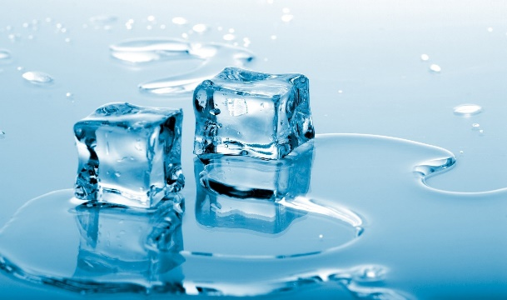
Before 1 kg of ice melts into 1 kg of water, it must be given 340 000 J of energy.
This is called latent heat (‘hidden heat’) because it does not increase the temperature - it is still at 0°C.

The specific latent heat L of a substance is the amount of energy required to change the state of 1 kg of the substance with no change in temperature.

We can calculate this energy by using the equation:

E = m x L

Where:
- E is energy in J
- m is mass in kg
- L is specific latent heat in J/kg

When a substance goes from solid to liquid (or vice versa) we talk about specific latent heat of fusion L_{F}.
When a substance goes from liquid to gas (or vice versa) we talk about specific latent heat of vaporisation L_{V}.

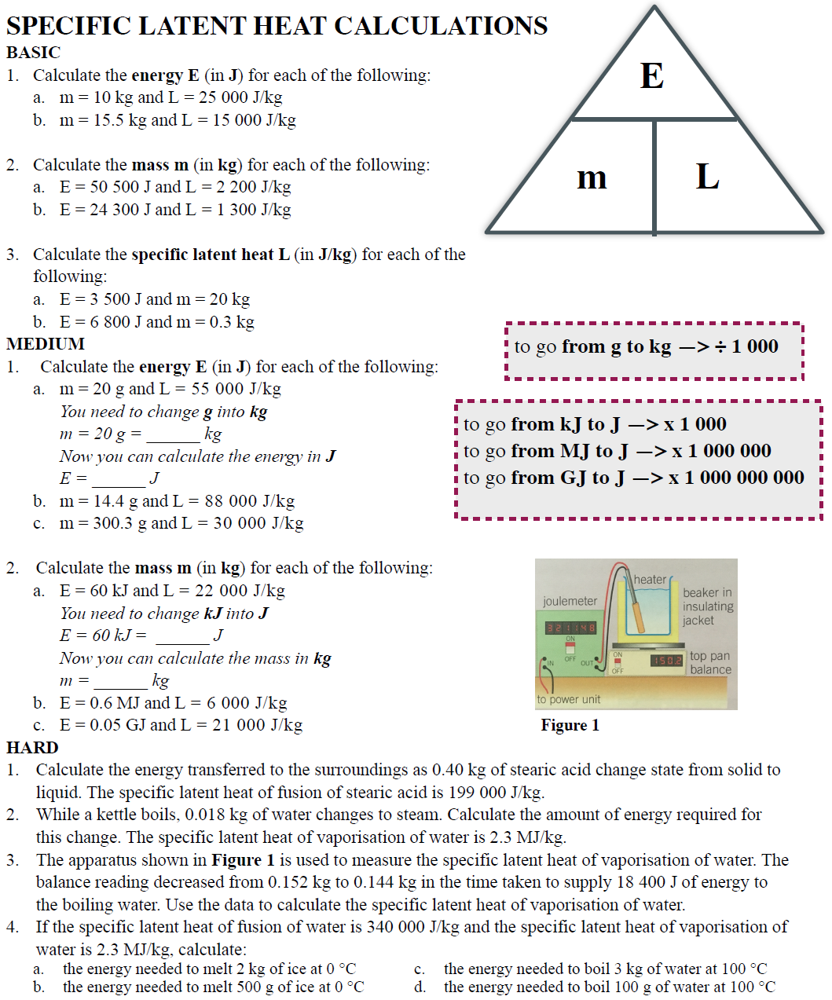

Easy
1a mL = 250000J
1b mL = 232500J
2a E/L =22.95kg
2b E/L =18.69kg
3a E/m = 175J/kg
3b E/m = 22666.67J/kg

Medium
1 a 0.02kg, 0.02 x 55000 = 1100J
1b 0.0144x 88000 = 1267.2J
1c 0.3003 x 30000 = 9009J
2a 60 000J, 60000/ 22000 = 2.73kg
2b 600000/ 6000 = 100kg
2c 0.05x10⁹ / 21000 = 2380.95kg

Hard
1. 0.4 x 199000 = 79 600J
2. 0.018 x 2300000 = 41 400J
3. 18400 / (0.152-1.444) = 2 300 000 J/kg
4a 2 x 340000 = 680 000J
4b 0.5 x 34000 = 170 000J
4c 3 x 2300000 = 6.9MJ
4d 0.1 x 2300000 = 0.23MJ

(a) (i) What is meant by specific latent heat of fusion? (2)
______________________________________________________________

amount of energy required to change (the state of a substance) from solid to liquid (with no change in temperature)

melt is insufficient

1

unit mass / 1kg

1
(ii) Calculate the amount of energy required to melt 15 kg of ice at 0 °C.
Specific latent heat of fusion of ice = 340,000 J/kg. (2)

5.1 × 10⁶ (J)

accept 5 x 10⁶

allow 1 mark for correct substitution ie E = 15 × 3.4 × 10⁵

2
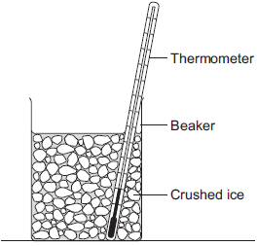
(b) A way to keep roads clear of ice in the winter is to spread salt on them.
When salt is added to ice, the melting point of the ice changes.
A student investigated how the melting point of ice varies with the mass of salt added.
The figure below shows the equipment that she used.

The student added salt to crushed ice and measured the temperature at which the ice melted.
(i) State one variable that the student should have controlled. (1)

mass of ice

allow volume / weight / amount / quantity of ice

1
(ii) The table below shows the data that the student obtained.

Mass of salt added in grams | 0 | 10 | 20
Melting point of ice in °C | 0 | -6 | -16
Describe the pattern shown in the table. (1)

melting point decreases as the mass of salt is increased

allow concentration for mass

accept negative correlation

do not accept inversely proportional

1

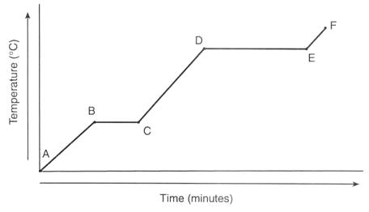
Specific heat: applies when the temperature of an object is increasing.
Specific and latent heat
ΔE = m × c × Δθ
Latent heat: applies when the state is changing. Temperature is constant as energy goes into breaking bonds.
E = m × L

Example question:
0.5kg of water is at a temperature of 20°C. Calculate how much energy is needed to evaporate all of the water.
Specific heat capacity of water = 4200 J/kg°C
Latent heat of vaporisation = 2.26 × 10⁶ J/kg

Copy the model answer in the space below:

Heat to 100°C
ΔE = m × c × Δθ
ΔE = 0.5 x 4200 x (100-20) = 168000J

Change State
E = m × L
E = 0.5 x 2.26 × 10⁶ = 1130000J

Total Energy = 168000 + 1130000 = 1298000J

Medium
- Calculate the energy for each of the following. ΔE = m × c × Δθ
- 0.5 kg of oil is heated by 5°C. Specific Heat capacity of oil = 540 J/kg°C. 0.5x540x5 =1350J
- 4 kg of lead is heated by 20°C. Specific Heat capacity of lead = 130 J/kg°C. 4x130x20 = 10400J
- 0.3 kg of water is heated by 50°C. Specific Heat capacity of water = 4200 J/kg°C. 0.3x4200x50 =63000J
- Calculate the energy for each of the following. E = m × L
- 5 kg of water is evaporated at 100°C. Latent heat of vaporisation of water = 2,260,000 J/kg. 5 x 2260000 = 11 300 000J
- 1 kg of ice is melting at 0°C. Latent heat of fusion of water = 334,000 J/kg. 1 x 334000 = 334000J
- The boiling point of oxygen is at -183°C. Calculate the energy needed for 50g of Oxygen to evaporate at its boiling point. Latent heat of vaporisation of oxygen = 213,000 J/kg. 0.05 x 213000 = 10650J
- Explain why the temperature of an object does not change while its state is changing.
Very hard
- 0.2 kg of water is at a temperature of 20°C. Calculate how much energy is needed to evaporate all of the water.
Specific heat capacity of water = 4200 J/kg°C
Latent heat of vaporisation = 2.26 × 10⁶ J/kg

Heat to 100°C
ΔE = m × c × Δθ
ΔE = 0.2 x 4200 x (100-20) = 67200J

Change State
E = m × L
E = 0.2 x 2.26 × 10⁶ = 452000J

Total Energy = 67200 + 452000 = 519200J

- 2 kg of ethanol is at a temperature of 28°C. Calculate how much energy is needed to evaporate all of the ethanol.
Boiling point of ethanol = 78 °C
Specific heat capacity of ethanol = 2570 J/kg°C
Latent heat of vaporisation = 8.38 × 10⁵ J/kg

Heat to 78°C
ΔE = m × c × Δθ
ΔE = 2 x 2570 x (78-28) = 257000J

Change State
E = m × L
E = 2 x 8.38 × 10⁵ = 1676000J

Total Energy = 257000 + 1676000 = 1933000J

- Dr. Edmunds’ hard work for HAB is finally being recognised. The school decides to melt 300 kg of bronze to make a statue of him. If the bronze is originally at a temperature of 20°C, calculate the energy needed to melt all of the bronze.
Melting point of bronze = 950 °C
Specific heat capacity of bronze = 435 J/kg°C
Latent heat of fusion = 2.30 × 10⁵ J/kg

Heat to 950°C
ΔE = m × c × Δθ
ΔE = 300 x 435 x (950-20) = 121 365 000J

Change State
E = m × L
E = 300 x 2.30 × 10⁵ = 69 000 000J

Total Energy = 121 365 000 + 69 000 000 = 190 365 000J

- Since spending too much money on the bronze statue, HAB has decided to sell ice-creams at break time to recoup the money. However, the ice creams are melting. Calculate the energy needed to melt a 200g ice cream at an initial temperature of -10°C.
Melting point of ice cream = -1°C
Specific heat capacity of ice cream = 3,100 J/kg°C
Latent heat of fusion = 1.5 × 10⁵ J/kg

Heat to -1°C
ΔE = m × c × Δθ
ΔE = 0.2 x 3100 x (-1--10) = 5580J

Change State
E = m × L
E = 0.2 x 1.5 × 10⁵ = 30000J

Total Energy = 5580 + 30000 = 35580J

(a) Which statement explains why energy is needed to melt ice at 0°C to water at 0°C?
Place a tick (✔) in the right-hand column to show the correct answer.

 | ✔ if correct
It provides the water with energy for its molecules to move faster.
It breaks all the intermolecular bonds. | Y
It allows the molecules to vibrate with more kinetic energy.
It breaks some intermolecular bonds.
(1)
(b) The diagram shows an experiment to measure the specific heat capacity of ice.
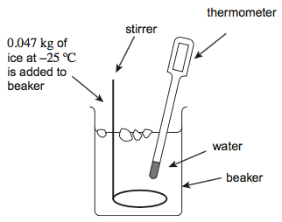
A student adds ice at a temperature of –25°C to water. The water is stirred continuously. The mass of ice added during the experiment is 0.047 kg.
(i) Calculate the total energy required to melt the ice.
The specific latent heat of fusion of water is 3.3 × 10⁵ J kg^{–1}.
The specific heat capacity of ice is 2100 J/kg°C

Heat to 0°C
ΔE = m × c × Δθ
ΔE = 0.047 x 2100 x (0--25) = 2467.5J

Change State
E = m × L
E = 0.047 x 3.3 × 10⁵ = 15510J

Total Energy = 2467.5 + 15510 = 17977.5J (3)
As a gas heats, it gains energy and the speed of the particles increases. Particles move randomly in all directions.
Particle motion
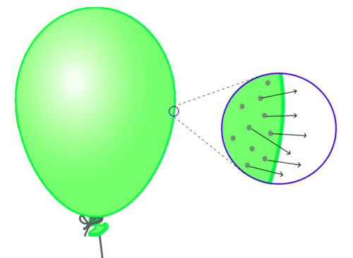
The pressure in a gas is caused by the random movement of particles hitting the walls of the container.
The reason balloons get bigger when you blow them us is because more air means more particles. More particles means more collisions with the walls of the balloon. More collisions means a higher force on the walls of the balloon, which means a higher pressure.
Increasing the temperature of a gas which is kept in a sealed container (i.e. constant volume) increases the kinetic energy of the particles, therefore the pressure increases.


Task: Watch the YouTube video where balloons are put into liquid nitrogen. Then use the words in the word bank to fill in the blanks below.
PRESSURE—DECREASES—INCREASES—QUICKLY—SLOWLY—PARTICLES—EXPAND—OFTEN

When a balloon is heated, its size increases. This is because the air particles inside the balloon are moving more quickly. The particles now hit the sides of the balloon more often and therefore exert more pressure on the side of the balloon. This causes the balloon to expand. Conversely if the balloon is cooled, its size decreases because the particles are moving more slowly.

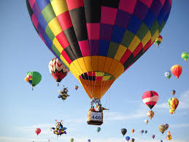
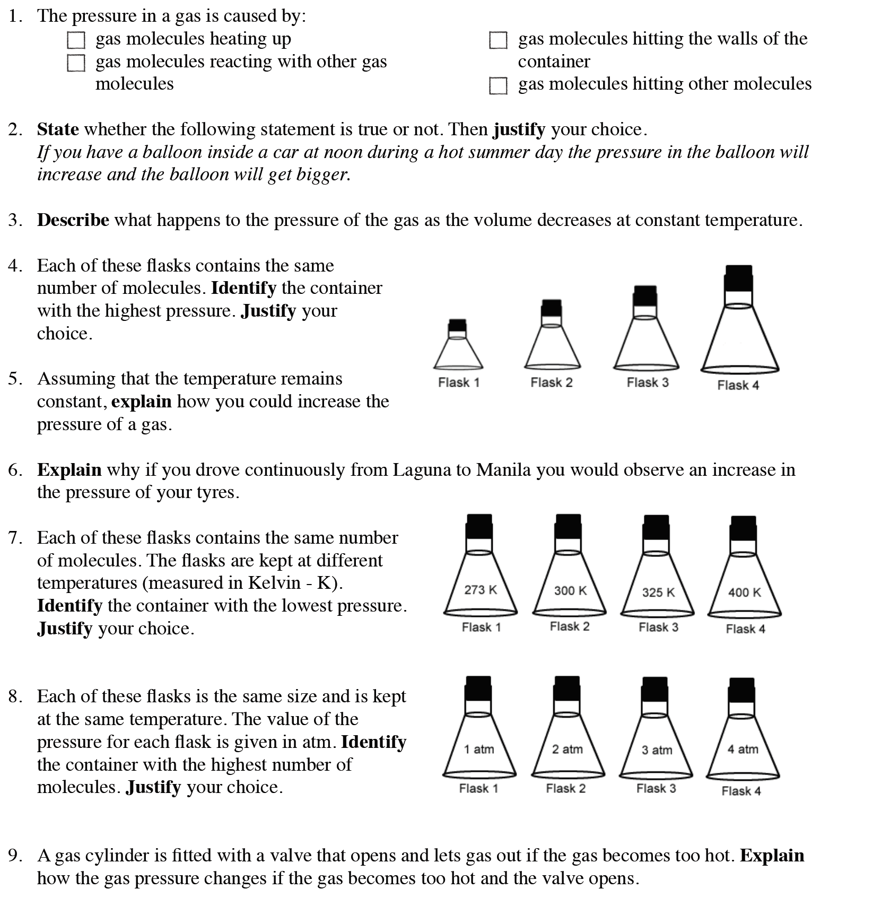
Task: Complete in exercise book
Stretch: John and Lisa are taking part in an air balloon
competition. They need to do the following:
- Rise to 500 m, move at that altitude for a while before moving up to 1000 m.
- After which they need to drift slowly down to the ground at the finishing line.
To accomplish this they have a flap at the top of the balloon, a heater in the basket of the
balloon, and weights on the side of the balloon.
Write a full account of what they have to do, and how it works according to the rules of density, pressure and temperature and kinetic theory of particles.

Particle Motion Answers
1. gas molecules hitting the walls of the container
2. True. The increase in temperature causes the particles to move faster, they hit the sides of the container more often and with a greater force thus increasing the pressure.
3. It increases as the particles will hit the sides of the container more often due to the decreased area of the container.
4. Flask 1. The particles will hit the sides of the container more often.
5. Decrease the size of the container or increase the number of particles in the flask.
6. The temperature increases due to work done against the road by friction. The particles move faster, they hit the sides of the container more often and with a greater force thus increasing the pressure.
7. Flask 1. The particles have less kinetic energy so they move slower and hit the sides of the container less often than the others.
8. Flask 4. It has higher pressure and so the particles must be hitting the side of the container more often. If they are the same temperature the only way this can happen is for there to be more particles.
9. The pressure decreases, there are now fewer particles so they collide with the walls of the container less often.
Stretch:
Sequence:
- Heat up the gas until they reach 500m, the heated up gas is less dense than the surrounding air, lighter things float on top of heavier things and so the balloon floats.
- Release the weights, this decreases the weight of the balloon and so the balloon rises to 1000m.
- Then open the flap at the top of the balloon this decreases the volume of air in the balloon and decreases the upthrust and so the balloon descends to the finish line.

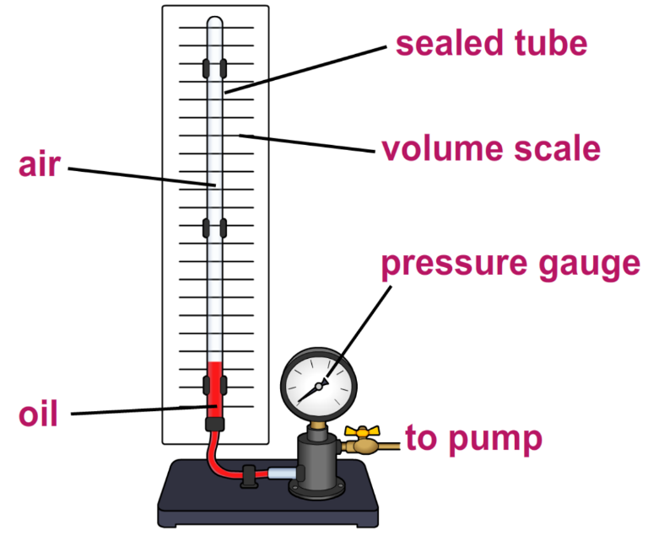
Boyle’s law
Boyle’s law gives the relationship between pressure of a gas and its volume.
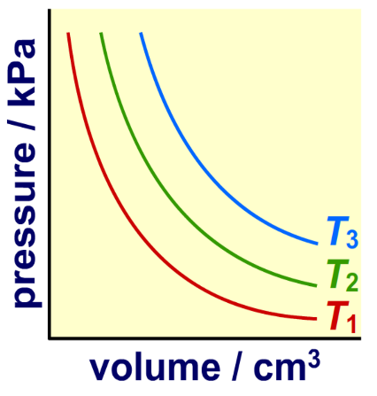
The diagram shows the apparatus used to prove this law. The apparatus consists of a sealed tube, with air above a layer of oil. A pump increases the pressure on the oil, which exerts pressure on the air. The pressure and volume of the gas can be measured.
The apparatus is pumped up to a high pressure then slowly vented. As the pressure decreases, the volume of the gas is recorded.
The apparatus is reset and the experiment is repeated at different temperatures. Boyle’s law states that for a fixed mass of as at constant temperature (T), the pressure (p) and volume (V) are inversely proportional.

Provided that the number of particles and the temperature of a gas are kept constant, then:
P x V = constant
Where:
- P is pressure in pascals (Pa)
- V is volume in metres cubed (m³)
- constant is a number in Pa m³
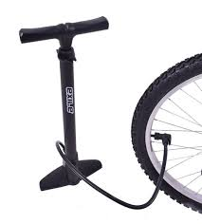
Work is the transfer of energy by a force.
Doing work on a gas increases the internal energy of the gas and can cause an increase in the temperature of the gas. This can be demonstrated by measuring the temperature of air inside a bicycle tyre as it is pumped up.
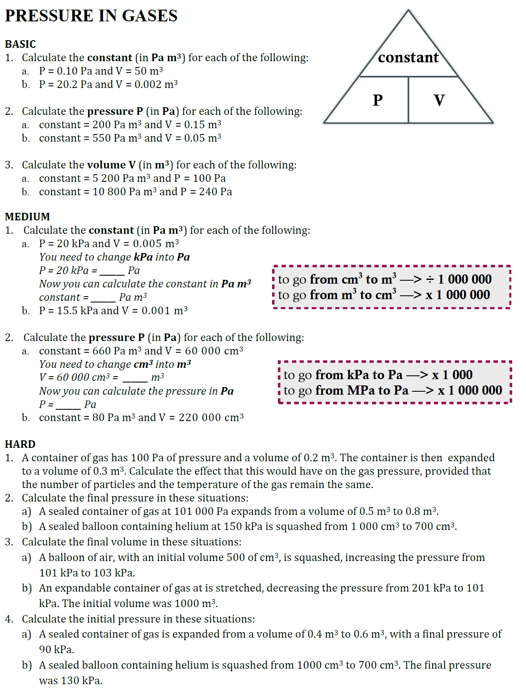

BASIC

- Calculate the constant (in Pa m³) for each of the following:
  - P = 0.10 Pa and V = 50 m³ PV = 5 Pa m³
  - P = 20.2 Pa and V = 0.002 m³ PV = 0.404Pa m³

- Calculate the pressure P (in Pa) for each of the following:

  - constant = 200 Pa m³ and V = 0.15 m³ const/V = 1333.33m³
  - constant = 550 Pa m³ and V = 0.05 m³ const/V = 11000m³

- Calculate the volume V (in m³) for each of the following:

  - constant = 5 200 Pa m³ and P = 100 Pa const/P = 52m³
  - constant = 10 800 Pa m³ and P = 240 Pa const /P = 45m³

MEDIUM

- Calculate the constant (in Pa m³) for each of the following: a. P = 20 kPa and V = 0.005 m³

You need to change kPa into Pa P = 20 kPa = 20 000 Pa

Now you can calculate the constant in Pa m3 constant = 100 Pa m³
- P = 15.5 kPa and V = 0.001 m³ 15.5Pa m³

to go from cm³ to m³ —> ÷ 1 000 000 to go from m³ to cm³ —> x 1 000 000

2. Calculate the pressure P (in Pa) for each of the following:

- constant = 660 Pa m³ and V = 60 000 cm³ You need to change cm³ into m³

V = 60 000 cm³ = 0.06 m³

Now you can calculate the pressure in Pa
P = 11 000 Pa
- constant = 80 Pa m³ and V = 220 000 cm³ 363.64Pa

HARD

- A container of gas has 100 Pa of pressure and a volume of 0.2 m³. The container is then expanded to a volume of 0.3 m³. Calculate the effect that this would have on the gas pressure, provided that the number of particles and the temperature of the gas remain the same. P₁V₁ = P₂V_{2,} 100x0.2 = P₂ x 0.3 (100x0.2)/0.3 = 66.67Pa

- Calculate the final pressure in these situations:
  - A sealed container of gas at 101 000 Pa expands from a volume of 0.5 m³ to 0.8 m³. P₁V₁ = P₂V_{2,} (101000 x 0.5) / 0.8 = 63125Pa

  - A sealed balloon containing helium at 150 kPa is squashed from 1 000 cm³ to 700 cm³. P₁V₁ = P₂V_{2,} (150x1000)/700 = 214.29kPa

- Calculate the final volume in these situations:

  - A balloon of air, with an initial volume 500 of cm³, is squashed, increasing the pressure from 101 kPa to 103 kPa. P₁V₁ = P₂V_{2,} (101 x 500)/103 = 490.29cm³

  - An expandable container of gas at is stretched, decreasing the pressure from 201 kPa to 101 kPa. The initial volume was 1000 m³. P₁V₁ = P₂V_{2,} (201 x 1000)/101 = 1990.10m³

- Calculate the initial pressure in these situations:

  - A sealed container of gas is expanded from a volume of 0.4 m³ to 0.6 m³, with a final pressure of 90 kPa. P₁V₁ = P₂V_{2,} (90 x 0.6) / 0.4 = 135kPa

  - A sealed balloon containing helium is squashed from 1000 cm³ to 700 cm³. The final pressure was 130 kPa. P₁V₁ = P₂V_{2,} (130 x 700)/1000 = 91kPa
Q1.
A student investigated how the pressure of a gas varied with the volume of the gas.
The mass and temperature of the gas were constant.
Figure 1 shows the equipment the student used.
Figure 1
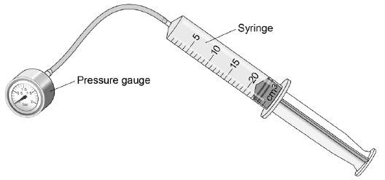
(a) What is the resolution of the syringe?
1 cm³
(1)
The student compressed the gas in the syringe and read the pressure from the pressure gauge.
Figure 2 shows the student's results.
Figure 2
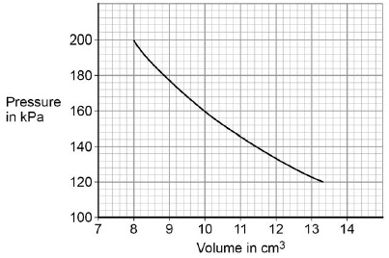

(b) What conclusion can the student make from the data in Figure 2?
Use data from Figure 2 in your answer.
Give the reason for your answer.

pressure is inversely proportional to volume

1

data to prove inversely proportional relationship

eg 8 × 200 = 1600

and 10 × 160 = 1600

if no other marks score allow for 1 mark: as volume decreases pressure increases

2
(c) Explain why the pressure in the gas increases as the gas is compressed.

(as the gas is compressed) the volume of gas decreases

1

(so there are) more frequent collisions of gas particles with container walls

1

(and) each particle collision with the wall causes a force

1

(so there is a) greater force on walls

1
(4)
(Total 8 marks)

