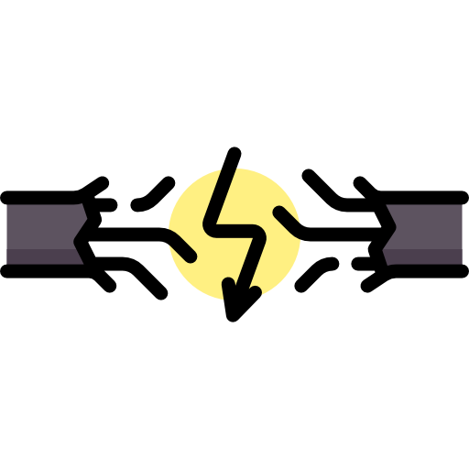
ANSWERS
Electricity
Definitions
Recap of GCSE
Current, I
Electrical current is the rate of flow of charge in a circuit. Electrons are charged particles that move around the circuit. So we can think of the electrical current is the rate of the flow of electrons, not so much the speed but the number of electrons moving in the circuit. If we imagine that electrons are Year 7 students and a wire of a circuit is a corridor, the current is how many students passing in a set time.
Current is measured in Amperes (or Amps), A

Charge, Q
The amount of electrical charge is a fundamental unit, similar to mass and length and time. From the data sheet we can see that the charge on one electron is actually -1.60 x 10⁻¹⁹ C. This means that it takes 6.25 x 10¹⁸ electrons to transfer 1C of charge.
Charge is measured in Coulombs, C

Voltage/Potential Difference, V
Voltage, or potential difference, is the work done per unit charge.
1 unit of charge is 6.25 x 10¹⁸ electrons, so we can think of potential difference as the energy given to each of the electrons, or the pushing force on the electrons. It is the p.d. that causes a current to flow and we can think of it like water flowing in a pipe. If we make one end higher than the other end, water will flow down in, if we increase the height (increase the p.d.) we get more flowing. If we think of current as Year 7s walking down a corridor, the harder we push them down the corridor the more we get flowing.
Voltage and p.d. are measured in Volts, V

Resistance, R
The resistance of a material tells us how easy or difficult it is to make a current flow through it. It is also the ratio of voltage across a component to the current flowing through it. If we think of current as Year 7s walking down a corridor, it would be harder to make the Year 7s flow if we added some Year 11 rugby players into the corridor. Increasing resistance lowers the current.
Resistance is measured in Ohms, Ω
Time, t
You know, time! How long stuff takes and that. Time is measured in seconds, s
Equations
There are three equations that we need to be able to explain and substitute numbers into.
1
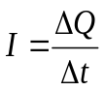
This says that the current is the rate of change of charge per second and backs up or idea of current as the rate at which electrons (and charge) flow.
This can be rearranged into
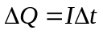
which means that the charge is equal to how much is flowing multiplied by how long it flows for.

2
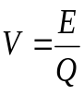
This says that the voltage/p.d. is equal to the energy per charge. The ‘push’ of the electrons is equal to the energy given to each charge (electron).

3
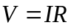
This says that increasing the p.d. increases the current. Increasing the ‘push’ of the electrons makes more flow.
It also shows us that for constant V, if R increases I gets smaller. Pushing the same strength, if there is more blocking force less current will flow.
V = I × R questions
- What is the definition of potential difference?
Potential difference is the work done per unit charge.
- What is the definition of current?
Electrical current is the rate of flow of charge in a circuit.
- An electric kettle uses mains voltage (230V). The current is 10A. What is the resistance?
R=V/I=230/10=23 Ω
- A light bulb with resistance 0.6 kΩ is connected to a 12 V battery. What is the current?
I=V/R=12/60=0.2A
- A hairdryer uses mains voltage (230 V). It takes a current of 5 A. Work out the resistance.
R=V/I=230/5=46 Ω
- A toy tractor has a 4.5 V battery operated motor. The resistance of the motor is 15 Ω. What is the current?
I=V/R=4.5/15=0.3A
- A torch takes a 3 V battery. The light bulb for the torch has ‘0.2 A’ stamped on the side, so 3 V gives a current of 0.2 A.
    - What is the resistance of the bulb? R=V/I=3/0.2=15A
    - An old battery with voltage 1.5 V is used instead. How much current will flow through the torch bulb? I=V/R=1.5/15=0.1A
    - What effect will this have on the torch? Torch will be dimmer
- A torch has resistance 120 Ω and the current is 100 mA. What is the battery voltage? V=IR=(100/1000)x120=12V
- When a 5 kΩ resistor is connected to a power supply 18 mA of current passes through it. What is the voltage of the power supply? V=IR=(18/1000)x5000=90V

ΔQ = I × Δt questions
- What is an electrical unit for i) electric charge and ii) electric current? Choose one each from JC⁻¹, Js⁻¹, Cs⁻¹, AV⁻¹ and A s. i) A s ii) Cs⁻¹
- If 0.01 coulombs of charge flow through a wire in 20 seconds, what is the current? 0.5mA
- If a current of 2A flows in a wire for 5 minutes, how much charge will pass? 600C
- There is a current of 5x10⁻³A through a lamp. How long does it take for 1C of charge to pass through it? 200s
- How long would it take to pass a charge of 500C along a wire if a steady current of 1.0mA was passed through it? 5×10⁵ s
- An ion beam delivers a charge of 50 nC during a time of 25 s. What is the current carried by the beam? 2×10⁻⁹ A
- A neon lamp indicator draws a current of 0.5A. How many electrons are moving through the lamp per second? 3.13 × 10¹⁸
Charge on the electron= - 1.6 x 10⁻¹⁹ C
- A blue LED carries a current of 20mA. How many electrons per second are passing through the LED? 1.25 × 10¹⁷
- An ion beam carries a current of 2nA, if the charge of each ion is 1.6 x 10⁻¹⁹ C, how many ions pass per second? 1.25 × 10¹⁰
- A gas containing doubly-charged ions flows to give an electric current of 0.64A. How many ions pass a point in 1 minute? 1.2 × 10²⁰
- In a cathode ray tube 7.5 × 10¹⁵ electrons strike the screen in 40s. What current does this represent? 3.0 × 10⁻⁵ A

V = E ÷ Q questions
- A laptop uses a power of 65 W, and uses 1300 J of energy. Calculate how long the laptop was used for.
t=E/P=1300/65=20s
- An iPhone charger uses 2400 J of energy and delivers 12 V of potential difference. Calculate the charge of the charger.
Q=E/V=2400/12=200C
- Calculate the charge transferred by a 0.05 kJ electrical appliance when the voltage supplied to it is 1000 mV.
(1000mV=1V) -- Q=E/V=(0.05x1000)/1=50C
- Calculate the voltage supplied to a 0.05 MJ appliance that transfers 3 C of electrical charge.
V=E/Q=(0.05x1000000)/3=16700V
- A solar cell delivers a constant current of 30mA for a period of 2.0 minutes. During this interval, the potential difference of the cell is 0.90 V. Calculatae the total energy transformed by the solar cell. 3.24 J
- A battery in a laptop has a potential difference of 14.8V and can store a maximum charge of 15.5 × 10³ C. Calculate the maximum amount of energy this battery can deliver. 229,000 J

Ohm’s Law
Ohm’s Laws and I-V Graphs
A voltage (or potential difference) causes a current to flow and that the size of the current depends on the size of the p.d.
For something to obey Ohm’s law the current flowing is proportional to the p.d. pushing it. V=IR so this means the resistance is constant. On a graph of current against p.d. this appears as a straight line.

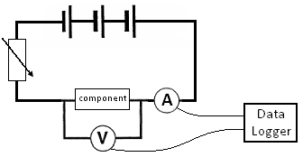
Taking Measurements
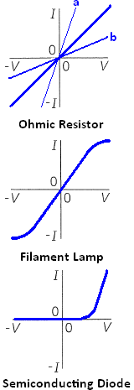
To find how the current through a component varies with the potential difference across it we must take readings. To measure the potential difference we use a voltmeter connected in parallel and to measure the current we use an ammeter connected in series.
If we connect the component to a battery we would now have one reading for the p.d. and one for the current. But what we require is a range of readings. One way around this would be to use a range of batteries to give different p.d.s. A better way is to add a variable resistor to the circuit, this allows us to use one battery and get a range of readings for current and p.d. To obtain values for current in the negative direction we can reverse either the battery or the component.

I-V Graphs
Resistor
This shows that when p.d. is zero so is the current. When we increase the p.d. in one direction the current increases in that direction. If we apply a p.d. in the reverse direction a current flows in the reverse direction. The straight line shows that current is proportional to p.d. and it obeys Ohm’s law. Graph a has a lower resistance than graph b because for the same p.d. less current flows through b.

Filament Lamp
At low values the current is proportional to p.d. and so, obeys Ohm’s law.
As the potential difference and current increase so does the temperature. This increases the resistance and the graph curves, since resistance changes it no longer obeys Ohm’s law.

Diode
This shows us that in one direction increasing the p.d. increases the current but in the reverse direction the p.d. does not make a current flow. We say that it is forward biased. Since resistance changes it does not obey Ohm’s law.

Three Special Resistors
Variable Resistor
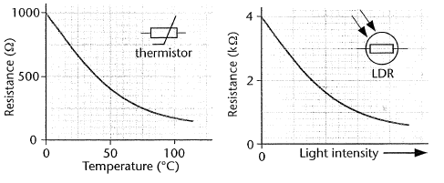
A variable resistor is a resistor whose value can be changed.
Thermistor
The resistance of a thermistor varied with temperature. At low temperatures the resistance is high, at high temperatures the resistance is low. As the temperature increases, the resistance decreases (negative temperature coefficient).
Light Dependant Resistor (L.D.R)
The resistance of a thermistor varied with light intensity. In dim light the resistance is high and in bright light the resistance is low.

I-V characteristics
- Define electrical resistance. The ratio of the potential difference across a device, to its current. R = V/I
- State Ohm’s Law. For something to obey Ohm’s law the current flowing is proportional to the p.d. pushing it.
- What is meant by a negative temperature coefficient? Resistance decreases with increasing temperature.
- What is meant by an Ohmic conductor? Current is directly proportional to potential difference.
- What happens to the resistance of an LDR when the light intensity increases? It decreases.
- What is the main characteristic of a diode? Only allows current to flow in one direction.
- A component is connected to a d.c supply. At a potential difference of 6.0 V, the current in the component is 0.023A. When the p.d. is doubled, the current in the component increases to 0.100 A.
- Calculate the resistance of the component at 6.0V. 261 Ω
- Does the component obey Ohm’s law? Explain you answer. No, potential difference is not proportional to current.
- A semiconductor diode is connected to a variable d.c. supply. The current in the diode is zero when the p.d. across it is 0.40 V. The current increases to 30 mA when the p.d. across the diode is 0.65 V. Calculate the resistance of the diode at 0.40 V and 0.65 V. Does the diode obey Ohm’s law? No
- a) Explain whether the I-V characteristics of a filament lamp represent an ohmic conductor. (4)
As the current increases, the temperature of the filament lamp increases. This increase the resistance of the filament lamps as there are more collisions between flowing electrons & ions in the filament. There a filament lamp is not an ohmic conductor.
- Sketch the I-V characteristics of a filament lamp.
- Does the resistance of a metal conductor increase or decrease with temperature? Explain your answer. It increases; similar answer to a).
- Describe how you would determine the I-V characteristics of a filament lamp; include a circuit diagram in your answer. As in notes.
- The table below shows the results of measuring the current through an electronic component.
- Plot a graph to show the current-voltage characteristics of this component.
- What does the value of the slope of the graph represent? 1/R
- Determine the resistance of the component. 300Ω
- Give a suggestion as to what the component could be and explain its behaviour. Metal conductor at a constant temp.
- The temperature of the component is now raised significantly and kept constant at this elevated temperature; the experiment is now repeated. What results would you expect to obtain under these conditions? Shallower gradient as resistance greater
- Explain the reasons why it might show this characteristic. Similar to 9a)

Current (A) | 0 | 0.003 | 0.007 | 0.010 | 0.013 | 0.017 | 0.020 | 0.023 | 0.026
Voltage (V) | 0 | 1.0 | 2.0 | 3.0 | 4.0 | 5.0 | 6.0 | 7.0 | 8.0
Q1.
(a) Define resistance.
___________________________________________________________________
___________________________________________________________________
___________________________________________________________________
(1)
(b) (i) Sketch onto the axes below a graph of the variation of current with potential difference for a filament lamp.
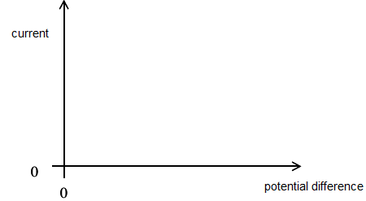
(1)
(ii) State and explain, in terms of electron flow, how the resistance of the filament lamp changes as the current in the lamp increases.
______________________________________________________________
______________________________________________________________
______________________________________________________________
______________________________________________________________
______________________________________________________________
______________________________________________________________
(3)
(Total 5 marks)

Q2.
(a) The graph shows the current–voltage (I–V) characteristic curve for a semiconductor diode.
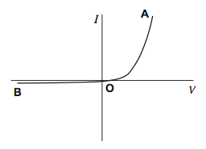
In order to produce this characteristic a student is given suitable equipment including an ammeter and a voltmeter.
(i) Draw a labelled circuit diagram of the apparatus that the student could use to obtain the part of the characteristic from O to A.

(2)
(ii) Describe how the student could use the circuit in part (a)(i) to obtain sufficient measurements to draw the part of the characteristic from O to A. Your account should include:
• details of how different readings of I and V are obtained
• a consideration of safety precautions when using the diode
• a discussion of the range and number of measurements that need to be taken
• a discussion of the advantages of using a data logger to obtain the measurements.
______________________________________________________________
______________________________________________________________
______________________________________________________________
______________________________________________________________
______________________________________________________________
______________________________________________________________
______________________________________________________________
______________________________________________________________
______________________________________________________________
______________________________________________________________
______________________________________________________________
______________________________________________________________
______________________________________________________________
______________________________________________________________
(6)
(iii) Suggest how the circuit you drew in part (a)(i) could be modified to obtain the characteristic from O to B.
______________________________________________________________
______________________________________________________________
______________________________________________________________
______________________________________________________________
(1)
(b) The student wants to find out how the resistance of the diode changes between O and A.
(i) Describe how the student could use the characteristic to determine how the resistance varies as the potential difference (pd) between O and A increases.
______________________________________________________________
______________________________________________________________
______________________________________________________________
______________________________________________________________
(2)
(ii) State how you would expect the resistance of the diode to vary as the pd increases.
______________________________________________________________
______________________________________________________________
(1)
(Total 12 marks)
Q1.
(a) ratio of voltage (across component) to current (through
component) or R = V/I with terms defined and R as subject
B1
1
(b) (i) correct curve
B1
1
(ii) resistance increases / increase in resistivity
B1
energy transfer increases lattice vibration/ temperature rise
increases lattice vibration / electron collisions increases
lattice vibration
B1
more frequent collisions/ ions now a larger target for electrons
B1
3
[5]
Q3.
(a) (i)
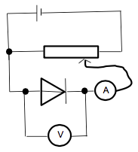
correct diode bias for variable supply, must have some attempt to vary pd ✔
Condone variable resistor (condone missing arrow) don’t allow thermistor symbol
correct symbols and positions for voltmeter, ammeter:
voltmeter in parallel with diode only
ammeter in series with diode ✔
Allow mA symbol instead of A symbol for ammeter
Allow symbols for diode without line through triangle and / or with a circle
Diode symbol must consist of a triangle and a straight line at nose perpendicular to wiring in circuit.
allow voltmeter across ammeter and diode
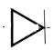
2
(ii) The candidate’s writing should be legible and the spelling, punctuation and grammar should be sufficiently accurate for the meaning to be clear.
The candidate’s answer will be assessed holistically. The answer will be assigned to one of three levels according to the following criteria.
High Level (Good to excellent): 5 or 6 marks
The information conveyed by the answer is clearly organised, logical and coherent, using appropriate specialist vocabulary correctly. The form and style of writing is appropriate to answer the question.
Candidate explains how to obtain sufficient values of I and V. They mention the need to limit the current through the diode and give an indication of the range and frequency of measurements. They discuss an advantage of using a data logger. Voltage does not exceed 1.0V, diode is forward biased
Intermediate Level (Modest to adequate): 3 or 4 marks
The information conveyed by the answer may be less well organised and not fully coherent. There is less use of specialist vocabulary, or specialist vocabulary may be used incorrectly. The form and style of writing is less appropriate.
Candidate explains how to obtain sufficient values of I and V. Includes mention of diode is forward biased or suitable voltage for switch on mentioned or advantage of data logger
Low Level (Poor to limited): 1 or 2 marks
The information conveyed by the answer is poorly organised and may not be relevant or coherent. There is little correct use of specialist vocabulary. The form and style of writing may be only partly appropriate.
vary pd obtain several readings of I and V
or an advantage of using data logger
or forward biased
low level safety may include switch off / avoid overheating type arguments / don't touch
The explanation expected in a competent answer should include a coherent selection of the following points concerning the physical principles involved and their consequences in this case.
means of controlling pd across diode
indication of range and frequency of measurement
mention of limiting current to avoid damage to diode
a consideration of the advantages of a datalogger e.g. many readings, computer display of results
use of potential divider instead of series resistor
All signs of quality that could lift mark
Lower band
vary pd obtain several readings of I and V
or an advantage of using data logger or low level safety and action to minimise risk
Middle band
vary pd and obtain several readings of I and V, at least 6 different values including an advantage of using data logger or mention of forward bias or mention of switch on voltage (0.6V) or safety
Top Band
Mention of how to vary pd (seen in viable circuit) obtain several readings of I and V, at least 6 different values (range given where maximum value of pd does not exceed 1.0V)
mention of limiting current through diode using protective resistor
consider advantage of data logger
mention forward bias
must include potentiometer for 6 marks
must have voltage as independent, no current led arguments in Top band
Data logger advantages:
Not more accurate
Not removes human error
6
(iii) reverse connections to the power supply / battery / cell / reverse diode ✔
not switch wires around (need clear link to reversing connections at supply's terminals)
1
(b) (i) divide V by I for a reading from graph or uses R = ^{V} ⁄ _{I} for a reading from graph ✔
Treat gradient = as TO
repeat for different values of V and I ✔
Must score 1st mark to achieve 2nd
2
(ii) (Resistance) decreases ✔
Or resistance starts off very high and then becomes much lower
1
[12]

Practical
The I/V characteristics of components
Apparatus

• | variable d.c. supply | • | digital ammeter
• 1m of 40swg nichrome wire |  | • | digital voltmeter
• | filament lamp (60mA, 6 V) | • | 100 Ω resistor (for diode experiment)
• | silicon diode | • | connecting leads

Aim

You can identify a component from its I/V characteristics. In this experiment you will determine the I/V characteristics of a metallic wire kept at a constant temperature, a filament lamp and a semiconductor diode.

Procedure

The diagrams show appropriate circuits for investigating the different components. For the diode experiment, it is vital to include a safety resistor.

            - Set up the appropriate circuit for the component you are investigating.
            - Change the potential difference across the component from zero to 6.0V in steps of 0.5V.
            - Measure the current for each p.d.
            - Record your results in a table.
            - On the same axes, plot a current against voltage graph for each of the components. (You should be able to identify the component from the specific shape of the I/V graph.)

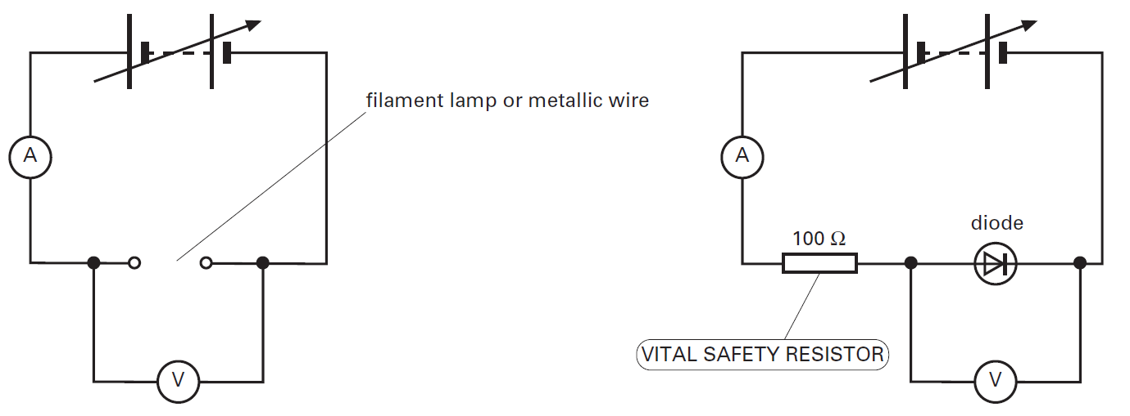

Practical
The effect of temperature on the resistance of a thermistor
Apparatus

• | 6.0V battery | • | thermometer
• | 100ml beaker | • | digital voltmeter
• | NTC thermistor | • | digital ammeter
• | plastic bag | • | connecting leads
• | electric kettle

Aim

In this experiment you will investigate the effect that temperature has on the resistance of a negative temperature coefficient (NTC) thermistor.

Procedure
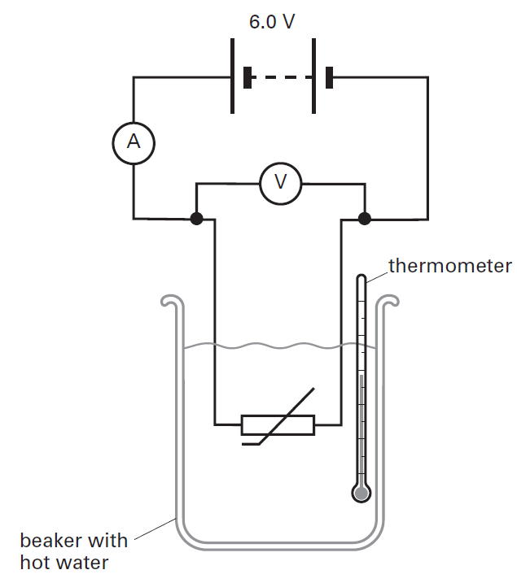
The circuit shown here may be used to investigate the behaviour of a thermistor.
            - Put the thermistor in a waterproof plastic bag and place it into a beaker.
            - Pour boiling hot water into the beaker.
            - Stir the water and measure the temperature θ of the water, the potential difference V and the current I.
            - Record your results in a table.
            - For every 10 °C drop in temperature, measure I and V.
            - Calculate the resistance R of the thermistor at each temperature using the equation: R = V/I
            - Repeat the experiment twice and determine the average resistance at each temperature.
            - Plot a graph of resistance R against temperature θ.

Resistance
Resistivity and Superconductivity
The resistance of a wire is caused by free electrons colliding with the positive ions that make up the structure of the metal. The resistance depends upon several factors:
Length, l Length increases – resistance increases
The longer the piece of wire the more collisions the electrons will have.
Area, A Area increases – resistance decreases
The wider the piece of wire the more gaps there are between the ions.
Temperature Temperature increases – resistance increases
As temperature increases the ions are given more energy and vibrate more, the electrons are more likely to collide with the ions.
Material
The structure of any two metals is similar but not the same, some metal ions are closer together, others have bigger ions.

Resistivity, ρ
The resistance of a material can be calculate using 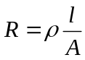 where ρ is the resistivity of the material.
Resistivity is a factor that accounts for the structure of the metal and the temperature. Each metal has its own value of resisitivity for each temperature. For example, the resistivity of copper is 1.7x10⁻⁸ Ωm and carbon is 3x10⁻⁵ Ωm at room temperature. When both are heated to 100°C their resistivities increase.
Resistivity is measured in Ohm metres , Ωm

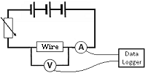Measuring Resistivity
In order to measure resistivity of a wire we need to measure the length, cross-sectional area (using Area = πr²) and resistance.
Remember, to measure the resistance we need to measure values of current and potential difference using the set up shown on the right
We then rearrange the equation to 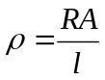 and substitute values in

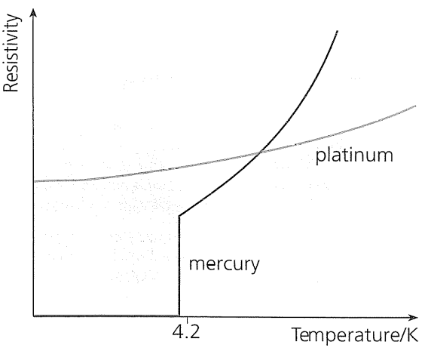
Superconductivity
The resistivity (and so resistance) of metals increases with the temperature. The reverse is also true that, lowering the temperature lowers the resistivity.
When certain metals are cooled below a critical temperature their resistivity drops to zero. The metal now has zero resistance and allows massive currents to flow without losing any energy as heat. These metals are called superconductors. When a superconductor is heated above it’s critical temperature it loses its superconductivity and behaves like other metals.
The highest recorded temperature to date is –196°C, large amounts of energy are required to cool the metal to below this temperature.

Uses of Superconductors
High-power electromagnets
Power cables
Magnetic Resonance Imaging (MRI) scanners
Resistivity questions

- Use the equation R = ρl/A to show that the unit of ρ is the Ωm

- Calculate the resistance of a copper wire of length 2.3 m and cross-sectional area 1.5 x 10⁻⁹ m². Copper has a resistivity of 1.6 x 10⁻⁸ Ωm.

- Calculate the resistance of a uniform wire of diameter 0.32 mm and length 5.5 m. The material has a resistivity of 5.0 x 10⁻⁷ Ωm..

- Calculate the resistance of a glass rod of length 24 cm and a radius of 4.0 mm. Glass has a resistivity of 1.0 x 10⁸ Ωm.

- Calculate the resistance of a rectangular strip of copper of length 0.08 m, thickness 15 mm and width 0.80 mm.

- A wire of uniform diameter 0.28 mm and length 1.5 m has a resistance of 45 Ω. Calculate:
  - its resistivity
  - the length of this wire that has a resistance of 1.0 Ω

- Consider two pieces of copper wire. The first one has a length of 200 mm and a diameter of 0.50 mm. The second one has a length of 100 mm and a diameter of 0.25 mm. Do they have the same resistance?

- A graphite block has length 12 mm, width 4.0 mm and height 5.0 mm. Current can be passed through it between opposite faces. Calculate the three values of resistance it can have if the resistivity of graphite is 7.84 x 10⁻⁶ Ωm

- Calculate the length of 0.32 mm diameter nichrome that has the same resistance as a 3.4 m length of 0.26 mm diameter constantan wire. Nichrome has a resistivity of 1.1 x 10⁻⁶ Ωm.. Constantan has a resistivity of 4.9 x 10⁻⁷ Ωm..

- A wire has a resistance of 6.0 Ω. It is then doubled back on itself . What is now the resistance between the ends of the doubled wire?

- A car has a flat battery and needs to be started using jump leads and a friend’s car. The current needs to be at least 800 A and the friend’s car battery can provide 12 V. The jump leads must be 1.5 m long to reach and each one is made of 20 strands of copper wire. What is the minimum diameter the copper wires can be? (This is hard. There are at least three steps to get your answer)

2) 24.5 ohms
3) 34.2 ohms
4) 2.06 x10(12) ohms
5) 1.07 x 10(-4) ohms
6) a. 6.6 x 10(-3) ohm metres, b.33.3mm
7) No
8) 5.23 x 10(-4) ohms, 8.17 x 10(-4) ohms, 0.47 ohms
9) 2.29 m
10) 1.5 ohms
11) 0.32mm

During the resistivity practical, we will be using micrometer screw gauges to measure the diameter of a wire.

The diagram of on the left shows the reading on the micrometer screw gauge when the spindle touches the anvil.

The diagram on the right shows the reading on the micrometer screw gauge when the object to be measured is placed between the spindle and the anvil.

Record all your measurements and corrected measurement in mm in the space below.

Record all your measurements and corrected measurement in mm in the space below.

1.
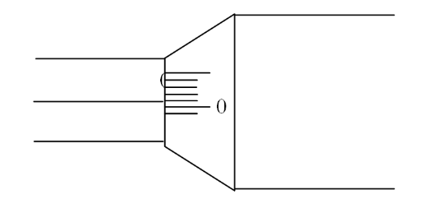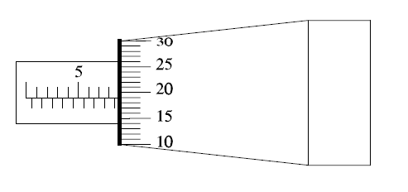
Zero Error: +0.01 mm Observed Reading: 8.69 mm

Corrected Reading: 8.68 mm

2.
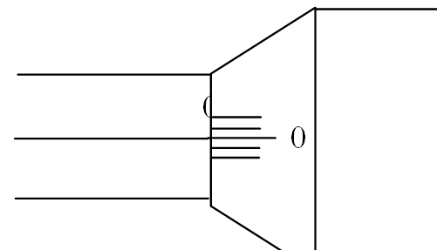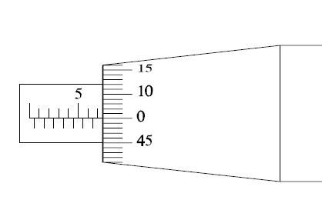

Zero Error: 0.00 mm Observed Reading: 7.00 mm

Corrected Reading: No need.

3.
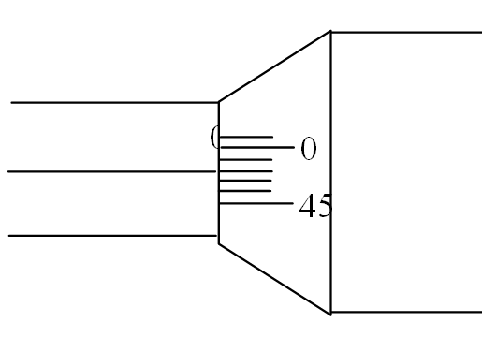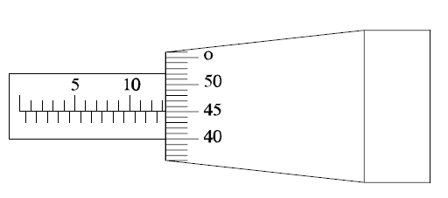

Zero Error: -0.02 mm Observed Reading: 13.45 mm

Corrected Reading: 13.47 mm

4.
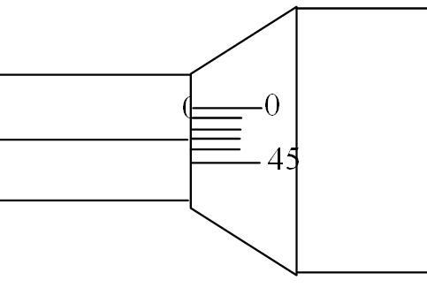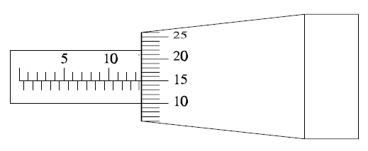
Zero Error: -0.03 mm Observed Reading: 13.15 mm

Corrected Reading: 13.18 mm

5.
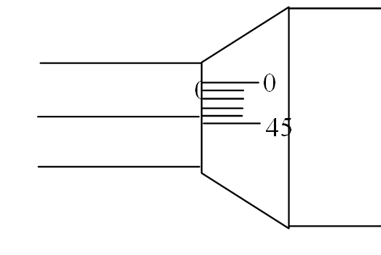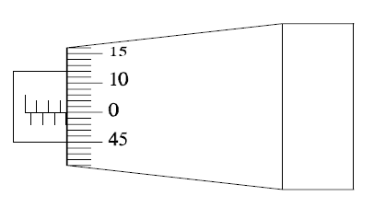
Zero Error: - 0.04 mm Observed Reading: 3.50 mm

Corrected Reading: 3.54 mm

6.
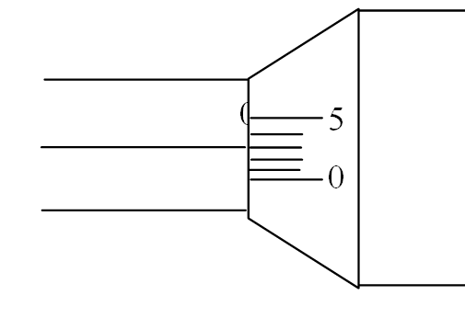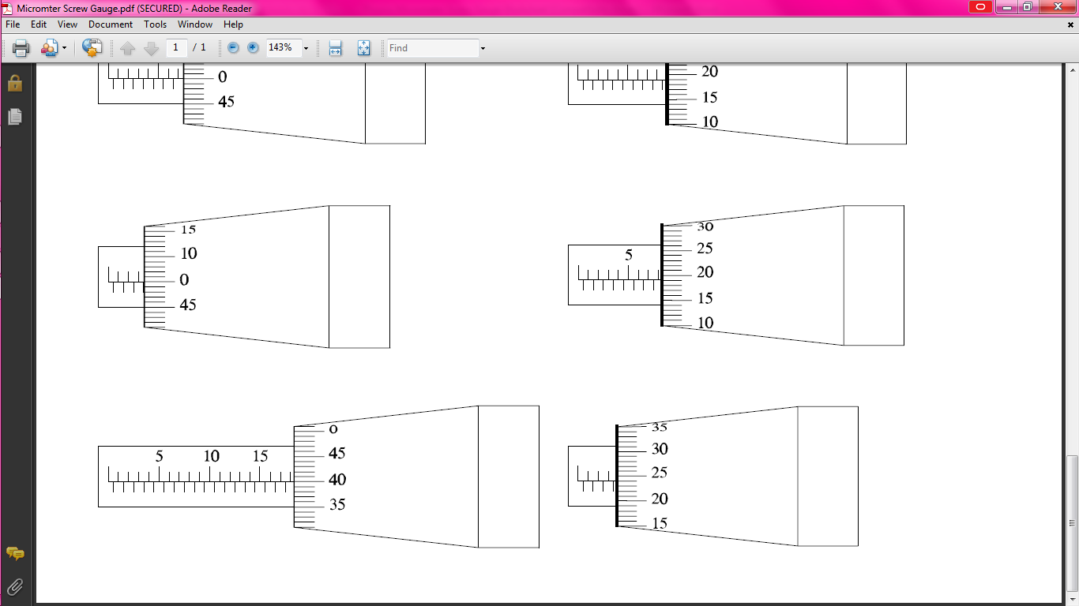

Zero Error: +0.03 mm Observed Reading: 3.74 mm

Corrected Reading: 3.71 mm
7.

Zero Error: 0.00 mm Observed Reading: 18.40 mm

Corrected Reading: No need.

Q1.
(a) State what is meant by a superconducting material.
___________________________________________________________________
___________________________________________________________________
___________________________________________________________________
___________________________________________________________________
(2)
(b) State an application of a superconductor and explain why it is useful in this application.
___________________________________________________________________
___________________________________________________________________
___________________________________________________________________
___________________________________________________________________
(2)
(Total 4 marks)
Q2.
At room temperature a metal has a resistivity of 4.5 × 10^{–7} Ωm. A wire made from this metal has a radius of 0.70 mm.
(a) (i) Calculate the resistance of a 2.5 m length of the wire at room temperature.

resistance ____________________Ω
(3)
(ii) Calculate the power dissipated in this length of wire when it carries a current of 20 mA. Assume the resistance of the wire is constant.

power ____________________W
(2)

(b) The wire becomes superconducting as it is cooled. Draw a sketch graph on the axes below to show how the wire’s resistivity would vary with temperature as it is cooled from room temperature θ_{r}.
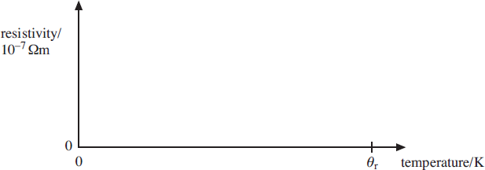
(3)
(c) Explain why the efficiency of electrical power transmission is improved when conventional wires are replaced with superconducting wires.
___________________________________________________________________
___________________________________________________________________
___________________________________________________________________
(1)
(Total 9 marks)
Q3.
(a) Some materials exhibit the property of superconductivity under certain conditions.
• State what is meant by superconductivity.
• Explain the required conditions for the material to become superconducting.
___________________________________________________________________
___________________________________________________________________
___________________________________________________________________
___________________________________________________________________
(3)

(b) The diagram below shows the cross–section of a cable consisting of parallel filaments that can be made superconducting, embedded in a cylinder of copper.
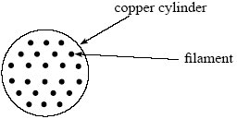
(i) The cross–sectional area of the copper in the cable is 2.28 × 10^{–7} m². The resistance of the copper in a 1.0 m length of the cable is 0.075 Ω. Calculate the resistivity of the copper, stating an appropriate unit.

answer = ____________________
(3)
(ii) State and explain what happens to the resistance of the cable when the embedded filaments of wire are made superconducting.
______________________________________________________________
______________________________________________________________
______________________________________________________________
(3)
(Total 9 marks)
Q1.
(a) no resistance
M1
(at or) below critical temperature
A1
alternative:
allow a labelled diagram which indicates features, allow T_{c} for
transition temp in diagram
2
(b) Use
eg mri scanner, transformer, generator, maglev train, particle
accelerators, microchips, computers, energy storage with detail
B1
Reason
eg strong magnetic field, no energy dissipation (mri scanner
/ maglev/ particle accelerator)
higher (processing) speeds, smaller, no
energy dissipation
(microchip / computer)
B1
smaller, no energy dissipation, no fire risk (transformer / generator)
no energy dissipation (power transmission / energy storage with detail)
2
[4]
Q2.
(a) (i) calculated cross-sectional area = 1.54 × 10⁻⁶ (m²) or correct substitution
C1
1.6 × 10⁻³ (treating r as A) gains 2
into resistivity equation with incorrect powers of ten correct substitution
C1
into resistivity equation with correct powers of ten
0.73 (Ω)
A1
3
(ii) Sub into I² R irrespective of power of 10 [ecf from (a)(i)]
C1
2.96 × 10⁻⁴ (W)
A1
2
(b) line with positive slope (linear or curve)
B1
knee and vertical line shown in first 2 / 3 on temperature axis
B1
resistivity falling to zero above 0 K
B1
3
(c) (with no resistance there can be) no power loss
B1
1
[9]
Q3.
(a) superconductivity means a material has zero resistivity/resistance (1)
resistivity decreases with temperature or idea of cooling (1)
becomes superconducting when you reach the critical/certain/
transition temperature (1)
3
(b) (i) (use of R = ρl/A)
0.075 = ρ × 1/(2.28 × 10^{–7}) (1) (must see working or equation)
R = 1.7 × 10^{–8} (1) Ωm (1)
(ii) max 3 from
the resistance decreases (to zero) (1)
copper still has resistance (1)
but this is in parallel with filaments (which have zero resistance) (1)
hence total resistance is zero (1)
current goes through filaments (1)
6
[9]

Practical
Identifying a material from its resistivity

Safety
Do not attempt to measure the current for zero length. This will short out the battery and send a potentially damaging current through the ammeter.

Apparatus

• 6.0V battery (or d.c. supply) |  | • | crocodile clip
• manganin or eureka or nichrome wire |  | • | digital voltmeter
• | ruler | • | digital ammeter
• | micrometer | • | connecting leads

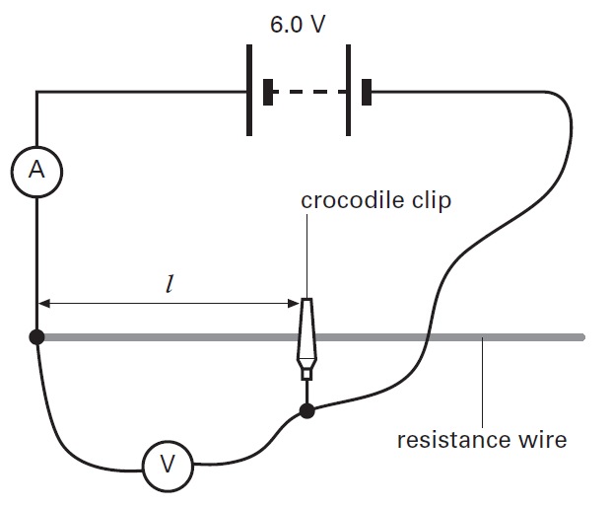
Introduction

In this experiment you will determine the resistivity of a metal and identify it by using either a databook or the Internet.
Procedure

The diagram shows an arrangement that may be used to determine the resistivity of a metal. You may use any available wires in the laboratory.

- Measure the diameter of the wire at different points. Use the average diameter d to determine the cross-sectional area A of the wire using $A=\frac{πd^{2}}{4}$.
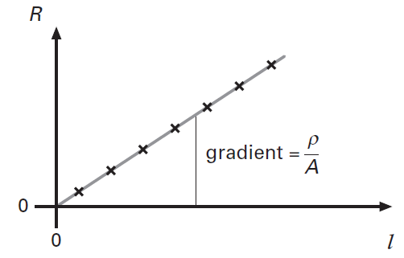
- For a 10cm long wire, measure the current I and the potential difference V.
- Record your results in a table.
- Calculate the resistance R of the wire using R = V/I.
- Increase the length of the wire in steps of 10cm and determine the resistance for each length.
- Plot a graph of resistance R of the wire against its length l.
- Draw a straight line of best fit through the data point.
- Find the gradient of the line, which is equal to ρ/A, where ρ is the resistivity of the metal.
- Calculate the resistivity by using the relationship: ρ = gradient × A.
- Use the Internet or a science databook to identify the metal.

Series Circuits
Series and Parallel Circuits
In a series circuit all the components are in one circuit or loop. If resistor 1 in the diagram was removed this would break the whole circuit.

The total current of the circuit is the same at each point in the circuit. 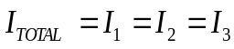
The total voltage of the circuit is equal to the sum of the p.d.s across each resistor. 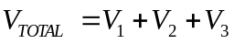
The total resistance of the circuit is equal to the sum of the resistance of each resistor. 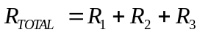
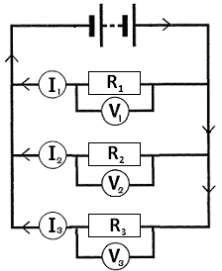
Parallel Circuits
Components in parallel have their own separate circuit or loop. If resistor 1 in the diagram was removed this would only break that circuit, a current would still flow through resistors 2 and 3.

The total current is equal to the sum of the currents through each resistor.
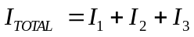
The total potential difference is equal to the p.d.s across each resistor.
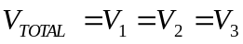
The total resistance can be calculated using the equation:
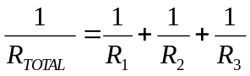

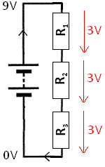
Water Slide Analogy
Imagine instead of getting a potential difference we get a height difference by reaching the top of a slide. This series circuit has three connected slides and the parallel circuit below has three separate slides that reach the bottom.

Voltages/P.D.s
In series we can see that the total height loss is equal to how much you fall on slide 1, slide 2 and slide 3 added together. This means that the total p.d. lost must be the p.d. given by the battery. If the resistors have equal values this drop in potential difference will be equal.
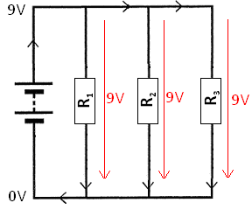
In parallel we see each slide will drop by the same height meaning the potential difference is equal to the total potential difference of the battery.

Currents
If we imagine 100 people on the water slide, in series we can see that 100 people get to the top. All 100 must go down slide 1 then slide 2 and final slide 3, there is no other option. So the current in a series circuit is the same everywhere.
In parallel we see there is a choice in the slide we take. 100 people get to the top of the slide but some may go down slide 1, some down slide 2 and some down slide 3. The total number of people is equal to the number of people going down each slide added together, and the total current is equal to the currents in each circuit/loop.

Combining Resistors
- What is the total resistance of these two resistors?
5kΩ
5kΩ

………………………………………….kΩ
- What is the total resistance of these two resistors?
27kΩ
43kΩ

……………………………………..kΩ
- What is the total resistance of these three resistors?
22kΩ
10kΩ

4.7kΩ

…………………………………….kΩ
- What is the total resistance of these three resistors?
22kΩ
10kΩ

4.7kΩ

…………………………………..kΩ
- What is the total resistance of these four resistors?
10kΩ

4.7kΩ
22kΩ
10kΩ

………………………………….kΩ
20Ω
20Ω

20Ω

- What is the total resistance of these three resistors?

……………………………………Ω

- What is the total resistance of these three resistors?
27Ω
2.2MΩ

4.7MΩ

………………………………………Ω
- What is the total resistance of these six resistors?
6kΩ
6kΩ

6kΩ

6kΩ

6kΩ

6kΩ

…………………………………kΩ
- What is the total resistance of these five resistors?
10kΩ

10kΩ

10kΩ

10kΩ

10kΩ

…………………………………kΩ

10. What is the total resistance of these five resistors?
22kΩ
10kΩ

27kΩ
2.2MΩ

4.7MΩ

…………………………………kΩ

11. The diagram below shows a circuit connected by a student.
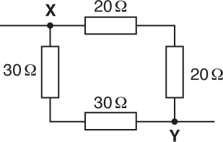
What is the total resistance of the circuit between points X and Y?
A | 24 Ω
B | 29 Ω
C | 38 Ω
D | 100 Ω

1. 2.5kΩ
2. 16.6kΩ
3. 11.6kΩ
4. 7.3kΩ
5. 11.4kΩ
6. 6.7Ω
7. 27Ω
8. 1kΩ
9. 20kΩ
10. 33.4kΩ
11. A

Calculate the missing currents, voltages and resistances.
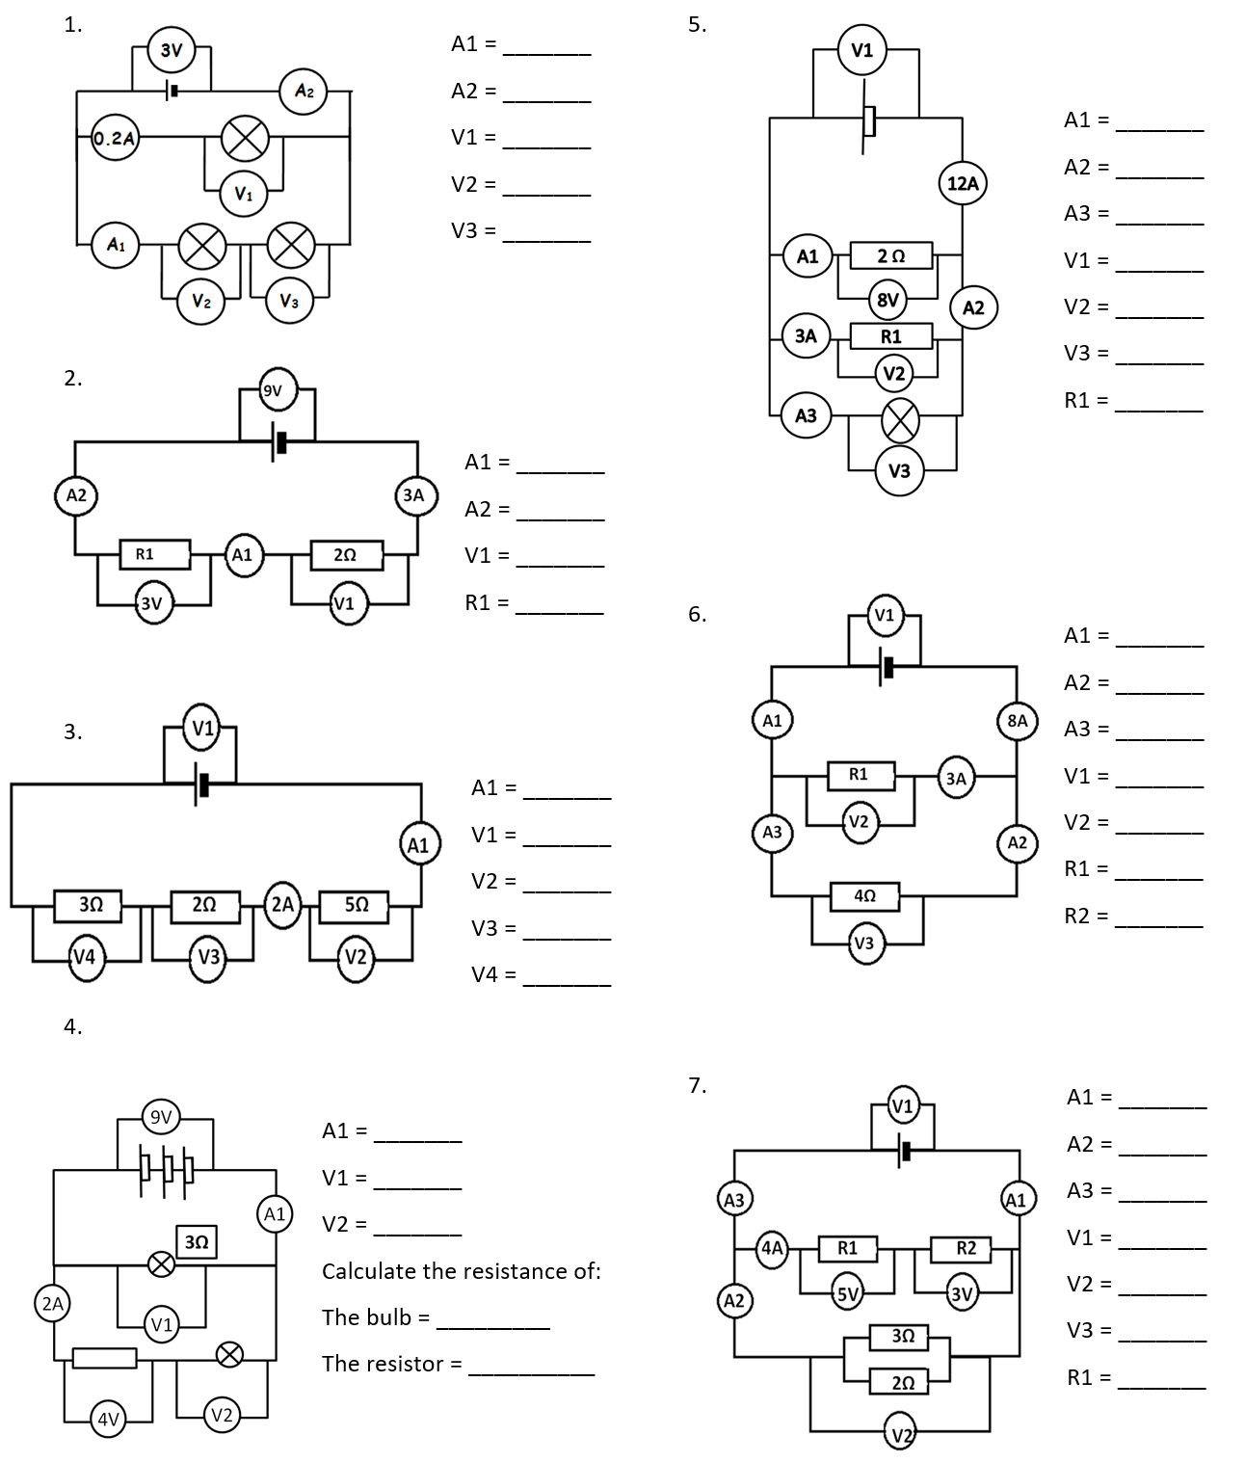

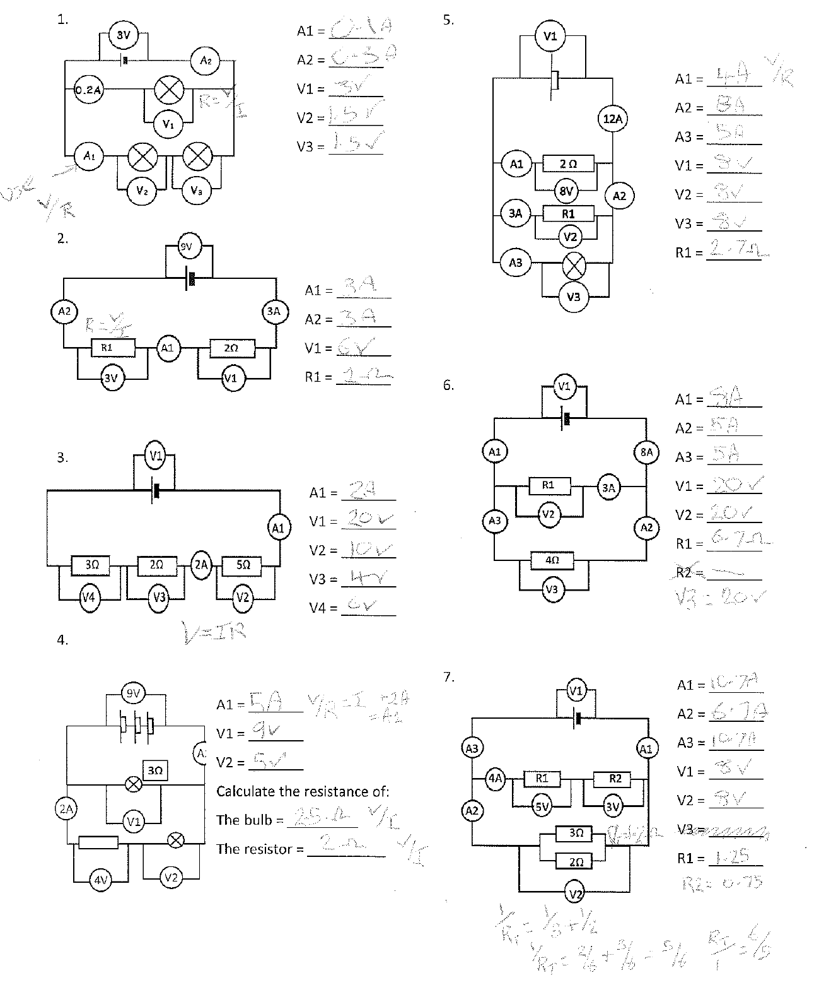
Q1.
(a) A student is given three resistors of resistance 3.0 Ω, 4.0 Ω and 6.0 Ω respectively.
(i) Draw the arrangement, using all three resistors, which will give the largest resistance.

(ii) Calculate the resistance of the arrangement you have drawn.
______________________________________________________________
______________________________________________________________
(iii) Draw the arrangement, using all three resistors, which will give the smallest resistance.

(iv) Calculate the resistance of the arrangement you have drawn.
______________________________________________________________
______________________________________________________________
______________________________________________________________
(5)
(b) The three resistors are now connected to a battery of emf 12 V and negligible internal resistance, as shown in Figure 1.
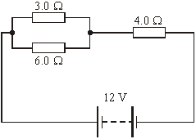
Figure 1

(i) Calculate the total resistance in the circuit.
______________________________________________________________
______________________________________________________________
(ii) Calculate the voltage across the 6.0 Ω resistor.
______________________________________________________________
______________________________________________________________
______________________________________________________________
(4)
(Total 9 marks)

Q1.
(a) (i) three resistors in series (1)
(ii) R = 3.0 + 4.0 + 6.0 = 13 Ω (1)
(iii) three resistors in parallel (1)
(iv) 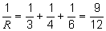 (1)
R = 1.3 Ω (1)
5
(b) (i) two resistors in parallel give 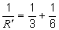 and R’ = 2.0 (Ω) (1)
total resistance = (2 + 4) = 6.0 Ω (1)
4
(ii) divide the emf in the ratio of 2 : 4 (1)
to give 4.0 V (1)
[or any suitable method]
[9]

Power
Energy and Power
Power is a measure of how quickly something can transfer energy. Power is linked to energy by the equation:
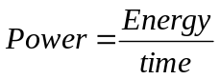 Power is measured in Watts, W
Energy is measured in Joules, J
Time is measured in seconds, s

New Equations
If we look at previous equations we can derive some new equations for energy and power.
Energy
can be rearranged into 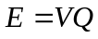 and we know that 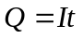so combining these equations we get a new one to calculate the energy in an electric circuit:
<---------------------- so 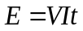 (1)

Power
If we look at the top equation, to work out power we divide energy by time:
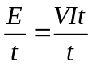 which cancels out to become 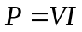 (2)

If we substituteinto the last equation we get another equation for power:
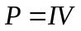<---------------------- so 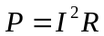 (3)

We can also rearrange into 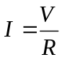and substitute this into to get our last equation for power:
<---------------------- so 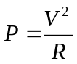 (4)
Energy again
Two more equations for energy can be derived from the equation at the top and equations 3 and 4
Energy = Power x time

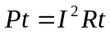 Equation 3 becomes 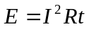 (5)

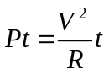 Equation 4 becomes 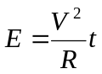 (6)

Fuses
Electrical devices connected to the Mains supply by a three-pin plug have a fuse as part of their circuit. This is a thin piece of wire that melts if the current through it exceeds its maximum tolerance. The common fuses used are 3A, 5A and 13A. A 100W light bulb connected to the UK Mains would have a 240V potential difference across it. Using we can see that the current would be 0.42A so a 2A fuse would be the best to use.

Applications
The starter motor of a motor car needs to transfer a lot of energy very quickly, meaning its needs a high power. Millions of Joules are required in seconds; since the voltage of the battery is unchanging we need current in the region of 160A which is enormous.
The power lines that are held by pylons and form part of the National Grid are very thick and carry electricity that has a very high voltage. Increasing the voltage lowers the current so if we look at the equation we can see that this lowers the energy transferred to the surroundings.

- Calculate the rate of energy transfer in the following examples:
    - A 3 V torch bulb with an operating current of 0.5 A.
P = V I = 3 × 0.5 = 1.5 W
    - A mains (230 V in the U.K.) kettle with an operating current of 13 A.
P = V I = 230 × 13 = 2990 W (3 s.f.)
    - A power cable of resistance 150 Ω with an operating current of 30 A.
P = I²R = 30² × 150 = 135 kW (3 s.f.)
    - A mains toaster with an electrical resistance of 24 Ω.
P = V² / R = 230² / 24 = 2200 W (2 s.f.)
    - A cell with internal resistance 1.5 Ω that supplies a current of 440 mA.
P = I²R = 0.440² × 1.5 = 290 mW (2 s.f.)

- Calculate the total energy transferred in the following examples:
    - The torch bulb from question 1a over its lifetime of 30 hours.
E = P t = 1.5 × (30 × 60 × 60) = 162 kJ (3 s.f.)
    - The kettle from question 1b during the 2 minutes that it takes to boil.
E = P t = 2990 × (2 × 60) = 360 kJ (3 s.f.)
    - The power cable from question 1c over a week’s continuous operation.
E = P t = 135 000 × (7 × 24 × 60 × 60) = 81.6 GJ (3 s.f.)
    - The toaster from question 1d during the 5 minutes that it takes to burn the toast.
E = P t = 2200 × (5 × 60) = 660 kJ (2 s.f.)
    - The cell from question 1e over its operating lifetime of 4 hours.
E = P t = 0.290 × (4 × 60 × 60) = 4200 J (2 s.f.)
- Calculate the current in the following examples:
    - A 12 V car headlamp of power 36 W.
I = P / V = 36 / 12 = 3.0 A (2 s.f.)
    - A mains electricity filament bulb of power 100 W.
I = P / V = 100 / 230 = 43 mA (2 s.f.)
    - A lantern bulb of power 4.5 W connected to a 9 V battery.
I = P / V = 4.5 / 9 = 0.50 A (2 s.f.)
    - A mains electricity compact fluorescent lamp of power 24 W.
I = P / V = 230 / 24 = 104 mA (3 s.f.)
    - An LED torch ‘bulb’ of power 1 W connected in series with three 1.5 V cells.
I = P / V = 1 / 4.5 = 222 mA (3 s.f.)
- Calculate the resistance of each of the examples in question 3.
    - A 12 V car headlamp of power 36 W.
R = V² / P = 12² / 36 = 4.0 Ω (2 s.f.) or by using R = V / I
    - A mains electricity filament bulb of power 100 W.
R = V² / P = 230² / 100 = 530 Ω (2 s.f.) or by using R = V / I
    - A lantern bulb of power 4.5 W connected to a 9 V battery.
R = V² / P = 9² / 4.5 = 18 Ω (2 s.f.) or by using R = V / I
    - A mains electricity compact fluorescent lamp of power 24 W.
R = V² / P = 230² / 24 = 2.2 kΩ (2 s.f.) or by using R = V / I
    - An LED torch ‘bulb’ of power 1 W connected in series with three 1.5 V cells.
R = V² / P = 4.5² / 1 = 20 Ω (2 s.f.) or by using R = V / I

- Calculate the current in the following examples, and for each example state whether the mains plug should be fitted with a 3 A fuse, a 5 A fuse or a 13 A fuse.
    - A 1200 W iron operating from a mains supply of 230 V.
5.2 A, 13 A fuse
    - A vacuum cleaner of power 900 W operating from a mains supply of 230 V.
3.9 A, 5 A fuse
    - A 100 W radio operating from a mains supply of 120 V.
0.83 A, 3 A fuse
    - A travel kettle of power 340 W operating from a mains supply of 120 V.
2.8 A, 3 A fuse
    - A microwave oven of power 1.4 kW operating from a mains supply of 230 V.
6.1 A, 13 A fuse
- An iron is rated at 230 V, 750 W. What power would be supplied to it if it is used with a mains p.d. of only 220 V? Assme that the resistance of the iron is constant.
If resistance is constant then V² / P is a constant, so V₁² / P₁ = V₂² / P₂
Therefore P₂ = (V₂ / V₁)² P₁ = (220 / 230)² × 750 = 686 W
Alternatively calculate R = 230² / 750 = 70.53 Ω and use this with 220 V to find P.
- An immersion heater has a resistance of 17 Ω and is used on a 230 V mains supply.
    - What is the current in the immersion heater?
I = V / R = 230 / 17 = 13.5 A
    - What is its power?
P = V² / R = 3112 W or P = V I = 230 × 13.5 = 3105 W
P = 3100 W (2 s.f.)
    - How long would it take to raise the temperature of 50 kg of water from 14 °C to 58 °C? Assume that the specific heat capacity of water is 4200 J kg^{–1} K^{–1}.
E = m c Δθ = 50 × 4200 × (58 – 14) = 9.24 MJ
t = E / P = 9.24 × 10⁶ / 3100 = 2971 s = 49.5 minutes
- A rechargeable AA battery (cell) has a terminal voltage of 1.2 V. The cell has negligible internal resistance and is rated at 2400 milliamp-hours (2400 mAh), which means that it can supply 2400 mA for 1 hour, or 1200 mA for 2 hours, etc.
    - What is the total energy storage capacity of the cell?
E = V I t = 1.2 × 2.4 × (60 × 60) = 10 kJ (2 s.f.)
    - What external resistance would be required in order to discharge the cell in a time of 12 hours?
2400 mAh / 12 h = 200 mA
R = V / I = 1.2 / 0.2 = 6.0 Ω (2 s.f.)
    - What power output does it give in the scenario from question 8b?
P = V I = 1.2 × 0.20 = 0.24 W (2 s.f.)
- The power source (“amp”) for an audio loudspeaker has an internal resistance of 15 Ω. There are three different loudspeakers that it could be connected to and these provide an external resistance of 8 Ω, 16 Ω and 32 Ω respectively.
    - Which of the three loudspeakers would have the greatest current when connected to this amp?
The smallest resistance (6 Ω) will have the greatest current.
    - With which of these three loudspeakers would the terminal p.d. from the amp be the greatest?
The greatest resistance (32 Ω) will have the greatest terminal p.d.
    - Which of these three loudspeakers would receive the greatest power from this amp?
The 16 Ω loudspeak would receive the greatest power from this amp.
    - What is the optimal value of loudspeaker resistance that would maximize the power delivered to the speaker?
Power dissipated by external resistance:​
P_{R} = ε² R / (r+R)²​
P_{R} will be a maximum when r²/R + 2r + R is a minimum.​
Minimum is found by differentiating w.r.t. R and setting equal to zero.​
−r² / R² + 1 = 0 R = r

Q1.
At room temperature a metal has a resistivity of 4.5 × 10^{–7} Ωm. A wire made from this metal has a radius of 0.70 mm.
(a) (i) Calculate the resistance of a 2.5 m length of the wire at room temperature.

resistance ____________________Ω
(3)
(ii) Calculate the power dissipated in this length of wire when it carries a current of 20 mA. Assume the resistance of the wire is constant.

power ____________________W
(2)
(b) The wire becomes superconducting as it is cooled. Draw a sketch graph on the axes below to show how the wire’s resistivity would vary with temperature as it is cooled from room temperature θ_{r}.
(3)
(c) Explain why the efficiency of electrical power transmission is improved when conventional wires are replaced with superconducting wires.
___________________________________________________________________
___________________________________________________________________
___________________________________________________________________
(1)
(Total 9 marks)
Q2.
A cable used in high-voltage power transmission consists of six aluminium wires surrounding a steel wire. A cross-section is shown below.
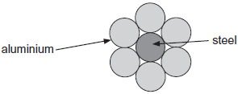
The resistance of a length of 1.0 km of the steel wire is 3.3 Ω. The resistance of a length of 1.0 km of one of the aluminium wires is 1.1 Ω.
(a) The steel wire has a diameter of 7.4 mm.
Calculate the resistivity of steel. State an appropriate unit.

resistivity = ____________________ unit ___________
(4)
(b) Explain why only a small percentage of the total current in the cable passes through the steel wire.
___________________________________________________________________
___________________________________________________________________
___________________________________________________________________
___________________________________________________________________
___________________________________________________________________
___________________________________________________________________
___________________________________________________________________
(3)
(c) The potential difference across a length of 1.0 km of the cable is 75 V.
Calculate the total power loss for a 1.0 km length of cable.

Total power loss ____________________ W
(3)
Q1.
(a) (i) calculated cross-sectional area = 1.54 × 10⁻⁶ (m²) or correct substitution
C1
1.6 × 10⁻³ (treating r as A) gains 2
into resistivity equation with incorrect powers of ten correct substitution
C1
into resistivity equation with correct powers of ten
0.73 (Ω)
A1
3
(ii) Sub into I² R irrespective of power of 10 [ecf from (a)(i)]
C1
2.96 × 10⁻⁴ (W)
A1
2
(b) line with positive slope (linear or curve)
B1
knee and vertical line shown in first 2 / 3 on temperature axis
B1
resistivity falling to zero above 0 K
B1
3
(c) (with no resistance there can be) no power loss
B1
1
[9]
Q2.
(a) Use of ρ=RA / l)
cross sectional area= × (3.7 × 10⁻³)² = 4.3 × 10⁻⁵ (m²)✓
ρ = 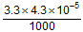 ✓ = 1.4(2) × 10⁻⁷✓Ω m✓

area : lose first mark if use diameter as radius or fail to convert to m² (if both errors still only lose 1 mark)
CE area for next two marks but if uses diameter in place of area then lose first two marks
if leave length in km lose 2nd mark but CE for answer
UNIT stand-alone 4th mark
4
(b) (current in) steel wire (is less than the current in an) aluminium wire as it has a higher resistivity / resistance OR aluminium is better conductor✓
the six aluminium wires are in parallel OR total cross-sectional area of aluminium is 6 times greater than steel wire✓
each aluminium wire carries three times as much current as the (single) steel wire✓
3
(c) resistance of 1 km of 6 Al cables in parallel = = 0.183 Ω✓

if ignored the steel wire then can score first and third mark
total resistance of the cable = 0.174 Ω✓
power loss per km = 32.3 kW (or 30.7 kW if they ignore the steel)✓
OR
power loss in 1 km of steel = 1.70kW✓
power loss in 1 km each of Al cable = 5.11 kW✓
total power loss per km = 32.4 kW (or 30.7 kW if they ignore the steel)✓
OR
calculate current in steel wire and aluminium wire (22.7 and 68.2) ✓
calculate power loss in aluminium wire and steel wire (1700 and 5115) ✓
calculate total power loss (1700 + 6 × 5115 = 32,4 kW) ✓
accept range 32 kW to 33 kW
if ignored steel wire
range for third mark is 30 kW to 31 kW
if wires treated as series resistors then zero
3
[10]

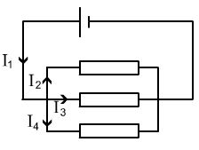
Kirchhoff’s Laws
Kirchhoff and Potential Dividers
Kirchhoff came up with two laws concerning conservation in electrical circuits.

First Law
Electric charge is conserved in all circuits, all the charge that arrives at a point must leave it.
Current going in = current going out.
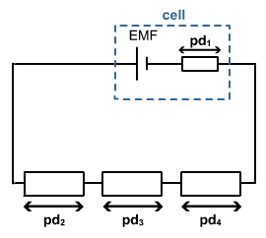In the diagram we can say that: I₁ = I₂ + I₃ + I₄

Second Law
Energy is conserved in all circuits, for any complete circuit the sum of the emfs is equal to the sum of the potential differences.
Energy givers = energy takers.
In the diagram we can say that: ε = pd₁ + pd₂ + pd₃ + pd₄.

Potential Dividers
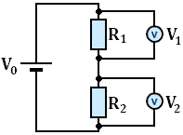
A potential divider is used to produce a desired potential difference, it can be thought of as a potential selector.
A typical potential divider consists of two or more resistors that share the emf from the battery/cell.
The p.d.s across R₁ and R₂ can be calculated using the following equations:
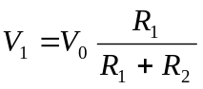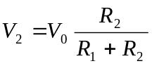

This actually shows us that the size of the potential difference is equal to the input potential multiplied by what proportion of R₁ is of the total resistance.
If R₁ is 10 Ω and R₂ is 90 Ω, R₁ contributes a tenth of the total resistance so R₁ has a tenth of the available potential. This can be represented using:
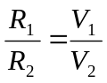 The ratio of the resistances is equal to the ratio of the output voltages.

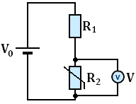
Uses
In this potential divider the second resistor is a thermistor. When the
temperature is low the resistance (R₂) is high, this makes the output voltage
high. When the temperature is high the resistance (R₂) is low, this makes the
output voltage low. A use of this would be a cooling fan that works harder
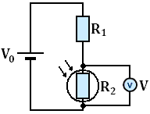
when it is warm.

In the second potential divider the second resistor is a Light Dependant Resisitor.
When the light levels are low the resistance (R₂) is high, making the output voltage
high. When the light levels increase the resistance (R₂) decreases, this makes the
output voltage decrease. A use of this could be a street light sensor that lights up
when the surrounding are dark.

Kirchoff’s Laws and Circuits
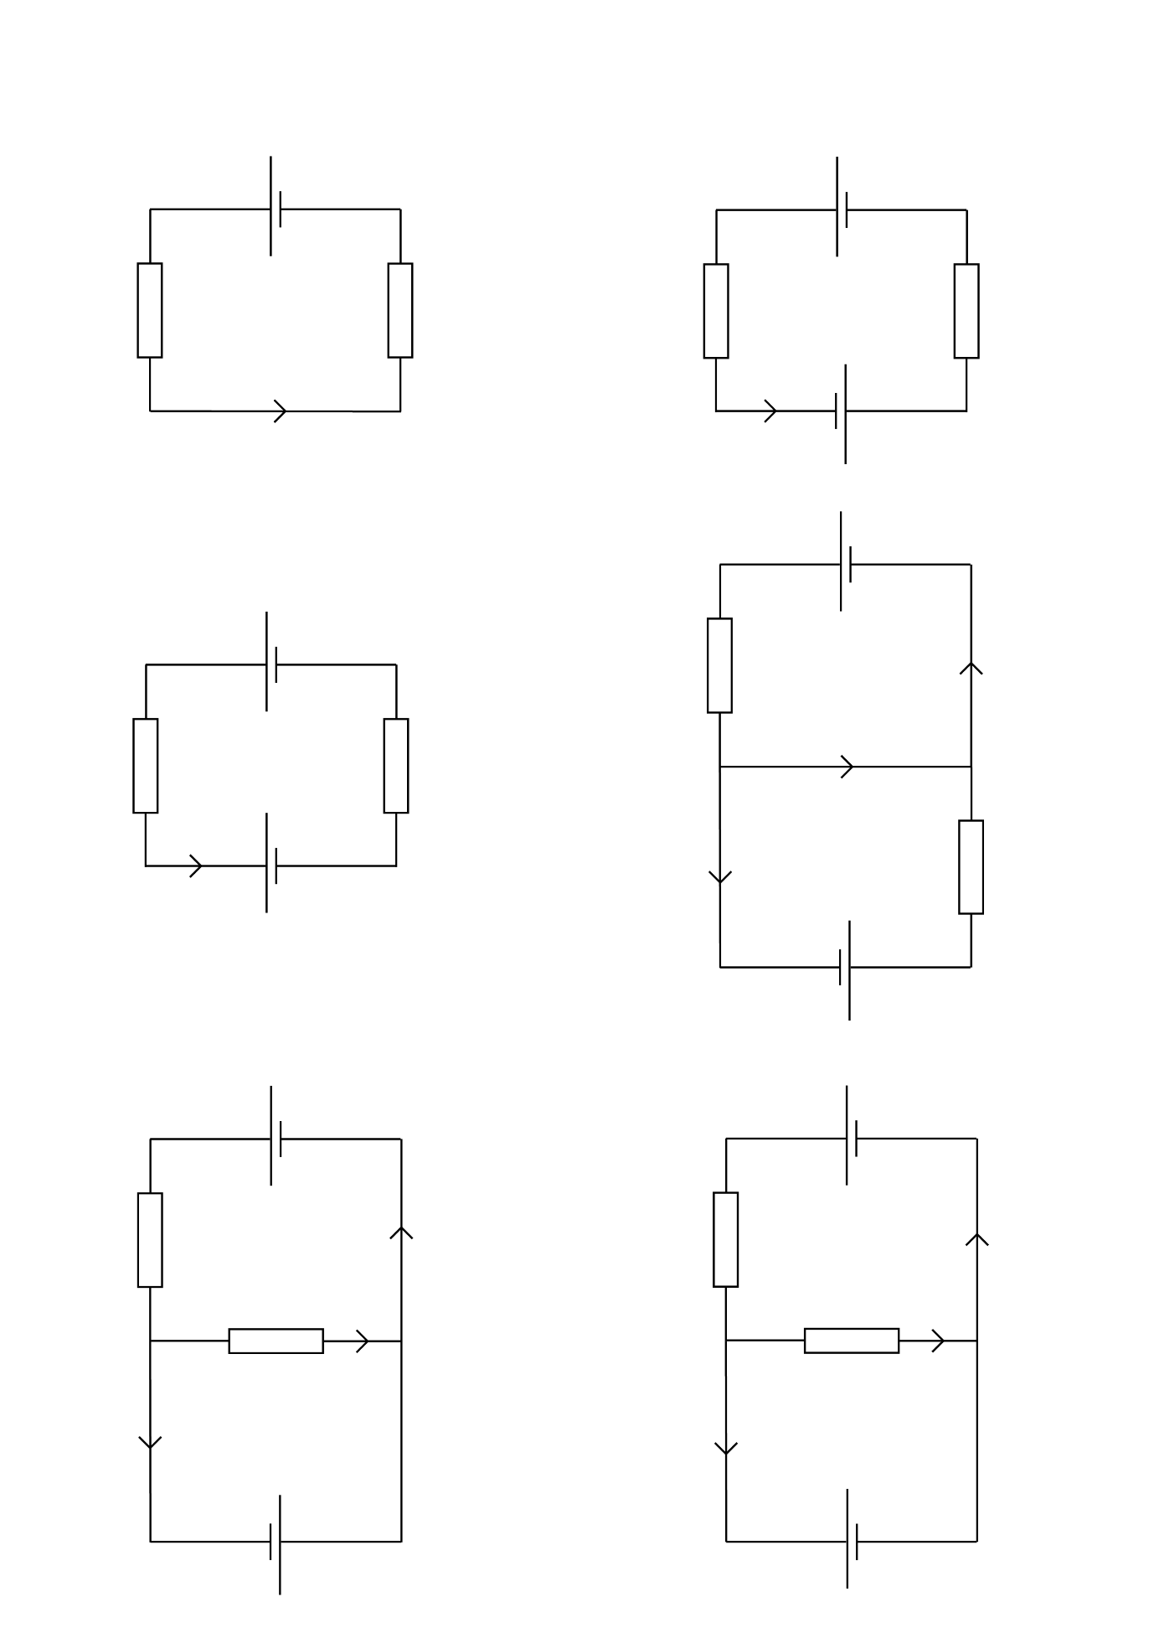
Find the labelled currents in each of the circuits shown.
6V
6V
6V
6V
6V
6V
4V
4V
4V
4V
4V
3Ω
3Ω
3Ω
3Ω
3Ω
3Ω
2Ω
2Ω
2Ω
2Ω
2Ω
I
I
I
I₁
I₂
I₃
I₁
I₁
I₂
I₂
I₃
I₃
1.
2.
3.
4.
5.
6.
2Ω

- 6 = 3I + 2I => 5I = 6 => I = 6/5 = 1.2A
- 6 + 4 = 3I + 2I => 5I = 10 => I = 10/5 = 2A
- 6 – 4 = 3I + 2I => 5I = 2 => I = 2/5 = 0.4A
- From loop A: 6 = 3I₁ => I₁ = 6/3 = 2A
From loop B: 4 = 2I₃ => I₃ = 4/2 = 2A
Using 1st Law: I₁ = I₂ + I₃ => I₂ = I₁ – I₃ = 2 – 2 = 0
- From loop A: 4 = -2I₂ => I₂ = -4/2 = -2A
From loop B: 6 + 4 = 3I₁ => I₁ = 10/3 = 3.33A
Using 1st Law: I₁ = I₂ + I₃ => I₃= I₁ – I₂ = 10/3 - -2 = 16/3 = 5.33 A
- From loop A: 4 = 2I₂ => I₂ = 4/2 = 2A
From loop B: 6 - 4 = 3I₁ => I₁ = 2/3 = 0.67A
Using 1st Law: I₁ = I₂ + I₃ => I₃ = I₁ – I₂ = 2/3 - 2 = -4/3 = -1.33 A
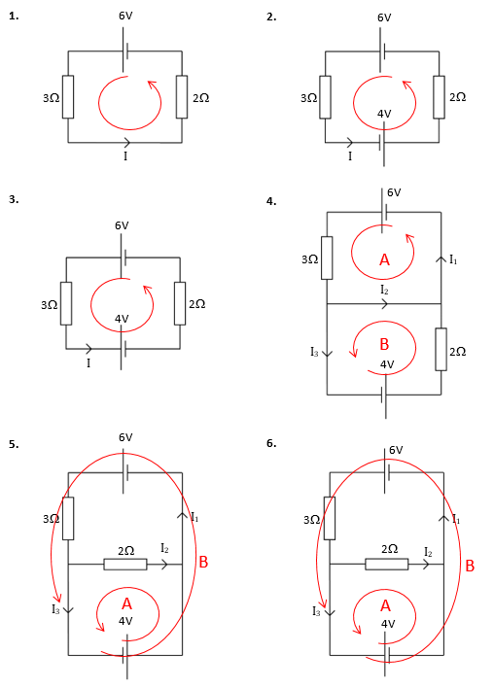

Potential Dividers
1. The input pd to a potential divider is 9.0 V.
a. What is the output pd across a 1.0 kΩ resistor if the second resistor is 5 kΩ?
- What is the output pd across a 330 Ω if the second resistor is 990 Ω?
- If the output pd across a 680 Ω resistor is 7.0 V, what is the resistance of the other resistor?

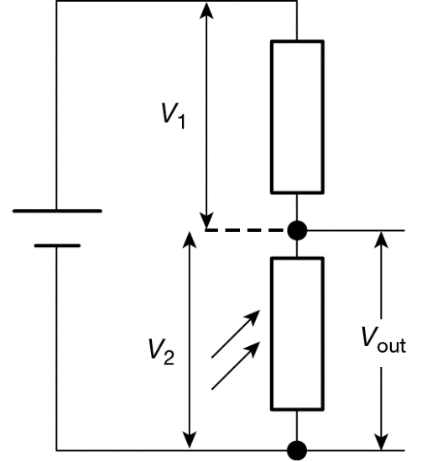
2. A potential divider circuit, like that shown in Figure 2, is used to switch on a light when the light intensity drops below a certain value.
The supply pd is 12 V. The light must switch on at twilight, when the resistance of the LDR has a value of 5.0 kΩ. A pd of 4.0 V is required to switch on the light.
Calculate the fixed resistance required for the circuit.

Figure 2

3. Figure 3 shows a length of uniform resistance wire AB connected in a circuit with a 12.0 V power supply to make a potentiometer.
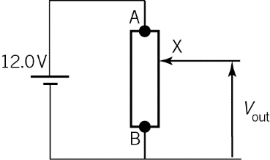
Figure 3
What will be the value of the output pd when:
  - the length AX = half the length of AB

  - the length AX =  the length of AB

  - the length of AX = the length of AB.

4. A heater switches on when the pd is 5.0 V. You have a supply pd of 9.0 V and a thermistor with a resistance that decreases with temperature, which has a resistance of 450 Ω at a temperature of 20°C.
Calculate the value of the series resistor that should be used in the circuit, shown in Figure 4, to switch on the heater when the temperature falls to 20°C.
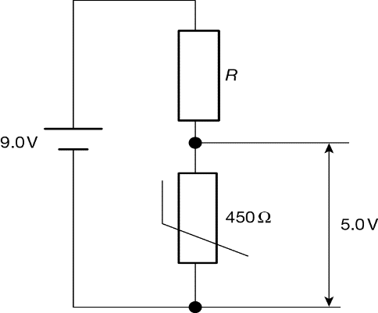
Figure 4
5. This question is about the use of a thermistor fitted inside a domestic oven as a temperature sensor in a potential divider circuit.
Fig. 2.1 shows the potential divider circuit in which the component R₂ is connected in parallel to the input of an electronic circuit that switches the mains supply to the heating element in the oven on or off.
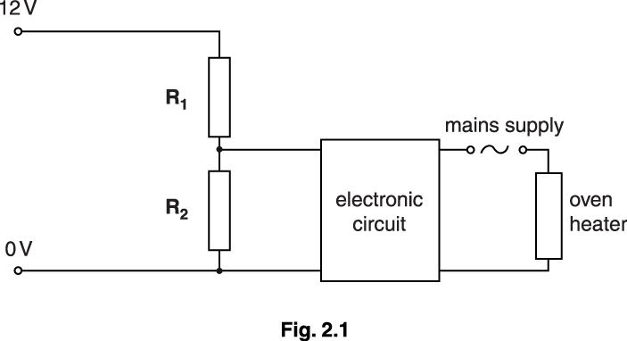
It is required that the p.d. across the thermistor R₂ is 7.0 V when at a temperature of 180 °C. The variation of resistance with temperature for R₂ is shown in Fig. 2.2.

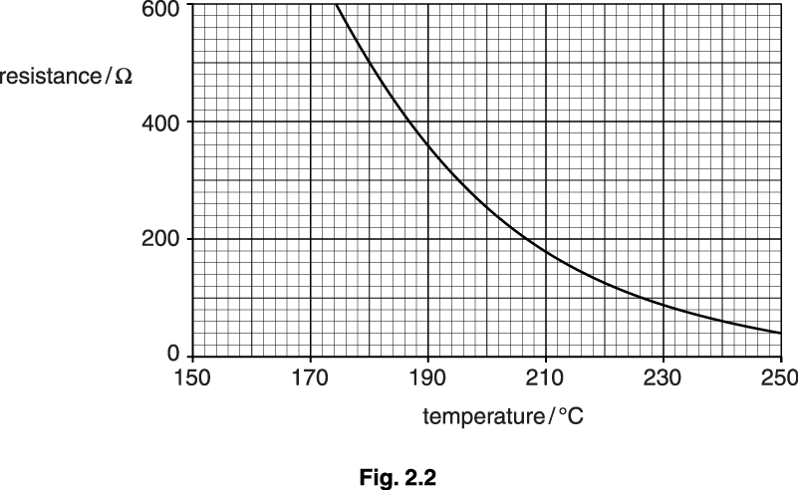
- Use Fig. 2.2 to determine the resistance of R₂ at a temperature of 180°C.
- When the temperature is 180°C the p.d. across R₂ is 7.0 V. Calculate the current in R₂.
iii. The electronic circuit draws a negligible current. Show that the resistance of the variable resistor R₁ must be about 350 Ω.

iv. R₂ is heated slowly. Show that the p.d. across R₂ must fall to about 5.0 V when the temperature of R₂ reaches 200°C.
b. It is required that the p.d. across the thermistor R₂ is 7.0 V when at a temperature of 180 °C. The variation of resistance with temperature for R₂ is shown in Fig. 2.2.

The thermistor R₂ is fitted inside the oven. When the p.d. across R₂ falls to 5.0 V the oven heater switches off. The oven cools until the p.d. across R₂ rises to 7.0 V when the heater switches on again.
R₁ is adjusted to 250 Ω. Calculate the temperatures at which the oven heater is switched on and off.

temperature on ........................................................... °C

temperature off ........................................................... °C [4]
1. a V_{out} = 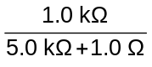 × 9.0V = 1.5 V
b V_{out} = 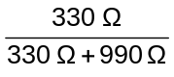 × 9.0V = 2.3 V (two significant figures)
c 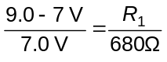
R₁ = 680 Ω × 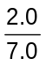 = 190 Ω (two significant figures)
2. V₁ = 12 V – 4.0 V = 8.0 V
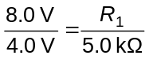
R₁ = 10 kΩ
3.a. AX = 0.5 × AB, so XB = 0.5 AB
So R₂ = 0.5 (R₁ + R₂)
V₂ = 0.5 (V₁ + V₂) (or V_{out} = 0.5 V_{in})
V_{out} = 0.5 × 12.0 V
V_{out} = 6.0 V
b. AX = × AB so XB = AB
So R₂ = (R₁ + R₂)
V₂ = (V₁ + V₂) (or V_{out} = V_{in})
V_{out} = × 12.0 V
V_{out} = 8.0 V
c. AX = × AB so XB = AB
So R₂ = (R₁ + R₂)
V₂ = (V₁ + V₂) (or V_{out} = V_{in})
V_{out} = × 12.0 V
V_{out} = 3.0 V
4. V_{out} = 9.0 V – 5.0 V
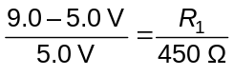
R₁ = 450 Ω × 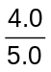 = 360 Ω
5. a.i. 500 Ω
a.ii. 7.0 = I × 500; I 0.014 (A)
a.iii. 5.0 = 0.014 × R or 12 = 0.014(500 + R)
R = 360 Ω
a.iv. (at 200°C) Rth = 250 Ω
V across thermistor = 12 × 250/(250 + 350) = 5.0 V
alt 5.0 = 12 × R/(R + 350)
or I = 7.0/350 = 0.02 A; Vth = 5.0 = 0.02 × R
b. R = 250 Ω which occurs at 200°C
switch on 5.0 = 12 × 250/(250 + R) or 7.0 = 12 × R/(250 + R)
giving R = 350 Ω which is 190°C
switch off 7.0 = 12 × 250/(250 + R) or 5.0 = 12 × R/(250 + R)
giving R = 180 Ω which is 210°C
or Switch on, R2 / R1 = 7/5 giving R2 - 250 × 7/5 = 350 ohm
Switch off, R2 / R1 = 5/7 giving R2 = 250 × 5/7 = 179 ohm

Circuit Analysis
1.
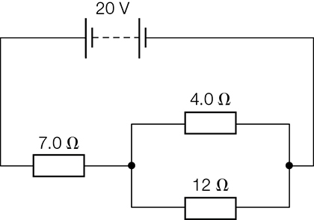
For the circuit shown above, calculate
  - the total resistance in the circuit
  - the current through the 7.0 Ω resistor
  - the pd across the 7.0 Ω resistor
  - the pd across the 4.0 Ω resistor
  - the pd across the 12 Ω resistor
  - the current through the 4.0 Ω resistor
g the current through the 12 Ω resistor.

- a. 4Ω and 12Ω in parallel: $\frac{1}{R_{t}}=\frac{1}{R_{1}}+\frac{1}{R_{2}}=\frac{1}{4}+\frac{1}{12}=\frac{4}{12}$, R_{t}=$\frac{12}{4}$=3Ω
3Ω and 7Ω in parallel: R_{t} = R₁+R₂=3+7 = 10Ω

b. $I=\frac{V}{R}=\frac{20}{10}=2A$
c. V=IR= 2A x 7Ω = 14V
d. Pd across 4Ω = pd across 12Ω (as in parallel)
Pd across 4Ω = emf of battery – pd across 7Ω
V₄ = ε - V₇ = 20 – 14 = 6V
e. Pd across 4Ω = pd across 12Ω (as in parallel)
=6V
f. $I=\frac{V}{R}=\frac{6}{4}=1.5A$
g. $I=\frac{V}{R}=\frac{6}{12}=0.5A$

Q1.
The diagram shows a circuit designed by a student to monitor temperature changes.

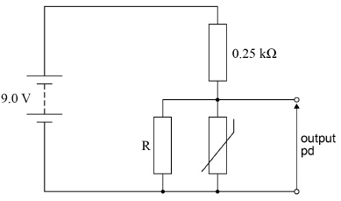
The supply has negligible internal resistance and the thermistor has a resistance of 750 Ω at room temperature. The student wants the output potential difference (pd) at room temperature to be 5.0 V
(a) The 0.25 kΩ resistor is made of 50 turns of wire that is wound around a non-conducting cylinder of diameter 8.0 mm
Resistivity of the wire = 4.2 × 10^{–7} Ω m
Determine the area of cross-section of the wire that has been used for the resistor.
area of cross-section = ____________________ m²
(3)
(b) The student selects a resistor rated at 0.36 W for the 0.25 kΩ resistor in the diagram.
Determine whether this resistor is suitable.
___________________________________________________________________
___________________________________________________________________
___________________________________________________________________
___________________________________________________________________
___________________________________________________________________
(2)
(c) Determine the value of R that the student should select.
Give your answer to an appropriate number of significant figures.
value of R = ____________________ Ω
(5)
(d) State and explain the effect on the output pd of increasing the temperature of the thermistor.
___________________________________________________________________
___________________________________________________________________
___________________________________________________________________
___________________________________________________________________
___________________________________________________________________
(2)
(Total 12 marks)

Q1.
(a) Length of resistance wire = 50 × 2 × 3.14 × 4 × 10^{–3} = 1.26 m ✔
or 50 × 3.14 × 8 × 10^{–3}
1
Substitution of data in resistance formula
or A = ρL/R seen ✔
ecf for incorrect length from attempt at a calculation
1
Area of cross section = 2.1(1) × 10^{–9} (m²) ✔
1
(b) Maximum possible pd across 0.25 kΩ is 9 V ✔
1
(Max power dissipated) = 9²/250 = 0.32 W so resistor is suitable ✔
1
OR
When resistor dissipates maximum power
V² = 0.36 × 250 so max V = 9.5 V ✔
This is higher than the supply pd so this power dissipation so will not be reached ✔
OR
Power dissipated when output is 5 V = 4²/250 = 0.064 W ✔
Which is below the max power dissipation of 0.36 W ✔
9²/250 = 0.32 W with incorrect conclusion scores 1
Second mark implies the first
9²/0.36 = 225 Ω alone is not a useful calculation in the context. Still need to explain the effect of using the 250 Ω
First mark is for a valid useful calculation
(c) Use of potential divider formula to determine resistance of parallel combination ✔
0.313 kΩ ✔
Use of equation for resistors in parallel ✔
540 Ω ✔
Alternative to find resistance of combination
Current in circuit at room temp = 4/250 = 16 mA ✔
Resistance of combination = 5/16mA = 313 Ω ✔
OR
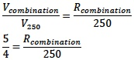
R_{combination} = 313 Ω
OR
Current in circuit at room temp = 4/250 = 16 mA ✔
Current in thermistor = 5/750 = 6.7 mA ✔
Current in R = 9.3 mA ✔
R = 5/9.3 = 540 Ω ✔
2sf answer ✔
(only allowed with some relevant working leading to a resistor value)
Max 5
(d) Resistance of thermistor decreases ✔
Output pd decreases since
resistance of the parallel combination /circuit decreases
1
OR
lower proportion of pd across the parallel combination (or higher proportion across 250Ω)
OR
higher current so greater pd across the 0.25 k resistor ✔
Accept correct consequences for R increasing with temperature for 1 mark
1
[12]

Energy in Circuits
EMF and Internal Resistance
In circuits there are two fundamental types of component: energy givers and energy takers.

Electromotive Force (emf), ε
Energy givers provide an electromotive force, they force electrons around the circuit which transfer energy.
The size of the emf can be calculate using: 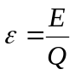
This is similar to the equation we use to find voltage/potential difference and means the energy given to each unit of charge. We can think of this as the energy given to each electron.
The emf of a supply is the p.d. across its terminals when no current flows
EMF is measured in Joules per Coulomb, JC⁻¹ or Volts, V
Energy takers have a potential difference across them, transferring energy from the circuit to the component.
emf = energy giver p.d. = energy taker
Energy is conserved in a circuit so energy in = energy out, or:
The total of the emfs = The total of the potential differences around the whole circuit

Internal Resistance, r
The chemicals inside a cell offer a resistance to the flow of current, this is the internal resistance on the cell.
Internal Resistance is measured in Ohms, Ω

Linking emf and r
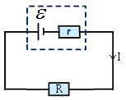If we look at the statement in the box above and apply it to the circuit below, we can reach an equation that links emf and r.
Total emfs = total potential differences
ε = (p.d. across r) + (p.d. across R) {Remember that V=IR}
ε = (I x r) + (I x R)
ε = Ir + IR
ε = I(r+R)
The terminal p.d. is the p.d. across the terminals of the cell when a current is flowing
ε = internal p.d + terminal p.d.
So the above equation can be written as ε = Ir + V where V is the terminal p.d.
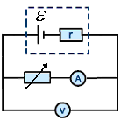

Measuring emf and r
We can measure the emf and internal resistance of a cell by measuring the current and voltage as shown on the right, the variable resistor allows us to get a range of values. If we plot the results onto a graph of voltmeter reading against ammeter reading we get a graph that looks like the one below.

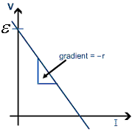Graphs have the general equation of y = mx+c, where y is the vertical (upwards) axis, x is the horizontal (across) axis, m is the gradient of the line and c is where the line intercepts (cuts) the y axis.
If we take ε = Ir + V and arrange it into y= mx + c
y axis = V and x axis = I
ε = Ir + V V = -Ir + ε V = -rI + ε
y = mx + c
So we can see that the:
y-intercept represents the emf
and
gradient represents (–)internal resistance

EMF and Internal Resistance
1. A cell has an EMF of 1.56V but when delivering a current of 0.4A has a terminal voltage of 1.47V. What is the p.d. across the internal resistance?
2. Calculate the internal resistance of the cell in question 1.
3. A cell has an EMF of 1.5V and an internal resistance of 0.02Ω. What is the maximum current that can be delivered by this cell if it were short-circuited ?
4. A cell of internal resistance 0.045Ω is delivering a current of 0.2A. Use Ohm’s law to find the p.d. across the internal resistance ?
5. A cell of internal resistance 0.2Ω and EMF 1.55V is delivering a current of 0.6A. Find the terminal voltage by subtracting the p.d. across the internal resistance from the EMF
6. A cell of internal resistance 0.35Ω is delivering a current of 0.09A and the terminal p.d. is measured as 1.36V. What is the cells EMF?
7. A resistor R, an ammeter and a switch are connected in series to a battery.
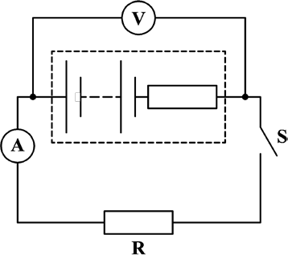
The switch S is open. The voltmeter reading is 9.0 V and the ammeter reading is zero. With S closed, the voltmeter reading is 6.0 V and ammeter reading is 2.0 A.
What is the internal resistance of the battery?
- 1.5 Ω
- 3.0 Ω
- 4.5 Ω
- 6.0 Ω

8. A bulb in a torch is powered by two identical cells connected in series, each of emf 1.5 V. The bulb dissipates power at the rate of 625 mW and the pd across the bulb is 2.5 V. Calculate
- the internal resistance of each cell
- the energy dissipated in each cell in one minute.

9. A 1.5 V cell of internal resistance 2.0 Ω is connected in two different ways to two 4.0 Ω resistors, as shown in Figure 5.
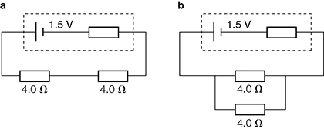
Figure 5
- For the series combination calculate
    - the current through both resistors
    - the terminal pd.
- For the parallel combination calculate
    - the current from the cell
    - the current through each resistor.
10. A battery of e.m.f. of 8.0 V and internal resistance 2.5 Ω is connected to an external resistor. The current in the resistor is 350 mA.
What is the power dissipated in the external resistor?
- 1.9 W
- 2.5 W
- 2.8 W
- 3.1 W
11. Explain how you would determine experimentally the e.m.f. E and internal resistance r of a charged 1.5V cell. Include a circuit diagram with meters and a variable load resistor. (5)

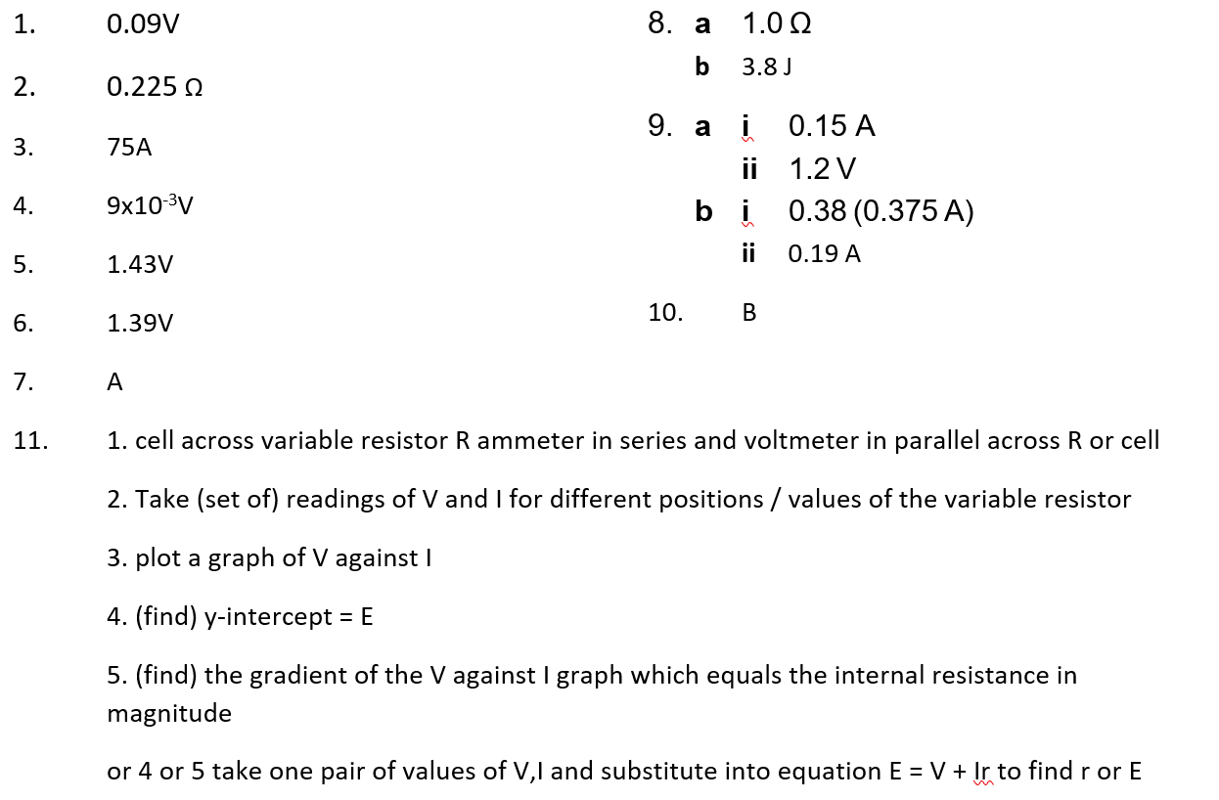

Q1.
A cell of emf, ε, and internal resistance, r, is connected to a variable resistor R. The current through the cell and the terminal pd of the cell are measured as R is decreased. The circuit is shown in the figure below.
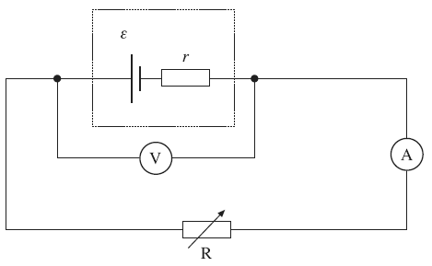
The graph below shows the results from the experiment.
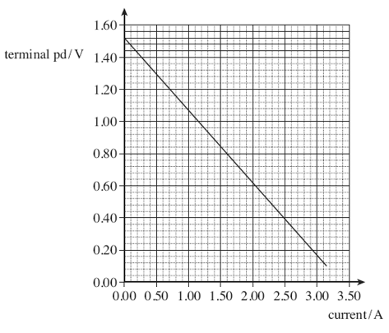
(a) Explain why the terminal pd decreases as the current increases.
___________________________________________________________________
___________________________________________________________________
___________________________________________________________________
___________________________________________________________________
(2)
(b) (i) Use the graph to find the emf, ε, of the cell.

answer = ______________________ V
(1)
(ii) Use the graph above to find the internal resistance, r, of the cell.

answer = ______________________ Ω
(3)
(c) Draw a line on the graph above that shows the results obtained from a cell with
(i) the same emf but double the internal resistance of the first cell labelling your graph A.
(2)
(ii) the same emf but negligible internal resistance labelling your graph B.
(1)
(d) In the original circuit shown in part (a), the variable resistor is set at a value such that the current through the cell is 0.89 A.
(i) Calculate the charge flowing through the cell in 15 s, stating an appropriate unit.

answer = ______________________
(2)

(ii) Calculate the energy dissipated in the internal resistance of the cell per second.

answer = ______________________ W
(2)
(Total 13 marks)

Q1.
(a) mention of pd across internal resistance or energy loss
in internal resistance or emf > V
pd across internal resistance/lost volts increases with
current or correct use of equation to demonstrate
2
(b) (i) y – intercept 1.52 V (± 0.01 V)
1
(ii) identifies gradient as r or use of equation
substitution to find gradient or substitution in equation
r = 0.45 ± 0.02 Ω
3
(c) (i) same intercept
double gradient (must go through 1.25, 0.40 ± 1.5 squares)
2
(ii) same intercept horizontal line
1
(d) (i) (use of Q = lt)
Q = 0.89 × 15 = 13 C
2
(ii) use of P = I²r
P = 0.89² × 0.45
P = 0.36 W
2
[13]

Practical
Investigation of the emf and internal resistance of electric cells and batteries
Apparatus

• | Cell or battery | • | Switch
• | Cell holder | • | Connecting leads
• | Digital voltmeter | • | Rheostat
• | Digital ammeter

Aim

To measure the internal resistance of a cell or battery.

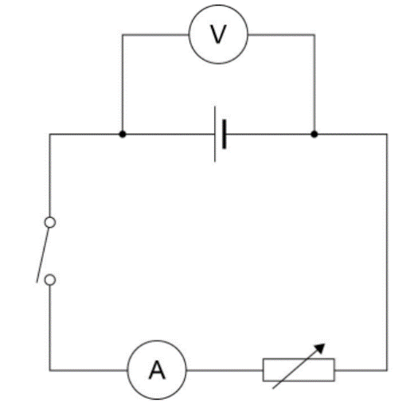
Procedure

            - Set up the circuit as shown in the diagram.
            - With the switch open record the reading, V, on the voltmeter.
            - Close the switch and take the readings of pd, V, on the voltmeter and current, I, on the ammeter.
            - Adjust the variable resistor to obtain pairs of readings of V and I, over the widest possible range.
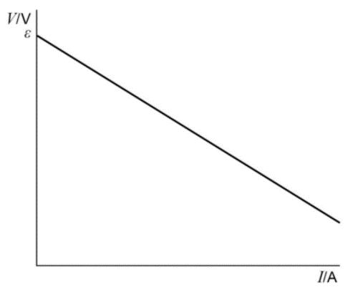
            - Open the switch after each pair of readings. Only close it for sufficient time to take each pair of readings.
            - Plot a graph of V on the y-axis against I
            - A graph of V against I will have a gradient = -r and an intercept ε on the y-axis.

Acknowledgements:
The notes in this booklet come from TES user dwyernathaniel. The original notes can be found here:
https://www.tes.com/teaching-resource/a-level-physics-notes-6337841
Resistivity questions come from TES user kate_m_flynn. The original questions can be found here:
https://www.tes.com/teaching-resource/resistivity-calculations-6175710
The micrometer screw gauge questions come from TES user mskitgan. The orginal questions can be found here:
https://www.tes.com/teaching-resource/micrometer-screw-gauge-7167371
Questions from multiple areas (including charge and current, resistors in series/parallel, kirchoff’s laws and potential dividers, EMF and internal resistance) come from Bernard Rand (@BernardRand). His original resources can be found here:
https://drive.google.com/drive/folders/1-2qNVLwGzJ_7AjQK9N0z4BQBIRmSHAwG
Questions for current and voltages in series/parallel come from TES user hayleytydemann. The original worksheet can be found here:
https://www.tes.com/teaching-resource/current-resistance-and-potential-difference-worksheet-with-answers-11891983
Questions in the energy and power section come from TES user JimChampion. The original worksheet can be found here:
https://www.tes.com/teaching-resource/a-level-physics-electrical-power-formula-work-questions-and-answers-12024179

