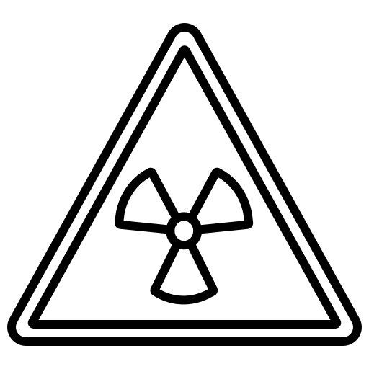
Separate Physics
Structure
Atomic
Name ______________________________
Class ______________________________
Teacher ______________________________

Atomic structure facts
- 1 × 10⁻¹⁰ m
- Protons and neutrons (inside the nucleus) and electrons orbiting around the nucleus.
- The number of protons and neutrons.

- The number of protons
- Isotopes have the same number of protons but different numbers of neutrons.
- An early model of the atom where the atom is a ball of positive charge with negative electrons embedded in it.
- The gold foil experiment; alpha particles were fired at gold foil. Plum pudding model predicted all would travel straight through; but some were deflected and reflected straight back.
- James Chadwick.
- Becquerel (Bq).

- Alpha – Helium nucleus (2 protons, 2 neutrons), Beta – fast moving electron, Gamma – EM wave
- Gamma radiation.

- Alpha radiation.
- Geiger-muller tube.
- Mass number goes down by 4, atomic number goes down by 2.
- Mass number – no change. Atomic number goes up by 1.
- No change.

- The time taken for the count rate to halve/number of radioactive nuclei to halve.
- When radioactive isotopes end up on other materials.
- Irradiation is exposing an object to nuclear radiation. The irradiated object does not become radioactive.
- Sterilising food/medical equipment.
- Gamma radiation. It can penetrate through packaging.
- Removal of an electron from an atom.
- Can mutate cells, lead to cancer/radiation sickness and even death.
- Keep as far away as possible, spend as little time as possible near radioactive source, shield yourself with thick lead/concrete

Fold page here
- What is the radius of an atom?
- What are the three subatomic particles?

- What does the mass number give?

- What does the atomic number give?
- What is an isotope?

- What is the plum pudding model?

- What was the experiment that disproved the plum pudding model?

- Who discovered the neutron?
- What is the activity of a radioactive isotope measured in?
- What is alpha, beta and gamma radiation made of?
- What type of radiation is the most penetrating?
- What type of radiation is the most ionising?
- What do we use to measure count rate?
- What happens to the mass number/atomic number during alpha decay?
- What happens to the mass number/atomic number during beta decay?
- What happens to the mass number/atomic number during gamma decay?
- What is the definition of half life?

- What is contamination?

- What is irradiation?

- What is irradiation used for?
- What type of radiation is used for irradiation?
- What does ionising mean?
- Why is radiation dangerous?

- What can we do to keep safe around radiation?

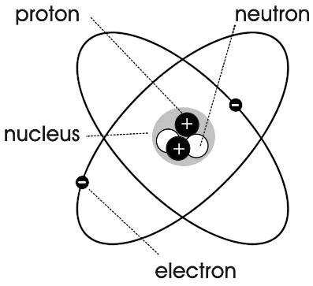
Everything, including us, is made of atoms. Atoms are tiny and have a radius of only 1 × 10⁻¹⁰ metres.
Structure of an atom.
Most of the atom is made of empty space.
The centre of an atom is called the nucleus and this nucleus one ten thousandth (1/10,000) of the radius of the atom. The nucleus is made of two sub-atomic particles:
- The neutron which has no charge (is neutral).
- The proton which has a positive charge.
Atoms also consist of a third sub-atomic particle which orbit around the nucleus. This particle is called the electron. The electron is negatively charged.
Usually atoms are neutral (no overall charge) Their number of protons is equal to the number of electrons.
If an atom loses or gains an electron the charges are no longer balanced and the charged atom is called an ion. This process is called ionisation.
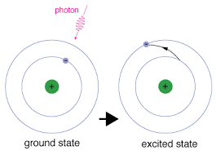
When an atom absorbs electro-magnetic radiation and electron can move further from the nucleus. This process is called excitation.
If an electron moves closer to the nucleus then electro-magnetic radiation is emitted. This process is called de-excitation.

Task: Complete in your exercise book.
Basic
- Complete the following sentences using words from the list below.
equal negative opposite positive zero
- A proton has …………….. charge.
- A neutron has …………….. charge.
- An electron has …………….. charge.
- A proton and an electron have …………….. and …………….. charge.
- What is the size of the radius of an atom?
- What is most of the atom made up of?
- What is the name of an atom that has lost an electron?
Medium
- Complete the following sentences using words from the list below.
electron(s) ion(s) neutron(s) nucleus (nuclei) proton(s)
- Every atom contains a …………….. which is positively charged.
- The nucleus of an atom is composed of …………….. and ……………...
- The …………….. in an atom move about in the space surrounding the nucleus.
- An uncharged atom has equal numbers of …………….. and ……………...
- A charged atom is called an ……………...
- An uncharged atom becomes charged as a result of transferring …………….. to or from it.
- An Oxygen atom contains 8 protons. How many electrons does it contain?
- A Nitrogen atom contains 7 protons. How many electrons does it contain?
Hard
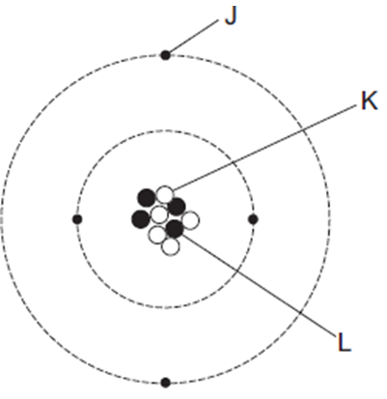
- Explain why atoms are usually neutral.
- The diagram represents an atom of beryllium.
- The particle with a positive charge is ……...
- The particle with the smallest mas is ……...
- The particle with no charge is ……...
- Some electromagnetic radiation (e.g. light) is being shone on some rubidium atoms. What happens to the electrons of the rubidium atoms?
- The electromagnetic radiation now stops being shone on the rubidium atoms. What happens now?

Task: Complete in your exercise book.
Basic
- Complete the following sentences using words from the list below.
equal negative opposite positive zero
- A proton has positive charge.
- A neutron has zero charge.
- An electron has negative charge.
- A proton and an electron have opposite and equal charge.
- What is the size of the radius of an atom? 1 × 10⁻¹⁰
- What is most of the atom made up of? empty space
- What is the name of an atom that has lost an electron? ion
Medium
- Complete the following sentences using words from the list below.
electron(s) ion(s) neutron(s) nucleus (nuclei) proton(s)
- Every atom contains a nucleus which is positively charged.
- The nucleus of an atom is composed of neutrons. and protons
- The electrons in an atom move about in the space surrounding the nucleus.
- An uncharged atom has equal numbers of protons and electrons
- A charged atom is called an ion
- An uncharged atom becomes charged as a result of transferring electrons to or from it.
- An Oxygen atom contains 8 protons. How many electrons does it contain? 8
- A Nitrogen atom contains 7 protons. How many electrons does it contain? 7
Hard
- Explain why atoms are usually neutral. Atoms contain equal numbers of positive protons, and negative electrons. Since the charge on a proton is equal to, and opposite to an electrons charge they have an overall charge of zero - neutral
- The diagram represents an atom of beryllium.
- The particle with a positive charge is L
- The particle with the smallest mass is J
- The particle with no charge is K
- Some electromagnetic radiation (e.g. light) is being shone on some rubidium atoms. What happens to the electrons of the rubidium atoms? Some of the electrons may get ‘exited’ and move away from the nucleus
- The electromagnetic radiation now stops being shone on the rubidium atoms. What happens now? The electrons that were exited move back to their original ‘state’, emitting electromagnetic radiation as they do so

Q1. Atoms contain three types of particle.
(a) Draw a ring around the correct answer to complete the sentence.

The particles in the nucleus of the atom are | electrons and neutrons.  electrons and protons.  neutrons and protons.
(1)
(b) Complete the table to show the relative charges of the atomic particles.

Particle | Relative charge
Electron | –1
Neutron | 0
Proton | +1
(2)
(c) Complete the table to show the relative masses of the atomic particles.

Particle | Relative mass
Electron | 0 or (1/1864)
Neutron | 1
Proton | 1
(2)

(d) (i) A neutral atom has no overall charge.
Explain this in terms of its particles.
total positive charge = total negative charge
accept protons and electrons have an equal opposite charge
(because) no of protons = no of electrons (2)
(ii) Complete the sentence.
An atom that loses an electron is called an ion
and has an overall positive charge.
(2)

Atoms and isotopes
The number of protons in an atom is called the atomic number.
The mass number is the total number of protons and neutrons in an atom.
The neutron number can therefore be calculated by subtracting the atomic number from the mass number (mass number – atomic number).

Element | Protons | Electrons | Neutrons
Neon (${}_{10}^{20}{Ne}$ ) | 10 | 10 | 10
Beryllium (${}_{4}^{9}{Be}$ ) | 4 | 4 | 5
Nitrogen (${}_{7}^{14}N$) | 7 | 7 | 7
Sodium (${}_{11}^{23}{Ne}$ ) | 11 | 11 | 12
Aluminium (${}_{13}^{27}{Ne}$ ) | 13 | 13 | 14
Task: Fill in the numbers of protons, neutrons and electrons in each of the following.

Isotopes have the same atomic number, but different mass numbers. In other words, they have the same number of protons but different numbers of neutrons.
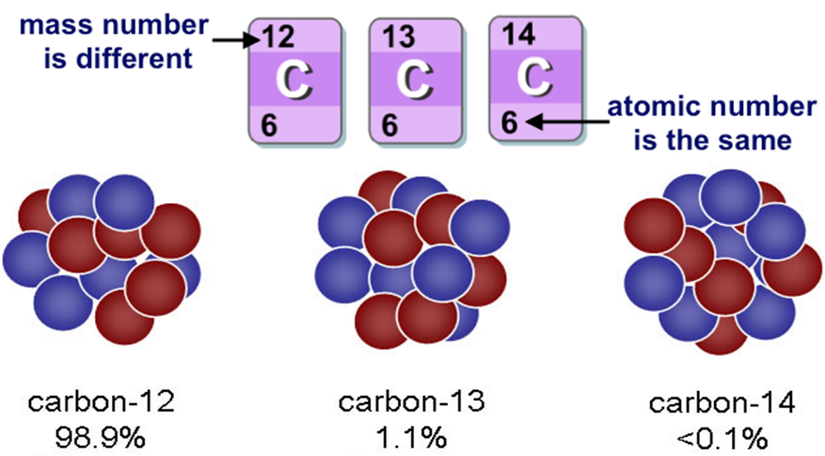
Stretch: How many electrons, neutrons and protons do the three isotopes of carbon have?
C-12 6 protons, 6 neutrons
C-13 6 protons, 7 neutrons
C-14 6 protons, 8 neutrons

Task: Complete in your exercise book.
Basic
1 What is the atomic number?
2 What is the mass number?
3 How can you calculate the neutron number from atomic and mass numbers?
4 What is an isotope?
Medium
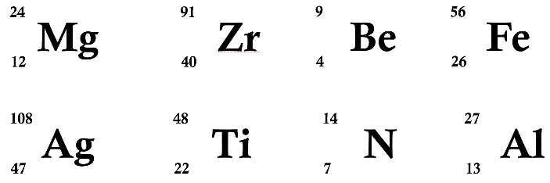
5. Calculate the number of protons, neutrons and electrons in each of the following:

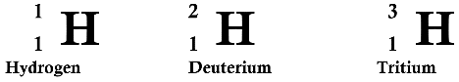
6. a) Describe whether or not the following atoms are isotopes:

b) Draw diagrams to show the structure of these atoms.
Hard
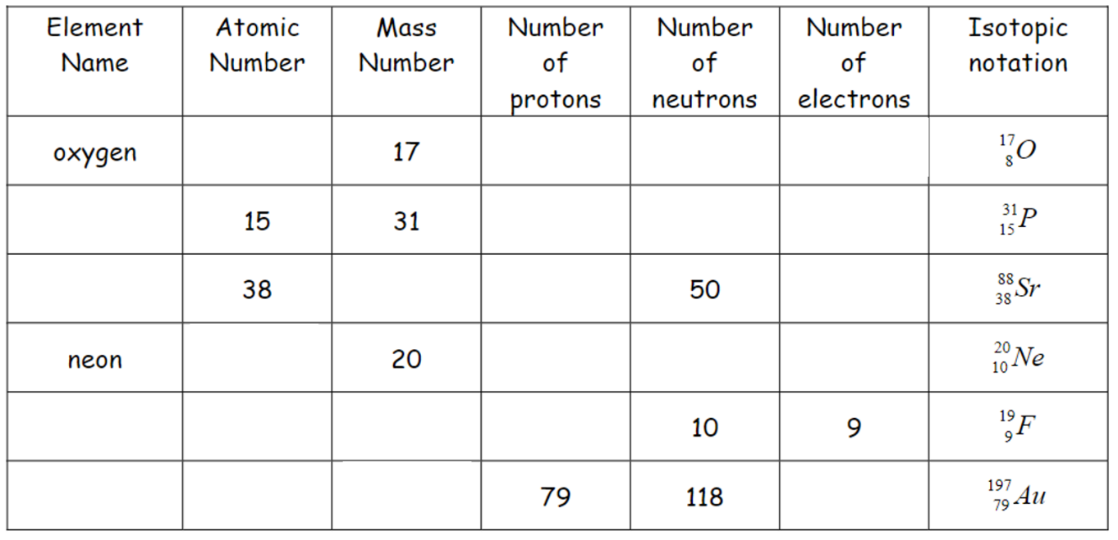
7. Complete the table. You can use the periodic table in your planners for the element names.

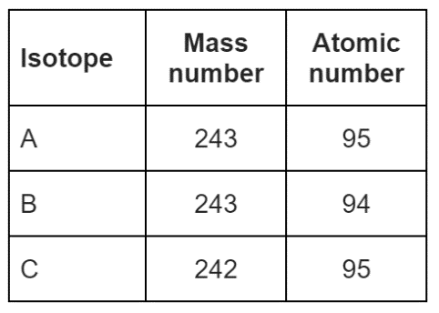
8. Americium-241 (${}_{95}^{241}{Am}$) is an isotope of americium. Which of the isotopes given in the table is not an isotope of americium? Give a reason for your answer.

Task: Complete in your exercise book.
Basic
1 What is the atomic number? Bottom number: Number of protons in the nucleus of atom. Charge of a nucleus
2 What is the mass number? Top number: Number of protons and neutrons in the nucleus of atom
3 How can you calculate the neutron number from atomic and mass numbers? Subtract atomic number from the mass number
4 What is an isotope? An isotope has less or more neutrons than the atom of the same element
Medium
5. Calculate the number of protons, neutrons and electrons in each of the following:
p=13
n=14
e=13
p=7
n=7
e=7
p=22
n=26
e=22
p=47
n=61
e=47
p=26
n=30
e=26
p=40
n=51
e=40
p=4
n=5
e=4
p=12
n=12
e=12

p=1
n=0
e=1
6. a) Describe whether or not the following atoms are isotopes: Deuterium & Tritium are both isotopes since they have 1 or more neutrons, respectively than the Hydrogen atom which has zero neutrons
p=1
n=2
e=1
p=1
n=1
e=1
b) Draw diagrams to show the structure of these atoms.
Hard
7. Complete the table. You can use the periodic table in your planners for the element names.
Strontium
Phosphorous
8
9
8
15
38
16
15
10
10
10
38
88
8
8

8
8
9
Flourine
79
8
8
Gold
8. Americium-241 (${}_{95}^{241}{Am}$) is an isotope of americium. Which of the isotopes given in the table is not an isotope of americium? Give a reason for your answer. B; Americium has 95 protons whereas B has 94 protons which makes it a different element.

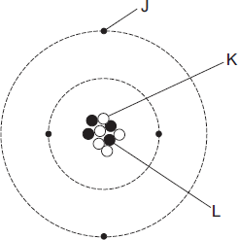
Q1. The diagram represents an atom of beryllium.
(a) Complete the following statements by writing one of the letters, J, K or L, in each box.
Each letter should be used only once. (2)
The particle with a positive charge is | L

The particle with the smallest mass is | J

The particle with no charge is | K
(b) Give the reason why all atoms have a total charge of zero. (1)
There are equal numbers of positive charged particles/protons and negatively charged particles/electrons
(c) Complete the following sentence. (1)
There are several isotopes of beryllium. Atoms of different beryllium
isotopes will have different numbers of neutrons
(d) What happens to the structure of an atom to change it into an ion? (1)
Gains or loses an electron

Q2. Atoms are different sizes.
One of the heaviest naturally occurring stable elements is lead.
Two of its isotopes are lead-206 (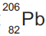) and lead-208 (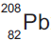).
(a) (i) What is meant by ‘isotopes’? (2)
(atoms with the) same number of protons
allow same atomic number
or same proton number
(atoms with) different number of neutrons
allow different mass number
(ii) How many protons are in the nucleus of a atom? (1)
82
(iii) How many neutrons are in the nucleus of a atom? (1)
124

Watch the following video: youtube.com/watch?v=xazQRcSCRaY
History of the atomic model
Using information from the video you have just watched, answer the following questions below with words from the box below.
- Who was the first person to come up with the idea of the atom? Democritus
- What does the word “atom” mean? indivisable
- Who disagreed with the idea of the atom, proposing instead that matter was made of 4 elements (i.e. Earth, Wind, Water and Fire)?
Aristotle

- Who first gained scientific evidence to support the idea that matter was indeed made of atoms?
John Dalton

- Who discovered the electron? J J Thompson

- Who is known as the “father of the nuclear age”? Rutherford

- Who proposed the “planetary model“ for the atom (i.e. electrons orbiting around the nucleus at fixed distances)? Bohr
Thomson Democritus Dalton Aristotle indivisible Bohr Rutherford

Task: Read the below text and match the scientist to their contribution
The plum pudding model was proposed by JJ Thomson. In this model the atom was suggested to be a ball of positive charge with negative particles distributed randomly within the ball of positive charge. Rutherford disproved this model with the gold foil experiment, in which he suggested that the positive charge of the atom was concentrated in the nucleus. Bohr later discovered that electrons within an atom were located within discrete energy levels known as shells. Following this, James Chadwick discovered the existence of neutrons which were also located within the nucleus.
JJ Thomson
Discovery of electron shells
Discovery of neutrons
Discovery of nucleus
Plum pudding model

Rutherford
Bohr
Chadwick
An early model of the atom was called the plum pudding model. In this model the atom was assumed to be a sphere of positive charge, with negative charges spread through it.
However, new evidence from Rutherford’s gold foil experiment disproved this model. In this experiment, alpha particles (a Helium nucleus) were fired at a gold foil and a detector was used to find out what happen to the particles at different angles.
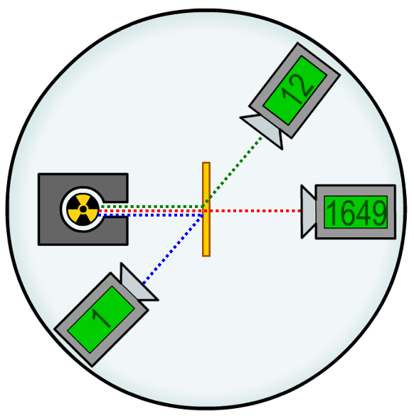
Three results were noted from this experiment:
- Most alpha particles went straight through the gold foil.
- Some alpha particles were deflected through small angles.
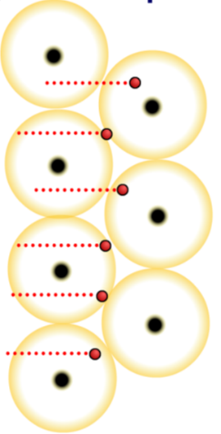
- Very few (about 1 in 2000) alpha particles were reflected backwards.

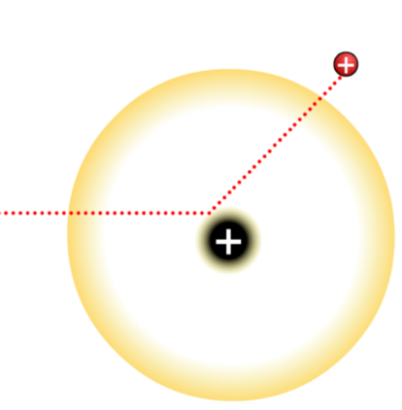
The reason that most of the alpha particles went straight through is because most of the atom is made of empty space. The particles therefore passed through the spaces between the gold nuclei.

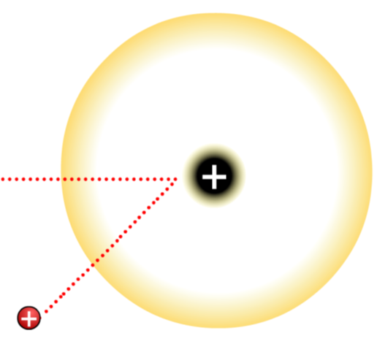
Some alpha particles were deflected through small angles. This is because both the alpha particle and the gold nucleus have a positive charge. Therefore when an alpha particle came near the positive nucleus of a gold atom, it was repelled.
When a positively charged alpha particle headed directly towards a positive gold nucleus, it was also repelled. In this case, the alpha particle was reflected backwards from the foil and travelled back towards the source.

This experiment disproved the plum pudding model. This model suggested that all the alpha radiation would pass through the gold foil. Rutherford therefore proposed his nuclear model of the atom. Three conclusions were made:
- Most of the atom is empty space.
- Most of the mass of the atom is in a tiny central nucleus, which is positively charged.
- Electrons orbited this nucleus at a distance, like planets around the Sun.

Task: Complete in your exercise book
Plum pudding model:
- Draw a diagram of the plum pudding model.
- Who proposed the plum pudding model?
- Where is the positive charge in the plum pudding model?
- Where are the electrons in the plum pudding model?
- Are there any neutrons in the plum pudding model?
The scientists in between:
- Who discovered the nucleus?
- Who discovered that electrons travel in shells?
- Who discovered the existence of neutrons?
The modern (nuclear) model:
- Draw a diagram of the nuclear model.
- Where is the positive charge in the nuclear model?
- Where are the electrons in the nuclear model?
- Are there any neutrons in the nuclear model? If so, where are they?
Gold foil experiment:
- What particles were fired at gold foil?
- What happened to these particles?
- Why did this disprove the plum pudding model?
- What three conclusions were made from the gold foil experiment?

Task: Complete in your exercise book
Plum pudding model:
- Draw a diagram of the plum pudding model.
- Who proposed the plum pudding model? JJ Thompson
- Where is the positive charge in the plum pudding model? The positive charge was distributed around the sphere that makes up the atom
- Where are the electrons in the plum pudding model? The negative charge was alos distributed around the sphere
- Are there any neutrons in the plum pudding model? No
The scientists in between:
- Who discovered the nucleus? Rutherford devised the gold foil experiment to prove his mentor, Thompson was correct. Geiger/Marsden conducted the experiment and Rutherford concluded that the positive charge/mass was concentrated in a nucleus in the centre of an atom.
- Who discovered that electrons travel in shells? Niels Bohr
- Who discovered the existence of neutrons? James Chadwick
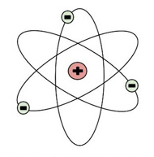
The modern (nuclear) model:
- Draw a diagram of the nuclear model.
- Where is the positive charge in the nuclear model? In a central nucleus
- Where are the electrons in the nuclear model? Orbiting the nucleus
- Are there any neutrons in the nuclear model? If so, where are they? The nuclear model proposed by Rutherford had missing mass. Chadwick discovered neutrons in 1932, and these made up the missing mass in the nucleus
Gold foil experiment:
- What particles were fired at gold foil? alpha
- What happened to these particles? most undeflected, small percentage deflected by a small amount, very small % deflected by a large amount
- Why did this disprove the plum pudding model? PPM suggests no/very little deflection should occur due to even distribution of positive charge in the ‘model’. Large deflections indicate that large mass of positive charge was in a small region causing large deflection
- What three conclusions were made from the gold foil experiment? Atom is mostly empty space, comparatively large mass of positive charge in a central nucleus, electrons orbit at a distance

Q1. The ‘plum pudding’ model of the atom was used by scientists in the early part of the 20th century to explain atomic structure.
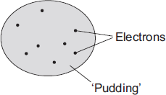
(a) Those scientists knew that atoms contained electrons and that the electrons had a negative charge. They also knew that an atom was electrically neutral overall.
What did this allow the scientists to deduce about the ‘pudding’ part of the atom?
has an equal amount of positive charge
accept pudding/it is positive
(1)
(b) An experiment, designed to investigate the ‘plum pudding’ model, involved firing alpha particles at a thin gold foil.
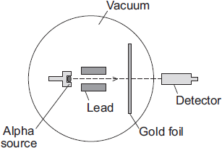
If the ‘plum pudding’ model was correct, then most of the alpha particles would go straight through the gold foil. A few would be deflected, but by less than 4°.
The results of the experiment were unexpected. Although most of the alpha particles did go straight through the gold foil, about 1 in every 8 000 was deflected by more than 90°.
Why did this experiment lead to a new model of the atom, called the nuclear model, replacing the ‘plum pudding’ model?
(experimental) results could not be explained using ‘plum pudding’ model
or
(experimental) results did not support plum pudding model
accept (experimental) results disproved plum pudding model
(1)

(c) The diagram shows the paths, A, B and C, of three alpha particles. The total number of alpha particles deflected through each angle is also given.

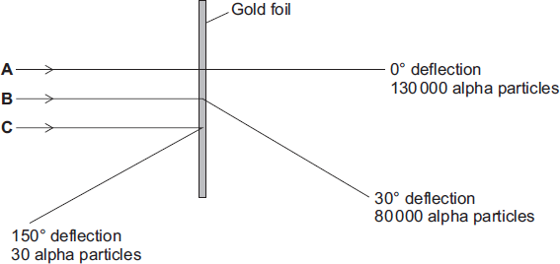
(i) Using the nuclear model of the atom, explain the three paths, A, B and C.
A most of atom is empty spaceormost of atom concentrated at the centre
B nucleus is positive (so repels alpha particles)
accept nucleus has the same charge as alpha
C nucleus is very small
accept nucleus is positive if not scored for B
or
nucleus is a concentrated mass
accept nucleus has a very concentrated charge (3)
(ii) Using the nuclear model, the scientist E. Rutherford devised an equation to predict the proportion of alpha particles that would be deflected through various angles.
The results of the experiment were the same as the predictions made by Rutherford.
What was the importance of the experimental results and the predictions being the same?
(if predictions correct, this) supports the new model
answers should be in terms of the nuclear model
accept supports his/new/nuclear theory
accept proves for supports
accept shows predictions/ Rutherford was correct
(1)
(Total 6 marks)

Atoms are radioactive if the nucleus has too many protons or neutrons. This makes the nucleus unstable. All types of radiation come from the nucleus of the atom. You cannot predict when a nucleus will emit radiation. The process is random. There are three types of radiation:
Types of radiation
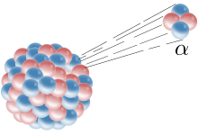
1. Alpha α (helium nucleus)
2. Beta β (electron)
3. Gamma γ (EM wave).
 | Alpha ${}_{2}^{4}α$ | Beta ${}_{-1}^{0}β$ | Gamma ${}_{0}^{0}γ$
What it’s made of | A helium nucleus (2 protons and 2 neutrons) | A fast moving electron | A high energy electro-magnetic wave.
Charge | +2 | -1 | 0
Atomic mass | 4 | 0 | 0
Penetrating power | Stopped by paper or a few cm of air. | Stopped by a few mm of aluminium or one metre of air | Stopped by thick lead or concrete.
Ionising effect | Strongly ionising. | Slightly ionising. | Very weakly ionising.
Effect of electro-magnetic field. | Weakly deflected | Strongly deflected | Not deflected

Radiation can knock an electron off an atom and turn it into an ion. This is known as ionisation.
Because alpha particles are the most massive, they are most likely to ionise an atom (the most ionising). However, in doing so they give up their energy and are not able to travel very far. They are the least penetrating.
Beta particles are slightly ionising and slightly penetrating because they have a size in between that of alpha and gamma particles.
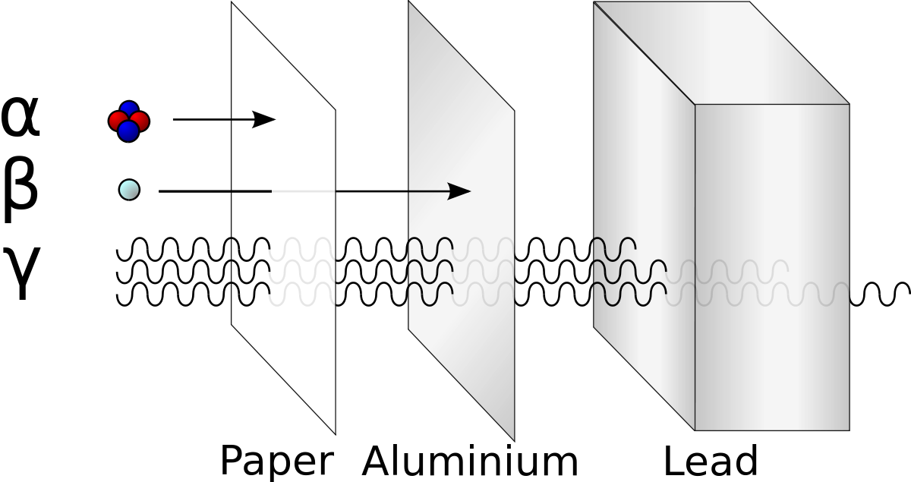
Gamma particles are only weakly ionising but they are the most penetrating.

One application of radioactivity is in a paper/cardboard mill. A radioactive beta source is on one side of the material and a detector on the other.
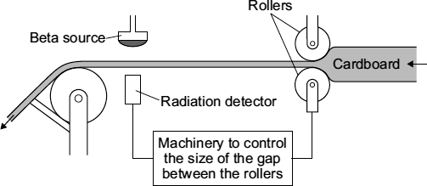
If too much radioactivity is getting through, then the material is too thin and the rollers open up a bit to make the material thicker. If not enough radioactivity is detected then the rollers compress to make the material thinner.
This method is used in the manufacture of lots of sheet materials: plastics, paper, sheet steel.

Basic
- What are the three types of radiation?
- What are alpha particles made of?
- What are beta particles made of?
- What is gamma radiation made of?
- What is ionisation?
- Why is radiation dangerous?
- What do we use to detect radiation?
- Complete the following sentences. Use the words in the box.
Gains ions unstable decay random loses

Ionising radiation is emitted from ___________ nuclei. The process is __________. This means you cannot predict when the nucleus will ___________ and emit radiation. This radiation can cause atoms to become __________. Ionisation occurs when an atom _________ or __________ electrons.

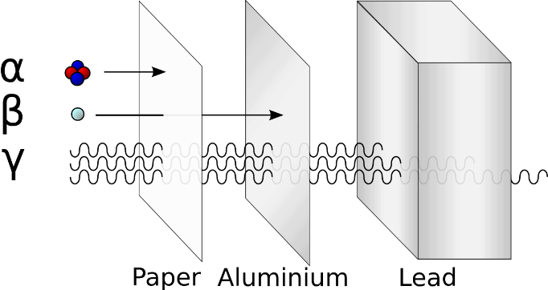
Medium
- Complete the table of radioactive penetration using the diagram. For the last two columns use the words “strongly”, “slightly” or “weakly”.

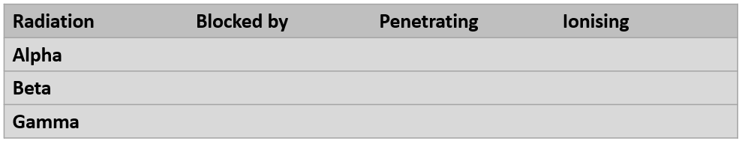

- Which of the three types of radiation:
- Has the greatest mass?
- Has the greatest charge?
- Does not have any mass?
- Has the same mass as an electron?
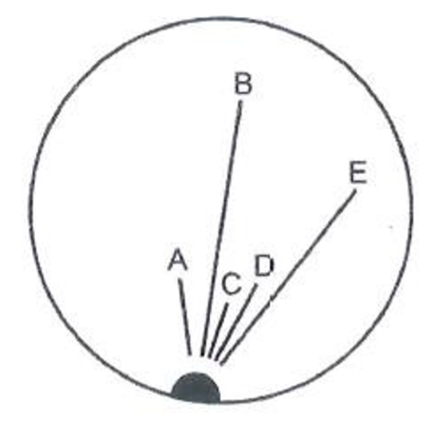
- Is equivalent to a helium nucleus.
- Is a type of electromagnetic radiation.
- What are the charges of alpha, beta and gamma radiation?
Hard
- Look at the diagram, which shows trails in a cloud chamber. The radioactive source is emitting both alpha and beta particles.
- Which trails are caused by alpha particles?
- Which trails are caused by beta particles?
- Explain how you can tell.
- Can you predict when alpha or beta particles will be emitted? Explain your answer?
- What happens when the alpha particles collide with the particles in the cloud chamber?
- When radioactive sources are stored in boxes in schools, the boxes are always lined with lead on the inside. Why is this necessary?
- A student said: “If I were to wear a lead suit, I would be completely protected from radiation!” Explain why this statement is not true.

Basic
- What are the three types of radiation? Alpha, Beta, Gamma
- What are alpha particles made of? Two protons, and two neutrons
- What are beta particles made of? A high velocity electron
- What is gamma radiation made of? An electromagnetic wave
- What is ionisation? When an atom loses, or gains an electron
- Why is radiation dangerous? Can cause bodies cell/nucleus/ to be ionised which can cause mutations within the cell leading to tumors/cancers
- What do we use to detect radiation? Geiger-Muller tube/counter
- Complete the following sentences. Use the words in the box.
Gains ions unstable decay random loses

Ionising radiation is emitted from unstable nuclei. The process is random. This means you cannot predict when the nucleus will decay and emit radiation. This radiation can cause atoms to become ions. Ionisation occurs when an atom loses or gains electrons.

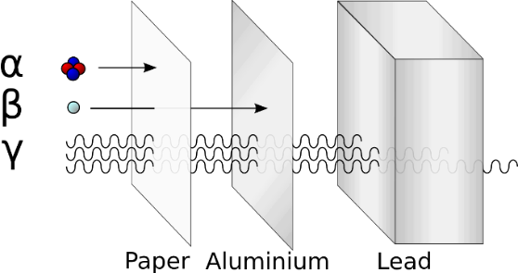
Medium
- Complete the table of radioactive penetration using the diagram. For the last two columns use the words “strongly”, “slightly” or “weakly”.

strongly
weakly
Paper/5cm air

slightly
slightly
Aluminium/1m air
weakly
strongly
Thick lead/concrete

- Which of the three types of radiation:
- Has the greatest mass? alpha
- Has the greatest charge? alpha
- Does not have any mass? gamma
- Has the same mass as an electron? beta
- Is equivalent to a helium nucleus. alpha
- Is a type of electromagnetic radiation. gamma
- What are the charges of alpha, beta and gamma radiation? Alpha is positive, beta is negative and gamma has no charge
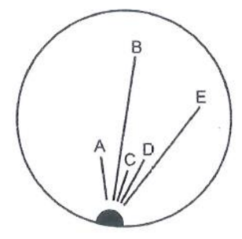
Hard
- Look at the diagram, which shows trails in a cloud chamber. The radioactive source is emitting both alpha and beta particles.
- Which trails are caused by alpha particles? A, C, D
- Which trails are caused by beta particles? B, E
- Explain how you can tell. Alpha travels the least distance, beta the greatest
- Can you predict when alpha or beta particles will be emitted? Explain your answer? No, radioactive decay is a random process
- What happens when the alpha particles collide with the particles in the cloud chamber? The alpha particle ionise the cloud chamber particles, losing kinetic energy in the process
- When radioactive sources are stored in boxes in schools, the boxes are always lined with lead on the inside. Why is this necessary? To prevent any of the three sources of radiation ‘leaking’. Most radioactive sources emit all three types of radiation. For example; Americium 241 is used as an alpha source and decays mainly by alpha emission however it also emits gamma radiation, Cobolt 60 is used as a Beta source but also emits gamma radiation.
- A student said: “If I were to wear a lead suit, I would be completely protected from radiation!” Explain why this statement is not true. Lead only partly blocks gamma, not all the radiation is absorbed.

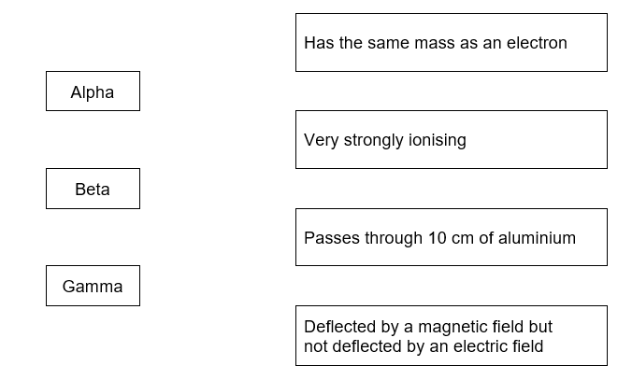
Q1 (a) Draw a straight line to link each type of radiation in the first list to its correct property in the second list.
Draw only three lines. (3)

(b) The diagram shows a system used to control the thickness of cardboard as it is made.
Time | Detector reading
08:00 | 150
08:15 | 148
08:30 | 151
08:45 | 101
09:00 | 149
The cardboard passes through a narrow gap between a beta radiation source and a radiation detector. The table gives the detector readings over 1 hour.

(i) Between 08:00 and 08:30, the cardboard is produced at the usual, correct thickness.
Explain how you can tell from the detector readings that the cardboard produced at 08:45 is thicker than usual. (2)
(the detector) reading had gone down
‘it’ equals detector reading
accept the reading in the table is the smallest, 101 is (much) lower than other readings / a specific value eg 150
do not accept this answer if it indicates the readings are the thickness
more beta (particles / radiation) is being absorbed / stopped
accept radiation for beta particles / radiation, fewer particles being detected

(iii) This control system would not work if the beta radiation source was replaced by an alpha radiation source.
Why not? (1)
(the detector) reading had gone down
‘it’ equals detector reading
accept the reading in the table is the smallest, 101 is (much) lower than other readings / a specific value eg 150
do not accept this answer if it indicates the readings are the thickness
more beta (particles / radiation) is being absorbed / stopped
accept radiation for beta particles / radiation
accept fewer particles being detected

Dangers of radiation
Ionisation of molecules in living cells can cause damage and mutate the cells. This can cause cancer. Radiation is detected using a Geiger-muller tube.
Because alpha radiation is the least penetrating, it is the least dangerous outside the body. It cannot penetrate through the skin.
Alpha radiation, however, it extremely dangerous if it gets inside the body. It can then ionise internal organs, causing mutations and eventually cancer.
Alexander Litvinenko was poisoned in this way with polonium in 2006.
Beta radiation is slightly penetrating and therefore carries a risk up to a distance of 1 metre. As gamma radiation is the most penetrating, it carries a danger up to long distances.
Workers who use ionising radiation reduce their exposure by:
- Keeping as far away as possible.
- Spending as little time as possible near the radioactive source.
- Shielding themselves with thick concrete/lead.

People who work with radiation also often wear film badges. When the film absorbs radiation it goes darker. These are checked regularly to monitor the levels of radiation absorbed.

Q1. (a) What is alpha, beta and gamma radiation made of? (3)
Alpha: two neutrons, two protons. A helium nuclei
Beta: high velocity electron.
Gamma: high energy electromagnetic wave

(b) Sam and Kris are arguing about alpha and gamma radiation.
Sam says that alpha radiation is more dangerous.
Kris disagrees. He thinks that gamma radiation is more dangerous. What do you think?
Explain your answer as fully as you can. (4)
ALPHA radiation is absorbed by skin/paper/thin mica, and has a short range in air. It is highly ionising and will cause a lot of tissue damage/cell mutation inside the body but outside it will do little damage. GAMMA radiation is highly penetrating and will pass through the body but causes little damage to cells because it is weakly ionising. However, intense beams of gamma radiation can be harmful.

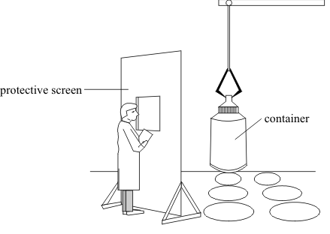
(c) Tritium is one of the elements found in the waste material of the nuclear power industry. The diagram below shows a worker behind a protective screen. The container holds a mixture of different waste materials which emit alpha (α), beta (β) and gamma (γ) radiation.

Suggest a suitable material for the protective screen. The material should prevent radiation from the container reaching the worker. Explain your answer. (2)

lead/concrete
lead/concrete needed to stop gamma rays

When a nucleus decays, the mass number, atomic number and charge is conserved. When alpha/beta decay happens, the nucleus transmutes into another element.
Nuclear Equations
Alpha decay example:
$${}_{95}^{241}{Am}→{}_{93}^{237}{Np}+ {}_{2}^{4}{He}$$
Beta decay example:
$${}_{6}^{14}{C→}{}_{7}^{14}N+{}_{-1}^{0}e$$

The emission of a gamma ray does not cause the mass or the charge of the nucleus to change.
Task

Alpha decay: complete the following equations
4
92
92

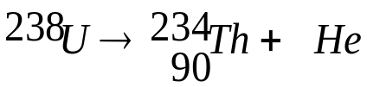
2
92
92

92
92
92

4
92
92

222
92
92

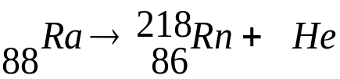
2
92
92

4
92
92

204
92
92

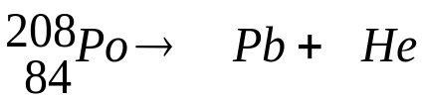
2
92
92

82
92
92

4
92
92

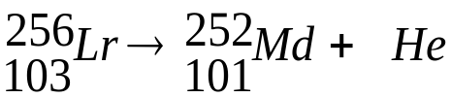
2
92
92

Beta decay: complete the following equations

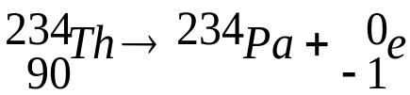
91
92
92

131
92
92

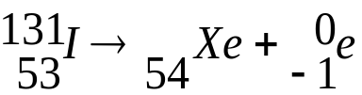
6
92
92

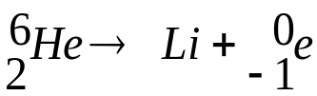
3
92
92

0
92
92

24
92
92

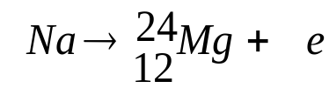
-1
92
92

11
92
92

Alpha or beta decay? You decide which is which:
alpha
beta
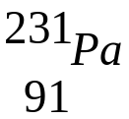 decays to 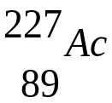

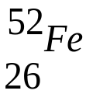 decays to 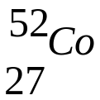

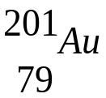 decays to 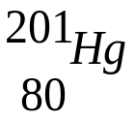
alpha
beta
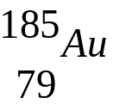 decays to 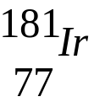

The following task is harder. Use the periodic table to identify which elements the atoms decay to (remembering that we identify an element from its atomic number.
Show how Uranium-238 undergoes a sequence of decays naturally to form lead a stable isotope of lead. You will need to use your periodic table to identify any unknown compounds. Fill in each decay equation as it happens.
Hint
Your isotope at the end of the decay is at the start of the next one
U decays by α decay to form Th
1.
Th decays twice by β decay to form a different isotope of the original element.
2.
3.
The new U isoptope undergoes 5 α decay processes
4.
5.
6.
7.
8.
This isotope of lead is not stable. A sequence of two β decay occur
9.
10.
Po undergoes the α decay process
11.
This isotope of lead is not stable either! Another sequence of two β decay occur
12.
13.
One more alpha decay to create a stable isotope of lead
14.
If your mass is 206 you have a stable isotope of lead. If not go back and check your maths!

The following task is harder. Use the periodic table to identify which elements the atoms decay to (remembering that we identify an element from its atomic number.
Show how Uranium-238 undergoes a sequence of decays naturally to form lead a stable isotope of lead. You will need to use your periodic table to identify any unknown compounds. Fill in each decay equation as it happens.
Hint
Your isotope at the end of the decay is at the start of the next one
U decays by α decay to form Th
- ${}_{92}^{238}U→{}_{90}^{234}{Th}+ {}_{2}^{4}{He}$

Th decays twice by β decay to form a different isotope of the original element.
2. ${}_{90}^{234}{Th→}{}_{91}^{234}{Pa}+{}_{-1}^{0}e$
3.${}_{91}^{234}{Pa→}{}_{92}^{234}U+{}_{-1}^{0}e$
The new U isoptope undergoes 5 α decay processes
4. ${}_{92}^{234}U→{}_{90}^{230}{Th}+ {}_{2}^{4}{He}$
5. ${}_{90}^{230}{Th}→{}_{88}^{226}{Ra}+ {}_{2}^{4}{He}$
6. ${}_{88}^{226}{Ra}→{}_{86}^{222}{Rn}+ {}_{2}^{4}{He}$
7.${}_{86}^{222}{Rn}→{}_{84}^{218}{Po}+ {}_{2}^{4}{He}$
8.${}_{84}^{218}{Po}→{}_{82}^{214}{Pb}+ {}_{2}^{4}{He}$
This isotope of lead is not stable. A sequence of two β decay occur
9. ${}_{82}^{214}{Pb→}{}_{83}^{214}{Bi}+{}_{-1}^{0}e$
10. ${}_{83}^{214}{Bi→}{}_{84}^{214}{Po}+{}_{-1}^{0}e$
Po undergoes the α decay process
11. ${}_{84}^{214}{Po}→{}_{82}^{210}{Pb}+ {}_{2}^{4}{He}$
This isotope of lead is not stable either! Another sequence of two β decay occur
12. ${}_{82}^{210}{Pb→}{}_{83}^{210}{Bi}+{}_{-1}^{0}e$
13. ${}_{83}^{210}{Bi→}{}_{84}^{210}{Po}+{}_{-1}^{0}e$
One more alpha decay to create a stable isotope of lead
14. ${}_{84}^{210}{Po}→{}_{83}^{206}{Pb}+ {}_{2}^{4}{He}$
If your mass is 206 you have a stable isotope of lead. If not go back and check your maths!
Q1. When the nucleus of a radium-225 atom decays, it changes into a nucleus of actinium-225.

What type of radiation is emitted by radium-225?
Draw a ring around your answer.

alpha | beta | gamma
Explain the reason for your answer.

any two from:

• mass number does not change
or
total number of protons and neutrons does not change

• atomic / proton number increases by 1
or
number of protons increases by 1

• number of neutrons goes down by 1

allow for 2 marks a neutron splits / changes into a proton and electron / beta

candidates that answer correctly in terms of why alpha and gamma are not possible, gain both marks
(Total 3 marks)
Q2.
(a) Uranium atoms do not always have the same number of neutrons.
What are atoms of the same element that have different numbers of neutrons called?
Isotopes
(1)
(b) By emitting an alpha particle, an atom of uranium-235 decays into an atom of thorium.
An alpha particle, which is the same as a helium nucleus, is represented by the symbol .
The decay can be represented by the equation below.
Complete the equation by writing the correct number in each of the two boxes.
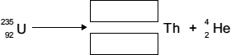
231
90
(2)

(Total 3 marks)
Over time, the amount of radiation coming from a radioactive sample goes down (decays). How quickly this happens depends on the half life of the sample. There are two definitions for half life:
Half life
- The time for the count rate to go down by half.
- The time for half of the radioactive nuclei to decay.
The activity (count rate) of a radioactive material has units of Becquerel (Bq). This is equal to one atom decaying per second.
To solve wordy half life questions, we can use something called the tree method. For example take the example below. Please fill out the blank space below with the worked solution.
Worked example: The half-life of carbon-14 is 5,600 years. A sample of carbon-14 has an initial activity of 1,000 Bq (counts/sec). What is the activity of the sample after 11,200 years?
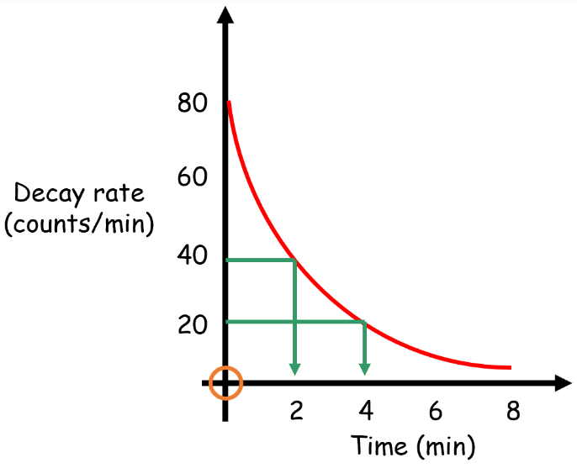
For graph-based questions, we need to look at what the initial count rate is. In the graph the initial count rate is 80 counts/minute.
The time taken to drop from 80 to 40 counts/minute is 2 minutes. This is therefore the half life.
Note how it also takes another 2 minutes to drop from 40 to 20 counts/minute.

Basic
- If a radioactive sample has an initial count rate of 400 Bq. What is its count rate after: i) 1 half life? ii) 2 half lives? iii) 3 half lives? iv) 4 half lives?
- The half-life of radium-226 is 1600 years. If a sample of radium-226 has an original activity of 200 Bq, what will it’s activity be after:
i) 3200 years? ii) 4800 years iii) 6400 years
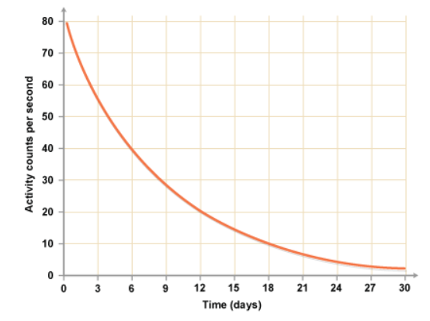
- Sodium-24 has a half-life of 15 hours. If a sample of sodium-24 has an original activity of 500 Bq, what will its activity be after:
i) 30 hours ii) 45 hours iii) 60 hours?
- What is the half life of the sample in the graph opposite?
Medium
- After 42 days the activity of a sample of phosphorus-32 has decreased from 400 Bq to 50 Bq. What is the half-life of phosphorus-32?
- The half-life of radon-222 is 3.8 days. What was the original activity if it has an activity of 10 Bq after 7.6 days?
- The half-life of thorium-227 is 19 days. How many days are required for 75% of a sample to decay?
Hard
- The half-life of protactinium-234 is 6.75 hours. What percentage of a sample will remain after 27 hours?
- The half-life of tritium (hydrogen-3) is 12.3 years. If 48.0 mg of tritium is released from a nuclear power plant during the course of a mishap, what mass of the sample will remain after 49.2 years?
- Carbon-14 is an isotope, with a half-life of 5730yrs, naturally occurring in the air. This means that all living things maintain a fixed ratio of carbon-14 to the stable carbon-12. In a 1g sample there would be 180 000 C-14 atoms. This number starts to drop the moment the living thing stops respiring.
- A 1g scraping of the charcoal from a cave painting in France contained 45000 C-14 atoms.
i) How many half-lives had passed since the tree (that made the charcoal) was felled?
ii) When was the painting made?
- For many years it was believed that the Romans were the first to introduce grapes to Britain. A 0.02g grape pip found at the British hillfort of Hambledon Hill contained 1800 C-14 atoms.
i) How many C-14 atoms would there have been in 1g of grape pip?
ii) How many half-lives had passed since the grape was picked?
iii) How long ago was the grape picked? iv. What evidence does this give for the introduction of grapes to Britain?

Basic
- If a radioactive sample has an initial count rate of 400 Bq. What is its count rate after: i) 200 ii) 100 iii) 50 iv) 25
- The half-life of radium-226 is 1600 years. If a sample of radium-226 has an original activity of 200 Bq, what will it’s activity be after:
i) 50 ii) 25 iii) approx. 12/13
- Sodium-24 has a half-life of 15 hours. If a sample of sodium-24 has an original activity of 500 Bq, what will its activity be after:
i) 125 ii) approx. 62/63 iii) approx. 31/32
- What is the half life of the sample in the graph opposite? 6 days
Medium
- After 42 days the activity of a sample of phosphorus-32 has decreased from 400 Bq to 50 Bq. What is the half-life of phosphorus-32? 14 days
- The half-life of radon-222 is 3.8 days. What was the original activity if it has an activity of 10 Bq after 7.6 days? 40 Bq
- The half-life of thorium-227 is 19 days. How many days are required for 75% of a sample to decay? 38 days
Hard
- The half-life of protactinium-234 is 6.75 hours. What percentage of a sample will remain after 27 hours? Approx.. 6/7%
- The half-life of tritium (hydrogen-3) is 12.3 years. If 48.0 mg of tritium is released from a nuclear power plant during the course of a mishap, what mass of the sample will remain after 49.2 years? 3mg
- Carbon-14 is an isotope, with a half-life of 5730yrs, naturally occurring in the air. This means that all living things maintain a fixed ratio of carbon-14 to the stable carbon-12. In a 1g sample there would be 180 000 C-14 atoms. This number starts to drop the moment the living thing stops respiring.
- A 1g scraping of the charcoal from a cave painting in France contained 45000 C-14 atoms.
i) How many half-lives had passed since the tree (that made the charcoal) was felled? 2
ii) When was the painting made? 11460 yrs ago
- For many years it was believed that the Romans were the first to introduce grapes to Britain. A 0.02g grape pip found at the British hillfort of Hambledon Hill contained 1800 C-14 atoms.
i) How many C-14 atoms would there have been in 1g of grape pip? 90,000
ii) How many half-lives had passed since the grape was picked? approx. 6
iii) How long ago was the grape picked? approx.. 34380 yrs ago iv. What evidence does this give for the introduction of grapes to Britain?

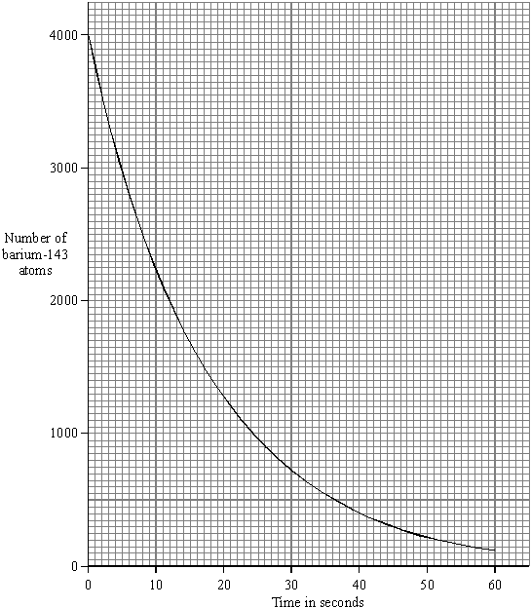
(a) The graph shows how a sample of barium-143, a radioactive isotope with a short half-life, decays with time.
- What is meant by the term isotope? (1)
element with equal number of protons, different number neutrons
or
same atomic/proton number different mass/nuclear number
- What is meant by the term half-life? (1)
time taken for activity or count rate or number of nuclei to decrease to half
accept parents atoms or radioactive isotope
do not accept time taken for radioactivity/substance/ material to halve
(iii) Use the graph to find the half-life of barium-143. (1)
Half-life = 12 seconds
(b) Humans take in the radioactive isotope carbon-14 from their food. After their death, the proportion of carbon-14 in their bones can be used to tell how long it is since they died. Carbon-14 has a half-life of 5700 years.
(i) A bone in a living human contains 80 units of carbon-14. An identical bone taken from a skeleton found in an ancient burial ground contains 5 units of carbon-14. Calculate the age of the skeleton. Show clearly how you work out your answer. (2)
22800 (years)
allow 1 mark for iterative steps 80-40-20-10-5 or statement of 4 half-lives
4 x 5700
Age of skeleton = _______________ years
(ii) Why is carbon-14 unsuitable for dating a skeleton believed to be about 150 years old? (1)
decay (of carbon 14) over 150 years is insignificant
accept very little decay
accept change is too small

One application of radioactive half lives is in carbon dating.
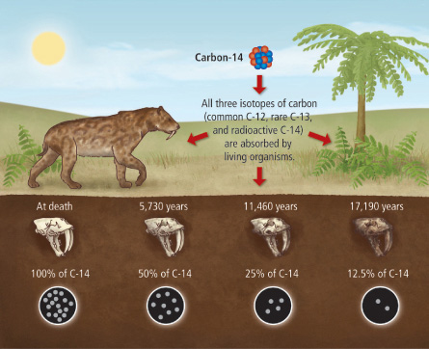
Carbon-14 is continually created naturally in the atmosphere. This carbon-14 then combines with oxygen in the atmosphere to form radioactive carbon dioxide, which is then taken in by plants during the process of photosynthesis. Animals then acquire carbon-14 by eating the plants. When the animal or plant dies, it stops exchanging carbon with its environment and so the amount of carbon-14 it contains begins to decrease (as the carbon-14 undergoes radioactive decay).
Worked example:
The half life of carbon-14 is 5,700 years. A skeleton had an initial activity of 1,800 Bq (counts/sec). If the skeleton now has an activity of 450 Bq, how old is it?
½ life of C-12 is 5700yrs. This means that every 5700yrs the activity/count rate decreases by half.
So, if initial activity is 1800Bq.
After 5700yrs the activity will be half the original value; 900Bq
After another 5700yrs the activity will be half the new value (900Bq); 450Bq
Since the skeleton has an activity of 450Bq, then the skeleton is approx. two half lives old, so:
5700 + 5700 = 11,400
The skeleton is approx. 11,400yrs old
Task: Answer the questions below. Carbon-14 has a half life of 5,700 years. Complete in your exercise book.
- A tree is found buried underground. It originally had an activity of 150,000 Bq. It now has an activity of 37,500Bq. How old is the tree? Approx. 11,400yrs
- A woolly mammoth skeleton originally had an activity of 20,000 Bq. If it now has an activity of 5,000 Bq. When did woolly mammoths go extinct? The skeleton has a ½ life of approx. 11,400yrs. Numbers of Woolly Mammoths started to decrease about 10,000yrs ago, becoming extinct around 4000yrs ago (Nat. Geographic/World Atlas).
- An insect died and became preserved in amber. It originally had an activity of 300 Bq. It now has an activity of 37.5 Bq. When did the insect die? Approx. 17,100yrs ago

- An alpha particle is the same as a helium nucleus.
The symbol below represents an alpha particle.
(i) The equation below represents the alpha decay of bismuth-212.
Complete the equation by writing the correct number in each of the two boxes. (2)
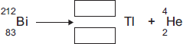
208
81
(ii) It is impossible for the alpha decay of bismuth-212 to produce the same element as the beta decay of bismuth-212.
Explain why. (2)

the number of protons determines the element

accept atomic number for number of protons

alpha and beta decay produce different changes to the number of protons

there must be a comparison between alpha and beta which is more than a description of alpha and beta decay alone

or
alpha and beta decay produce different atomic numbers

ignore correct reference to mass number
(b) Humans take in the radioactive isotope carbon-14 from their food. After their death, the proportion of carbon-14 in their bones can be used to tell how long it is since they died. Carbon-14 has a half-life of 5700 years.
(i) A bone in a living human contains 80 units of carbon-14. An identical bone taken from a skeleton found in an ancient burial ground contains 5 units of carbon-14. Calculate the age of the skeleton. Show clearly how you work out your answer.

22800 (years)

allow 1 mark for iterative steps 80-40-20-10-5 or statement of 4 half-lives

Age of skeleton = 22800 (years) years
(2)
(ii) Why is carbon-14 unsuitable for dating a skeleton believed to be about 150 years old?

decay (of carbon 14) over 150 years is insignificant

accept very little decay

accept change is too small
(1)

Contamination and Irradiation
Contamination is when radioactive atoms get onto other materials.
One example of radioactive contamination is at Chernobyl in Ukraine. In 1986, the nuclear power plant in Chernobyl exploded. This scattered radioactive material across Chernobyl, contaminating the whole city.
To help, the top surface (about 10-20 cm) of soil was dug up and buried underground. However, Chernobyl is still highly radioactive and the city is abandoned to this day.
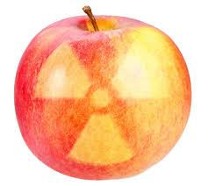
Irradiation is when an object/person is exposed to nuclear radiation. The irradiated object does not become radioactive.
We irradiate food with gamma rays (so it can travel through packaging) to kill bacteria and prevent sickness. We do the same with medical equipment to prevent infection after an operation.
Gamma rays are used to kill bacteria, mould and insects in food. This can be done even after the food has been packaged. It can affect the taste, but supermarkets like it because it lengthens the shelf life.
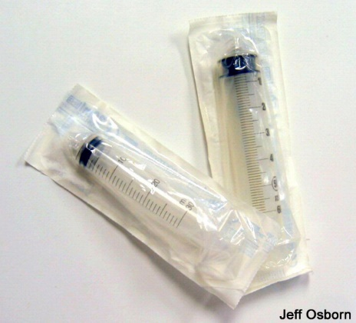
Gamma rays are also used to kill bacteria on medical equipment. It is particularly useful with plastic equipment that would be damaged by heat sterilization.

Contamination and irradiation worksheet
Basic
- What does contamination mean?
- What does irradiation mean?
- Which type of radiation is most dangerous inside the body?
- Which type(s) of radiation are most dangerous outside the body?
- What type of radiation do we use to sterilise medical equipment?
- How can workers who use ionising radiation protect themselves?
Medium
- Explain your answer to Q3. Why is this type of radiation most dangerous inside the body?
- Explain your answer to Q4. Why are these types of radiation most dangerous outside the body?
- Why would alpha radiation not be suitable to sterilise medical equipment?
- What would happen to workers if they are exposed to too much ionising radiation?
- Why is Chernobyl abandoned to this day?
- Describe the difference between contamination and irradiation.
Hard
- HAB have built their own nuclear power plant and Dr. Edmunds has put all of his classes in charge. But, oh no! There’s been an accident and a small explosion spreads some radioactive Caesium isotopes across the playground. The initial half life of the Caesium is 30 years; and the initial count rate is 200 Bq. Southwark council have said that the playground will be “safe” when the count rate reaches 25 Bq. How long will we have to abandon HAB for?
- Tinned food is often irradiated. Why is it irradiated and why would this process not work with alpha or beta radiation?
- Chernobyl nuclear power plant is now covered with a sarcophagus. This is the world’s largest moving structure and the two halves were wheeled into place. Why couldn’t they build the sarcophagus close to the power plant itself?
- After the Chernobyl disaster, the Ukrainian government dug up the top layer of soil and buried it in trenches, covering it with a layer of sand. Why did they do this?

Contamination and irradiation worksheet
Basic
- What does contamination mean? Physical contact with radioactive substance
- What does irradiation mean? When you have become exposed to radiation
- Which type of radiation is most dangerous inside the body? Alpha
- Which type(s) of radiation are most dangerous outside the body? Beta & gamma
- What type of radiation do we use to sterilise medical equipment? Gamma
- How can workers who use ionising radiation protect themselves? Shielding (lead glass), reduce exposure time. Work at a distance
Medium
- Explain your answer to Q3. Why is this type of radiation most dangerous inside the body? Alpha is highly ionising, causing cell/DNA damage leading to cell mutations & cancer
- Explain your answer to Q4. Why are these types of radiation most dangerous outside the body? Beta can penetrate through layers of skin & soft tissue causing ionisation of cells/DNA. Gamma can penetrate soft tissue, organs & bones. Exposure for lengths of time or intense beams can kill cells
- Why would alpha radiation not be suitable to sterilise medical equipment? Can’t pass through packaging
- What would happen to workers if they are exposed to too much ionising radiation? Number of issues ranging from: radiation sickness, skin & tissue burns, genetic mutations, cancers
- Why is Chernobyl abandoned to this day? Contamination of; (top) soil, water supply, plants, very high background radiation count which would lead to see question above
- Describe the difference between contamination and irradiation. Contamination involves physical contact with radioactive substance, irradiation means exposure to radioactive substance
Hard
- HAB have built their own nuclear power plant and Dr. Edmunds has put all of his classes in charge. But, oh no! There’s been an accident and a small explosion spreads some radioactive Caesium isotopes across the playground. The initial half life of the Caesium is 30 years; and the initial count rate is 200 Bq. Southwark council have said that the playground will be “safe” when the count rate reaches 25 Bq. How long will we have to abandon HAB for? 3 ½ lives: 90yrs. A little longer than Covid-19 lockdown
- Tinned food is often irradiated. Why is it irradiated and why would this process not work with alpha or beta radiation? Alpha/Beta cannot penetrate the tin can. Gamma is used which kills bacteria that may cause food to go ‘off/bad’
- Chernobyl nuclear power plant is now covered with a sarcophagus. This is the world’s largest moving structure and the two halves were wheeled into place. Why couldn’t they build the sarcophagus close to the power plant itself? High risk of contamination from materials in area (dust particles/soil etc), also irradiation from high levels of background radiation make it unsafe (or any other acceptable answer)
- After the Chernobyl disaster, the Ukrainian government dug up the top layer of soil and buried it in trenches, covering it with a layer of sand. Why did they do this? It had become contaminated and was radioactive (or any other acceptable answer)

Food irradiation is a process that exposes food to radiation. Irradiation can be used to kill the bacteria that cause food poisoning or to slow down the ripening of fresh fruit and vegetables. Frozen foods and food inside packaging can also be irradiated.
(a) The table gives information about five radioactive isotopes.

Isotope | Half-life | Radiation emitted
Caesium-134 | 2.1 years | beta
Cobalt-60 | 5.3 years | gamma
Curium-242 | 160 days | alpha
Strontium-90 | 28 years | beta
Technetium-99 | 6 hours | gamma
Which of these radioactive isotopes would be most suitable for irradiating food?
cobalt-(60)
Explain the reasons for your choice. (3)
gamma (radiation) will pass through food / packaging
this can score if technetium chosen
1
long half-life so level of radiation (fairly) constant for (a number) of years
this can score if strontium / caesium is chosen
accept long half-life so source does not need frequent replacement
accept answers in terms of why alpha and beta cannot be used
gamma kills bacteria is insufficient

(b) Many people think that food should not be irradiated. Consumer groups have said that they are worried about the nutritional value and safety of eating irradiated foods.
(i) Suggest one reason why some people may be concerned about the safety of eating irradiated food. (1)
people may link the use of radiation with illness / cancer
accept (they think) food becomes radioactive
accept (they think) it is harmful to them
‘it’ refers to irradiated food
(ii) Independent scientific committees in several countries, including Sweden, Canada and the UK, have concluded that it is safe to eat irradiated food.
These scientific committees need to be independent from government influence. Suggest why. (1)
not biased / influenced (by government views)
(iii) One group of scientists has compared the vitamin content of non-irradiated foods with irradiated foods.
The table below gives the data obtained for 1 kg of cooked chicken.

Vitamin | Non-irradiated food  in milligrams | Irradiated food  in milligrams
B6 | 1.22 | 1.35
B12 | 21.00 | 28.00
E | 3.30 | 2.15
Niacin | 58.00 | 55.50
Riboflavin | 2.10 | 2.25
Considering only the data in the table, is it valid to conclude that irradiated food is less nutritional than non-irradiated food?
Explain your answer. (2)
any two from:
• data refers only to (cooked) chicken
• data may not generalise to other foods
• the content of some vitamins increases when food / chicken is irradiated
• no vitamins are (completely) destroyed
• (only) two vitamins decrease (but not significantly)
accept irradiated chicken / food contains a higher level of vitamins
marks are for the explanation only
(iv) In a restaurant, meals with ingredients that have been irradiated must be clearly identified on the menu.
It is important that people eating in a restaurant are given this information. Suggest why. (1)
so can choose to eat / not eat that (particular) food
accept irradiated food may cause health problems
(for some people)
accept people may have ethical issues
(over eating irradiated food)
(c) The isotope caesium-137 decays by emitting beta radiation.
Caesium-137 has a half-life of 30 years.
(i) What is a beta particle, and from which part of an atom is a beta particle emitted? (1)
electron
from nucleus / neutron
both parts required
(ii) A sample containing caesium-137 has a count rate of 600 counts per minute.
Calculate how long it would take for the count rate from the sample to fall to 75 counts per minute. Show clearly how you work out your answer. (2)
90 years
allow 1 mark for showing 3 half-lives
Time taken = _________________________ years

Task: Calculate the half life of each of the graphs.
Half life practical
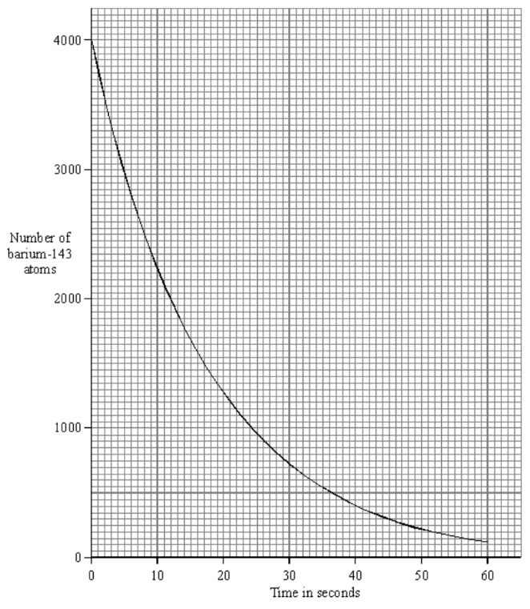
Use a ruler to draw the lines & write the answer on the graphs themselves.
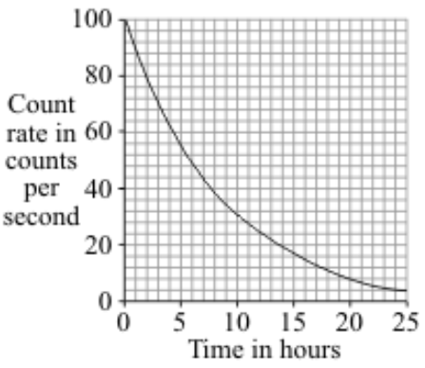
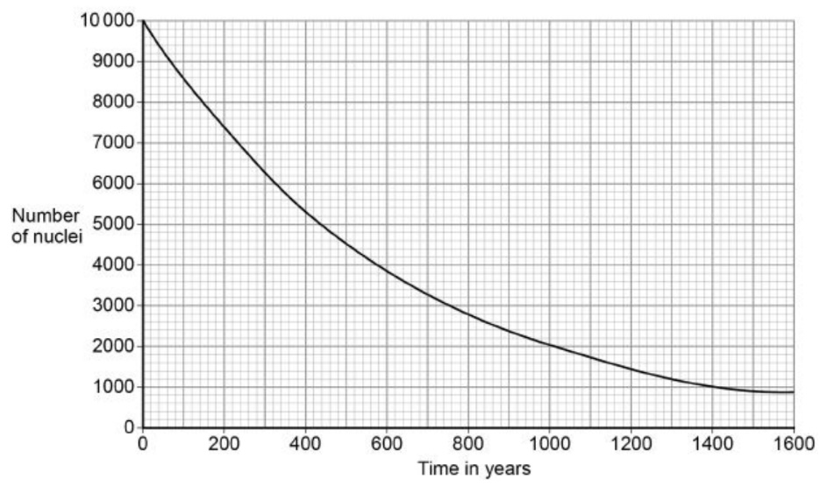
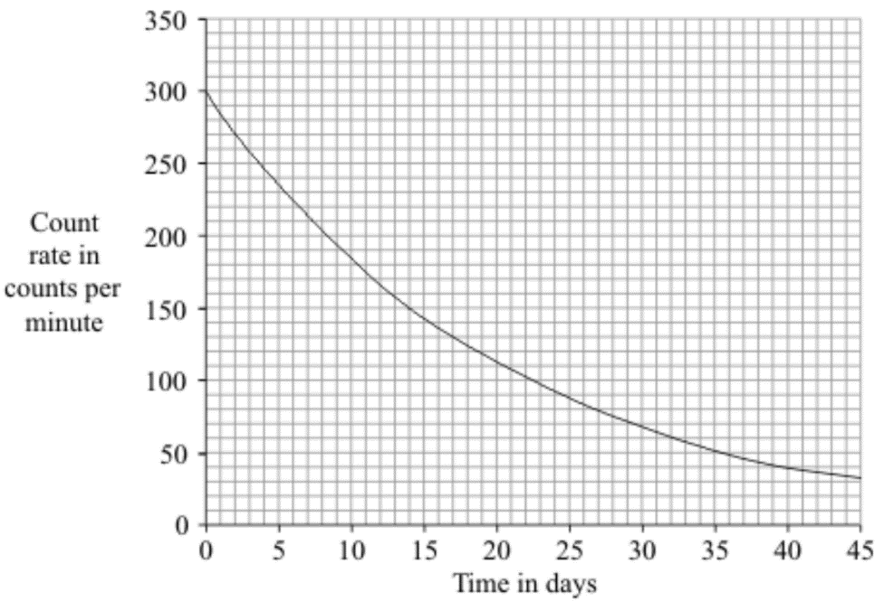
14 days
12s
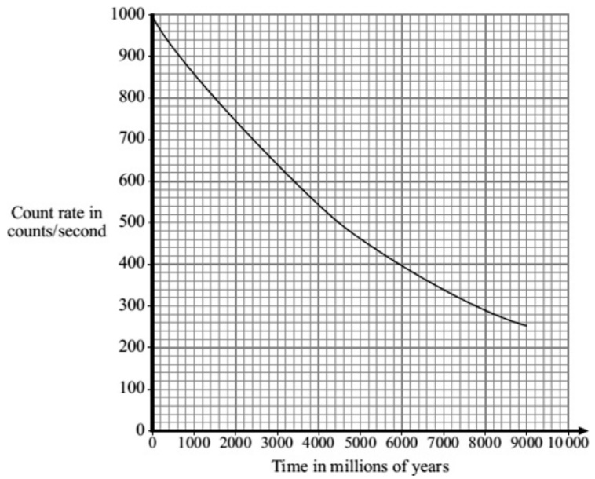
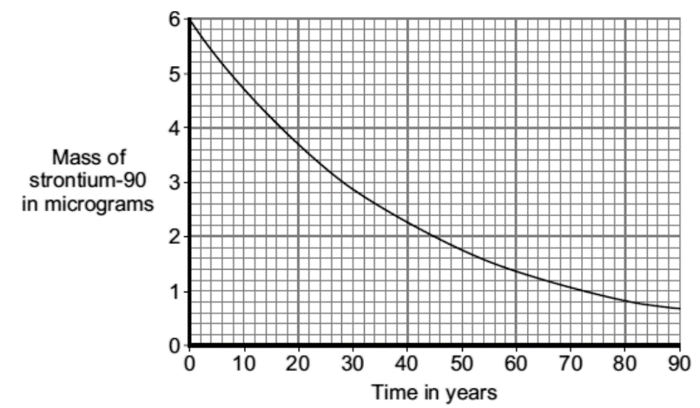
4600 million years days
28 years

6 hours
440 years

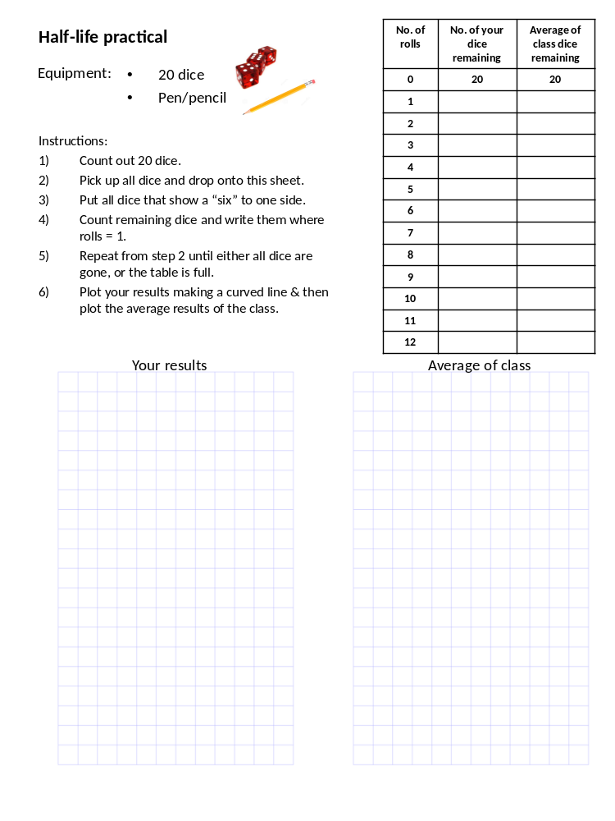

(a) A radiation detector and counter were used to detect and measure the radiation emitted from a weak source. The graph shows how the number of counts recorded in one minute changed with time.
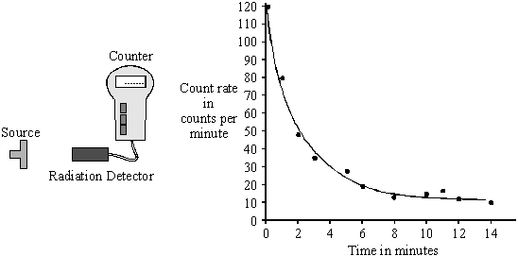
Even though the readings from the counter were accurately recorded, not all the points fit the smooth curve. What does this tell us about the process of radioactive decay? (1)
it is random
do not accept unpredictable
do not accept irregular
(b) The radioactive isotope sodium-24 injected into the bloodstream can be used to trace blood flow to the heart. Sodium-24 emits both beta particles and gamma rays.
(i) What is a beta particle? (1)
an electron
(ii) What is a gamma ray? (1)
electromagnetic wave with high frequency or short wavelength
must have high frequency or short wavelength
(iii) The count rate from a solution containing sodium-24 decreases from 584 counts per minute to 73 counts per minute in 45 hours. Calculate the half-life of sodium-2.2. Show clearly how you work out your answer. (3)
15
allow 1 mark for 3 iterative steps 584/2 292/2 146/2
allow I mark for 45/3
Half-life = _______________ hours
(iv) Give one advantage of using sodium-24 to trace blood flow compared to using an isotope with a half-life of: (2)
[A] ten years; a safe level of radiation reached much quicker
could answer in terms of isotope but answer must be clear whether it refers to isotope or sodium-24

[B] ten seconds. long enough to obtain measurements
The energy released in nuclear power plants comes from nuclear fission.
Nuclear Fission
Large, unstable nuclei such as uranium-235 or plutonium-239 break into smaller nuclei, releasing energy as they do so.
²³⁵U + neutron smaller nuclei + neutrons + energy
When a uranium-235 nucleus undergoes induced fission after collision with a neutron, it breaks up into two smaller nuclei and two/three neutrons. These are called fission neutrons.
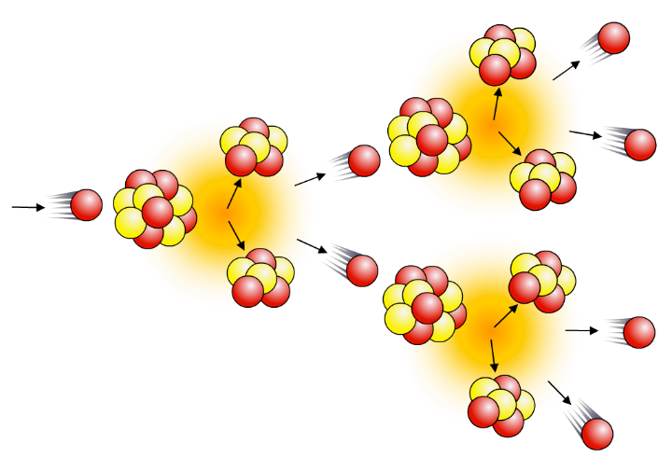
The fission neutrons can go on to cause further fission events, which will produce further neutrons, and so on, causing a chain reaction.
Uncontrolled chain reactions are used in atomic bombs.
The smallest amount of mass needed to sustain a chain reaction is called a critical mass.

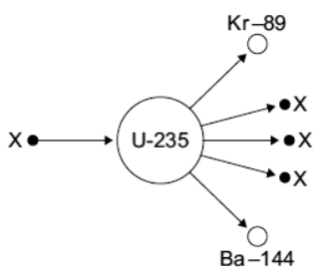
Task: Complete in exercise book
Basic
- Name the process shown in the diagram.
- Name the particles labelled X.
- Uranium-235 is used as a fuel in some nuclear reactors. Name another substance used as a fuel in some nuclear reactors.
- What is a chain reaction?
- What are uncontrolled chain reactions used in?
- What type of energy does this process produce?
Medium: Put the following sentences into the correct order. The first sentence is already correct.
- A slow-moving neutron is absorbed by an atom of Uranium-235
- Each of the three neutrons can be absorbed by another atom of uranium-235.
- This is known as a chain reaction.
- This is known as nuclear fission.
- Each of these uranium atoms undergoes fission, releasing even more neutrons.
- The uranium-235 becomes uranium-236, an unstable isotope
- The uranium splits into two daughter nuclei and three neutrons
Hard
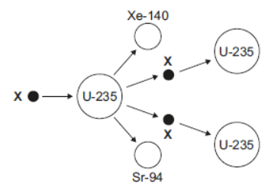
- Complete the diagram to show how the particles X start a chain reaction.

- Uranium has two natural isotopes, uranium-235 and uranium-238. Describe the difference between the isotopes.
- The following nuclear equation represents the fission of uranium-235 (U-235).
Use the information in the equation to describe the process of nuclear fission.
- The UK needs at least 25 000 000 kW of electrical power at any time. A nuclear power station has an electrical power output of 2 400 000 kW. Calculate how many nuclear power stations are needed to provide 25 000 000 kW of electrical power.
- How is the energy produced from nuclear fission used to generate electricity?

Task: Complete in exercise book
Basic
- Name the process shown in the diagram. Nuclear fission
- Name the particles labelled X. neutron
- Uranium-235 is used as a fuel in some nuclear reactors. Name another substance used as a fuel in some nuclear reactors. Plutonium
- What is a chain reaction? A nuclear fission reaction that causes other nuclear fission reactions which turn cause others . . .
- What are uncontrolled chain reactions used in? Nuclear bomb
- What type of energy does this process produce? Thermal
Medium: Put the following sentences into the correct order. The first sentence is already correct.
- A slow-moving neutron is absorbed by an atom of Uranium-235 1
- Each of the three neutrons can be absorbed by another atom of uranium-235. 5
- This is known as a chain reaction. 7
- This is known as nuclear fission. 4
- Each of these uranium atoms undergoes fission, releasing even more neutrons. 6
- The uranium-235 becomes uranium-236, an unstable isotope 2
- The uranium splits into two daughter nuclei and three neutrons 3
Hard
- Complete the diagram to show how the particles X start a chain reaction.
Xe-140
U-235
U-235
U-235
Sr-94
Xe-140
U-235
Sr-94

- Uranium has two natural isotopes, uranium-235 and uranium-238. Describe the difference between the isotopes. U-238 has a larger atomic mass since it has three more neutrons than U-335

- The following nuclear equation represents the fission of uranium-235 (U-235).
Use the information in the equation to describe the process of nuclear fission. U-235 absorbs a neutron and becomes an unstable isotope, U-236. [U-236 is unstable because the strong nuclear force holding the neucleus together only acts over a short distance and is no longer able to overcome the electrostatic forces between the protons.] The unstable isotope breaks apart into two daughter nuclei; Barium and Krypton, releasing three neutrons in the process along with large amounts of thermal energy
- The UK needs at least 25 000 000 kW of electrical power at any time. A nuclear power station has an electrical power output of 2 400 000 kW. Calculate how many nuclear power stations are needed to provide 25 000 000 kW of electrical power. 11
- How is the energy produced from nuclear fission used to generate electricity? The thermal energy produced by nuclear fission is used to heat water to produce steam which turns steam turbines. The spinning turbines cause ‘magnets’ to spin in a generator which generates electricity

The first commercial nuclear power station in the world was built at Calder Hall in Cumbria.

(a) The fuel used at the Calder Hall power station is uranium. Natural uranium consists mainly of two isotopes: uranium-235 and uranium-238. The nucleus of a uranium-235 atom is different to that of a uranium-238 atom.
(i) Where is the nucleus in an atom?
Centre (1)
(ii) Name the two types of particle found in the nucleus.
protons and neutrons
(2)
(iii) How is the nucleus of a uranium-238 atom different to the nucleus of a uranium-235 atom?
different number of neutrons
gets 1 mark
heavier
gets 1 mark
3 more neutrons or specified numbers
gets 2 marks
(2)
(b) In the nuclear reactor fission of uranium atoms takes place in reactions such as the one shown below.
+ + + 3()
The nuclear reactions are carefully controlled in the power station so that a chain reaction takes place.
Explain, as fully as you can: (4)
(i) how fission of uranium atoms takes place in a nuclear reactor;
(ii) how this leads to a chain reaction;
- why it can be used to generate electricity.
atom hit by neutron;
splits into smaller nuclei;
further neutrons released;
neutrons released when one atom splits
cause further fission;
energy released.
any 4 for 1 mark each

A nuclear reactor uses a controlled chain reaction to produce heat to produce steam for a generator. Apart from the source of heat, it works in the same way as a coal-fired power station.
Nuclear power plant
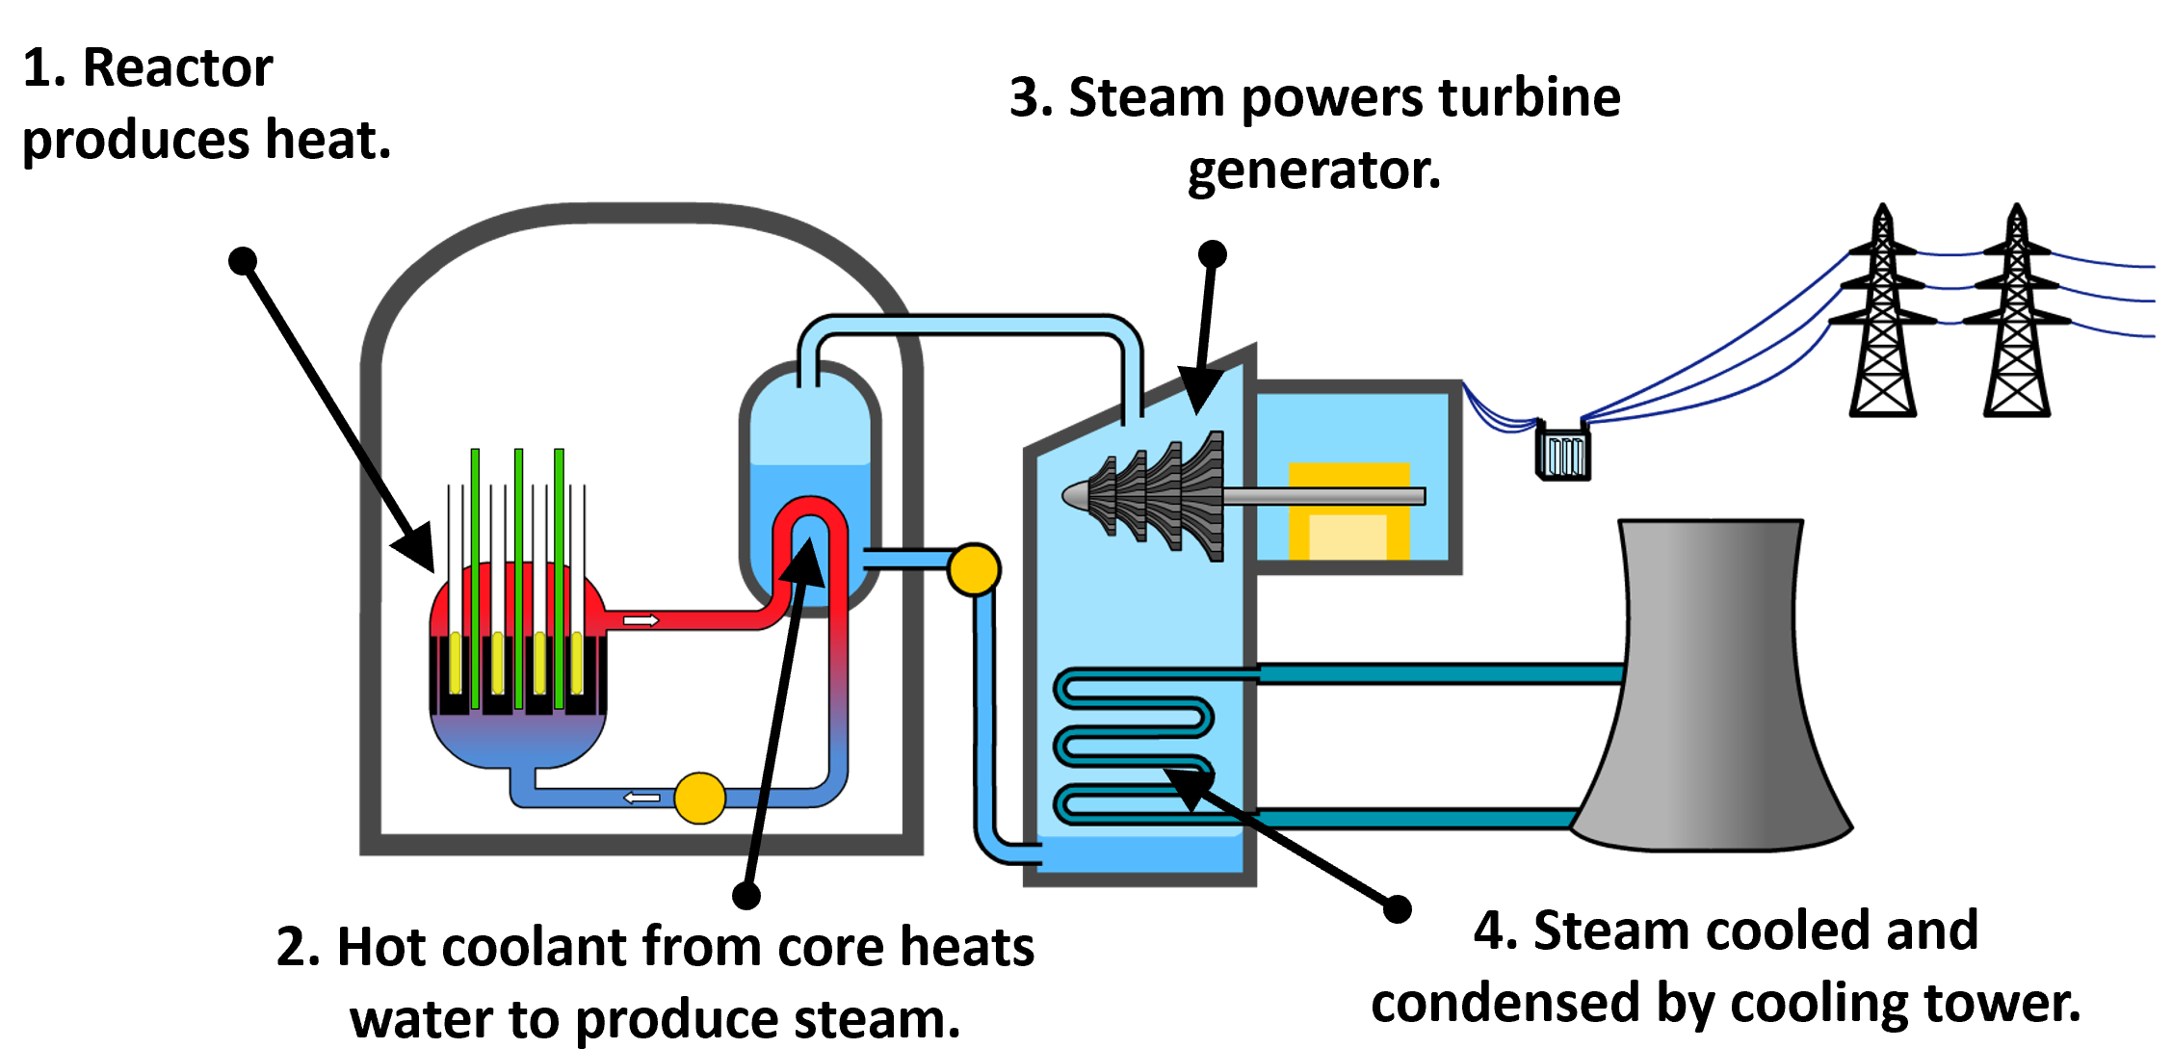

A nuclear reactor contains four key parts:
- The fuel rods. These contain enriched uranium. This means that the uranium contains an increased percentage of uranium-235 compared to the uranium ore from which it is extracted.
- The control rods. These are made of cadmium or boron, to absorb neutrons. They can be lifted in and out of the reactor to control the number of neutrons present and keep the fission happening at a steady rate.
- The moderator. This is made of graphite or water. It slows down fission neutrons into ones with thermal energies, to increase the likelihood of absorption by uranium-235 nuclei.
- Coolant. Water flows around the core, transferring heat away from the fuel, to be used to produce steam to drive the turbine. The water can also act as the moderator in some reactors.

Basic: Fill in the blanks below.
N___________ reactors use rods of u___________ that are rich in ²³⁵U as “fuel” for f___________ reactions. These fission reactions produce more n___________ which induce other nuclei to fission – this is called a c__________ r___________.
The neutrons will only cause a chain reaction if they are s___________ down, which allows them to be captured by the uranium nuclei. Fuel rods need to be placed in a moderator (for example water or g___________) to slow down and/or absorb neutrons. Coolant is sent around the reactor to remove heat produced by the fission. Often, the same w_________ that is being used in the reactor as a m___________ is used. The heat from the reactor can be used to make s___________ for powering e___________ generating turbines.
The chain reaction needs to continue at a steady rate. C__________ r_________ control the chain reaction by limiting the number of neutrons in the reactor. They are made of a material that a__________ neutrons, such as boron, and can be inserted by varying amounts to control the chain reaction. The nuclear reactor is surrounded by a thick c___________ case, which acts as shielding. This prevents radiation escaping and reaching the people working in the power station.
In an e___________, the r___________ can be shut down automatically by the release of control rods into the reactor. The control rods are l___________ fully into the reactor, which slows down the reaction as quickly as possible.
emergency absorb lowered neutrons graphite electricity chain reaction reactor fission steam concrete control rods slowed nuclear uranium moderator water

Medium
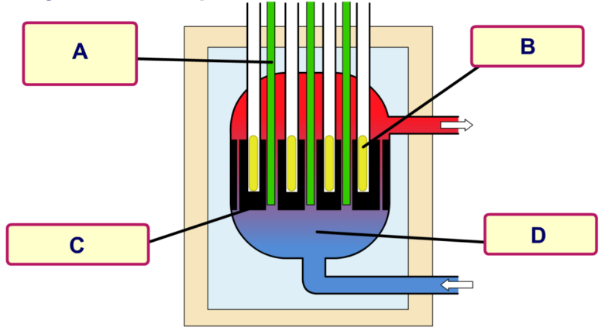
Q1. From the words below label the nuclear reactor.
Control rods, fuel rods, moderator, coolant

Q2. State the purpose of each of the labels in Q1.
Q3. Why is the reactor encased in thick concrete?
Q4. Why is the cooling water contained within the reactor instead of it being allowed to cool in the cooling towers?
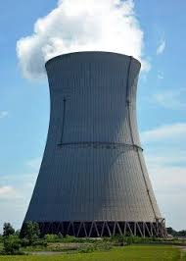
Q5. Explain the roles of the turbine and generator.
Q6. You drive past a nuclear power plant that looks like the image to the right. What is coming out of the tower and entering the air? Is it radioactive?
Hard: Congratulations! The owners of the HAB nuclear power plant are impressed with your knowledge of nuclear reactors and want you to be in charge of HAB’s very own reactor.
Q1. a) Uh-oh! It’s your first day and the reactor is overheating and in danger of going into meltdown. Describe what you need to do to the control rods to slow the chain reaction down. Explain why.
b) Success! The reaction has been slowed down but is now not generating enough electricity for the school. What do you need to do to the control rods now?

Basic: Fill in the blanks below.
Nuclear reactors use rods of uranium that are rich in ²³⁵U as “fuel” for fission reactions. These fission reactions produce more neutrons which induce other nuclei to fission – this is called a chain reaction.
The neutrons will only cause a chain reaction if they are slowed down, which allows them to be captured by the uranium nuclei. Fuel rods need to be placed in a moderator (for example water or graphite) to slow down and/or absorb neutrons. Coolant is sent around the reactor to remove heat produced by the fission. Often, the same water that is being used in the reactor as a moderator is used. The heat from the reactor can be used to make steam for powering electricity generating turbines.
The chain reaction needs to continue at a steady rate. Control rods control the chain reaction by limiting the number of neutrons in the reactor. They are made of a material that absorbs neutrons, such as boron, and can be inserted by varying amounts to control the chain reaction. The nuclear reactor is surrounded by a thick concrete case, which acts as shielding. This prevents radiation escaping and reaching the people working in the power station.
In an emergency, the reactor can be shut down automatically by the release of control rods into the reactor. The control rods are lowered fully into the reactor, which slows down the reaction as quickly as possible.
emergency absorb lowered neutrons graphite electricity chain reaction reactor fission steam concrete control rods slowed nuclear uranium moderator water

Medium
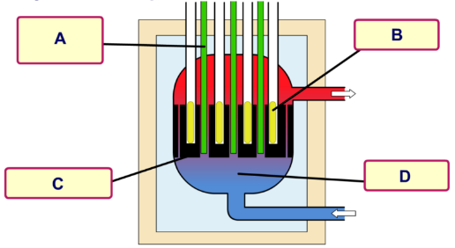
Q1. From the words below label the nuclear reactor.
A Control rods, B fuel rods, C moderator, D coolant

Q2. State the purpose of each of the labels in Q1.
A: to absorb neutrons. B: Store of Uranuim. C: Slow down neutrons. D: Remove thermal energy produced by reaction
Q3. Why is the reactor encased in thick concrete? Absorb radiation emitted by chain reaction
Q4. Why is the cooling water contained within the reactor instead of it being allowed to cool in the cooling towers?
Q5. Explain the roles of the turbine and generator. Turbine: transfer thermal/kinetic energy in steam to kinetic energy. Generator: transfer kinetic energy of turbine to moving charges in National Grid
Q6. You drive past a nuclear power plant that looks like the image to the right. What is coming out of the tower and entering the air? Is it radioactive? Steam. No
Hard: Congratulations! The owners of the HAB nuclear power plant are impressed with your knowledge of nuclear reactors and want you to be in charge of HAB’s very own reactor.
Q1. a) Uh-oh! It’s your first day and the reactor is overheating and in danger of going into meltdown. Describe what you need to do to the control rods to slow the chain reaction down. Explain why. The control rods need to be lowered into the reactor, to absorb more neutrons which will decrease the number of chain reactions and the thermal energy produced.
b) Success! The reaction has been slowed down but is now not generating enough electricity for the school. What do you need to do to the control rods now? The control rods need to be lifting out the reactor, so less neutrons are absorbed which will allow more chain reactions and increase the thermal energy produced
Q2. All nuclear power plants have backup generators in case the plant stops producing electricity. Why is this necessary? What exactly are the generators providing power for? What might happen if these backup generators fail? Back-up generators allow the control rods to be lowered/lifted so the chain reaction can be controlled. They also keep the coolant pumps working so coolant flows and the reactor don’t ‘overheat’.
Q1.
Nuclear power stations use the energy released from nuclear fuels to generate electricity.
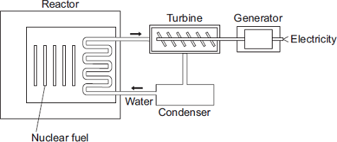
(a) Which substance do the majority of nuclear reactors use as fuel?
Draw a ring around your answer.

plutonium-239 | thorium-232 | uranium-235
(1)
(b) Energy is released from nuclear fuels by the process of nuclear fission.
Describe what happens to the nucleus of an atom during nuclear fission.
splits / breaks (into two smaller parts)
nucleus is separated is insufficient
do not accept atom splits – on its own
and (two / three) neutrons
(2)
(c) Use words from the box to complete each sentence.

condenser | gas | generator | reactor | steam | turbine
The energy released from the nuclear fuel is used to heat water. The water turns
into steam and this is used to drive a turbine .
This turns a generator to produce electricity.
(3)
(Total 6 marks)

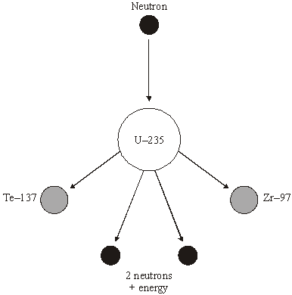
Q2.
(a) The diagram shows what can happen when the nucleus of a uranium atom absorbs a neutron.

(i) What name is given to the process shown in the diagram? (1)
(nuclear) fission
accept fision providing clearly not fusion
(ii) Explain how this process could lead to a chain reaction.
You may wish to add further detail to the diagram to help your answer. (2)
(released) neutrons are absorbed by further (uranium) nuclei
accept hit nuclei for absorbed / hit
do not accept atom for nuclei
more neutrons are released (when new nuclei split)
accept for both marks a correctly drawn diagram
(iii) How does the mass number of an atom change when its nucleus absorbs a neutron? (1)
increases by 1 or goes up to 236
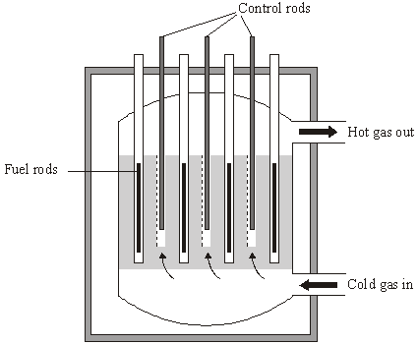
(b) Uranium-235 is used as a fuel in some nuclear reactors.
The reactor contains control rods used to absorb neutrons.
Suggest what happens when the control rods are lowered into the reactor. (2)
any two from:
• (more) neutrons are absorbed
accept there are fewer neutrons
• (chain) reaction slows down / stops
accept keeping the (chain) reaction controlled
• less energy released
accept heat for energy
accept gases (from reactor) are not as hot

Whereas nuclear fission involves very large nuclei splitting into smaller nuclei, fusion involves the small nuclei joining together to form larger ones.
Nuclear fusion
The energy emitted by a star, such as the Sun, comes from nuclear fusion. In order for this to happen, the core temperature has to be extremely high – in excess of 10 million degrees.
Nuclear fusion in a star like the Sun involves the combination of lighter isotopes of hydrogen to form helium, and the release of energy:
$${}_{1}^{2}H+{}_{1}^{1}H→{}_{2}^{3}{He} + \text{energy}$$
Once these reactions have begun, the energy released maintains the temperature in the star, and fusion continues until all the reactants have been used.
To start a fusion reaction the fuel must be heated to a temperature about 150 million degrees.
This makes it into a plasma – a gas in which the electrons have been stripped from the nuclei.
If the temperature is not high enough, the particles will simply collide and rebound due to electrostatic repulsion.
Compared to nuclear fission, nuclear fusion reactions:
- Release more energy per kg of fuel.
- Make less radioactive emissions as many of the products are stable (eg He-4).
- Use ‘cleaner’ fuel: isotopes of hydrogen, which can be made from water and lithium.

Task: Complete in exercise book
Identify each as a fusion or fission reaction:
- Used in nuclear power plants: ______________
- Occurs on the Sun: _______________
- More power per gram: _______________
- A larger nucleus divides to make a smaller nucleus: _______________
- Two hydrogen atoms fuse to make a helium atom: _______________
- An atomic bomb: _______________
- A hydrogen bomb: _______________
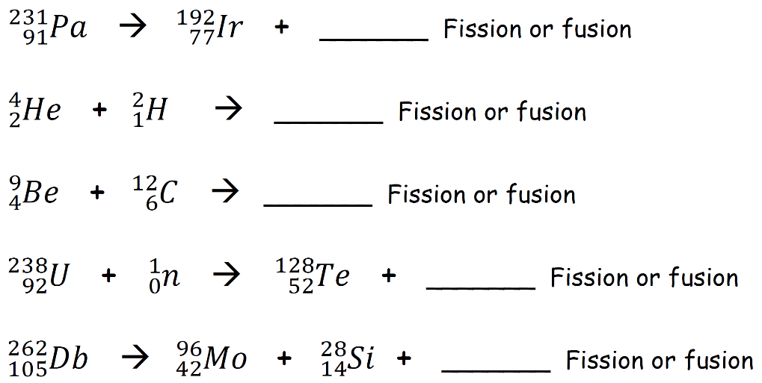

- Why can’t we currently use fusion reactions in a nuclear power plant?
- Why is it so hard to dispose of nuclear waste?
- Compare and contrast fission and fusion in terms of energy production, particles involved and examples.
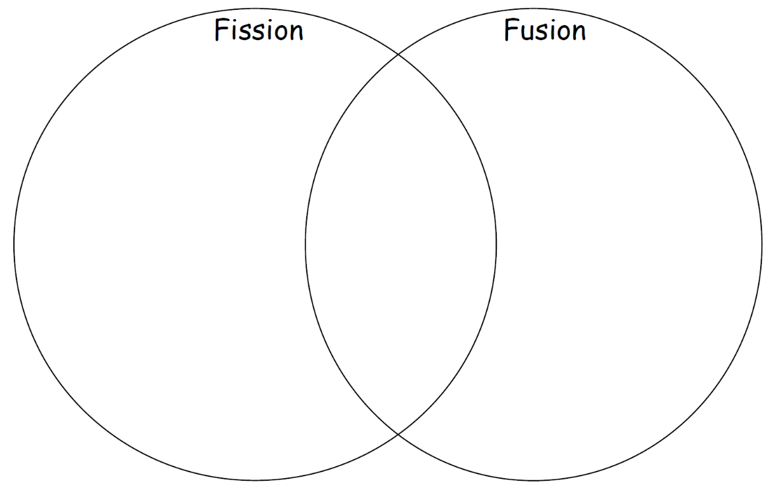

Task: Complete in exercise book
Identify each as a fusion or fission reaction:
- Used in nuclear power plants: fission
- Occurs on the Sun: fusion
- More power per gram: fusion
- A larger nucleus divides to make a smaller nucleus: fission
- Two hydrogen atoms fuse to make a helium atom: fusion
- An atomic bomb: fission
- A hydrogen bomb: fusion
$${}_{14}^{39}{Si}$$
$${}_{3}^{6}{Li}$$
$${}_{10}^{21}{Ne}$$

$${}_{40}^{111}{Zr}$$
$${}_{49}^{138}{In}$$

- Why can’t we currently use fusion reactions in a nuclear power plant? Very difficult to obtain the high pressure and temperature needed. Cost/energy required to obtain conditions is more than the energy produced
- Why is it so hard to dispose of nuclear waste? High level waste (eg. fuel rods) has a very long half-life and it is difficult to isolate from the environment and place in secure area for long periods. Intermediate level waste (eg. components used), also has a long ½ life and is usually placed in concrete/steel drums and stored securely. Low level waste (eg. Gloves) small amounts can be placed in landfill, however disposing of larger amounts is regulated by individual countries
- Compare and contrast fission and fusion in terms of energy production, particles involved and examples.

Q1.
Many countries use nuclear power stations to generate electricity.
Nuclear power stations use the process of nuclear fission to release energy.
(a) (i) What is nuclear fission?

splitting of a(n atomic) nucleus do not accept splitting an atom
(1)
(ii) Plutonium-239 is one substance used as a fuel in a nuclear reactor. For nuclear fission to happen, the nucleus must absorb a particle.
What type of particle must be absorbed?
Neutron
(1)
(b) Nuclear fusion also releases energy.
Nuclear fusion happens at very high temperatures. A high temperature is needed to overcome the repulsion force between the nuclei.
(i) Why is there a repulsion force between the nuclei of atoms?

nuclei have the same charge or nuclei are positive

accept protons have the same charge
(1)
(ii) Where does nuclear fusion happen naturally?

(main sequence) star

accept Sun or any correctly named star

accept red (super) giant
(1)
(c) In 1991, scientists produced the first controlled release of energy from an experimental nuclear fusion reactor. This was achieved by fusing the hydrogen isotopes, deuterium and tritium.
Deuterium is naturally occurring and can easily be extracted from seawater. Tritium can be produced from lithium. Lithium is also found in seawater.
The table gives the energy released from 1 kg of fusion fuel and from 1 kg of fission fuel.

Type of fuel | Energy released from  1 kg of fuel in joules
Fusion fuel | 3.4 × 10¹⁴
Fission fuel | 8.8 × 10¹³
(i) Suggest two advantages of the fuel used in a fusion reactor compared with plutonium and the other substances used as fuel in a fission reactor.

any two from:

• easy to obtain / extract

• available in (very) large amounts

• releases more energy (per kg)

do not accept figures only

• produces little / no radioactive waste.

naturally occurring is insufficient

seawater is renewable is insufficient

less cost is insufficient
(2)
(ii) Some scientists think that by the year 2050 a nuclear fusion power station capable of generating electricity on a large scale will have been developed.
Suggest one important consequence of developing nuclear fusion power stations to generate electricity.

any one from:

• makes another source of energy available

• increases supply of electricity

• able to meet global demand

• less environmental damage

• reduces amount of other fuels used.

accept any sensible suggestion

accept a specific example

accept a specific example
(1)
(d) Tritium is radioactive.
After 36 years, only 10 g of tritium remains from an original sample of 80 g.
Calculate the half-life of tritium.
Show clearly how you work out your answer.

12

allow 1 mark for obtaining 3 half-live
Half-life = __________________ years
(2)
(Total 9 marks)

Nuclear radiation is used in medicine for:
Uses of radiation
- Exploration of internal organs.
- Control or destruction of unwanted tissue (eg. cancer).
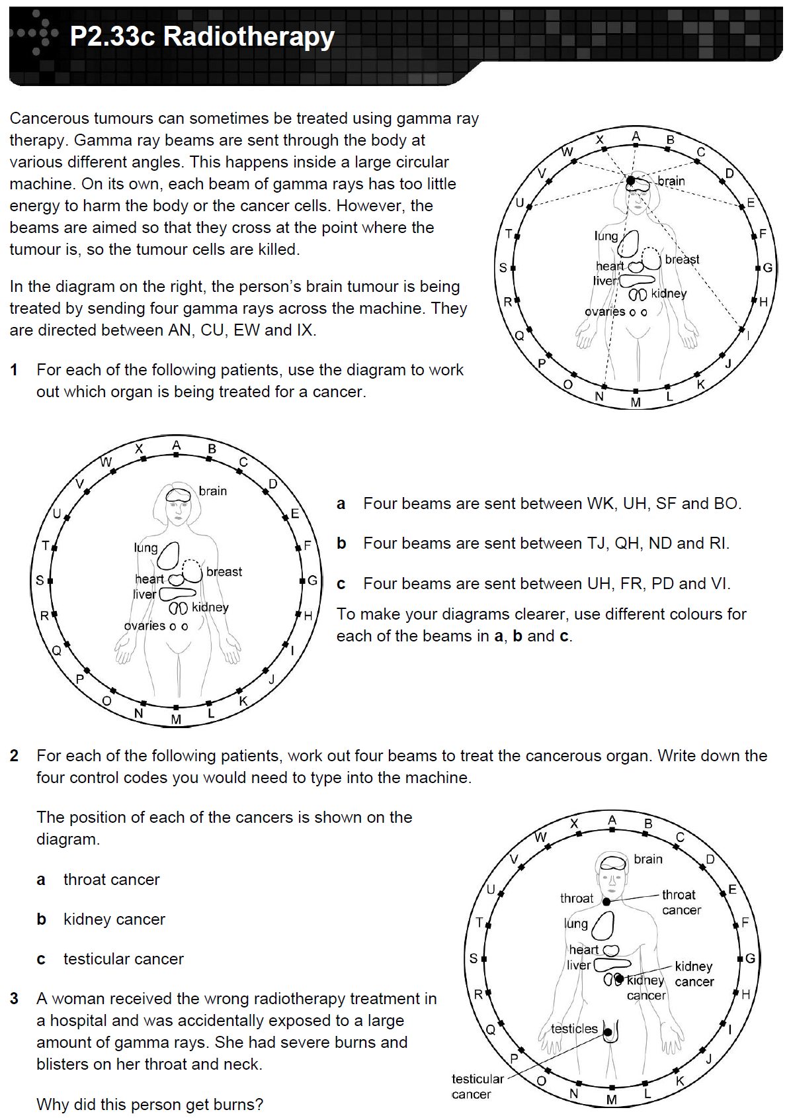
Radiotherapy involves carefully targeting gamma rays at a tumour. Separate gamma rays are used in different directions to reduce the intensity on healthy tissue (and therefore avoiding damage to healthy tissue). The rays combine on the tumour so that the intensity is higher and the tumour is destroyed.
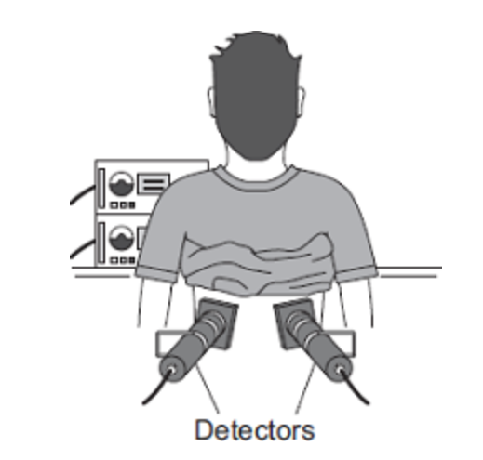
Gamma sources can also be used as a medical tracer.
The radioactive source should pass out of the kidney’s into the blood. If it does not then there’s a problem with the kidney.
We want medical tracers to have a short half life so that the amount of radiation exposure to the patient is limited.
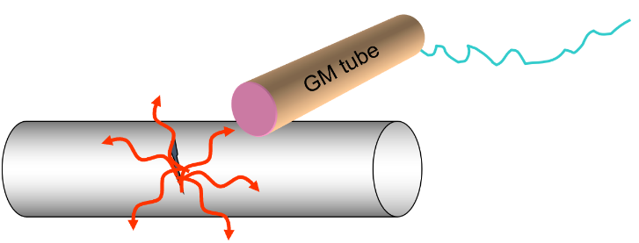
Gamma radiation can also be used for leak detection in pipes. The radioactive isotope is injected into the pipe. Then the outside of the pipe is checked with a Geiger-Muller detector, to find areas of high radioactivity. These are the points where the pipe is leaking. This is useful for underground pipes that are hard to get near.
The isotope must have a short half life so the material does not become a long term problem.
The radioactive isotope must be a gamma emitter so that it can be detected through the metal and the earth where the pipe leaks. Alpha and beta rays would be blocked by the metal and the earth.
Task: Complete in exercise book
Basic
- Name two uses of nuclear radiation in medicine.
- What type of radiation is used in radiotherapy?
- Why is it important that medical tracers have a short half life?
- Where in the body does the person opposite have a tumour?
- What is done to protect healthy tissue?
Medium
6. For each of the following patients, use the diagram to work out which organ is being treated for a cancer. Using different colours for each of the questions will help.
a) Four beams are sent between WK, UH, SF and BO.
b) Four beams are sent between TJ, QH, ND and RI.
c) Four beams are sent between UH, FR, PD and VI.
7. For each of the following patients, work out four beams to treat the cancerous organ. Write down the four control codes you would need to type into the machine.
a) Throat cancer.
b) Kidney cancer.
c) Ovarian cancer.
Hard
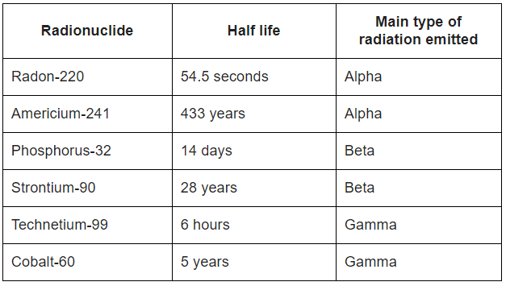
8. The table gives the properties of some radionuclides (radioactive isotopes).
a) Which radionuclide would be best for monitoring the thickness of aluminium foil? Explain the reason for your answer.
b) Which radionuclide would be best for acting as a tracer inside the human body? Explain the reason for your answer.
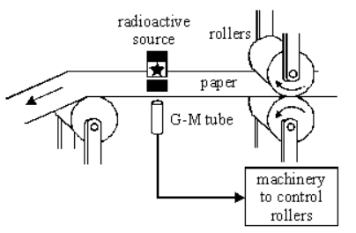
9. The diagram shows a method of controlling the thickness of paper produced at a paper mill. A radioactive source which emits beta radiation is placed on one side of the paper and a radiation detector is placed on the other.
a) How will the amount of radiation reaching the detector change as the paper gets thicker?
b) Explain why a radioactive source which emits alpha radiation could not be used for this application.
c) Explain why a radioactive source which emits gamma radiation could not be used for this application.
d) Explain why a radioactive source which emits beta radiation can be used for this application.
e) Americium-241 is a radioisotope used in smoke detectors. It has a proton number of 95, and a mass number of 241. Americium-241 has a half-life of 433 years. How long would it take the americium-241 in a smoke detector to decrease to one eighth of its original number of radioactive atoms?
Task: Complete in exercise book
Basic
- Name two uses of nuclear radiation in medicine. Destruction of unwanted tissue/cancer, examine where internal organs are working/not working
- What type of radiation is used in radiotherapy? Gamma
- Why is it important that medical tracers have a short half life? Reduce exposure of patient to radioactive material
- Where in the body does the person opposite have a tumour? Brain
- What is done to protect healthy tissue? Use a number of ‘beams’ of lower intensity, directed at same point
Medium
6. For each of the following patients, use the diagram to work out which organ is being treated for a cancer. Using different colours for each of the questions will help.
a) Four beams are sent between WK, UH, SF and BO. Lung
b) Four beams are sent between TJ, QH, ND and RI. Ovaries
c) Four beams are sent between UH, FR, PD and VI. Breast
7. For each of the following patients, work out four beams to treat the cancerous organ. Write down the four control codes you would need to type into the machine.
a) Throat cancer. WI, DS, BO, GV (could be other combinations)
b) Kidney cancer. KV, GQ, CN, HR (could be other combinations)
c) Ovarian cancer. KU, EO, LW, IR (could be other combinations)
Hard
8. The table gives the properties of some radionuclides (radioactive isotopes).
a) Which radionuclide would be best for monitoring the thickness of aluminium foil? Explain the reason for your answer.
Sr-90. Beta will penetrate and as the thickness changes the amount of Beta penetrating will change allowing the thickness to be monitored and controlled. Sr-90 has a longer ½ life than P-32, so the source will not need replacing as often. Alpha would not penetrate. Gamma would just penetrate and no variation would be counted
b) Which radionuclide would be best for acting as a tracer inside the human body? Explain the reason for your answer. Tc-99. It is a Gamma source and will be detected outside the body being able to penetrate soft tissue and bones. It has a shorter half life than Co-60, so exposing the patient to less radiation
9. The diagram shows a method of controlling the thickness of paper produced at a paper mill. A radioactive source which emits beta radiation is placed on one side of the paper and a radiation detector is placed on the other.
a) How will the amount of radiation reaching the detector change as the paper gets thicker? The amount of radiation detected will decrease
b) Explain why a radioactive source which emits alpha radiation could not be used for this application. Alpha radiation will not penetrate
c) Explain why a radioactive source which emits gamma radiation could not be used for this application. The amount of Gamma penetrating will not vary
d) Explain why a radioactive source which emits beta radiation can be used for this application. Beta will penetrate and as the thickness changes. If the paper thickness increases the amount of Beta radiation penetrating will decrease and the rollers will move closer together. If the paper thickness decreases the amount of Beta radiation penetrating will increase and the rollers will move further apart.
e) Americium-241 is a radioisotope used in smoke detectors. It has a proton number of 95, and a mass number of 241. Americium-241 has a half-life of 433 years. How long would it take the americium-241 in a smoke detector to decrease to one eighth of its original number of radioactive atoms? To decay to 1/8 of its original amount is 3 half-lives, so approx. 1300 yrs

Nuclear power produces lots of energy and produces no carbon dioxide (and so doesn’t contribute to global warming) or sulphur dioxide (which leads to acid rain).
Nuclear energy pros & cons
Nuclear power is expensive to build and decommission but the fuel costs are low.
Nuclear power creates radioactive waste. Disposal is difficult and expensive.
Task: Complete the agree-o-meter below

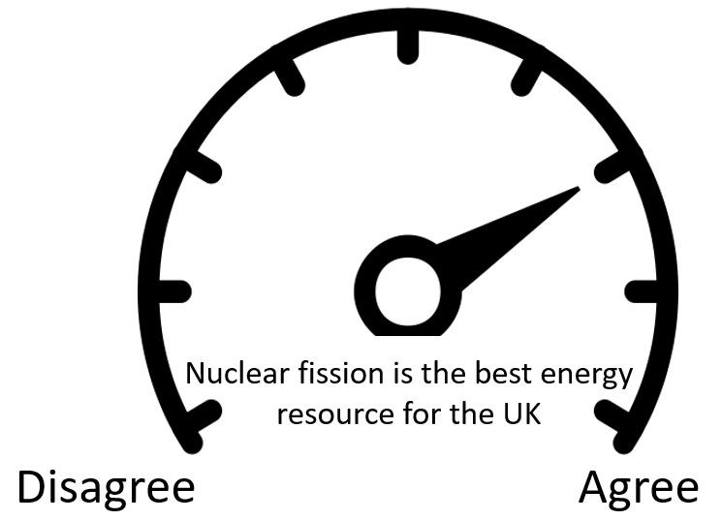

Q1.
Nuclear power stations generate electricity through nuclear fission. Electricity can also be generated by burning shale gas.
(a) Shale gas is natural gas trapped in rocks. Shale gas can be extracted by a process called fracking. There is some evidence that fracking causes minor earthquakes. Burning shale gas adds carbon dioxide to the atmosphere.
Describe the advantages of nuclear power compared with the use of shale gas to generate electricity.

any three from:

• no carbon dioxide emitted (to produce electricity)

no greenhouse gases is insufficient

• doesn’t cause global warming

allow climate change or greenhouse effect for global warming

• nuclear power doesn’t cause earthquakes

• more energy released per kg of fuel (compared to shale gas)
(3)
(b) What is the name of one fuel used in nuclear power stations?

uranium

or

plutonium

ignore any numbers given
(1)
(c) Describe the process of nuclear fission.

a neutron is absorbed by a (large) nucleus

a description in terms of only atoms negates first two marking points

the nucleus splits into two (smaller) nuclei

releasing energy (and gamma rays)

and (two / three) neutrons
(4)
(Total 8 marks)

Quiz

- Which subatomic particle has a positive charge? Circle the correct answer. (1)

- electron | - proton | - neutron

- Which two particles are in the nucleus? Circle the correct two answers. (1)

- electron | - proton | - neutron

- What type of radiation do we use for irradiation? Circle the correct answer. (1)

- Alpha | - Beta | - Gamma

- What type of radiation is most penetrating? Circle the correct answer. (1)

- Alpha | - Beta | - Gamma

- What type of radiation is most ionising? Circle the correct answer. (1)

- Alpha | - Beta | - Gamma

- What is an isotope? (1)

- What is the definition of half life? (1)

- What is ionisation? (1)

- Why is radiation dangerous? (1)

- What is the plum pudding model? (1)

- What three things can we do to keep safe around radiation? (3)

- What happens to the mass number of a radioactive isotope during alpha decay? (1)

