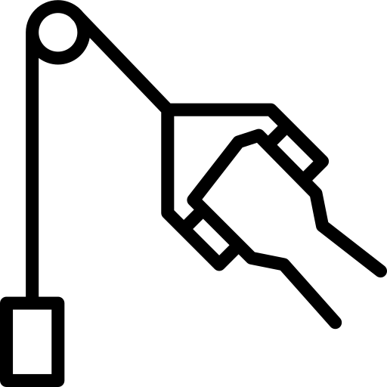
Combined Science
Forces
Name ______________________________
Class ______________________________
Teacher ______________________________

Forces facts
- A quantity with magnitude (size) but no direction.
- A quantity with magnitude (size) and direction.
- The magnitude of the vector.
- The direction of the vector.
- A force is a push or pull that acts on an object.
- A Newton.
- A Newton meter.
- A contact force is a force that needs to touch to act.
- A non-contact force is a force that does not need to touch to act.
- Friction, air resistance, tension and normal reaction.
- Gravitational, electrostatic and magnetic.
- Energy, mass, distance, time, power, speed.
- Velocity, acceleration, force, displacement.
- It is the amount of matter in an object. It is constant for an object everywhere.
- W = m × g
- 9.8 N/kg
- A single force that has the same effect as all forces acting together.
- It is an energy transfer. One joule of work is done when a force of one newton causes a displacement of one metre.
- W = F × s
- A rise in temperature of the object.
- One newton-metre equals one joule.
- When an object is stretched but can still return to its original size.
- When an object is stretch but does not return to its original size.
- F = k × e
- Elastic potential energy.
- The extension of an elastic object is directly proportional to the force applied.

Fold page here
- What is a scalar?
- What is a vector?
- What does the direction of an arrow of a vector quantity represent?
- What does the size of the arrow of a vector quantity represent?
- What is a force?
- What is the unit of a force?
- What can we use to measure a force?
- What is a contact force?
- What is a non-contact force?
- Give four examples of contact forces.
- Give three examples of non-contact forces.
- Give some examples of scalars.
- Give some examples of vectors.
- What is mass?
- What is the equation for weight?
- What is the value for gravitational field strength on Earth?
- What is a resultant force?
- What is work done?
- What is the equation for work done?
- What does work done against frictional forces cause?
- What does one newton-metre equal in joules?
- What is elastic deformation?
- What is inelastic deformation?
- What is the equation for Hooke’s law
- What type of energy is stored in a stretched spring?
- What is the relationship between the force applied and the extension of an elastic object.

A force is a push or pull; and forces have unit of Newtons. To measure a force we can use a device called a Newton meter.
Introduction to forces
Scalar quantities have size (“magnitude”) only and no direction.
An example of a scalar quantity is mass.
Scalar quantities can be added up normally
Example: 36 kg + 14 Kg = 50 kg
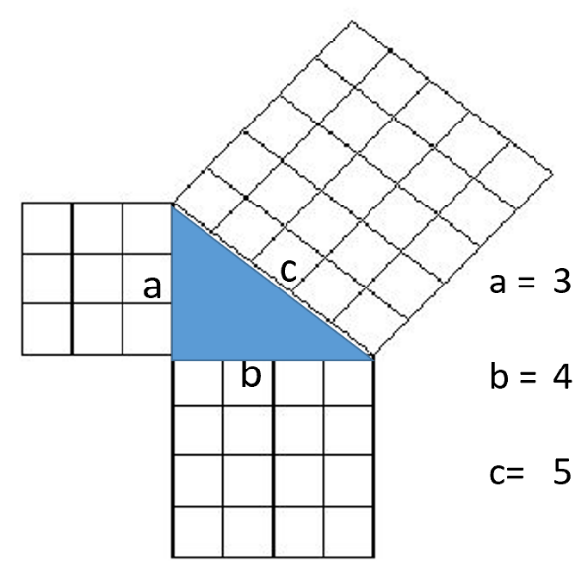
Vectors have both size and direction.
Sort the quantities into the correct column:
Mass distance acceleration speed velocity energy time power force displacement
Scalar | Vector
Mass | Force
Distance | Displacement
Speed | Velocity
Energy | Acceleration
Time
Power
If one vector is at right angles to another then we can use Pythagoras’ theorem to find out the resultant vector (combined effect of more than one vector).
c² = a² + b²
We can also use scale diagrams to find a resultant vector.
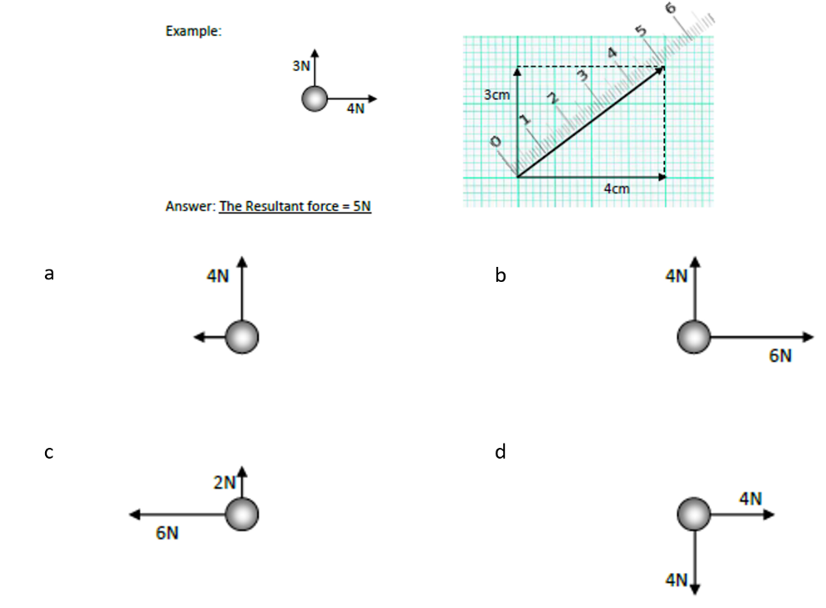
Task: Complete in exercise book
Basic
- What is a force? A force is a push or pull
- What is the unit of a force? newton (N)
- What do we use to measure forces? newton meter
- What is the definition of a scalar? A scalar quantity has size only but no direction. Give three examples of scalars. mass, distance, speed
- What is the definition of a vector? A vector quantity has size and direction. Give three examples of vectors. Velocity, displacement, force
- What is the equation for Pythagoras’ theorem? a²+b²=c²
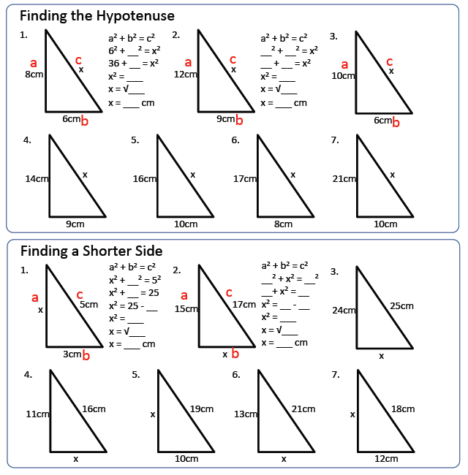
- Draw scale diagrams (1cm = 1N) to work out the resultant force in each of the cases to the right. a. 4.5N b. 7.2N c. 6.3N d. 5.7N

Medium
- Describe the difference between distance and displacement. Distance is how far an object has moved. It is scalar. Displacement is a vector quantity. It measures the distance and direction in a straight line from the start point to the finish point.
23.3cm

18.8cm
18.9cm
16.6cm
11.7cm
15cm
10cm
- Use Pythagoras’ theorem to calculate the missing lengths of each triangle to the right.
Hard
7cm
8cm
4cm
- A woman walks 200m east and then 100m south.
- Find the total distance travelled. 300m
13.4cm
16.5cm
16.2cm
11.6cm
- Now find the resultant displacement. 224m
- Dr. Edmunds’ cat Lola runs after a squirrel 40m North and 30m West.
- What is the distance that Lola has run? 70m
- What is Lola’s resultant displacement? 50m
- An aeroplane travels with a speed of 100 m/s North, and a speed of 20 m/s East. What is the plane’s overall velocity? 102m/s NE
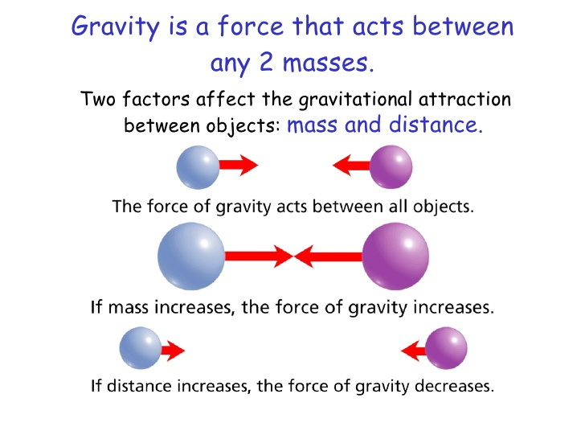
All objects have a force that attracts them towards each other. This force is due to gravity.
Mass, weight and gravity
Even you attract other objects to you because of gravity, but you have too little mass for the force to be very strong.
The strength of gravity at the surface of a planet is determined by its mass. g is a measurement of the gravitational field strength
The gravitational field strength on the surface of the earth is 9.8 N/kg
Weight is the force caused by gravity. The weight of an object can be calculated using the formula:
W = m x g
Where W is weight (in Newtons)
M is mass (in kg)
g is gravitational field strength (in N/kg)
The mass of an object is the amount of matter it contains.
The mass of an object stays the same wherever it is, but its weight can change depending on the gravitational field strength.
This happens if the object goes somewhere where gravity is stronger, or weaker, such as the Moon.
The Moon has less mass than the Earth, so its gravity is less than the Earth's gravity.
Basic:
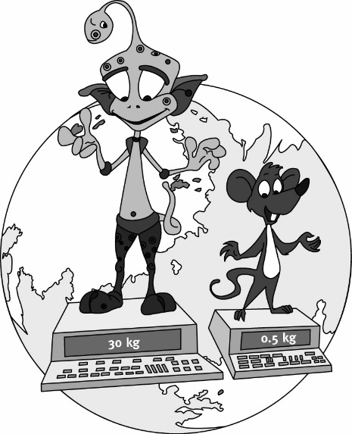
Arnie and Markey have been travelling the Solar
System on a mission to find out about weight on
all the planets. They came to Earth and found out
their mass in kilograms (shown in the picture).
Complete the tables for Arnie and Markey and fill in the missing numbers. Hint – information from elsewhere in the table could be useful!

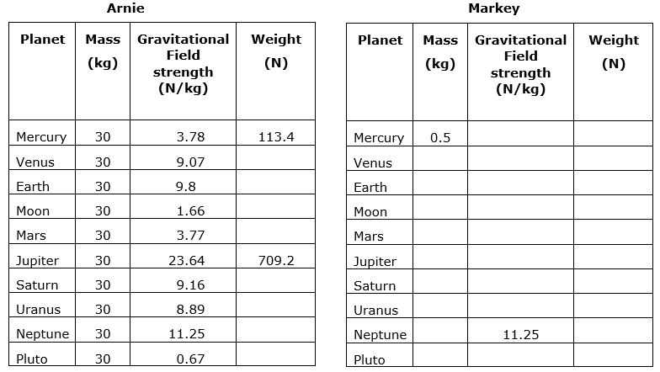
0.34
5.63
4.58
4.45
9.07
0.67
8.89
9.16
23.64
3.77
1.66
9.8
3.78
11.8
1.89
0.83
4.9
4.54
1.89
113.1
20.1
337.5
266.7
274.8
49.8
294
272.1
0.5
0.5
0.5
0.5
0.5
0.5
0.5
0.5
0.5
Medium: For these questions you need to re-arrange the formula. (g = 9.8 N/kg for questions 1-5).
- A Formula 1 car weighs 7150N, calculate its mass. 729.6kg
- A cat weighs 42 N, calculate its mass. 4.29kg
- A dog weighs 180 N, calculate its mass. 18.37kg
- An iPad weighs 2.2 N, calculate its mass. 0.22kg
- A Boeing 747 aeroplane weighs 1.9 × 10⁶ N, calculate its mass. 193878kg
- A man of mass 70 kg is standing on a planet where he weighs 1750 N. Calculate the planet’s gravitational field strength. 25N/kg
- The curiosity Rover was sent to search Mars. It has a mass of 900 kg weighs 3400 N while on Mars. Calculate Mars’ gravitational field strength. 3.78N/kg
Hard: Rearranging and unit conversion.
- An iphone has a weight of 1.2N on Earth. Calculate its mass in grams. 122.4g
- A bottle of water has a weight of 10N on Earth. Calculate its mass in grams. 1020g
- A car has a weight of 12 kN on Earth. Calculate its mass in kg. 1224.5kg
- A rocket of mass 133,000 kg has a weight of 500 kN on Mars. Calculate the gravitational field strength on Mars. 3.76N/kg

The diagram shows a helicopter being used to rescue a person from the sea.
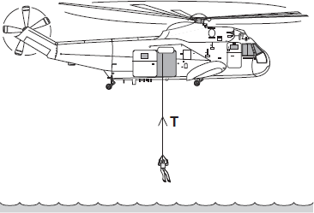
(a) The mass of the rescued person is 72 kg.
gravitational field strength = 9.8 N/kg
Show clearly how you work out your answer. (2)
Weight = mass x gravitational field strength
Weight = 72 x 9.8
Weight = 705.6
Weight = 705.6N
(b) To lift the person up to the helicopter, the electric motor transformed 21 600 joules of energy usefully.
(i) Use a form of energy from the box to complete the following sentence.

gravitational potential | heat | sound
The electric motor transforms electrical energy to kinetic energy. The kinetic
energy is then transformed into useful gravitational potential energy.
(1)
(ii) It takes 50 seconds for the electric motor to lift the person up to the helicopter.
Show clearly how you work out your answer and give the unit.
Choose the unit from the list below. (3)

coulomb (C) | hertz (Hz) | watt (W)
Power = $\frac{energy transferred}{time}$
Power = $\frac{21000}{50}$
Power = 420
Power = 420W

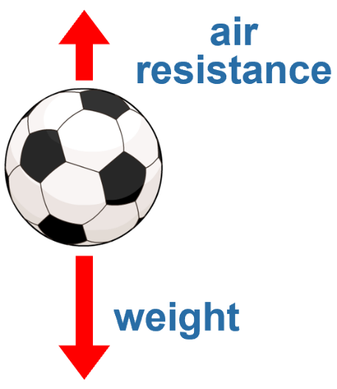
The forces acting on any object can be shown using a force diagram. A force diagram uses labelled arrows to show all the forces acting on the object.
Resultant forces
- The direction of each arrow shows the direction of each force.
- The length of each arrow is proportional to the size of the force.
The motion of the object will depend on the resultant force. This is calculated by adding all the forces together, taking their direction into account. When more than one force acts on an object, the forces combine to form a resultant force.
To draw resultant force you need to add one force onto the end of the other and draw a line from the start to the finish.
Mini task: Draw the resultant force of the force diagram to the right.

resultant
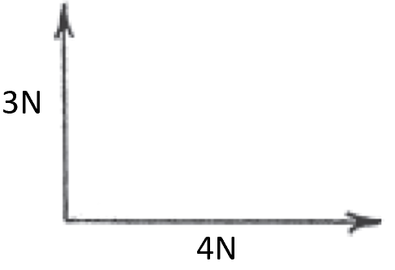
We can draw a scale diagram to find value of resultant force.
Mini task: In the space below draw a diagram (1 cm = 1N) of the force diagram to the left.

Basic
Support = 35N
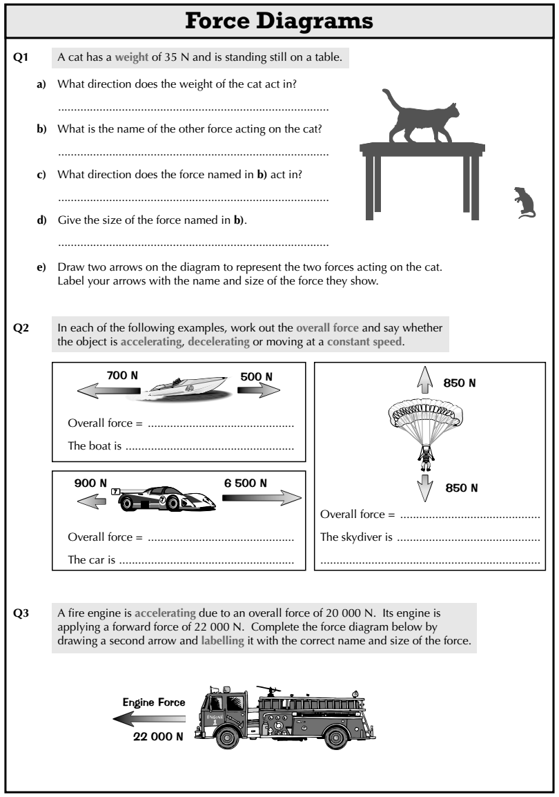
- What does the length of an arrow in a force diagram show? Size of force
- What does the direction of an arrow in a force diagram show? Direction of force
- A cat has a weight of 35N and is standing still on a table.
- What direction does the weight of the cat act in? downwards
- What is the name of the other force acting on the cat? reaction/support
Weight = 35N
- What direction does the force named in b) act in? upwards
- Give the size of the force named in b). 35N (equal to weight of cat)
- Draw two arrows on the diagram to represent the two forces acting on the cat. Label your arrows with the name and size of the force they show.
- In each of the examples to the right, work out the overall force and say whether the object is accelerating, decelerating or moving at a constant speed.
decelerating
200N left
0N
accelerating
at a constant velocity
5600N forwards

Medium
- Below we see a top view of an airplane being blown off course by wind in various directions. Draw the resultant speed and direction of travel for each case. In which case does the airplane travel fastest (d) & slowest (c) ?
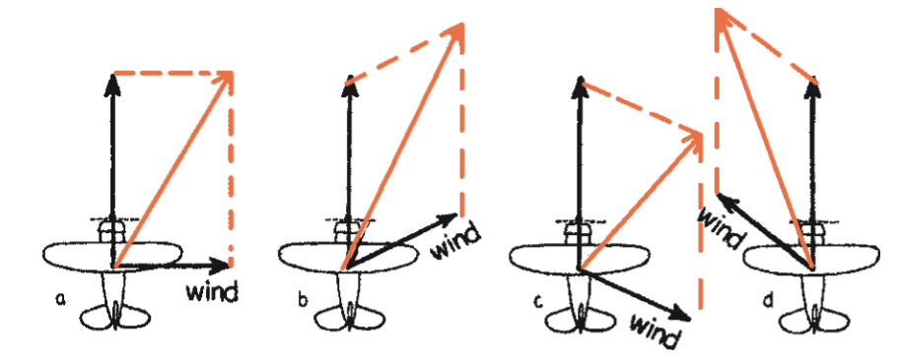
Hard
- If we ignore air resistance, we can assume that the horizontal velocity of an object does not change.
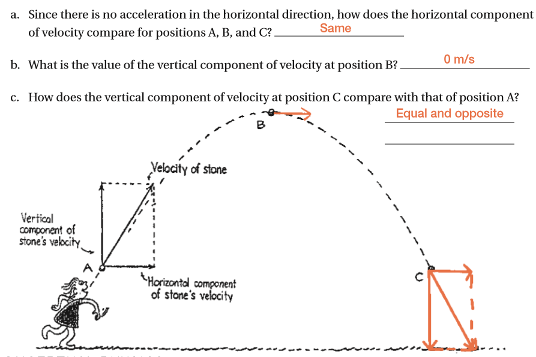

Figure 1 shows a boat floating on the sea. The boat is stationary.
Figure 1
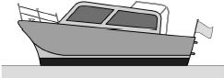
(a) Figure 2 shows part of the free body diagram for the boat.
Complete the free body diagram for the boat.
Figure 2
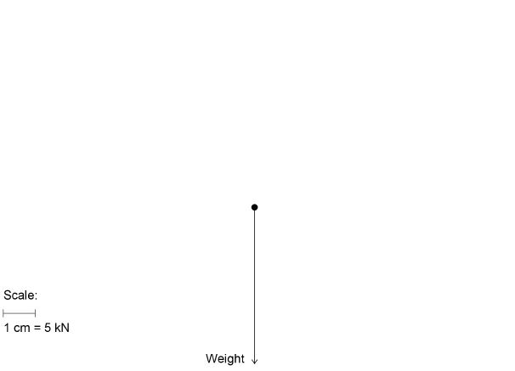
Upthrust
(2)
(b) Calculate the mass of the boat.
Use the information given in Figure 2.
gravitational field strength = 9.8 N/kg
Give your answer to two significant figures. (4)
Weight = 5 x 5kN = 25kN = 25000N
25000 = mass x 9.8
mass = 25000/9.8 = 2551
Mass = 2600 kg

(c) Figure 3 shows the boat towing a small dinghy.
Figure 3
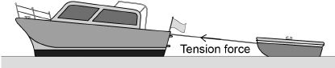
The tension force in the tow rope causes a horizontal force forwards and a vertical force upwards on the dinghy.
horizontal force forwards = 150 N
vertical force upwards = 50 N
Draw a vector diagram to determine the magnitude of the tension force in the tow rope and the direction of the force this causes on the dinghy.
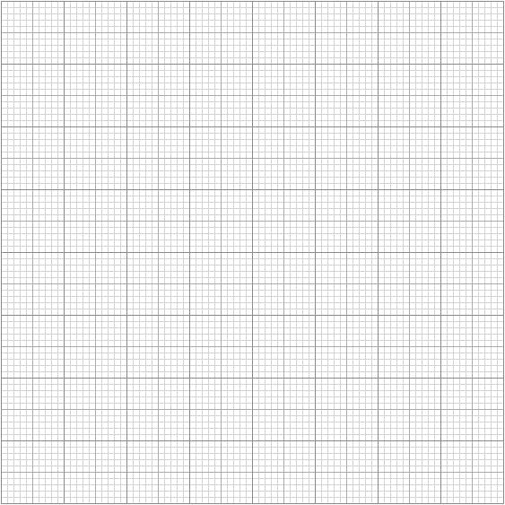
19°
157N
150N
50N
Magnitude of the tension force in the tow rope = 157 N
Direction of the force on the dinghy caused
by the tension force in the tow rope = 19°

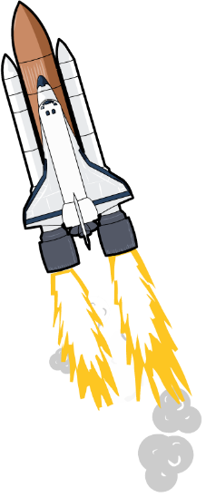
What happens when a rocket is launched into space?
Work done and energy transfer
When the rocket’s engines are fired, chemical energy in the fuel is transferred to kinetic energy in the rocket. This transfer of energy is called work.
work done = energy transferred
This means the units for work are the same as the units for energy – joules. For example, if a person does 500 J of work, then 500 J of energy is transferred.
Work done can be calculated using the following equation:
W = F × s
Where W is the work done (in Joules)
F is the force applied (in Newtons)
s is the distance travelled (in metres)

Example question: Mo Farah uses 50,000 Joules of energy while running, at a force of 10 N. How far has he run?
Step 1: Write the equation. Rearrange if necessary.
s = W ÷ F
Step 2: Write down the variables
W = 50,000 J
F = 10 N
Step 3: Calculate the answer
s = 50,000 ÷ 10 = 5,000m

Task: Complete in exercise book
Basic:
- What is work done? Energy transferred
W (joules) = F (newtons) × s (metres)
- Write the equation for work done. Include the units.
- Rearrange the equation for force and distance. $Force= \frac{work done}{distance}$ $distance= \frac{work done}{force}$
- Calculate the work done if:
- F = 5 N, s = 5 m 25J b) F = 150 N, s = 0.1 m 15J c) F = 0.2 N, s = 200 m 40J
- F = 2000 N, s = 1.5 m 3000J e) F = 800 N, s = 25 m 20kJ f) F = 150,000 N, s = 0.5 m 75kJ
- What is the work done if we apply a 1.2N force and we move 4m in the direction of force? 4.8J
- What is the work done if we apply a 7N force and we move 8m in the direction of the force? 56J
- A car drives with a force of 300,000 N over a distance of 200m. What is the work done by the car? 60MJ
Medium: Rearranging needed
- Calculate the distance moved if:
- W = 20 J, F = 10 N 2m b) W = 150 J, F = 7.5 N 20m c) W = 200,000 J, F = 2 N 100km
- W = 300 J, F = 0.5 N 600m e) W = 90,000 J, F = 4.5 N 20km f) W = 3,000 J, F = 9 N 333.3m
- Calculate the force if:
- W = 15 J, s = 0.75 m 20N b) W = 450 J, s = 225 m 2N c) W = 9000 J, s = 3000 m 3N
- W = 5000 J, s = 1250 m 4N e) W = 140 J, s = 35 m 4N f) W = 800 J, s = 0.2 m 1600N
- What distance is moved if we have a 8 N force and the work done is 90 J? 11.25m
- What is the distance moved if we have a 70 N force and work done is 8 J? 11.4cm
- What force is required to move 7 m if the work done is 9 J? 1.29N
Hard: Rearranging and unit conversion
- What is the work done when a force of 5kN is applied to a ball and it moves 0.8km? 4000000J or 4MJ
To go from kN to N → ⨯ 1000
- What is the work done to a car if a force of 9kN is applied and it moves 7km? 63000000J or 63MJ
To go from km to m → ⨯ 1000
- What force is required if 2.5kJ moves an object 56cm? 4464N
To go from cm to m → ÷ 100
- Dr. Edmunds’ cat Lola accelerates with a force of 220 N along a distance of 80 cm. Calculate the work done. 176J
- A teacher is late for a lesson and expends 400,000 J of energy sprinting to a lesson. If the distance covered is 0.2 km, with what force does the teacher sprint? 2000N or 2kN
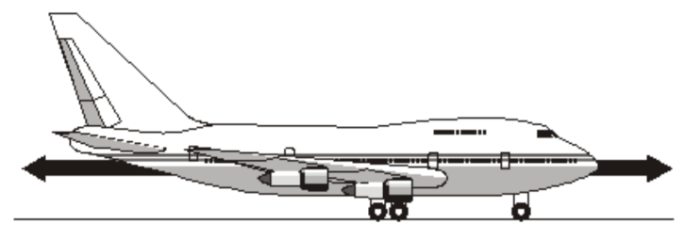
- An aeroplane does 1.2 × 10⁸ J of work in flying a distance of 400 km. With what force is the aeroplane flying? 300N
- a) The diagram shows an aircraft and the horizontal forces acting on it as it moves along a runway. The resultant force on the aircraft is zero.
- What is meant by the term resultant force?
The combined force acting on an object
- Describe the movement of the aircraft when the resultant force is zero. Constant velocity
- The aircraft has a take-off mass of 320,000 kg. Each of the 4 engines can produce a force of 240 kN. The aircraft takes a distance of 0.8 km to take off. Calculate the work done by the aircraft in taking off. 768MJ

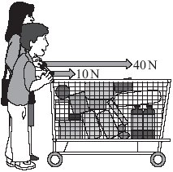
Q1.
The diagram shows an adult and a child pushing a loaded shopping trolley.

(a) (i) What is the total force on the trolley due to the adult and child?
50N (1)
(ii) Which one of the terms in the box means the same as total force?
Draw a ring around your answer.

answer force mean force resultant force
(1)
(iii) The trolley is pushed at a constant speed for 80 metres.
Calculate the work done to push the trolley 80 metres.
Show clearly how you work out your answer.
Work done = force x distance
Work done = 50 x 80
Work done = 4000J
(2)
(b) Complete the following sentences by drawing a ring around the correct word in each of the boxes.

(i) The unit of work done is the | joule  newton  watt | .
(1)

(ii) Most of the work done to push the trolley is transformed into | heat  light  sound | .
(1)
(Total 6 marks)

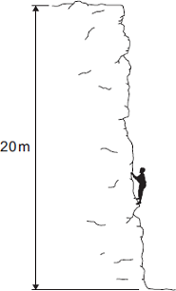
Q2.
The diagram shows a climber part way up a cliff.

(a) Complete the sentence.
When the climber moves up the cliff, the climber
gains gravitational potential energy.
(1)
(b) The climber weighs 660 N.
(i) Calculate the work the climber must do against gravity, to climb to the top of the cliff.
Work done = force x distance
Work done = 660 x 20
Work done = 13200J
(2)
(ii) It takes the climber 800 seconds to climb to the top of the cliff.
During this time the energy transferred to the climber equals the work done by the climber.
Use the equation in the box to calculate the power of the climber during the climb.
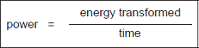
Calculate the power of the climber during the climb.
Power = $\frac{13200}{800}$
Power = 16.5W
(2)
(Total 5 marks)

Hooke’s law says that the amount a spring stretches is proportional to the amount of force applied to it.
Hooke’s law
F = k × e
Where:
- F is the applied force (in newtons, N),
- e is the extension (in metres, m)
- k is the spring constant (in N/m).
The spring constant measures how difficult it is to compress or stretch a spring.
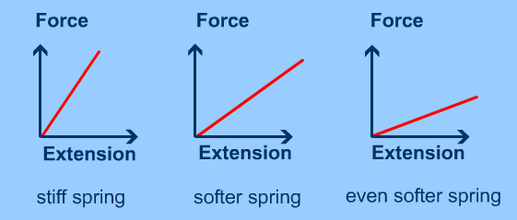
The larger the spring constant the more difficult is to compress or stretch.

If a material returns to its original size and shape when you remove the forces stretching or deforming it (reversible deformation), we say that the material is demonstrating elastic behaviour.
A plastic (or inelastic) material is one that stays deformed after you have taken the force away. If deformation remains (irreversible deformation) after the forces are removed then it is a sign of plastic behaviour.
If you apply too big a force a material will lose its elasticity.
Task: Complete in your exercise book
Basic
- a) What is the equation that links force, spring constant and extension? Force = spring constant x extension
b) What are the units of force, spring constant and extension? Force = newtons, spring constant = newtons/metre, extension = metres
- Calculate the force on a spring if:
- k = 10 N/m, e = 0.20 m. 2N
- k = 25 N/m, e = 0.05 m. 1.25N
- k = 150 N/m, e = 0.15 m. 22.5N
- If the spring constant is 30 N/m and a spring is stretched by 0.3m, how much force has been applied? 9N
- If the spring constant is 12.6 N/m and a spring is stretch by 0.25m, how much force has been applied? 3.15N
- What force would be needed to extend a spring with a spring constant k = 10 N/m by an extension of 0.3 m? 3N
Medium
- Re-arrange Hooke’s law to give equations for the spring constant k, and the extension e. You will need to use these equations for the rest of the medium questions. $spring constant= \frac{force}{extension}$ $extension= \frac{force}{spring constant}$
- Calculate the spring constant if:
- F = 150 N, e = 0.075 m. 2000N/m
- F = 50 N, e = 0.1 m. 500N/m
- Calculate the extension if:
- F = 15 N, k = 150 N/m. 0.1m
- F = 45 N, k = 90 N/m. 0.5m
- If a 6N weight is hung on a spring, and it extends by 0.2m, what is the spring constant? 30N/m
- If the force applied is 4.5 N and the spring constant is 9 N/m, how much will the spring extend by? 0.5m
Hard
- A mass of 620 g is hung on a spring of spring constant 31 N/m.
- Convert 620 g into kg. 0.62kg
To go from g to kg → ÷ 1000
- Using F = m × g, what is the force of the mass acting on the spring (g = 10 N/kg)? 6.2N
- Calculate the extension of the spring. 0.2m
- A spring of spring constant 40 N/m starts at a length of 13 cm, and it extends to a length of 21 cm.
- What is the extension of the spring (in cm)? 8cm
To go from cm to m → ÷ 100
- Convert this extension into metres. 0.08m
- What is the force on this spring? 3.2N
- A spring has a weight of 200g hanging on it, and has a spring constant of 40 N/m. Calculate the extension of the spring. 0.05m
- A spring has a weight of 500g hanging on it, and is stretched from a length of 5cm to a length of 15 cm. What is the spring constant of the spring? 50N/m
- A spring has a weight of 750g hanging on it, and is stretched from a length of 2.5cm to a length of 10 cm. What is the spring constant of the spring? 100N/m
Stretch: Write some of your own questions and solve them. To make them hard, put extension in cm/mm or give a mass in grams. Try to make the numbers realistic.

(a) When a force is applied to a spring, the spring extends by 0.12 m.
The spring has a spring constant of 25 N / m.
Calculate the force applied to the spring.
F = k x e
F = 25 x 0.12
Force = 3N
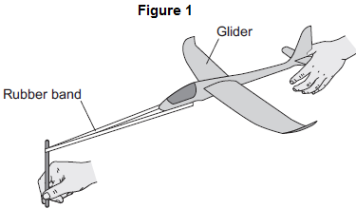
(b) Figure 1 shows a toy glider. To launch the glider into the air, the rubber band and glider are pulled back and then the glider is released.
(i) Use the correct answers from the box to complete the sentence.

chemical | elastic potential | kinetic | thermal
When the glider is released, the elastic potential energy
stored in the rubber band decreases and the glider gains
kinetic energy.

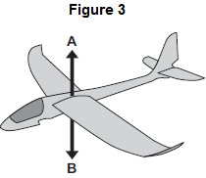
(c) Figure 3 shows the vertical forces, A and B, acting on the glider when it is flying.
(i) What name is given to the force labelled B?
Draw a ring around the correct answer.

drag | friction | weight
(ii) Which one of the following describes the downward speed of the glider when force B is greater than force A?
Tick () one box.
Downward speed increases | 
Downward speed is constant
Downward speed decreases
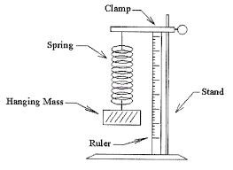
Aim: To investigate the relationship between force applied and the extension of a spring.
Hooke’s law practical
Materials: A spring, a clamp stand, clamps, rulers, 100g masses and mass hanger.
Method:
- Hang the spring on a clamp and add a splint so it’s easier to read the length.
- Making sure the splint is horizontal, take a reading on the ruler – this is the length of the unstretched spring (at Weight = 0.0 N)
- Carefully hook the 100g mass hanger onto the bottom of the spring. This weighs 1.0 newton (1.0 N).
- Take a reading of the length of the spring.
- Add further masses. Measure and record the length of the spring each time. Get at least 8 results.
- Calculate the extension i.e. the amount the string has stretched. To calculate this you subtract the length of the unstretched spring from each of your length readings.

Write your results in the table below:

Mass (kg) | Force (N) | Length (cm) | Extension (cm)
Plot a graph of extension (cm) vs Force (N) on the graph paper below.

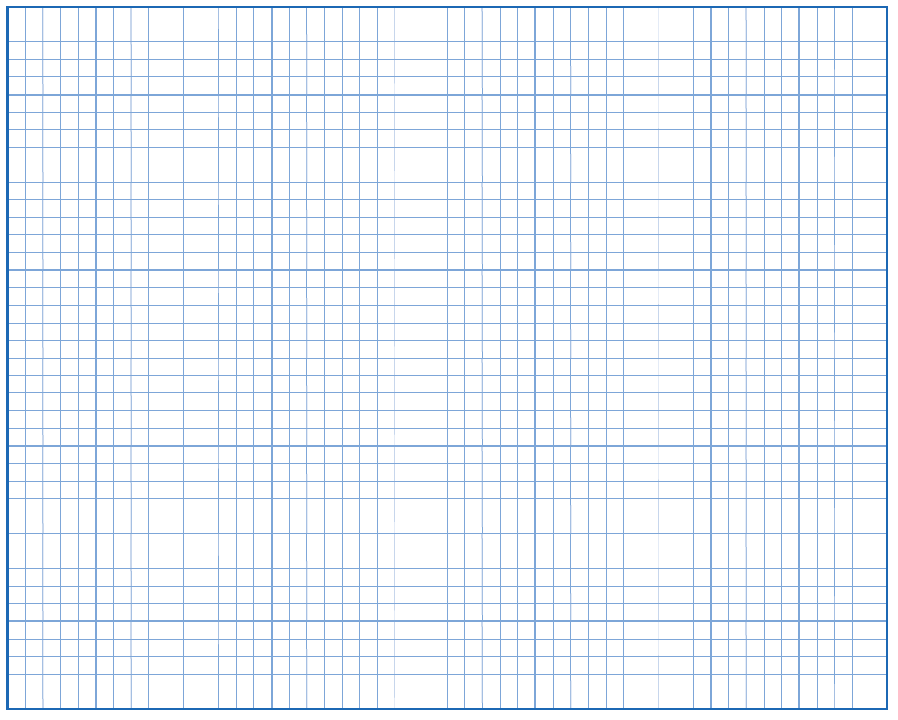

Stretch: Calculate the weight (in Newtons) of an unknown object:
1) Calculate the gradient of your straight line.
2) Hang the unknown object on the spring, and measure the extension.
3) The weight of the object is equal to your extension divided by your gradient.
4) Check the weight of the object with the measuring scales.
A student carried out an investigation to determine the spring constant of a spring.
The table gives the data obtained by the student.
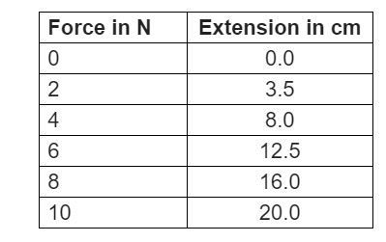

(a) The student measured the extension for five different forces rather than just measuring the extension for one force. Suggest why. (1)
To identify anomalies
The diagram below shows some of the data obtained by the student.
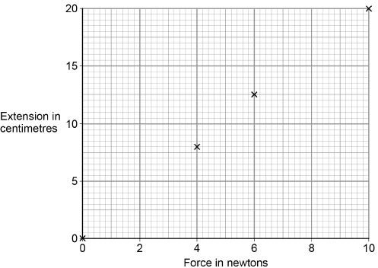
(b) Complete the diagram above by plotting the missing data from the table above. Draw the line of best fit. (2)
(c) Write down the equation that links extension, force and spring constant. (1)
Force = spring constant x extension
(d) Calculate the spring constant of the spring that the student used.
Give your answer in newtons per metre. (4)
F = 10N extension = 20cm = 0.2m
10 = spring constant x 0.2
Spring constant = 50 N/m
Distance is a scalar because it gives how far an object moves regardless of direction.
Distance and displacement
Displacement is a vector because it gives how far an object moves from its start position (measured in a straight line from the start point to the finish point)

This is Wayde van Niekerk, the 400 m world and Olympic champion. Wayde also holds the 400 m world record at 43.03 s.
During a race, Wayde travels a distance of 400 m from start to finish.

If he runs on an oval track, what will his displacement be?
Because he ends up back where he started his displacement is 0 m.
Example question:
A cat walks along a path from A to B. Calculate:
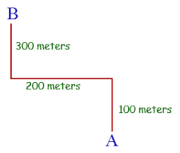
- The distance travelled.
Distance travelled = 100 + 200 + 300= 600 m
- The displacement.
This is more complicated:
- Draw a straight line between the start and finish points.
- Draw a triangle showing how far horizontally and vertically the cat has travelled.
- Use Pythagoras to calculate the displacement and give a direction.
$$a^{2}+b^{2}=c^{2}$$
$$→{200}^{2}+{400}^{2}= c^{2}$$
$→c= \sqrt{200,000}=447 m$ North West
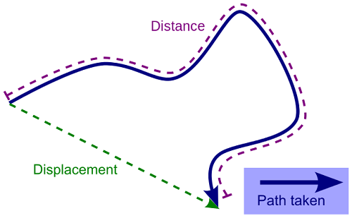
Basic
- Distance is how far an object has moved.
- Its value cannot be zero.
- It doesn’t depend on direction.
- Distance is a scalar
- Displacement is how far an object has moved from its original position.
- Its value can be zero.
- It depends on direction.
- Displacement is a vector.
Medium
- A man swims clockwise around a swimming pool and wants to know how far he has travelled at certain points. Calculate the distance travelled between:
A → C 1000m A → F 1800m A → G 2000m
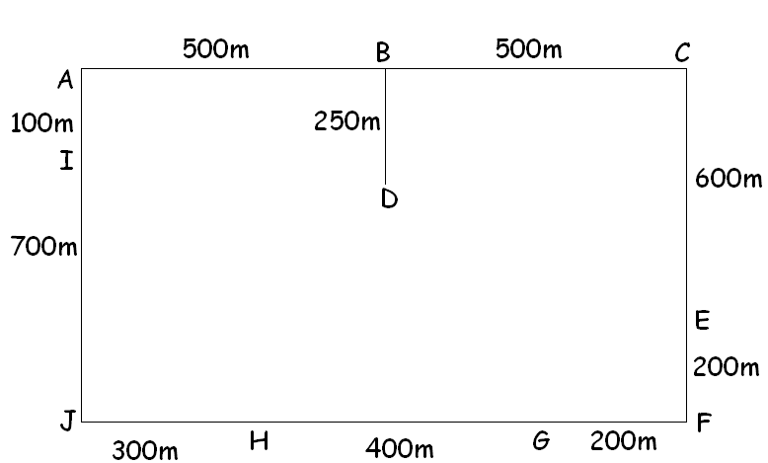
B → H 1900m F→ A 1700m H → A 1100m

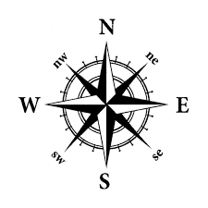
- If he swims around the pool 4.5 times, what is the distance that he has travelled? 4.5 x 3500m = 15750m
Hard: For some you will need to draw a triangle and use Pythagoras. Remember the direction it’s going in as well.
- Now find his displacement between the following points:
A → C 1000m E A → F 1281m SE A → G 1130m SSE
B → H 830m SSW F→ A 1281m NW H → A 850m NNW
- He swims from point A → B → D for a chat with his friend.
- Calculate the distance (in km) he has swum. 0.75km
To go from m to km → ÷ 1000
- Calculate his displacement (in km). 0.56km ESE
- He completes 3 laps of the pool.
- Calculate the distance (in km) he has swum. 10.5km
- Calculate his displacement (in km). 0km

A train travels from town A to town B.
Figure 1 shows the route taken by the train.
Figure 1 has been drawn to scale.
Figure 1
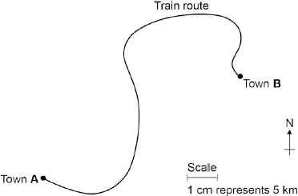
(a) The distance the train travels between A and B is not the same as the displacement of the train.
What is the difference between distance and displacement?
Distance is a scalar quantity (magnitude only) and displacement is a vector quantity (magnitude and direction)
(1)
(b) Use Figure 1 to determine the displacement of the train in travelling from A to B.
Show how you obtain your answer.
7.4cm x 5km = 37.0
Displacement = 37.0 km
Direction = 61°NE
(2)
(c) There are places on the journey where the train’s velocity changes without changing speed.
Explain how this can happen. (2)
Velocity is a vector quantity and can be calculated by $\frac{displacement}{time}$. Speed is scalar and can be calculated by $\frac{distance}{time}$. Because displacement is distance with direction, if direction changes then there must be a change in velocity (acceleration) even though there may not be a change in speed.

