
(motion)
Combined Science
Forces
Name ______________________________
Class ______________________________
Teacher ______________________________

Forces & motion facts
- What is the difference between distance and displacement?
- What are typical values for walking, running and cycling speeds?
- What is the speed of sound?
- What is the equation for speed?
- What is the difference between speed and velocity.
- How can we calculate the speed of an object from a distance-time graph.
- What is the equation for acceleration?
- How can we calculate the acceleration of an object from a velocity-time graph?
- How can we calculate the distance travelled from a velocity-time graph?
- What do the symbols in the equation v² – u² = 2 × a × s all stand for?
- What happens to the force of air resistance as an object travels faster?
- If an object is falling, why does it reach a terminal velocity?
- What does Newton’s first law say?
- What does Newton’s second law say?
- What does Newton’s third law say?
- What is the stopping distance of a vehicle?
- What is a typical reaction time for a person?
- What can affect a driver’s reaction time?
- What can affect the braking distance of a vehicle?
- What happens when force is applied to the brakes of a vehicle?
- What happens if the braking force is larger?
- What is the equation for momentum?
- What is the conservation of momentum?

- Distance is a scalar, while displacement is a vector.
- Walking speed – 1.5 m/s, running speed – 3 m/s, cycling speed – 6 m/s
- 330 m/s
- Speed = distance ÷ time (v = s ÷ t)
- The velocity of an object is its speed in a given direction. Velocity is a vector.
- The speed of an object can be calculated from the gradient of a distance-time graph.
- a = Δv ÷ t
- The acceleration can be calculated from the gradient of a velocity-time graph.
- The distance travelled can be calculated from the area under a velocity-time graph.
- v – final velocity (m/s), u – initial velocity (m/s), a – acceleration (m/s²), s – distance travelled (m)
- The air resistance increases.
- As an object falls, it accelerates and its velocity increases. This means the air resistance increases. When the air resistance is equal to the weight of the object, the forces are balanced. The resultant force will then be zero and the object will no longer accelerate and move at its terminal velocity.
- If the resultant force is zero then an object either remains stationary or remains moving at the same speed in the same direction.
- The acceleration of an object is proportional to the resultant force on the object, and inversely proportional to the mass of the object (F = m × a)
- When two objects interact, the forces they exert on each other are equal and opposite.
- It is the sum of the distance the vehicle travels during the driver’s reaction time (thinking distance) and the distance it travels under the braking force (braking distance). Stopping distance = thinking distance + braking distance.
- 0.2 to 0.9s.
- Tiredness, drugs and alcohol.
- Adverse road and weather conditions (wet/icy roads) and poor condition of the vehicle (worn tyres/brakes)
- Work done by the friction force between the brakes and the wheel reduces the kinetic energy of the vehicle and the temperature of the brakes increases.
- The greater the braking force the great the deceleration of the vehicle. Large decelerations may lead to brakes overheating and/or loss of control.
- p = m × v
- In a closed system, the total momentum before an event is equal to the total momentum after an event.

Fold page here
Speed is a measure of how far an object has moved in a certain time. Speed is a scalar, while velocity is a vector.
Speed
They both can be calculated using the equation:
v = s ÷ t

where v is the velocity or speed (in m/s)
s is the distance (in m)
t is the time (is s)
Example question: Usain Bolt ran his 100m world record at an average speed of 10.44 m/s. How long did it take for him to finish the race?
Step 1: Write the equation. Rearrange if necessary.
t = s ÷ v
Step 2: Write down the variables
s = 100 m
v = 10.44 m/s
Step 3: Calculate the answer
t = 100 ÷ 10.44 = 9.58 s
The average person walks at a speed of 1.5 m/s, runs at a speed of 3 m/s and cycles at a speed of 6 m/s. The speed of sound in air is 330 m/s.
Speed can also be measured in units of kilometres per hour (km/h) or miles per hours (mph).

Basic Q1 Work out the speed of a car travelling on a straight track for:
a) 100 m in 10 s e) 1000 m in 200 s
b) 320 m in 16 s f) 300 m in 20 s
c) 1500 m in 180 s g) 50 m in 4 s
d) 700 m in 35 s h) 450 m in 22 s
Medium Q2 How far does a bus move if it’s travelling at:
a) 10 m/s for 30 s e) 15 m/s for 28 s
b) 15 m/s for 20 s f) 20 m/s for 20 s
c) 12 m/s for 180 s g) 100 m/s for 300 s
d) 5 m/s for 70 s h) 180 m/s for 20 s
Q3 How long does it take a car to travel:
a) 10 m at 20 m/s e) 180 m at 6 m/s
b) 50 m at 10 m/s f) 40 m at 12 m/s
c) 55 m at 30 m/s g) 200 m at 8 m/s
d) 90 m at 20 m/s h) 2,000 m at 16 m/s
Hard
To go from km to m → × 1000
Q4 A plane travels 15 km in 3 mins.
- Convert 15 km into m.
- Convert 3 mins into seconds.
- How fast is the plane travelling?
Q5 A runner runs at 3 m/s for 5 minutes. How far have they run?
Q6 A bird flies at a speed of 7 m/s for 3 minutes. How far has it travelled?
Q7 A car travels 15 metres in 2 seconds.
- Calculate its speed.
- How long would it take the car to travel 2km?
Q8 A bus travels 50 km in 2 hours. Calculate its speed in
- km/h b) m/s.
Q9 A car travels 100 km in 90 minutes. Calculate its speed.
Q10 A train travels at 30 m/s for 2 minutes. How far has it travelled in this time?
Q11 A car travels at 30 km/hour. How far, in metres, will the car cover in 90 seconds?
Q12 A cyclist travels 20 km in one hour. What is the average speed?
Conversion questions
There are 1,600m in one mile. Convert 30 mph into metres/second.
Copy the model answer in the space below:

Task:
- Usain Bolt sprints at 23 mph. Convert his speed into m/s.
- A car drives at 70 mph on the motorway. Convert the car’s speed to m/s.
- A train travels at 100 mph. Convert the trains speed to m/s.
- An aeroplane travels at 500 mph. Convert the plane’s speed to m/s.
- Bradley Wiggins cycles at a speed of 40 mph. Convert his speed into m/s.
- During a hurricane, there are winds of 80 mph. What is the speed of the wind in m/s?

Q1.
A car has an oil leak. Every 5 seconds an oil drop falls from the bottom of the car onto the road.
(a) What force causes the oil drop to fall towards the road?
___________________________________________________________________
(1)
(b) The diagram shows the spacing of the oil drops left on the road during part of a journey
Describe the motion of the car as it moves from A to B.
___________________________________________________________________
Explain the reason for your answer.
___________________________________________________________________
___________________________________________________________________
___________________________________________________________________
___________________________________________________________________
(3)
(c) When the brakes are applied, a braking force slows down and stops the car.
A braking force of 3 kN is used to slow down and stop the car in a distance of 25 m.
Calculate the work done by the brakes to stop the car and give the unit.
______________________________________________________________
______________________________________________________________
______________________________________________________________
Work done =_________________________
(3)
(Total 7 marks)

A distance-time graph can be used to see when an object is stationary or travelling at a constant speed.
Distance-time graphs
The steeper the slope, the faster the speed. The gradient (slope) of a distance-time graph shows the speed. This is because of the equation for speed:
v = s ÷ t
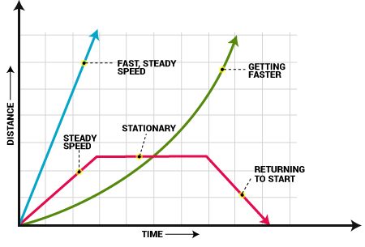

If the distance-time graph is a straight line then the object is moving at a constant velocity. A steeper gradient on a straight line means a faster constant velocity.
An upwards curve means that the object is accelerating and a curve that’s levelling off shows an object is decelerating.
A flat line shows an object is stationary as its not travelling any distance. A line with a negative gradient shows that the object is travelling back in the reverse direction.

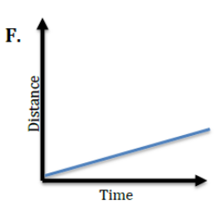
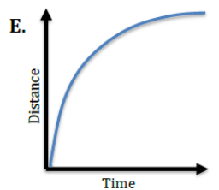
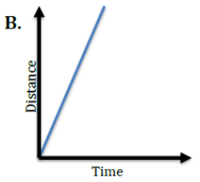
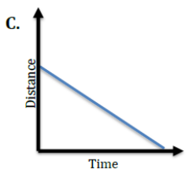
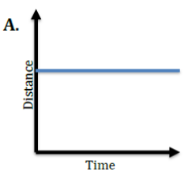
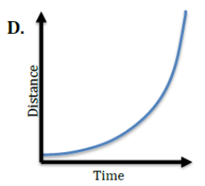
Basic: For each graph below, match the description of the object’s motion.

- _____ Speeding Up (acceleration) 6. _____ No Motion (stopped)
- _____ Constant Speed (high rate of speed) 7. _____ Slowing Down (deceleration)
- _____ Constant Speed (low rate of speed) 8. _____ Moving Backwards (constant velocity
in reverse)

Medium: Calculate the speeds in each of the distance time graphs.
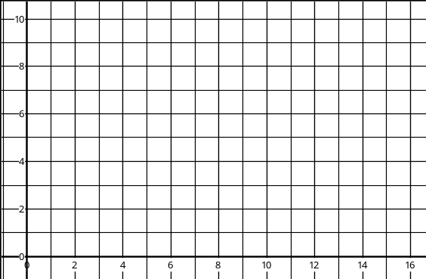
Distance (m)
Time (s)
f)
e)
Time (s)
Distance (m)
d)
Time (s)
Distance (m)
Distance (m)
Time (s)
b)
c)
Distance (m)
Time (s)
Distance (m)
Time (s)
a)

Hard:
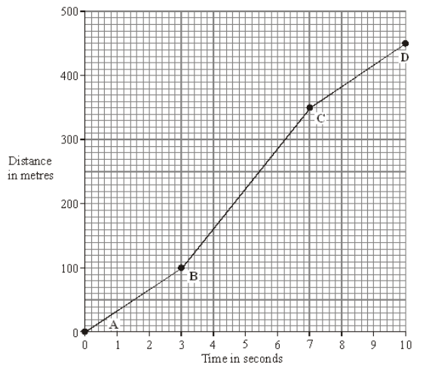
- Describe the motion of the car between point A and point D. You should not carry out any calculations.
- Calculate the gradient of the graph between:
- Point A and point B
- Point B and point C
- Point C and point D.
- Another car travels at a constant velocity of 40m/s. Draw the distance time graph for this car.
- At what time does the first car overtake the second?

Q1.
Part of a bus route is along a high street.
The distance – time graph shows how far the bus travelled along the high street and how long it took.
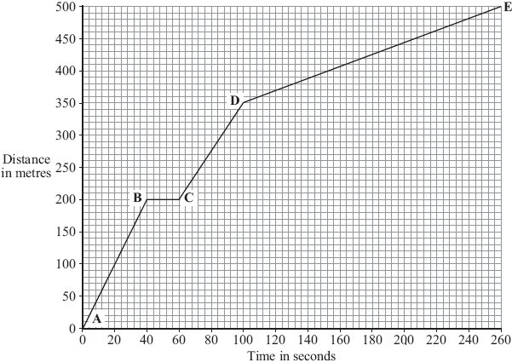
(a) The bus travels the slowest between points D and E.
How can you tell this from the graph?
___________________________________________________________________
___________________________________________________________________
(1)
(b) Between which two points was the bus travelling the fastest?
Put a tick () in the box next to your answer.

Points
A – B
B – C
C – D
(1)

(c) There is a bus stop in the high street.
This is marked as point B on the graph.
(i) What is the distance between point A on the graph and the bus stop?
Distance _______________ metres
(1)
(ii) How long did the bus stop at the bus stop?
Show clearly how you work out your answer.
______________________________________________________________
Time = _______________ seconds
(2)
(d) A cyclist made the same journey along the high street.
The cyclist started at the same time as the bus and completed the journey in 200 seconds. The cyclist travelled the whole distance at a constant speed.
(i) Draw a line on the graph to show the cyclist’s journey.
(2)
(ii) After how many seconds did the cyclist overtake the bus?
The cyclist overtook the bus after _______________ seconds.
(1)
(Total 8 marks)

Acceleration is a measure of how much the velocity changes by in a given time:
Acceleration

Acceleration = change in velocity ÷ time taken
$$a= ∆v÷t$$
where a is the acceleration (in m/s²)
Δv is the change in velocity (in m/s)

t is the time (in s).
Note that this equation has be re-written as:
$$a=(v-u)÷t$$
where v is the final velocity (in m/s)
u is the initial velocity (in m/s).
Example question: Dina Asher-Smith accelerates from a speed of 2 m/s to 8 m/s in a time of 2 seconds. Calculate her acceleration.
Step 1: Write the equation. Rearrange if necessary.
a = Δv ÷ t
Step 2: Write down the variables
Δv = 8 – 2 = 6 m/s
t = 2 s
Step 3: Calculate the answer
a = 6 ÷ 2 = 3 m/s²

Task: Complete in your exercise book
Basic Q1 Calculate the acceleration when:
- Δv = 20 m/s, t = 5 s b) Δv = 50 m/s, t = 25 s c) Δv = 15 m/s, t = 3 s d) Δv = 40 m/s, t = 10 s
e) Δv = 80 m/s, t = 4 s f) Δv = 50 m/s, t = 2.5 s g) Δv = 70 m/s, t = 35 s h) Δv = 80 m/s, t = 4 s
Q2 Change in speed = 14 m/s, time taken = 2 seconds. Calculate the acceleration.
Q3 A car accelerates from rest (zero speed) up to a speed of 30 m/s in 12 seconds. Calculate the acceleration.
Q4 A car travels from rest to 65 m/s in 10 seconds. What is its acceleration?
Q5 A car travels from rest to 56 m/s in 28 seconds. What is its acceleration?
Medium
Q6 A cyclist accelerates from 0 m/s to 8 m/s in 3 seconds.
- What is his acceleration?
- Is this acceleration higher than that of a car which accelerates from 0 to 30 m/s in 8 seconds?
Q7 A cyclist in the Tour de France accelerates down a hill from 22 m/s to a speed of 37 m/s. This acceleration takes him 2 seconds.
a) What is the change in velocity?
b) Calculate the acceleration.
Q8 A car is travelling at a steady speed of 28 m/s and its velocity changes to 38 m/s in 20 seconds. What is its acceleration?
Q9 A lizard accelerates from 2 m/s to 10 m/s in 4 seconds. What is the lizard’s average acceleration?
Q10 Re-arrange the equation for acceleration to give equations for change in velocity and time taken
Hard
Q11 Complete the following table.
Acceleration (m/s²) | Starting speed (m/s) | Final speed (m/s) | Time taken (s)
 | 2 | 6 | 2
2 | 5 | 25
10 | 4 |  | 2
8 | 5 |  | 10
4 |  | 8 | 2

Q12 If a Ferrari, with an initial velocity of 10 m/s accelerates at a rate of 50 m/s² for 3 seconds, what will its final velocity be?
Q13 A car starts from stationary and then increases its speed to 50m/s in 50s
- Calculate its acceleration
- It then slows its speed by 20% in 10s calculate the deceleration
Q14 In a motorcycle test the speed from rest was recorded as intervals in the table below
- Plot a velocity time graph of these results
- Calculate the initial acceleration of the motorcycle
- Calculate how far the motorcycle moved in the first 20s and the following 10s
- Calculate the velocity of the motorcycle after 1.0km from the start if it had kept the same acceleration as it had during the first 20s

(a) The arrows in the diagram represent the size and direction of the forces on a space shuttle, fuel tank and booster rockets one second after launch. The longer the arrow the bigger the force.
Thrust force
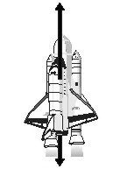
Weight of shuttle, fuel tanks and
booster rockets plus air resistance
(i) Describe the upward motion of the space shuttle one second after launch.
______________________________________________________________
(1)
(ii) By the time it moves out of the Earth’s atmosphere, the total weight of the space shuttle, fuel tank and booster rockets has decreased and so has the air resistance.
How does this change the motion of the space shuttle? (Assume the thrust force does not change).
______________________________________________________________
(1)
(b) The space shuttle takes 9 minutes to reach its orbital velocity of 8100 m/s.
(i) Write down the equation that links acceleration, change in velocity and time taken.
______________________________________________________________
(1)
(ii) Calculate, in m/s², the average acceleration of the space shuttle during the first 9 minutes of its flight. Show clearly how you work out your answer.
______________________________________________________________
______________________________________________________________
average acceleration = _______________________ m/s²
(2)
(iii) How is the velocity of an object different from the speed of an object?
______________________________________________________________
______________________________________________________________
(1)
(Total 6 marks)

Time (s) | Speed (m/s)
0 | 0
5 | 8
10 | 15
15 | 23
20 | 30
25 | 30
30 | 30
35 | 30
40 | 20
45 | 10
50 | 0
55 | 0
Velocity-time graphs
Diagonally Up
Constant Acceleration
Horizontal
Constant speed
Diagonally Down
Constant Deceleration
Gradient
This is the acceleration of the object.
Area under the graph
This is the distance travelled by the object.

Task: Plot a velocity-time graph for the above object.
Label where:
-The object is accelerating.
-The object is travelling at a constant speed.
-The object is decelerating.
-The object is stationary.
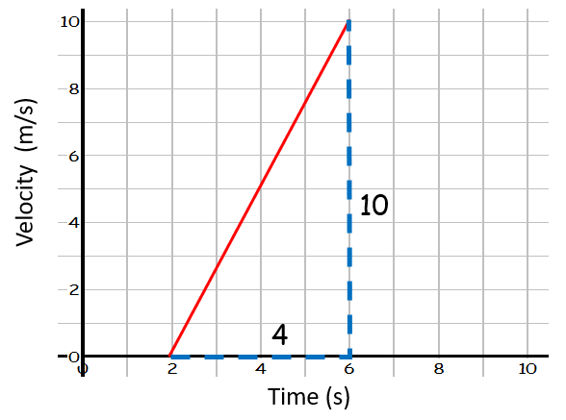
Worked Examples
- Find the acceleration of the object.
a = Δv ÷ t
= 10 ÷ 4
= 2.5 m/s²
- Find the distance travelled by the object.
Distance travelled = area under line
= area of triangle
= ½ b × h = ½ 4 × 10 = 20 m

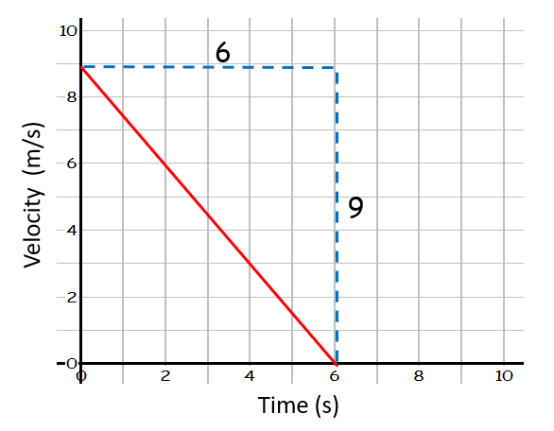
- Find the acceleration of the object.
a = Δv ÷ t
= -9 ÷ 6
= -1.5 m/s²
- Find the distance travelled by the object.
Distance travelled = area under line
= area of triangle
= ½ b × h = ½ 6 × 9 = 27 m

Harder worked example
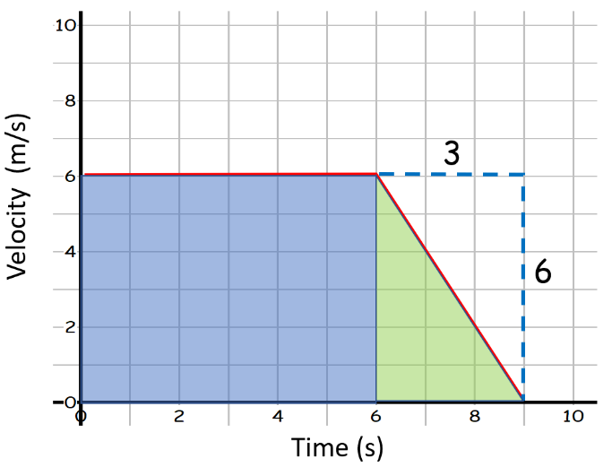
Find the distance travelled by the object.

Distance travelled = area under line
= area of square (in blue) + area of triangle (in green)
= (6 × 6) + (½ 6 × 3) = 45 m

Basic: Write what each graph shows: constant velocity, stationary, positive constant acceleration, negative constant acceleration, increasing acceleration or decreasing acceleration.
For example; graph a) shows ___________________.
f)
Time (s)
Velocity (m/s)
Velocity (m/s)
Time (s)
e)
Velocity (m/s)
Time (s)
d)
Velocity (m/s)
Time (s)
b)
c)
Time (s)
Velocity (m/s)
a)
Time (s)
Velocity (m/s)

Medium: Calculate: 1) The acceleration for each of the graphs below (using the gradient).
2) The distance travelled for each of the graphs below (using the area under the graph).
f)
Time (s)
Velocity (m/s)
Velocity (m/s)
Time (s)
e)
Velocity (m/s)
Time (s)
d)
Velocity (m/s)
Time (s)
b)
c)
Time (s)
Velocity (m/s)
a)
Time (s)
Velocity (m/s)

Hard: Calculate the distance travelled for each of the graphs below (you will have to divide the area under the graph into different shapes and add up the areas of each shape to give a total area).
f)
Time (s)
Velocity (m/s)
Velocity (m/s)
Time (s)
e)
Velocity (m/s)
Time (s)
d)
Velocity (m/s)
Time (s)
b)
c)
Time (s)
Velocity (m/s)
a)
Time (s)
Velocity (m/s)

The graph below shows the speed of a runner during an indoor 60 metres race.
- Calculate the acceleration of the runner during the first four seconds.
- How far does the runner travel during the first four seconds?
- How long does the runner take to decelerate after the end of the race?
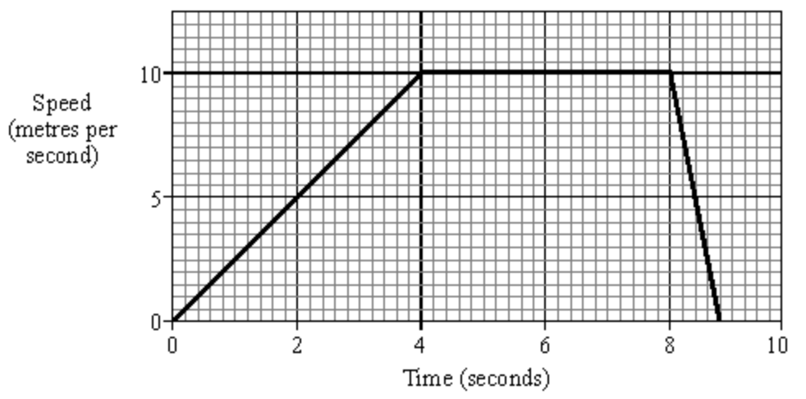
- What is the total distance travelled by the runner?

Q1.
(a) Some students have designed and built an electric-powered go-kart. After testing, the students decided to make changes to the design of their go-kart.
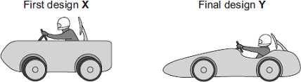
The go-kart always had the same mass and used the same motor.
The change in shape from the first design (X) to the final design (Y) will affect the top speed of the go-kart.
Explain why.
___________________________________________________________________
___________________________________________________________________
___________________________________________________________________
___________________________________________________________________
___________________________________________________________________
___________________________________________________________________
(3)
(b) The final design go-kart, Y, is entered into a race.
The graph shows how the velocity of the go-kart changes during the first 40 seconds of the race.
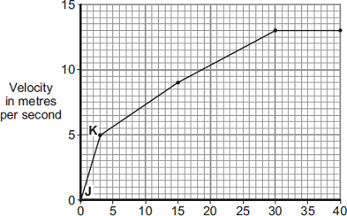
Time in seconds

(i) Use the graph to calculate the acceleration of the go-kart between points J and K.
Give your answer to two significant figures.
______________________________________________________________
______________________________________________________________
______________________________________________________________
Acceleration = ____________________ m/s²
(2)
(ii) Use the graph to calculate the distance the go-kart travels between points J and K.
______________________________________________________________
______________________________________________________________
______________________________________________________________
Distance = ____________________ m
(2)
(iii) What causes most of the resistive forces acting on the go-kart?
______________________________________________________________
(1)
(Total 8 marks)

Acceleration II
v² - u² = 2 × a × s
where v = final velocity (in m/s)
u = initial velocity (in m/s)
a = acceleration (in m/s²)
s = distance (m)

Occasionally some variables in a question can be hidden. The following are some examples of hidden variables:

Initially at rest = initial velocity (u) is 0 m/s
Constant velocity = acceleration of 0 m/s²
Acceleration due to gravity = g of 9.8 m/s²

Worked example:

A horse starts at rest. It accelerates at 3m/s² over a distance of 40m. What will its final velocity be?

v² – u² = 2 x a x s
v² – 0 = 2 x 3 x 40
v² = 240
v = √240 = 15.5 m/s

Task: Complete in your exercise book.
- A sports car starts at rest. It accelerates at 11.25 m/s² over a distance of 32m. What will its final velocity be?
- Dr. Edmunds’ cat Lola jumps at a mouse that is 1.5m away. Lola starts from rest and accelerates at 12 m/s². What will Lola’s final velocity be when she reaches the mouse?
- A sloth starts from rest and accelerates at 0.02 m/s² over a distance of 40m before reaching its top speed (final velocity). What will the sloths top speed be?
- A super tanker accelerates 0.1 m/s² over a distance of 1.5 km to reach its maximum speed. What will its maximum speed be?
Worked example:

A kangaroo is bouncing at 20m/s when it accelerates at 2m/s² over a distance of 15m. What will its final velocity be?

v²- u² = 2 x a x s
v²– 20² = 2 x 2 x 15
v² - 400 = 60
v² = 60 + 400
v = √460 = 21.4 m/s

Task: Complete in your exercise book.

- A helicopter is flying at 35m/s when it accelerates at 4m/s² over a distance of 300m. What will its final velocity be?
- A lorry driver is driving at 45m/s when she hits the breaks. The lorry slows down with an acceleration of –5m/s² over a distance of 200m before driving on normally. What will its final velocity be?

Harder questions: For these you first need to use a = Δv ÷ t and then use
v² - u² = 2 × a × s

- a) Usain Bolt starts from rest and reaches a top speed of 12 m/s in 6 seconds. What is his acceleration?
b) Using your answer from part a) and assuming he ran at a constant acceleration, what was his final velocity after he had travelled 10m?
- a) A space shuttle starts from rest and reaches a speed of 44 m/s after only 8 seconds. What was its acceleration?
b) If the shuttle started at 10 m/s and accelerated at the same rate over a distance of 2 km, what would its final velocity be?
- a) A squirrel is moving at 0.2 m/s. It accelerates to 1.4 m/s in one minute. What was its acceleration?
b) If the squirrel kept accelerating at this rate, with what speed would it head-butt the fence after travelling the full length of the 11m garden?

Figure 1 shows an electric wheelchair.
Figure 1
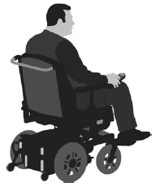
(a) The wheelchair moves at a constant speed of 2.4 m/s for 4.5 seconds.
Calculate the distance moved by the wheelchair.
___________________________________________________________________
___________________________________________________________________
___________________________________________________________________
___________________________________________________________________
Distance = ____________________ m
(2)
(b) What could be a reason for the speed of the wheelchair decreasing?
Tick one box.

It started going downhill. | 
It started going uphill.
Its store of kinetic energy increased.
It used more power from its battery.
(1)

A student measured how the distance travelled by the wheelchair changed over time.
Figure 2 shows a sketch-graph of the results.
Figure 2
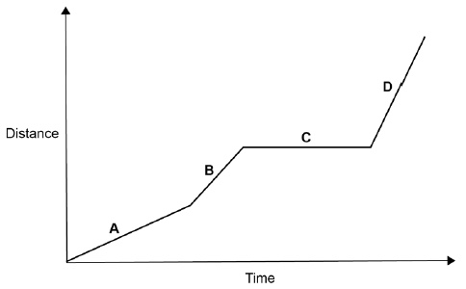
(c) In which section of the graph, A, B, C, or D, did the wheelchair travel fastest?
Give the reason for your answer.
Section ____________________
Reason ____________________________________________________________
___________________________________________________________________
(2)
The velocity of the wheelchair changes as it accelerates to its top speed.
Figure 3 shows a sketch-graph of the changes.
Figure 3
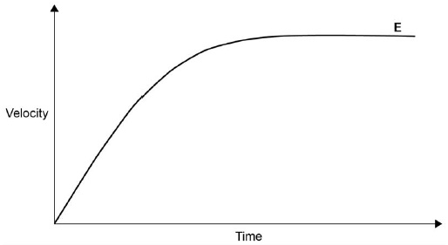

(e) The forward force on the wheelchair is constant as it accelerates on flat ground.
Which force reduces the acceleration? (1)
Tick one box.

Air resistance
Magnetism
Tension
Weight
(g) The wheelchair starts from rest.
It accelerates at a constant rate until it has a speed of 1.5 m/s
The wheelchair travels a distance of 2.0 m while it is accelerating.
Calculate the acceleration of the wheelchair.
Using the Physics Equations Sheet. (3)
___________________________________________________________________
___________________________________________________________________
___________________________________________________________________
___________________________________________________________________
___________________________________________________________________
___________________________________________________________________
Acceleration = ____________________ m/s²

Newton’s laws
Newton’s 1st law:
An object:
-At rest remains at rest.
-Moving remains moving at constant velocity.
Unless a resultant force acts on it.

Newton’s 2nd law:
The acceleration of an object is directly proportional to the force applied. The acceleration of an object is also inversely proportional to the mass of an object. This can be summarised by the equation below:
Force = mass × acceleration
$$F= m×a$$
where F is the force (in N)
m is the mass (in kg)
a is the acceleration (in m/s²).
Newton’s 3rd law:
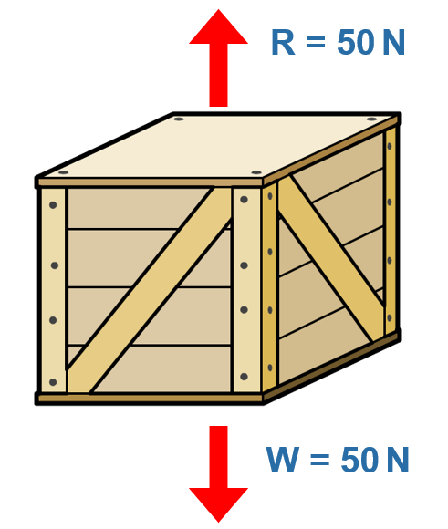
Every force has an equal and opposite reaction force.
For example, take the crate to the right. It has a weight of 50 Newtons. Because it is stationary on the ground and not moving it therefore must have an equal force in the opposite direction. This force (when the crate is on a surface) is called the reaction force and is also equal to 50 Newtons.
If the crate was floating in the sea, the equal and opposite force would be called the upthrust.
Task: Complete in exercise book.
Basic
1. Give the units and symbol for each term in the table below
Term | Symbol | Unit
Acceleration
Force
Mass
- Work out force in each of the following:
  - mass = 4kg, acceleration = 2 m/s²
  - mass = 150kg, acceleration = 3 m/s²
  - mass = 20kg, acceleration = 2.7 m/s²
  - mass = 500kg, acceleration = 5 m/s²
- How much force is needed to accelerate a 66 kg skier at 2 m/s²?
- What is the force on a 1,000 kg elevator that is falling freely at 9.8 m/s²?
- A 50 kg skater pushed by a friend accelerates 5 m/s². How much force did the friend apply?
Medium
7. Complete the equations for mass and acceleration below by rearranging the equation
Force = mass x acceleration | mass = | acceleration =
- Work out the mass in each of the following:
  - acceleration = 5 m/s², force = 12N
  - acceleration = 25 m/s², force = 200N
  - acceleration = 15 m/s², force = 3N
  - acceleration = 0.5 m/s², force = 3N
- Work out the acceleration in each of the following:
  - force = 20N, mass = 5kg
  - force = 7N, mass = 14kg
  - force = 2,000N, mass = 1250kg
  - force = 0.75N, mass = 0.45kg
- What is the acceleration of a 50 kg object pushed with a force of 500 newtons?
- A force of 250 N is applied to an object that accelerates at a rate of 5 m/s². What is the mass of the object?
Hard
To go from g to kg → ÷ 1000
- A force of 20 N acts upon a 500 g block. Calculate the acceleration of the object.
- A 200 g block is pulled across a table by a horizontal force of 40 N with a frictional force of 8 N opposing the motion.
a) Calculate the resultant force.
b) Calculate the acceleration of the object.
- An object of mass 300 g is falling in air and experiences a force due to air resistance of 1.5 newtons. Determine the net force acting on the object and calculate the acceleration of the object.
- If a 60 kg person on a 15 kg sled is pushed with a force of 300 N, what will be person’s acceleration?

Q1.
(a) The diagram shows two forces acting on an object.
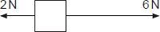
What is the resultant force acting on the object?
Tick ( ) one box.
8 N to the right | 
8 N to the left
4 N to the right
4 N to the left
(1)
(b) BASE jumpers jump from very high buildings and mountains for sport.
The diagram shows the forces acting on a BASE jumper in flight.
The BASE jumper is wearing a wingsuit.
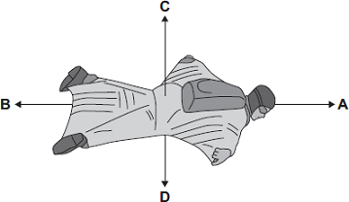
(i) Draw a ring around the correct answer in the box to complete each sentence.
The BASE jumper accelerates forwards when force A

 | smaller than
is | equal to | force B.
 | bigger than

The BASE jumper falls with a constant speed when force C

 | smaller than
is | equal to | force D.
 | bigger than
(2)
Q2.
Figure 1 shows four blocks of different materials floating on water.
The four blocks are the same volume.
Figure 1
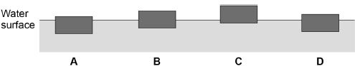
(a) Which of the blocks has the smallest weight?
Tick one box.

A |  | B |  | C |  | D
(1)
Figure 2 shows a lifebuoy next to a deep swimming pool.
Figure 2
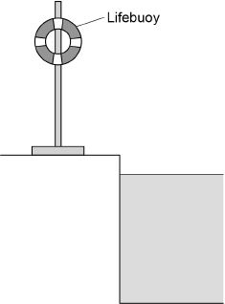

(b) The lifebuoy has a mass of 2.5 kg.
gravitational field strength = 9.8 N/kg
Calculate the weight of the lifebuoy. (2)
___________________________________________________________________
___________________________________________________________________
___________________________________________________________________
___________________________________________________________________
Weight = _____________________ N
(c) When thrown into the water the lifebuoy floats. The two forces acting on the lifebuoy are the weight of the lifebuoy downwards and upthrust upwards.
How big is the upthrust on the lifebuoy compared to the weight of the lifebuoy?
Tick one box. (1)

The upthrust is greater than the weight.
The upthrust is less than the weight.
The upthrust is the same as the weight.
(d) Write down the equation which links acceleration, mass and resultant force. (1)
___________________________________________________________________
(e) A rope is used to pull the lifebuoy to the side of the swimming pool.
A resultant force of 4.0 N acts on the lifebuoy.
The mass of the lifebuoy is 2500g.
Calculate the acceleration of the lifebuoy. (4)
___________________________________________________________________
___________________________________________________________________
___________________________________________________________________
___________________________________________________________________
Acceleration = _______________________ ____

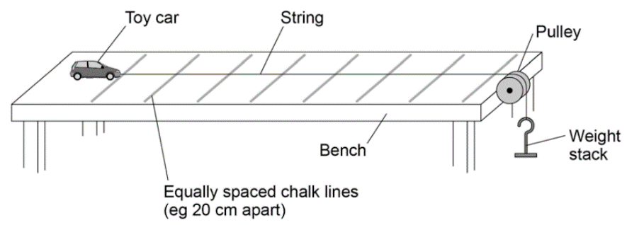
Hypothesis: I think that the car will accelerate ___________ when more __________ are applied to the string. This is because Newton’s _________ law says that the force is equal to the mass multiplied by the _________. The larger the _________ applied the larger the acceleration.
Required practical 7
acceleration – second – masses – faster – force

Mass (kg) | Force (N) | Time (s) | Acceleration (m/s²)
0.01 | 0.1
0.02 | 0.2
0.03 | 0.3
0.04 | 0.4
0.05 | 0.5
0.06 | 0.6
0.07 | 0.7
0.08 | 0.8
Conclusion:
Calculate this by using a = (2 × s) ÷ t²
(It’s an A-level equation but we can use it anyway).
Distance s of the ramp = 1 metre.

Equation for weight:
W = m × g
(We have rounded g up to 10 N/kg)
As I added more masses the time taken for the car to travel one metre _________. This is because the car _____________ faster because of a _________ force. My graph shows that the force is directly ___________ to the acceleration, and proves Newton’s _________ law.
accelerated – decreased – larger – second – proportional
Task: Plot a graph of acceleration (on the y axis) against the force (on the x axis).
Using a ruler, draw a line of best fit and calculate the gradient.

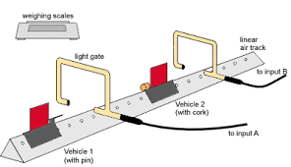
Note: This practical can also be carried out with light gates. A light gate is a device that gives out light. It can detect the amount of time that light is blocked by a moving object.
From v = s ÷ t we can then calculate the velocity (and the acceleration if we have two light gates).
Two students investigated how the acceleration of a trolley depends on the force applied to the trolley.
Before starting the investigation, each student wrote a hypothesis.
Hypothesis of student A:
‘The acceleration of the trolley is directly proportional to the force applied to the trolley.'
Hypothesis of student B:
‘Changing the force applied to the trolley will change the acceleration of the trolley.'
(a) Consider the hypothesis of student A.
Predict what would happen to the acceleration of the trolley if the force applied to the trolley is doubled. (1)
___________________________________________________________________
(b) Why is it difficult to make a valid prediction using the hypothesis of student B? (1)
___________________________________________________________________
___________________________________________________________________
Figure 1 shows some of the equipment used by the students.
Figure 1
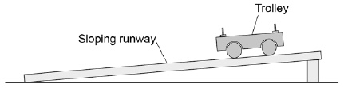
(c) Write a list of any other equipment the students will need to complete the investigation. (2)
___________________________________________________________________
___________________________________________________________________
___________________________________________________________________
___________________________________________________________________
(d) Why should the students use a sloping runway?
Tick one box. (1)

To reduce the effect of friction on the trolley. | 
To decrease the acceleration of the trolley.
To stop the trolley rolling back up the runway.
(e) Describe a method the students could have used for their investigation. (6)
___________________________________________________________________
___________________________________________________________________
___________________________________________________________________
___________________________________________________________________
___________________________________________________________________
___________________________________________________________________
___________________________________________________________________
___________________________________________________________________
___________________________________________________________________
___________________________________________________________________
___________________________________________________________________
___________________________________________________________________
___________________________________________________________________
___________________________________________________________________
___________________________________________________________________
___________________________________________________________________

(f) The students used the same trolley throughout the investigation.
Suggest why. (2)
___________________________________________________________________
___________________________________________________________________
___________________________________________________________________
___________________________________________________________________

The students' results are shown as a graph in Figure 2.
Figure 2
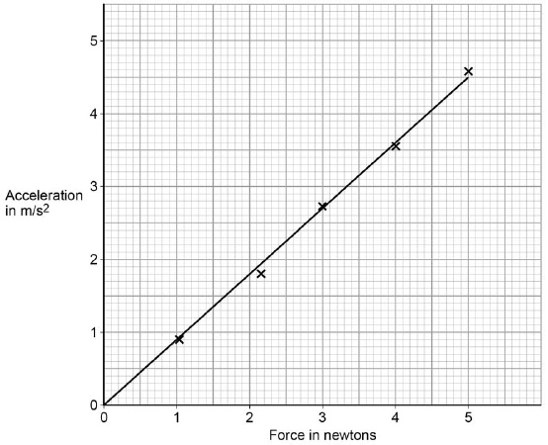
(g) Explain why hypothesis A gives a better explanation of the results. (2)
___________________________________________________________________
___________________________________________________________________
___________________________________________________________________
___________________________________________________________________
(Total 8 marks)

Fill in the missing gaps in the sentences. Some words can be used more than once.
Terminal velocity
Constant Terminal Upward Unbalanced Increases Decreases Small Increase Weight Balanced Same Accelerate Decelerate Large

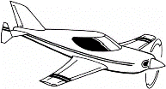
A The skydiver jumps out of the plane and the downward force of her _____________ pulls her down, her air resistance at the start is very _____________ but soon she starts to ________________ ,

B As she accelerates the air resistance force _____________ and acts in the opposite direction to her _______________ .

C As she accelerates faster the air resistance force continues to _____________ until eventually it is the ____________ as her weight. She is now moving at a _______________ speed and her weight is equal to the air resistance. Her speed is called her ______________ velocity (She cannot go any faster). The two forces are ___________________ .

D She opens her parachute. There is now a very _____________ air resistance force so she starts to ___________________ (slow down).

E As she decelerates the air resistance force on her parachute _______________
until it is the _____________ size as her weight. She is now again falling at a
_____________ speed but she has a new and slower ______________ velocity.

F On the ground her ____________ is now equal to the _______________force
from the ground, the forces are balanced.



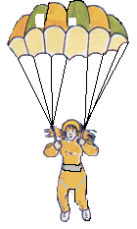

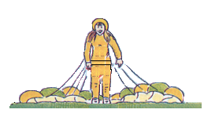

Task: The table below shows how the velocity of a skydiver changes over time. Plot a velocity-time graph below and draw a smooth curve that passes through each point.
Time (s) | 0 | 5 | 10 | 15 | 20 | 25 | 30 | 35 | 40 | 45 | 50 | 55 | 60
Velocity (m/s) | 0 | 28 | 43 | 48 | 50 | 50 | 50 | 49 | 12 | 10 | 10 | 10 | 0
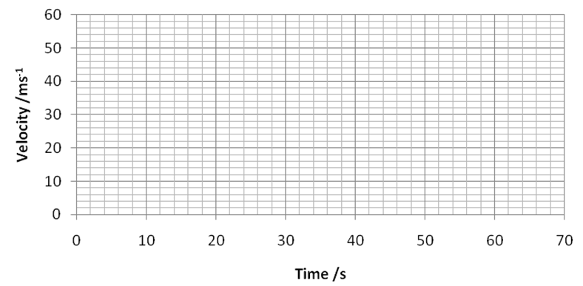

Label the following part of the skydivers descent:
- Acceleration
- Deceleration
- Terminal velocity
- Parachute open
- Speed jumper hit the ground.

(a) The diagram shows the forces acting on a parachutist in free fall.
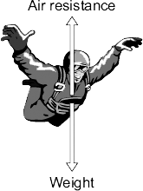
The parachutist has a mass of 75 kg.
Calculate the weight of the parachutist.

gravitational field strength = 9.8 N/kg
Show clearly how you work out your answer and give the unit.
___________________________________________________________________
___________________________________________________________________
Weight = __________________________
(3)
(b) The graph shows how the vertical velocity of a parachutist changes from the moment the parachutist jumps from the aircraft until landing on the ground.
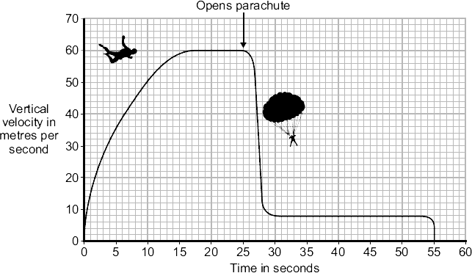

Using the idea of forces, explain why the parachutist reaches a terminal velocity and why opening the parachute reduces the terminal velocity. (6)
___________________________________________________________________
___________________________________________________________________
___________________________________________________________________
___________________________________________________________________
___________________________________________________________________
___________________________________________________________________
___________________________________________________________________
___________________________________________________________________
___________________________________________________________________
___________________________________________________________________
(c) A student wrote the following hypothesis.
‘The larger the area of a parachute, the slower a parachutist falls.’
To test this hypothesis the student made three model parachutes, A, B and C, from one large plastic bag. The student dropped each parachute from the same height and timed how long each parachute took to fall to the ground.
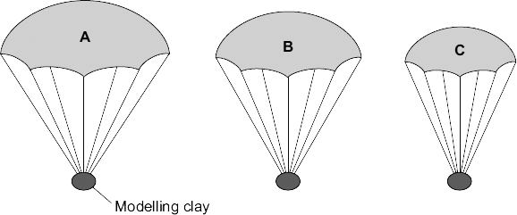
(i) The height that the student dropped the parachute from was a control variable.
Name one other control variable in this experiment. (1)
______________________________________________________________
(ii) Use the student’s hypothesis to predict which parachute, A, B or C, will hit the ground first.
Write your answer in the box. 
Give a reason for your answer. (2)
______________________________________________________________
______________________________________________________________
______________________________________________________________
(2)
(Total 12 marks)
Any mass that is moving carries momentum. The equation for this is below:
Momentum

Momentum = mass × velocity
p = m × v
Where p is momentum in kg m/s
m is mass in kg
v is velocity in m/s

Note that because the equation for momentum contains velocity, momentum must be a vector.

If two objects collide or interact, the forces acting on each one will be the same size but in opposite directions. The same is true for the change in momentum of each object.

This means that the momentum lost by one of the objects will be gained by the other object. Therefore, whenever two objects collide or interact, momentum is conserved.

Example question: Dr. Edmunds drops his iPad. Just before it hits the ground it has a velocity of 5 m/s. If the iPad has a mass of 500g, what is its momentum?

Step 1: Write the equation. Rearrange if necessary.
p = m × v
Step 2: Write down the variables
m = 500 g = 0.5 kg
v = 5 m/s
Step 3: Calculate the answer
p = m × v = 0.5 × 5 = 2.5 kg m/s

Task: Complete in your exercise book.
Basic

Q1. The momentum of this snowball increases because two factors increase as it rolls down the hill. What do you think the two factors are?
………………………………………………………………………………………………………………………………………………………………………………………………………………………………………………………
Q2. Momentum can be calculated using this equation:
Momentum = ………………………. x ……………………….
Q3. The units of momentum are …………………………….
Q4. Calculate the momentum if:
- m = 0.3 kg, v = 7 m/s b) m = 5 kg, v = 12 m/s
Q5. Calculate the velocity if:
- p = 1.5 kg m/s, m = 0.3 kg b) p = 17 kg m/s, m = 8.5 kg
Q6. Calculate the mass if:
- p = 1400 kg m/s, v = 20 m/s b) p = 1,800,000 kg m/s, v =9 m/s.
Medium (re-arranging and unit conversion)
Q7. Calculate the momentum of a football of mass 500g travelling at a velocity of 10 m/s.
Q8. Calculate the momentum of a mouse of mass 400g running through the grass at 3 m/s.
Q9. An athlete running at 8 m/s has a momentum of 520 kg m/s. What is her mass?
Q10. Cristiano Ronaldo kicks a football at a momentum of 50 kg m/s. If the mass of the football is 500g, what velocity has he kicked the football at?
Q11. Dr. Edmunds is late for a lesson and runs with a momentum of 700 kg m/s. If his velocity is 10 m/s, what is his mass? (be nice…)
Q12. 10H1 is going on a school trip to the moon. The rocket we’re using has a momentum of 700,000,000 kg m/s and is travelling at a speed of 1,400 m/s. What is the mass of the rocket?
Hard (hard unit conversion or using more than one equation)
Q13. A car that weighs 2 tonnes is travelling at a velocity of 20 m/s. Calculate its momentum.
Tonne → kg × 1000
Q14. A train is travelling at 80 mph, and has a mass of 100 Tonnes. Calculate its momentum.
miles → metres × 1600
Q15 Usain Bolt runs at a maximum speed of 27 mph. If he has a momentum of 960 kgm/s, what is his mass?
Q16 An eagle travels a distance of 150m in a time of 12 seconds. If the eagle weighs 4kg, what is the momentum of the eagle.
Q17. An aeroplane of mass 200 tonnes travels a distance of 900 km in a time of 90 minutes. Calculate the momentum of the aeroplane.
Q1.
(a) The diagram shows a car travelling at a speed of 12 m/s along a straight road.
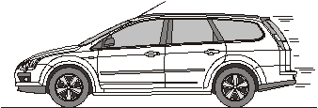
(i) Calculate the momentum of the car.
Mass of the car = 900 kg
Show clearly how you work out your answer.
______________________________________________________________
______________________________________________________________
______________________________________________________________
______________________________________________________________
Momentum = _______________ kg m/s
(2)
(ii) Momentum has direction.
Draw an arrow on the diagram to show the direction of the car’s momentum.
(1)
(b) The car stops at a set of traffic lights.
How much momentum does the car have when it is stopped at the traffic lights?
___________________________________________________________________
Give a reason for your answer.
___________________________________________________________________
___________________________________________________________________
___________________________________________________________________
___________________________________________________________________
(2)
(Total 5 marks)

Conservation of momentum
Conservation of momentum means that momentum before a collision/explosion is the same as after.
Examples of this include car crashes, balls hitting each other and explosions.
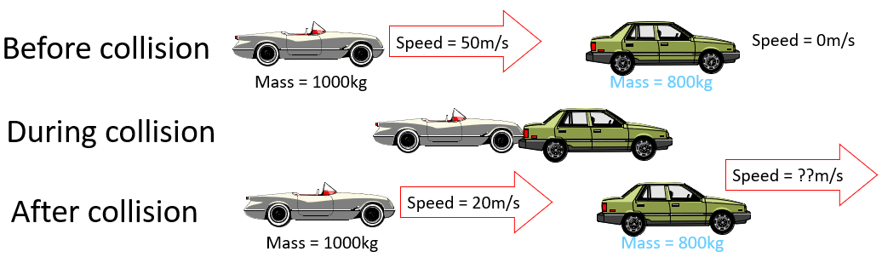

Worked example:

- Calculate the change in momentum of the white car.

Initial momentum = p × v = 1000 × 50 = 50,000 kg m/s
Final momentum = p × v = 1000 × 20 = 20,000 kg m/s
Change in momentum = 50,000 – 20,000 = 30,000 kg m/s

- Calculate the velocity after the collision of the green car.

If the momentum of the white car has gone down by 30,000 kg m/s. The velocity of the green car must have gone up by 30,000 kg m/s as momentum is conserved.

Therefore p = m × v → 30,000 = 800 × v

→ v = 30,000 ÷ 800 = 37.5 m/s

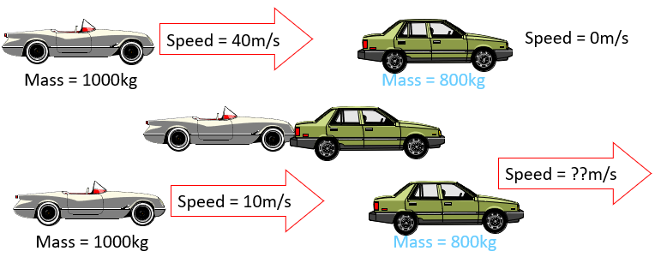
Task: Complete in your exercise book.
- Calculate the change in momentum of the first car.
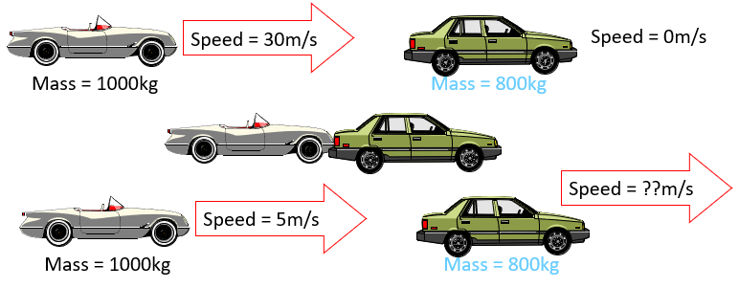
- Calculate the velocity after the collision of the second car.
- Calculate the change in momentum of the first car.
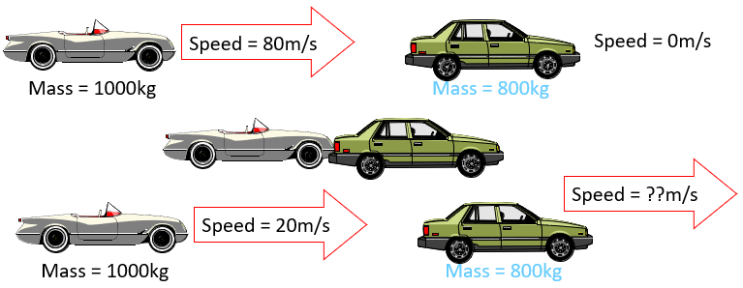
- Calculate the velocity after the collision of the second car.
- Calculate the change in momentum of the first car.
- Calculate the velocity after the collision of the second car.

Q1.
(a) In any collision, the total momentum of the colliding objects is usually conserved.
What is meant by the term ‘momentum is conserved’?
______________________________________________________________
______________________________________________________________
(1)
(b) The diagram shows a car and a van, just before and just after the car collided with the van.

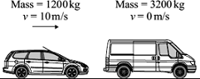  Before collision | 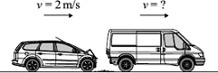  After collision
(i) Use the information in the diagram to calculate the change in the momentum of the car.
Show clearly how you work out your answer and give the unit.
______________________________________________________________
______________________________________________________________
______________________________________________________________
______________________________________________________________
Change in momentum =_________________________
(3)
(ii) Use the idea of conservation of momentum to calculate the velocity of the van when it is pushed forward by the collision.
Show clearly how you work out your answer.
______________________________________________________________
______________________________________________________________
______________________________________________________________
Velocity =_________________________ m/s forward
(2)
(Total 6 marks)

When you fire a rifle, the explosion causes the bullet to fly out of the barrel. It also causes the rifle to push back into your shoulder (recoil). The velocity of the bullet can be calculated using the equation p = m × v.

Worked example:

A bullet of mass 0.01kg is fired from a rifle of mass 2kg, which recoils with a velocity of 1m/s. What is the velocity of the bullet?

Momentum of Rifle = Momentum of bullet (just in opposite directions)
Momentum of rifle = m × v = 2 × 1 = 2 kg m/s
Therefore momentum of bullet = 2 kg m/s
p = m × v → 2 = 0.01 × v
→ v = 2 ÷ 0.01 = 200 m/s

Note how even though the bullet has much less mass than the rifle, it has the same momentum because its velocity is much higher.

A paintball gun is used to fire a small ball of paint, called a paintball, at a target. The figure below shows someone just about to fire a paintball gun. The paintball is inside the gun.

(a) What is the momentum of the paintball before the gun is fired? (2)
___________________________________________________________________
Give a reason for your answer.
___________________________________________________________________
(b) The gun fires the paintball forwards at a velocity of 90 m / s. The paintball has a mass of 0.0030 kg. Calculate the momentum of the paintball just after the gun is fired. (2)
___________________________________________________________________
___________________________________________________________________
Momentum = ____________________ kg m / s
(c) The momentum of the gun and paintball is conserved.
Use the correct answer from the box to complete the sentence. (1)

equal to greater than less than
The total momentum of the gun and paintball just after the gun is fired
will be ____________________________ the total momentum of the gun and
paintball before the gun is fired.
d) The gun has a mass of 500g. Using conservation of momentum, calculate the recoil speed of the gun. (4)
___________________________________________________________________
___________________________________________________________________
___________________________________________________________________
___________________________________________________________________
___________________________________________________________________

Stopping distance
The stopping distance of a car is the minimum distance that a car can safely stop in. It is made up of the thinking distance and the braking distance.
Stopping distance = thinking distance + braking distance
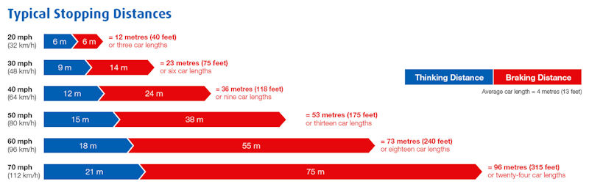

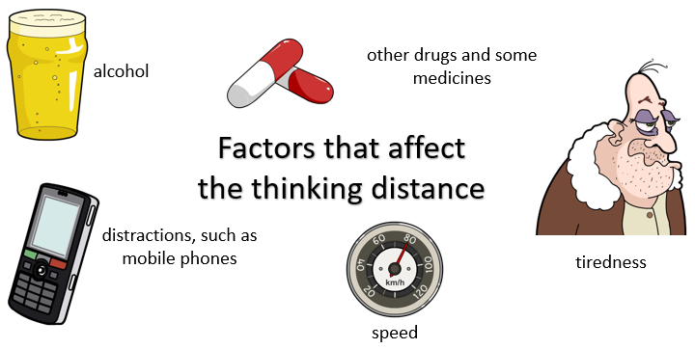
The thinking distance is the distance travelled by the vehicle in the time it takes for the driver to react. If the vehicle is travelling quickly, or if the drivers reaction time is slowed then the thinking distance will be increased.

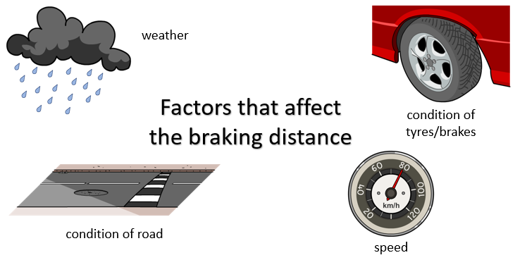
The braking distance is the distance travelled by the vehicle during the time the braking force acts.

Speed also effects the braking distance, but so do conditions that reduce friction.
Task: Complete in your exercise book.
- Vehicle stopping distances are made up from the thinking distance and the braking distance.
- Describe two factors that could affect the thinking distance.
- The braking distance is how far the vehicle travels from when the brakes are first pressed to when the vehicle stops. Explain the energy change that happens during this time.

- The diagram shows typical stopping distances at different speeds. 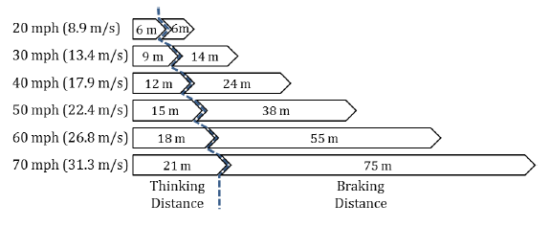
- During the thinking distance, the speed of the vehicle does not change. Use the equation for speed, distance and time to work out the time taken to cover the thinking distance at 50 mph.
- Look at the stopping distances at 30 mph and 60 mph. Compare how the thinking distance and braking distance change with this doubling of speed.
- At 40 mph, the thinking distance is 12 m and the braking distance is 24m. Estimate the size of the stopping distance at 80 mph.

- Many modern vehicles can stop in a shorter distance than those in the chart.
What difference do modern brakes and tyres make to the physics of the slowing down of the vehicle?

(a) A car driver makes an emergency stop.
The chart shows the ‘thinking distance’ and the ‘braking distance’ needed to stop the car.

Calculate the total stopping distance of the car. (1)
___________________________________________________________________
Stopping distance = _________________________ m
(b) The graph shows how the braking distance of a car driven on a dry road changes with the car’s speed.
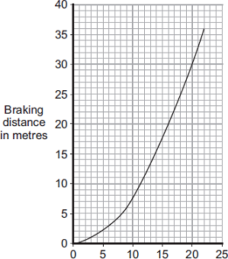
Speed in m/s
The braking distance of the car on an icy road is longer than the braking distance of the car on a dry road.
(i) Draw a new line on the graph to show how the braking distance of the car on an icy road changes with speed. (2)
(ii) Which one of the following would also increase the braking distance of the car? Put a tick ( ) in the box next to your answer. (1)
Rain on the road
The driver having drunk alcohol
The driver having taken drugs
(c) The thinking distance depends on the driver’s reaction time.
The table shows the reaction times of three people driving under different conditions.

Car driver | Condition | Reaction time in second
A | Wide awake with no distractions | 0.7
B | Using a hands-free mobile phone | 0.9
C | Very tired and listening to music | 1.2
The graph lines show how the thinking distance for the three drivers, A, B, and C, depends on how fast they are driving the car.
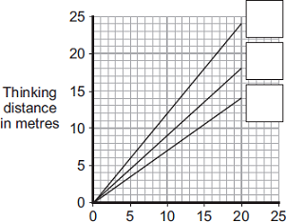
Speed in m/s
- Match each graph line to the correct driver by writing A, B, or C in the box next to the correct line. (2)
(ii) The information in the table cannot be used to tell if driver C’s reaction time is increased by being tired or by listening to music. Explain why. (2)
______________________________________________________________
______________________________________________________________
_____________________________________________________________

