Basic:
- What is the definition of a renewable energy resource?
- What is the definition of a non-renewable energy resource?
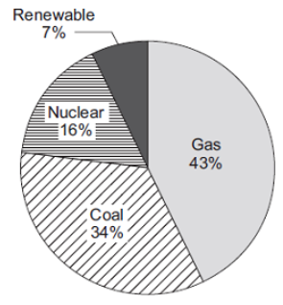
- Give four examples of non-renewable energy.
- What are the three fossil fuels?
- Give four examples of renewable energy resources.
- Give a disadvantage of:
- Burning a fossil fuel.
- Wind power
- Solar power
- Hydro-electric power
- Nuclear power.
Medium:
- a) The pie chart shows the proportions of electricity generated in the UK from different energy sources in 2010. Calculate the percentage of electricity generated using fossil fuels.
b) Complete the following sentence:
In some types of power station, fossil fuels are burned to heat ____________ to produce steam.
c) Burning fossil fuels releases carbon dioxide into the atmosphere. Why do many scientists think adding carbon dioxide to the atmosphere is harmful to the environment?
- The graph gives information about the production of electricity in the UK in 2016.
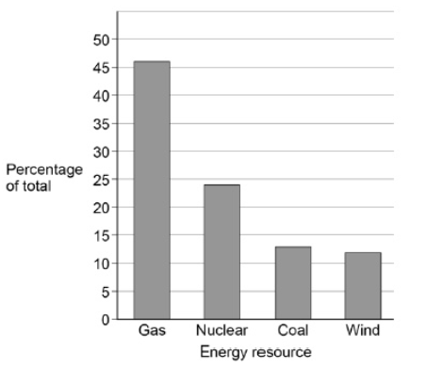
- The UK government signed the Paris Climate Agreement in April 2016. The agreement commits the UK to reduce the amount of carbon dioxide released into the atmosphere. Explain which energy resources in the graph should be used to meet the UK’s commitment to the Paris Climate Agreement.
- On average, there is enough wind in the UK each year to supply all of the UK’s electricity needs. Explain why the UK may still need power stations that use fuel to generate electricity.
- All European countries signed the Paris Climate Agreement in 2016. In the future, some European countries will only allow electric vehicles. Suggest how this is likely to affect methods of electricity generation in these countries.
Hard:
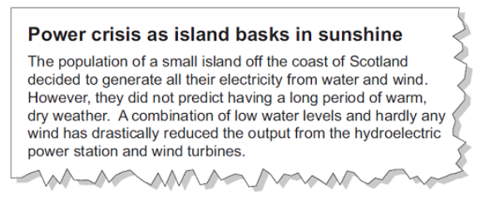
- Shale gas is natural gas trapped in rocks. Shale gas can be extracted by a process called fracking. There is some evidence that fracking causes minor earthquakes. Burning shale gas adds carbon dioxide to the atmosphere. Describe the advantages of nuclear power compared with the use of shale gas to generate electricity. (3)
- Read this extract from a newspaper. Explain one way in which the islanders could try to ensure that a similar power crisis does not happen in the future?

