Basic
- What are the three ways that thermal energy can be transferred?
- What does thermal conductivity mean?
- What are the units of thermal conductivity?
- Which of the following statements are true, and which are false:
- Energy is only transferred by heating if there is no temperature difference.
- The particles in a hot solid vibrate more than those in an identical but cold solid.
- Conduction is when vibrating particles pass on energy to neighbouring particles.
- Only hot objects radiate energy to the surroundings.
- Energy can only be transferred by radiation if the objects are touching.
- Substances like wood and plastic are better conductors than metals.
- Use words in the box to complete the paragraph below:
Thermal energy temperature cooler hotter

When _________________ is transferred between objects of different temperatures, it is transferred from the _____________ object to the _____________ object. When the two objects reach ________________ equilibrium it means they are at the same _______________.
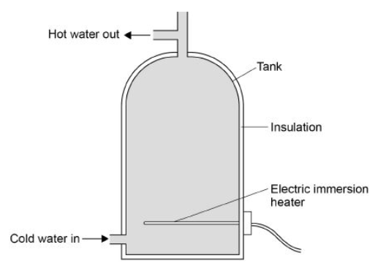
Medium: The diagram shows a hot water tank made of copper.
- Copper has a higher thermal conductivity than most metals. How does the rate of energy transfer through copper compare with the rate of energy transfer through most metals?
- The tank is insulated. When the water is hot, the immersion heater switches off. Complete the sentences.

Compared to a tank with no insulation, the rate of energy transfer from the water in an insulated tank is ___________. This means that the water in the insulated tanks stays ___________ for longer.
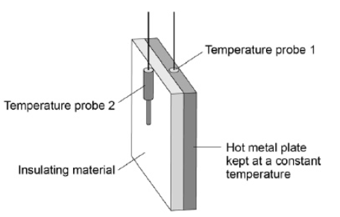
- The power output of the immersion heater is 5000W. Calculate the time taken for the immersion heater to transfer 4,070,000 J of energy.
Hard: A student investigated the properties of three types of insulation. The diagram shows the apparatus the student used. In the investigation, different insulating materials were placed in contact with the hot metal plate. Temperature probes measured the temperature on each side of the material. The temperature probes were connected to a data logger.
The graph shows how the temperature measured by temperature probe 2 changes over 20 minutes for each of the materials.
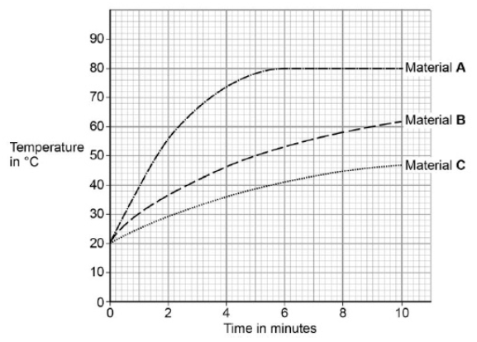
- What was the temperature of the hot metal plate?
- Which material is the best insulator? Explain why.
- Another student repeated the investigation but doubled the thickness for all three insulating materials. Suggest how using thicker insulation would affect the results of the seconds student’s investigation compared with the first student’s results.
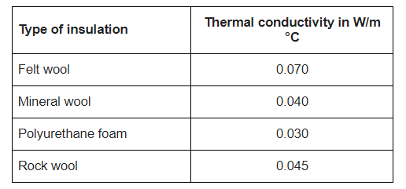
- Using the table, explain which material would be the best to use in cavity wall insulation.

