
Mechanics
Name ______________________________
Teacher ______________________________

Resolving Vectors
Resolving Vectors
A vector can be ‘broken down’ or resolved into its vertical and horizontal components.
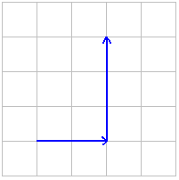
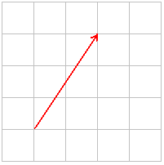
We can see that this vector can be resolved into two perpendicular components, in this case two to the right and three up.
This is obvious when it is drawn on graph paper but becomes trickier when there isn’t a grid and still requires an element of scale drawing.

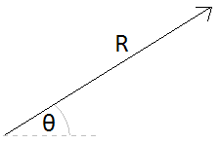
We can calculate the vertical and horizontal components if we know the magnitude and direction of the vector. In other words; we can work out the across and upwards bits of the vector if we know the length of the line and the angle between it and the horizontal or vertical axis.
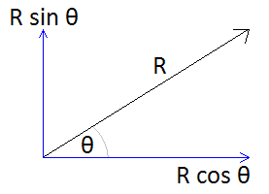

Adding Resolved Vectors
Now that we can resolve vectors into the vertical and horizontal components they are made from, we can add them together. Look at this example of multiple vectors acting in the first diagram (A).
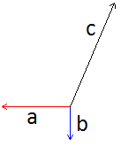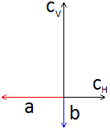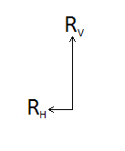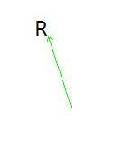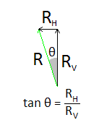
A B C D E
If we resolve the vector C we get what is shown in the second diagram (B). We can now find the resultant of the horizontal components and the resultant of the vertical components (C). We can then add these together to find the resultant vector (D) and the angle can be found using trigonometry (E)

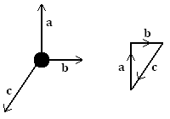
Equilibrium
When all the forces acting on a body cancel out equilibrium is reached and the object does not move. As you sit and read this the downwards forces acting on you are equally balanced by the upwards forces, the resultant is that you do not move.
With scale drawing we can draw the vectors, one after the other. If we end up in the same position we started at then equilibrium is achieved.
With resolving vectors we can resolve all vectors into their vertical and horizontal components. If the components up and down are equal and the components left and right are equal equilibrium has been reached.

Scalar and Vector Quantities
1. The following is a list of scalar and vector quantities.
acceleration, density, displacement, energy, power, speed, time, weight.
In the blank spaces provided in the table below, list the quantities as either scalars or vectors.
scalar | vector
[Total 4 marks]
2. State a similarity and a difference between distance and displacement.
(i) similarity
(ii) difference
3. (i) Below is a list of five quantities. Which are scalar quantities?
acceleration energy force power speed
(ii) What is a vector quantity? [2]
4. The figure below shows the path of a ball as it is passed between three players. Player A passes a ball to player B. When player B receives the ball, she immediately passes the ball to player C. The distances for each pass are shown on the figure.
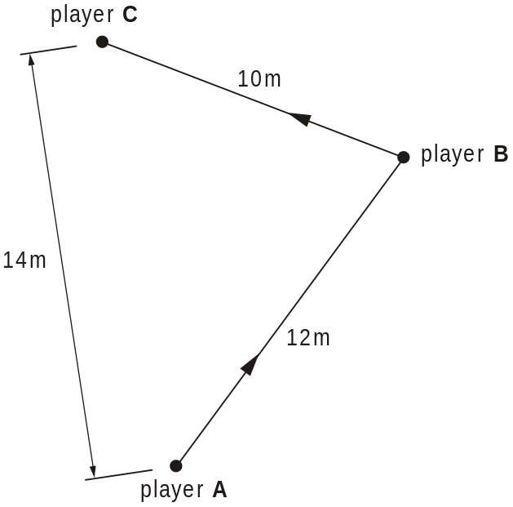

The ball takes 2.4 s to travel from player A to player C.
(i) Calculate, for the total journey of the ball
1. the average speed of the ball [2]
2. the magnitude of the average velocity of the ball. [2]
(ii) Explain why the values for the average speed and average velocity are different. [2]

Adding Vectors
1. The figure below shows a ship S being pulled by two tug-boats.
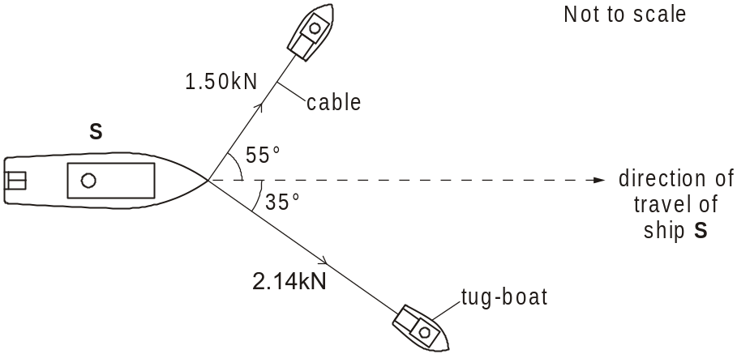
The ship is travelling at a constant velocity. The tensions in the cables and the angles made by these cables to the direction in which the ship travels are shown in the figure above.
Draw a vector triangle and determine the resultant force provided by the two cables. [3]

Resolving Vectors
1. The figure below shows a 20 N force acting at an angle of 38° to the horizontal.
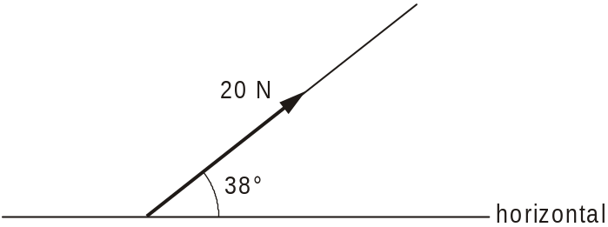
Determine the horizontal and vertical components of this force. [2]

Non-perpendicular vectors
- The figure below shows the direction of two forces of 16 N and 12 N acting at an angle of 50 to each other.
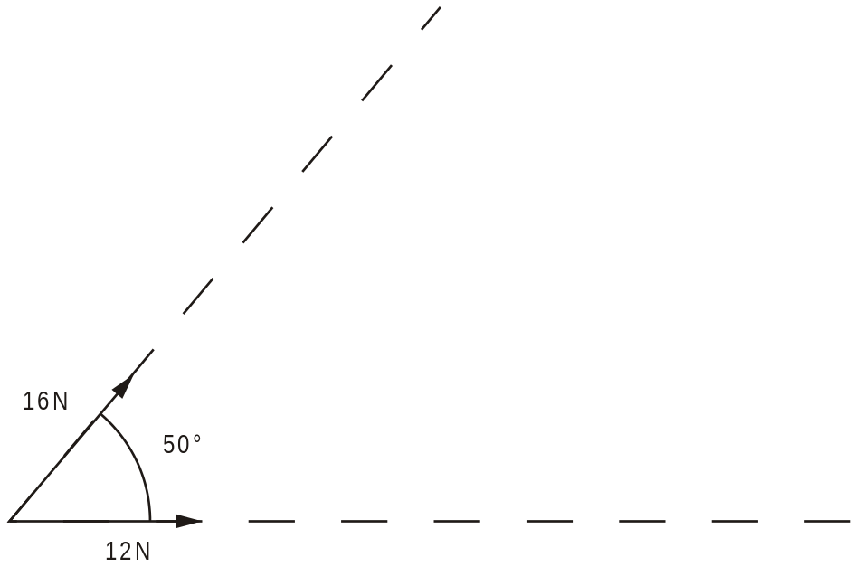
Using the figure, draw a vector diagram to determine the magnitude of the resultant of the two forces. [4]

- The weight of the trolley in the diagram is 3.4 N. The trolley is not moving.

3.4 N

N

F

25^{ο}

Calculate
(a) the normal reaction, N, and
(b) the horizontal force, F.

- The diagram below shows a circus performer in a high-wire act.

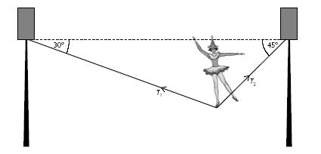

(a) The total mass of the performer plus props is 76.5 kg. Using a scale of 1 cm to 100 N, draw a vector triangle to show the forces acting on the performer.
(b) Use your diagram to find the tensions T₁ and T₂ in the cable.
(c) A member of the audience is worried that the cable might break, and thinks that this would be less likely to happen if the cable were shorter so that it did not sag so much.
Explain, with the aid of a diagram, whether this would really reduce the tension in the cable.

Q1.
The diagram shows a 250 kg iron ball being used on a demolition site. The ball is suspended from a cable at point A, and is pulled into the position shown by a rope that is kept horizontal. The tension in the rope is 1200 N.
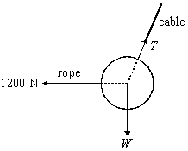
(a) In the position shown the ball is in equilibrium.
(i) What balances the force of the rope on the ball?
______________________________________________________________
(ii) What balances the weight of the ball?
______________________________________________________________
(2)
(b) Determine
(i) the magnitude of the vertical component of the tension in the cable,
______________________________________________________________
(ii) the magnitude of the horizontal component of the tension in the cable,
______________________________________________________________
______________________________________________________________
(iii) the magnitude of the tension in the cable,
______________________________________________________________
______________________________________________________________
______________________________________________________________
______________________________________________________________
______________________________________________________________
______________________________________________________________
(iv) the angle the cable makes to the vertical.
______________________________________________________________
______________________________________________________________
(6)
(Total 8 marks)

Q2.
The figure below shows a stationary gymnast suspended by his arms at the end of two ropes.
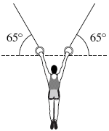
The tension in each rope is 4.1 × 10² N. The angle between each of the ropes and the horizontal is 65°.
Calculate the weight of the gymnast.
Give your answer to an appropriate number of significant figures.
_______________________________________________________________________
_______________________________________________________________________
_______________________________________________________________________
_______________________________________________________________________
_______________________________________________________________________
weight of gymnast ______________________ N
(Total 3 marks)
Q3.
Figure 1 shows a parascender being towed at a constant velocity.
Figure 1
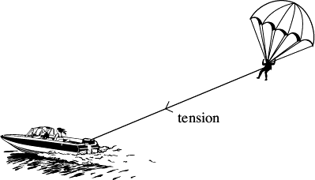
The forces acting on the parascender are shown in the free-body diagram in Figure 2.

Figure 2
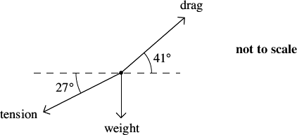
The rope towing the parascender makes an angle of 27° with the horizontal and has a tension of 2.2 kN. The drag force of 2.6 kN acts at an angle of 41° to the horizontal. Calculate the weight of the parascender.

weight ______________________ N
(Total 3 marks)
Q4.
A canoeist can paddle at a speed of 3.8 ms^{–1} in still water.
She encounters a current which opposes her motion. The current has a velocity of 1.5 ms^{–1} at 30° to her original direction of travel as shown in the figure below.
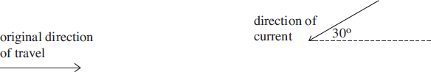
By drawing a scale diagram determine the magnitude of the canoeist’s resultant velocity.

magnitude of velocity ____________________ ms^{–1}
(Total 3 marks)
Q5.
The diagram below shows a rock climber abseiling down a rock face. At the instant shown the climber is stationary and in equilibrium. The forces acting on the climber are shown in the diagram below.
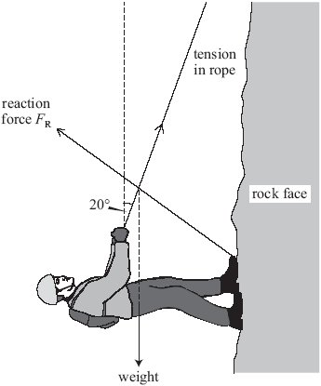
The tension in the rope is 610 N and it acts at 20 ° to the vertical.
The weight of the climber is 590 N.
Calculate the vertical component of the reaction force, F_{R}, between the feet of the climber and the rock.

vertical component ____________________ N
(Total 3 marks)

Q6.
The diagram below shows a long-distance swimmer swimming due north at 1.3 m s^{–1} in a tide that flows at 1.0 m s^{–1} due east.
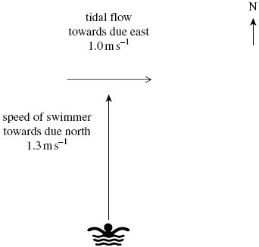
(a) Calculate the magnitude of the resultant velocity of the swimmer.
___________________________________________________________________
___________________________________________________________________
___________________________________________________________________
___________________________________________________________________
magnitude of resultant velocity ____________________ m s^{–1}
(2)
(b) Calculate the angle the resultant velocity of the swimmer makes with due north.
___________________________________________________________________
___________________________________________________________________
___________________________________________________________________
___________________________________________________________________
angle ____________________ degrees
(2)
(Total 4 marks)

Q7.
(a) (i) State what is meant by a scalar quantity.
______________________________________________________________
______________________________________________________________
______________________________________________________________
(ii) State two examples of scalar quantities.
example 1: ____________________________________________________
______________________________________________________________
example 2: ____________________________________________________
(3)
(b) An object is acted upon by two forces at right angles to each other. One of the forces has a magnitude of 5.0 N and the resultant force produced on the object is 9.5 N.
Determine
(i) the magnitude of the other force,
______________________________________________________________
______________________________________________________________
______________________________________________________________
______________________________________________________________
______________________________________________________________
______________________________________________________________
(ii) the angle between the resultant force and the 5.0 N force.
______________________________________________________________
______________________________________________________________
(4)
(Total 7 marks)

Q8.
The diagram shows the forces acting on a stationary kite. The force F is the force that the air exerts on the kite.
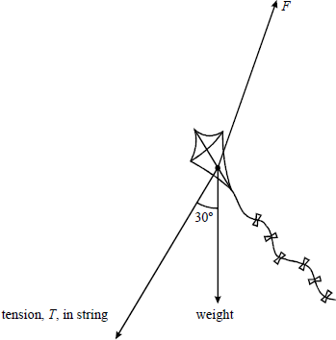
(a) Show on the diagram how force F can be resolved into horizontal and vertical components.
(2)
(b) The magnitude of the tension, T, is 25 N.
Calculate
(i) the horizontal component of the tension,
______________________________________________________________
(ii) the vertical component of the tension.
______________________________________________________________
(2)
(c) (i) Calculate the magnitude of the vertical component of F when the weight of the kite is 2.5 N.
______________________________________________________________
(ii) State the magnitude of the horizontal component of F.
______________________________________________________________
(iii) Hence calculate the magnitude of F.
______________________________________________________________
______________________________________________________________
(4)
(Total 8 marks)

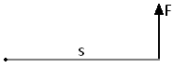
Moments
Moments
The moment of a force is its turning affect about a fixed point (pivot).
The magnitude of the moment is given by:
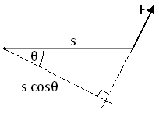
moment = force x perpendicular distance from force to the pivot
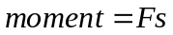

In this diagram we can see that the force is not acting perpendicularly to the pivot. We must find the perpendicular or closest distance, this is s cosθ.
The moment in this case is given as: 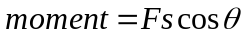
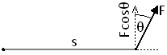
We could have also used the value of s but multiplied it by the vertical component of the force. This would give us the same equation. 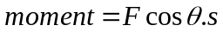

Moments are measured in Newton metres, Nm

Couples
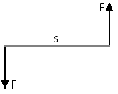
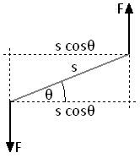
A couple is a pair of equal forces acting in opposite directions. If a couple acts on an object it rotates in position. The moment of a couple is called the torque.
The torque is calculated as: torque = force x perpendicular distance
between forces
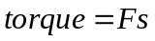
In the diagram to the right we need to calculate the perpendicular distance, s cosθ.
So in this case: 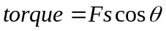

Torque is measured in Newton metres, Nm

Centre of Mass
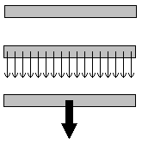
If we look at the ruler to the right, every part of it has a mass. To make tackling questions easier we can assume that all the mass is concentrated in a single point.

Centre of Gravity
The centre of gravity of an object is the point where all the weight of the object appears to act. It is in the same position as the centre of mass.
We can represent the weight of an object as a downward arrow acting from the centre of mass or gravity. This can also be called the line of action of the weight.
Balancing
When an object is balanced:
the total moments acting clockwise = the total moments acting anticlockwise
An object suspended from a point (e.g. a pin) will come to rest with the centre of mass directly below the point of suspension.
If the seesaw to the left is balanced then the clockwise moments must be equal to the anticlockwise moments.
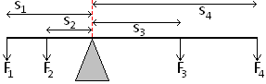
Clockwise moment due to 3 and 4
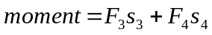
Anticlockwise moments due to 1 and 2
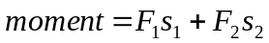
So 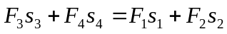

Stability
The stability of an object can be increased by lowering the centre of mass and by widening the base.
An object will topple over if the line of action of the weight falls outside of the base.

Moments
1. State the two conditions necessary for a system to be in equilibrium.
2. A child of weight 480N sits 1.5m to the left of the pivot point on a seesaw. What is the moment of the child’s weight about the pivot?
3. (a) A 40kg child sits 1.2m to the right of the pivot point on the same seesaw. What is the moment of the child’s weight about the pivot?
(b) In order for the seesaw to balance the child to the right moves herself to a different position. At what distance from the pivot must she sit.

4. A child of weight 400 N and another child of weight 300 N play on a seesaw of negligible weight. If the first child sits 2.7 m from the pivot of the seesaw, where must the second child sit to make it balance? (2 marks)
5. A uniform bridge of weight 5.0 × 10⁴ N is supported on pillars A and B, which are 20 m apart. A lorry of weight 3.0 × 10⁴ N is stationary 4.0 m from pillar A. Find the forces acting on each pillar. (4 marks)
6. (a) Explain why moment of a force and torque of a couple have the same unit N m.
(b) The figure below shows an irregular shaped metal plate of constant thickness that can swing freely about point P.
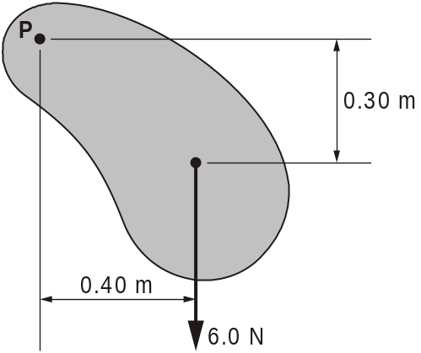

(i) The weight of the plate is 6.0 N. With the plate in the position as shown in the figure, calculate the clockwise moment of the weight of the plate about an axis through point P.
(ii) Explain why the moment of the weight reduces to zero when the plate reaches the bottom of the swing.

7. Define
(i) the moment of a force
.........................................................................................................................
.........................................................................................................................
[2]
(ii) the torque of a couple.
.........................................................................................................................
.........................................................................................................................
[1]
[Total 3 marks]

8. The figure below shows a section of the human forearm in equilibrium.
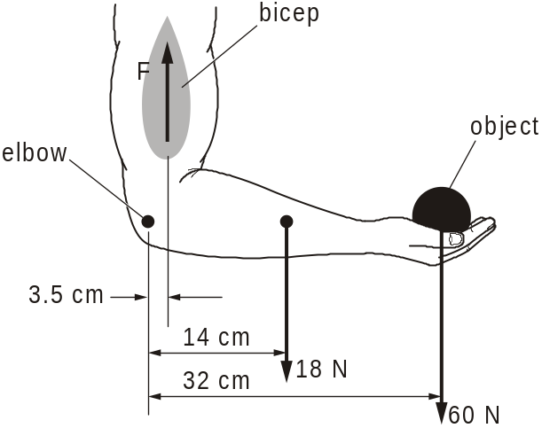
The weight of the object in the hand is 60 N. The centre of gravity of this object is
32 cm from the elbow. The bicep provides an upward force of magnitude F. The distance between the line of action of this force and the elbow is 3.5 cm. The weight of the forearm is 18 N. The distance between the centre of gravity of the forearm and the elbow is 14 cm.
By taking moments about the elbow, determine the magnitude of the force F provided by the bicep.

F = ...................................................... N
[Total 3 marks]

9. The figure below shows a lawn mower which is carried by two people.
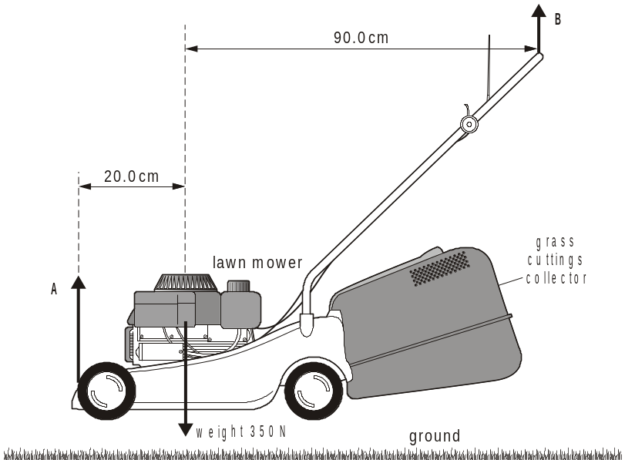
(i) The two people apply forces A and B at each end of the lawn mower. The weight of the lawn mower is 350 N.
1 Explain why the weight of the lawn mower does not act in the middle of the lawn mower, that is 55 cm from each end.
................................................................................................................
................................................................................................................
[1]
2 Use the principle of moments to show that the force B is 64 N.

[2]
3 Determine the force A.

A = ................................N
[1]
(ii) State and explain what happens to the forces A and B if the person that applies force B moves his hands along the handle towards the middle of the lawn mower.
.........................................................................................................................
.........................................................................................................................
.........................................................................................................................
.........................................................................................................................
[2]
[Total 6 marks]

10. The figure below shows a kitchen cupboard securely mounted to a vertical wall. The cupboard rests on a support at A.
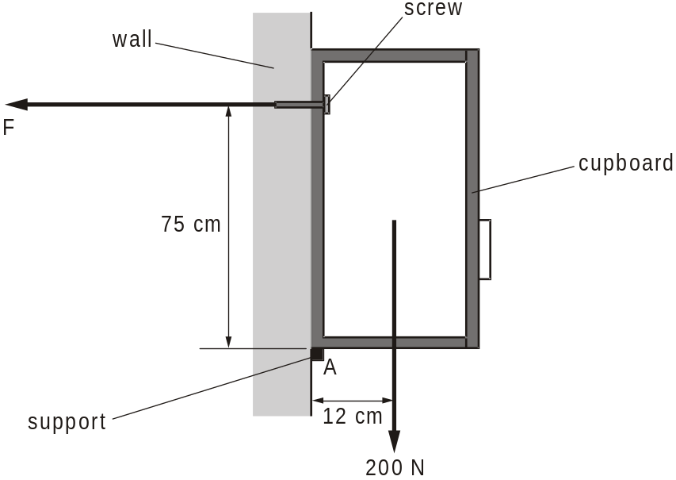
The total weight of the cupboard and its contents is 200 N. The line of action of its weight is at a distance of 12 cm from A. The screw securing the cupboard to the wall is at a vertical distance of 75 cm from A.
(i) State the principle of moments.
In your answer, you should use appropriate technical terms, spelled correctly.
.........................................................................................................................
.........................................................................................................................
.........................................................................................................................
[2]
(ii) The direction of the force F provided by the screw on the cupboard is horizontal as shown in the figure above. Take moments about A. Determine the value of F.

F = ...................................................... N
[2]
[Total 4 marks]

11. The diagram below shows a simple model to demonstrate the forces exerted by back muscles for a person bending over at an angle of 30° to the horizontal.
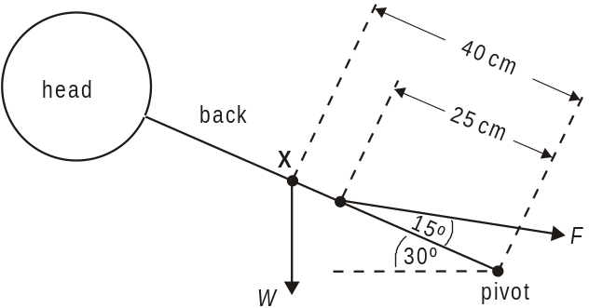
The back muscles may be considered to act as a single force F through a point on the back situated 25 cm from the pivot and making a constant angle of 15° with the back. The weight W of the upper body acts through a point X, situated a distance of 40 cm from the pivot.
(a) Calculate for an upper body weight W of 450 N, the size of the force F needed by the back muscles to keep the back at an angle of
(i) 30° to the horizontal

F = ..................................................... N
[4]
(ii) 70° to the horizontal.

F = ..................................................... N
[1]
(b) Explain including reference to your answers to (a), the body position which should be adopted when lifting heavy loads from the ground.
........................................................................................................................
........................................................................................................................
........................................................................................................................
........................................................................................................................
........................................................................................................................
........................................................................................................................ [4]

Velocity and acceleration

Distance
Distance is a scalar quantity. It is a measure of the total length you have moved.

Displacement
Displacement is a vector quantity. It is a measure of how far you are from the starting position.

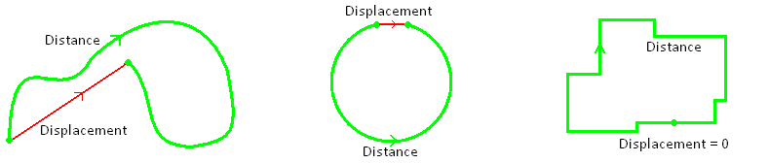
If you complete a lap of an athletics track: distance travelled = 400m
displacement = 0
Distance and Displacement are measured in metres, m

Speed
Speed is a measure of how the distance changes with time. Since it is dependent on speed it too is a scalar.
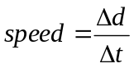

Velocity
Velocity is measure of how the displacement changes with time. Since it depends on displacement it is a vector too.
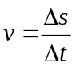

Speed and Velocity are is measured in metres per second, m/s
Time is measured in seconds, s

Acceleration
Acceleration is the rate at which the velocity changes. Since velocity is a vector quantity, so is acceleration.
With all vectors, the direction is important. In questions we decide which direction is positive (e.g. +ve)
If a moving object has a positive velocity: - A positive acceleration means an increase in the velocity
- A negative acceleration means a decrease in the velocity
(it begins the ‘speed up’ in the other direction)
If a moving object has a negative velocity: - A positive acceleration means an increase in the velocity
(it begins the ‘speed up’ in the other direction)
- A negative acceleration means an increase in the velocity
If an object accelerates from a velocity of u to a velocity of v, and it takes t seconds to do it then we can write the equations as 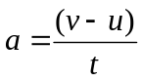 it may also look like this 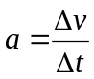 where Δ means the ‘change in’

Acceleration is measured in metres per second squared, m/s²
Uniform Acceleration
In this situation the acceleration is constant – the velocity changes by the same amount each unit of time.
For example: If acceleration is 2m/s², this means the velocity increases by 2m/s every second.
Time (s) | 0 | 1 | 2 | 3 | 4 | 5 | 6 | 7
Velocity (m/s) | 0 | 2 | 4 | 6 | 8 | 10 | 12 | 14
Acceleration (m/s²) |  | 2 | 2 | 2 | 2 | 2 | 2 | 2

Non-Uniform Acceleration
In this situation the acceleration is changing – the velocity changes by a different amount each unit of time.
For example:
Time (s) | 0 | 1 | 2 | 3 | 4 | 5 | 6 | 7
Velocity (m/s) | 0 | 2 | 6 | 10 | 18 | 28 | 30 | 44
Acceleration (m/s²) |  | 2 | 4 | 6 | 8 | 10 | 12 | 14

Distance, speed, displacement, velocity and acceleration
- What is the average velocity if a ball rolls 20 metres in 10 seconds?
- If a car travels at a speed of 25ms⁻¹ for 12 minutes, how far has it travelled?
- If a cyclist travels 30 km in 2 hours, what is her average speed in ms⁻¹?
- If light takes about eight and a half minutes to reach the Earth from the sun, how far away is the sun? (Speed of light = 3 X 10⁸ ms⁻¹)?
- What is the average acceleration of a motorbike which reaches a speed of 30ms⁻¹ from rest in 25s?
- If an electron is travelling at a speed of 2500kms⁻¹ and accelerates through a potential difference for 0.2s at an acceleration of 1.5 X 10⁷ ms⁻², how fast is it going when it emerges?
- A train is travelling at 150 mph, how fast is that in metres per second? (1 mile = 1.6 km)
- If a train travelling at 55ms⁻¹ undergoes a deceleration of 0.2ms⁻² for 2 minutes, how fast is it travelling afterwards?
9. State a similarity and a difference between distance and displacement.
(i) similarity: ........................................................................................................
.........................................................................................................................
[1]
(ii) difference: .......................................................................................................
.........................................................................................................................
[1]
[Total 2 marks]
10. (i) Define speed of an object. Explain how you would determine the constant speed of a conker at the end of length of string being whirled in a horizontal circle.
.........................................................................................................................
.........................................................................................................................
.........................................................................................................................
.........................................................................................................................
.........................................................................................................................
.......................................................................................................................
.......................................................................................................................
[3]
(ii) Define velocity of an object.
 In your answer, you should use appropriate technical terms, spelled correctly.
.......................................................................................................................
.......................................................................................................................
[1]

(iii) By reference to speed and velocity, explain the difference between a scalar quantity and a vector quantity, using as an example the terms speed and velocity.
.........................................................................................................................
.........................................................................................................................
.........................................................................................................................
.........................................................................................................................
[2]
[Total 6 marks]

11. The figure below shows two airports A and C.
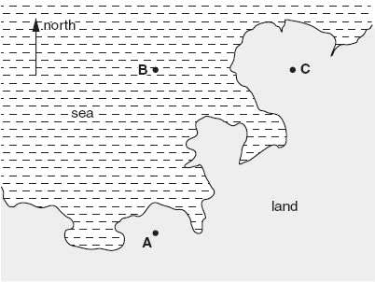

An aircraft flies due north from A for a distance of 360 km (3.6 × 105 m) to point B. Its average speed between A and B is 170 m s–1. At B the aircraft is forced to change course and flies due east for a distance of 100 km to arrive at C.
(i) Calculate the time of the journey from A to B.

time = ....................................................... s
[1]

(ii) Draw a labelled displacement vector triangle below. Use it to determine the magnitude of the displacement in km of the aircraft at C from A.

displacement = ....................................................km
[3]
[Total 4 marks]

Motion graphs
Before we look at the two types of graphs we use to represent motion, we must make sure we know how to calculate the gradient of a line and the area under it.

Gradient
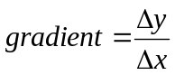We calculate the gradient by choosing two points on the line and calculating the change in the y axis (up/down) and the change in the x axis (across).

Area Under Graph
At this stage we will not go over how to calculate the area under curves, only straight lines.
We do this be breaking the area into rectangles (base x height) and triangles (½ base x height).

Displacement-Time Graphs
A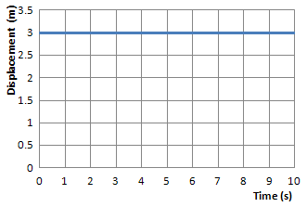 B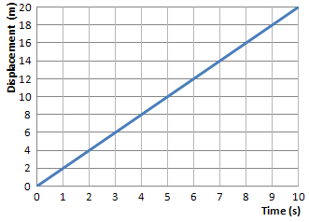 C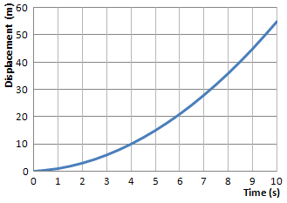
Graph A shows that the displacement stays at 3m, it is stationary.
Graph B shows that the displacement increases by the same amount each second, it is travelling with constant velocity.
Graph C shows that the displacement covered each second increases each second, it is accelerating.
Since 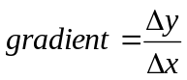 and y = displacement and x = time 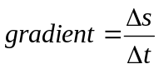 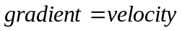

Velocity- Time Graphs
A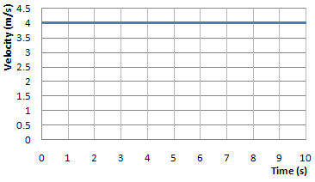 B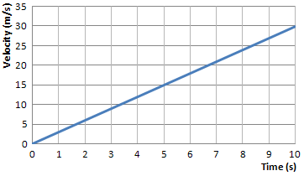 C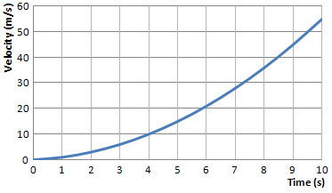
Graph A shows that the velocity stays at 4m/s, it is moving with constant velocity.
Graph B shows that the velocity increases by the same amount each second, it is accelerating by the same amount each second (uniform acceleration).
Graph C shows that the velocity increases by a larger amount each second, the acceleration is increasing (non-uniform acceleration).
Since and y = velocity and x = time 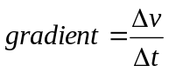 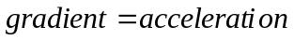
area = base x height area = time x velocity area = displacement

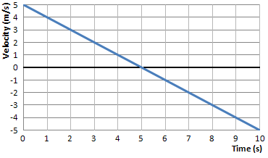
This graph show the velocity decreasing in one direction and increasing in the opposite direction.
If we decide that is negative and is positive then the graph tells us:
The object is initially travels at 5 m/s
It slows down by 1m/s every second
After 5 seconds the object has stopped
It then begins to move
It gains 1m/s every second until it is travelling at 5m/s

Graphs of Motion
1. For the velocity–time graph in Figure 1:
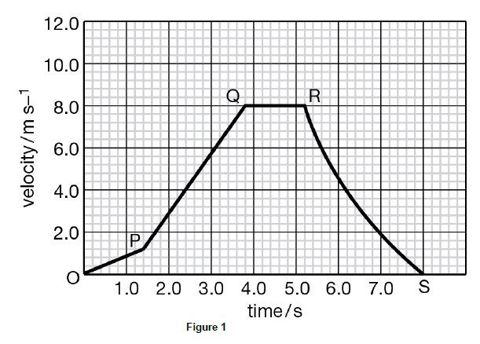
a state the velocity after the object has been moving for 3.4 s (1 mark)

b state the velocity after the object has been moving for 5.6 s (1 mark)

c calculate the acceleration between O and P (1 mark)

d calculate the acceleration at t = 7.0 s. (1 mark)

e Estimate the total distance travelled. (3 marks)

2 Calculate the distance travelled during the journey shown in Figure 2. (2 marks)

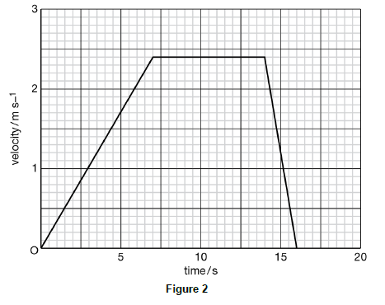
3. In this question, two marks are available for the quality of written communication.
Below is a graph of the displacement against time for the motion of a radio-controlled model car.
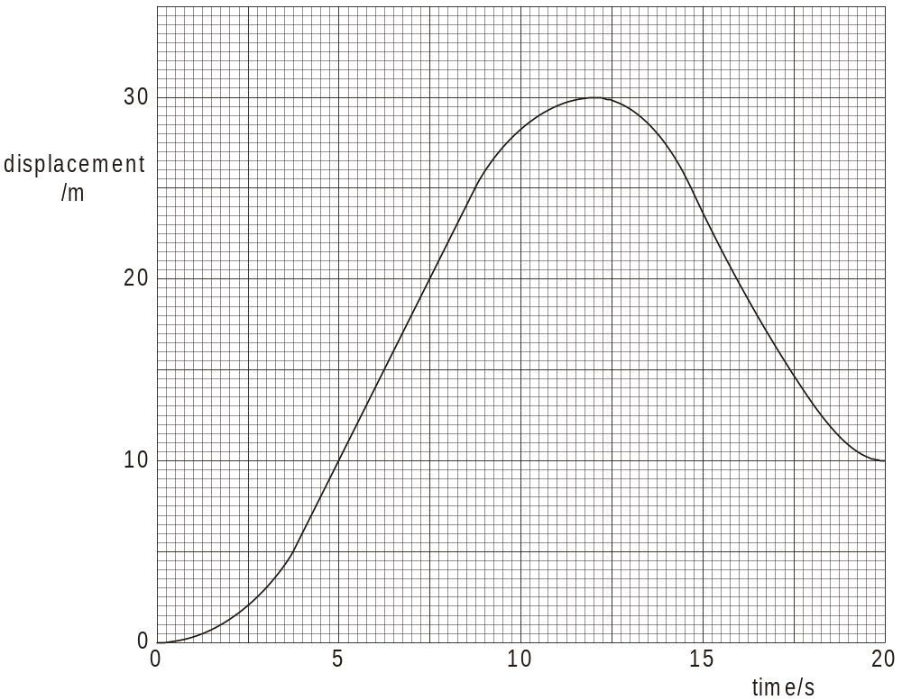

Use the graph to describe and explain, without calculation
(a) how the velocity changes from time t = 0 to time t = 20 s
.........................................................................................................................
.........................................................................................................................
.........................................................................................................................
.........................................................................................................................
.........................................................................................................................
.........................................................................................................................
.........................................................................................................................
[5]
(b) how the acceleration changes from time t = 0 to time t = 20 s.
.........................................................................................................................
.........................................................................................................................
.........................................................................................................................
.........................................................................................................................
.........................................................................................................................
.........................................................................................................................
[4]
4. The figure below shows graphs of velocity v against time t for two cars A and B travelling along a straight level road in the same direction.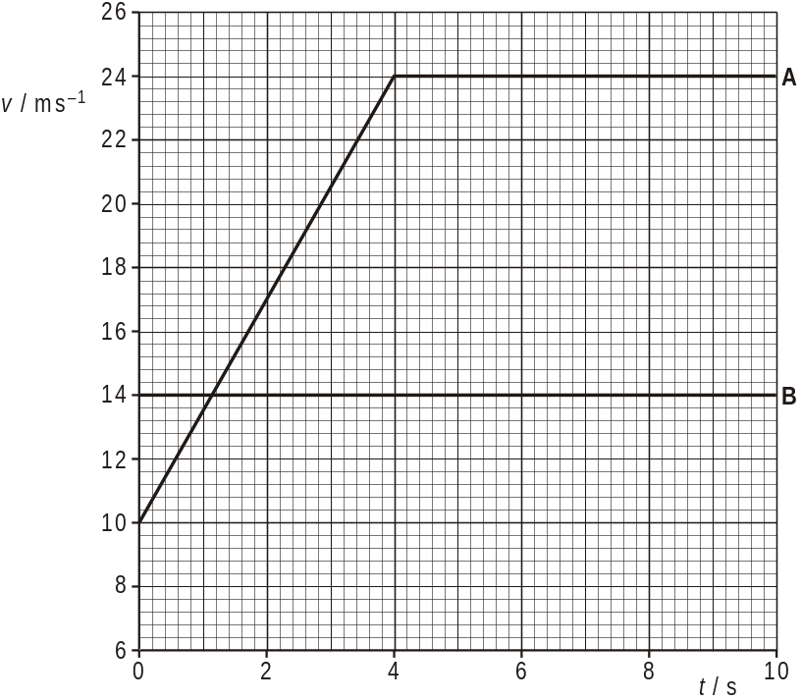

At time t = 0, both cars are side-by-side.
(i) Describe the motion of car A from t = 0 to t = 10 s.
.........................................................................................................................
.........................................................................................................................
.........................................................................................................................
[2]
(ii) Calculate the distance travelled by car A in the first 4.0 s.

distance = ..................................................... m
[2]
(iii) Use the figure above to find
1 the time at which both cars have the same velocity

time = ...................................................... s
[1]
2 the time t at which car A overtakes car B.

t = ...................................................... s
[2]
[Total 7 marks]

Defining Symbols
Equations of motion
Before we look at the equations we need to assign letters to represent each variable
Displacement = s m metres
Initial Velocity = u m/s metres per second
Final Velocity = v m/s metres per second
Acceleration = a m/s² metres per second per second
Time = t s seconds

Equations of Motion
Equation 1
If we start with the equation for acceleration we can rearrange this to give us an equation 1
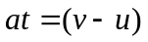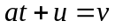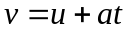

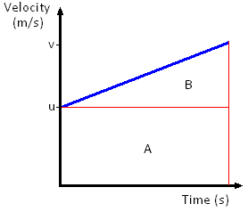
Equation 2
We start with the definition of velocity and rearrange for displacement
velocity = displacement / time displacement = velocity x time

In situations like the graph to the right the velocity is constantly changing, we need to use the average velocity.
displacement = average velocity x time
The average velocity is give by: average velocity =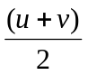
We now substitute this into the equation above for displacement
displacement = x time 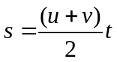 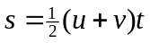

Equation 3
With Equations 1 and 2 we can derive an equation which eliminated v. To do this we simply substitute into
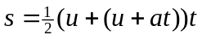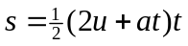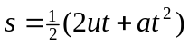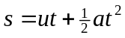

This can also be found if we remember that the area under a velocity-time graph represents the distance travelled/displacement. The area under the line equals the area of rectangle A + the area of triangle B.
Area = Displacement = s = 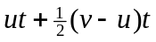 since then 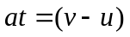 so the equation becomes 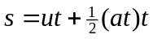 which then becomes equation 3

Equation 4
If we rearrange equation 1 into 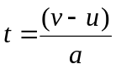 which we will then substitute into equation 2:
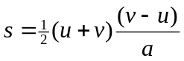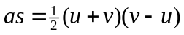
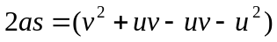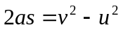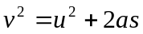

Any question can be solved as long as three of the variables are given in the question.
Write down all the variables you have and the one you are asked to find, then see which equation you can use.
These equations can only be used for motion with UNIFORM ACCELERATION.

The (SUVAT) Equations of Uniformly Accelerated Motion
1. A racing car travelling at 13 m/s accelerates at 4.0 m s–2 for 9.0 s. What is its final speed? (2 marks)
2 A car travelling at 28 m/s slows down and stops in 75 m. Calculate the acceleration, assuming it is constant. (2 marks)

3. A stone is dropped down a dry well. It is heard to hit the bottom after 2.9 s. How deep is the well? (2 marks)

4. A stone is dropped over the edge of a cliff and at the same time a small ball is fired vertically up in the air from the same height, with velocity 10 m s–1, so that it falls and hits the beach next to the stone. The cliff is 100 m high. Calculate:

a the time for the ball to reach its maximum height (2 marks)

b the maximum height above the cliff reached by the ball (2 marks)

c the time for the ball to fall from this height to the beach (2 marks)

d the time for the stone to fall to the beach (2 marks)

e the time interval between the stone and the ball hitting the beach. (2 marks)

5. A passenger on a roller coaster drops their purse at the moment when they are travelling vertically downwards at 4.5ms⁻¹ and are 38m above the ground. At what speed does the purse hit the ground?
6. (a) The figure below illustrates a racetrack near a refuelling station.
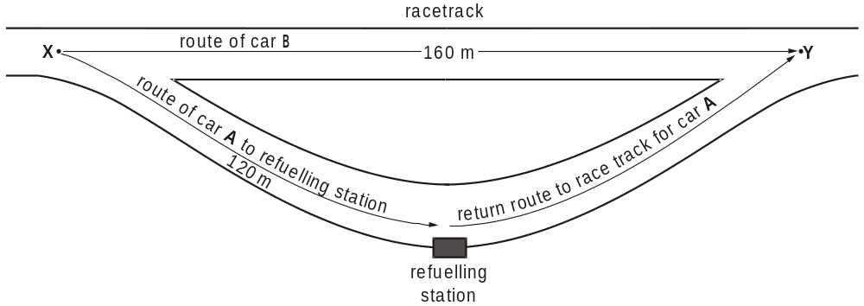
The cars A and B are in a race and both have a speed of 80 m s–1. Car A has a lead over car B of 17.0 s at X when A leaves the racetrack to refuel. Car A travels 120 m from X to the refuelling station.
Calculate the following values for car A, from the point where it leaves the racetrack until it comes to rest at the refuelling station. Assume the deceleration is constant.
- the average deceleration [3]
(ii) the time taken [2]
(b) Car A refuels in 9.0 s and then takes 4.0 s to travel to Y. During the refuelling of car A, car B continues to travel at 80 m s –1. Calculate the time difference between the cars A and B as car A arrives back on the racetrack at Y. [4]

7. The figure below shows a graph of velocity against time for an object travelling in a straight line.
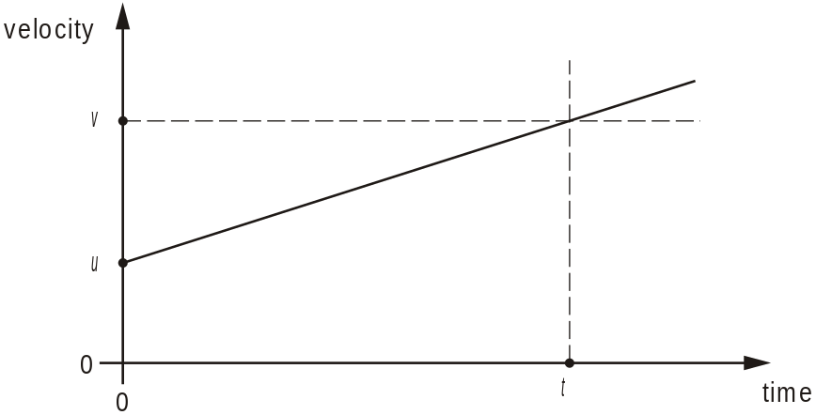

The object has a constant acceleration a. In a time t its velocity increases from u to v.
(a) Describe how the graph of the figure above can be used to determine
(i) the acceleration a of the object
In your answer, you should use appropriate technical terms, spelled correctly.
................................................................................................................
................................................................................................................
[1]
(ii) the displacement s of the object.
................................................................................................................
................................................................................................................
................................................................................................................
(b) Use the graph of the figure above to show that the displacement s of the object is given by the equation:
s = ut + at2

[2]

(c) In order to estimate the acceleration g of free fall, a student drops a large stone from a tall building. The height of the building is known to be 32 m. Using a stopwatch, the time taken for the stone to fall to the ground is 2.8 s.

(i) Use this information to determine the acceleration of free fall.

acceleration = .................................................m s–2
[2]

(ii) One possible reason why your answer to (c)(i) is smaller than the accepted value of 9.81 m s–2 is the reaction time of the student. State another reason why the answer is smaller than 9.81 m s–2.
................................................................................................................
................................................................................................................
[1]
[Total 7 marks]

Acceleration Due To Gravity
Terminal velocity and projectiles
An object that falls freely will accelerate towards the Earth because of the force of gravity acting on it.
The size of this acceleration does not depend mass, so a feather and a bowling ball accelerate at the same rate. On the Moon they hit the ground at the same time, on Earth the resistance of the air slows the feather more than the bowling ball.
The size of the gravitational field affects the magnitude of the acceleration. Near the surface of the Earth the gravitational field strength is 9.81 N/kg. This is also the acceleration a free falling object would have on Earth. In the equations of motion a = g = 9.81 m/s.
Mass is a property that tells us how much matter it is made of.
Mass is measured in kilograms, kg
Weight is a force caused by gravity acting on a mass:
weight = mass x gravitational field strength 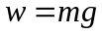
Weight is measured in Newtons, N

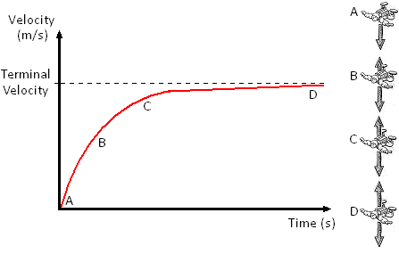
Terminal Velocity
If an object is pushed out of a plane it will accelerate towards the ground because of its weight (due to the Earth’s gravity). Its velocity will increase as it falls but as it does, so does the drag forces acting on the object (air resistance). Eventually the air resistance will balance the weight of the object. This means there will be no overall force which means there will be no acceleration. The object stops accelerating and has reached its terminal velocity.

Projectiles
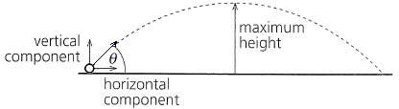
An object kicked or thrown into the air will follow a parabolic path like that shown to the right.
If the object had an initial velocity of u, this can be resolved into its horizontal and vertical velocity.
The horizontal velocity will be ucosθ and the vertical velocity will be usinθ. With these we can solve projectile questions using the equations of motion we already know.

Horizontal and Vertical Motion
The diagram shows two balls that are released at the same time, one is released and the other has a horizontal velocity. We see that the ball shot from the cannon falls at the same rate at the ball that was released. This is because the horizontal and vertical components of motion are independent of each other.

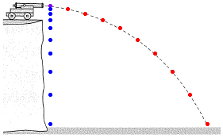
Horizontal: The horizontal velocity is constant; we see that the fired ball covers the same horizontal (across) distance with each second.
Vertical: The vertical velocity accelerates at a rate of g (9.81m/s²). We can see this more clearly in the released ball; it covers more distance each second.

The horizontal velocity has no affect on the vertical velocity. If a ball were fired from the cannon at a high horizontal velocity it would travel further but still take the same time to reach the ground.

Non-uniform acceleration
1. A skydiver jumps from a stationary hot-air balloon several kilometres above the ground.
(a) In terms of acceleration and forces, explain the motion of the skydiver
immediately after jumping ...............................................................................
.........................................................................................................................
.........................................................................................................................
.........................................................................................................................
.........................................................................................................................
.........................................................................................................................
at a time before terminal velocity is reached ...................................................
.........................................................................................................................
.........................................................................................................................
.........................................................................................................................
.........................................................................................................................
at terminal velocity. ..........................................................................................
.........................................................................................................................
.........................................................................................................................
.........................................................................................................................
.........................................................................................................................
[6]
(b) In the final stage of the fall, the skydiver is falling through air at a constant speed. The skydiver’s kinetic energy does not change even though there is a decrease in the gravitational potential energy. State what happens to this loss of gravitational potential energy.
.........................................................................................................................
.........................................................................................................................
[1]

(c) The figure below shows a sketch graph of the variation of the velocity v of the skydiver with time t.
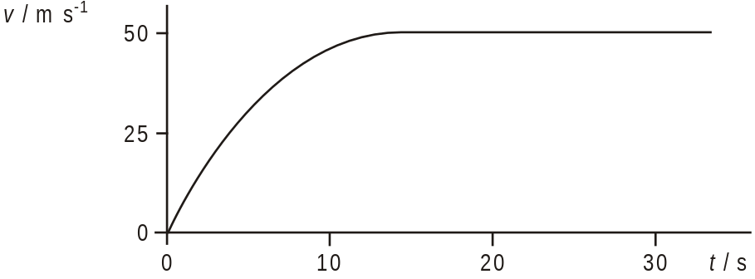
Suggest the changes to the graph of the figure above, if any, for a more massive (heavier) skydiver of the same shape.
.........................................................................................................................
.........................................................................................................................
.........................................................................................................................
.........................................................................................................................
[2] [Total 9 marks]
Projectile Motion
1. A ball is thrown out of a window 18 m above the ground.
It is thrown horizontally at 5.0 m s–1.
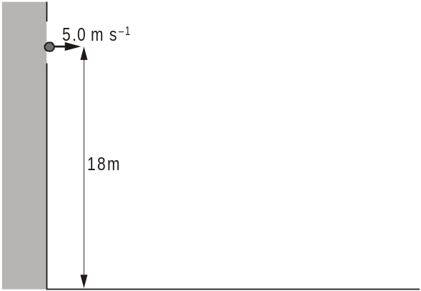
(a) Show that it takes about 2 seconds to reach the ground.
g = 9.81 m s–2 [2]
(b) Calculate the distance from the bottom of the building to the place where the ball hits the ground. [1]

2. A motorcycle stunt rider, moving at constant speed, takes off horizontally from a launch point 2.0 m above the ground, as shown below.
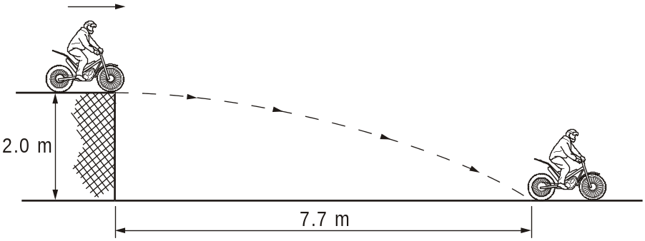
He lands on the ground 7.7 m away as shown.
(a) By considering his vertical motion only, show that the time taken to reach the ground after he has taken off is about 0.6 s. Neglect the effects of any resistive forces.
acceleration due to gravity = 9.81 m s–2 [2]
(b) Calculate the horizontal velocity at which he leaves the launching point. [2]
3. A projectile is launched horizontally at a speed of 0.5 m s–1 above the surface of the Moon.
The velocity of the projectile, at equal time intervals, is represented in magnitude and direction by the arrows shown in the graphic below.
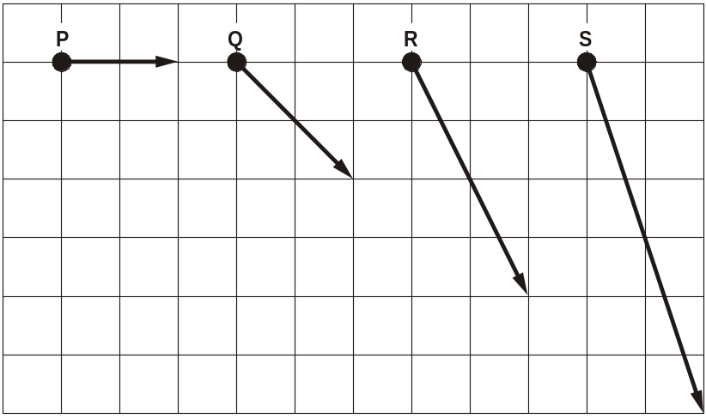
(a) (i) Construct arrows on the diagram to represent the vertical component of velocity for each of the vectors Q, R and S.
[1]
(ii) The grid on the diagram is drawn to the scale: 1 division represents
0.25 m s–1. Complete the table below.
velocity vector | P | Q | R | S
vertical component of velocity / m s–1 | 0
[1]

(b) The velocity vectors of the projectile are shown at 0.3 s intervals.
Using the information from (a), calculate the acceleration due to gravity on the Moon.

acceleration = ...................................... m s–2
[2]
[Total 4 marks]

4. This question is about a simple model of the physics of the long jump.
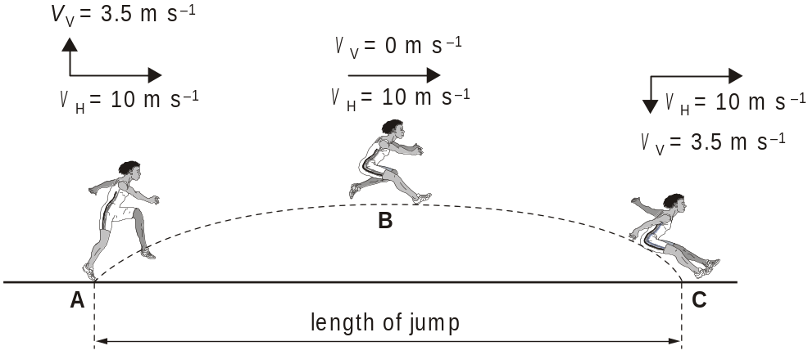
The figure above shows a long jumper at three different stages, A, B and C, during the jump. The horizontal and vertical components of velocity at each position are shown.

(a) (i) In the model, the horizontal component of velocity vH is constant at 10 m –1 throughout the jump.
State the assumption that has been made in the model.

[1]

(ii) Without calculation, explain why the vertical component of velocity vV changes from 3.5 m s–1 at A to 0 m s–1 at B.

[2]
(b) (i) By considering only the vertical motion, show that it takes about 0.4 s for the jumper to reach maximum height at B after taking off from A.
g = 9.8 m s–2

[2]
(ii) Hence, calculate the length of the jump.

length of the jump = ………………………… m
[2]

(c) Long jumpers can use this model to help them to improve their performance.
Explain why the length of the jump can be increased by
- increasing the horizontal component of velocity vH, keeping vV the same

[2]
(ii) increasing the vertical component of velocity vV, keeping vH the same.

[2]
[Total 11 marks]

5. This question is about the mathematical modelling of a golf shot.
(a) A golf professional demonstrates how to play an approach shot to a green. When struck, the golf ball follows the path shown from W, reaching its greatest vertical height h at X, and pitches onto the front of the green at Y as shown in Fig. 1.
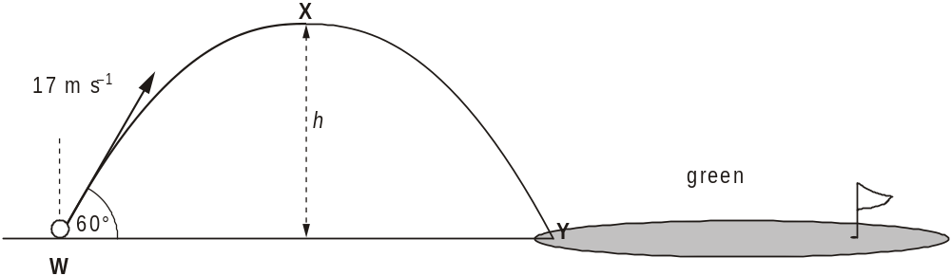
Fig. 1
(i) The ball leaves the ground at 17 m s–1 at an angle of 60° to the horizontal.
Show that the initial vertical component of velocity vy of the ball is
14.7 m s–1.

[1]
(ii) At the highest point X, the vertical component of velocity vy = 0.
Explain why the vertical component of velocity has changed.

[1]
(iii) The ball takes 1.5 s to reach its maximum height.
Calculate the maximum vertical height h reached by this ball.
g = 9.8 m s–2

h = .......................m
[3]

(b) The golf professional plays a second shot from the same position W using a different golf club. Again the ball pitches onto the front of the green at the same point Y, but the path through the air followed by this ball is quite different, as shown in Fig. 2.
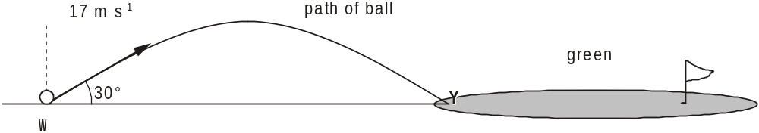
Fig. 2
This ball leaves the ground at 17 m s–1 as in the first shot, but at an angle of only 30° to the horizontal.
- State and explain how the time of flight for this ball travelling from W to Y compares with that of the first ball.

[2]
(ii) Explain why the horizontal range WY can be the same for each shot even though the times of flight are different.

[2]
(iii) Suggest and explain which of the two balls might be expected to travel further across the green after pitching onto it at Y

[2]
[Total 11 marks]

Newton’s 1st Law
Newton’s Laws
An object will remain at rest, or continue to move with uniform velocity, unless it is acted upon by an external resultant force.

Newton’s 2nd Law
The rate of change of an object’s linear momentum is directly proportional to the resultant external force. The change in the momentum takes place in the direction of the force.

Newton’s 3rd Law
When body A exerts a force on body B, body B exerts an equal but opposite force on body A.
Force is measured in Newtons, N
Say What?
Newton’s 1st Law
If the forward and backward forces cancel out, a stationary object will remain stationary.
If the forward forces are greater than the backwards forces, a stationary object will begin to move forwards.
If the forward and backward forces cancel out, a moving object will continue to move with constant velocity.
If the forward forces are greater than the backward forces, a moving object will speed up.
If the backward forces are greater than the forward forces, a moving object will slow down.
Newton’s 2nd Law
The acceleration of an object increases when the force is increased but decreases when the mass is increased: 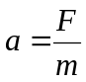 but we rearrange this and use 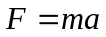
Newton’s 3rd Law
Forces are created in pairs.
As you sit on the chair your weight pushes down on the chair, the chair also pushes up against you.
As the chair rests on the floor its weight pushes down on the floor, the floor also pushes up against the chair.
The forces have the same size but opposite directions.

Riding the Bus
Newton’s 1st Law
You get on a bus and stand up. When the bus is stationary you feel no force, when the bus accelerates you feel a backwards force. You want to stay where you are but the bus forces you to move. When the bus is at a constant speed you feel no forwards or backwards forces. The bus slows down and you feel a forwards force. You want to keep moving at the same speed but the bus is slowing down so you fall forwards. If the bus turns left you want to keep moving in a straight line so you are forced to the right (in comparison to the bus). If the bus turns right you want to keep moving in a straight line so you are forced left (in comparison to the bus).
Newton’s 2nd Law
As more people get on the bus its mass increases, if the driving force of the bus’s engine is constant we can see that it takes longer for the bus to gain speed.
Newton’s 3rd Law
As you stand on the bus you are pushing down on the floor with a force that is equal to your weight. If this was the only force acting you would begin to move through the floor. The floor is exerting a force of equal magnitude but upwards (in the opposite direction).

Taking the Lift
Newton’s 1st Law
When you get in the lift and when it moves at a constant speed you feel no force up or down. When it sets off going up you feel like you are pushed down, you want to stay where you are. When it sets off going down you feel like you are lighter, you feel pulled up.
Newton’s 2nd Law
As more people get in the lift its mass increases, if the lifting force is constant we can see that it takes longer for the lift to get moving. Or we can see that with more people the greater the lifting force must be.
Newton’s 3rd Law
As you stand in the lift you push down on the floor, the floor pushes back.

Newton’s second law

An 80 kg skier has a force of 200 N exerted on him down the slope.
1. Calculate his acceleration down the slope.
2. Is the slope less than or more than 45°? Explain your answer.
An ice hockey player has a sudden impact force of 2000 N exerted on him due to unexpected collision with the wall. The mass of the player is 100 kg.
3. Find his acceleration.
4. Compare this with the acceleration when he free falls.
Coming out of a dive, 75 kg astronauts in training experience an acceleration of 40 m s–2.
5. Calculate the force acting on them.
6. Compare this with the force which normally acts on them when stationary on Earth.
7. Why is it important that they are seated and strapped in before the dive ends?
A 50 g tennis ball may be accelerated at 1000 m s–2 to reach a service speed of 130 mph.
8. Calculate the force required to accelerate the ball.
9. Is your answer reasonable? Comment.
When a force of 200 N is exerted on an asteroid it accelerates at 0.002 m s–2.
10. Find the mass of the asteroid.

Q1.
An object of mass 3.2 kg is acted on by two forces which are at right angles to each other. The resultant force is 11.5 N.
(a) Calculate the acceleration of the object.

(2)
(b) One of the forces has a magnitude of 6.0 N.
Using a scale diagram or otherwise, find:
(i) the magnitude of the other force;

(2)
(ii) the angle between the resultant force and the 6.0 N force.

(2)
(Total 6 marks)
Q2.
A car of mass 1300 kg is stopped by a constant horizontal braking force of 6.2 kN.
(a) Show that the deceleration of the car is about 5 m s^{–2}.
___________________________________________________________________
___________________________________________________________________
___________________________________________________________________
___________________________________________________________________
___________________________________________________________________
(3)
(b) The initial speed of the car is 27 m s^{–1}.
Calculate the distance travelled by the car as it decelerates to rest.
___________________________________________________________________
___________________________________________________________________
___________________________________________________________________
___________________________________________________________________
___________________________________________________________________
___________________________________________________________________
distance travelled ____________________ m
(3)
(Total 6 marks)

Q3.
Figure 1 shows the variation of velocity v with time t for a Formula 1 car during a test drive along a straight, horizontal track.
The total mass of the car and driver is 640 kg. The car engine provides a constant driving force of 5800 N.
Figure 1
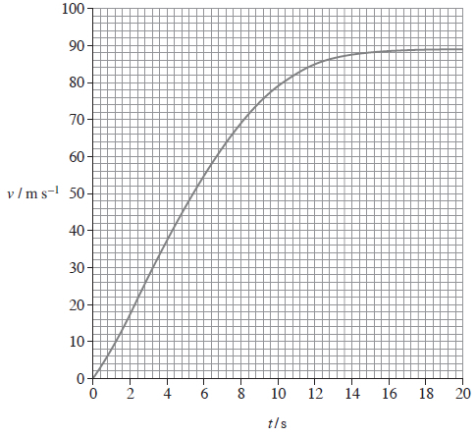
(a) (i) Determine the distance travelled by the car during the first 10 s.
distance ____________________ m
(3)
(ii) Show that the instantaneous acceleration is about 4 m s⁻² when t is 10 s.

(2)

(iii) Calculate the magnitude of the resistive forces on the car when t is 10 s.
resistive forces ____________________ N
(3)
(b) Figure 2 shows the aerofoil that is fitted to a Formula 1 car to increase its speed around corners.
Figure 2
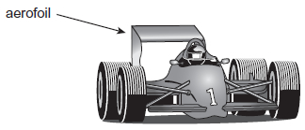
However, the aerofoil exerts an unwanted drag force on the car when it is travelling in a straight line so a Drag Reduction System (DRS) is fitted. This system enables the driver to change the angle of the aerofoil to reduce the drag.
The graph in Figure 1 is for a test drive along a straight, horizontal track. Under the conditions for this test drive, the DRS was not in use and the engine produced a constant driving force.
Explain why the velocity varies in the way shown in the graph.
Go on to explain how the graph will be different when the DRS is in use and the driving force is the same.
The quality of written communication will be assessed in your answer.
___________________________________________________________________
___________________________________________________________________
___________________________________________________________________
___________________________________________________________________
___________________________________________________________________
___________________________________________________________________
___________________________________________________________________
___________________________________________________________________
___________________________________________________________________
___________________________________________________________________
___________________________________________________________________
___________________________________________________________________
(6)
(Total 16 marks)
Q4.
A car is designed to break the land speed record. The thrust exerted on the car is 230 kN at one instant of its motion. The mass of the car at this instant is 11 000 kg.
(a) The acceleration of the car at this instant is 2.9 m s⁻².
Calculate the air resistance acting on the car.
air resistance =__________________ N
(3)
(b) The thrust on the car remains constant as the speed increases.
Explain why the acceleration decreases and eventually reaches zero.
___________________________________________________________________
___________________________________________________________________
___________________________________________________________________
___________________________________________________________________
___________________________________________________________________
(2)
(c) A supersonic car is attempting to break the land speed record on a horizontal track. When it is travelling at 320 m s⁻¹, a small part P that is 1.5 m above the ground becomes detached from the car. The initial vertical velocity of P is 2.5 m s⁻¹ in the upwards direction.
Calculate the time taken for the small part P to reach the ground.
Assume that air resistance has a negligible effect on the vertical motion.
time =______________________s
(3)

(d) The graph below shows the path that P would follow from the instant that it became detached if there were no air resistance in the horizontal direction.
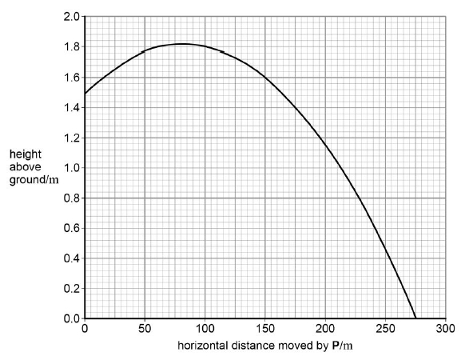
In practice, air resistance is not negligible in the horizontal direction.
Draw, on the graph, a line to show the path that P would follow assuming that air resistance only affects motion in the horizontal direction.
(2)
(e) Explain your answer to part (d), including the reason why air resistance is negligible in the vertical direction.
___________________________________________________________________
___________________________________________________________________
___________________________________________________________________
___________________________________________________________________
___________________________________________________________________
(2)
(Total 12 marks)

Momentum
Momentum and collisions
The momentum of an object is given by the equation: momentum = mass x velocity 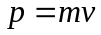
Since it depends on the velocity and not speed, momentum is a vector quantity. If we assign a direction to be positive for example if was positive, an object with negative velocity would be moving . It would also have a negative momentum.
Momentum is measured in kilogram metres per second, kg m/s or kg m s⁻¹

Conservation
In an isolated system (if no external forces are acting) the linear momentum is conserved.
We can say that: the total momentum before = the total momentum after
The total momentum before and after what? A collision or an explosion.

Collisions
There are two types of collisions; in both cases the momentum is conserved.
Elastic – kinetic energy in conserved, no energy is transferred to the surroundings
If a ball is dropped, hits the floor and bounces back to the same height it would be an elastic collision with the floor. The kinetic energy before the collision is the same as the kinetic energy after the collision.
Inelastic – kinetic energy is not conserved, energy is transferred to the surroundings
If a ball is dropped, hits the floor and bounces back to a lower height than released it would be an inelastic collision. The kinetic energy before the collision would be greater than the kinetic energy after the collision.
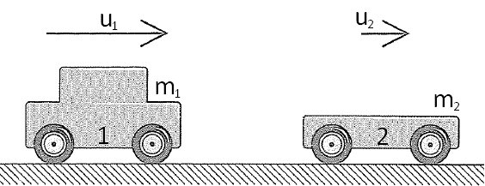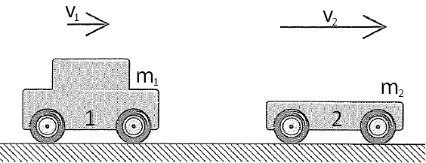
Before After
In the situation above, car 1 and car 2 travel to the right with initial velocities u₁ and u₂ respectively. Car 1 catches up to car 2 and they collide. After the collision the cars continue to move to the right but car 1 now travels at velocity v₁ and car 2 travels a velocity v₂. [ is positive]
Since momentum is conserved the total momentum before the crash = the total momentum after the crash.
The total momentum before is the momentum of A + the momentum of B
The total momentum after is the new momentum of A + the new momentum of B
We can represent this with the equation: 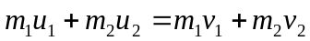

Explosions
We look at explosions in the same way as we look at collisions, the total momentum before is equal to the total momentum after. In explosions the total momentum before is zero. [ is positive]
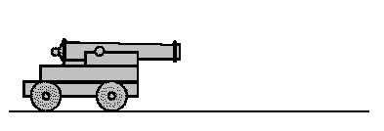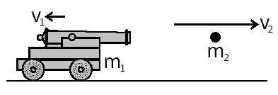
Before After
If we look at the example above we can see that the whole system is not moving, so the momentum before is zero. After the explosion the shell travels right with velocity v₂ and the cannon recoils with a velocity v₁.
The momentum of the system is given as:
So the equation for this diagram would be: 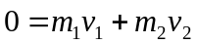
But remember, v₁ is negative so: 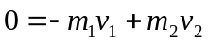 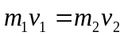

Linear Momentum and Collisions
- What is the value of the momentum of a 10 kg ball running down a bowling alley at a speed of 5ms⁻¹?
- The momentum of an object of mass 43.5kg is 200kgms⁻¹, what is its speed?
- A railway truck of mass 3000kg moving at a speed of 2.0 ms⁻¹ collides with a stationary truck. The two trucks stick together and move off after the collision at a speed of 1.2ms⁻¹. What is the mass of the second truck?
- A skater of mass 60kg and velocity 3ms⁻¹ collides with a stationary skater of mass 50kg. The two skaters join together and move off in the same direction. What is their velocity after impact?
- A bullet of mass 5g is shot from a rifle at a speed of 200ms⁻¹. The rifle has a mass of 4kg. Calculate the velocity at which the rifle recoils.
- A rocket of mass 500kg prepares to dock with a space station. The rocket is travelling at a constant speed of 0.5ms⁻¹ relative to the space station, which has a mass of 3500kg. Calculate the change in the velocity of the space station when the rocket docks with it.
- A radioactive nucleus of mass number 235, travelling at 4.0 × 10⁵ m s−1, disintegrates into a nucleus of mass 95 (which travels backwards at 2.0 × 10⁵ m s−1) and a nucleus of mass number 140.
Calculate the velocity of the nucleus of mass number 140 and state in which direction it will travel.

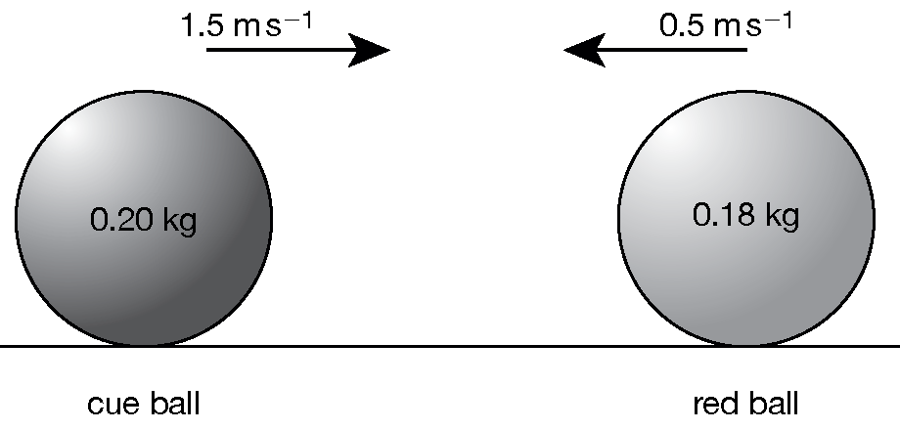
Figure 2 Two billiard balls colliding head on
During a game of billiards two balls collide head on as shown in Figure 2. The cue ball has a mass of 0.20 kg while the red ball has a mass of 0.18 kg. After the collision, the cue ball recoils with a speed of 0.50 m s^{–1}.
  - Calculate the total momentum before the collision.
  - Calculate the momentum of the cue ball after the collision.
  - Calculate the velocity of the red ball after the collision.
- A mass of 5.00 kg moving with velocity 20.0 m s^{–1} to the right collides with a stationary mass of 10.0 kg. The final velocity of the 5.00 kg mass is 6.67 m s^{–1}
to the left.
Calculate the final velocity of the 10.0 kg mass. Is the collision elastic?
- An alpha particle of mass 4.0 u with a velocity of 1.0 × 10⁶ m s–1 to the right collides with a stationary proton of mass 1.0 u. After the collision, the alpha particle moves with velocity 0.60×10⁶ m s–1 to the right.
Calculate the velocity of the proton. Show that the collision is elastic.
- A car has a total mass of 2000 kg and is moving at 12.5 m s⁻¹ when it strikes a smaller car head on. The smaller car has a mass of 1200 kg and was moving at 16.7 m s⁻¹ before the collision.
Calculate the velocity of the cars if they move off together as one after the collision.
Is the collision elastic or inelastic? You must show your working.

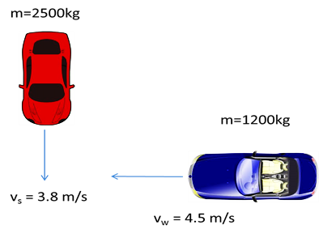
Collision in 2D
- A driver is driving south in a 2500kg car at 3.8ms⁻¹ when they collide with a 1200kg car that is driving west at 4.5 ms⁻¹. The two vehicles lock together in the impact. Find the speed and direction of the damaged vehicles immediately after the collision.

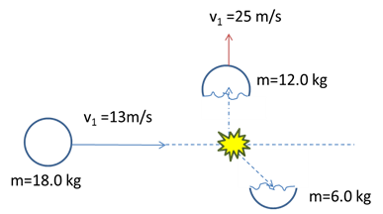
- An 18.0kg object moving at 13ms⁻¹ to the east explodes into 2 unequal fragments. After the explosion the 12.0 kg fragment moves at 15ms⁻¹ south, what is the magnitude of the velocity of the smaller 6kg object?

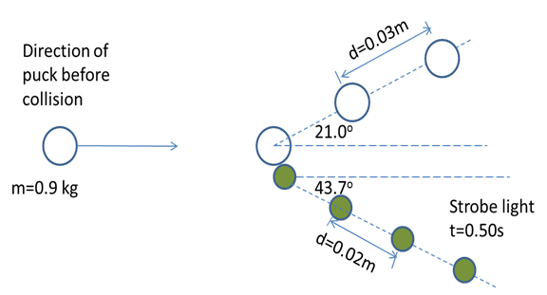
- A long exposure image with a strobe light shows 2 pucks at 0.5s time intervals. The 0.90 kg incident puck is observed to be deflected form its original path by 21º. The 0.70kg target puck, initially at rest, is propelled forward at an angle of 43.7º to the incident path. Calculate the speed of the 0.9kg puck before the collision.

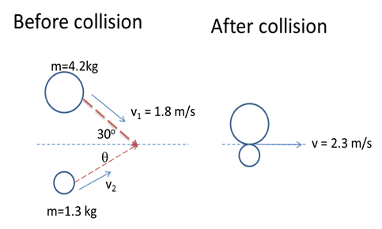

- Two cakes are moving as shown in the diagram. They collide and stick together. Determine the speed and direction (θ) of the 1.3kg cake before the collision.

Q1.
The figure below shows a neutron of mass 1.7 × 10^{–27} kg about to collide inelastically with a stationary uranium nucleus of mass 4.0 × 10^{–25} kg. During the collision, the neutron will be absorbed by the uranium nucleus.
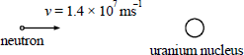
(a) Calculate the velocity of the uranium nucleus immediately after the neutron has been absorbed.

(3)
(b) Collisions between neutrons and uranium nuclei can also be elastic. State, and explain briefly, how the speed of the uranium nucleus after impact would be different in the case of an elastic collision.
Do not perform any further calculations.
___________________________________________________________________
___________________________________________________________________
___________________________________________________________________
___________________________________________________________________
___________________________________________________________________
___________________________________________________________________
(3)
(c) Using the data at the beginning of the question, calculate the kinetic energy of the neutron before it collides with the uranium nucleus.

(3)
(Total 9 marks)
Q2.
Deep space probes often carry modules which may be ejected from them by an explosion. A space probe of total mass 500 kg is travelling in a straight line through free space at 160 m s^{–1} when it ejects a capsule of mass 150 kg explosively, releasing energy. Immediately after the explosion the probe, now of mass 350 kg, continues to travel in the original straight line but travels at 240 m s^{–1}, as shown in the figure below.
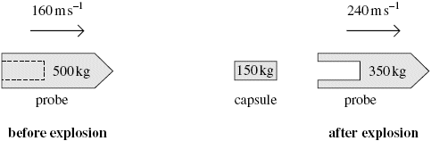
(a) Discuss how the principles of conservation of momentum and conservation of energy apply in this instance.
The quality of your written communication will be assessed in this question.
___________________________________________________________________
___________________________________________________________________
___________________________________________________________________
___________________________________________________________________
___________________________________________________________________
___________________________________________________________________
___________________________________________________________________
___________________________________________________________________
___________________________________________________________________
___________________________________________________________________
___________________________________________________________________
___________________________________________________________________
___________________________________________________________________
(6)
(b) (i) Calculate the magnitude of the velocity of the capsule immediately after the explosion and state its direction of movement.

magnitude of velocity = ______________________ m s^{–1}
direction of movement ______________________
(3)
(ii) Determine the total amount of energy given to the probe and capsule by the explosion.

answer = ______________________ J
(4)
(Total 13 marks)

Force
Force and Impulse
If we start at F = ma we can derive an equation that links force and momentum.
we can replace a in this equation with
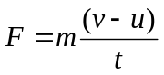 multiplying out makes the equation
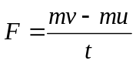 or 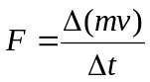 where ∆ means ‘the change in’
This states that the force is a measure of change of momentum with respect to time. This is Newton’s Second Law of Motion:
The rate of change of an object’s linear momentum is directly proportional to the resultant external force. The change in the momentum takes place in the direction of the force.

If we have a trolley and we increase its velocity from rest to 3m/s in 10 seconds, we know that it takes a bigger force to do the same with a trolley that’s full of shopping. Ever tried turning a trolley around a corner when empty and then when full?
Force is measured in Newtons, N

Car Safety
Many of the safety features of a car rely on the above equation. Airbags, seatbelts and the crumple zone increase the time taken for the car and the people inside to stop moving. Increasing the time taken to change the momentum to zero reduces the force experienced.

Catching
An Egg: If we held our hand out and didn’t move it the egg would smash. The change in momentum happens in a short time, making the force large. If we cup the egg and move our hands down as we catch it we make it take longer to come to a complete stop. Increasing the time taken decreases the force and the egg remains intact.
Cricket Ball: If we didn’t move our hands it would hurt when the ball stopped in our hands. If we make it take longer to stop we reduce the force on our hands from the ball.

Impulse
multiply both sides by t 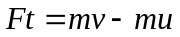
multiply both sides by t 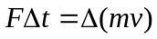
We now have an equation for impulse. Impulse is the product of the force and the time it is applied for.
An impulse causes a change in momentum.
Impulse is measured in Newton seconds, Ns

Since , the same impulse (same force applied for the same amount of time) can be applied to a small mass to cause a large velocity or to a large mass to cause a small velocity
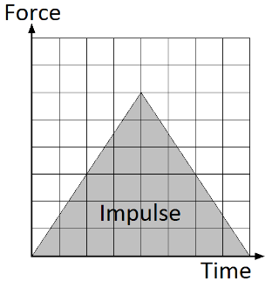
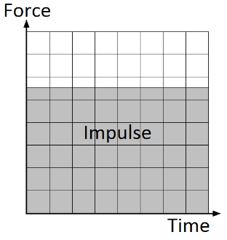
Ft = mv = mv

Force-Time Graphs
The impulse can be calculated from a force-time graph, it is the same as the area under the graph.
The area of the first graph is given by:
height x length = Force x time = Impulse

Force, Impulse and Momentum

- A car of mass 1000kg travelling at 13.5ms⁻¹ is stopped in 13s. What force was exerted by the brakes?
- A toy car with a mass of 1kg is travelling at 5ms⁻¹, it hits a wall and stops in a time of 0.5s. What is the average force on the car?
- A car bumper is designed not to bend in impacts at less than 4ms⁻¹. It was fitted to a car of mass 900kg and tested by driving the car into a wall. The time of impact was measured and found to be 1.8s. What was the force of impact if the car is travelling at 4ms⁻¹?
- During a virtual skydiving ride, a column of air is pushed upwards by a rapidly rotating fan. This column of air is used to support a rider in free fall. The fan causes a mass of 120 kg of air per second to move upwards at a velocity of 10 ms^{–1}.
  - Calculate the rate of change of momentum of the air.
  - Calculate the maximum mass of a person who could be supported by this upwards column of air.

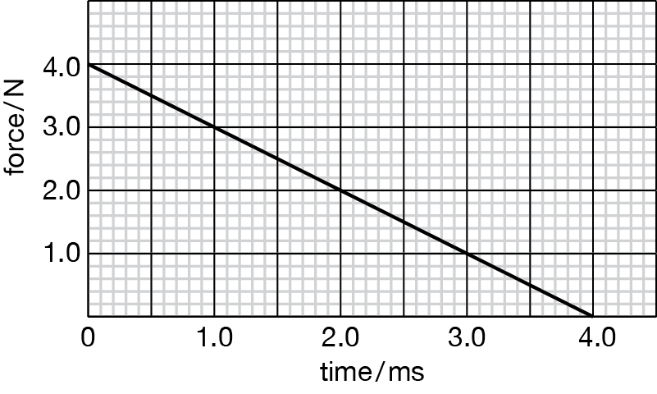
Figure 1 Graph of force against time
A toy arrow is projected horizontally by a bow. The graph in Figure 1 shows how the force on the arrow varies as the string is released. The toy arrow has a mass of 0.025 kg.
  - What quantity is represented by the area under the graph?

  - The initial velocity of the arrow is zero. Calculate the velocity of the arrow immediately after it is launched from the bow.

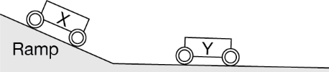
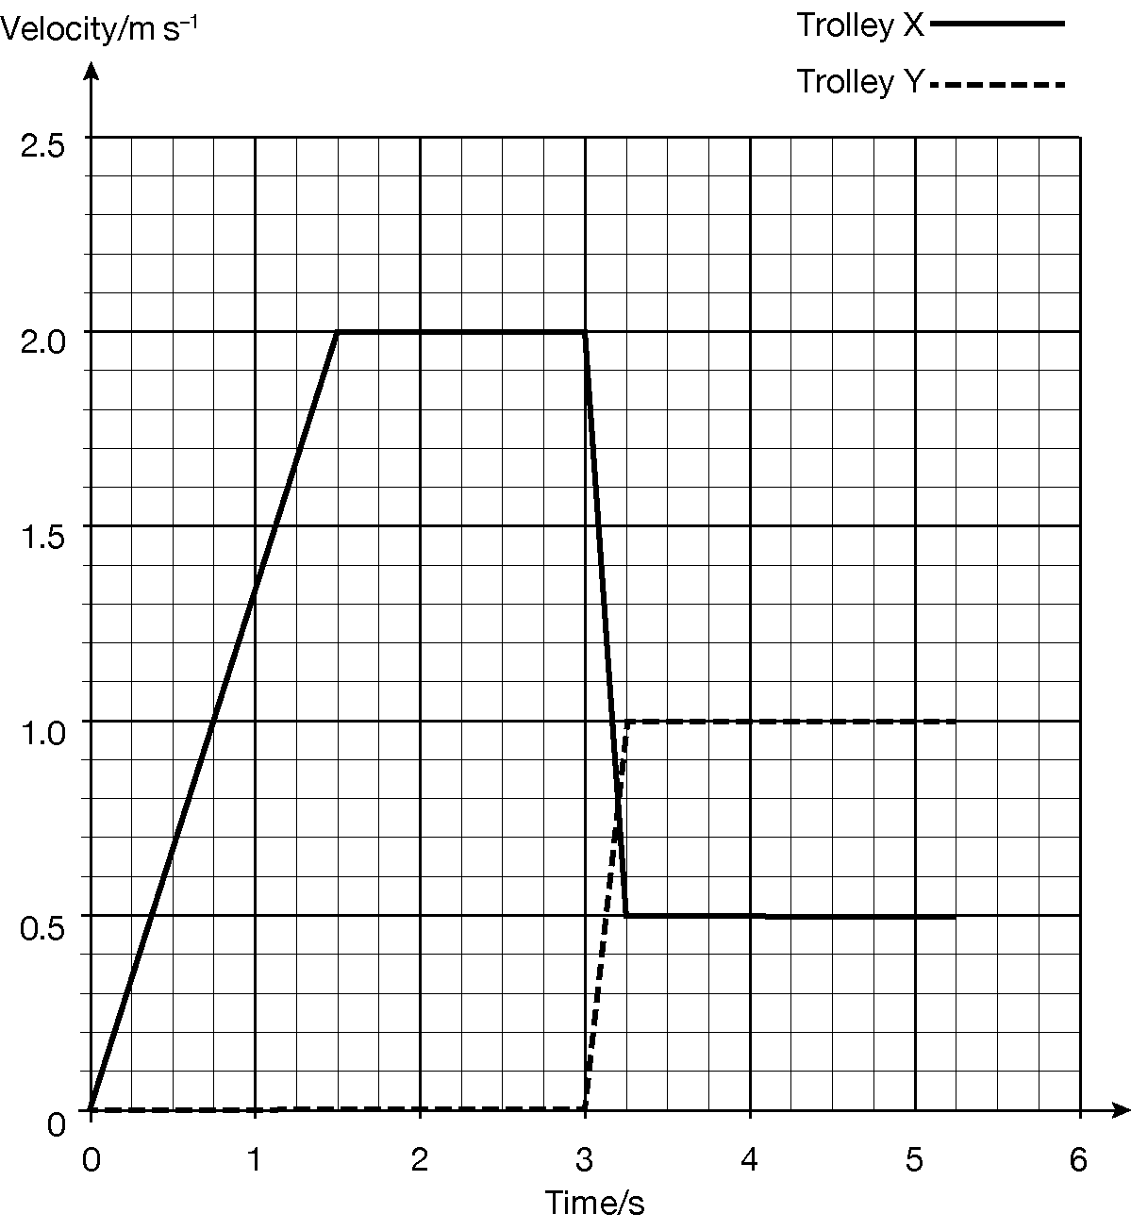
During an investigation into the law of conservation of momentum, two trolleys (X and Y) are positioned as shown in Figure 3. Trolley X accelerates down a ramp, then rolls down another ramp, adjusted to counteract frictional forces. Trolley X then collides with trolley Y, causing both trolleys to continue moving forwards separately. The mass of trolley X is 0.50 kg.
Figure 3 Collision between two trolleys

  - Use the graph to calculate the acceleration of trolley X as it travels down the ramp.
  - Calculate the distance trolley X travels before the impact with trolley Y.
  - Calculate the momentum of trolley X just before the impact.
  - Calculate the momentum of trolley X just after the impact.
  - Calculate the mass of trolley Y.
  - The impact between the two trolleys lasts for 0.25 s. Calculate the net force acting on trolley Y during the impact.

- A cricket ball of mass 0.12 kg strikes a stationary bat at a speed of 20 m s⁻¹. The contact time of the ball with the bat is 0.15 s. The ball then returns along its original path with a speed of 16 m s⁻¹.
Assuming the bat remains stationary, calculate
  - the momentum of the ball before the impact with the bat
  - the momentum of the ball after the impact with the bat
  - the change of momentum of the ball during contact with the bat
  - the average force acting on the ball while in contact with the bat
  - the amount of kinetic energy lost by the ball during the impact, stating whether the collision was elastic or inelastic.

Q1.
The diagram shows two railway trucks A and B travelling towards each other on the same railway line which is straight and horizontal.
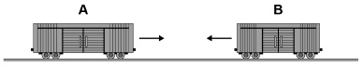
The trucks are involved in an inelastic collision. They join when they collide and then move together.
The trucks move a distance of 15 m before coming to rest.
Truck A has a total mass of 16 000 kg and truck B has a total mass of 12 000 kg
Just before the collision, truck A was moving at a speed of 2.8 m s^{–1} and truck B was moving at a speed of 3.1 m s^{–1}
(a) State the quantity that is not conserved in an inelastic collision.
___________________________________________________________________
(1)
(b) Show that the speed of the joined trucks immediately after the collision is about 0.3 m s^{–1}

(3)
(c) Calculate the impulse that acts on each truck during the collision.
Give an appropriate unit for your answer.
impulse = ____________________ unit ___________
(2)
(d) Explain, without doing a calculation, how the motion of the trucks immediately after the collision would be different for a collision that is perfectly elastic.
___________________________________________________________________
___________________________________________________________________
___________________________________________________________________
___________________________________________________________________
___________________________________________________________________
___________________________________________________________________
___________________________________________________________________
___________________________________________________________________
___________________________________________________________________
(2)
(Total 8 marks)
Q2.
A golf ball is raised from the ground and dropped onto a hard plate to test the properties of the ball. A sensor measures the force exerted by the plate on the ball during its collision with the plate. The graph below shows the variation of force exerted on the golf ball with time.
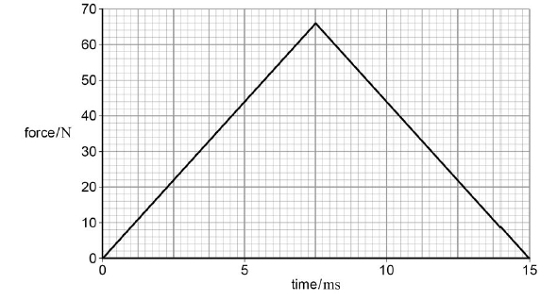
(a) Show that the change in momentum of the golf ball during the collision is about 0.5 N s.

(2)

(b) The ball strikes the plate with a speed of 7.1 m s⁻¹ and has a mass of 45 g. It leaves the plate with a speed of 3.9 m s⁻¹.
Show that this is consistent with a change in momentum of about 0.5 N s.

(3)
(c) The ball continues to bounce, each time losing the same fraction of its energy when it strikes the plate. Air resistance is negligible.
Determine the percentage of the original gravitational potential energy of the ball that remains when it reaches its maximum height after bouncing three times.
gravitational potential energy remaining = _____________________ %
(4)
(d) Explain, with reference to the conservation of momentum, the effect that the motion of the golf ball has on the motion of the Earth from the instant it is released until it bounces at the plate.
___________________________________________________________________
___________________________________________________________________
___________________________________________________________________
___________________________________________________________________
___________________________________________________________________
___________________________________________________________________
___________________________________________________________________
___________________________________________________________________
(3)
(Total 12 marks)

Energy
Work, energy and power
We already know that it appears in a number of different forms and may be transformed from one form to another. But what is energy? Energy is the ability to do work.
We can say that the work done is equal to the energy transferred
Work done = energy transferred 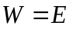

Work Done
In Physics we say that work is done when a force moves through a distance and established the equation
Work Done = Force x Distance moved in the direction of the force 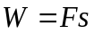
Work Done is measured in Joules, J
Force is measured in Newtons, N
Distance is measured in metres, m
The distance moved is not always in the direction of the force. In the diagram we can see that the block moves in a direction that is θ away from the ‘line of action’ of the force. To calculate the work done we must calculate the distance we move in the direction of the force or the size of the force in the direction of the distance moved. Both of these are calculated by resolving into horizontal and vertical components.
Work Done = Force x Distance moved in the direction of the force
Work Done = Size of Force in the direction of movement x Distance moved
Work Done = 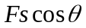
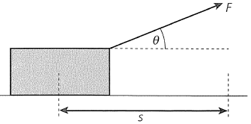 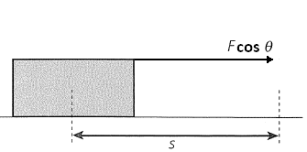 or 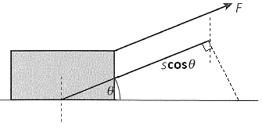

Power
Power is a measure of how quickly something can transfer energy. Power is linked to energy by the equation:
Power is measured in Watts, W
Energy is measured in Joules, J
Time is measured in seconds, s

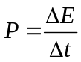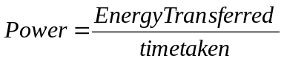
But Work Done = Energy Transferred so we can say that power is a measure of how quickly work can be done.
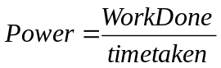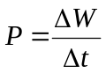
Now that we can calculate Work Done we can derive another equation for calculating power:
We can substitute into 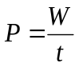 to become 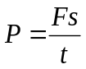this can be separated into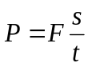 .
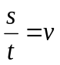so we can write 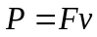
Velocity is measured in metres per second, m/s or ms⁻¹

Efficiency
We already know that the efficiency of a device is a measure of how much of the energy we put in is wasted.
Efficiency = useful energy transferred by the device this will give us a number less than 1
total energy supplied to the device
Useful energy means the energy transferred for a purpose, the energy transferred into the desired form.
Since power is calculated from energy we can express efficiency as:
Efficiency = useful output power of the device again this will give us a number less than 1
input power to the device
To calculate the efficiency as a percentage use the following:
percentage efficiency = efficiency x 100%

Work Done and Energy
1. Define work done by a force.
2. Calculate the work done when:
  - The resultant force on a car is 22 kN and it travels 2.0 km.
  - A skier of weight 620 N skis for 150 m down a slope at 80º to the vertical.
  - A passenger pulls a suitcase across a horizontal floor, with a force of 160 N at an angle of 35º to the horizontal, to the check-in desk 55 m away along the floor.
3. The Moon has a mass of 7.3 × 10²² kg and an orbital speed of 1.02 km s^{–1}.
  - Calculate the kinetic energy it has due to this motion.
  - The Moon also rotates. State what effect this will have on its total kinetic energy.

4. Felix Baumgartner set a world skydiving record in October 2012 for falling from a height of 39 045 m. His mass (with gear) was 118 kg.
(a) Calculate the gravitational potential energy transferred during the fall.
- Felix reached a speed of 370 m s^{–1} Calculate his kinetic energy at this speed.

5. Calculate the work done when a weightlifter lifts a weight of 200 kg to a height 1.8 m above the ground.

6. A girl has a mass of 58 kg. She is standing at the top of a fairground slide, 24 m above the ground. The bottom of the side is 0.50 m above the ground. Assuming negligible frictional forces between the top and the bottom of the slide, deduce or calculate her:
- decrease in gravitational potential energy as she goes down the slide
- kinetic energy at the bottom of the slide
- speed at the bottom of the slide.

Power and Efficiency
1. Define power.
- A weightlifter lifts a weight of 2000 N a distance of 2.1 m from the floor in 2.4 s. Calculate their average power.
- Calculate the output power when:
  - A motor lifts a 2500 N load 15 m, in 5.0 s.
  - A motor accelerates a roller-coaster of mass 800 kg from 0 to 30 m s^{–1}, in 6.0 s.
  - A car of mass 1100 kg accelerates from 20 m s^{–1} to 30 m s^{–1}, in 3.0 s.
  - A driver and passengers push a broken-down car with a force of 1020 N along a level road to a garage 430 m away. It takes them 15 minutes, not including stops.
- A car travels on a level road at constant speed of 27 m s^{–1}. The output power of the engine is 15 kW. Calculate the total resistive force on the car.
- A 1000 W microwave oven has a power consumption of 1.2 kW. Calculate its efficiency.
- The resultant force on a train is 28 kN and it travels a constant velocity of 45 m s^{–1}.
  - What is the useful output power of the engines?
  - If the engines are 30% efficient, what is the input power needed?
- Calculate how long a 92% efficient electric motor with input power 55 W takes to lift a 15 kg mass 2.5 m.
- Solar panels are installed with an area of 45 m². The maximum intensity of sunlight on the panels is 180 W m^{–2}. The efficiency of the panels is 19%.
  - Calculate the electrical power generated.
  - Suggest one reason why the electrical power generated by the panels is often less than this.
9. A car of weight 1.5 × 10⁴ N drives up a slope at a steady speed of 12 m s⁻¹. The car gains 1.0 m of height for every 10 m travelled in the horizontal direction. Assuming weight is the only resistive force calculate the power of the engine. (2 marks)
Q1.
The diagram below shows a man participating in a ‘strong man’ competition. The event requires the man to haul a concrete block along a horizontal path for a distance of 15 m. The frictional force between the block and the path is 2800 N.
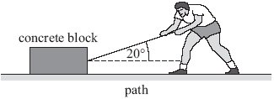
(a) The rope is inclined at an angle of 20° to the horizontal.
Calculate the minimum force that the man must exert on the rope to move the block.

force ____________________ N
(1)
(b) Calculate the minimum work that the man has to do to complete the event.

work done ____________________ J
(1)
(Total 2 marks)
Q2.
The mass of a car and its passengers is 950 kg. When the brakes are applied the car decelerates uniformly from a speed of 25 m s^{–1} to a speed of 15 m s^{–1} in 2.5 s.
(a) Calculate the decelerating force developed by the brakes.

(2)
(b) Calculate the work done in decelerating the car.

(3)
(c) Calculate the rate of energy dissipation by the brakes.

(2)

(d) There are four brake discs, each of mass 1.2 kg. The material from which the discs are made has a specific heat capacity of 510 J kg^{–1} K^{–1}.
(i) Assuming that all the energy dissipated during braking is converted into internal energy of the brake discs equally, calculate the temperature rise of the discs.

(3)
(ii) State and explain the effect on the temperature rise of one factor that has not been taken into account in the assumption in part (i).
______________________________________________________________
______________________________________________________________
______________________________________________________________
______________________________________________________________
(2)
(Total 12 marks)

Energy Transformations
Conservation of energy
We already know that energy cannot be created or destroyed, only transformed from one type to another and transferred from one thing to another. Eg a speaker transforms electrical energy to sound energy with the energy itself is being transferred to the surroundings.
An isolated (or closed) system means an energy transformation is occurring where none of the energy is lost to the surroundings. In reality all transformations/transfers are not isolated, and all of them waste energy to the surroundings.

Kinetic Energy
Kinetic energy is the energy a moving object has. Let us consider a car that accelerates from being stationary (u=0) to travelling at a velocity v when a force, F, is applied.
The time it takes to reach this velocity is give by 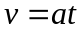 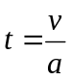
The distance moved in this time is given by 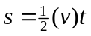 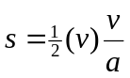 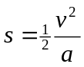
Energy transferred = Work Done, Work Done = Force x distance moved and Force = mass x acceleration
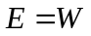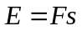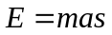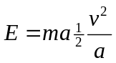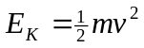
Velocity is measured in metres per second, m/s
Mass is measured in kilograms, kg
Kinetic Energy is measured in Joules, J

Gravitational Potential Energy
This type of potential (stored) energy is due to the position of an object. If an object of mass m is lifted at a constant speed by a height of h we can say that the acceleration is zero. Since F=ma we can also say that the overall force is zero, this means that the lifting force is equal to the weight of the object F=mg
We can now calculate the work done in lifting the object through a height, h.
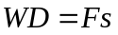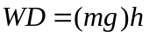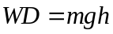
Since work done = energy transferred 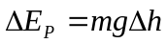
Height is a measure of distance which is measured in metres, m
Gravitational Potential Energy is measured in Joules, J

Work Done against….
In many situations gravitational potential energy is converted into kinetic energy, or vice versa. Some everyday examples of this are:
Swings and pendulums If we pull a pendulum back we give it GPE, when it is released it falls, losing its GPE but speeding up and gaining KE. When it passes the lowest point of the swing it begins to rise (gaining GPE) and slow down (losing KE).
Bouncing or throwing a ball Holding a ball in the air gives it GPE, when we release this it transforms this into KE. As it rises it loses KE and gains GPE.
Slides and ramps A ball at the top of a slide will have GPE. When it reaches the bottom of the slide it has lost all its GPE, but gained KE.

In each of these cases it appears as though we have lost energy. The pendulum doesn’t swing back to its original height and the ball never bounces to the height it was released from. This is because work is being done against resistive forces.
The swing has to overcome air resistance whilst moving and the friction from the top support.
The ball transforms some energy into sound and overcoming the air resistance.
Travelling down a slide transforms energy into heat due to friction and air resistance

The total energy before a transformation = The total energy after a transformation

Energy Transfers
1. State the principle of conservation of energy.
2. A car of mass 1500 kg is driving on a road at 15 m s⁻¹. Calculate the car’s kinetic energy.
3. A commercial jet has gravitational potential energy of 500 MJ. If the jet has a mass of 5.5 tonnes, determine its altitude.
4. A runner has a mass of 70 kg and kinetic energy equal to 2240 J. Determine how fast they are running.
5. A flea has a mass of 0.5 mg and can reach a top speed in a vertical jump of 40 cm s⁻¹.
  - Calculate the maximum kinetic energy of the flea.
  - Determine how high the flea can jump.
6. A student throws a ball vertically up in the air to a height of 15 m. Use the law of conservation of energy to deduce how fast the ball was thrown.
7. A 25 kg child slides down a 5 m long slide, which is 4 m high. The child reaches a maximum speed of 3 m s⁻¹ at the bottom of the slide. Calculate how much energy was transferred to thermal energy by the friction between the slide and the child.
8. The figure below shows a simple pendulum with a metal ball attached to the end of a string.
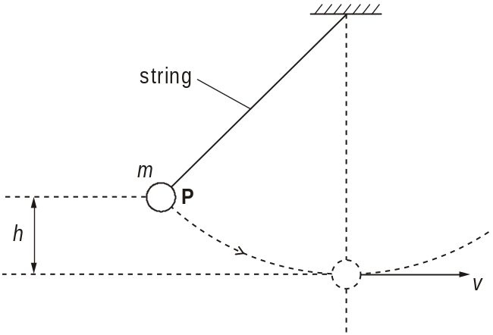
When the ball is released from P, it describes a circular path. The ball has a maximum speed v at the bottom of its swing. The vertical distance between P and bottom of the swing is h. The mass of the ball is m.
(i) Write the equations for the change in gravitational potential energy, Ep, of the ball as it drops through the height h and for the kinetic energy, Ek, of the ball at the bottom of its swing when travelling at speed v.
Ep =
Ek =
(ii) Use the principle of conservation of energy to derive an equation for the speed v.
Assume that there are no energy losses due to air resistance.

9. The diagram below shows a part of a fairground ride with a carriage on rails.
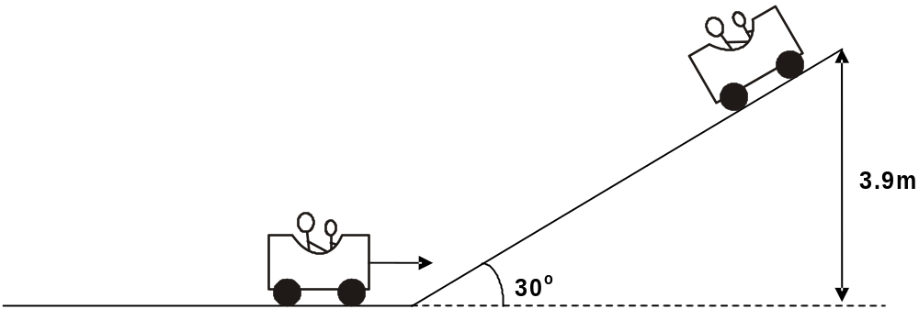
The carriage of mass 500 kg is travelling towards a slope inclined at 30° to the horizontal. The carriage has a kinetic energy of 25 kJ at the bottom of the slope. The carriage comes to rest after travelling up the slope to a vertical height of 3.9 m.
- Show that the gravitational potential energy gained by the carriage is 19 kJ.
(ii) Calculate the total work done against the resistive forces as the carriage moves up the slope.
- Calculate the magnitude of the resistive force acting against the carriage as it moves up the slope.

Synoptic Questions
1. The largest and most expensive machine many people use on a daily basis is the escalator.
In the escalator an electric motor pulls a chain linked to moving steps. When the escalator is fully laden, as one person steps on at the bottom another steps off at the top.
Facts about a typical escalator
- slopes at 30° to the horizontal
- each step rises 15 m in 1.0 minute
- efficiency of electric motor is 70%
When fully laden
- 80 people get on and off in 1.0 min
- average mass of one person 70 kg
- a frictional force of 1.2 × 10⁴ N, moving 30 m in 1.0 min, acts against the motion

- Calculate the potential energy given each minute to the people on a fully laden escalator. Take g = 9.8 N kg⁻¹.
- Show that the kinetic energy given to the people on the escalator is small compared to the potential energy they receive.
- Calculate the work done per second by the frictional force.
- the total output power of the electric motor.
- the input power to the electric motor.
- the overall efficiency of the escalator.

2. The web site www.britishwindenergy.co.uk gives the following information for wind turbines.
rotor diameters 30 m − 65 m
useable wind speeds 4 m s–1 − 25 m s–1
maximum power output occurs at 15 m s–1 wind speed
rate of turning of rotor 15 − 50 revolutions per minute
maximum theoretical efficiency at wind speed 15 m s–1 60%
average power output 30% of theoretical maximum
data sourced from British Wind Energy Association, www.bwea.com
In this question about wind turbines you will need to use some of this information.
(a) Consider the mass of the cylinder of air which travels past the blades of a turbine in one second. Take the wind speed to be 15 m s–1 and the diameter of the rotor to be 40 m. See the figure below.
The density of air is 1.3 kg m–3.
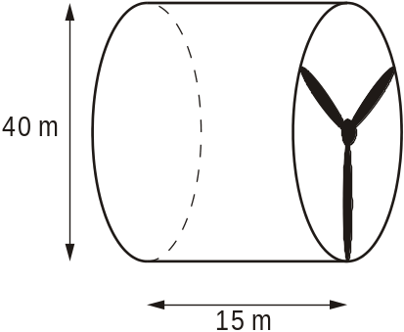
Calculate
(i) the volume of the cylinder of air passing the rotor in one second

volume = ................................................... m3
[2]
(ii) the mass of air passing the rotor in one second

mass = ..................................................... kg
[1]
(iii) the kinetic energy of this mass of air

kinetic energy = ...................................................... J
[2]
(iv) the maximum theoretical power output.

power = ..................................................... W
[2]
(b) (i) Calculate the average power output from the wind turbine in (a).

average power output = ..................................................... W
[1]
(ii) How many of these turbines would be required to replace one 1000 MW conventional power station?

number = .........................................................[1]
(c) (i) Wind power is often said to be free. Give another reason why wind power is desirable.
...............................................................................................................
...............................................................................................................[1]
(ii) Explain why wind power cannot be relied upon.
...............................................................................................................
...............................................................................................................
...............................................................................................................
...............................................................................................................[2]
(d) Suggest reasons why
(i) maximum useable wind speed does not produce maximum power
...............................................................................................................
...............................................................................................................
...............................................................................................................
...............................................................................................................[2]
(ii) turbines have to be stopped when the wind speed is too high
...............................................................................................................
...............................................................................................................
...............................................................................................................
...............................................................................................................[1]
[Total 15 marks]
3. Sail systems are being developed to reduce the running costs of cargo ships. The sail and ship’s engines work together to power the ship. One of these sails is shown in the figure below pulling at an angle of 40° to the horizontal.
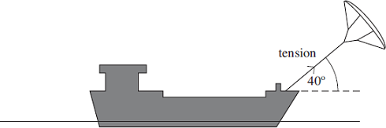
(a) The average tension in the cable is 170 kN.
Show that, when the ship travels 1.0 km, the work done by the sail on the ship is
1.3 × 10⁸ J.

(2)
(b) With the sail and the engines operating, the ship is travelling at a steady speed of 7.0 ms^{–1}.
(i) Calculate the power developed by the sail.

answer = ................................. W (2)
(ii) Calculate the percentage of the ship’s power requirement that is provided by the wind when the ship is travelling at this speed.
The power output of the engines is 2.1 MW.

answer = .................................% (2)
(c) The angle of the cable to the horizontal is one of the factors that affects the horizontal force exerted by the sail on the ship. State two other factors that would affect this force.
Factor 1 .........................................................................................................
Factor 2 ......................................................................................................... (2)
(Total 8 marks)

Acknowledgements:
The notes in this booklet come from TES user dwyernathaniel. The original notes can be found here:
https://www.tes.com/teaching-resource/a-level-physics-notes-6337841
Questions in *all* sections come from Bernard Rand’s amazing resources (@BernardRand). Thank you Bernard for making the collation of this booklet so easy! His original resources can be found here:
https://drive.google.com/drive/folders/1-2qNVLwGzJ_7AjQK9N0z4BQBIRmSHAwG

