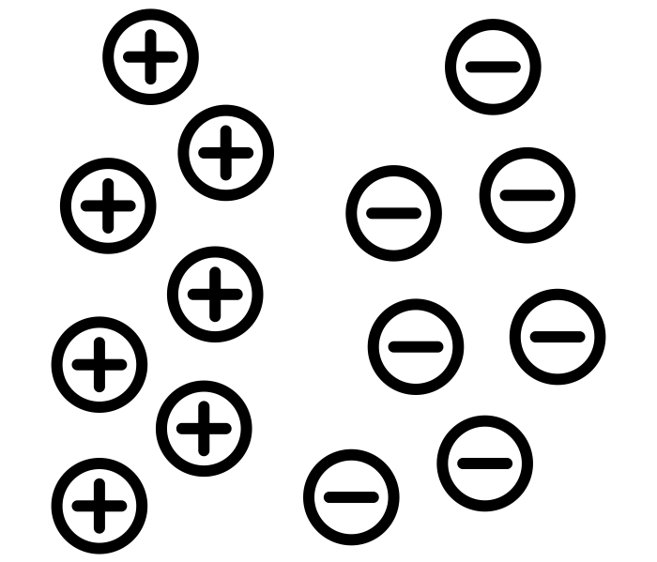
Electric
Name ______________________________
Teacher ______________________________
fields

Coulomb’s Law (Electric Force)
Electric fields
The electrostatic force acts between all charged particles and can be attractive or repulsive. It is the charges themselves that cause the force to exist. The force that acts between two charges, Q₁ and Q₂, whose centres are separated by a distance of r is given by:
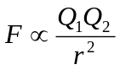
Like charges Opposite charges Like charges

The proportional constant was found and the equation becomes:
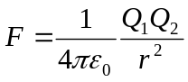
ε₀ is the Permittivity of Free Space, ε₀ = 8.854 x 10⁻¹² F m⁻¹
When one of the charges is large, Q, the force between it and a test charge, q, whose centres are separated by a distance of r is given by:
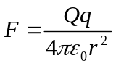
If the two charges are positive, (+Q)(+q) = + Qq A positive force means the charges repel.
If the two charges are negative, (–Q)(–q) = + Qq A positive force means the charges repel.
If one is negative and one is positive, (–Q)(+q) = – Qq A negative force means the charges attract.

Electric Fields
An electric field is the area around a charge where any other charge will experience a force. We can model a field with field lines or lines of force.
Radial Fields
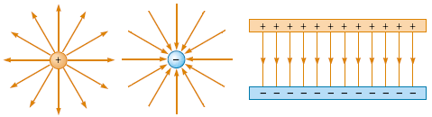
For a positive charge the field lines start at the charge and go out to infinity. For a negative charge the field lines end at the centre of a mass and tail back from infinity. We can see that they become more spread out the further from the charge we go.
Uniform Fields
The field lines are parallel in a uniform field. Between two conducting plates the field lines leave the positive plate and enter the negative plate.

Electric Field Strength, E
We can think of electric field strength as the concentration of the field lines at that point. We can see from the diagrams above that the field strength is constant in a uniform field but drops quickly as we move further out in a radial field.
The electric field strength at a point is a vector quantity and is defined as:
The force per unit charge acting on a small charge placed at that point in the field
We can represent this with the equation: 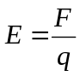
If we use our equation for the electric force at a distance r and substitute this in for F we get:
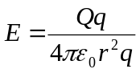 which simplifies to: 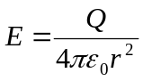 (RADIAL FIELDS)
Electric Field Strength is measured in Newtons per Coulomb, N C⁻¹
Coulomb’s law
Data required:
ε₀ = 8.854 x 10⁻¹² F m⁻¹
mass of an electron = 9.11 × 10⁻³¹ kg
mass of a proton = 1.67 × 10⁻²⁷ kg
G = 6.67 × 10⁻¹¹ N m² kg⁻²

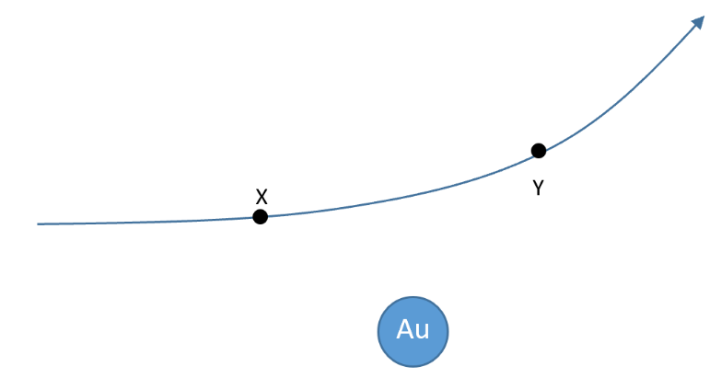
- State Coulomb’s Law in words.
- Calculate the electric force between two protons placed 1.0 x 10⁻¹² m apart in a vacuum.
- The diagram shows the path an alpha particle follows as it travels towards a gold ${}_{79}^{197}{Au}$ nucleus. Calculate the electric force between the alpha particle and the nucleus at points X and Y, both points being 2.0 x 10⁻⁹ m from the centre of the nucleus. Draw arrows at X and Y to illustrate these forces
- a) What is the force of repulsion between two electrons held one metre apart in a vacuum?
F = kQ₁Q₂/r² = (9.0 x 10⁹ x 1.6 x 10⁻¹⁹ x 1.6 x 10⁻¹⁹)/ 1² = 2.3 x 10⁻²⁸ N
b) What is the gravitational force of attraction between them?
F = Gm₁m₂/r² = (6.67 x 10⁻¹¹ x 9.11 x 10⁻³¹ x 9.11 x 10⁻³¹)/ 1² = 5.5 x 10⁻⁷¹ N
c) By what factor is the electric repulsion greater than the gravitational attraction?
Electrical force/gravitational force = 2.3 x 10⁻²⁸ / 5.5 x 10⁻⁷¹ = 4 x 10⁴² !!!!
5. By what factor is the electric force between two protons greater than the gravitational force between them?
Electrical force is same as with 2 electrons (they have the same magnitude of charge).
Gravitational force = (6.67 x 10⁻¹¹ x 1.67 x 10⁻²⁷ x 1.67 x 10⁻²⁷)/ 1²= 1.9 x 10⁻⁶⁴ N
Electrical force/gravitational force = 1.2 x 10³⁶
- Given the difference in magnitudes of gravitational and electrical forces you’ve just discovered, why do you feel gravitational attraction from the earth, but no electrical forces?
Because even though the Earth has a very large mass, providing a strong gravitational field, both it and you are electrically neutral overall.
7. Human beings are electrically neutral objects to a high degree of accuracy. In this question you will estimate the force that would exist between 2 students standing one metre apart if they had just 1% of the electrons in their body somehow removed, leaving them both positively charged. Take the mass of each student to be 60 kg, and as a rough estimate, assume that humans are 100% water. The molar mass of H₂O (the mass of 6.02 × 10²³ molecules) is 18 g.
a) How many water molecules do the students contain?
Number of molecules = (60/0.018) x 6.02 x 10²³ = 2.0 x 10²⁷

b) How many electrons are there in a water molecule?
There are 10 electrons in a water molecule (8 from the O atom and one each from H)

c) How many electrons are there in total in each student?
Thus total number of electrons in student = 2.0 x 10²⁸

d) Taking 1% of these away will leave each student with a net positive charge equal to the charge of 1% of their electrons. What is this value?
1% of electrons is 2.0 x 10²⁶ which have a charge of 2.0 x 10²⁶ x 1.6 x 10⁻¹⁹ =32 MC (i.e. 32 million coulombs!).

e) Now calculate the force between the two students, if they are standing 1 metre apart, and comment.
F = kQ₁Q₂/r² = 9.0 x 10⁹ x 32 x 10⁶ x 32 x 10⁶ / 1² = 9.3 x 10²⁴ N
This is a huge force on each student – it is almost the weight of our entire planet!!!

Electric fields

- A charge of 5.0 μC experiences an electric force of 100 mN when at a point in an electric field. Calculate the magnitude of electric field strength at that point.
- An electron (charge = -1.6 x 10⁻¹⁹ C; mass = 9.1 x 10⁻³¹ kg) is placed at rest in a region of electric field strength 1.0 x 10⁶ N C⁻¹.
- What is the electric force on the electron?
- What is the acceleration of the electron (assume that its weight is negligible)
- The electron continues this constant acceleration for a distance of 30 cm. Calculate the velocity it reaches and comment on your answer.
- Here is an electric field of strength 1000 N C⁻¹. Calculate the force on the charge shown and indicate the force direction on the diagram.
Charge = -50μ C
- Find the electric field strength 150 mm away from a 10.0 nC point charge.
- At what distance away from a 1.0 μC point charge will the electric field strength be 10 N C⁻¹ ?
- Using the data and answer for Q5, what will the electric field strength be if you increase the distance you found by 50%?
- Calculate the resultant electric field strength at a point half way between charges of +40 nC and +70 nC held 40 cm apart in a vacuum. State the direction of the resultant electric field strength.
S
20°
- A small positively charged conducting sphere – carrying a charge of 1.5 x 10⁻⁹ C - is suspended by an insulating thread from a support S. Another charged sphere – carrying a charge of 3.5 x 10⁻⁹ C - that is attached to an insulting handle is brought closer to the suspended sphere and causes the thread to deflect 20° to the right as shown. The separation of the spheres is 10 cm. Treat the spheres as point charges.
  - Calculate the electric force between the charged spheres.
  - If the weight of the suspended ball is 1.3 x 10⁻⁵ N, by resolving forces or using a force triangle show that the tension in the thread is 1.39 x 10⁻⁵ N.

[ANS

Q1.
(a) State, in words, Coulomb’s law.
___________________________________________________________________
___________________________________________________________________
___________________________________________________________________
___________________________________________________________________
(2)
(b) The diagram below shows two point charges of +4.0 nC and +6.0 nC which are 68 mm apart.

(i) Sketch on the diagram above the pattern of the electric field surrounding the charges.
(3)
(ii) Calculate the magnitude of the electrostatic force acting on the +4.0 nC charge.

magnitude of force ____________________ N
(2)
(c) (i) Calculate the magnitude of the resultant electric field strength at the mid-point of the line joining the two charges in the diagram above.
State an appropriate unit for your answer.

electric field strength ____________________ unit __________
(4)
(ii) State the direction of the resultant electric field at the mid-point of the line joining the charges.
______________________________________________________________
(1)
(Total 12 marks)
Q2.
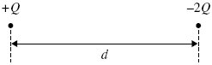
The diagram shows two particles at a distance d apart. One particle has charge +Q and the other –2Q. The two particles exert an electrostatic force of attraction, F, on each other. Each particle is then given an additional charge +Q and their separation is increased to a distance 2d.
Which one of the following gives the force that now acts between the two particles?
A an attractive force of
B a repulsive force of
C an attractive force of
D a repulsive force of
(Total 1 mark)
Q3.
The distance between two point charges of + 8.0 nC and + 2.0 nC is 60 mm.
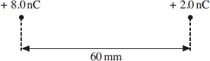
At a point between the charges, on the line joining them, the resultant electric field strength is zero. How far is this point from the + 8.0 nC charge?
A 20 mm
B 25 mm
C 40 mm
D 45 mm
(Total 1 mark)
Q4.
The diagram shows four point charges, each +Q, at the corners of a square of side 2a.
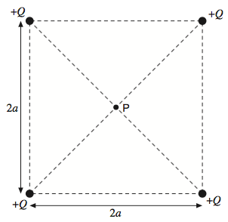
What is the electric field strength at P, the centre of the square?

A | zero
B | 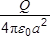
C | 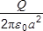
D | 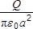
(Total 1 mark)

Q1.
(a) force between two (point) charges is proportional to (product of) charges
and inversely proportional to the square of their distance apart
Formula not acceptable. Accept “charged particles” for charges. Accept separation for distance apart.
2
(b) (i) lines with arrows radiating outwards from each charge
more lines associated with 6nC charge than with 4nC
lines start radially and become non-radial with correct curvature
further away from each charge correct asymmetric pattern (with neutral pt closer to 4nC charge)
3 max
(ii) force 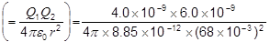
= 4.6(7) × 10⁻⁵ (N)
Treat substitution errors such as 10⁻⁶(instead of 10⁻⁹) as AE with ECF available.
2
(c) (i) E₄ 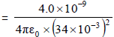 (= 3.11 × 10⁴ V m⁻¹) (to the right)

For both of 1st two marks to be awarded, substitution for either or both of E₄ or E₆ (or a substitution in an expression for E₆ - E₄) must be shown.
E₆ 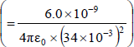 = (4.67 × 10⁴ V m ⁻¹) (to the left)

If no substitution is shown, but evaluation is correct for E₄ and E₆, award one of 1 st two marks.
E_{resultant} = (4.67 − 3.11) × 10⁴ = 1.5(6) × 10⁴
Unit: V m⁻¹ (or N C⁻¹)
Use of r = 68 × 10⁻³ is a physics error with no ECF.
Unit mark is independent.
4
(ii) direction: towards 4 nC charge or to the left
1
[12]
Q2.
A
[1]
Q3.
C
[1]
Q4.
A
[1]

Electric Potential, V
Electric potential
The electric potential at a point r from a point charge is defined as:
The work done per unit charge against the field to move a positive point charge from infinity to that point
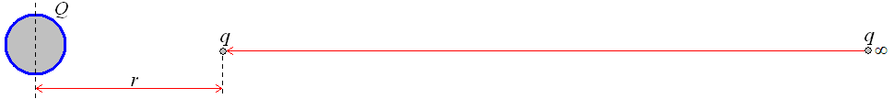
The electric potential at a distance r from a charge Q is given by: 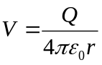
The value will be positive when work is done against the field (when like charges are repelling).
The value will be negative when work is done by the field (when opposite charges attract).
In both cases the potential at infinity is zero. Electric potential is a scalar quantity.
Electric Potential is measured in Joules per Coulomb, J C⁻¹

Electric Potential Difference
Electric potential is the work done per unit charge which can be written like this:
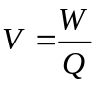
We have previously used this equation to define the potential difference as the energy given to each charge. From what we have just defined we can now update our definition of potential difference. Potential difference is the difference in electric potential between two points in an electric field.
The work done to move a charge from potential V₁ to potential V₂ is given by:
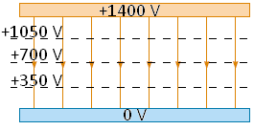
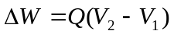 which can be written as 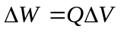

Uniform Fields
In a uniform field like that between two conducting plates the field strength is constant as we have already seen. Now that we understand electric potential we can use an equation for the field strength in a uniform field.
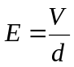 Where V is the potential difference between the plates and d is the separation of the plates.
Electric Field Strength can be measured in Volts per metre, V m⁻¹

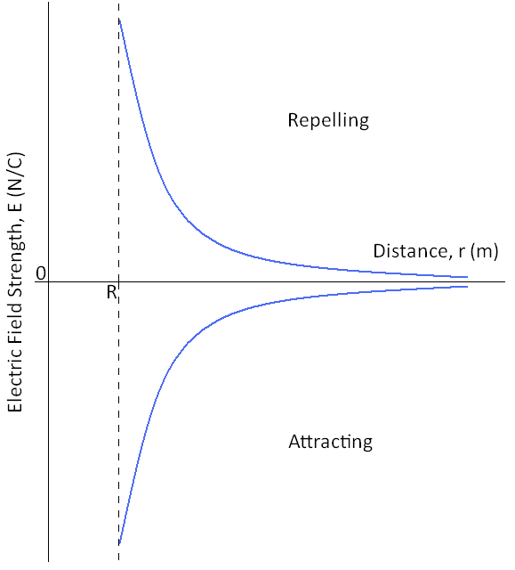
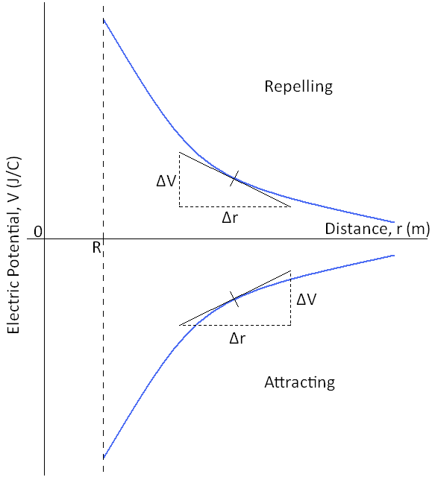
Graphs
Here are the graphs of how electric field strength and electric potential vary with distance from the centre of a charged sphere. In both cases R is the radius of the sphere.

The gradient of the electric potential graph gives us the electric field strength at that point. To find the gradient at a point on a curve we must draw a tangent to the line then calculate the gradient of the tangent:
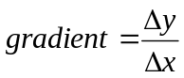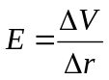
If we rearrange the equation we can see where we get the top equation for electric potential.
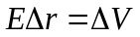 sub in the equation for E 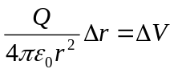 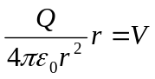 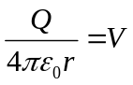
Electric potential:
- What is the electric potential at a distance of 5.00 mm from a charge of 25.0 μC?
- What charge produces an electrical potential of 10.0 V at a distance of 2.00 m?
- At what distance is there an electric potential of 100 V away from a point charge of 1.30 × 10⁻⁶ C?
- Calculate the electric potential energy of a point charge q = +2.0 × 10⁻⁶ C at a distance of 0.4 m from a point charge Q = +5.0 × 10⁻⁶ C.
- Calculate the electric potential energy of a point charge q = -1.5 × 10⁻⁶ C at a distance of 0.4 m from a point charge Q = +6.0 × 10⁻⁶ C.

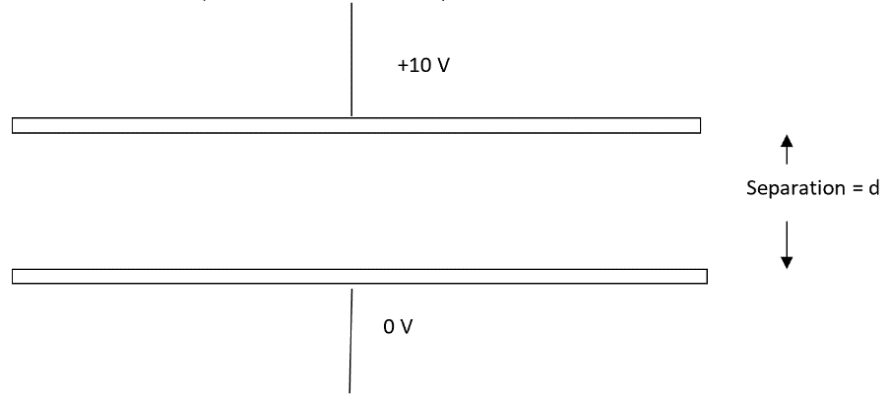
Uniform electric fields:
- a) Draw the electric field pattern between the two plates.
The potential difference between the plates is 10 V (in volts)
b) If V is in volts and d is in metres, then the units for Electric Field Strength can be given as…
c) Show that N C⁻¹ are equivalent to V m⁻¹.
- The p.d. between the two plates is 100 V. The plates are 20 cm apart. Calculate the electric field strength between the plates.
- If the field between two flat parallel plates is 4.00 x 10³ N C⁻¹, what is the force on a charge of 1.00 x 10⁻⁶ C?
- Two horizontal metal plates are 15 cm apart. The lower and upper plates have respective potentials of 4.0 x 10² V and 1.0 x 10² V. Find the electric field strength at points 5.0 cm and 10 cm above the lower plate, stating the direction.
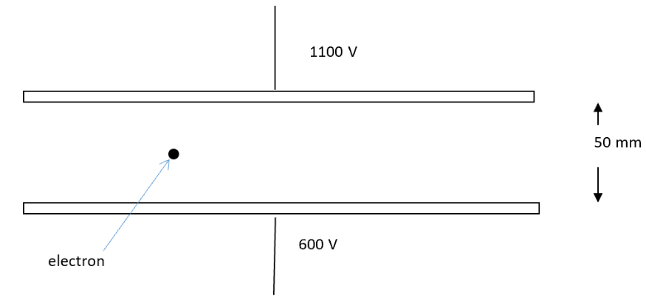
- The top plate is at 1100 V and the bottom one at 600 V. The plates are 50 mm apart. An electron (-1.6 x 10⁻¹⁹ C; 9.1 x 10⁻³¹ kg) is released from a point midway between the two plates.
- Draw the electric field pattern between the plates.
- Calculate the electric field strength between the plates.
- Calculate the electric force on the electron and state its direction.
- Find the acceleration of the electron when released (ignore the weight of the electron – it is negligible here)
- How long it takes for the electron to reach one of the plates (which plate?)
Millikan’s oil drop experiment

Data required
charge on electron = 1.6 × 10⁻¹⁹ C
gravitational field strength = 9.8 N kg^{–1}

These questions are about an experiment designed to measure the charge on an electron. In this experiment, ‘Millikan’s Oil Drop Experiment’, two parallel metal plates, 3.2 × 10⁻² m apart, are connected to a 600 V power supply:

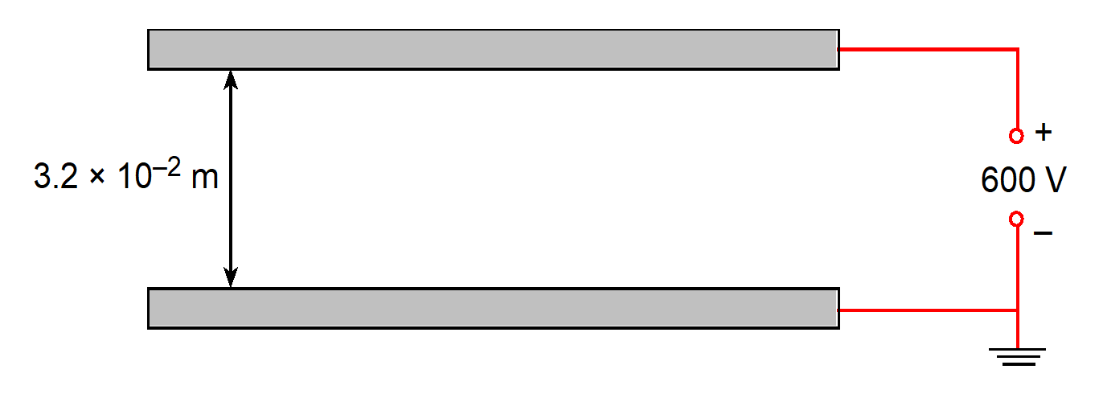

1) Draw four arrowed lines on the diagram to show the electric field between the plates, well away from the edges of the plates.
2) Add dotted lines to the diagram to represent the 200 V and 400 V equipotentials between the plates. Indicate which is which.
3) Calculate the electric field strength between the two plates.
4) The electric field between the plates just supports the weight of an oil drop of mass 1.8 × 10⁻¹⁵ kg, which has acquired a charge due to a few excess electrons. Calculate the charge on the oil drop.
5) What is the most likely number of excess electrons acquired by the oil drop?

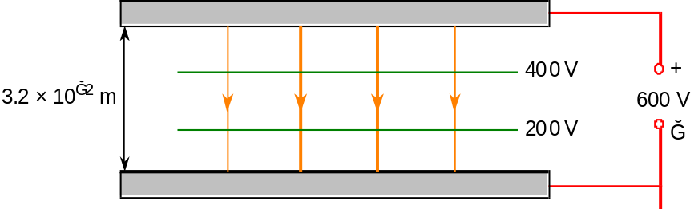

1) Orange lines above, with arrows

2) Green lines above, without arrows

3) E = V/d = 600 / 3.2 x 10⁻² = 18,750 V m⁻¹ = 1.9 x 10⁴ V m⁻¹ (2sf)

4) electric force upward = weight downward
EQ = mg
Q = mg/E = 1.8 x 10⁻¹⁵ x 9.81 / 1.9 x 10⁴ = 9.4 x 10⁻¹⁹ C

5) 9.4 x 10⁻¹⁹ / 1.6 x 10⁻¹⁹ = 5.9
Therefore, most likely number of extra electrons = 6.

Q1.
(a) Define the electric potential at a point in an electric field.
___________________________________________________________________
___________________________________________________________________
___________________________________________________________________
___________________________________________________________________
___________________________________________________________________
___________________________________________________________________
(3)
(b) Figure 1 shows part of the region around a small positive charge.
Figure 1
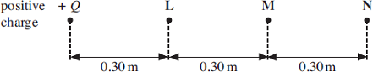
(i) The electric potential at point L due to this charge is + 3.0 V. Calculate the magnitude Q of the charge. Express your answer to an appropriate number of significant figures.

answer = ______________________ C
(3)
(ii) Show that the electric potential at point N, due to the charge, is +1.0 V.

(1)
(iii) Show that the electric field strength at point M, which is mid-way between L and N, is 2.5 Vm^{–1}.

(1)

(c) R and S are two charged parallel plates, 0.60 m apart, as shown in Figure 2.
They are at potentials of + 3.0 V and + 1.0 V respectively.
Figure 2
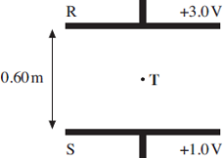
(i) On Figure 2, sketch the electric field between R and S, showing its direction.
(2)
(ii) Point T is mid-way between R and S.
Calculate the electric field strength at T.

answer = ______________________ Vm^{–1}
(1)
(iii) Parts (b)(iii) and (c)(ii) both involve the electric field strength at a point mid-way between potentials of + 1.0 V and + 3.0 V. Explain why the magnitudes of these electric field strengths are different.
______________________________________________________________
______________________________________________________________
______________________________________________________________
(1)
(Total 12 marks)

Q2.
(a) The diagram below shows part of a precipitation system used to collect dust particles in a chimney. It consists of two large parallel vertical plates maintained at potentials of +25 kV and –25 kV.
The diagram below also shows the electric field lines between the plates.
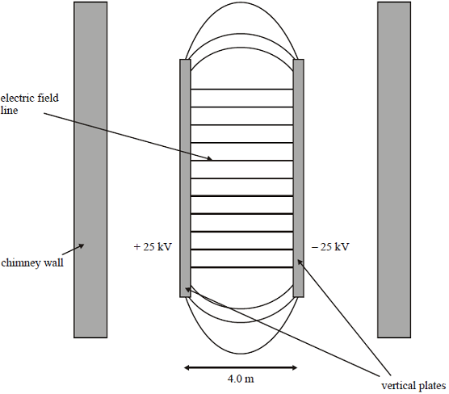
(i) Add arrows to the diagram to show the direction of the electric field.
(1)
(ii) Explain what is meant by an equipotential surface.
______________________________________________________________
______________________________________________________________
______________________________________________________________
(1)
(iii) Draw and label on the diagram equipotentials that correspond to potentials
of –12.5 kV, 0 V, and +12.5 kV.
(2)

(b) A small dust particle moves vertically up the centre of the chimney, midway between the plates.
(i) The charge on the dust particle is +5.5 nC. Show that there is an electrostatic force on the particle of about 0.07 mN.

(2)
(ii) The mass of the dust particle is 1.2 × 10^{–4} kg and it moves up the centre of the chimney at a constant vertical speed of 0.80 m s^{–1}.
Calculate the minimum length of the plates necessary for this particle to strike one of them. Ignore air resistance.

(4)
(Total 10 marks)

Q1.
(a) work done [or energy needed] per unit charge
[or (change in) electric pe per unit charge]
on [or of] a (small) positive (test) charge
in moving the charge from infinity (to the point)
[not from the point to infinity]
3
(b) (i) 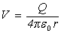 gives Q (= 4πε₀rV) = 4π × 8.85 × 10^{–12} × 0.30 × 3.0
= 1.0 × 10^{–10} (C)
to 2 sf only
3
(ii) use of V ∞ gives V_{M} = (= (+) 1.0 V)
1
(iii) 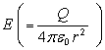 = 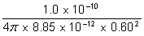 (= 2.50 V m^{–1})
1
(c) (i) uniformly spaced vertical parallel lines which start and end on plates
relevant lines with arrow(s) pointing only downwards
2
(ii) = 3.3(3) (V m^{–1})
1
(iii) part (b) is a radial field whilst part (c) is a uniform field
[or field lines become further apart between L and M but are equally spaced between R and S]
1
[12]
Q2.
(a) (i) shows arrows from + to –
Bl
(ii) surface of constant potential / no work done in moving charge
on surface OWTTE
Bl
(iii) 3 correct lines between plates, straight, labelled, +12.5 kV on left
Bl
outwards curvature at edge of plates
Bl
(b) (i) F = Vq / d or 50000 × 5.5 × 10^{–9} / 4
Bl
= 0.0690 [mN] [0.0688]
Bl
(ii) a = F / m = 0.069 × 10^{–3} / 0.12 × 10^{–3}
= 0.575 / 0.573 m s^{–2}
Cl
use of appropriate kinematic equation
Cl
t = √2 × 2 / 0.575 = (2.63) s
Cl
so length must be 0.8 × 2.63 = 2.11 m [gets mark ecf from
third mark if number quoted]
allow alternative energy approach
Bl
[10]

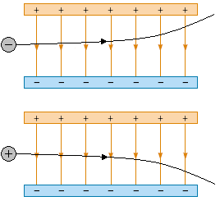
Motion in an Electric Field
Fields comparison
A charged particle moving through an electric field will feel a force towards the oppositely charged plate.
We see that the electron moves in a parabola towards the positive plate and the positron moves towards the negative plate.

The field strength is constant so the force is the same at all points in the field and is given by 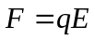. The direction of the force depends on the charge of the particle entering the field

Like the projectiles we looked at during AS Unit 2, the vertical velocity is independent from the horizontal velocity.
The acceleration in the vertical plane will be equal to E and it will ‘freefall’ like a mass in a gravitational field.

Comparing Fields
We have seen that the characteristics of gravitational and electric fields have some similarities and differences.
 | Gravitational Fields | Electric Fields
Force is between | Masses | Charges
Constant of proportionality | 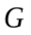 | 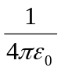
Equation for force | 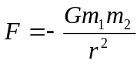  Newton (N)  Vector | Newtons (N)  Vector
Nature of force | Attractive only | Like charges repel  Different charges attract
Definition of field strength | Force per unit mass | Force per unit charge
Field strength in radial field | 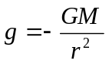  Newtons per kilogram (N/kg)  Vector | Newtons per Coulomb (N/C)  Vector
Definition of potential | The work done in bringing a unit mass from infinity to the point in the field | The work done in bringing a unit charge from infinity to the point in the field
Potential | 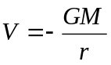  Joules per kilogram (J/kg)  Scalar | Joules per Coulomb (J/C)  Scalar
Potential at infinity | 0 | 0
Work done moving between points of different potential | 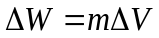  Joules (J)  Scalar | Joules (J)  Scalar
Gradient of potential against distance graph | Field strength | Field strength

Motion of Charged Particles in Uniform Electric fields
1. These plates are held horizontally, one above the other and 10 cm apart. An electron (charge = 1.6 x 10⁻¹⁹ C) enters the field horizontally at 5.0 x 10⁶ m s⁻¹ at a level halfway between the plates. Ignore the weight of the electron, although its mass = 9.1 x 10⁻³¹ kg. There is a vacuum between the plates.
20 cm

-
0 V

+ 100 V

(a) Draw on the field lines between the two plates.
(b) Draw the path an electron may take as it travels between the plates
(c) Draw on the diagram a possible path that a proton might take if it entered the field at the same point with the same velocity. Label this path with the word “proton”.
(d) Calculate the magnitude and direction of the force on the electron.
(f) Calculate the acceleration of the electron within the electric field
(g) Calculate the time taken for the electron to strike the lower plate.
(h) Determine how far along the lower plate the electron hits the plate.
(i) What is the resultant velocity of the electron when it hits the lower plate?
(j) What is the minimum velocity that the electron must enter the field at so that it just misses the bottom plate as it leaves the plate region?

2.
This question is about changing the motion of electrons using electric fields. The diagram below shows a horizontal beam of electrons moving in a vacuum. The electrons pass through a hole in the centre of a metal plate A. At B is a metal grid through which the electrons can pass. At C is a further metal sheet. The three vertical conductors are maintained at voltages of +600 V at A, 0V at B and +1200 V at C. The distance from plate A to grid B is 40 mm.
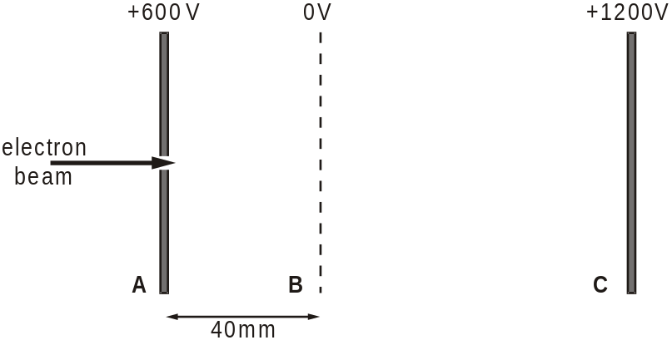
(a) On the diagram above draw electric field lines to represent the fields in the regions between the three plates. [3]
(b) Show that the magnitude of the electric field strength between plate A and grid B is 1.5 × 104 V m–1. [2]
(c) Calculate the horizontal force on an electron after passing through the hole in A. [2]
(d) Show that the minimum speed that an electron in the beam must have at the hole in A to reach the grid at B is about 1.5 × 107 m s–1. [2]
(e) Calculate the speed of these electrons when they collide with sheet C. [1]
(f) Describe and explain the effect on the current detected at C when the voltage of the grid B is increased negatively. [2]
(a) equally spaced horizontal parallel lines from plate to plate; arrows towards B; quality mark 3
(b) E = V/d; = 600/0.04;(= 1.5 × 104 V m–1) 2
(c) F = QE / 1.6 × 10–19 × 1.5 × 104;= 2.4 × 10–15 (N) 2
(d) 1/2mv2 = Fd or QV; = 1.6 × 10–19 × 600 or = 2.4 × 10–15 × 0.04 ecf (c) 2
or alternative method by constant acceleration formulae;
(either method giving v2 = 2.1 × 1014 and v = 1.45 × 107 m s–1)
(e) √2v = 2.05 × 107 (m s–1) 1
(f) fewer electrons will reach grid B or C (as higher initial speed required);
so current will fall (to zero if beam is taken to be monoenergetic) 2
Q1.
Both gravitational and electric field strengths can be described by similar equations written in the form
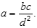
(a) Complete the following table by writing down the names of the corresponding quantities, together with their SI units, for the two types of field.

symbol | gravitational field  quantity SI unit |  | electrical field  quantity SI unit
a | gravitational  field strength
b |  |  | 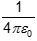 | m F^{–1}
c
d
(4)
(b) Two isolated charged objects, A and B, are arranged so that the gravitational force between them is equal and opposite to the electric force between them.
(i) The separation of A and B is doubled without changing their charges or masses. State and explain the effect, if any, that this will have on the resultant force between them.
______________________________________________________________
______________________________________________________________
(ii) At the original separation, the mass of A is doubled, whilst the charge on A and the mass of B remain as they were initially. What would have to happen to the charge on B to keep the resultant force zero?
______________________________________________________________
______________________________________________________________
(3)
(Total 7 marks)
Q2.
The figure below shows a system that separates two minerals from the ore containing them using an electric field.
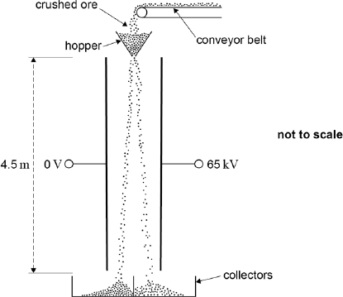
The crushed particles of the two different minerals gain opposite charges due to friction as they travel along the conveyor belt and through the hopper. When they leave the hopper they fall 4.5 metres between two parallel plates that are separated by 0.35 m.
(a) Assume that a particle has zero velocity when it leaves the hopper and enters the region between the plates.
Calculate the time taken for this particle to fall between the plates.

time taken = _____________s
(2)
(b) A potential difference (pd) of 65 kV is applied between the plates.
Show that when a particle of specific charge 1.2 × 10^{–6} C kg^{–1} is between the plates its horizontal acceleration is about 0.2 m s^{–2}.

(3)
(c) Calculate the total horizontal deflection of the particle that occurs when falling between the plates.

horizontal deflection = _____________m
(1)
(d) Explain why the time to fall vertically between the plates is independent of the mass of a particle.
___________________________________________________________________
___________________________________________________________________
___________________________________________________________________
___________________________________________________________________
(2)
(e) State and explain two reasons, why the horizontal acceleration of a particle is different for each particle.
___________________________________________________________________
___________________________________________________________________
___________________________________________________________________
___________________________________________________________________
___________________________________________________________________
___________________________________________________________________
___________________________________________________________________
___________________________________________________________________
(4)
(Total 12 marks)

Q1.
(a)

________ | N kg^{–1} | electric field strength | N C^{–1}  or V m^{–1} | (1)
gravitational constant | N m² kg^{–2} | ________ | ________ | (1)
mass | kg | charge | C | (1)
distance (from mass to point) | m | distance (from charge to point) | m | (1)
(4)
(b) (i) none (1)
both F_{E} and F_{G} ∝ (hence both reduced to [affected equally] (1)
(ii) charge on B must be doubled (1)
(3)
[7]
Q2.
(a) t = or 4.5 = × 9.81 × t ² ✓
t = 0.96 s✓
2
(b) Field strength = 186000V m^{–1}✓
Acceleration = Eq / m
or 186 000 × 1.2 × 10^{–6} ✓
0.22 m s^{–2} ✓
3
(c) 0.10(3)m (allow ecf from (i))✓
1
(d) Force on a particle = mg and
acceleration = F / m so always = g✓
Time to fall (given distance) depends (only) on the distance and acceleration✓
OR:
g = GM / r² ✓
Time to fall = √2s / g
so no m in equations to determine time to fall✓
2
(e) Mass is not constant since particle mass will vary✓
Charge on a particle is not constant✓
Acceleration = Eq / m or (V / d) (q / m) or Vq / dm✓
E or V / d constant but charge and mass are ‘random’ variables so q / m will vary (or unlikely to be the same)✓
4
[12]

Acknowledgements:
The notes in this booklet come from TES user dwyernathaniel. The original notes can be found here:
https://www.tes.com/teaching-resource/a-level-physics-notes-6337841
Questions on Coulomb’s law & Millikan’s oil drop experiment are from the IoP TAP project. The original resources can be found here:
https://spark.iop.org/episode-407-coulombs-law#gref
Questions from multiple areas (including Coulomb’s law, electric fields & motion of charged particles in uniform electric fields) come from Bernard Rand (@BernardRand). His original resources can be found here:
https://drive.google.com/drive/folders/1-2qNVLwGzJ_7AjQK9N0z4BQBIRmSHAwG

