
Capacitance
Name ______________________________
Teacher ______________________________
Capacitors

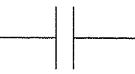
Capacitors
A capacitor is an electronic component that can store electrical charge and then release it.
It is made of two conducting plates separated by an insulator.
The charge that is stored by the capacitor is due to the potential difference across. We can write this as:
Q V or Q = kV
k is a constant specific to the capacitor, this is called the capacitance and is represented by the symbol C
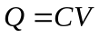
Capacitance is measured in Farads, F
Charge is measured in Coulombs, C
We can rearrange the equation into C = Q / V and from this we can see that capacitance is a measure of the charge stored per volt of potential difference. 1 Farad means 1 Coulomb of charge is stored per Volt.

Parallel-plate capacitor
For a parallel-plate capacitor with dielectric filling the space between its plates the capacitance can be written as:
$$C=\frac{Aε_{0}ε_{r}}{d}$$
where A is the surface area of each plate and d is the spacing between the plates.

Dielectrics can be made of polar molecules (these have “positive” and “negative” poles naturally; somewhat like a magnetic). When these molecules are unpolarised they lie in random directions. They align (polarise) when an electric field is applied. As a result, more charge is stored on the plates because:
- The positive side of the dielectric attracts more electrons from the battery onto the negative plate.
- The negative side of the dielectric pushes electrons back to the battery from the positive side.
Charging and Discharging
When a capacitor is connected to a battery is sends out electrons to one of the plates, this becomes negatively charged. The same amount of electrons move from the second plate and enter the battery, leaving the plate positively charged. The capacitor is now storing a charge or is ‘charged’.

If the charged capacitor is disconnected from the battery and connected to a lamp it will give out the stored charge or will ‘discharge’. The electrons on the negative plate move through the circuit and onto the positive plate. The plates now have no charge on them. The energy stored by the capacitor is transferred to the bulb whilst the electrons move (whilst a current flows).

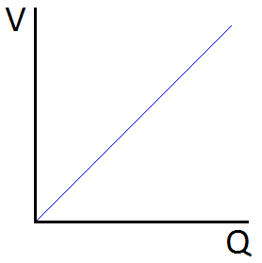
Energy Stored by a Capacitor
The top equation shows us that the charge of a capacitor increases with the potential difference across it. If we plotted p.d. against charge we get a graph that looks like this

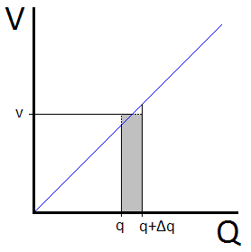
We can derive an equation to find the energy that a capacitor stores by considering the energy transferred during the shaded section on the lower graph.
In this section the charge changes from q to q+Δq when an average p.d. of v is applied across it.
Using E = VQ the energy stored is E = v Δq.
The total energy is equal to the total of all the little rectangular sections and is given by E = ½ QV. This is also equal to the area under the graph.
We can use the top equation to derive two more equations for the energy stored by a capacitor:
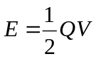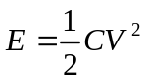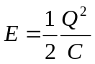
Energy is measured in Joules, J
Charge and capacitance
- A 470μF capacitor is charged with a 6.00V supply. How much charge is stored on the capacitor?
- A 10F capacitor is charged with a 1.5V supply. How much charge is stored on the capacitor?
- A 22pF capacitor is charged with a 18V supply. How much charge is stored on the capacitor?
- A 10000μF capacitor is charged with a 40V supply. How much charge is stored on the capacitor?
- What is the capacitance of a capacitor capable of storing 25μC of charge at a p.d. of 25V?
- What is the capacitance of a capacitor capable of storing 2.2nC of charge at a p.d. of 10V?
- What is the capacitance of a capacitor capable of storing 0.22C of charge at a p.d. of 0.10V?
- What p.d. is required to charge a 22nF capacitor to 770nC?
- What p.d. is required to charge a 4.7μF capacitor to 118μC?
- What p.d. is required to charge a 600F capacitor to 1.5kC?

1. 2.82mC
2. 15C
3. 400pC
4. 400mC
5. 1.0μF
6. 0.22nF
7. 2.2F
8. 35V
9. 25V

Parallel plate capacitor (not yet answered)

Data
$C=\frac{Q}{V}$, $C=\frac{ε_{r}ε_{0}A}{d}$, $V=\frac{1}{4πε_{0}}\frac{Q}{R}$, $E=\frac{V}{d}$
ϵ₀ = 8.85 × 10⁻¹² Fm⁻¹ R_{Earth} = 6370 km

- The plates of a parallel-plate capacitor are 5mm apart and 2m² in area. The plates are separated only by air. A potential difference of 10,000V is applied across the capacitor.
  - Sketch the electric field between the plates of the capacitor
  - Add equipotential lines (use dashed lines) to your diagram at intervals of 2000V
  - Determine the capacitance
  - Find the charge on each plate of the capacitor
  - Find the magnitude of the electric field in the space between them.
- A parallel plate capacitor filled with benzene (_{r} = 2.28) has a capacitance of 500 pF and a charge of 2 × 10⁻⁷ C on each plate. The plates are 0.2 mm apart.
  - What is the potential difference between the plates?
  - What is the area of each plate?
  - What is the electric field between the plates?

- An air-filled parallel plate capacitor has a capacitance of 1.0 × 10⁻⁹ F.
  - What potential difference is required for a charge of 1.0 × 10⁻⁷ C on each plate?
  - If the plates are 1.0 mm apart, what is the area of the plates?

- The parallel plates of an air-filled capacitor have an area of 2.0 × 10⁻¹ m² and are 1.0 cm apart. The original potential difference between them is 3000 V. It decreases to 1000V when a sheet of dielectric is inserted between the plates (the charge remains on the plates).
  - Determine the original capacitance.
  - Find the charge on each plate.
  - Find the capacitance after the dielectric is inserted.
  - Find the dielectric constant.

- Consider parallel plate capacitor (air filled) with a surface area of 225 cm² and a charge of 1.5C on its plates and a plate separation distance of 1.0 × 10⁻⁴ m.
  - What is the capacitance of the capacitor?
  - What is the potential difference across the capacitor?
  - If the capacitor were filled with a dielectric material, _{r}=3.3 (while still maintaining the same amount of charge on the plates) what is the new capacitance?
  - How much charge would be stored in this capacitor with this dielectric material, at the same potential difference as in part (b)?

- Consider an isolated sphere of radius, R, with a surface charge of +Q in a medium of permittivity .
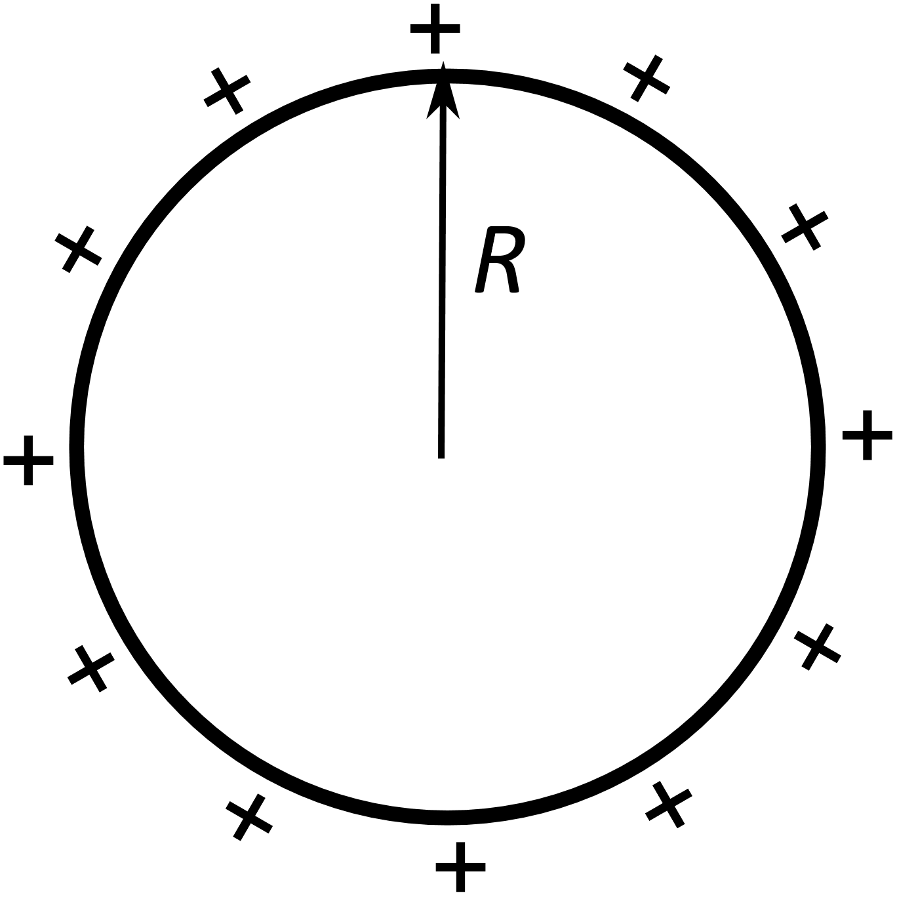
  - What is the value electrical potential at an infinite distance from the sphere?
  - What is the value electrical potential at the surface of the sphere?
  - What is the potential difference that the charge has moved through to charge the sphere?
  - Using the definition of capacitance and your answer to part c, show that the capacitance of a sphere is $C=4πε_{0}R$ (i.e. the capacitance simply depends on the radius of the sphere).
  - What is the capacitance of the Earth?

- A van der Graaf generator with a dome of radius 20cm is charged until the surface potential is 100kV.
- What is the capacitance of a van der Graaf generator?
- Determine the surface charge of the van der Graaf
- The van der Graaf discharges in 0.01s, determine the current in the spark.

Energy stored
1. A 1.2 µF capacitor is charged to 3.0 kV. Calculate the energy stored in the capacitor.
2. Calculate the energy stored in a 60 pF capacitor:
a) When it is charged to a potential difference of 2.0 kV.
b) When the charge on each plate is 30 nC.
3. A capacitor of capacitance 22 µF is charged by connecting it to a 400 V power supply, and is then discharged.
a) Calculate the energy transferred during the discharge.
b) If the discharge takes 10 µs, what is the average power of the discharge?
4. A 8.0µF capacitor is completely charged by joining it to a 500 V supply through a resistor.
a) What charge flows through the supply and the resistor?
b) How much electrical energy is taken from the supply?
c) How much electrical energy is stored in the capacitor?
d) Suggest the cause of the difference between these two amounts?
5. A capacitor of capacitance 22 µF is charged to a potential difference of 200 V and then isolated from the supply.
a) What is the energy stored in it?
b) If an identical capacitor, initially uncharged, is joined across it will discharge into it until both capacitors are at 100V, what is the energy now stored in the pair of capacitors? Comment on your answer.
1. 5.4 J
2. a) 12 mJ
b) 7.5 µJ
3. a) 1.8 J
b) 1.8 x 10⁵
4. a) 4.0 mC
b) 2.0 J
c) 1.0 J
d) Some energy lost to heating due to electrical resistance
5. a) 0.44 J
b) 0.22 J
Q1. The figure below shows a capacitor of capacitance 370 pF. It consists of two parallel metal plates of area 250 cm². A sheet of polythene that has a relative permittivity 2.3 completely fills the gap between the plates.
not to scale
(a) Calculate the thickness of the polythene sheet.

thickness = _____________m
(2)
(b) The capacitor is charged so that there is a potential difference of 35 V between the plates. The charge on the capacitor is then 13 nC and the energy stored is 0.23 µJ.
The supply is now disconnected and the polythene sheet is pulled out from between the plates without discharging or altering the separation of the plates.
Show that the potential difference between the plates increases to about 80 V.

(2)
(c) Calculate the energy that is now stored by the capacitor.

energy stored = _____________µJ
(2)
(d) Explain why there is an increase in the energy stored by the capacitor when the polythene sheet is pulled out from between the plates.
___________________________________________________________________
___________________________________________________________________
___________________________________________________________________
___________________________________________________________________
(2)
(Total 8 marks)
Q2.
(a) A capacitor is made from two parallel metal plates of the same area, separated by an air gap. It is connected across a battery of constant e.m.f.
The plates are moved further apart, maintaining the same area of overlap, whilst the battery remains connected. State and explain what change, if any, occurs to
(i) the potential difference across the plates,
______________________________________________________________
(ii) the capacitance of the capacitor,
______________________________________________________________
(iii) the charge on each plate of the capacitor,
______________________________________________________________
(iv) the energy stored by the capacitor.
______________________________________________________________
(4)
(b) A thunder cloud and the earth beneath it can be considered to form a parallel plate capacitor. The area of the cloud is 8.0 km² and it is 0.75 km above the earth.
(i) Calculate the energy stored if the potential difference between the cloud and the earth is 200 kV.
______________________________________________________________
______________________________________________________________
______________________________________________________________
______________________________________________________________
(ii) The air suddenly conducts, allowing all the charge to flow to earth in 120 μs. Calculate the mean current flowing between the cloud and the earth when this happens.
______________________________________________________________
______________________________________________________________
______________________________________________________________
______________________________________________________________
(6)
(Total 10 marks)

Q1.
(a) d = ✓
1.4 ×10^{–3} m (1.4 (1.38) mm)✓
Data substitution – condone incorrect powers of 10 for C and A ✓
2
(b) New capacitance = 161 pF✓
New V = 0.13 nC / 161pF = 81 V✓
2
(c) Energy stored = ½ × 161 × 10⁻¹² × 81² ✓
0.53 μJ✓
2
(d) Energy increases because:
In the polar dielectric molecules align in the field with positive charged end toward the negative plate (or WTTE).✓
Work is done on the capacitor separating the positively charged surface of the dielectric from the negatively charged plate (or vice versa).✓
2
[8]
Q2.
(a) (i) remains constant since connected to constant p.d. (1)
(ii) decreases because C ∝ (1)
(iii) decreases because Q = CV and C has decreased (1)
(iv) decreases because E = CV² and C has decreased (1)
4
(b) (i) C 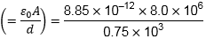 (1) (= 9.44 × 10^{–8} F)
E (= CV²) = × 9.44 × 10^{–8} × (200 × 10³)² (1)
= 1890J (1)
(ii) I 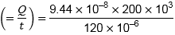 use of Q = CV (1) use of I = (1)
= 157 A (1)
6
[10]

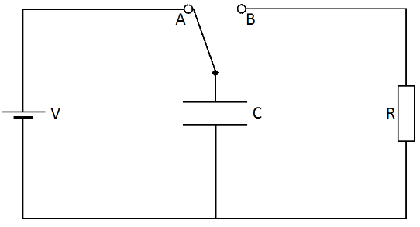
In the diagram to the right a capacitor can be charged by the battery if the switch is moved to position A. It can then be discharged through a resistor by moving the switch to position B.
Charging and Discharging

Charging a Capacitor
When the switch is moved to A the battery sends electrons to the lower plate and takes them from the upper plate. This leaves the lower plate negatively charged and the upper plate positively charged. An electric field is set up between the plates.
Current The current is the flow of electrons through the circuit.There is a large current initially as electrons move to the lower plate. As time passes and more electrons are on the plate it becomes more difficult to add more due to the electrostatic repulsion of similar charges. When no more electrons move in the circuit the current drops to zero.
Charge The charge stored by the capacitor increases with every electron the moves to the negative plate. The amount of charge increases quickly at the beginning because a large current is flowing. As the current drops the rate at which the charge increases also drops. A maximum charge is reached.
P.D. Since potential difference is proportional to charge, as charge builds up so does p.d. The maximum value of p.d. is reached as is equal to the terminal p.d. of the battery.
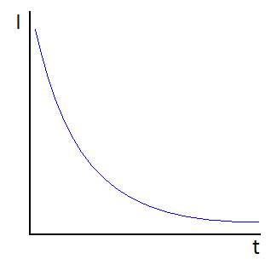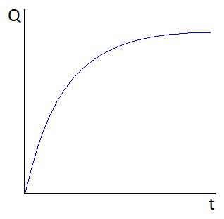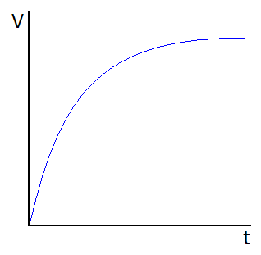
Discharging a Capacitor
When the switch in moved to B the electrons on the negative plate repel each other and move back into the circuit. Eventually both plates lose their charge and the electric field between them disappears.
Current There is initially a large current as the electrons leave the negative plate. As the number of electrons on the negative plate falls so does the size of the repulsive electrostatic force, this makes the current fall at a slower rate. When no more electrons move in the circuit the current drops to zero.
Charge The charge that was stored on the plates now falls with every electron that leaves the negative plate. The charge falls quickly initially and then slows, eventually reaching zero when all the charge has left the plates.
P.D. As the charge falls to zero so does the potential difference across the capacitor.
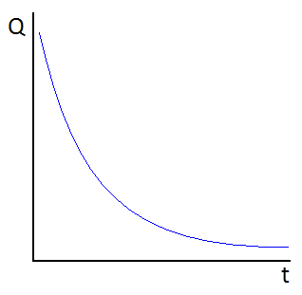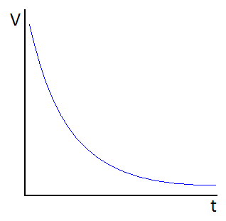
Time Constant, τ
The time it takes for the capacitor to discharge depends on the ‘time constant’.
The time constant is the time it takes for the charge or p.d. of a capacitor to fall to 37% of the initial value. OR
The time constant is the time it takes for the charge or p.d. of a capacitor to fall by 63% of the initial value.
It is given by the equation: 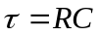

If the capacitor has a larger capacitance it means it can hold more charge, this means it will take longer to discharge. If the resistor has a larger resistance it means it is harder to move the electrons around the circuit, this also means it will take longer to discharge.

Q1.
The capacitor in the circuit is initially uncharged. The switch S is closed at time t = 0.
Which pair of graphs, A to D, correctly shows how the pd across the capacitor and the current in the circuit change with time?
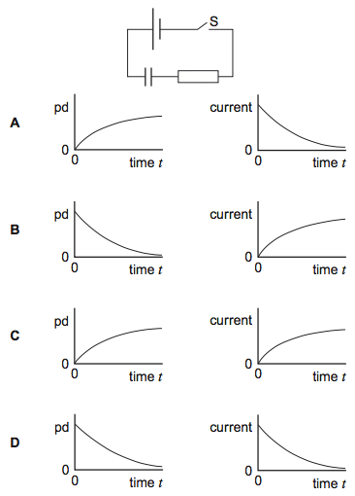
(Total 1 mark)
Q2.
A capacitor of capacitance C discharges through a resistor of resistance R. Which one of the following statements is not true?
A The time constant will decrease if C is increased.
B The time constant will increase if R is increased.
C After charging to the same voltage, the initial discharge current will increase if R is decreased.
D After charging to the same voltage, the initial discharge current will be unaffected if C is increased.
(Total 1 mark)

Q3.
(a) Define the capacitance of a capacitor.
___________________________________________________________________
___________________________________________________________________
___________________________________________________________________
___________________________________________________________________
(2)
(b) The circuit shown in the figure below contains a battery, a resistor, a capacitor and a switch.
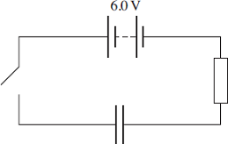
The switch in the circuit is closed at time t = 0. The graph shows how the charge Q stored by the capacitor varies with t.
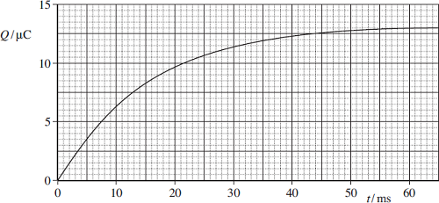
(b) (i) When the capacitor is fully charged, the charge stored is 13.2 μC. The electromotive force (emf) of the battery is 6.0 V. Determine the capacitance of the capacitor.

answer = ______________________ F
(2)

(ii) The time constant for this circuit is the time taken for the charge stored to increase from 0 to 63% of its final value. Use the graph to find the time constant in milliseconds.

answer = ______________________ ms
(2)
(iii) Hence calculate the resistance of the resistor.

answer = ______________________ Ω
(1)
(iv) What physical quantity is represented by the gradient of the graph?
______________________________________________________________
______________________________________________________________
(1)
(c) (i) Calculate the maximum value of the current, in mA, in this circuit during the charging process.

answer = ______________________ mA
(1)
(ii) Sketch a graph on the outline axes to show how the current varies with time as the capacitor is charged. Mark the maximum value of the current on your graph.
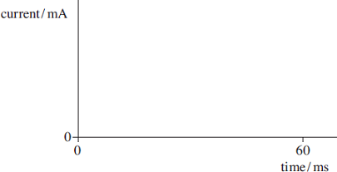
(2)
(Total 11 marks)

Q4.
(a) When an uncharged capacitor is charged by a constant current of 4.5 μA for 60 s the pd across it becomes 4.4 V.
(i) Calculate the capacitance of the capacitor.

capacitance ____________________ F
(3)
(ii) The capacitor is charged using the circuit shown in Figure 1. The battery emf is 6.0 V and its internal resistance is negligible. In order to keep the current constant at 4.5 μA, the resistance of the variable resistor R is decreased steadily as the charge on the capacitor increases.
Figure 1
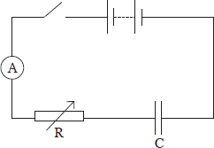
Calculate the resistance of R when the uncharged capacitor has been charging for 30 s.

resistance ____________________ Ω
(3)

(b) The circuit in Figure 2 contains a cell, an uncharged capacitor, a fixed resistor and a two-way switch.
Figure 2
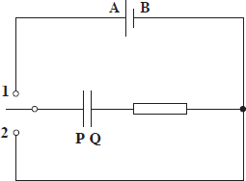
The switch is moved to position 1 until the capacitor is fully charged. The switch is then moved to position 2.
Describe what happens in this circuit after the switch is moved to position 1, and after it has been moved to position 2. In your answer you should refer to:
• the direction in which electrons flow in the circuit, and how the flow of electrons changes with time,
• how the potential differences across the resistor and the capacitor change with time,
• the energy changes which take place in the circuit.
The terminals of the cell are labelled A and B and the capacitor plates are labelled P and Q so that you can refer to them in your answer.
The quality of your written communication will be assessed in your answer.
___________________________________________________________________
___________________________________________________________________
___________________________________________________________________
___________________________________________________________________
___________________________________________________________________
___________________________________________________________________
___________________________________________________________________
___________________________________________________________________
___________________________________________________________________
___________________________________________________________________
(6)
(Total 12 marks)

Q5.
Figure 1 shows a circuit that is used in a defibrillator in which a short pulse of charge is used to revive a patient who suffers a cardiac arrest in which their heart stops beating.
Figure 2 shows how the charge on the capacitor varies with time when the capacitor is charging.
Figure 1
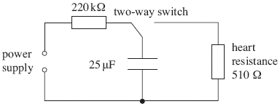
Figure 2
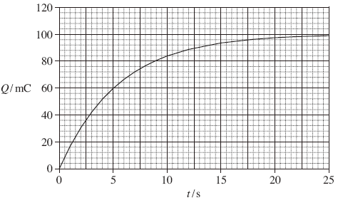
(a) (i) Use Figure 2 to determine the initial charging current.
______________________________________________________________
______________________________________________________________
______________________________________________________________
______________________________________________________________
______________________________________________________________
______________________________________________________________
______________________________________________________________
initial charging current ______________________ A
(2)

(ii) Calculate the emf of the supply used to charge the capacitor.
Assume that the supply has negligible internal resistance.
______________________________________________________________
______________________________________________________________
______________________________________________________________
______________________________________________________________
emf of the supply ______________________ V
(2)
(iii) Explain why the current that charges the capacitor falls as the capacitor charges.
______________________________________________________________
______________________________________________________________
______________________________________________________________
______________________________________________________________
______________________________________________________________
______________________________________________________________
(3)
(b) For the system to work successfully, the capacitor has to deliver 140 J of energy to the heart in a pulse that lasts for 10 ms.
(i) Show that the charge on the capacitor when it is storing this much energy is about 85 mC.
______________________________________________________________
______________________________________________________________
______________________________________________________________
______________________________________________________________
______________________________________________________________
(2)
(ii) Calculate the average power supplied during the pulse.
______________________________________________________________
______________________________________________________________
______________________________________________________________
average power ______________________ W
(1)

Q1.
A
[1]
Q2.
A
[1]
Q3.
(a) charge (stored) per unit potential difference
[or C = Q/V where Q = charge (stored by one plate) V = pd (across plates) ]
2
(b) (i) 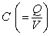 = 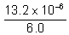 = 2.2 × 10^{–6} (F) (or 2.2 μF)
2
(ii) when t = time constant Q = 0.63 × 13.2 = 8.3 (μC)
[or = 0.63 × 13(.0) (from graph) = 8.2 (μC)]
reading from graph gives time constant = 15 (± 1) (ms)
2
(iii) resistance of resistor 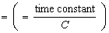 = 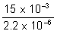 = 6820 (Ω)
1
(iv) gradient = current
1
(c) (i) maximum current = 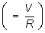 = 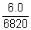 = 0.88 (mA)
[or value from initial gradient of graph: allow 0.70 – 1.00 mA for this approach]
1
(ii) curve starts at marked l_{max} on l axis and has decreasing negative gradient
line is asymptotic to t axis and approaches ≈ 0 by t = 60 ms
2
[11]
Q4.
(a) (i) Q(= It) 4.5 × 10^{–6} × 60 or = 2.70 × 10^{–4} (C) ✓
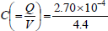 ✓ = 6.1(4) × 10^{–5} = 61 (μF) ✓
3
(ii) since V_{C} was 4.4V after 60s, when t = 30s V_{C} = 2.2 (V) ✓
[ or by use of Q = It and V_{C} = Q / C ]
∴ pd across R is (6.0 – 2.2) = 3.8 (V) ✓
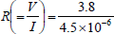 = 8.4(4) × 10⁵ (Ω) ✓ (=844 kΩ)
In alternative method,
Q = 4.5 × 10^{–6} × 30 = 1.35 × 10^{–4} (C)
V_{C} = 1.35 × 10^{–4} / 6.14 × 10^{–5} = 2.2 (V)
(allow ECF from wrong values in (i)).
3
(b) The candidate’s writing should be legible and the spelling, punctuation and grammar should be sufficiently accurate for the meaning to be clear.
The candidate’s answer will be assessed holistically. The answer will be assigned to one of three levels according to the following criteria.
High Level (Good to excellent): 5 or 6 marks
The information conveyed by the answer is clearly organised, logical and coherent, using appropriate specialist vocabulary correctly. The form and style of writing is appropriate to answer the question.
The candidate gives a coherent and logical description of the flow of electrons taking place during the charging and discharging processes, indicating the correct directions of flow and the correct time variations. There is clear understanding of how the pds change with time during charging and during discharging. The candidate also gives a coherent account of energy transfers that take place during charging and during discharging, naming the types of energy involved. They recognise that the time constant is the same for both charging and discharging.
A High Level answer must contain correct physical statements about at least two of the following for both the charging and the discharging positions of the switch:-
• the direction of electron flow in the circuit
• how the flow of electrons (or current) changes with time
• how V_{R} and / or V_{C} change with time
• energy changes in the circuit
Intermediate Level (Modest to adequate): 3 or 4 marks
The information conveyed by the answer may be less well organised and not fully coherent. There is less use of specialist vocabulary, or specialist vocabulary may be used incorrectly. The form and style of writing is less appropriate.
The candidate has a fair understanding of how the flow of electrons varies with time, but may not be entirely clear about the directions of flow. Description of the variation of pds with time is likely to be only partially correct and may not be complete. The candidate may show reasonable understanding of the energy transfers.
An Intermediate Level answer must contain correct physical statements about at least two of the above for either the charging or the discharging positions of the switch.
Low Level (Poor to limited): 1 or 2 marks
The information conveyed by the answer is poorly organised and may not be relevant or coherent. There is little correct use of specialist vocabulary. The form and style of writing may be only partly appropriate.
The candidate is likely to confuse electron flow with current and is therefore unlikely to make effective progress in describing electron flow. Understanding of the variation of pds with time is likely to be quite poor. The candidate may show some understanding of the energy transfers that take place.
A Low Level answer must contain a correct physical statement about at least one of the above for either the charging or the discharging positions of the switch.
Incorrect, inappropriate or no response: 0 marks
No answer, or answer refers to unrelated, incorrect or inappropriate physics.
The explanation expected in a competent answer should include a coherent selection of the following points concerning the physical principles involved and their consequences in this case.
Charging
• electrons flow from plate P to terminal A and from terminal B to plate Q
(ie. from plate P to plate Q via A and B)
• electrons flow in the opposite direction to current
• plate P becomes + and plate Q becomes –
• the rate of flow of electrons is greatest at the start, and decreases to zero
when the capacitor is fully charged
• V_{R} decreases from E to zero whilst V_{C} increases from zero to E
• at any time V_{R} + V_{C} = E
• time variations are exponential decrease for V_{R} and exponential increase
for V_{C}
• chemical energy of the battery is changed into electric potential energy
stored in the capacitor, and into thermal energy by the resistor (which passes
to the surroundings)
• half of the energy supplied by the battery is converted into thermal energy and
half is stored in the capacitor
Discharging
• electrons flow back from plate Q via the shorting wire to plate P
• at the end of the process the plates are uncharged
• the rate of flow of electrons is greatest at the start, and decreases to zero
when the capacitor is fully discharged
• V_{C} decreases from –E to zero and V_{R} decreases from E to zero
• at any time V_{C} = – V_{R}
• both V_{C} and V_{R} decrease exponentially with time
• electrical energy stored by the capacitor is all converted to thermal energy
by the resistor as the electrons flow through it and this energy passes to
the surroundings
• time constant of the circuit is the same for discharging as for charging
Any answer which does not satisfy the requirement for a Low Level answer should be awarded 0 marks.
max 6
[12]
Q5.
(a) (i) tangent drawn at t = 0
M1
coordinates correct and manipulated correctly
0.015 to 0.020 (A) 15 mA – 20 mA
or V = 4000 V as in (ii) then I = 18 mA
A1
2
(ii) V = 220 × their (i) condoning powers of 10
C1
about 4000 V (3300 – 4400 V)
A1
or use of V = Q/C; V = 100 mC/25 µF
C1
4000 V
A1
2
(iii) more charge leads to increased potential difference across
the capacitor
M1
pd = V_{R} + V_{C}
or if V_{C} increases then V_{R} decreases
M1
(if V_{R} falls) so I falls
A1
3
(b) (i) use of energy = ½ Q²/C or use of C = Q/V and ½ QV
C1
0.083(7) or 0.084 C condone 0.083 C
A1
2
(ii) power = 14 kW
B1
1

Exponential Decay

Finding τ from Graphs
The time constant of a discharging capacitor can be found from a graph of either charge, current or potential difference against time. After one time constant the value will have dropped to 0.37 of the initial value.
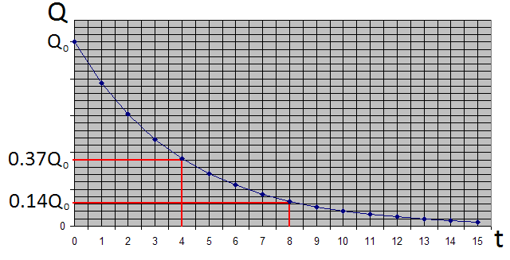
In this case the time constant is 4 seconds.

Quantitative Treatment
We could use the graph above to find the charge on the capacitor after a time, t. We could also use it to find the time it takes for the charge to fall to a value of Q.
This requires the graph to be drawn very accurately and values need to be taken from it very carefully.
Instead of doing this we can use the following equation to calculate the charge, Q after a time, t.
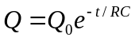
t is the time that has elapsed since discharge began
Q is the remaining charge
Q₀ is the initial (or starting) charge
RC is the time constant, also equal to the resistance multiplied by the capacitance.
Time is measured in seconds, s
When the time elapsed is equal to the time constant the charge should have fallen to 37% of the initial value.
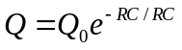 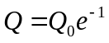 (but e⁻¹ = 0.37) 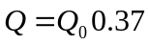
When the time elapsed is equal to twice the time constant the charge should have fallen to 37% of 37% of the initial value.
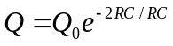 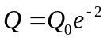 (but e⁻² = 0.37 x 0.37) 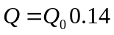

Similar equations can be established for the current flowing through and the potential difference across the capacitor after time, t:
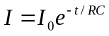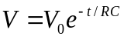

Rearranging
The equations above can be rearranged to make t the subject. We will use the equation for charge:
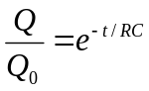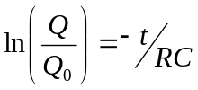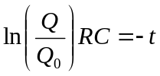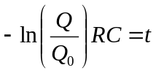
They can also be rearranged to make RC (time constant) the subject:
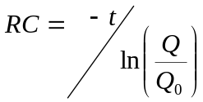
Discharge and time constants

A 250 μF capacitor is charged through a 100 kΩ resistor.
1. Calculate the time constant of the circuit.
2. The initial current is 100 μA. What is the current after 30 s?
3. Suggest values of R and C which would produce RC circuits with time constants of 1.0 s and 20 s.
4. The insulation between the plates of some capacitors is not perfect, and allows a leakage current to flow, which discharges the capacitor. The capacitor is thus said to have a leakage resistance. A 10 μF capacitor is charged to a potential difference of 20 V and then isolated. If its leakage resistance is 10 MΩ how long will it take for the charge to fall to 100 μC?
A 100 μF capacitor is charged and connected to a digital voltmeter (which has a very high resistance). The pd measured across the capacitor falls to half its initial value in 600 s.
5. Calculate the time constant of the discharge process.
6. Calculate the effective resistance of the capacitor insulation.

1.
R C = 250 × 10–6 F × 100 × 103 Ω = 25 s
2.
3.
Any pair of values such that R C = 1.0 s and R C = 20 s is acceptable.
4.
.
Since
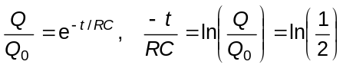
and
5.
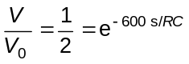
so
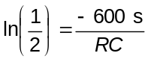
and
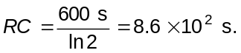
6.
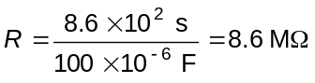

Capacitors with the exponential equation

A 10 F capacitor is charged to 5.0 V and then discharged through a 5 kΩ resistor.
1. Calculate the time constant for the circuit.
2. How much energy is stored in the capacitor when it is fully charged?
3. Calculate how long it takes for the pd across the capacitor to fall to 4.0 V.
4. How much energy will have been transferred from the capacitor during this process?
5. What will be the pd across the capacitor after 5.0 × 104 s?
6. Calculate the time taken for 50% of the energy initially stored in the capacitor to go into heating in the resistor.
1.
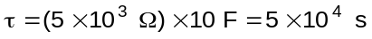
2.
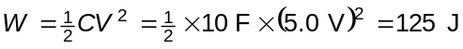
3.
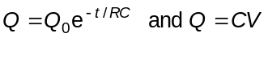
so
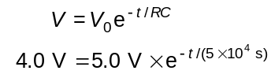
gives
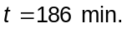
4.
Energy at 4.0 V
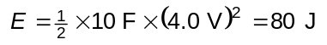
so the energy lost is 45 J.
5.
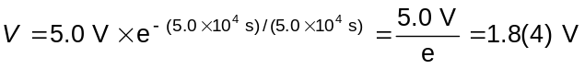
6. For 50% energy:
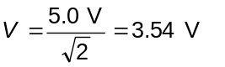
so
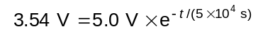 which gives t = 1.73 x 10⁴ s, or just under 5 hours.

Discharging a capacitor

A capacitor is charged to a potential difference of 1.0 V. The potential difference is measured at 10 s intervals, as shown in the table. When t = 15 s, a resistance of 1.0 MW is connected across the capacitor terminals.

t / s | V / V
0 | 1.00
10 | 1.00
20 | 0.81
30 | 0.54
40 | 0.35
50 | 0.23
60 | 0.15

1. What is the current in the resistor at t = 15 s?
2. Plot a graph of V against t, and measure the rate of decrease of V immediately after
t = 15 s.
3. Using the relationship I = dQ / dt = CdV / dt, calculate the value of the capacitance.
4. Plot also a graph of ln V against t to show the exponential decay of voltage, and use the gradient to find the time constant (RC).
5. From the time constant calculate the capacitance C.
6. Explain which method gives a better value of C, and why.
1.
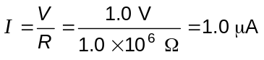
2.
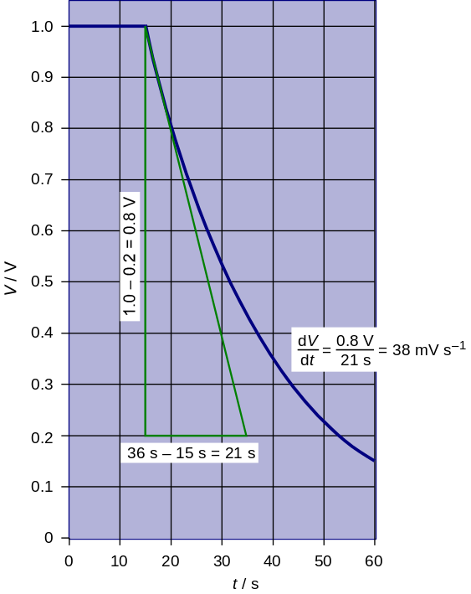

3.
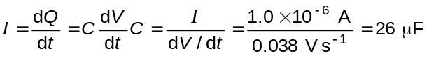
4.
t / s | ln V
0 | 0
10 | 10
20 | –0.21
30 | –0.62
40 | –1.05
50 | –1.47
60 | –1.90
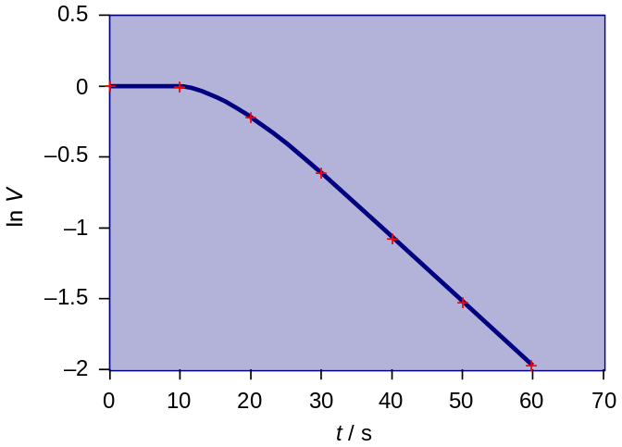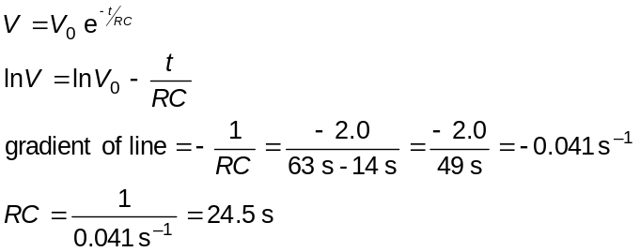
5.
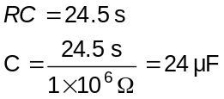
6. The second method is better, because it avoids the difficulty of accurately drawing a gradient for the V–t graph at 15 s.

Q1.
The graph below shows how the charge stored by a capacitor varies with time when it is discharged through a fixed resistor.
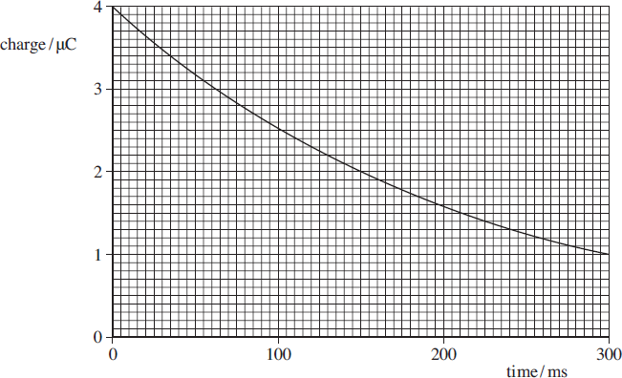
(a) Determine the time constant, in ms, of the discharge circuit.

time constant ____________________ ms
(3)
(b) Explain why the rate of discharge will be greater if the fixed resistor has a smaller resistance.
___________________________________________________________________
___________________________________________________________________
___________________________________________________________________
___________________________________________________________________
___________________________________________________________________
(2)
(Total 5 marks)

Q2.
(a) State what is meant by a capacitance of 370 μF
___________________________________________________________________
___________________________________________________________________
___________________________________________________________________
___________________________________________________________________
(2)
(b) The charging of a 370 μF capacitor is investigated using the circuit shown in Figure 1.
Both meters in the circuit are ideal.
Figure 1
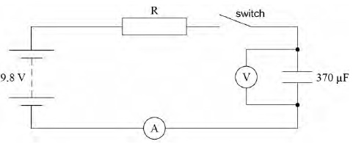
The power supply of emf 9.8V has a negligible internal resistance. The capacitor is initially uncharged. When the switch is closed at time t = 0 charge begins to flow through resistor R. The time constant of the charging circuit is 1.0 s
Calculate the resistance of R.
resistance of R = ____________________ Ω
(1)

(c) Identify, with the symbol X on Figure 2, the potential difference (pd) across the capacitor when the switch has been closed for 2.0 s
Sketch the graph that shows how the pd varies from t = 0 to t = 2.0 s
Figure 2
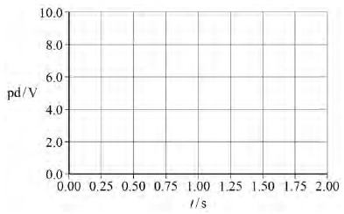
(2)
(d) Calculate the time taken for the charging current to fall to half its initial value.
time = ____________________ s
(1)
(e) Calculate the time taken for the charge on the capacitor to reach 3.0 mC
time = ____________________ s
(3)
(Total 9 marks)

Q3.
The figure below shows part of the discharge curve for a capacitor that a manufacturer tested for use in a heart pacemaker.
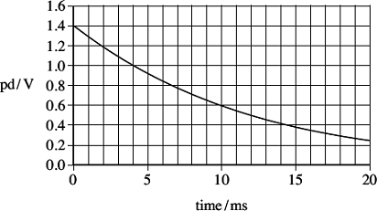
The capacitor was initially charged to a potential difference (pd) of 1.4 V and then discharged through a 150 Ω resistor.
(a) Show that the capacitance of the capacitor used is about 80 μF.
___________________________________________________________________
___________________________________________________________________
___________________________________________________________________
___________________________________________________________________
___________________________________________________________________
(3)
(b) Explain why the rate of change of the potential difference decreases as the capacitor discharges.
___________________________________________________________________
___________________________________________________________________
___________________________________________________________________
___________________________________________________________________
___________________________________________________________________
___________________________________________________________________
(3)

(c) Calculate the percentage of the initial energy stored by the capacitor that is lost by the capacitor in the first 0.015 s of the discharge.

energy lost ______________________%
(3)
(d) The charge leaving the capacitor in 0.015 s is the charge used by the pacemaker to provide a single pulse to stimulate the heart.
(i) Calculate the charge delivered to the heart in a single pulse.

charge ______________________C
(1)
(ii) The manufacturer of the pacemaker wants it to operate for a minimum of 5 years working at a constant pulse rate of 60 per minute.
Calculate the minimum charge capacity of the power supply that the manufacturer should specify so that it will operate for this time.
Give your answer in amp-hours (Ah).

minimum capacity ______________________Ah
(2)
(Total 12 marks)

Q1.
(a) (Q = Q ₀e^{−t /RC} gives )1.0 = 4.0e^{−300 / RC}
from which
[Alternative answer:
time constant is time for charge to decrease to Q₀ /e [or 0.37 Q₀ ]
4.0/e = 1.47
reading from graph gives time constant = 216 ± 10 (ms)
In alternative scheme, 4.0/e = 1.47 subsumes 1st mark. Also, accept T_{½} = 0.693 RC (or = ln 2 RC) for 1st mark.
3
(b) current is larger (for given V)(because resistance is lower)
[or correct application of I = V / R]
current is rate of flow of charge
[or correct application of I =Δ Q / Δt]
larger rate of flow of charge (implies greater rate of discharge)
[or causes larger rate of transfer of electrons from one plate back to the other]
[Alternative answer:
time constant (or RC) is decreased (when R is decreased)
explanation using Q = Q₀e^{−t / RC} or time constant explained ]
Use either first or alternative scheme; do not mix and match.
Time constant = RC is insufficient for time constant explained.
max 2
[5]
Q2.
(a) (Refers to a capacitor that) stores/holds/changes by 370 μC of charge ✔
For every (1) volt/volt change (of pd across its plates) ✔
OR
Reference to charge to pd OR charge to voltage ratio ✔ includes units C or coulomb and V or volt ✔
“Unit of pd” is no substitute for using volt and “unit of charge” is no substitute for coulomb.
However the alternative marking could give a single mark for 370 × 10^{–6} units of charge per unit of pd.
An equation may contribute towards the first mark but only if the symbols are identified. A second mark can be given if the units are identified.
Ignore poor phrasing like ‘per unit volt passing through’.
2
(b) (Using time constant = R C)
(R = 1.0 / 370 × 10^{–6})
R = 2.7 × 10³ (Ω) ✔
Check that the unit on answer line has not been altered.
1
(c) First mark for marking a cross at 2 s and 8.5 V (by eye) ✔
Second mark for graph starting at the origin and having a decreasing gradient ie not reaching horizontal ✔
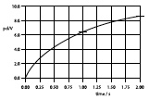
Cross must be in the bottom half but not on the 8.0 V major grid line or exactly half way up (9.0 V).
If a series of plotting crosses are given only consider the one placed at 2 s for the first mark.
2
(d) (Using T½ = 0.69 RC = 0.69 × 1.0)
T½ = 0.69 (s) ✔
1 sig fig is not acceptable
1
(e) (Use of Q = Q_{o}(1 − )= CV_{o} (1 − ))
Mark for max charge = CV_{o} which may come from substitution or seeing 3.6(2) × 10^{–3} C ✔
3.0 × 10^{–3} = 370 × 10^{–6} × 9.8 (1 – e^{–t}) ✔
Mark for substitution (0.8274 = (1 – e^{–t}) so e^{t} = 1/0.173 = 5.79)
t = 1.7 s or 1.8 s ✔
OR
Voltage V = Q/C = 3 × 10^{–3} / 370 × 10^{–6}
= 8.1(1) V ✔
(Substitute into V = V_{o}(1 − ) )
8.1 = 9.8 (1 – e^{–t}) ✔
t = 1.7 s or 1.8 s ✔
Alternative mark scheme uses the voltage as proportional to the charge.
Do not allow use of the graph for 2nd mark and 3rd mark.
An answer only gains only the last mark.
Evidence of working must be shown which shows substitution into a (1 – e^{–t}) form of the equation.
3
[9]
Q3.
(a) time to halve = 0.008 s or two coordinates correct
C1
C = T_{1/2}/(0.69 × 150) or eg 0.4 = 1.4 e^{–0.015/150C}
A1
77 μF (consistent with numerical answer)
A1
3
(b) max 3 from
as capacitor discharges:
pd decreases
B1
current through resistor decreases (since IV)
B1
rate at which charge leaves the capacitor decreases (since I = ∆Q/∆t)
B1
rate of change of charge is proportional to rate of change of pd
(since VQ)
B1
condone quicker discharge when pd is larger
B1
3
(c) energy stored ∝ V ² or use of ½ CV ²
or initial energy = 78.4 (or 75.5) μJ
or final energy using V = 0.38–0.4 0 V
(answer in range 5.6 – 6.4 μJ)
C1
fraction remaining = (0.4/1.4)² or 0.072 – 0.081
or energy lost = 72 μJ
C1
91.8 to 92.8% lost
A1
3
(d) (i) charge = 77 μC to 82 μC
B1
1
(ii) charge required = 77 × 10^{–6} × 5 × 3.15 × 10⁷ (= 12128 C)
or 1A–h =3600 C
C1
3.36(3.4) Ah
Practical
Determining the capacitance of an unmarked commercial capacitor
Apparatus

• | Low-voltage power supply (or battery pack)
• | Digital voltmeter
• | Commercial capacitor (its rating obscured with tape)
• | Resistor/resistance substitution box.
• | Stopwatch  Connecting leads

Aim
In this experiment, the definition for the time constant is used to determine the capacitance of an unmarked capacitor.

Procedure
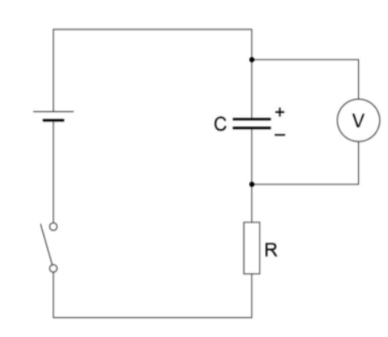
• Set up the circuit as shown in the diagram. (Ensure the capacitor is connected with correct polarity). With the switch open and the capacitor initially uncharged, the voltmeter should read zero.
• Close the switch to start the charging process and observe and record the voltage across the capacitor at 5s intervals (or longer time intervals if the charging process is ‘slow’)
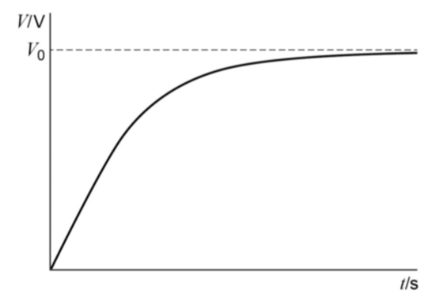
• Plot graphs of pd, V, on the y-axis against time, t. The graph will show an ‘exponential growth’ of pd across the capacitor as it charges as given by the equation V = V₀ (1-e^{–t/RC})

• Once the capacitor has been charged detach the wires from the power supply and connect them together. This will immediately discharge the capacitor.
• Record the voltage across the capacitor at 5s intervals (or longer time intervals if the charging process is ‘slow’).
• Plot a graph of pd across the capacitor, V, on the y-axis against time, t. This should give an exponential decay curve, as given by the equation V = V₀e ^{–t/RC}
• To confirm that this is an exponential, plot a graph of Ln(V) on the y-axis against t. This will give a straight line graph with a negative gradient according to the ‘log form’ of the equation lnV = lnV₀ - t/RC This graph will have a gradient of – 1/RC Hence the time constant RC can be determined from the gradient of the graph. If C is known, the value of R can also be found.
Q1.
Figure 1 shows a circuit that is used in a defibrillator in which a short pulse of charge is used to revive a patient who suffers a cardiac arrest in which their heart stops beating.
Figure 2 shows how the charge on the capacitor varies with time when the capacitor is charging.
Figure 1
Figure 2
(a) (i) Use Figure 2 to determine the initial charging current.
______________________________________________________________
______________________________________________________________
______________________________________________________________
______________________________________________________________
______________________________________________________________
______________________________________________________________
______________________________________________________________
initial charging current ______________________ A
(2)

(ii) Calculate the emf of the supply used to charge the capacitor.
Assume that the supply has negligible internal resistance.
______________________________________________________________
______________________________________________________________
______________________________________________________________
______________________________________________________________
emf of the supply ______________________ V
(2)
(iii) Explain why the current that charges the capacitor falls as the capacitor charges.
______________________________________________________________
______________________________________________________________
______________________________________________________________
______________________________________________________________
______________________________________________________________
______________________________________________________________
(3)
(b) For the system to work successfully, the capacitor has to deliver 140 J of energy to the heart in a pulse that lasts for 10 ms.
(i) Show that the charge on the capacitor when it is storing this much energy is about 85 mC.
______________________________________________________________
______________________________________________________________
______________________________________________________________
______________________________________________________________
______________________________________________________________
(2)
(ii) Calculate the average power supplied during the pulse.
______________________________________________________________
______________________________________________________________
______________________________________________________________
average power ______________________ W
(1)

(c) The circuit designer suggests that the capacitor can be used successfully after a charging time equal to 1.5 time constants of the charging circuit shown in Figure 1.
Explain with a calculation whether or not the designer’s suggestion is valid.
___________________________________________________________________
___________________________________________________________________
___________________________________________________________________
___________________________________________________________________
___________________________________________________________________
___________________________________________________________________
___________________________________________________________________
___________________________________________________________________
___________________________________________________________________
___________________________________________________________________
(3)
(Total 13 marks)

Q1.
(a) (i) tangent drawn at t = 0
M1
coordinates correct and manipulated correctly
0.015 to 0.020 (A) 15 mA – 20 mA
or V = 4000 V as in (ii) then I = 18 mA
A1
2
(ii) V = 220 × their (i) condoning powers of 10
C1
about 4000 V (3300 – 4400 V)
A1
or use of V = Q/C; V = 100 mC/25 µF
C1
4000 V
A1
2
(iii) more charge leads to increased potential difference across
the capacitor
M1
pd = V_{R} + V_{C}
or if V_{C} increases then V_{R} decreases
M1
(if V_{R} falls) so I falls
A1
3
(b) (i) use of energy = ½ Q²/C or use of C = Q/V and ½ QV
C1
0.083(7) or 0.084 C condone 0.083 C
A1
2
(ii) power = 14 kW
B1
1
(c) time constant = 5.5 s
M1
sensible attempt to find the charge after 8.3 s – by
calculation or reading from graph
M1
about 78 mC and needs to be 85 mC/has not reached
85 mC so designer’s suggestion is not valid
A1
3
[13]

Acknowledgements:
The notes in this booklet come from TES user dwyernathaniel. The original notes can be found here:
https://www.tes.com/teaching-resource/a-level-physics-notes-6337841
Questions in the “capacitors” section come from Bernard Rand (@BernardRand). His original resources can be found here:
https://drive.google.com/drive/folders/1-2qNVLwGzJ_7AjQK9N0z4BQBIRmSHAwG
Questions in the “exponential decay” section come from the IoP TAP project. The original resources can be found here:
https://spark.iop.org/collections/capacitors

