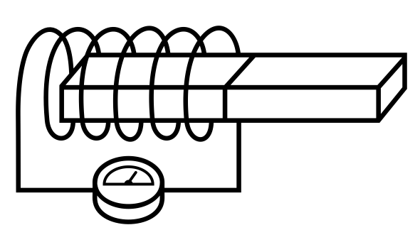
Magnetic
Name ______________________________
Teacher ______________________________
fields
We will be looking at the force a current carrying wire experiences when it is in a magnetic field.
Force on a current carrying wire
Before we look into the size and direction of the force we need to establish some basics.

Conventional Current
We know that the current flowing in a circuit is due to the negative electrons flowing from the negative terminal of a battery to the positive terminal.
Negative to Positive is the flow of electrons
Before the discovery of the electron scientist thought that the current flowed from the positive terminal to the negative one. By the time the electron was discovered many laws had been established to explain the world around them using current as flowing from positive to negative.
Positive to Negative is the Conventional Current

Magnetic Field Lines
We are familiar with the shape of a magnetic field around a bar magnet. Magnetic field lines leave the North Pole of the magnet and enter the South Pole. The poles of a magnet are stronger than the side because there are more field lines in the same area of space.
Magnetic field lines go from North to South

A 3D Problem
We will be looking at movement, fields and currents in 3D but our page is only 2D. To solve this problem we will use the following notation: A dot means coming out of the page and a cross means going into the page. Imagine an arrow fired from a bow, pointy end means it’s coming towards you, cross means its moving away.
out of the page, into the page

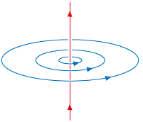
Current Carrying Wires
When a current flows through a straight piece of wire it creates a circular magnetic field. The Right Hand Grip Rule shows us the direction of the magnetic field. If we use our right hand and do a thumbs up the thumb is the direction of the conventional current and the fingers point the direction of the field lines.
Right hand thumbs up

Force on a Current Carrying Wire
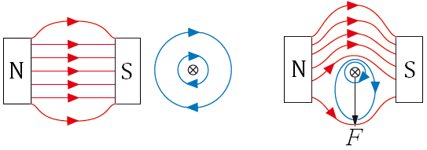
When a wire is placed between a North and South Pole (in a magnetic field), nothing happens.
When a (conventional) current flows through the wire it experiences a force due to the magnetic fields of the magnet and the wire. If we look at the diagram we can see that the magnetic field lines above are more compact than below. This forces the wire downwards.
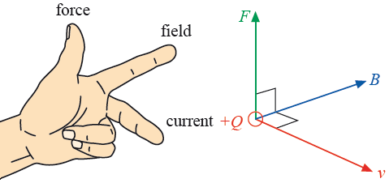

Fleming’s Left Hand Rule
This rule links the directions of the force, magnetic field and conventional current which are all at right angles to each other. Your first finger points from North to South, your middle finger points from positive to negative and your thumb points in the direction of the force.

Size of the Force
The size of the force on a wire of length l, carrying a current I placed in a magnetic field of magnetic flux density B is given by the equation: 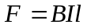
Here the wire is at 90° to the magnetic field lines.
When the wire is at an angle of θ with the magnetic field the force is given by: 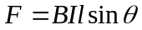
If we rearrange the equation to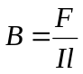we see that 1 Tesla is the magnetic flux density (field strength) that causes a 1 Newton force to act on 1 metre of wire carrying 1 Amp of current.
Magnetic Flux Density is measured in Tesla, T
This equation looks very familiar if we compare it to the force in a gravitational and electric field.
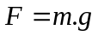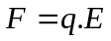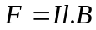


Fleming’s Left Hand Rule
Current coming out of page

Current going into page

1 | S  N  N  S | Label the direction of force on the wire.
2 | N  S  N  S | Label the direction of force on the wire.
3 |  | Label the poles of the magnets.
4 | N  S  N  S | Label the direction of current in the wire.
5 |  | Label the poles of the magnets.
6 | S  N  S  N | Label the direction of current in the wire.
7 | N  S  N  S | Label the direction of force on the wire.
8 |  | Label the poles of the magnets.
9 | N  S  N  S | Label the direction of current in the wire.
10 |  | Label the poles of the magnets.
11 | S  N  N  S | Label the direction of the forces on the two wires.
12 | N  S  N  S | Label the direction of the currents in the two wires.
13 |  | Label the poles of the magnets.
14 | S  N  N  S | The two wires are now connected by a rod attached to an axle that can turn. Which way does it turn? ______________
15 |  | The rod turns anticlockwise around the axle. Label the poles of the magnets.
16 | S  N  N  S | Which direction does the rod turn?
17 | 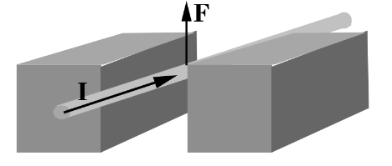 | Label the poles of the magnets.
18 | 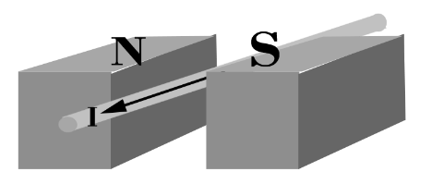 | Draw an arrow to show the force on the wire.
19 | 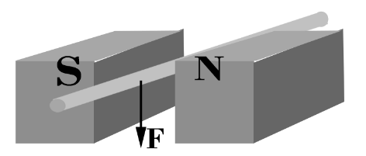 | Label the direction of current in the wire.
20 | 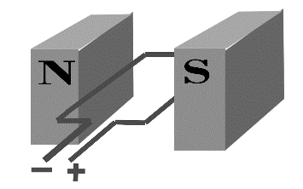 | Which way will this simple motor turn?

Forces on currents in magnetic fields
1. (a) Write down the formula for the force on a straight wire of length L placed at right angles to a magnetic field of flux density B.
(b) A pivot arrangement using a wire of length 15 cm is placed in a magnetic field. When a current of 4 A is passed through the wire it is found that a mass of 2.0 g must be hung from the wire to return it to a horizontal position. g = 9.81 m s⁻²
Calculate the magnetic flux density of the magnet.
2. A horizontal wire 6 cm long and mass 1.5 g is placed at right angles to a magnetic file of flux density 0.5 T. Calculate the current that must be passed through the wire so that it is self-supporting
3. A wire of length 0.5 m carrying a current of 2 A is placed at right angles to a magnetic field of 0.2 T. Calculate the force on the wire.
Questions 4 and 5:
A magnetic field exerts a force of 0.25 N on an 8.0 cm length of wire carrying a current of 3.0 A at right angles to the field.
4. Calculate the force the same field would exert on a wire 20 cm long carrying the same current.
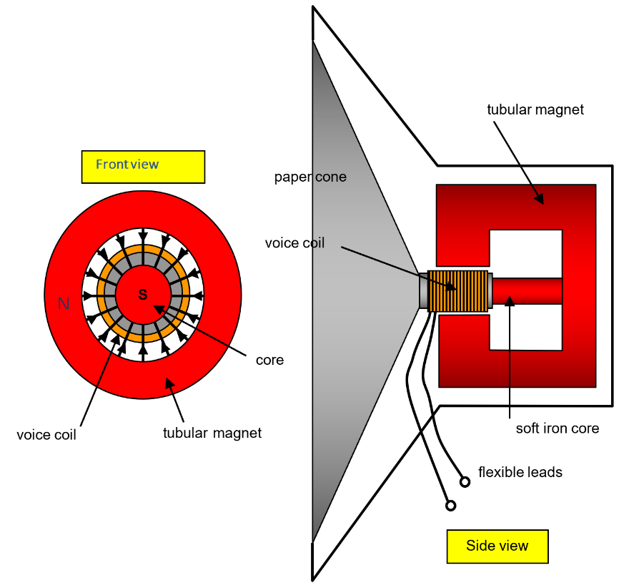
5. Calculate the force the same field would exert on three insulated wires, each 20 cm long and held together parallel to each other, each carrying a current of 3.0 A in the same direction.
6. (a) Using the ideas of forces on currents in magnetic fields and the diagram explain the operation of a moving coil loudspeaker.
(b) Calculate the force on the voice coil of a loudspeaker that has a diameter of 2 cm, a 100 turns and carries a current of 20 mA if the field strength of the tubular magnet is 0.1T.
- What force acts on a 3.00m wire at an angle of 10˚ to the field lines of a magnetic field of magnetic flux density 0.150 T if it carries a current of 5.00A.
- What is the current in a 4.00m wire at right angles to the field lines of a magnetic field of magnetic flux density 300 mT, which experiences a force of 15.3 N
- What is the magnetic flux density of a magnetic field if a 50.0m wire at an angle of 88˚ to the field lines experiences a force of 45.0N, and it carries a current of 25A?
- What is the current in a 100m wire if it is at an angle of 15˚ to a magnetic field of magnetic flux density of 13.0 mT, and experiences a force of 1.30 N.
- How long is a conductor that carries a current of 0.200A at right angles to a magnetic field with a magnetic flux density of 120mT, and which experiences a force of 1.20 N?
- What is the angle between a 20.0m wire and field lines, if the wire carries a current of 3A and experiences a force of 0.350N in a magnetic field of magnetic flux density of 12.0 mT?

Q1.
The diagram shows a horizontal conductor of length 50 mm carrying a current of 3.0 A at right angles to a uniform horizontal magnetic field of flux density 0.50 T.
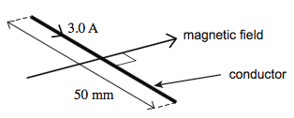
What is the magnitude and direction of the magnetic force on the conductor ?

A | 0.075 N vertically upwards
B | 0.075 N vertically downwards
C | 75 N vertically upwards
D | 75 N vertically downwards
(Total 1 mark)

Q2.
A horizontal straight wire of length 0.30 m carries a current of 2.0 A perpendicular to a horizontal uniform magnetic field of flux density 5.0 × 10^{–2} T. The wire ‘floats’ in equilibrium in the field.
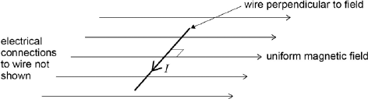
What is the mass of the wire?

A | 8.0 × 10^{–4} kg
B | 3.1 × 10^{–3} kg
C | 3.0 × 10^{–2} kg
D | 8.2 × 10^{–1} kg
(Total 1 mark)
Q3.

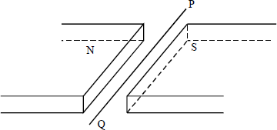
A wire lies perpendicularly across a horizontal uniform magnetic field of flux density 20 × 10⁻³ T so that 0.30 m of the wire is effectively subjected to the field. If the force exerted on this length of wire due to a current in it is 30 × 10⁻³ N downward, what is the current in the wire?
A 0.45 A from P to Q
B 0.45 A from Q to P
C 5.0 A from P to Q
D 5.0 A from Q to P
(Total 1 mark)

Q4.
The diagram shows a rigidly-clamped straight horizontal current-carrying wire held mid-way between the poles of a magnet on a top-pan balance. The wire is perpendicular to the magnetic field direction.
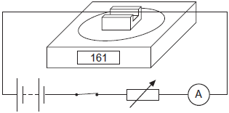
The balance, which was zeroed before the switch was closed, read 161 g after the switch was closed. When the current is reversed and doubled, what would be the new reading on the balance?
A −322 g
B −161 g
C zero
D 322 g
(Total 1 mark)
Q5.
A horizontal copper wire of mass 4.0 × 10⁻³ kg and length 80 mm is placed perpendicular to a horizontal magnetic field of flux density 0.16 T. The magnetic force acting on the wire supports the weight of the wire.
How many electrons are passing a point in the wire in each second?

A | 1.9 × 10¹⁸
B | 1.9 × 10¹⁹
C | 1.9 × 10²⁰
D | 1.9 × 10²¹
(Total 1 mark)

Q6.
Figure 1 shows two magnets, supported on a yoke, placed on an electronic balance.
Figure 1
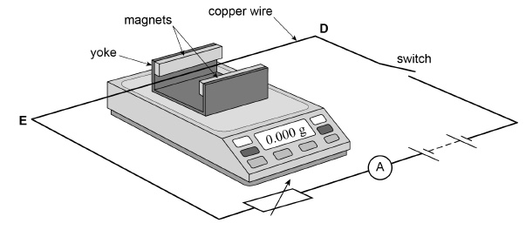
The magnets produce a uniform horizontal magnetic field in the region between them. A copper wire DE is connected in the circuit shown in Figure 1 and is clamped horizontally at right angles to the magnetic field.
Figure 2 shows a simplified plan view of the copper wire and magnets.
Figure 2
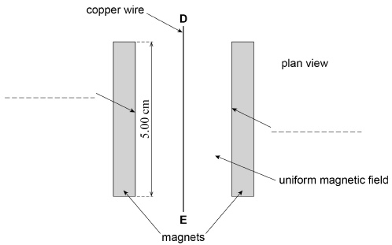
When the apparatus is assembled with the switch open, the reading on the electronic balance is set to 0.000 g. This reading changes to a positive value when the switch is closed.

(a) Which of the following correctly describes the direction of the force acting on the wire DE due to the magnetic field when the switch is closed?
Tick (✔) the correct box.

towards the left magnet in Figure 2 | 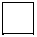
towards the right magnet in Figure 2
vertically up
vertically down
(1)
(b) Label the poles of the magnets by putting N or S on each of the two dashed lines in Figure 2.
(1)
(c) Define the tesla.
___________________________________________________________________
___________________________________________________________________
___________________________________________________________________
(1)
(d) The magnets are 5.00 cm long. When the current in the wire is 3.43 A the reading on the electronic balance is 0.620 g.
Assume the field is uniform and is zero beyond the length of the magnets.
Calculate the magnetic flux density between the magnets.
magnetic flux density = ____________________ T
(2)
(Total 5 marks)

Practical
Determining the magnetic flux density between the poles of a magnet
Apparatus

• | Top pan balance | • | Copper wire
• Variable d.c. supply |  | • | Clamp stands
• | Digital ammeter | • | Connecting wires
• | Magnadur magnets and yoke | • | Crocodile clips

Introduction

In this experiment, you will use an arrangement like that shown here to determine the magnetic flux density between the poles of a magnet using the equation $B=\frac{F}{Il}$ . You will then compare your results with the reading from a commercial magnetic probe such as a Tesla meter or a Hall probe. The direction of the force experienced by a current-carrying wire is given by Fleming’s left-hand rule. In the arrangement shown in the diagram, the wire experiences an upward force. The force experienced by the magnet is equal and opposite to that experienced by the current-carrying wire. Hence the change in the reading of the balance is an indication of the force experienced by the wire.

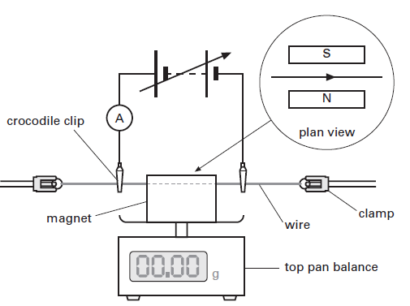
Procedure

            - Switch off the power supply.
            - Place the magnet on the top pan balance and zero the balance.
            - Switch on the power supply and alter the e.m.f. of the supply until the current in the wire is 0.2 A. Record the balance reading. Convert the balance reading into a force F using: F = mg, where m is the balance reading in kilograms and g is the gravitational field strength, 9.81 N/Kg.
            - Record your results in a table.
            - Determine the force acting on the wire as the current is increased in increments of 0.2 A.
            - Plot a graph of force F against current I. Draw a straight line of best fit (see sketch).
            - Determine the gradient G of the line. The magnetic flux density B is given by: B = G/l where l is the length of the wire in the magnetic field.
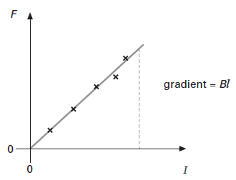
            - What is the uncertainty in your value for the magnetic flux density? Hint: draw maximum and minimum gradient lines.
            - Measure the flux density using a magnetic prob. How does this reading com pare with your calculated value?

Force on Charged Particle
Force on a charged particle
From our equation for the force a magnetic field will exert on a wire we can derive a equation for the force it will exert on a single charged particle.
Start with 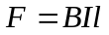. In Unit 1 we defined the current as 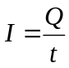 so we can sub this in to become 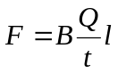
We can rewrite this equation 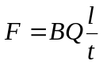and use 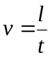 from Unit 2 to arrive at the equation: 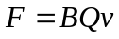
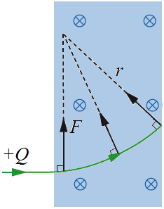

Moving in a Circle
If a charged particle enters a magnetic field it will feel a force. We now know the size of the force (given by equation above) and direction of the force (given by Fleming’s Left Hand Rule).
If we use the left hand rule in the diagram to the right we can see that the force is always at right angles to the velocity. First finger points into the page, middle finger points along the line and our thumb points upwards.
While the particle is in the magnetic field it will move in a circle.
Radius of the circle
We can calculate the radius a charged particle will move in by using our equation for the force on a charged particle in a magnetic field and a centripetal force equation.
and 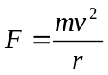 are equal to each other so we can write 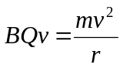 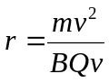 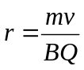
Time for a complete circle
We can also calculate the time it takes for the charged particle to move in one complete circle.
Starting at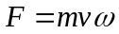 we can use 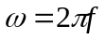to make the equation become 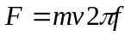 and then 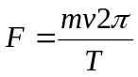
The centripetal force is due to the magnetic force on the charged particle so we can put these equal to each other. 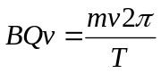 cancel the v to become 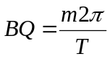 which rearranges to: 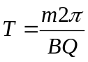
So the time it takes to complete a full circle does not depend on the velocity.

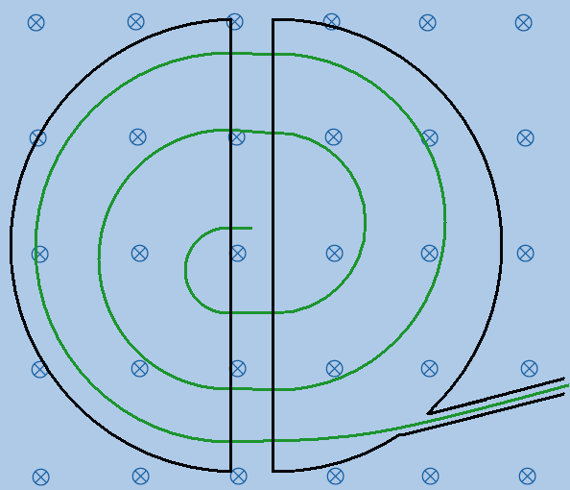
The Cyclotron
A cyclotron is a particle accelerator. It consists of two hollow D-shaped electrodes (called ‘dees’) that are attached to an alternating p.d. supply. The dees are placed in vacuum chamber and a magnetic field which acts at right angles to them.
A particle will move in a circle because of the magnetic field.
When it reaches the gap between the dees the alternating supply has made the other dee have the opposite charge to the particle. This causes the particle to accelerate across the gap and enter the second dee. This continues to happen until the particle is moving at the required speed. At this point it leaves the cyclotron.

The Mass Spectrometer
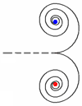
A mass spectrometer is used to analyse the types of atom that are in a sample. The atoms are given a charge, accelerated and sent into a magnetic field. If we look at the radius equation above we can see that atoms travelling at the same speed in the same magnetic field given the same charge will be deflected based on their mass. Heavy atoms will move in bigger circles than lighter ones.

Pair Production
Pair production is when a photon of energy is converted into a particle and an antiparticle, such as an electron and a positron. If this happens in a magnetic field the electron will move in a circle in one direction and the positron will move in a circle in the other direction.
Charged particles in magnetic fields
Where does the particle go?
The magnetic field in each case below is directed downward into the paper. Show the force direction on the particle and its likely path in the field.
Charge +Q
Mass m

v

Charge +2Q
Mass m

v

Charge - Q
Mass m

v

Charge -2Q
Mass 2m

2v

Combined Electric and Magnetic Fields
Electric force alone
A +ve charge q moving horizontally at velocity v enters the region between two metal plates that are separated by distance d and have a potential difference V.

+ V
0
v
+ q

- Draw on the electric field in the region between the plates.
- Draw on the charge an arrow to show the electric force on the charge: label it F_{E}.
- Write down an expression for the electric field strength E in in the region between the 2 plates:
E = V / d
- Now write down an expression for the force F_{E} on a charge q particle due to the electric field:
F_{E} = E Q
- Combining these two gives: F_{E} = V q/d

- Draw on the diagram a possible path the charge will follow.

Magnetic force alone

The p.d. between the plates is set to zero, and a uniform horizontal magnetic field of flux density B, directed into the paper, is switched on in the region between the plates.
X X X X X X X X X X X X X X X X X X X X X X X X
X X X X X X X X

v
+ q

- Draw on the charge an arrow to show the magnetic force on the charge: label it F_{M}.

- Write down an expression for the force F_{M} on a charge q particle due to the electric field:

F_{M} = B q v

- Draw on the diagram a possible path the charge will follow

Combining electric and magnetic effects
X X X X X X X X X X X X X X X X X X X X X X X
X X X X X X X X

+ V
0
v
+ q

Both electric and magnetic fields are now switched on together.
(j) The charged particle follows a straight-line path (in the plane of the paper) through the region between the plates. How is this possible?

(k) Draw on the charge an arrows to show the magnetic force F_{M} and electric force F_{E} on the charge in this situation. V q/d so B v = V / dase B or v or d, or decrease V

The Velocity Selector
When you have a set-up in which the effect of the B field on the moving particle is balanced by an E field, you can use this to select only particles that are travelling at a certain velocity
When we have the situation where the electric force = the magnetic force,

$$Eq=Bqv$$
Then
$$v=\frac{E}{B}$$
So, by adjusting the ratio of the E to the B field, you can adjust to select particles travelling at certain velocities – only these will pass through the selector undeviated.
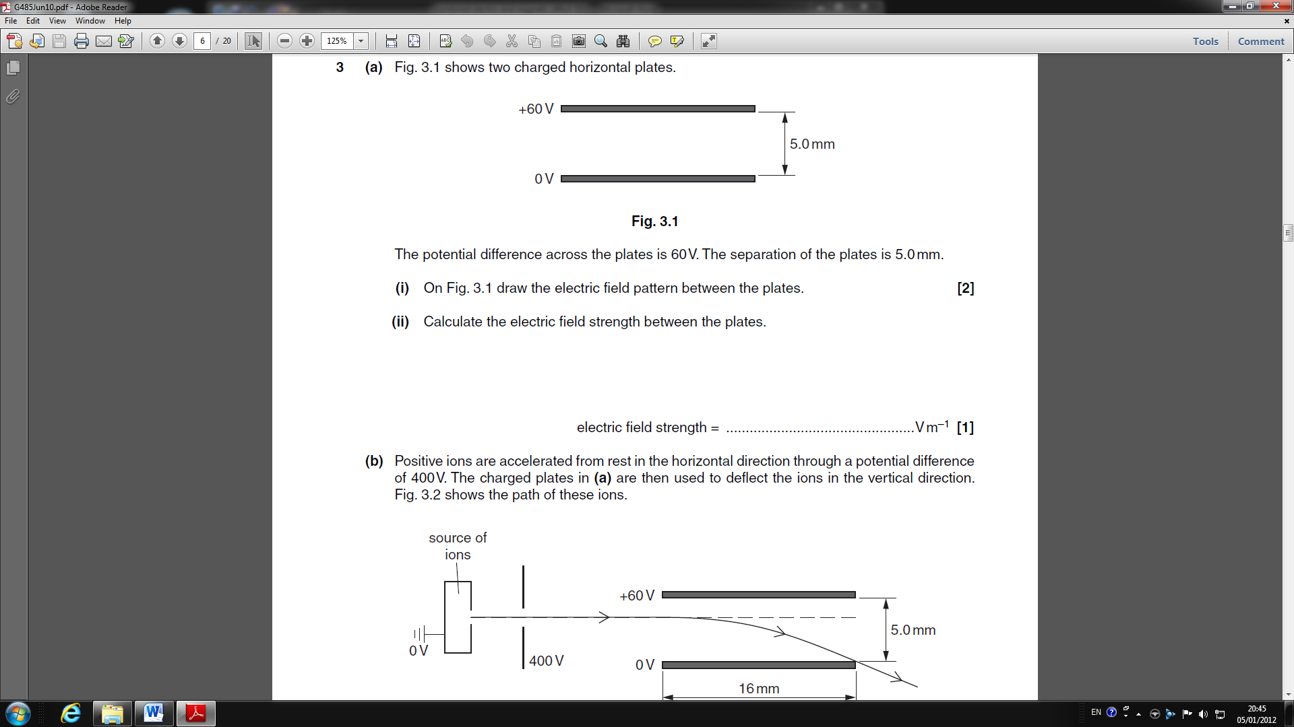
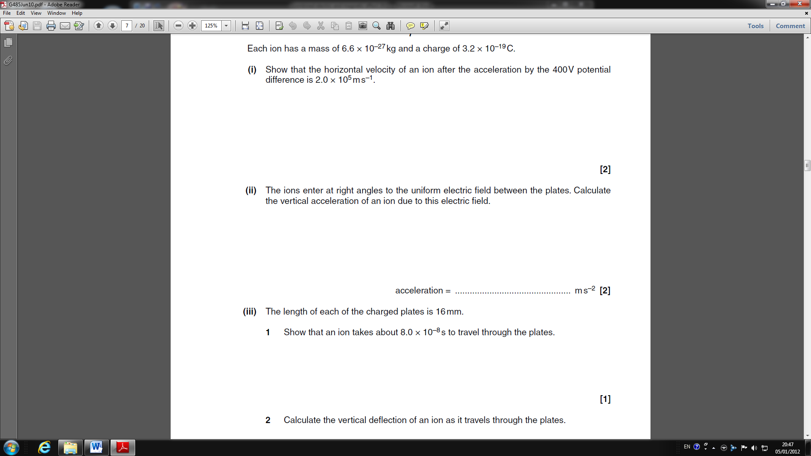

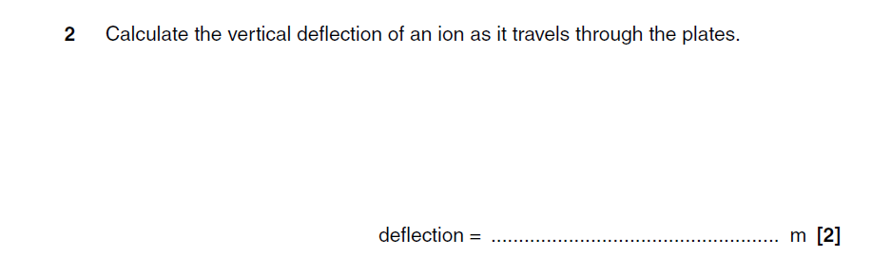
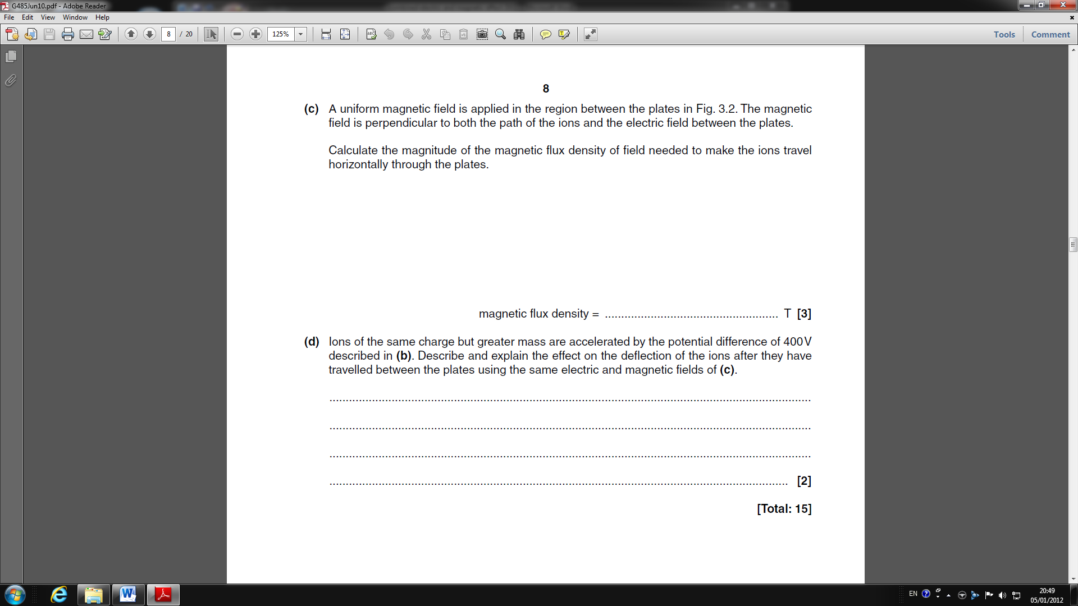

The cyclotron
You will need the following data:
mass of proton = 1.7 x 10^{–27} kg
charge on proton = 1.6 x 10^{–19} C
mass of electron = 9.1 × 10⁻³¹ kg

1. What is the velocity of a proton with an energy of 80 keV?
2. The largest possible path had a radius of about 50 mm. What strength of magnetic field must have been used?
3. What would be the radius of the path followed by a proton with half this maximum energy in the same field?
4. How long would it take 80 keV protons to travel once round their path? How long would it take for those with half this energy?
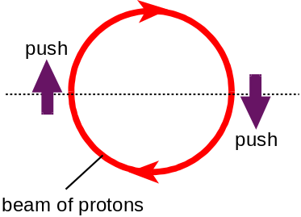
Constructed of two D -shaped chambers (later called ‘dees’ because of their shape), the cyclotron worked by giving particles of any energy, on their respective paths, a push every time they had completed half an orbit.

5. How was it possible for particles of differing energy all to be accelerated together?

Charged particles moving in a magnetic field

Questions 1– 5 are about the motion of charged particles in a bubble chamber.
1. An electron gun in a vacuum accelerates electrons up to a kinetic energy of 2.9 × 10⁻¹⁶ J. Show that the speed acquired by each electron is 2.5 × 10⁷ m/s.

The electron beam enters a region of uniform magnetic field of strength, B, perpendicular to the beam. The magnetic field causes the beam to follow a circular path as in the diagram below.

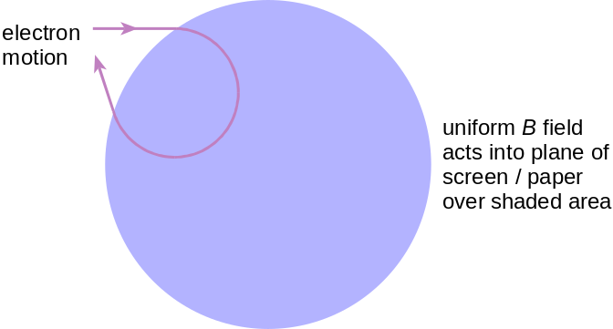
2. Show that the force experienced by the electron is about 8.8 × 10⁻¹⁵ N,
when B is 2.2 × 10⁻³ T.
3. Use your answer to question 2 to find the radius of this circular path.
4. Evidence for the motion of electrons in magnetic fields can be observed from the trail of bubbles they leave as they pass through liquid hydrogen. In these bubble-chamber experiments a single electron tends to produce a track which is a spiral rather than a circle. Explain why.

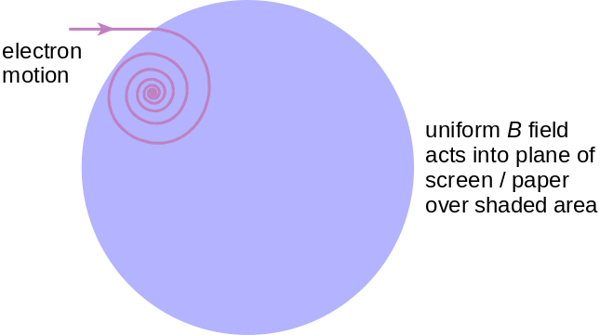

5. On the diagram below draw the likely path of a proton travelling at the same speed in an identical field.
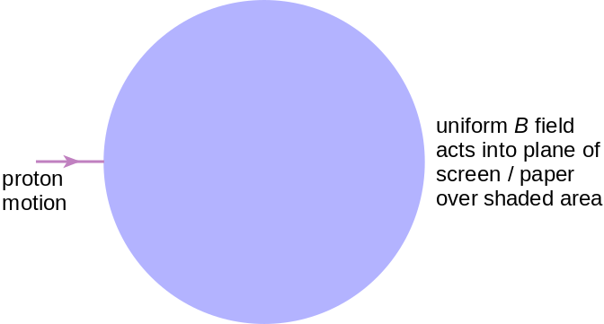

Questions 6–10 are about the motion of charged particles in magnetic fields and the cyclotron frequency.

6. Explain why a charged particle, moving with a constant speed v perpendicular to a uniform magnetic field B, will follow a circular path.
7. Show that for a particle of mass m and charge q the radius of the circular path is given by the expression r = mv/Bq.
8. Using your answer to question 7, show that the frequency of this circular motion, known as the cyclotron frequency, is given by the expression f = qB/2πm.
9. Some astrophysicists believe that the radio signals of 10⁹ Hz reaching us from Jupiter are emitted by electrons orbiting in Jupiter’s magnetic field. Assuming the frequency of the radio emission is identical to the cyclotron frequency; find the strength of the magnetic field around Jupiter.
10 The electrons lose energy as they emit radiation. What effect, if any, will this have on the frequency of the radio signals detected? Explain your answer.

Q1.
Figure 1 shows the plan view of a cyclotron in which protons are emitted in between the dees. The protons are deflected into a circular path by the application of a magnetic field. Figure 2 shows a view from in front of the cyclotron.
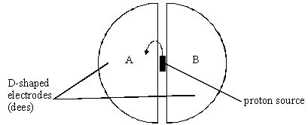
Figure 1
Figure 2
(a) (i) Mark on Figure 2 the direction of the magnetic field in the region of the dees such that it will deflect the proton beam in the direction shown in Figure 1.
(2)
(ii) Show that the velocity of the proton, v, at some instant is given by:
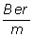
v =

where m is the proton mass, r the radius of its circular path, B the magnetic flux density acting on the proton and +e the proton charge.

(2)

(iii) Write down an equation for the time T for a proton to make a complete circular path in this magnetic field.

(2)
(iv) Explain how your equation leads to the conclusion that T is independent of the speed with which the proton is moving.
______________________________________________________________
______________________________________________________________
______________________________________________________________
(1)
(b) In addition to this magnetic field there is an electric field provided between the dees. This accelerates the proton towards whichever dee is negatively charged. An alternating potential difference causes each dee to become alternately negative and then positive. This causes the proton to accelerate each time it crosses the gap between the dees.
(i) Describe and explain the effect the acceleration has on the path in which the proton moves.
______________________________________________________________
______________________________________________________________
______________________________________________________________
(2)
(ii) In terms of T, write down the frequency with which the p.d. must alternate to match the period of motion of the proton.

(1)

(c) (i) Calculate the velocity of a proton of energy 0.12 keV.
the proton mass, m = 1.7 × 10^{–27} kg
the magnitude of the electronic charge, e = 1.6 × 10^{–19} C

(3)
(ii) Calculate the de Broglie wavelength of the 0.12 keV proton.
the Planck constant, h = 6.6 × 10^{–34} J s

(3)
(iii) Name the region of the electromagnetic spectrum which has an equivalent wavelength to that of the proton.
______________________________________________________________
(1)
(Total 17 marks)

Q2.
The diagram below shows a diagram of a mass spectrometer.
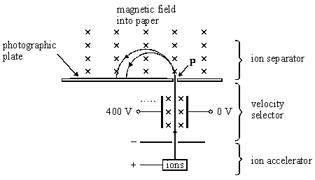
(a) The magnetic field strength in the velocity selector is 0.14 T and the electric field strength is 20 000 V m^{–1}.
(i) Define the unit for magnetic flux density, the tesla.
______________________________________________________________
______________________________________________________________
(2)
(ii) Show that the velocity selected is independent of the charge on an ion.

(2)
(iii) Show that the velocity selected is about 140 km s^{–1}.

(1)

(b) A sample of nickel is analysed in the spectrometer. The two most abundant isotopes of nickel are Ni and Ni. Each ion carries a single charge of +1.6 × 10^{–19} C.
mass of a proton or neutron = 1.7 × 10^{–27} kg
The Ni ion strikes the photographic plate 0.28 m from the point P at which the ion beam enters the ion separator.
Calculate:
(i) the magnetic flux density of the field in the ion separator;

(3)
(ii) the separation of the positions where the two isotopes hit the photographic plate.

(2)
(Total 10 marks)

Magnetic Flux, φ
Magnetic flux and flux linkage
Magnetic flux is a measure of how many magnetic field lines are passing through an area of A m².
The magnetic flux through an area A in a magnetic field of flux density B is given by: 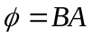
This is when B is perpendicular to A, so the normal to the area is in the same direction as the field lines.
Magnetic Flux is measured in Webers, Wb
The more field pass through area A, the greater the concentration and the stronger magnetic field.
This is why a magnet is strongest at its poles; there is a high concentration of field lines.

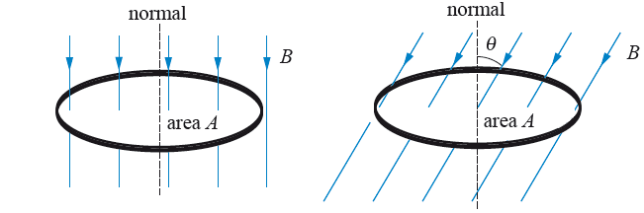
We can see that the amount of flux flowing through a loop of wire depends on the angle it makes with the field lines. The amount of flux passing through the loop is given by: 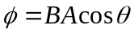
θ is the angle that the normal to the loop makes with the field lines.

Magnetic Flux Density
We can now see why B is called the magnetic flux density. If we rearrange the top equation for B we get:
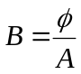 So B is a measure of how many flux lines (field lines) passes through each unit area (per m²).
A flux density of 1 Tesla is when an area of 1 metre squared has a flux of 1 Weber.

Flux Linkage
We now know that the amount of flux through one loop of wire is:
If we have a coil of wire made up of N loops of wire the total flux is given by: 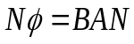
The total amount of flux, 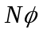, is called the Magnetic Flux Linkage; this is because we consider each loop of wire to be linked with a certain amount of magnetic flux.
Sometimes flux linkage is represented by 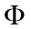, so 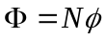 which makes our equation for flux linkage 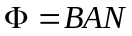
Flux Linkage is measured in Webers, Wb

Rotating Coil in a Magnetic Field
If we have a rectangle of wire that has an area of A and we place it in a magnetic field of flux density B, we have seen that the amount of flux flowing through the wire depends on the angle between it and the flux lines.
The flux linkage at an angle θ from the perpendicular to the magnetic field is given by: 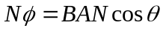
From circular motion we established that the angular speed is given by 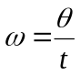 which can be rearranged to 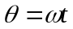and substituted into the equation above to transform it into: 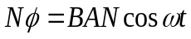
When t = 0 the wire is perpendicular to the field so there is a maximum amount of flux.
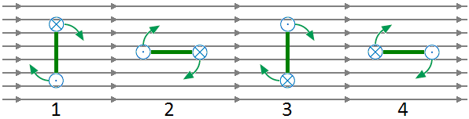
At 1 the flux linkage is a maximum in one direction. There is the lowest rate of change at this point.
At 2 the flux linkage is zero. There is the biggest rate of change at this point
At 3 the flux linkage is maximum but in the opposite direction. The lowest rate of change occurs here too.
At 4 the flux linkage is zero. There is the biggest rate of change at the point too but in the opposite direction.
Next lesson we will be looking at inducing an e.m.f. using a wire and a magnetic field. The size of the e.m.f. depends on the rate of change of flux linkage.
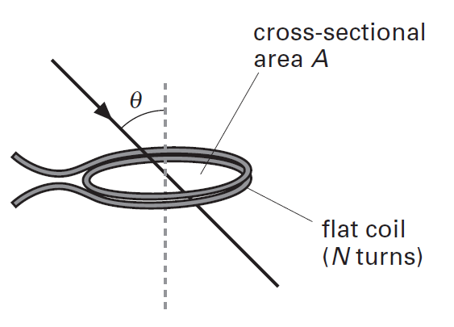
- A flat coil of N turns and cross-sectional area A is placed in a uniform magnetic field of flux density B. The plane of the coil is normal to the magnetic field.
- Write an equation for:
- the magnetic flux Φ through the coil;
- the magnetic flux linkage for the coil.
- The diagram shows the coil when the magnetic field is at an angle θ to the normal of the plane of the coil. What is the flux linkage for the coil?

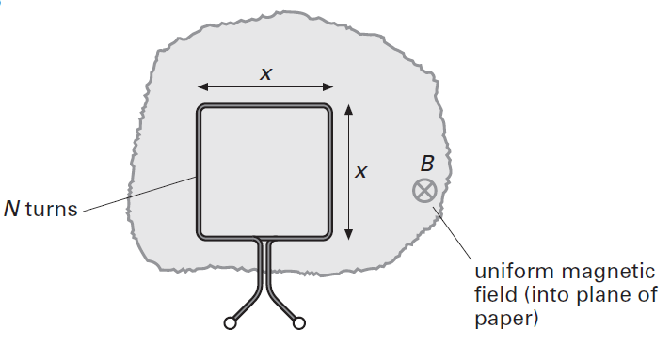

- A square coil of N turns is placed in a uniform magnetic field of magnetic flux density B. Each side of the coil has length x. What is the magnetic flux linkage for this coil?

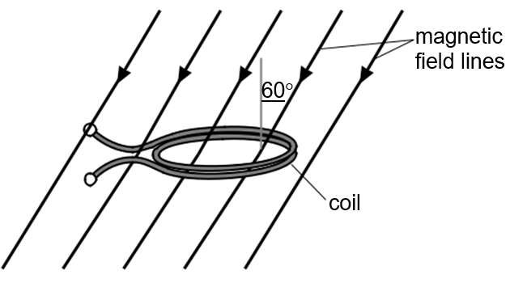
- A coil of cross-sectional area 4.0 × 10^{–4} m² and 70 turns is placed in a uniform magnetic field.
- The plane of the coil is at right angles to the magnetic field. Calculate the magnetic flux density when the flux linkage for the coil is 1.4 × 10^{–4} Wb.
- The coil is placed in a magnetic field of flux density 0.50 T. The normal to the coil makes an angle of 60˚ to the magnetic field, as shown in the diagram. Calculate the flux linkage for the coil.

- A square coil is placed in a uniform magnetic field of flux density 40 mT.
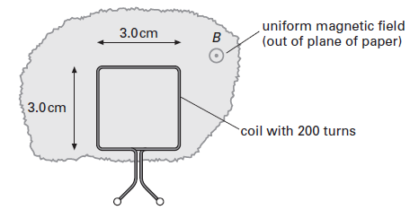
The plane of the coil is normal to the magnetic field. The coil has 200 turns and the length of each side of the coil is 3.0 cm.
- Calculate
- the magnetic flux Φ through the coil;
- the magnetic flux linkage for the coil.
- The plane of the coil is turned through 90°. What is the change in the magnetic flux linkage for the coil?

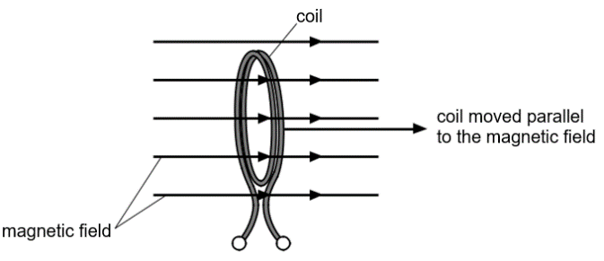
- The diagram shows a coil of radius 4.0cm and 1000 turns placed in a uniform magnetic field of flux density 0.060 T. The place of the coil is at right-angles to the magnetic field. Determine the magnetic flux Φ through the coil and the magnetic flux linkage.
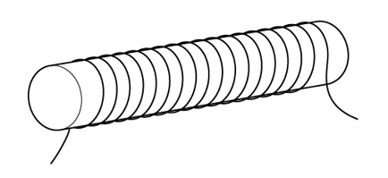
- The diagram shows an iron rod with 200 turns of wire around it. The current in the coil produces a magnetic field in the rod. The flux density in the iron is 0.070 T. The cross-sectional area of the rod is 2.4 × 10⁻⁵ m².Calculate the flux linkage of the coil. State the units.

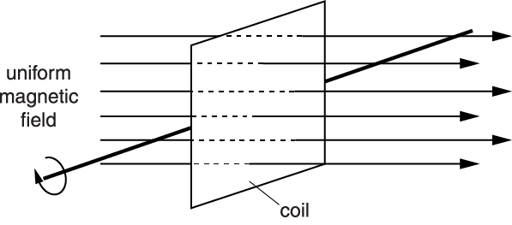
- The diagram shows a square coil initially perpendicular to a uniform magnetic field.

The graph below shows how the flux linkage through the coil changes as it rotates in the field.

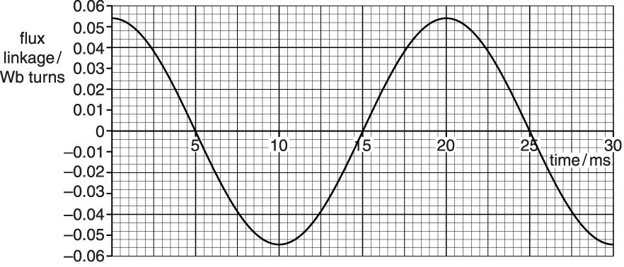

The coil has 200 turns. The magnetic field has a flux density of 7.5 × 10⁻² T.
Use these data and data from the graph to calculate the length of a side of the square coil.

- A single-turn square coil of side 0.050m is placed in a magnetic field of flux density B of magnitude 0.026 T. The coil is placed in three different orientations to the field as shown in the diagram.

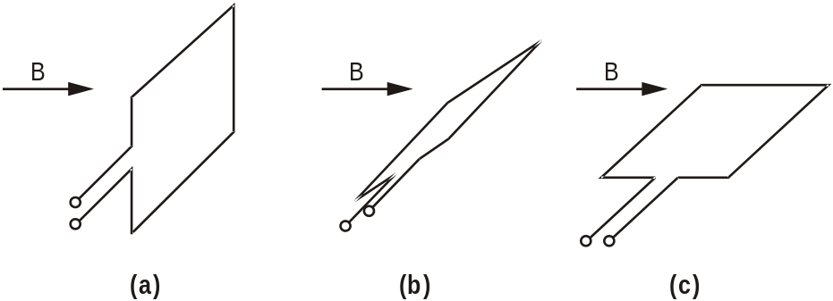

In position a) the plane of the coil is perpendicular to the field. In b), it is at 45˚ to the field and in c), it is parallel to the field.
Calculate the value of the magnetic flux linkage in positions a), b) and c).

Q1. A 500 turn coil of cross-sectional area 4.0 × 10^{–3} m² is placed with its plane perpendicular to a magnetic field of flux density 7.5 × 10^{–4} T. What is the value of the flux linkage for this coil?
A 3.0 × 10^{–6} Wb turns
B 1.5 × 10^{–3} Wb turns
C 0.19 Wb turns
D 94 Wb turns

Q2. An aircraft, of wing span 60 m, flies horizontally at a speed of 150 m s^{–1}. If the vertical component of the Earth’s magnetic field in the region of the plane is 1.0 × 10^{–5} T, what is the magnitude of the magnetic flux cut by the wings in 10 s?
A 1.0 × 10^{–5} Wb
B 1.0 × 10^{–4} Wb
C 9.0 × 10^{–2} Wb
D 9.0 × 10^{–1} Wb
Q3. The diagram shows a coil placed in a uniform magnetic field. In the position shown, the angle between the normal to the plane of the coil and the magnetic field is is rad.
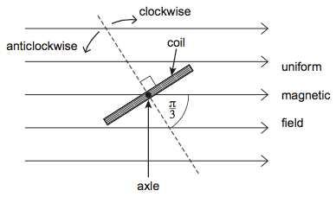
Which line, A to D, in the table shows the angles through which the coil should be rotated, and the direction of rotation, so that the flux linkage becomes (i) a maximum, and (ii) a minimum?

Angle of rotation / rad
 | (i) for maximum flux linkage | (ii) for minimum flux linkage
A | clockwise | anticlockwise
B | anticlockwise | clockwise
C | clockwise | anticlockwise
D | anticlockwise | clockwise
Q4.
A rectangular coil of area A has N turns of wire. The coil is in a uniform magnetic field of flux density B with its plane parallel to the field lines.
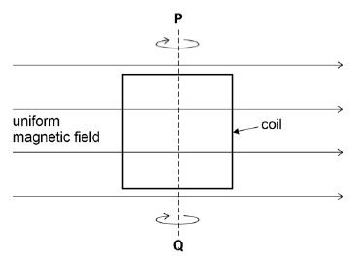
The coil is then rotated through an angle of 30° about axis PQ.
What are the correct initial value and correct final value of the magnetic flux linkage?

 | Initial magnetic flux linkage | Final magnetic flux linkage
A | 0 | BAN
B | 0 | BAN
C | BAN | BAN
D | BAN | BAN

Q5.
A rectangular coil measuring 20 mm by 35 mm and having 650 turns is rotating about a horizontal axis which is at right angles to a uniform magnetic field of flux density 2.5 × 10^{–3} T.
The plane of the coil makes an angle θ with the vertical, as shown in the diagrams.
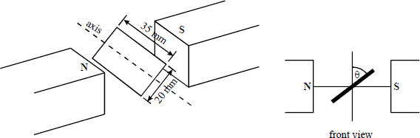
(a) State the value of θ when the magnetic flux through the coil is a minimum.
___________________________________________________________________
(1)
(b) Calculate the magnetic flux passing through the coil when θ is 30°.
___________________________________________________________________
___________________________________________________________________
(2)
(c) What is the maximum flux linkage through the coil as it rotates?
___________________________________________________________________
___________________________________________________________________
___________________________________________________________________
(2)
(Total 5 marks)

Making Electricity
Electromagnetic induction
An e.m.f. can be induced across the ends of a conducting wire in two ways:
1) Move the wire through a magnetic field or 2) Move a magnet through a coil of the wire
In both cases magnetic field lines and wires are cutting through each other. We say that the wire is cutting through the magnetic field lines (although it is fair to say that the field lines are cutting through the wire).
If the conductor is part of a complete circuit a current will be induced through it as well as an e.m.f. across it.
There are two laws that describe the induced e.m.f...

Faraday’s Law – Size of induced e.m.f.
The magnitude of the e.m.f. induced in a conductor equals the rate of change of flux linkages or the rate at which the conductor cuts a magnetic flux.
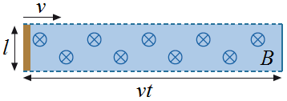
Straight Wire
Imagine a straight piece of wire of length l is moved through a magnetic field at a velocity v. If the wire is moving at right angles to the field lines an e.m.f. is induced (because field lines are being cut).
The size of the e.m.f. is given by the equation:
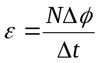
For one loop of wire 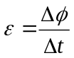 and the flux is given by which are combine to become 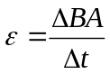
B is constant so 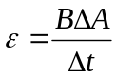. ΔA is the area the wire cuts through in a time t and is given by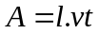 so we get: 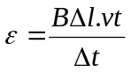 The length of the wire and velocity are constant so it becomes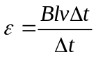 which cancels to: 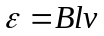
Rotating Coil of Wire
If we have a coil of wire with N turns, each of which has an area of A and placed it a magnetic field of flux density B nothing would happen. If it was rotated with an angular speed of ω it would cut through the magnetic field lines and an e.m.f. would be induced. The size of the e.m.f. is given by:
Since 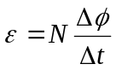 and 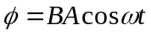 we get 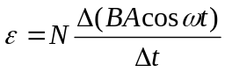 and if we differentiate it: 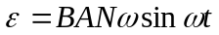
This is why the Mains supply is alternating; the rotating coil cuts the field lines in one direction on the way up and the other direction on the way down.

Lenz’s Law – Direction of induced e.m.f.
The direction of the e.m.f. induced in a conductor is such that it opposes the change producing it.
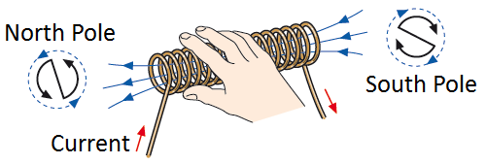
Solenoid (Right Hand Grip Rule)
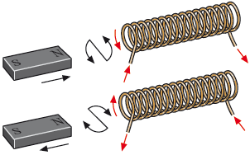
A solenoid with a current flowing through it produces a magnetic field like that of a bar magnet. We can work out which end is the North Pole and which is the South by using the Right Hand Grip Rule from our force on a wire lesson. If our fingers follow the direction of the current through the coils our thumb points out of the North Pole.
-When we push the North Pole of a magnet the induced current in the solenoid flows to make a North Pole to repel the magnet.
-When we pull the North Pole out of the solenoid the induced current flows to make a South Pole to attract the magnet.
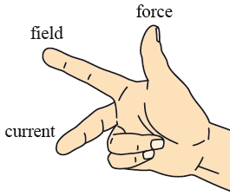
Fleming’s Right Hand Rule
If we are just moving a straight wire through a uniform magnetic field the direction of the induced current can be worked out using Fleming’s Right Hand Rule.
Your first finger points in the direction of the field from North to South, your thumb points in the direction the wire is moved and your middle finger points in the direction of the conventional current.

- a) State Faraday’s law of electromagnetic induction
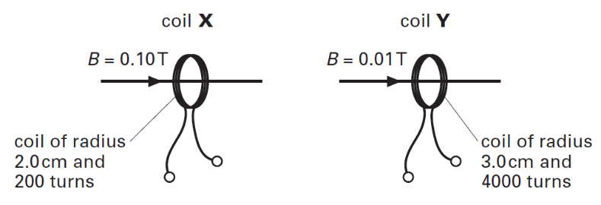
b) Lenz’s law expresses an important conservation law. Name this conservation law.
c) Define magnetic flux for a coil placed at right angles to a magnetic field.
d) Determine for which of the two coils X and Y, each placed at right angles to the magnetic field, is the magnetic flux linkage the greatest.
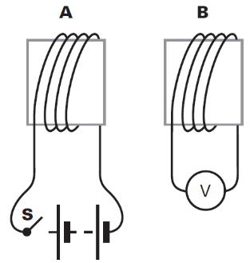
2. a) The diagram shows two coils A and B placed close to each other.
b) The switch S is closed. Explain why the voltmeter placed across coil B indicates an induced e.m.f. for a short period of time.
c) The coil A has 200 turns and cross-sectional area 9.0 × 10⁻⁴ m². With the switch S closed, the current through the coil A produces a uniform magnetic field within the coil of magnetic flux density 2.5 × 10⁻³ T. Calculate the magnetic flux linkage for this coil.

- A rectangular coil of length 3.0 cm and width 2.0 cm has 100 turns. The coil is placed at right-angles to a uniform magnetic field of magnetic flux density 1.2 × 10⁻² T.
- The coil is removed from the magnetic field in a time of 50 ms. Calculate the magnitude of the average induced emf across the ends of the coil.
- Explain how your answer to a) would change if the magnetic field were parallel to the plane of the coil.
- A rectangular coil of 100 turns has length 2.0 cm and width 1.0 cm. The coil is placed in a uniform magnetic field between the poles of a strong electromagnet. The magnetic field has a magnetic flux density of 0.30 T. The coil is withdrawn from the field in a time of 0.15 s. Determine the magnitude of the average induced e.m.f. across the ends of the coil.
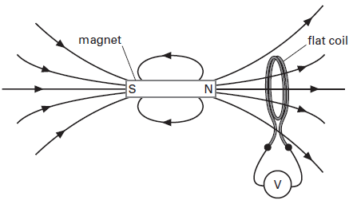
- The diagram shows a magnet placed close to a flat circular coil.
- Explain why there is no induced emf even though there is magnetic flux linking the coil.
- Explain why there is an induced emf when the magnet is pushed towards the coil.

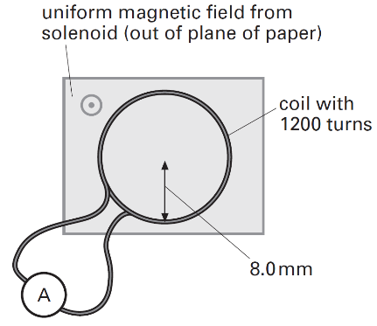

- A flat circular coil of 1200 turns and of mean radius 8.0 mm is connected to an ammeter of negligible resistance. The coil has a resistance of 6.3 Ω. The plane of the coil is placed at right-angles to a magnetic field of flux density 0.15 T from a solenoid. The current in the solenoid is switched off. It takes 20 ms for the magnetic field to decrease from its maximum value to zero. Calculate:
- The average magnitude of the induced emf across the ends of the coil.
- The average current measured by the ammeter.

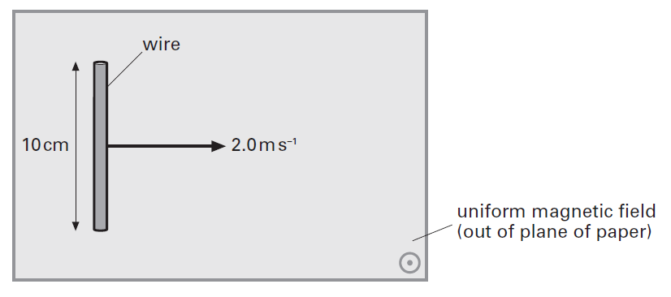
- The diagram shows a straight wire of length 10 cm moved at a constant speed of 2.0 m/s in a uniform magnetic field of flux density 0.050 T.

For a period of 1 second, calculate:
- The distance travelled by the wire.
- The area swept by the wire.
- The change in magnetic flux for the wire.
- The emf induced across the ends of the wire.

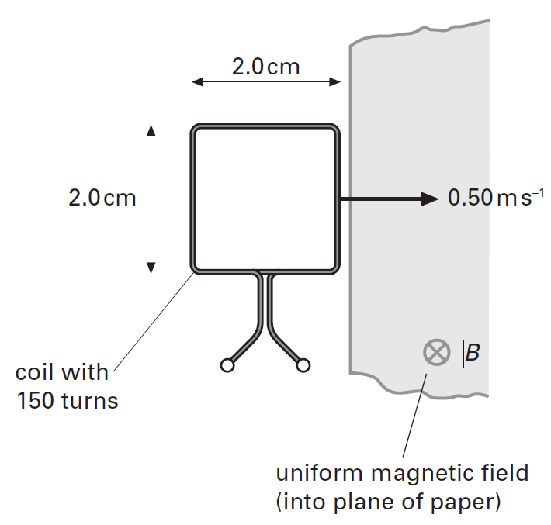
- A circular coil of radius 1.2 cm has 2000 turns. The coil is placed at right-angles to a magnetic field of flux density 60 mT. Calculate the average magnitude of the induced e.m.f. across the ends of the coil when the direction of the magnetic field is reversed in a time of 30 ms.
- The diagram shows a square coil about to enter a region of uniform magnetic field of magnetic flux density 0.30 T. The magnetic field is at right-angles to the plane of the coil. The coil has 150 turns and each side is 2.0 cm in length. The coil moves at a constant speed of 0.50 m/s.
- i) Calculate the time taken for the coil to enter completely the region of magnetic field.
ii) Calculate the magnetic flux linkage through the coil when it is all within the region of the magnetic field.
- Explain why the induced emf is a constant value when the coil is entering the magnetic field.
- Use your answer to a) to determine the induced emf across the ends of the coil.
- What is the induced emf across the ends of the coil when it is completely within the magnetic field. Explain your answer.
- A wire of length l is placed in a uniform magnetic field of flux density B. The wire is moved at a constant velocity v at right-angles to the magnetic field. Use Faraday’s law of electromagnetic induction to show that the induced e.m.f. E across the ends of the wire is given by: E = Bvl

Hence calculate the e.m.f. induced across the ends of a 20 cm long rod rolling along a horizontal table at a speed of 0.30m/s. (The vertical component of the Earth’s magnetic flux density is about 40 μT.)

Q1.
An aircraft, of wing span 60 m, flies horizontally at a speed of 150 m s^{–1}, If the vertical component of the Earth’s magnetic field in the region of the plane is 1.0 × 10^{–5} T, what emf is induced across the wing tips of the plane?
A 0.09 V
B 0.90 V
C 9.0 V
D 90 V
(Total 1 mark)
Q2.
(a) State Lenz’s law.
___________________________________________________________________
___________________________________________________________________
___________________________________________________________________
___________________________________________________________________
(2)

(b) Figure 1 shows two small, solid metal cylinders, P and Q. P is made from aluminium. Q is made from a steel alloy.
Figure 1
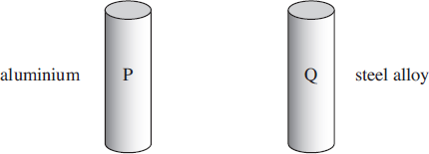
(i) The dimensions of P and Q are identical but Q has a greater mass than P. Explain what material property is responsible for this difference.
______________________________________________________________
______________________________________________________________
______________________________________________________________
(1)
(ii) When P and Q are released from rest and allowed to fall freely through a vertical distance of 1.0 m, they each take 0.45 s to do so. Justify this time value and explain why the times are the same.
______________________________________________________________
______________________________________________________________
______________________________________________________________
______________________________________________________________
______________________________________________________________
______________________________________________________________
(2)

(c) The steel cylinder Q is a strong permanent magnet. P and Q are released separately from the top of a long, vertical copper tube so that they pass down the centre of the tube, as shown in Figure 2.
Figure 2
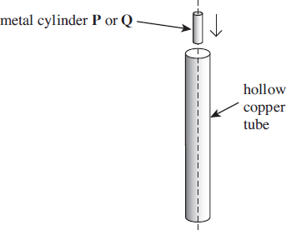
The time taken for Q to pass through the tube is much longer than that taken by P.
(i) Explain why you would expect an emf to be induced in the tube as Q passes through it.
______________________________________________________________
______________________________________________________________
______________________________________________________________
______________________________________________________________
(2)
(ii) State the consequences of this induced emf, and hence explain why Q takes longer than P to pass through the tube.
______________________________________________________________
______________________________________________________________
______________________________________________________________
______________________________________________________________
______________________________________________________________
______________________________________________________________
______________________________________________________________
______________________________________________________________
(3)

(d) The copper tube is replaced by a tube of the same dimensions made from brass. The resistivity of brass is much greater than that of copper. Describe and explain how, if at all, the times taken by P and Q to pass through the tube would be affected.
P: ________________________________________________________________
___________________________________________________________________
___________________________________________________________________
___________________________________________________________________
Q: ________________________________________________________________
___________________________________________________________________
___________________________________________________________________
___________________________________________________________________
(3)
(Total 13 marks)
Q3.
The figure below shows an end view of a simple electrical generator. A rectangular coil is rotated in a uniform magnetic field with the axle at right angles to the field direction. When in the position shown in the figure below the angle between the direction of the magnetic field and the normal to the plane of the coil is θ.
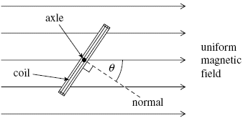
(a) The coil has 50 turns and an area of 1.9 × 10^{–3} m². The flux density of the magnetic field is 2.8 × 10^{–2} T. Calculate the flux linkage for the coil when θ is 35°, expressing your answer to an appropriate number of significant figures.

answer = ______________________ Wb turns
(3)

(b) The coil is rotated at constant speed, causing an emf to be induced.
(i) Sketch a graph on the outline axes to show how the induced emf varies with angle θ during one complete rotation of the coil, starting when θ = 0. Values are not required on the emf axis of the graph.
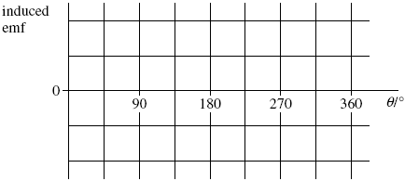
(1)
(ii) Give the value of the flux linkage for the coil at the positions where the emf has its greatest values.
answer = ______________________ Wb turns
(1)
(iii) Explain why the magnitude of the emf is greatest at the values of θ shown in your answer to part (b)(i).
______________________________________________________________
______________________________________________________________
______________________________________________________________
______________________________________________________________
______________________________________________________________
______________________________________________________________
______________________________________________________________
______________________________________________________________
(3)
(Total 8 marks)

AC/DC Definitions
Alternating current

Direct Current
Cells and batteries are suppliers of direct current; they supply an emf in one direction.
In the graph below we can see that the current and voltage are constant. The bottom line shows that when the battery or cell is reversed the voltage and current are constants in the other direction

Alternating Current
The Mains electricity supplies an alternating current; it supplies an emf that alternates from maximum in one direction to maximum in the other direction.
In the graph below we see the voltage and current start at zero, increase to a maximum in the positive direction, then fall to zero, reach a maximum in the negative direction and return to zero. This is one cycle.
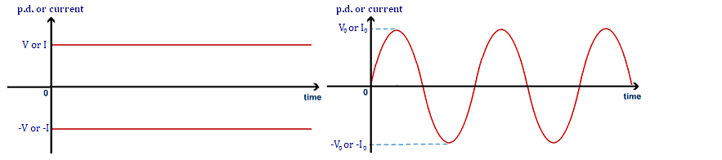

Alternating Current Definitions

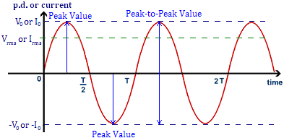
Peak Value
The peak value of either the current or the potential difference is the maximum in either direction. It can be measured from the wave as the amplitude, the distance from 0 to the top (or bottom) of the wave. We denote peak current with I₀ and peak p.d. with V₀.

Peak-to-Peak Value
The peak-to-peak value of either the current or potential difference is the range of the values. This is literally the distance from the peak above the zero line to the peak below the line.

Time Period
In an a.c. current or p.d. this is the time taken for one complete cycle (or wave).

Frequency
As with its use at GCSE, frequency is a measure of how many complete cycles that occur per second.
Frequency is measured in Hertz, Hz.

Root Mean Squared, r.m.s.
Since the current and p.d. is constantly changing it is impossible to assign them a fixed value over a period of time, the average would be zero. The r.m.s. current produces the same heating effect in a resistor as the equivalent d.c. for example 12V dc = 12Vrms ac

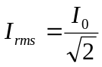 which can be rearranged to give 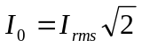

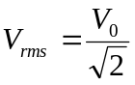 which can also be rearranged to give 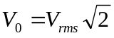

Q1.
Domestic users in the United Kingdom are supplied with mains electricity at a root mean square voltage of 230V.
(a) State what is meant by root mean square voltage.
___________________________________________________________________
___________________________________________________________________
___________________________________________________________________
(1)
(b) (i) Calculate the peak value of the supply voltage.

answer = ______________________ V
(2)
(ii) Calculate the average power dissipated in a lamp connected to the mains supply when the rms current is 0.26 A.

answer = ______________________ W
(1)

(c) The frequency of the voltage supply is 50 Hz. On the axes below draw the waveform of the supplied voltage labelling the axes with appropriate values.
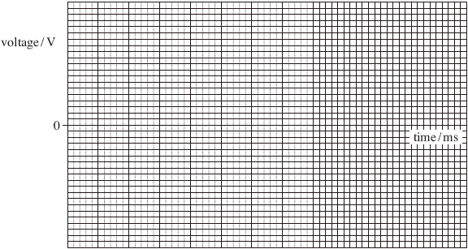
(4)
(Total 8 marks)
Q2.
This question is about experiments to investigate the magnetic flux density around a current−carrying conductor.
A student is provided with apparatus shown in Figure 1.
Figure 1
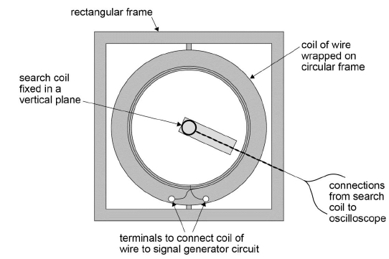

The apparatus consists of a circular frame on which is wound a coil of wire. This arrangement is mounted inside a rectangular frame.
The student clamps a search coil so it is co−axial with the circular coil then arranges the apparatus so that both frames and the search coil lie in the same vertical plane.
The coil of wire is connected to a signal generator and the search coil is connected to an oscilloscope. When a sinusoidal alternating current is passed through the coil an alternating emf is induced in the search coil.
The induced emf displayed on the oscilloscope is shown in Figure 2.
Figure 2
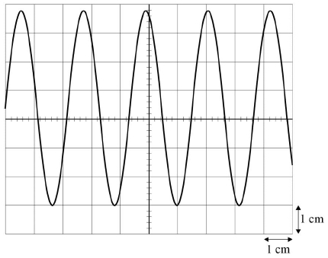
(a) Determine, using Figure 2, the frequency of the current in the coil.
Time−base setting of the oscilloscope is 0.2 ms cm⁻¹.
frequency = __________________ Hz
(2)

(b) Determine, using Figure 2, the root mean square (rms) voltage of the emf induced in the search coil.
y−voltage gain of the oscilloscope = 10 mV cm⁻¹
rms voltage = _________________ V
(2)
(c) Figure 3 and Figure 4 show the search coil and B_{peak}, the peak magnetic flux density produced by the current in the circular coil, when the apparatus is viewed from above.
Figure 3 shows the direction of B_{peak} when the search coil is arranged as in Figure 1.
Figure 4 shows the direction of B_{peak} when the circular frame is rotated through an angle θ.
The shaded area in these diagrams shows how the flux linked with the search coil changes as the circular coil is rotated.
Figure 3
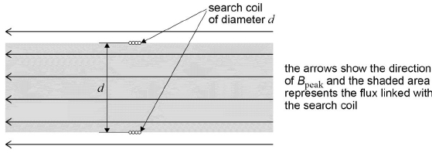
Figure 4
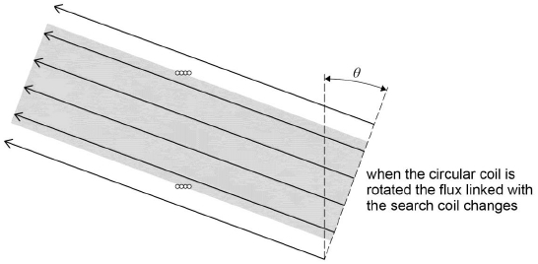
Explain why the flux linked with the coil is directly proportional to cosθ.
___________________________________________________________________
___________________________________________________________________
___________________________________________________________________
(2)
(d) The student clamps the rectangular frame so that it remains in a vertical plane. Without changing the position of the search coil she rotates the circular frame about a vertical axis so that it is turned through an angle, as shown in Figure 5.
Figure 5
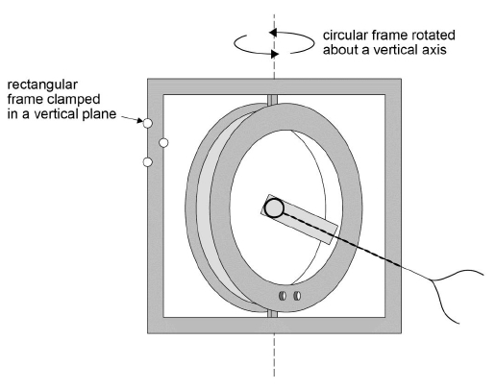
She turns off the time−base on the oscilloscope so that a vertical line is displayed on the screen. Keeping the y−voltage gain at 10 mV cm⁻¹ she records the length l of the vertical line and the angle θ through which the circular frame has been rotated. She measures further results for l as θ is increased as shown in the table below.

θ/degree | l/cm | cosθ
10 | 6.7
34 | 5.6
50 | 4.4
60 | 3.4
72 | 2.1
81 | 1.1
Plot on Figure 6 a graph to test if these data confirm that l is directly proportional to cosθ. Use the additional column in Table 1 to record any derived data you use.
Figure 6
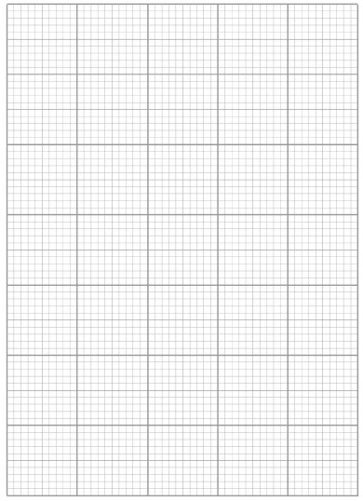
(4)
(e) State and explain whether the graph you have drawn confirms the suggestion that l is directly proportional to cosθ.
___________________________________________________________________
___________________________________________________________________
(1)

(f) When the time−base is switched off, the trace on the oscilloscope appears as shown in Figure 7.
Figure 7
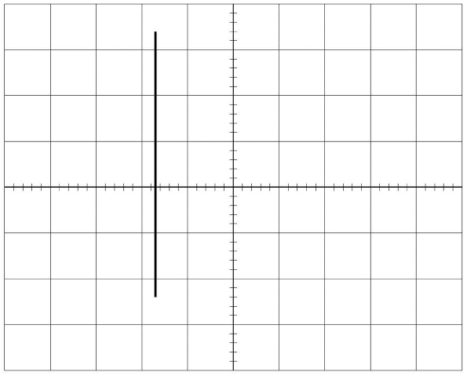
Describe two adjustments the student should make to the trace to reduce the uncertainty in l.
You should refer to specific controls on the oscilloscope. You may use Figure 7 to illustrate your answer.
___________________________________________________________________
___________________________________________________________________
___________________________________________________________________
___________________________________________________________________
___________________________________________________________________
___________________________________________________________________
___________________________________________________________________
(4)
(g) The student adjusts the signal generator so that the frequency of the current in the circular coil is doubled.
State and explain any changes she should make to the settings of the oscilloscope in part (f) so that she can repeat the experiment.
___________________________________________________________________
___________________________________________________________________
___________________________________________________________________
___________________________________________________________________
___________________________________________________________________
___________________________________________________________________
(3)
(h) The apparatus is re−arranged as in Figure 1 so that both coils lie in the same vertical plane and are co-axial along a line PQ.
The search coil is then moved a distance x along PQ, as shown in Figure 8.
Figure 8
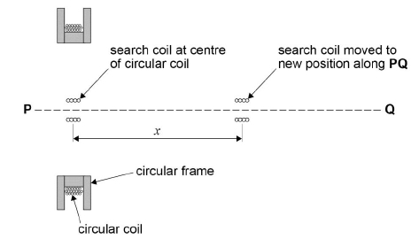
The values of l corresponding to different values of x are recorded. A graph of these data is shown in Figure 9.
Figure 9
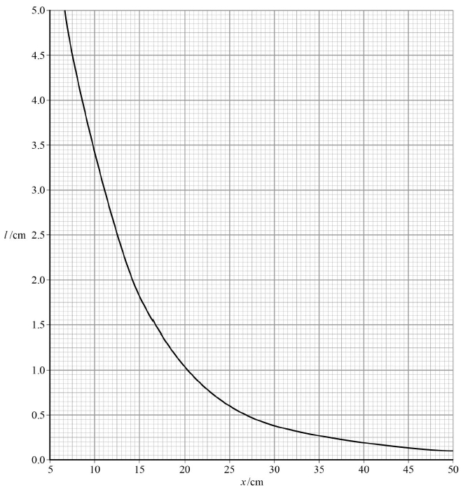
It is suggested that l decreases exponentially as x increases.
Explain whether Figure 9 supports this suggestion.
___________________________________________________________________
___________________________________________________________________
___________________________________________________________________
___________________________________________________________________
(2)
(Total 20 marks)

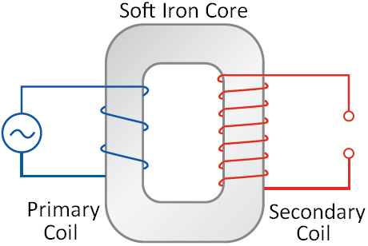
Transformers
Transformers
A transformer is a device used to change the voltage/current of a circuit using electromagnetic induction. It consists of a soft iron core wrapped on both side with wire. The first coil of wire is called the primary coil and the other coil of wire is called the secondary coil.
A current doesn’t flow from one coil of wire to the other.
How They Work
A current flows through the primary coil which creates a magnetic field.
As this field is established the field lines cut through the turns of wire on the secondary coil. This induces an e.m.f. (voltage) and a current in the second coil.
Since the supply to the primary coil is constantly changing direction the magnetic field is constantly changing direction. This means the secondary coil also has an alternating e.m.f. and current.
An iron core is used because it is easily magnetised and demagnetised and conducts the magnetic field.

Transforming Voltage and Current
There are two types of transformers:
Step Up
The voltage in the secondary coil is larger than the voltage in the primary coil.
The current in the secondary coil is smaller than the current in the primary coil.
There will be more turns of wire on the secondary coil meaning more flux linkage
Step Down
The voltage in the secondary coil is smaller than the voltage in the primary coil.
The current in the secondary coil is larger that the current in the primary coil.
There will be fewer turns of wire on the secondary coil meaning less flux linkage

In both cases the voltage and current (V_{P} and I_{P}) in the primary coil of N_{P} turns is linked to the voltage and current (V_{S} and I_{S}) in the secondary coil of N_{S} turns by the following equation:
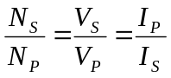

The National Grid
The National Grid is a system of transformers that increases the voltage (reducing the current) of an alternating electrical supply as it leaves the power station. Thick cables held above the ground by pylons carry the supply to our neighbourhood. A second series of transformers lowers the voltage to a safe level and increases the current to be used in our homes.
Why Bother?
Energy is lost in the transmission of electricity. The electrons flowing in the wire are constantly colliding with the positive ions of the metal that the wire is made from. If we increase the voltage of a supply this lowers the current. Lowering the current reduces the number of collisions happening per second hence reducing the amount of energy lost in reaching our homes.
The cables that carry the current have a larger cross sectional area, this lowers the resistance and energy lost.

Efficiency of a Transformer
The efficiency of a transformer can be calculated using the following equation:
Efficiency 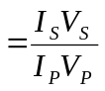
The efficiency of a transformer can be increased by:
-Using low resistance windings to reduce the power wasted due to the heating effect of the current.
-Use a laminated core which consists of layers of iron separated by layers of insulation. This reduces heating in the iron core and currents being induced in the core itself (referred to as eddy currents).

Transformers
This arrangement is an experiment to investigate electromagnetic induction.
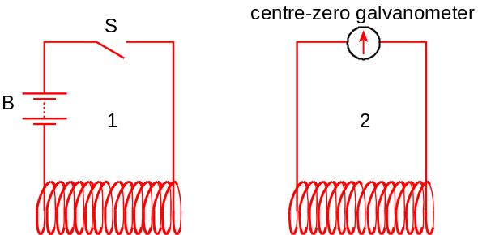

State, giving a reason for your answer in each case, what is observed as:
1. The switch S is closed.
2. Switch S remains closed.
3. Switch S is reopened.
The battery is replaced by an ac supply. The voltmeter can register either dc or ac
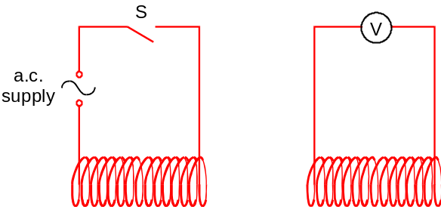
4. State what will be observed with switch S closed.
5. Give a reason for your answer.
6. Door bells in houses are often connected to the mains electricity supply through a step-down transformer. Here are two circuits to do this.
A
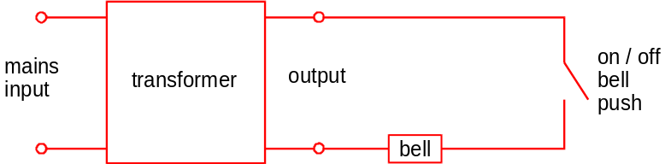
B
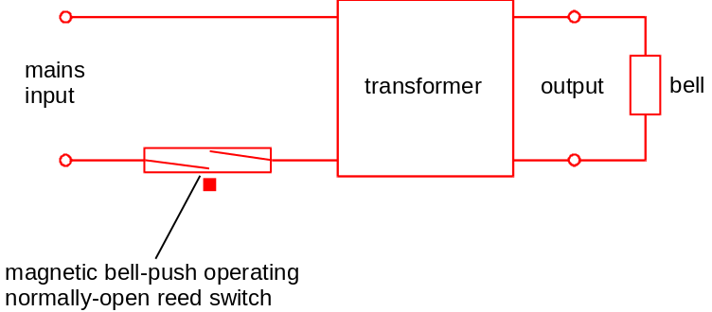
Which circuit do you consider to be less expensive to operate once it has been installed? Explain your choice.

7. In petrol engines, the fuel is ignited by a spark across a gap which must be less than about 0.60 mm. To establish the field necessary for this spark, voltages of up to 40 kV are needed, using only a 12 V battery. To achieve this, two coils are wound around the same iron core.
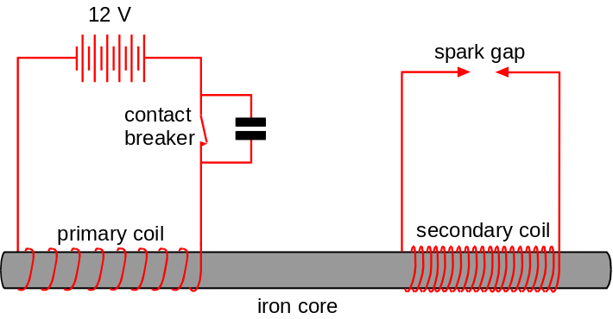

The secondary coil is in series with the spark gap. The primary coil is in series with the battery and a contact breaker. When the primary circuit is broken, a spark is produced. The capacitor prevents sparking across the contact breaker.
Explain why a large voltage is induced when the contact with the battery is broken.

8 Many home electrical devices, such as televisions, refrigerators and hi-fi systems, incorporate transformers to step down the supply voltage.
(a) An ideal transformer with a primary coil of 3000 turns provides a 9 V ac output when the input is 230 V ac. How many turns must there be on the secondary coil?
(b) No transformer is 100% efficient, although most are nearly so. State two effects that may in practice reduce the efficiency of a transformer.
(c) Explain why a transformer cannot provide an output of 20 V dc when connected to a car battery whose emf is 12 V.

Q1.
A transformer has an efficiency of 80%
It has 7000 turns on its primary coil and 175 turns on its secondary coil. When the primary of the transformer is connected to a 240 V ac supply, the secondary current is 8.0 A
What are the primary current and secondary voltage?

 | Primary current / mA | Secondary voltage / V
A | 250 | 6.0
B | 160 | 6.0
C | 250 | 9600
D | 160 | 9600
(Total 1 mark)

Q2.
A mains transformer has a primary coil of 2500 turns and a secondary coil of 130 turns.
The primary coil is connected to a mains supply where V_{rms} is 230 V.
The secondary coil is connected to a lamp of resistance 6.0 Ω.
The transformer is 100% efficient.
What is the peak power dissipated in the lamp?

A | 12 W
B | 24 W
C | 48 W
D | 96 W
(Total 1 mark)
Q3.
Figure 1 shows a step−down transformer used in a laptop power supply.
Figure 1
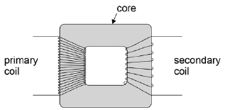
(a) Explain the purpose of the core in the transformer.
___________________________________________________________________
___________________________________________________________________
(1)
(b) Describe and explain two features of the core that improve the efficiency of the transformer.
1. _________________________________________________________________
___________________________________________________________________
___________________________________________________________________
2. _________________________________________________________________
___________________________________________________________________
___________________________________________________________________
(2)

(c) Explain why transformers only work continuously when supplied with an alternating current.
___________________________________________________________________
___________________________________________________________________
___________________________________________________________________
___________________________________________________________________
(1)

(d) The primary coil of the transformer is connected to a 230 V_{rms} ac supply. The current in the primary coil is 0.30 A_{rms}. The secondary coil has 300 turns and provides an output of 20 V_{rms} and a power of 65 W.
Calculate the number of turns on the primary coil.
number of turns on primary =_____________________
(1)
(e) Calculate the efficiency of the transformer.
efficiency ____________________
(2)
(Total 7 marks)

Acknowledgements:
The notes in this booklet come from TES user dwyernathaniel. The original notes can be found here:
https://www.tes.com/teaching-resource/a-level-physics-notes-6337841
Questions on Fleming’s left hand rule have been contributed by @HSE_physics. The original worksheet can be viewed here:
https://drive.google.com/file/d/1P7KzBRXYKTiGaCpMlDaeLvSs5YRPqlCO/view
Questions on forces on current in magnetic fields are from the IoP TAP project. The original resources can be found here:
https://spark.iop.org/episode-412-force-conductor-magnetic-field
Questions in the “force on a charged particle” section are either from Bernard Rand (@BernardRand) or from the IoP TAP project. The original resources can be found here:
https://drive.google.com/drive/folders/1-2qNVLwGzJ_7AjQK9N0z4BQBIRmSHAwG
https://spark.iop.org/episode-413-force-moving-charge
Questions in the transformer part of the booklet are from the IoP TAP project. The original resources can be found here:
https://spark.iop.org/episode-416-generators-and-transformers

