Acceleration = Change in speed ÷ Time
a = Δv ÷ t
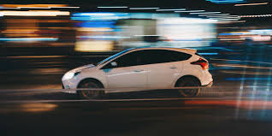
- A car accelerates from 0 m/s to 100 m/s in a time of 8 seconds. What is the acceleration of the car?
∆v=100 m/s-0 m/s=100 m/s
Time=8 s
Acceleration = Change in speed ÷ Time
a= _____ m/s ÷ _____ s
= ____________ m/s²
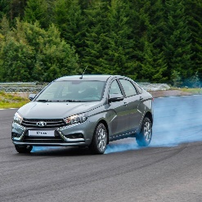
- The same car sees an old lady crossing the street and brakes quickly. His speed was 20 m/s and he takes 5 seconds to come to a full stop. What is the acceleration of the car?
Change in speed ∆v=0 m/s – 20 m/s= _____ m/s
Time t=____ s
Acceleration = Change in speed ÷ Time
acceleration= _____ m/s ÷ _____ s
= ____________ m/s²

- A runner starts to get tired and her speed goes from 8 m/s to 6.5 m/s in the last 120 seconds. What is her acceleration?
Change in speed ∆v=_____ m/s – _____ m/s= _____ m/s
Time t=____ s
Acceleration = Change in speed ÷ Time
a= _____ ___ ÷ _____ __
= ____________ m/s²

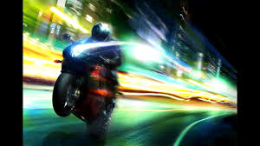
- A bike accelerates from 20 m/s to 80 m/s in 5 seconds. What is his acceleration?
Change in speed ∆v=_____ ___ – _____ ___= _____ ___
Time t=____
Acceleration = Change in speed ÷ Time
a= _____ ___ ÷ _____ __
= ____________ m/s²

- Mo Farah took 9.5 s to accelerate to a speed of 10 m/s at the start of his marathon? What was his acceleration?
Change in speed ∆v=_____ ___ – _____ ___= _____ ___
Time t=____
Acceleration = ____________ ÷ _____________
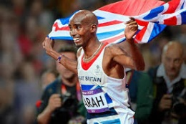
= _____ ___ ÷ _____ ___
= ____________ ____
- After crossing the line at 8 m/s Mo Farah took his time celebrating, and stopped after 180 seconds. What was his acceleration?
Change in speed ∆v=_____ ___ – _____ ___= _____ ___
Time t=____
Acceleration = _________ ÷ _______
= _____ ___ ÷ _____ __
= ____________ ____

