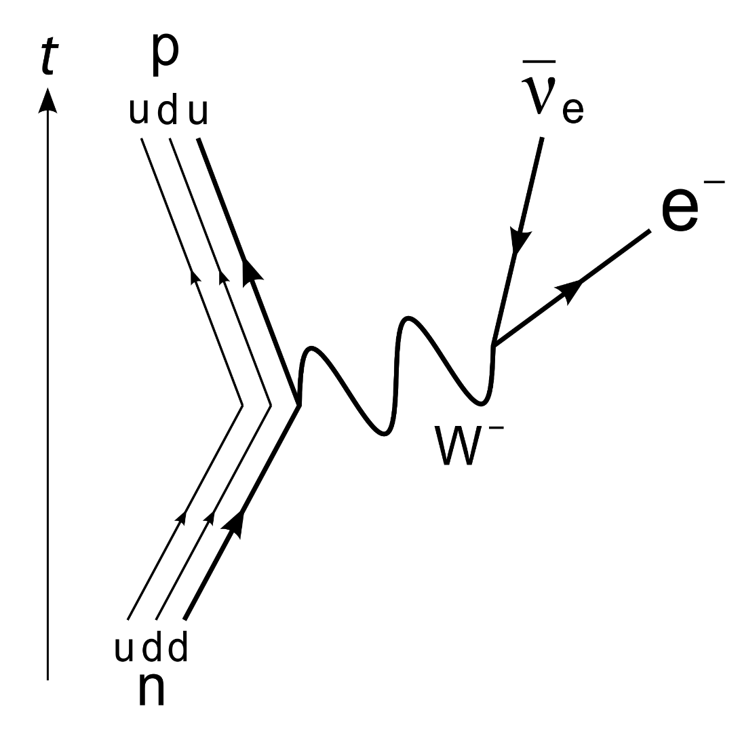
& radiation
Particles
Name ______________________________
Teacher ______________________________

Particles and radiation facts
Fold page here
- What is the definition of specific charge?
- Describe the range of the strong nuclear force.
- Write a general equation for alpha decay.
- Write a general equation for beta-minus decay.
- Write a general equation for beta-plus decay.
- What is a neutrino?
- What happens when a particle meets an anti-particle?
- What is pair production?
- What is the minimum energy for pair production?
- Name four leptons.
- What are the four fundamental forces?
- What are the three quark flavours?
- What is a hadron?
- What is a baryon? Give two examples.
- Which is the only stable baryon?
- What is a meson? Give two examples.
- What four things are conserved in a strong interaction?
- What can happen to strangeness in a weak interaction?
- What are the exchange particles of the electromagnetic, weak and strong interactions?
- What interaction is responsible for producing and decaying strange particles?
- What is the photoelectric effect?
- What is the threshold frequency?
- If the frequency of radiation is equal to the threshold frequency what will be the kinetic energy of the photoelectrons?
- What evidence is there for particles possessing wave properties & for EM waves possessing particle properties (wave-particle duality)?
- What evidence do we have for discrete energy levels in atoms?
- What is meant by “de Broglie” wavelength?
- What is thermionic emission?
- What is fluorescence?

- The ratio of the charge of an ion or subatomic particle to its mass (Q/m).
- There is short-range attraction up to 3 fm, and very short-range repulsion closer than ~0.5 fm.
- ${}_{Z}^{A}X→{}_{Z-2}^{A-4}Y+{}_{2}^{4}α$
- ${}_{Z}^{A}X→{}_{Z+1}^{A-0}W+{}_{-1}^{0}β+{\overline{υ}}_{e}$
- ${}_{Z}^{A}X→{}_{Z-1}^{A-0}V+{}_{+1}^{0}β+υ_{e}$
- A neutral and almost massless fundamental particle that rarely interacts with matter. It was hypothesised to account for conservation of energy in beta decay.
- They annihilate each other; and their total mass is converted into energy in the form of two gamma ray photons.
- Pair production is the creation of a particle-antiparticle pair in the presence of a nucleus from a high-energy photon.
- It is the combined rest energies of the particle and anti-particle.
- Electrons, tauons, muons each with an associated neutrino.
- Gravity, electromagnetic, weak and strong nuclear.
- Up, down and strange.
- Hadrons are made of quarks and are subject to the strong interaction.
- A baryon is a type of hadron. They consist of three quarks (like protons and neutrons).
- The proton.
- A meson is a type of hadron. They consist of a quark and an antiquark. E.g. mesons (which have no strangeness) and kaons (which have strangeness).
- Charge, baryon number, lepton number and strangeness.
- Strangeness can change by 0, +1, -1 in a weak interaction.
- Electromagnetic – photon, weak – W⁺ and W⁻ bosons, strong – gluon.
- Producing a strange particle – strong interaction. Decaying a strange particle – weak interaction.
- Radiation is incident onto the surface of a metal. If it has energy above the work function of the metal then photoelectrons are released.
- The minimum frequency to release a photoelectron from a metal.
- The kinetic energy of photoelectrons will be zero (all energy is used to release a photoelectron).
- Electron diffraction suggests that particles possess wave properties & the photoelectric effect suggests that EM waves possess particle properties.
- Line spectra (e.g. of atomic hydrogen)

- Corresponding wavelength of a moving particle.
- A heated filament (cathode) emits fast moving electrons.
- When a material absorbs short-wavelength (e.g. UV) radiation and re-emits it at a longer wavelength (e.g. visible light).

Constituents of the atom

The Nuclear Model
Constituent | Charge (C) | Mass (kg)
Proton | 1.6 x 10⁻¹⁹ | 1.673 x 10⁻²⁷
Neutron | 0 | 1.675 x 10⁻²⁷
Electron | - 1.6 x 10⁻¹⁹ | 9.1 x 10⁻³¹
We know from Rutherford’s experiment that the structure of an atom consists of positively charged protons and neutral neutrons in one place called the nucleus. The nucleus sits in the middle of the atom and has negatively charged electrons orbiting it. At GCSE we used charges and masses for the constituents relative to each other, the table above shows the actual charges and masses.
Almost all of the mass of the atom is in the tiny nucleus which takes up practically no space when compared to the size of the atom. If we shrunk the Solar System so that the Sun was the size of a gold nucleus the furthest electron would be twice the distance to Pluto.
If the nucleus was a full stop it would be 25 m to the first electron shell, 100 to the second and 225 to the third.
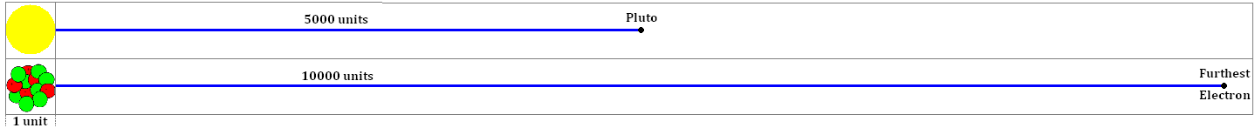

Notation
We can represent an atom of element X in the following way: 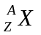
Z is the proton number. This is the number of protons in the nucleus. In an uncharged atom the number of electrons orbiting the nucleus is equal to the number of protons.
In Chemistry it is called the atomic number
A is the nucleon number. This is the total number of nucleons in the nucleus (protons + neutrons) which can be written as A = Z + N.
In Chemistry it is called the atomic mass number
N is the neutron number. This is the number of neutrons in the nucleus.

Isotopes
Isotopes are different forms of an element. They always have the same number of protons but have a different number of neutrons. Since they have the same number of protons (and electrons) they behave in the same way chemically.
Chlorine If we look at Chlorine in the periodic table we see that it is represented by 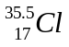. How can it have 18.5 neutrons? It can’t! There are two stable isotopes of Chlorine, 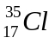which accounts for ~75% and 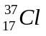which accounts for ~25%. So the average of a large amount of Chlorine atoms is .

Specific Charge
Specific charge is another title for the charge-mass ratio. This is a measure of the charge per unit mass and is simply worked out by worked out by dividing the charge of a particle by its mass.
You can think of it as a how much charge (in Coulombs) you get per kilogram of the ‘stuff’.
Constituent | Charge (C) | Mass (kg) | Charge-Mass Ratio (C kg⁻¹) or (C/kg)
Proton | 1.6 x 10⁻¹⁹ | 1.673 x 10⁻²⁷ | 1.6 x 10⁻¹⁹ ÷ 1.673 x 10⁻²⁷ | 9.58 x 10⁷
Neutron | 0 | 1.675 x 10⁻²⁷ | 0 ÷ 1.675 x 10⁻²⁷ | 0
Electron | (-) 1.6 x 10⁻¹⁹ | 9.1 x 10⁻³¹ | 1.6 x 10⁻¹⁹ ÷ 9.11 x 10⁻³¹ | (-) 1.76 x 10¹¹
We can see that the electron has the highest charge-mass ratio and the neutron has the lowest.

Ions
An atom may gain or lose electrons. When this happens the atoms becomes electrically charged (positively or negatively). We call this an ion.
If the atom gains an electron there are more negative charges than positive, so the atom is a negative ion.
Gaining one electron would mean it has an overall charge of -1, which actually means -1.6 x 10⁻¹⁹C.
Gaining two electrons would mean it has an overall charge of -2, which actually means -3.2 x 10⁻¹⁹C.
If the atom loses an electron there are more positive charges than negative, so the atom is a positive ion.
Losing one electron would mean it has an overall charge of +1, which actually means +1.6 x 10⁻¹⁹C.
Losing two electrons would mean it has an overall charge of +2, which actually means +3.2 x 10⁻¹⁹C
Specific charge and Isotopes
Charge of electron = - 1.6 x 10⁻¹⁹ C
Proton rest mass = 1.673 x 10⁻²⁷ kg
Neutron rest mass = 1.675 x 10⁻²⁷ kg
1. How many electron, protons and neutrons are there in the atoms shown below :
- ${}_{20}^{40}{Ca}$, b)${}_{26}^{56}{Fe}$ , c) ${}_{29}^{63}{Cu}$
- Which of the above nuclei has the largest specific charge?

2. Name the part of an atom has
- no charge
- has the largest specific charge
- when removed, leaves a different isotope of the element

3. One of the isotopes of nitrogen may be represented ${}_{7}^{15}N$
- i) State the number of each type of particle in its nucleus.
ii) Determine the specific charge, in C kg⁻¹, of its nucleus.
b) i) What is the charge, in C, of an atom of N from which a single electron has been removed?
ii) What name is used to describe an atom from which an electron has been removed?
4. a) Determine the charge , in C, of a ${}_{92}^{239}U$ nucleus.
b) A positive ion with a U nucleus has charge of +4.8 x 10⁻¹⁹ C. Determine how many electrons are in this ion.
5. A radioactive isotope of carbon is represented by ${}_{6}^{16}C$
a) Using the same notation, give the isotope of carbon that has two fewer neutrons.
b) Calculate the charge on the ion formed when two electrons are removed from an atom of C-16.
c) Calculate the value of the specific charge for the nucleus of an atom of C-16.
6 a) Calculate the mass of an ion with a specific charge of 1.20 x 10⁷ C kg⁻¹ and a negative charge of -3.2 x 10⁻¹⁹ C.
- The ion has eight protons in its nucleus. Calculate its number of electrons and neutrons.

Q1.
(a) An ion of plutonium Pu has an overall charge of +1.6 × 10^{–19}C.
For this ion state the number of
(i) protons ____________________
(ii) neutrons ____________________
(iii) electrons ____________________
(3)
(b) Plutonium has several isotopes.
Explain the meaning of the word isotopes.
___________________________________________________________________
___________________________________________________________________
___________________________________________________________________
(2)
(Total 5 marks)
Q2.
(a) The nucleus of a particular atom has a nucleon number of 14 and a proton number of 6.
(i) State what is meant by nucleon number and proton number.
nucleon number ________________________________________________
______________________________________________________________
______________________________________________________________
proton number __________________________________________________
______________________________________________________________
______________________________________________________________
(1)
(ii) Calculate the number of neutrons in the nucleus of this atom.

answer = ____________________
(1)
(iii) Calculate the specific charge of the nucleus.

answer = ____________________ Ckg^{–1}
(3)
(b) The specific charge of the nucleus of another isotope of the element is 4.8 × 10⁷ Ckg^{–1}.
(i) State what is meant by an isotope.
______________________________________________________________
______________________________________________________________
______________________________________________________________
(2)
(ii) Calculate the number of neutrons in this isotope.

answer = ____________________
(3)
(Total 10 marks)
Q3.
(a) State what is meant by the specific charge of a nucleus and give an appropriate unit for this quantity.
___________________________________________________________________
___________________________________________________________________
___________________________________________________________________
___________________________________________________________________
unit: ____________________
(2)
(b) Nucleus X has the same nucleon number as nucleus Y. The specific charge of X is 1.25 times greater than that of Y.
(i) Explain, in terms of protons and neutrons, why the specific charge of X is greater than that of Y.
______________________________________________________________
______________________________________________________________
______________________________________________________________
______________________________________________________________
(2)
(ii) Nucleus X is . Deduce the number of protons and the number of neutrons in nucleus Y.

number of protons ____________________
number of neutrons ____________________
(4)
(Total 8 marks)
Q4.
(a) Explain what is meant by an isotope.
___________________________________________________________________
___________________________________________________________________
___________________________________________________________________
___________________________________________________________________
(2)
(b) The incomplete table shows information for two isotopes of uranium.

 | number of protons | number of neutrons | specific charge of nucleus/
first isotope | 92 | 143
second isotope |  |  | 3.7 × 10⁷
(i) Write the unit for the specific charge in the heading of the last column of the table.
(1)
(ii) In the above table write down the number of protons in the second isotope in the table.
(1)
(iii) Calculate the specific charge of the first isotope and write this in the table.
______________________________________________________________
______________________________________________________________
______________________________________________________________
______________________________________________________________
(3)
(iv) Calculate the number of neutrons in the second isotope and put this number in the table
______________________________________________________________
______________________________________________________________
______________________________________________________________
______________________________________________________________
______________________________________________________________
(3)
(Total 10 marks)

Antimatter
Particles and antiparticles
British Physicist Paul Dirac predicted a particle of equal mass to an electron but of opposite charge (positive). This particle is called a positron and is the electron’s antiparticle.
Every particles has its own antiparticle. An antiparticle has the same mass as the particle version but has opposite charge. An antiproton has a negative charge, an antielectron has a positive charge but an antineutron is also uncharged like the particle version.
American Physicist Carl Anderson observed the positron in a cloud chamber, backing up Dirac’s theory.
Anti particles have opposite Charge, Baryon Number, Lepton Number and Strangeness.
If they are made from quarks the antiparticle is made from antiquarks

Annihilation
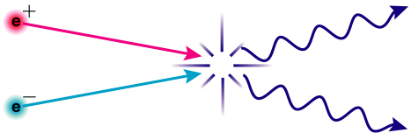
Whenever a particle and its antiparticle meet they annihilate each other. Annihilation is the process by which mass is converted into energy, particle and antiparticle are transformed into two photons of energy.
Mass and energy are interchangeable and can be converted from one to the other. Einstein linked energy and mass with the equation: 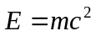
You can think of it like money; whether you have dollars or pounds you would still have the same amount of money. So whether you have mass or energy you still have the same amount.
The law of conservation of energy can now be referred to as the conservation of mass-energy.
The total mass-energy before is equal to the total mass-energy after.

Photon
Max Planck had the idea that light could be released in ‘chunks’ or packets of energy. Einstein named these wave-packets photons. The energy carried by a photon is given by the equation:
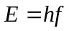 Since 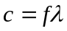 we can also write this as: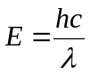

How is there anything at all?
When the Big Bang happened matter and antimatter was produced and sent out expanding in all directions. A short time after this there was an imbalance in the amount of matter and antimatter. Since there was more matter all the antimatter was annihilated leaving matter to form protons, atoms and everything around us.

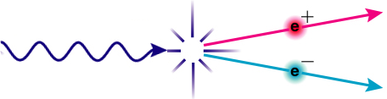
Pair Production
Pair production is the opposite process to annihilation, energy is converted into mass. A single photon of energy is converted into a particle-antiparticle pair. (This happens to obey the conservation laws)
This can only happen if the photon has enough mass-energy to “pay for the mass”.
Let us image mass and energy as the same thing, if two particles needed 10 “bits” and the photon had 8 bits there is not enough for pair production to occur.
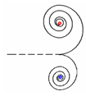
If two particles needed 10 bits to make and the photon had 16 bits the particle-antiparticle pair is made and the left over is converted into their kinetic energy.

If pair production occurs in a magnetic field the particle and antiparticle will move in circles of opposite direction but only if they are charged.

Pair production can occur spontaneously but must occur near a nucleus which recoils to help conserve momentum. It can also be made to happen by colliding particles. At CERN protons are accelerated and fired into each other. If they have enough kinetic energy when they collide particle-antiparticle pair may be created from the energy.
The following are examples of the reactions that have occurred:
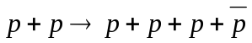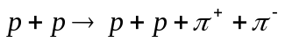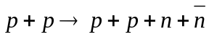
In all we can see that the conservation laws of particle physics are obeyed.

Creation and annihilation

Using Erest = m c 2
These questions give practice in using Erest = m c 2 to calculate photon energies and masses of particles created or annihilated.

Energy and mass
The energy of a particle at rest is all due to its mass. This energy is called the rest energy. The rest energy in joules of a particle with mass m measured in kilograms is given by
Erest = m c 2, where c is the speed of light in metres per second. An energy in joules can be converted to electron volts by dividing by 1.60 ´ 10–19 J eV–1.

The mass of an electron or positron is 9.11 ´ 10–31 kg. The speed of light is 3.00 ´ 108 m s–1.
1. Show that the rest energy of an electron is 8.2 ´ 10–14 J.
2. Use the answer to question 1 to show that the rest energy of an electron is 0.51 MeV.
3. Write down the rest energy of a positron (antielectron).
4. An electron and a positron which meet annihilate one another. By how much does the rest energy decrease in total? Express the answer in MeV.
5. The annihilation of an electron and a positron at rest produces a pair of identical gamma ray photons travelling in opposite directions. Write down in MeV the energy you expect each photon to have
6. A single photon passing near a nucleus can create an electron–positron pair. Their rest energy comes from the energy of the photon. Write down the smallest photon energy that can produce one such pair.
7. Cosmic rays can send high-energy photons through the atmosphere. What approximately is the maximum number of electron–positron pairs that a 10 GeV photon can create?
8. The isotope 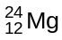 is stable. The light isotope 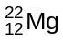 emits positrons and gamma rays including a photon of energy 1.28 MeV. How can decays of this nucleus result in both annihilation and creation of electron–positron pairs?
9. A photon can create particle–antiparticle pairs of greater mass than electrons and positrons. Approximately what energy must a photon have to create a proton–antiproton pair? (The mass of a proton is 2000 times the mass of an electron).
10. Why do the photons from the annihilation of an electron–positron pair not themselves go on to create new electron–positron pairs?

Creation from annihilation

Colliding electrons and positrons
The passage below is from The New Physics, edited by Paul Davies. Read the passage, in which some phrases or words are highlighted in bold. Write a fuller explanation of what is meant by each highlighted word or phrase. Questions to guide you are offered, but you can go further if you wish.

Electron–positron annihilation
Electrons colliding with positrons provide one of the most exciting ways of learning about bizarre varieties of matter…. The key feature is that positrons are the antiparticles of electrons. When matter and antimatter meet, they can mutually annihilate. The energy associated with their masses has been unlocked: Erest = mc2 at work.
What is the point of this?
Destroying the electrons and positrons is just the start. The aim is to watch what happens when their energy ‘recongeals’ into new forms of matter and antimatter. It can return whence it came, into electron and positron, but more interestingly it may produce new forms of matter with their corresponding antimatter. The hunt is on for those occasions when new forms of matter, not previously seen on Earth, emerge from the encounter. Exotic forms of matter can occur fleetingly in the heat of stars, and when we temporarily simulate that heat on Earth, so that we can capture these new varieties in earthbound laboratories.
This continuous destruction of matter and antimatter was common in the brief heat of the primordial Big Bang. By annihilating electrons and positrons in the laboratory we are reproducing conditions similar to those that occurred a split second after the Big Bang. We can create matter and antimatter, built for example of quarks and antiquarks, to order.

1. Positrons: what are they?
2. Antiparticles: what’s the relation between a particle and antiparticle?
3. Antimatter: what is antimatter? Where can it be found?
4. Mutually annihilate: what happens? What vanishes and what does not vanish?
5. Erest = mc2: give an example of how to use this equation.
6. It can return whence it came, into electron and positron: what is happening here?
7. Emerge from the encounter: what emerges?
8. The temperature of stars: why does it matter how hot the stars are?
9. Temporarily simulate that heat: how is this temporary simulation done? By heating stuff up?
10. Primordial Big Bang: what is this?
11. By annihilating electrons and positrons in the laboratory: how?

Q1.
(a) State the name of the antiparticle of a positron.
___________________________________________________________________
(1)
(b) Describe what happens when a positron and its antiparticle meet.
___________________________________________________________________
___________________________________________________________________
(2)
Q2.
Under certain conditions a photon may be converted into an electron and a positron.
(a) State the name of this process.
___________________________________________________________________
(1)
(b) For the conversion to take place the photon has to have an energy equal to or greater than a certain minimum energy.
(i) Explain why there is a minimum energy.
______________________________________________________________
______________________________________________________________
(2)
(ii) Show that this minimum energy is about 1 MeV.

(1)
(iii) Explain what happens to the excess energy when the photon energy is greater than the minimum energy.
______________________________________________________________
______________________________________________________________
(1)
(iv) A photon has an energy of 1.0 MeV.
Calculate the frequency associated with this photon energy.
State an appropriate unit in your answer.
frequency = __________ unit = __________ (4)
Q3.
(a) Pair production can occur when a photon interacts with matter. Explain the process of pair production.
___________________________________________________________________
___________________________________________________________________
___________________________________________________________________
___________________________________________________________________
(2)
(b) Explain why pair production cannot take place if the frequency of the photon is below a certain value.
___________________________________________________________________
___________________________________________________________________
___________________________________________________________________
___________________________________________________________________
___________________________________________________________________
___________________________________________________________________
(3)
(Total 5 marks)

Rutherford
Quarks
Rutherford fired a beam of alpha particles at a thin gold foil. If the atom had no inner structure the alpha particles would only be deflected by very small angles. Some of the alpha particles were scattered at large angles by the nuclei of the atoms. From this Rutherford deduced that the atom was mostly empty space with the majority of the mass situated in the centre. Atoms were made from smaller particles.

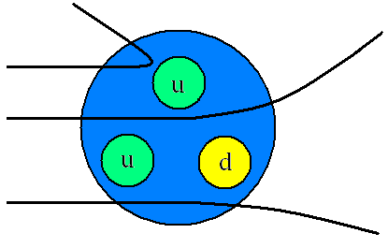
Smaller Scattering
In 1968 Physicists conducted a similar experiment to Rutherford’s but they fired a beam of high energy electrons at nucleons (protons and neutrons). The results they obtained were very similar to Rutherford’s; some of the electrons were deflected by large angles. If the nucleons had no inner structure the electrons would only be deflected by small angles. These results showed that protons and neutrons were made of three smaller particles, each with a fractional charge.

Quarks
These smaller particles were named quarks and are thought to be fundamental particles (not made of anything smaller). There are six different quarks and each one has its own antiparticle.
We need to know about the three below as we will be looking at how larger particles are made from different combinations of quarks and antiquarks.
Quark | Charge  (Q) | Baryon Number (B) | Strangeness  (S) |  | Anti Quark | Charge  (Q) | Baryon Number (B) | Strangeness  (S)
d | -⅓ | +⅓ | 0 |  | d̄ | +⅓ | -⅓ | 0
u | +⅔ | +⅓ | 0 |  | ū | -⅔ | -⅓ | 0
s | -⅓ | +⅓ | -1 |  | s̄ | +⅓ | -⅓ | +1

The other three are Charm, Bottom and Top. You will not be asked about these three
Quark | Charge | Baryon No. | Strangeness | Charmness | Bottomness | Topness
d | -⅓ | +⅓ | 0 | 0 | 0 | 0
u | +⅔ | +⅓ | 0 | 0 | 0 | 0
s | -⅓ | +⅓ | -1 | 0 | 0 | 0
c | +⅔ | +⅓ | 0 | +1 | 0 | 0
b | -⅓ | +⅓ | 0 | 0 | -1 | 0
t | +⅔ | +⅓ | 0 | 0 | 0 | +1

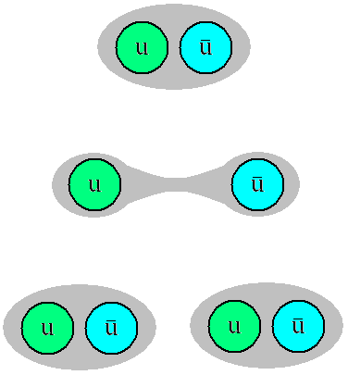
The Lone Quark?
Never! Quarks never appear on their own. The energy required to pull two quarks apart is so massive that it is enough to make two new particles. A quark and an antiquark are created, another example of pair production.
A particle called a neutral pion is made from an up quark and an antiup quark. Moving these apart creates another up quark and an antiup quark. We now have two pairs of quarks.
Trying to separate two quarks made two more quarks.

Particle Classification
Now that we know that quarks are the smallest building blocks we can separate all other particles into two groups, those made from quarks and those that aren’t made from quarks.
Hadrons – Heavy and made from smaller particles
Leptons – Light and not made from smaller particles

Putting quarks together

Three quarks for Muster Mark
The American physicist Murray Gell-Mann gave the name ‘quarks’ to the particles he proposed as the basic building bricks of other particles. The name refers to a line in the novel Finnegans Wake by James Joyce, who was famed for his word play. The line is: ‘Three quarks for Muster Mark’. His colleague George Zwieg wanted to call the particles ‘aces’, but Gell-Mann’s choice won out. In spite of the rhyme suggested by Joyce’s line, the word ‘quark’ is generally pronounced ‘quork’. The word is also German slang for ‘nonsense’ and the trade name for a type of yoghurt!
These questions ask about how quarks go together to make other particles.
Two kinds of quark
The simplest particles, including all the ones that everyday matter is made of, are built from two kinds (‘flavours’) of quark: ‘up’ and ‘down’. The most peculiar thing about them is that their electric charges come in multiples of 1/3 of the charge on an electron. On a scale where the charge on an electron is –1e, with e = 1.6 × 10–19 C, the charges on the quarks are:
- Up quark u: charge + 2/3 e.
- Down quark d: charge – 1/3 e.

Making massive particles
Relatively massive particles like the proton and neutron are made of combinations of three quarks.
1. What is the charge on the combination uuu?
2. What is the charge on the combination uud?
3. What is the charge on the combination udd?
4. What is the charge on the combination ddd?
There are four compound particles here.
5. Which combination has the right charge to be a proton?
6. Which combination has the right charge to be a neutron?
7. There is a particle called the Δ– which has a charge of –1e. Which quark combination could be the Δ –?
8. There is a particle called the Δ ++ which has a charge of + 2e. Which quark combination could be the Δ ++?
9. A neutron can be changed to a proton if one quark changes ‘flavour’. What change is needed? What charge must be carried away if this happens?
Q1.
What is the quark structure for antiprotons?

A
B
C
D
(Total 1 mark)
Q2.
(a) Name three types (or flavours) of quark.
___________________________________________________________________
___________________________________________________________________
(2)
(b) By referring to the charges on quarks, explain why the neutron is uncharged.
___________________________________________________________________
___________________________________________________________________
(2)
(Total 4 marks)

Made from Smaller Stuff
Hadrons
Hadrons, the Greek for ‘heavy’ are not fundamental particles they are all made from smaller particles, quarks.
The properties of a hadron are due to the combined properties of the quarks that it is made from.
There are two categories of Hadrons: Baryons and Mesons.

Baryons Made from three quarks
Proton | Charge  (Q) | Baryon Number (B) | Strangeness  (S) |  | Neutron | Charge  (Q) | Baryon Number (B) | Strangeness  (S)
u | +⅔ | +⅓ | 0 |  | d | -⅓ | +⅓ | 0
u | +⅔ | +⅓ | 0 |  | u | +⅔ | +⅓ | 0
d | -⅓ | +⅓ | 0 |  | d | -⅓ | +⅓ | 0
p | +1 | +1 | 0 |  | n | 0 | +1 | 0

The proton is the only stable hadron, all others eventually decay into a proton.

Mesons Made from a quark and an antiquark
Pion Plus | Charge  (Q) | Baryon Number (B) | Strangeness  (S) |  | Pion Minus | Charge  (Q) | Baryon Number (B) | Strangeness  (S)
u | +⅔ | +⅓ | 0 |  | ū | -⅔ | -⅓ | 0
d̄ | +⅓ | -⅓ | 0 |  | d | -⅓ | +⅓ | 0
π⁺ | +1 | 0 | 0 |  | π⁻ | -1 | 0 | 0

Pion Zero | Charge  (Q) | Baryon Number (B) | Strangeness  (S) |  | Pion Zero | Charge  (Q) | Baryon Number (B) | Strangeness  (S)
u | +⅔ | +⅓ | 0 |  | d | -⅓ | +⅓ | 0
ū | -⅔ | -⅓ | 0 |  | d̄ | +⅓ | -⅓ | 0
π⁰ | 0 | 0 | 0 |  | π⁰ | 0 | 0 | 0

Kaon Plus | Charge  (Q) | Baryon Number (B) | Strangeness  (S) |  | Kaon Minus | Charge  (Q) | Baryon Number (B) | Strangeness  (S)
u | +⅔ | +⅓ | 0 |  | ū | -⅔ | -⅓ | 0
s̄ | +⅓ | -⅓ | +1 |  | s | -⅓ | +⅓ | -1
K⁺ | +1 | 0 | +1 |  | K⁻ | -1 | 0 | -1

Kaon Zero | Charge  (Q) | Baryon Number (B) | Strangeness  (S) |  | AntiKaon  Zero | Charge  (Q) | Baryon Number (B) | Strangeness  (S)
d | -⅓ | +⅓ | 0 |  | d̄ | +⅓ | -⅓ | 0
s̄ | +⅓ | -⅓ | +1 |  | s | -⅓ | +⅓ | -1
K⁰ | 0 | 0 | +1 |  | K̄⁰ | 0 | 0 | -1

Anti Hadrons
Anti hadrons are made from the opposite quarks as their Hadron counterparts, for example a proton is made from the quark combination uud and an antiproton is made from the combination ūūd̄
We can see that a π⁺ and a π⁻ are particle and antiparticle of each other.
Anti Proton | Charge  (Q) | Baryon Number (B) | Strangeness  (S) |  | Anti  Neutron | Charge  (Q) | Baryon Number (B) | Strangeness  (S)
ū | -⅔ | -⅓ | 0 |  | d̄ | +⅓ | -⅓ | 0
ū | -⅔ | -⅓ | 0 |  | ū | -⅔ | -⅓ | 0
d̄ | +⅓ | -⅓ | 0 |  | d̄ | +⅓ | -⅓ | 0
p̄̄ | -1 | -1 | 0 |  | n̄ | 0 | -1 | 0
You need to know all the quark combination shown on this page as they may ask you to recite any of them.

Making mesons
Other, lighter ‘middle-weight’ particles called mesons can be made from pairs of quarks. But they have to be made from a special combination: a quark and an antiquark. There are now four particles to play with:
- Up quark u: charge +2/3 e
- Down quark d: charge –1/3 e.
- Antiup quark : charge –2/3 e.
- Antidown quark: charge + 1/3 e.
1. What is the charge on the combination u?
2. What is the charge on the combination d?
3. What is the charge on the combination u?
4. What is the charge on the combination d?
5. Which combination could be the π+ meson?
6. Which combination could be the π– meson?
7. Which could be the neutral π0 meson?

Strange quarks
An early classification of strange baryons by Murray Gell-Mann and Yuval Ne’emen gave this arrangement, called the baryon decuplet. The diagonal rows show baryons of the same charge. The Δ⁰ and Δ⁺ particles are more massive versions of the neutron and proton respectively

Δ⁻ |  | Δ⁰ |  | Δ⁺ |  | Δ⁺⁺ | strangeness 0
 | Σ⁻ |  | Σ⁰ |  | Σ⁺ |  | strangeness -1
 |  | Ξ⁻ |  | Ξ⁰ |  |  | strangeness -2
 |  |  | Ω⁻ |  |  |  | strangeness -3

The Ω⁻ was, in fact, predicted by Gell-mann from a gap in this pattern in much the same way as Mendeleyev predicted missing elements from gaps in his table. The subsequent discovery of the Ω⁻ confirmed that particle physicists were on the right track with this classification, which led Gell-mann and Zweig to the quark theory.

The strange quark s is a more massive version of the down quark d, and has the same charge (-e/3).

The presence of a strange quark gives a baryon or meson a strangeness of -1.
1. The Δ⁰ and Δ⁺ particles are more massive versions of the neutron and proton respectively. Underneath each particle in the first row, write the three quarks that make up that baryon.
2. The strange quark s is a more massive version of the down quark d, and has the same charge (-e/3). How many strange quarks must there be in
(a) the Σ particles?
(b) the Ξ particles?
(c) the Ω⁻ particle?
3. Write under all the strange baryons the three quarks they must contain.
The strange mesons fit a similar pattern:

 | K ⁰ |  | K⁺ |  | strangeness +1
π⁻ |  | π⁰ |  | π⁺ | strangeness 0
 | K ⁻ |  | K ⁰ |  | strangeness -1
4. If the strange quark s has a strangeness of -1, what is the strangeness of its anti-quark, s-bar?
5. Each of these seven mesons consists of a u, d or s quark and a u-bar, d-bar or s-bar antiquark. Write down under each meson the quark and antiquark it contains.

Q1.
Which of the following is not true?

A | Each meson consists of a single quark and a single antiquark.
B | Each baryon consists of three quarks.
C | The magnitude of the charge on every quark is
D | A particle consisting of a single quark has not been observed.
(Total 1 mark)
Q2.
Which line correctly classifies the particle shown?

 | Particle | Category | Quark combination
A | neutron | baryon | ūd
B | neutron | meson | udd
C | proton | baryon | uud
D | positive pion | meson | ūd
(Total 1 mark)
Q3.
What are the numbers of hadrons, baryons and mesons in an atom of ⁷ ₃Li?

 | hadrons | baryons | mesons
A | 7 | 3 | 3
B | 7 | 4 | 4
C | 7 | 7 | 0
D | 10 | 7 | 0
(Total 1 mark)
Q4.
State the differences in quark structure between a meson and a baryon.
_______________________________________________________________________
_______________________________________________________________________
_______________________________________________________________________
_______________________________________________________________________
(Total 2 marks)
Q5.
(a) Give the name of a particle that is a hadron.
___________________________________________________________________
(1)
(b) Pions are mesons.
Give a possible quark structure for a pion.
___________________________________________________________________
(1)
(Total 2 marks)
Q6.
(a) The table gives information about some fundamental particles.
Complete the table by filling in the missing information.

particle | quark  structure | charge | strangeness | baryon  number
 | uud |  | 0
Sigma ⁺ | uus | + 1
 | ud̄ |  | 0 | 0
(7)
(b) Each of the particles in the table has an antiparticle.
(i) Give one example of a baryon particle and its corresponding antiparticle.
particle _______________________________________________________
antiparticle ____________________________________________________
(1)
(ii) State the quark structure of an antibaryon.
______________________________________________________________
(1)
(iii) Give one property of an antiparticle that is the same for its corresponding particle and one property that is different.
Same _________________________________________________________
______________________________________________________________
Different ______________________________________________________
______________________________________________________________
(2)
(Total 11 marks)

Q7.
Cosmic rays are high-energy particles coming from Space. They collide with the air molecules in the Earth’s atmosphere to produce pions and kaons.
(a) Pions and kaons are mesons. Identify the quark–antiquark composition for a meson.
Tick (✔) the correct answer in the right-hand column.

✔ if correct
qqq
qq̄q̄
qq̄
qq
(1)
(b) A positron with a kinetic energy of 2.0 keV collides with an electron at rest, creating two photons that have equal energy.
Show that the energy of each photon is 8.2 × 10⁻¹⁴ J.
(3)
(c) Calculate the wavelength of a photon of energy 8.2 × 10⁻¹⁴ J.
wavelength = _______________________ m
(2)
(d) Show that the speed of the positron before the collision was about 2.7 × 10⁷ m s^{−1.}
(3)
Q8.
(a) The positive kaon, K⁺, has a strangeness of +1.
(i) What is the quark structure of the K⁺?
______________________________________________________________
(1)
(ii) What is the baryon number of the K⁺?
______________________________________________________________
(1)
(iii) What is the antiparticle of the K⁺?
______________________________________________________________
(1)

Fundamental Particles
Leptons
A fundamental particle is a particle which is not made of anything smaller. Baryons and Mesons are made from quarks so they are not fundamental, but quarks themselves are. The only other known fundamental particles are Bosons and Leptons.

Leptons
Leptons are a family of particles that are much lighter than Baryons and Mesons and are not subject to the strong interaction. There are six leptons in total, three of them are charged and three are uncharged.
The charged particles are electrons, muons and tauons. The muon and tauon are similar to the electron but bigger. The muon is roughly 200 times bigger and the tauon is 3500 times bigger (twice the size of a proton).
Each of the charged leptons has its own neutrino. If a decay involves a neutrino and a muon, it will be a muon neutrino, not a tauon neutrino or electron neutrino.
The neutrino is a chargeless, almost massless particle. It isn’t affected by the strong interaction or EM force and barely by gravity. It is almost impossible to detect.

Lepton |  | Charge  (Q) | Lepton Number (L) |  | Anti Lepton |  | Charge  (Q) | Lepton Number (L)
Electron | e⁻ | -1 | +1 |  | Anti Electron | e⁺ | +1 | -1
Electron Neutrino | ν_{e} | 0 | +1 |  | Anti Electron Neutrino | ν̄_{e} | 0 | -1
Muon | μ⁻ | -1 | +1 |  | Anti Muon | μ⁺ | +1 | -1
Muon Neutrino | ν_{μ} | 0 | +1 |  | Anti Muon Neutrino | ν̄_{μ} | 0 | -1
Tauon | τ⁻ | -1 | +1 |  | Anti Tauon | τ⁺ | +1 | -1
Tauon Neutrino | ν_{τ} | 0 | +1 |  | Anti Tauon Neutrino | ν̄_{τ} | 0 | -1

Conservation Laws
For a particle interaction to occur the following laws must be obeyed, if either is violated the reaction will never be observed (will never happen):
Charge: Must be conserved (same total value before as the total value after)
Baryon Number: Must be conserved
Lepton Number: Must be conserved
Strangeness: Conserved in EM and Strong Interaction. Doesn’t have to be conserved in Weak Interaction

Examples
In pair production a photon of energy is converted into a particle and its antiparticle
 | γ | → | e⁻ | + | e⁺
Q | 0 | → | -1 | + | +1 | 0 | → | 0 | Conserved
B | 0 | → | 0 | + | 0 | 0 | → | 0 | Conserved
L | 0 | → | +1 | + | -1 | 0 | → | 0 | Conserved
S | 0 | → | 0 | + | 0 | 0 | → | 0 | Conserved
Let us look at beta plus decay as we knew it at GCSE. A neutron decays into a proton and releases an electron.
 | n | → | p | + | e⁻
Q | 0 | → | +1 | + | -1 | 0 | → | 0 | Conserved
B | +1 | → | +1 | + | 0 | +1 | → | +1 | Conserved
L | 0 | → | 0 | + | +1 | 0 | → | +1 | Not Conserved
S | 0 | → | 0 | + | 0 | 0 | → | 0 | Conserved
This contributed to the search for and discovery of the neutrino.
Number Reminders
There may be a clue to the charge of a particle; π⁺, K⁺ and e⁺ have a positive charge.
It will only have a baryon number if it IS a baryon. Mesons and Leptons have a Baryon Number of zero.
It will only have a lepton number if it IS a lepton. Baryons and Mesons have a Lepton Number of zero.
It will only have a strangeness if it is made from a strange quark. Leptons have a strangeness of zero.

Conservation rules: charge
Q

You need to know that:

Particle reactions are possible if certain quantities are conserved. These quantities are:

- charge ● lepton number
- baryon number ● strangeness

Key fact: Charge is conserved in all particle reactions.
The total charge before equals the total charge afterwards.

To do
Test the following suggested particle reactions for conservation of charge. The first example has been done for you. Set out your working in the way shown.

Suggested particle reaction | Charge |  | Reaction possible? (yes / no)
Suggested particle reaction | LHS | RHS | Reaction possible? (yes / no)
π⁻ + p → K⁺ + Σ⁻ | -1 + (+1) = 0 | +1 + (-1) = 0 | yes
p + p → p + p + p + $\overline{p}$
π⁻ + p → K⁺ + Σ⁻ + π⁻
Ξ⁻ → Λ⁰ + π⁺
Σ⁺ → Λ⁰ + π⁻
n → p + e⁻ + υ
p + $\overline{p}$ → π⁺ + π⁻ + π⁰
p + p → p + p + π⁻ + π⁺
p + π⁻ → p + π⁺
K⁺ + n → K⁰ + Σ⁺
p + n → p + n + π⁻
K⁺ + n → π⁰ + Δ⁺
p → e⁺ + π⁰
Conservation rules:
B
baryon number

You need to know that:
Particle reactions are possible if certain quantities are conserved. These quantities are:
- charge ● lepton number
- baryon number ● strangeness
Key fact: In any particle reaction, the total baryon number remains the same.
The baryon numbers of some particles:
Particle | Baryon number, B
Baryons (e.g. proton, neutron, sigma) | +1
Baryon antiparticle (e.g. antiproton) | -1
Mesons (e.g. pion, kaon) | 0
Leptons (e.g. electron, positron) | 0

To do
Test the following suggested particle reactions for conservation of baryon number. The first example has been done for you. Set out your working in the way shown.
Suggested particle reaction | Baryon number |  | Reaction possible? (yes / no)
Suggested particle reaction | LHS | RHS | Reaction possible? (yes / no)
p + p → p + p + p + $\overline{p}$* | +1 + (+1) = +2 | +1 + (+1) +1 + (-1) = +2 | yes
p + p → p + π⁻
π⁺ + n → K⁰ + Σ⁺
π⁺ + p → K⁺ + Σ⁺
K⁺ + n → π⁰ + π⁺
p + p → p + p + n
p + p → p + p + π⁰
n + p → n + n + p
p → e⁺ + π⁰
p + p → p + p + p + $\overline{n}$

* This is the reaction in which the antiproton was first observed
Conservation rules: lepton number
L

It is necessary to take into account lepton number when considering which particle reactions involving leptons might be possible. To do this, the lepton numbers of the three lepton families must be treated separately.
E.g. the decay of a muon

Lepton numbers: lepton +1
antilepton -1
other particle 0

Families of leptons and lepton number
Family | Particle | Lepton number, L
Electron | Electron (e⁻) and electron neutrino (υ_{e}) | +1
Electron | Positron (e⁺) and electron antineutrino ( υ) | -1
Muon | Muon (μ⁻) and muon neutrino (υ_{μ}) | +1
Muon | Antimuon (μ⁺) and muon antineutrino ( υ_{μ}) | -1
Tau | Tau (τ⁻) and tau neutrino (υ_{τ}) | +1
Tau | Antitau (τ⁺) and tau antineutrino ( υ_{τ}) | -1

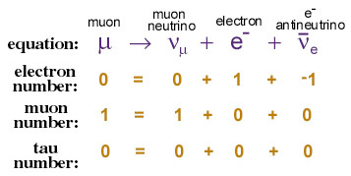

Suggested reaction | L_{e} |  | L_{μ} |  | L_{τ} |  | Reaction possible? (yes / no)
Suggested reaction | LHS | RHS | LHS | RHS | LHS | RHS | Reaction possible? (yes / no)
n → p + e⁻ + $\overline{υ_{e}}$
p → n + e⁺ + υ_{e}
$\overline{υ_{e}}$ + p → e⁺ + n
υ_{e} + n → e⁻ + p
υ_{μ} + n → μ⁻ + p
μ⁻ → e⁻ + $\overline{υ_{e}}$ + υ_{μ}
$\overline{υ_{μ}}$ + p → n + μ⁺
$\overline{υ_{μ}}$ + p → n + e⁺
e⁻ + u → d + υ_{e}
e⁻ + υ_{e} → μ⁻ + υ_{μ}

Conservation of Q, B, L and S

You need to know that:

Particle reactions are possible if certain quantities are conserved. These quantities are:

- charge
- baryon number
- lepton number
- strangeness (only conserved in strong interactions).

Some assorted hadrons

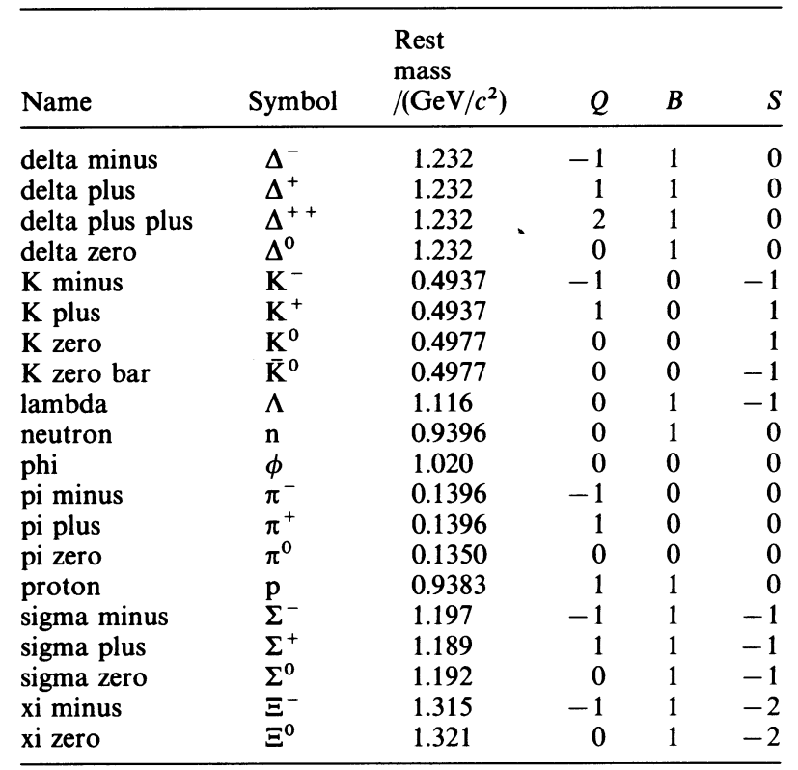

To do
Check conservation of charge, baryon number, lepton number and strangeness to see which of these reactions via the strong interaction are allowed.

Suggested particle reaction | Q |  | B |  | L |  | S |  | Reaction possible? (yes / no)
Suggested particle reaction | LHS | RHS | LHS | RHS | LHS | RHS | LHS | RHS | Reaction possible? (yes / no)
π⁺ + p → K⁺ + n
K⁺ + p → π⁰
p + p → p + p + π⁰
π⁻ + p → n + p
Σ⁻ + p → Σ⁰ + n
K⁻ + p → + n
p + p → π⁺ + p + n
p + p → π⁺ + p + n + n

Q1.
(a) (i) Name two baryons.
______________________________________________________________
(2)
(ii) State the quark structure of the pion .
______________________________________________________________
(1)
(b) (i) The K⁺ kaon is a strange particle. Give one characteristic of a strange particle that makes it different from a particle that is not strange.
______________________________________________________________
______________________________________________________________
(1)
(ii) One of the following equations represent a possible decay of the K⁺ kaon.
K⁺ → π⁺ + π⁰
K⁺→ μ⁺ +
State, with a reason, which one of these decays is not possible.
______________________________________________________________
______________________________________________________________
(2)
(c) Another strange particle, X, decays in the following way:
X → π– + p
(i) State what interaction is involved in this decay.
______________________________________________________________
(1)
(ii) Show that X must be a neutral particle.
______________________________________________________________
______________________________________________________________
(1)
(iii) Deduce whether X is a meson, baryon or lepton, explaining how you arrive at your answer.
______________________________________________________________
______________________________________________________________
______________________________________________________________
______________________________________________________________
(2)
(iv) Which particle in this interaction is the most stable?
______________________________________________________________
(1)
(Total 11 marks)
Q2.
(a) Complete the table by naming one example of each type of particle.

type of particle | example
lepton
baryon
meson
(3)
(b) The following reaction cannot occur.
π⁺ + n → p + π–
(i) State and explain which conservation law would be broken by this reaction.
______________________________________________________________
______________________________________________________________
______________________________________________________________
______________________________________________________________
______________________________________________________________
(2)
(ii) State and explain one conservation law that would not be broken in this reaction.
______________________________________________________________
______________________________________________________________
______________________________________________________________
(1)
(c) Describe what happens when a proton and an antiproton collide.
___________________________________________________________________
___________________________________________________________________
___________________________________________________________________
___________________________________________________________________
(2)
(Total 8 marks)
Q3.
(a) There are a number of ways in which u, d and s quarks and their associated antiparticles may be combined to form mesons. Use the table ‘properties of quarks’, in the Data booklet, to complete parts (i) to (iii).
(i) The kaon K– has a strangeness –1. Write down its quark composition.
K– ____________________________________________________________
(ii) The kaons K⁰ and K⁺ both have strangeness +1. Write down their quark composition.
K⁰ ____________________________________________________________
K⁺ ____________________________________________________________
(iii) Write down the quark composition of a proton.
p _____________________________________________________________
(5)
(b) In the strong interaction,
K– + p → K⁰ + K⁺ + X,
deduce the quark composition of, and state the type of, hadron represented by X.
___________________________________________________________________
___________________________________________________________________
(2)
(c) A positive muon may decay to a positron and two neutrinos. Write down an equation representing the muon decay.
μ⁺ →
(2)
(Total 9 marks)

The Four Interactions
Forces and exchange particles
There are four forces in the universe, some you will have come across already and some will be new:
The electromagnetic interaction causes an attractive or repulsive force between charges.
The gravitational interaction causes an attractive force between masses.
The strong nuclear interaction causes an attractive (or repulsive) force between quarks (and so hadrons).
The weak nuclear interaction does not cause a physical force, it makes particles decay. ‘Weak’ means there is a low probability that it will happen.
Interaction/Force | Range | Relative Strength
Strong Nuclear | ~10⁻¹⁵m | 1 | (1)
Electromagnetic | ∞ | ~10^{–2} | (0.01)
Weak Nuclear | ~10⁻¹⁸m | ~10^{–7} | (0.0000001)
Gravitational | ∞ | ~10^{–36} | (0.000000000000000000000000000000000001)

Exchange Particles
In 1935 Japanese physicist Hideki Yukawa put forward the idea that the interactions/forces between two particles were caused by ‘virtual particles’ being exchanged between the two particles.
He was working on the strong nuclear force which keeps protons and neutrons together and theorised that they were exchanging a particle back and forth that ‘carried’ the force and kept them together. This is true of all the fundamental interactions.
The general term for exchange particles is bosons and they are fundamental particles like quarks and leptons.

Ice Skating Analogy
Imagine two people on ice skates that will represent the two bodies experiencing a force.
If A throws a bowling ball to B, A slides back when they release it and B moves back when they catch it. Repeatedly throwing the ball back and forth moves A and B away from each other, the force causes repulsion.
The analogy falls a little short when thinking of attraction, but bear with it.
Now imagine that A and B are exchanging a boomerang (bear with it), throwing it behind them pushes A towards B, B catches it from behind and moves towards A. The force causes attraction.

Which Particle for What Force
Each of the interactions/forces has its own exchange particles.
Interaction/Force | Exchange Particle |  |  |  | What is acts upon
Strong Nuclear | Gluons between quarks |  | Pions between Baryons |  | Nucleons (Hadrons)
Electromagnetic | Virtual Photon |  |  |  | Charged particles
Weak Nuclear | W⁺ | W– |  | Z⁰ | All particles
Gravitational | Graviton |  |  |  | Particles with masses

Borrowing Energy to Make Particles
The exchange particles are made from ‘borrowed’ energy, borrowed from where? From nowhere! Yukawa used the Heisenberg Uncertainty Principle to establish that a particle of mass-energy ΔE could exist for a time Δt as long as 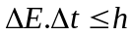 where h is Planck’s constant. This means that a heavy particle can only exist for a short time while a lighter particle may exist for longer.
h is Planck’s Constant, h = 6.63 x 10⁻³⁴ J s.
In 1947 the exchange particle of the strong nuclear interaction were observed in a cloud chamber.

Lending Money Analogy
Think of making exchange particles in terms of lending somebody some money.
If you lend somebody £50 you would want it paid back fairly soon.
If you lend somebody 50p you would let them have it for longer before paying you back.

Q1.
Which line does not give the correct exchange particle for the process?

 | Process | Exchange particle
A | gravitational attraction | W boson
B | electrostatic repulsion of electrons | virtual photon
C | strong interaction | pion
D | β⁻ decay | W boson
(Total 1 mark)
Q2.
(a) State the role of exchange particles in the creation of forces between particles.
___________________________________________________________________
___________________________________________________________________
(1)
(b) Complete the table below to show an exchange particle that is responsible for each of the forces mentioned.

force | exchange particle responsible
weak nuclear force
strong force
electromagnetic force
(3)
(Total 4 marks)
Q3.
(a) Complete the table to show the four fundamental forces and their corresponding exchange particles.

fundamental force | corresponding  exchange particle
strong nuclear | gluon
electromagnetic
 | W⁺W– Z⁰
gravitational | graviton
(2)
(b) Name the physical quantity that a particle must have for the electromagnetic force to act on it.
___________________________________________________________________
(1)
(c) Name the particle believed to be responsible for mass.
___________________________________________________________________
(1)
(Total 4 marks)
Q4.
(a) (i) Give an example of an exchange particle other than a W⁺ or W– particle, and state the fundamental force involved when it is produced.
exchange particle _______________________________________________
fundamental force _______________________________________________
(ii) State what roles exchange particles can play in an interaction.
______________________________________________________________
______________________________________________________________
______________________________________________________________
(4)
(b) From the following list of particles,
p e⁺ μ– π⁰
identify all the examples of
(i) hadrons, ______________________________________________________
(ii) leptons, _______________________________________________________
(iii) antiparticles, ___________________________________________________
(iv) charged particles. _______________________________________________
(4)
(Total 8 marks)
Q5.
(a) (i) Explain what is meant by an exchange particle.
______________________________________________________________
______________________________________________________________
______________________________________________________________
______________________________________________________________
(2)
(ii) Name the exchange particle that mediates the strong force.
______________________________________________________________
(1)
(iii) The weak nuclear force acts over a much shorter distance than the strong force.
Explain two differences between the relevant exchange particles that account for this.
______________________________________________________________
______________________________________________________________
______________________________________________________________
______________________________________________________________
(2)
(b) The following equation shows the β– decay of a free neutron.
→ X + + Y
Identify each of the particles X and Y.
Show the appropriate nucleon and proton number for each of the particles.
X ____________________
Y ____________________
(2)
(c) For a decay to be possible each of baryon number, lepton number and charge must be conserved. Use these rules to show that the following decay is possible.
μ– → e– + + v_{μ}
conservation of baryon number:

conservation of lepton number:

conservation of charge:

(3)
(Total 10 marks)

Q6.
(a) Baryons, mesons and leptons are affected by particle interactions.
Write an account of these interactions. Your account should:
• include the names of the interactions
• identify the groups of particles that are affected by the interaction
• identify the exchange particles involved in the interaction
• give examples of two of the interactions you mention.
The quality of your written communication will be assessed in your answer.
___________________________________________________________________
___________________________________________________________________
___________________________________________________________________
___________________________________________________________________
___________________________________________________________________
___________________________________________________________________
___________________________________________________________________
___________________________________________________________________
___________________________________________________________________
___________________________________________________________________
(6)

Alpha Decay
The weak interaction
When a nucleus decays in this way an alpha particle (a helium nucleus) is ejected from the nucleus.
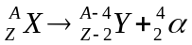 or 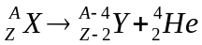
All the emitted alpha particles travelled at the same speed, meaning they had the same amount of energy. The law of conservation of mass-energy is met, the energy of the nucleus before the decay is the same as the energy of the nucleus and alpha particle after the decay.
Alpha decay is NOT due to the weak interaction but Beta decay IS

Beta Decay and the Neutrino
In beta decay a neutron in the nucleus changes to a proton and releases a beta particle (an electron).
The problem with beta decay was that the electrons had a range of energies so the law of conservation of mass-energy is violated, energy disappears. There must be another particle being made with zero mass but variable speeds, the neutrino.
We can also see from the particle conservation laws that this is a forbidden interaction: 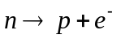
Charge Q: 0+1–1 00 Charge is conserved
Baryon Number B: +1+1+0 11 Baryon number is conserved
Lepton Number L: 00+1 01 Lepton number is NOT conserved

Beta Minus (β–) Decay
In neutron rich nuclei a neutron may decay into a proton, electron and an anti electron neutrino.
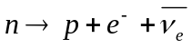
Charge Q: 0+1–1+0 00 Charge is conserved
Baryon Number B: +1+1+0+0 11 Baryon number is conserved
Lepton Number L: 00+1–1 00 Lepton number is conserved

In terms of quarks beta minus decay looks like this: 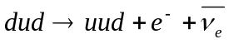 which simplifies to:
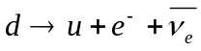
Charge Q: – ⅓+⅔–1+0 – ⅓– ⅓ Charge is conserved
Baryon Number B: +⅓+⅓+0+0 ⅓⅓ Baryon number is conserved
Lepton Number L: 00+1–1 00 Lepton number is conserved

Beta Plus (β⁺) Decay
In proton rich nuclei a proton may decay into a neutron, positron and an electron neutrino.
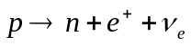
Charge Q: +10+1+0 11 Charge is conserved
Baryon Number B: +1+1+0+0 11 Baryon number is conserved
Lepton Number L: 00–1+1 00 Lepton number is conserved

In terms of quarks beta plus decay looks like this: 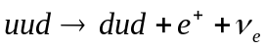 which simplifies to:
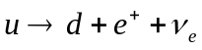
Charge Q: +⅔–⅓+1+0 ⅔⅔ Charge is conserved
Baryon Number B: +⅓+⅓+0+0 ⅓⅓ Baryon number is conserved
Lepton Number L: 00–1+1 00 Lepton number is conserved

Strangeness
The weak interaction is the only interaction that causes a quark to change into a different type of quark. In beta decay up quarks and down quarks are changed into one another. In some reactions an up or down quark can change into a strange quark meaning strangeness is not conserved.
During the weak interaction there can be a change in strangeness of ±1.

Q1.
A radium-288 nuclide () is radioactive and decays by the emission of a β– particle to form an isotope of actinium (Ac).
(a) Complete the equation for this decay.
(3)
(b) β– decay is the result of a neutron within a nucleus decaying into a proton. Describe the change in the quark sub-structure that occurs during the decay.
___________________________________________________________________
___________________________________________________________________
___________________________________________________________________
(1)
(Total 4 marks)
Q2.
An isotope of potassium is used to date rocks. The isotope decays into an isotope of argon (Ar) mainly by electron capture.
(a) The decay is represented by this equation:
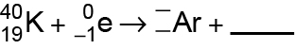
Complete the equation to show the decay by filling in the gaps.
(2)
(b) Explain which fundamental interaction is responsible for the decay in question (a).
___________________________________________________________________
___________________________________________________________________
___________________________________________________________________
___________________________________________________________________
(2)
(c) One decay mechanism for the decay of results in the argon nucleus having an excess energy of 1.46 MeV. It loses this energy by emitting a single gamma photon.
Calculate the wavelength of the photon released by the argon nucleus.
wavelength = ____________________ m
(3)
(d) The potassium isotope can also decay by a second decay process to form a calcium-40 nuclide ().
Suggest how the emissions from a nucleus of decaying potassium can be used to confirm which decay process is occurring.
___________________________________________________________________
___________________________________________________________________
___________________________________________________________________
___________________________________________________________________
___________________________________________________________________
___________________________________________________________________
___________________________________________________________________
___________________________________________________________________
(3)
(Total 10 marks)
Q3.
(a) An unstable nucleus, , can decay by emitting a β– particle.
(i) What part of the atom is the same as a β– particle?
______________________________________________________________
(1)
(ii) State the changes, if any, in A and Z when X decays.
change in A ____________________________________________________
change in Z ____________________________________________________
(2)
(b) In the process of β– decay an anti-neutrino is also released.
(i) Give an equation for this decay.
______________________________________________________________
(1)
(ii) State and explain which conservation law may be used to show that it is an
anti-neutrino rather than a neutrino that is released.
______________________________________________________________
______________________________________________________________
______________________________________________________________
______________________________________________________________
(2)
(iii) What must be done to validate the predictions of an unconfirmed scientific theory?
______________________________________________________________
______________________________________________________________
______________________________________________________________
______________________________________________________________
______________________________________________________________
(2)
(Total 8 marks)
Q4.
(a) Complete the following equations
p + e– ____ + ____
n + v p + ____
p + p p + p + K– + ____
(4)
(b) Give an equation that represents β– decay, using quarks in the equation rather than nucleons.
___________________________________________________________________
___________________________________________________________________
(2)
(c) (i) Which fundamental force is responsible for electron capture?
______________________________________________________________
(ii) What type of particle is an electron?
______________________________________________________________
(iii) State the other fundamental forces that electrons may experience.
______________________________________________________________
(3)
(Total 9 marks)
Q5.
More than 200 subatomic particles have been discovered so far. However, most are not fundamental and are composed of other particles including quarks.
It has been shown that a proton can be made to change into a neutron and that protons and neutrons are made of quarks.
(a) Name one process in which a proton changes to a neutron.
___________________________________________________________________
___________________________________________________________________
(1)
(b) Name the particle interaction involved in this process.
___________________________________________________________________
___________________________________________________________________
(1)
(c) Write down an equation for the process you stated in part (a) and show that the baryon number and lepton number are conserved in this process.
baryon number ______________________________________________________
___________________________________________________________________
___________________________________________________________________
lepton number _______________________________________________________
___________________________________________________________________
___________________________________________________________________
(2)
(d) The strange quark was used to explain the existence of particles whose tracks had been seen in experiments in the early 1950s. These were unexplained at that time and were referred to as ‘strange particles’. One of these particles was later named the K⁺ kaon.
State the quark composition of a K⁺ kaon.
___________________________________________________________________
___________________________________________________________________
(1)
(e) A K⁺ kaon decays into a π⁺ particle and a π° particle.
Explain one property which is conserved and one property which is not conserved in this decay.
conserved __________________________________________________________
___________________________________________________________________
not conserved _______________________________________________________
(2)
(Total 7 marks)

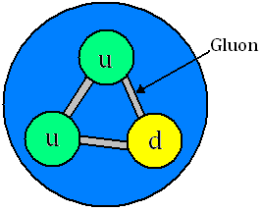
The Strong Interaction
The strong interaction
The strong nuclear force acts between quarks. Since Hadrons are the only particles made of quarks only they experience the strong nuclear force.
In both Baryons and Mesons the quarks are attracted to each other by exchanging virtual particles called ‘gluons’.
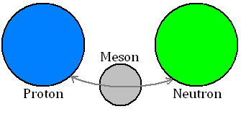
On a larger scale the strong nuclear force acts between the Hadrons themselves, keeping them together. A pi-meson or pion (π) is exchanged between the hadrons. This is called the residual strong nuclear force.

Force Graphs
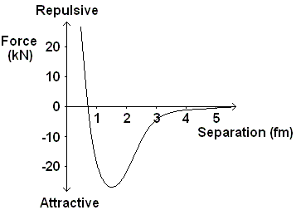
Neutron-Neutron or Neutron-Proton
Here is the graph of how the force varies between two neutrons or a proton and a neutron as the distance between them is increased.
We can see that the force is very strongly repulsive at separations of less than 0.7 fm ( x 10^{–15} m). This prevents all the nucleons from crushing into each other.
Above this separation the force is strongly attractive with a peak around 1.3 fm. When the nucleons are separated by more than 5 fm they no longer experience the SNF.
Proton-Proton
The force-separation graphs for two protons is different. They both attract each other due to the SNF but they also repel each other due to the electromagnetic force which causes two like charges to repel.
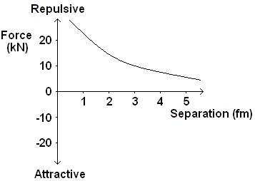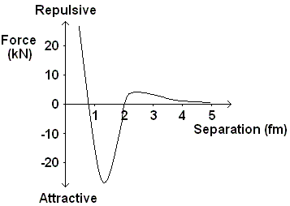
Graph A Graph B Graph C
Graph A shows how the strong nuclear force varies with the separation of the protons
Graph B shows how the electromagnetic force varies with the separation of the protons
Graph C shows the resultant of these two forces: repulsive at separations less than 0.7 fm, attractive up to 2 fm when the force becomes repulsive again.

Neutrons – Nuclear Cement
In the lighter elements the number of protons and neutrons in the nucleus is the same. As the nucleus gets bigger more neutrons are needed to keep it together.
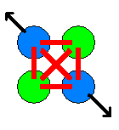
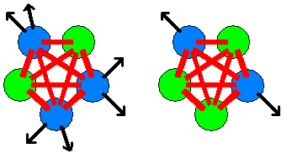
Adding another proton means that all the other nucleons feel the SNF attraction. It also means that all the other protons feel the EM repulsion.

Adding another neutron adds to the SNF attraction between the nucleons but, since it is uncharged, it does not contribute to the EM repulsion.

Q1.
(a) Describe the interaction that is responsible for keeping protons and neutrons together in a stable nucleus.
You should include details of the properties of the interaction in your answer.
___________________________________________________________________
___________________________________________________________________
___________________________________________________________________
___________________________________________________________________
___________________________________________________________________
___________________________________________________________________
___________________________________________________________________
___________________________________________________________________
(3)
(b) Nuclei can decay by alpha decay and by beta decay.
In alpha decay only one particle is emitted but in beta decay there are two emitted particles.
Explain how baryon number is conserved in alpha and beta decay.
___________________________________________________________________
___________________________________________________________________
___________________________________________________________________
___________________________________________________________________
___________________________________________________________________
___________________________________________________________________
___________________________________________________________________
(3)
(c) Kaons are mesons that can be produced by the strong interaction between pions and protons.
The equation shows a reaction in which a kaon and a lambda particle are produced.
π– + p → K⁰ + Λ⁰
Deduce the quark structure of the Λ⁰
quark structure = ____________________
(2)
(d) The kaon decays by the weak interaction.
The equation shows an example of kaon decay.
K⁰ → π⁺ + π–
State one feature of this decay that shows it is an example of the weak interaction.
___________________________________________________________________
___________________________________________________________________
(1)
(e) There have been considerable advances in our understanding of particle physics over the past 100 years.
Explain why it is necessary for many teams of scientists and engineers to collaborate in order for these advances to be made.
___________________________________________________________________
___________________________________________________________________
___________________________________________________________________
___________________________________________________________________
___________________________________________________________________
(2)
(Total 11 marks)
Q2.
(a) Describe how the strong nuclear force between two nucleons varies with the separation of the nucleons quoting suitable values for separation.
___________________________________________________________________
___________________________________________________________________
___________________________________________________________________
___________________________________________________________________
___________________________________________________________________
___________________________________________________________________
(3)
(b) An unstable nucleus can decay by the emission of an alpha particle.
(i) State the nature of an alpha particle.
______________________________________________________________
______________________________________________________________
(1)
(ii) Complete the equation below to represent the emission of an α particle by a
nucleus.
 → Th + α
(2)
(c) decays in stages by emitting α particles and β– particles, eventually forming
, a stable isotope of lead.
(i) State what is meant by isotopes.
______________________________________________________________
______________________________________________________________
(2)
(ii) If there are eight alpha decays involved in the sequence of decays from
to deduce how many β– decays are involved.

answer = ______________________
(3)
(Total 11 marks)
Q3.
State the type of interaction in which strangeness is
(i) conserved
___________________________________________________________________
(1)
(ii) not conserved.
___________________________________________________________________
(1)
(Total 2 marks)

Q4.
(a) The table below contains data for four different nuclei, P, Q, R and S.

Nuclei | Number of neutrons | Nucleon number
P | 5 | 11
Q | 6 | 11
R | 8 | 14
S | 9 | 17
(i) Which nucleus contains the fewest protons?

nucleus ____________________
(1)
(ii) Which two nuclei are isotopes of the same element?

nuclei ____________________ and ____________________
(1)
(iii) State and explain which nucleus has the smallest specific charge.
______________________________________________________________
______________________________________________________________
______________________________________________________________
______________________________________________________________
______________________________________________________________
______________________________________________________________
(2)
(iv) Complete the following equation to represent β– decay of nucleus R to form nucleus X.

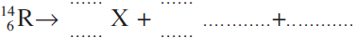

(3)

(b) (i) The strong nuclear force is responsible for keeping the protons and neutrons bound in a nucleus.
Describe how the strong nuclear force between two nucleons varies with the separation of the nucleons, quoting suitable values for separation.
______________________________________________________________
______________________________________________________________
______________________________________________________________
______________________________________________________________
______________________________________________________________
______________________________________________________________
(3)
(ii) Another significant interaction acts between the protons in the nucleus of an atom.
Name the interaction and name the exchange particle responsible for the interaction.
Interaction _____________________________________________________
Exchange particle _______________________________________________
(2)
(Total 12 marks)

Synoptic questions
Basic:
Q1. What is a baryon?
Q2. What is a lepton? What are the three flavours?
Q3. What is a meson?
Q4. Describe the quark composition of an anti-baryon.
Q5. What are the three quarks?
Q6. What four things need to be conserved in a strong interaction? Which one doesn’t have to be conserved in a weak interaction?
Q7. What is a hadron?
Q8. What is the lepton number of:
- electron b) positron c) μ⁻ d) τ⁻ e) neutron f) Electron anti-neutrino
Q9. What is the baryon number of:
- Neutron b) Proton c) Kaon d) Pion e) electron f) Anti-proton
Medium:
Q7. Write whether the following are baryons, mesons or leptons. If they are a baryon/meson then give the quark composition. If they are a lepton then give the lepton number.
- Neutron b) π⁺ c) μ⁻ d) Proton e) K⁺ f) Positron (e⁺)
g) Electron (e⁻) h) μ⁺ i) τ⁺ j) K⁻ k) ν_{e} l) Muon anti-neutrino
m) π⁻ n) K⁰ o) τ⁻ p) Anti-neutron q) ν_{τ} r) Electron anti-neutrino
Q8. Are the following interactions possible?
- ${}_{0}^{1}{n→{}_{1}^{1}{p+ e^{-}+ν_{e}}}$
- ${ π}^{+}+ n→p+π^{-}$
- ${ n+μ}^{-}→p+\overline{ν}$_{μ}
- $u→d+β^{-}+\overline{ν}$_{e} (quarks have baryon number +1/3)
- $d→u+e^{-}+\overline{v}$_{e} (quarks have baryon number +1/3)
- $K^{+}→π^{+}+π^{0}$ (is this weak or strong?)
- $K^{+}→μ^{+}+ν$_{μ} (is this weak or strong?)
- ${p+π}^{-}→K^{-}+π^{+}$ (is this weak or strong?)

Hard:
Q9. Nuclei can decay by alpha decay and by beta decay. In alpha decay only one particle is emitted but in beta decay there are two emitted particles. Explain how baryon number is conserved in alpha and beta decay.
Q10. a)Name one process in which a proton changes into a neutron.
b) Name the particle interaction involved in this process
c) Write down an equation for this process.
d) Show that the baryon and lepton number are conserved in this process.
Q11. Write an equation to show beta-plus decay. Show that the baryon and lepton number are conserved in this process.
Q12. In the strong interaction, the following interaction happens:
K– + p → K⁰ + K⁺ + X,
Deduce the quark composition of, and state the type of hadron represented by X.
Q13. A positive muon may decay to a positron and two neutrinos. Write down an equation representing the muon decay.

Feynman Diagrams
Feynman diagrams
An American Physicist called Richard Feynman came up with a way of visualising forces and exchange particles. Below are some examples of how Feynman diagrams can represent particle interactions.
The most important things to note when dealing with Feynman diagrams are the arrows and the exchange particles, the lines do not show us the path that the particles take only which come in and which go out.
The arrows tell us which particles are present before the interaction and which are present after the interaction.
The wave represents the interaction taking place with the appropriate exchange particle labelled.

Examples
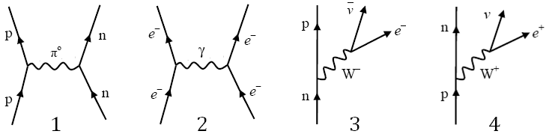
Diagram 1 represents the strong interaction. A proton and neutron are attracted together by the exchange of a neutral pion.
Diagram 2 represents the electromagnetic interaction. Two electrons repel each other by the exchange of a virtual photon.
Diagram 3 represents beta minus decay. A neutron decays due to the weak interaction into a proton, an electron and an anti electron neutrino
Diagram 4 represents beta plus decay. A proton decays into a neutron, a positron and an electron neutrino.
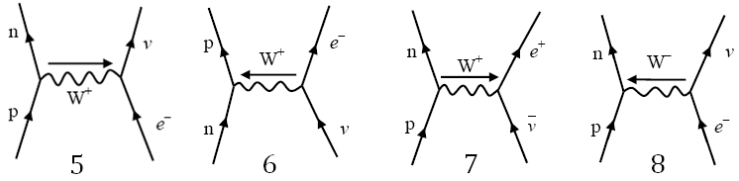
Diagram 5 represents electron capture. A proton captures an electron and becomes a neutron and an electron neutrino.
Diagram 6 represents a neutrino-neutron collision. A neutron absorbs a neutrino and forms a proton and an electron.
Diagram 7 represents an antineutrino-proton collision. A proton absorbs an antineutrino and emits a neutron and an electron.
Diagram 8 represents an electron-proton collision. They collide and emit a neutron and an electron neutrino.

Getting the Exchange Particle
The aspect of Feynman diagrams that students often struggle with is labelling the exchange particle and the direction to draw it. Look at what you start with:
If it is positive and becomes neutral you can think of it as throwing away its positive charge so the boson will be positive. This is the case in electron capture.
If it is positive and becomes neutral you can think of it as gaining negative to neutralise it so the boson will be negative. This is the case in electron-proton collisions.
If it is neutral and becomes positive we can think of it either as gaining positive (W+ boson) or losing negative (W– boson in the opposite direction).
Work out where the charge is going and label it.

Feynman diagram worksheet
Basic
- Give an example of an exchange particle other than a W⁺ or W⁻ particle, and state the fundamental force involved when it is produced.
- State what roles exchange particles can play in the interaction.
- What force do charged particles feel?
- What force do quarks feel?
- What force do particles with mass feel?
- Which is the only stable baryon.
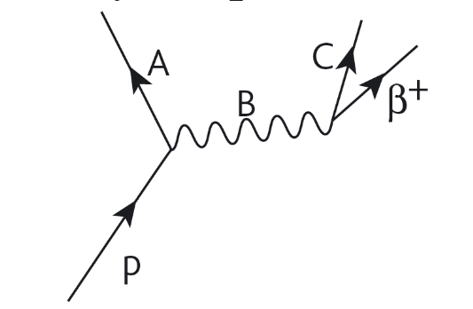
Medium
- Beta-plus decay may be represented by the Feynman diagram to the right. Name the particles represented by A, B and C.
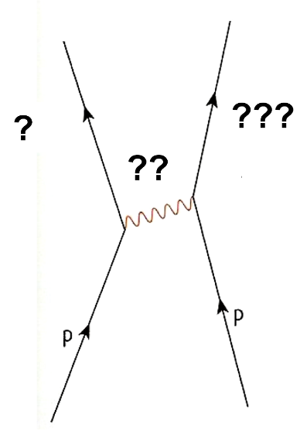
- Complete the labels on the Feynman diagram to the left.
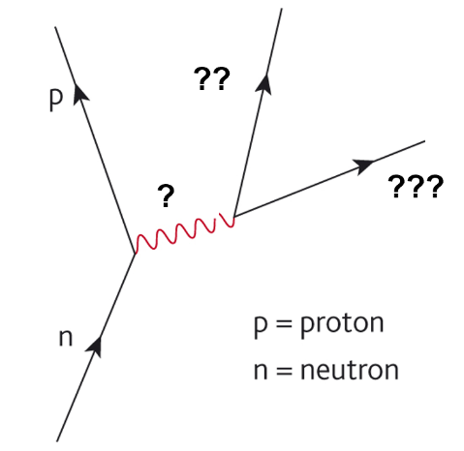
- Complete the labels on the Feynman diagram below.

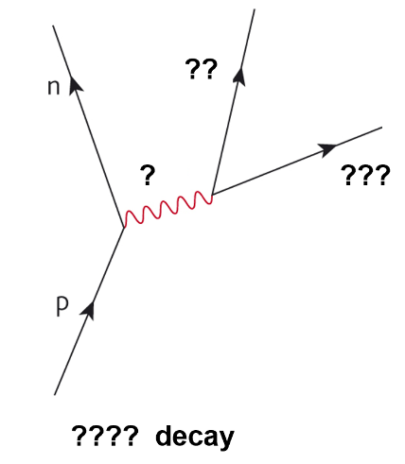
- Complete the labels on the Feynman diagram to the left.

Hard
- Draw a Feynman diagram for electron-positron pair production.
- Beryllium-7 is a proton rich nucleus. It is unstable because it has more protons than neutrons. One of the protons will have to ‘capture’ an electron from the inner shell and change into a neutron!
- Draw a Feynman diagram for the electron capture.
- What changes will happen to the nucleus after the capture?
- Neutrinos very rarely interact with other particles.
- Draw a Feynman diagram of an interaction between a neutrino and a neutron.
- State a property that is conserved in the interaction.
- Draw a Feynman diagram for electron capture.
- Draw a Feynman diagram for an electron-proton collision.
Q1.
The partially completed diagram represents electron capture.
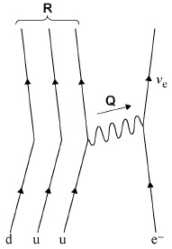
Which row identifies the exchange particle Q and the quark structure of particle R?

 | Particle Q | Quark structure of particle R
A | W– | uuu
B | W⁺ | dud
C | W⁺ | uuu
D | W– | dud
(Total 1 mark)

Q2.
Which diagram represents the process of beta-plus decay?
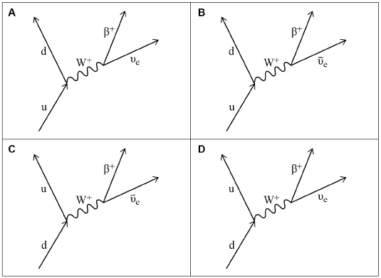

A
B
C
D
(Total 1 mark)
Q3.
The diagram below represents the decay of a particle X into a particle Y and two other particles.
The quark structure of particles X and Y are shown in the diagram.
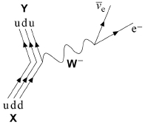
(a) Deduce the name of particle X.
___________________________________________________________________
(1)
(b) State the type of interaction that occurs in this decay.
___________________________________________________________________
(1)
(c) State the class of particles to which the W ⁻ belongs.
___________________________________________________________________
(1)
(d) Show clearly how charge and baryon number are conserved in this interaction.
You should include reference to all the particles, including the quarks, in your answer.
___________________________________________________________________
___________________________________________________________________
___________________________________________________________________
___________________________________________________________________
___________________________________________________________________
(2)
(e) Name the only stable baryon.
___________________________________________________________________
(1)
(f) A muon is an unstable particle.
State the names of the particles that are produced when a muon decays.
___________________________________________________________________
(1)
(Total 7 marks)
Q4.
The equation
p n + β⁺ + v_{e}
represents the emission of a positron from a proton.
(a) Energy and momentum are conserved in this emission.
What other quantities are conserved in this emission?
___________________________________________________________________
___________________________________________________________________
___________________________________________________________________
___________________________________________________________________
(3)

(b) Draw the Feynman diagram that corresponds to the positron emission represented in the equation.

(4)
(c) Complete the following table using ticks and crosses .

particle | fundamental particle | meson | baryon | lepton
p
n
β⁺
v_{e}
(4)
(Total 11 marks)

Observations
The photoelectric effect
When light fell onto a metal plate it released electrons from the surface straight away. Increasing the intensity increased the number of electrons emitted. If the frequency of the light was lowered, no electrons were emitted at all. Increasing the intensity and giving it more time did nothing, no electrons were emitted.

If Light was a Wave…
Increasing the intensity would increase the energy of the light. The energy from the light would be evenly spread over the metal and each electron would be given a small amount of energy. Eventually the electron would have enough energy to be removed from the metal.

Photon
Max Planck had the idea that light could be released in ‘chunks’ or packets of energy. Einstein named these wave-packets photons. The energy carried by a photon is given by the equation:
Since we can also write this as:

Explaining the Photoelectric Effect
Einstein suggested that one photon collides with one electron in the metal, giving it enough energy to be removed from the metal and then fly off somewhere. Some of the energy of the photon is used to break the bonds holding the electron in the metal and the rest of the energy is used by the electron to move away (kinetic energy). He represented this with the equation: 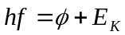
hf represents the energy of the photon, φ is the work function and E_{K} is the kinetic energy.

Work Function, φ
The work function is the amount of energy the electron requires to be completely removed from the surface of the metal. This is the energy just to remove it, not to move away.

Threshold Frequency, f₀
The threshold frequency is the minimum frequency that would release an electron from the surface of a metal, any less and nothing will happen.
Since , the minimum frequency releases an electron that is not moving, so E_{K} = 0
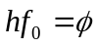 which can be rearranged to give: 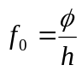
Increasing the intensity increases the number of photons the light sources gives out each second.
If the photon has less energy than the work function an electron can not be removed. Increasing the intensity just sends out more photons, all of which would still not have enough energy to release an electron.

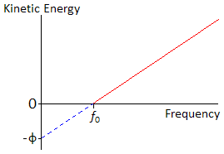
Graph
If we plot a graph of the kinetic energy of the electrons against frequency we get a graph that looks like this:
Start with and transform into 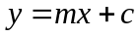.
E_{K} is the y-axis and f is the x- axis.
This makes the equation become: 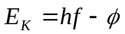
So the gradient represents Planck’s constant
and the y-intercept represents (–) the work function.

Nightclub Analogy
We can think of the photoelectric effect in terms of a full nightclub; let the people going into the club represent the photons, the people leaving the club represent the electrons and money represent the energy.
The club is full so it is one in and one out. The work function equals the entrance fee and is £5:
If you have £3 you don’t have enough to get in so noone is kicked out.
If 50 people arrive with £3 no one has enough, so one gets in and noone is kicked out.
If you have £5 you have enough to get in so someone is kicked out, but you have no money for drinks.
If 50 people arrive with £5 you all get in so 50 people are kicked out, but you have no money for drinks.
If you have £20 you have enough to get in so someone is kicked out and you have £15 to spend on drinks.
If 50 people arrive with £20 you all get in so 50 people are kicked out and you have £15 each to spend on drinks.

The photon model
1. Ultraviolet radiation has a frequency of 6.8 × 10¹⁵ Hz. Calculate the energy, in joules, of the photon.
2. Find the energy, in joules per photon, of microwave radiation with a frequency of 7.91 × 10¹⁰ Hz.
3. A sodium vapor lamp emits light photons with a wavelength of 5.89 × 10⁻⁷ m. What is the energy of these photons?
4. One of the electron transitions in a hydrogen atom produces infrared light with a wavelength of 746.4 nm. What amount of energy causes this transition?
5. Find the energy in kJ for an x-ray photon with a frequency of 2.4 × 10¹⁸ Hz
6. A ruby laser produces red light that has a wavelength of 500 nm. Calculate its energy in joules.
7. What is the frequency of UV light that has an energy of 2.39 × 10⁻¹⁸ J?
8. What is the wavelength and frequency of photons with an energy of 1.4 × 10⁻²¹ J?
9. What is the energy of a light that has 434 nm?
10. What is the wavelength of a light that has a frequency of 3.42 x 10¹¹ Hz?

1. (a) A helium-neon laser emits red light of wavelength 6.3 × 10^{–7} m.
(i) Show that the energy of a single photon is about 3 × 10–19 J.

[2]
(ii) The power of the laser beam is 1.0 mW. Show that about 3 × 1015 photons are emitted by the laser each second.

[1]
(iii) Another laser emits blue light. The power in its beam is also 1.0 mW.
Explain why the laser emitting blue light emits fewer photons per second compared with a laser of the same power emitting red light.
..............................................................................................................
..............................................................................................................
..............................................................................................................
[2]
(b) A photodiode is a circuit component which can be used to convert a light signal into an electrical one. The figure below shows an enlarged cross-section through a photodiode to illustrate how it is constructed. Light incident on the thin transparent conducting surface layer of the diode passes through it to be absorbed in the insulating layer. The energy of each photon is sufficient to release one electron in the insulating layer. The potential difference V applied across the insulating layer causes these electrons to move to one of the conducting layers.
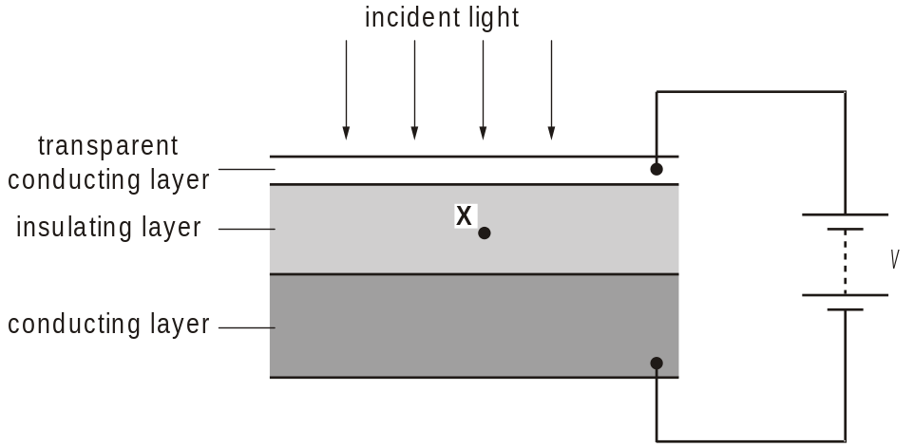

(i) Draw an arrow on the figure above to show the direction of motion of an electron released at point X in the centre of the insulating layer. [1]
A helium-neon laser emits red light of wavelength 6.3 × 10–7 m.
(ii) The red light from the laser is incident on the photodiode. Experiments show that only 20% of the red light photons release electrons in the insulating layer and hence in the circuit of the figure above. Calculate the current through the photodiode.

current = ................................ A [3]
(iii) Suggest one reason why the efficiency of the photodiode is less than 100%.
..............................................................................................................
..........................................................................................................[1]
[Total 14 marks]
2. In a laser beam, each photon has energy 2.0 eV.
(i) Show that the wavelength of the electromagnetic waves emitted by the laser is about 6  10–7 m.
[2]
(ii) Identify the region of the electromagnetic spectrum to which the waves emitted by the laser belong.
...................................................................................................................[1]
[Total 3 marks]
3. The particle-like behaviour of electromagnetic waves is modelled using the idea of photons. What is a photon?
.................................................................................................................................
.............................................................................................................................[1]

4. In order for a light sensitive cell in the retina to be stimulated, a minimum of 10 photons per second must reach the cell. 3 cells need to be stimulated to trigger a single nerve fibre. 85% of the photons incident on the eye reach the retina.
At low light intensity, 5000 nerve fibres must be triggered each second in order to just form a recognisable image.

(i) Calculate the minimum number of photons incident each second on the cornea needed to just form an image.

number = .........................................................
[3]

(ii) If the average wavelength of the incident light is 4.0 × 10–7 m, calculate the minimum power of light needed to just form an image.

power = ..................................................... W
[3]
[Total 6 marks]

Photoelectric effect questions

hf = f + (1/2) mv² and hf = f + eV_{s}

e = 1.60 x 10⁻¹⁹ C,
h = 6.63 x 10⁻³⁴ J s,
mass of electron = 9.11 x 10⁻³¹ kg

1 The work function for lithium is 4.6 x 10⁻¹⁹ J.
(a) Calculate the lowest frequency of light that will cause photoelectric emission.
(b) What is the maximum energy of the electrons emitted when light of 7.3 x 10¹⁴ Hz is used?

2 Complete the table.

Metal | Work Function  /eV | Work Function  /J | Frequency  used /Hz | Maximum KE of  Ejected electrons /J
Sodium | 2.28 |  | 6 x 10¹⁴
Potassium |  | 3.68 x 10⁻¹⁹ |  | 0.32 x 10⁻¹⁹
Lithium | 2.9 |  | 1 x 10¹⁵
Aluminium | 4.1 |  |  | 0.35 x 10⁻¹⁹
Zinc | 4.3 |  |  | 1.12 x 10⁻¹⁹
Copper |  | 7.36 x 10⁻¹⁹ | 1 x 10¹⁵

3 The stopping potential when a frequency of 1.61 x 10¹⁵ Hz is shone on a metal is 3 V.
(a) What is energy transferred by each photon?
(b) Calculate the work function of the metal.
(c) What is the maximum speed of the ejected electrons?

4 Selenium has a work function of 5.11 eV. What frequency of light would just eject electrons? (The threshold frequency is when the max KE of the ejected electrons is zero)

5 A frequency of 2.4 x 10¹⁵ Hz is used on magnesium with work function of 3.7 eV.
(a) What is energy transferred by each photon?
(b) Calculate the maximum KE of the ejected electrons.
(c) The maximum speed of the electrons.
(d) The stopping potential for the electrons.

Q1.
(a) Describe what occurs in the photoelectric effect.
___________________________________________________________________
___________________________________________________________________
___________________________________________________________________
___________________________________________________________________
(2)
(b) Violet light of wavelength 380 nm is incident on a potassium surface.
Deduce whether light of this wavelength can cause the photoelectric effect when incident on the potassium surface.
work function of potassium = 2.3 eV
(4)
(c) The photoelectric effect provides evidence for light possessing particle properties.
State and explain one piece of evidence that suggests that light also possesses wave properties.
___________________________________________________________________
___________________________________________________________________
___________________________________________________________________
___________________________________________________________________
___________________________________________________________________
(2)
(Total 8 marks)
Q2.
Figure 1 shows a photocell which uses the photoelectric effect to provide a current in an external circuit.
Figure 1
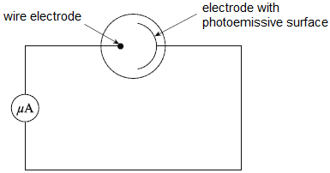
(a) Electromagnetic radiation is incident on the photoemissive surface.
Explain why there is a current only if the frequency of the electromagnetic radiation is above a certain value.
___________________________________________________________________
___________________________________________________________________
___________________________________________________________________
___________________________________________________________________
___________________________________________________________________
___________________________________________________________________
(3)
(b) State and explain the effect on the current when the intensity of the electromagnetic radiation is increased.
___________________________________________________________________
___________________________________________________________________
___________________________________________________________________
___________________________________________________________________
(2)
(c) A student investigates the properties of the photocell. The student uses a source of electromagnetic radiation of fixed frequency and observes that there is a current in the external circuit.
The student then connects a variable voltage supply so the positive terminal is connected to the electrode with a photoemissive surface and the negative terminal is connected to the wire electrode. As the student increases the supply voltage, the current decreases and eventually becomes zero. The minimum voltage at which this happens is called the stopping potential. The student’s new circuit is shown in Figure 2.
Figure 2
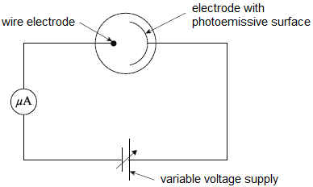
The photoemissive surface has a work function of 2.1 eV. The frequency of the electromagnetic radiation the student uses is 7.23 × 10¹⁴ Hz.
Calculate the maximum kinetic energy, in J, of the electrons emitted from the photoemissive surface.
maximum kinetic energy = ____________________ J
(3)
(d) Use your answer from part (c) to calculate the stopping potential for the photoemissive surface.
stopping potential = ____________________ V
(1)
(e) The student increases the frequency of the electromagnetic radiation.
Explain the effect this has on the stopping potential.
___________________________________________________________________
___________________________________________________________________
___________________________________________________________________
___________________________________________________________________
___________________________________________________________________
___________________________________________________________________
(3)
(Total 12 marks)
Q3.
The photoelectric effect can be demonstrated by illuminating a negatively charged plate, made from certain metals, with ultraviolet (UV) light and showing that the plate loses its charge.
(a) Explain why, when ultraviolet light is shone on a positively charged plate, no charge is lost by the plate.
___________________________________________________________________
___________________________________________________________________
___________________________________________________________________
___________________________________________________________________
___________________________________________________________________
___________________________________________________________________
(2)
(b) Threshold frequency and work function are important ideas in the study of the photoelectric effect.
Tables 1 and 2 summarise the work functions of three metals and photon energies of three UV light sources.
Table 1

Metal | Work function /  eV
Zinc | 4.3
Iron | 4.5
Copper | 4.7
Table 2

Light source | Photon energy /  eV
1 | 4.0
2 | 4.4
3 | 5.0
Discuss the combinations of metal and UV light source that could best be used to demonstrate the idea of threshold frequency and the idea of work function.
___________________________________________________________________
___________________________________________________________________
___________________________________________________________________
___________________________________________________________________
___________________________________________________________________
___________________________________________________________________
(6)
(c) Calculate the maximum kinetic energy, in J, of the electrons emitted from a zinc plate when illuminated with ultraviolet light.
work function of zinc = 4.3 eV
frequency of ultraviolet light = 1.2 × 10¹⁵ Hz

maximum kinetic energy ____________________ J
(3)
(d) Explain why your answer is a maximum.
___________________________________________________________________
___________________________________________________________________
___________________________________________________________________
(1)
(Total 12 marks)

Q4.
In the photoelectric effect, electrons are emitted from a metal surface when it is irradiated with electromagnetic radiation. The graph below shows the variation of the maximum photoelectron kinetic energy with the frequency of the radiation incident on the emitting surface.
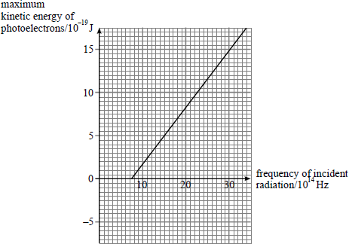
(a) Use the data from the graph to calculate the Planck constant.

(3)
(b) Determine the minimum energy required to remove an electron from the target metal.

(2)

(c) Explain how the photoelectric effect produces evidence which illustrates the particulate nature of light.
___________________________________________________________________
___________________________________________________________________
___________________________________________________________________
___________________________________________________________________
___________________________________________________________________
___________________________________________________________________
___________________________________________________________________
(3)
(Total 8 marks)

The Electronvolt, eV
Excitation, ionisation and energy levels
The Joule is too big use on an atomic and nuclear scale so we will now use the electronvolt, represented by eV.
One electronvolt is equal to the energy gained by an electron of charge e, when it is accelerated through a potential difference of 1 volt. 1eV = 1.6 x 10⁻¹⁹J 1J = 6.25 x 10¹⁸eV
eV J multiply by e J eV divide by e

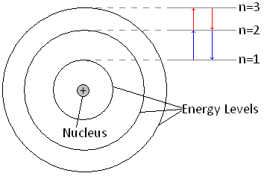
The Problem with Atoms
Rutherford’s nuclear model of the atom leaves us with a problem: a charged particle emits radiation when it accelerates. This would mean that the electrons would fall into the nucleus.

Bohr to the Rescue
Niels Bohr solved this problem by suggesting that the electrons could only orbit the nucleus in certain ‘allowed’ energy levels. He suggested that an electron may only transfer energy when it moves from one energy level to another. A change from one level to another is called a ‘transition’.
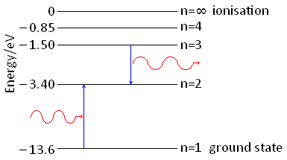
To move up and energy level the electron must gain the exact amount of energy to make the transition.
It can do this by another electron colliding with it or by absorbing a photon of the exact energy.
When moving down a level the electron must lose the exact amount of energy when making the transition.
It releases this energy as a photon of energy equal to the energy it loses.
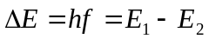
E₁ is the energy of the level the electron starts at and E₂ is the energy of the level the electron ends at

Excitation
When an electron gains the exact amount of energy to move up one or more energy levels

De-excitation
When an electron gives out the exact amount of energy to move back down to its original energy level

Ionisation
An electron can gain enough energy to be completely removed from the atom.
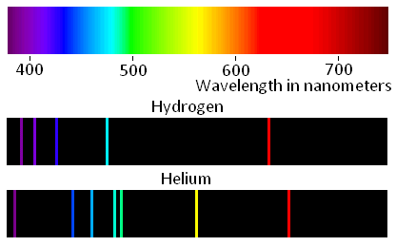
The ground state and the energy levels leading up to ionisation have negative values of energy, this is because they are compared to the ionisation level. Remember that energy must be given to the electrons to move up a level and is lost (or given out) when it moves down a level.

Line Spectra
Atoms of the same element have same energy levels. Each transition releases a photon with a set amount of energy meaning the frequency and wavelength are also set. The wavelength of light is responsible for colour it is. We can analyse the light by using a diffraction grating to separate light into the colours that makes it up, called its line spectra. Each element has its own line spectra like a barcode.
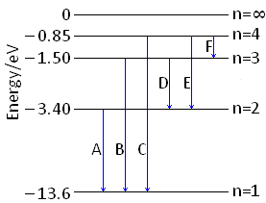
To the above right are the line spectra of Hydrogen and Helium.
We can calculate the energy difference that created the colour.
If we know the energy differences for each element we can work out which element is responsible for the light and hence deduce which elements are present.
We can see that there are 6 possible transitions in the diagram to the left, A to F.
D has an energy difference of 1.9 eV or 3.04 x 10⁻¹⁹ J which corresponds to a frequency of 4.59 x 10¹⁴ Hz and a wavelength of 654 nm – red.
Energy levels and transitions
1. What is meant by the term “ionisation energy”?
2. What is the name given to the lowest energy state for electrons in an atom?
3. What is “excitation”?
4. What happens when an electron moves from a higher energy level to a lower energy level?
5. Which number energy level corresponds to zero energy?
6. How is the energy of a transition calculated?
7. What happens to an electron when it absorbs a photon of exactly the right energy?
8. An electron moves from n = 3 (-1.51 eV) to n = 2 (-3.40 eV). Determine the wavelength of the emitted photon.
9. In which part of the visible spectrum would the above transition occur?
10. An electron may be excited in one of two ways. State the methods by which this can occur.
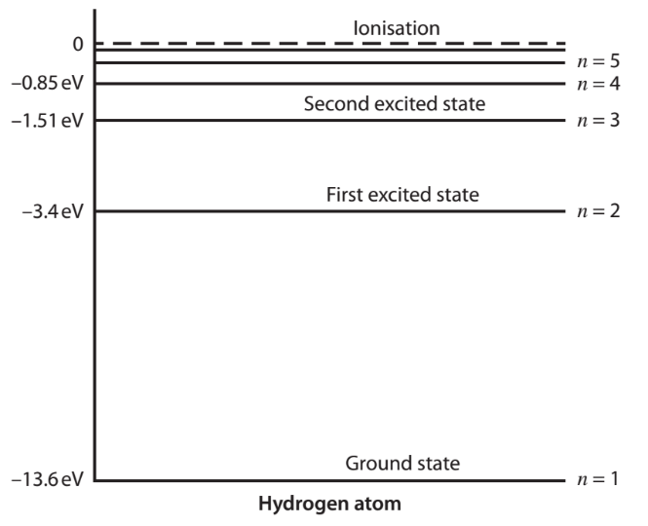
11. An electron is accelerated through a potential difference of 12.5 volts.
a) Calculate the gain in kinetic energy in i) electronvolts and ii) joules.
This electron then collides with a hydrogen atom.
b) Using the energy level diagram shown, describe what happens within the atom.
c) Determine the three energy transitions that are possible when the excited electron drops down to is lowest energy state.
d) Calculate the energies of these three transitions in eV.
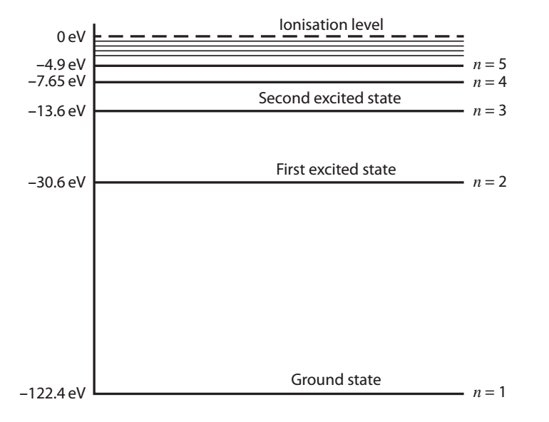
12. The diagram to the left shows the energy states in lithium metal.
a) Express the ground state energy in terms of joules.
b) What is the ionisation energy of lithium?
c) An electron is in the excited state n = 3.
i) Write down the possible transitions from this level to the ground state.
ii) Determine the photon energies emitted in these processes.
d) Calculate the wavelength of the transition between n = 5 and n = 4 and state whether the photon is emitted in the IR, visible or UV regions of the EM spectrum.

Emission and absorption spectra
1. What is a line emission spectra?
2. How can an absorption spectrum be obtained?
3. What are the lines in an emission and absorption spectrum for a particular gas at identical positions?
4. Fluorescent tubes are used extensively around the world. They are tubes filled with mercury vapour at low pressure and give off light in the visible region.
a) Explain how mercury atoms become excited in a fluorescent tube and emit photons.
b) What is meant by the term fluorescence?
c) Explain how visible light is produced in a fluorescent tube.
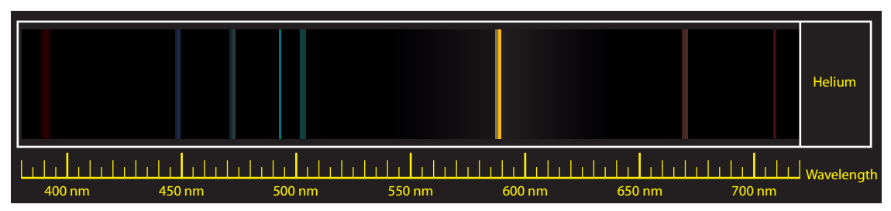
5. The diagram shows part of the emission spectrum for helium. The lowest energy level in a helium atom (the ground state) is -24.6 eV and there are a considerable number of excited states above this.
- What is meant by an emission spectrum?
- What does the ground state signify?
- Owing to the complex nature of helium, there are two possible transitions from level 3 to level 2, with energy differences of i) 1.86 eV and ii) 2.79 eV. Calculate the wavelength of the emitted photons in nm in each case and identify their colour using the emission spectrum shown.
- Determine the wavelength for the transition from n = 2 (-4.4 eV) to the ground state and indicate what part of the spectrum it would appear in.
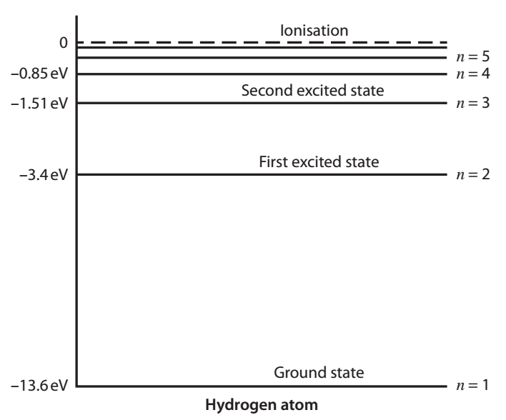
6. The Sun’s absorption spectrum shows over 700 dark absorption lines (Fraunhofer lines) on top of a continuous spectrum between 300 nm and 900 nm.
- With reference to the Sun’s cooler atmosphere, explain why these dark lines appear and what they represent.
One of these dark lines corresponds to what is a prominent feature of the hydrogen spectrum, the H_{α} line at a wavelength of 658 nm.
- Using the energy level diagram shown, calculate the wavelength of the photon emission for the transition between levels n = 3 to n = 2 and compare this with the figure given above for H_{α}.
- In which part of the visible spectrum does this line appear?
Q1.
The diagram shows some of the energy levels for a hydrogen atom.
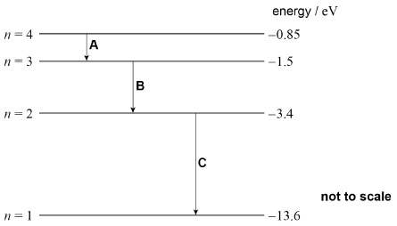
An excited hydrogen atom can emit photons of certain discrete frequencies. Three possible transitions are shown in the diagram.
(a) The transitions shown in the diagram result in photons being emitted in the ultraviolet, visible and infrared regions of the electromagnetic spectrum.
To which region of the spectrum do the emitted photons belong?
Tick (✔) the correct box for each transition, A, B and C.

Transition | Ultraviolet | Visible | Infrared
A | 
B
C
(1)
(b) Two ways to excite a hydrogen atom are by collision with a free electron or by the absorption of a photon.
Explain why, for a particular transition, the photon must have an exact amount of energy whereas the free electron only needs a minimum amount of kinetic energy.
___________________________________________________________________
___________________________________________________________________
___________________________________________________________________
___________________________________________________________________
___________________________________________________________________
___________________________________________________________________
___________________________________________________________________
___________________________________________________________________
(3)
(c) The surface of a sample of caesium is exposed to photons emitted in each of the three transitions shown in the diagram.
The threshold frequency of caesium is 5.1 × 10¹⁴ Hz
Determine whether any of these transitions would produce photons that would cause electrons to be emitted from the surface of caesium.
___________________________________________________________________
___________________________________________________________________
___________________________________________________________________
(3)
(d) Photons each with energy 12.1 eV are incident on the surface of the caesium sample.
Calculate the maximum speed of electrons emitted from the caesium.
maximum speed = ____________________ m s^{–1}
(3)
(Total 10 marks)
Q2.
In a discharge tube a high potential difference is applied across hydrogen gas contained in the tube. This causes the hydrogen gas to emit light that can be used to produce the visible line spectrum shown in Figure 1.
Figure 1
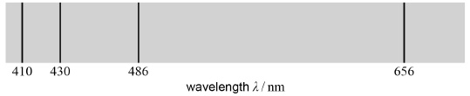
The visible line spectrum in Figure 1 has been used to predict some of the electron energy levels in a hydrogen atom.
The energy levels predicted from the visible line spectrum are those between 0 and −3.40 eV in the energy level diagram.
Some of the predicted energy levels are shown in Figure 2.
Figure 2
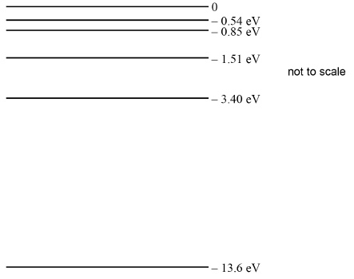
(a) Calculate the energy, in eV, of a photon of light that has the lowest frequency in the visible hydrogen spectrum shown in Figure 1.
energy of photon = ____________________________ eV
(3)
(b) Identify the state of an electron in the energy level labelled 0.
___________________________________________________________________
___________________________________________________________________
(1)
(c) Identify the state of an electron that is in the energy level labelled –13.6 eV.
___________________________________________________________________
___________________________________________________________________
___________________________________________________________________
(1)
(d) Explain why the energy levels are negative.
___________________________________________________________________
___________________________________________________________________
___________________________________________________________________
(1)
(e) Discuss how the discharge tube is made to emit electromagnetic radiation of specific frequencies.
In your answer you should:
• explain why there must be a high potential difference across the tube
• discuss how the energy level diagram in Figure 2 predicts the spectrum shown in Figure 1
• show how one of the wavelengths of light is related to two of the energy levels in the energy level diagram.
___________________________________________________________________
___________________________________________________________________
___________________________________________________________________
___________________________________________________________________
___________________________________________________________________
___________________________________________________________________
___________________________________________________________________
___________________________________________________________________
___________________________________________________________________
___________________________________________________________________
___________________________________________________________________
___________________________________________________________________
(6)
(Total 12 marks)
Q3.
(a) A fluorescent tube is filled with mercury vapour at low pressure. In order to emit electromagnetic radiation the mercury atoms must first be excited.
(i) What is meant by an excited atom?
______________________________________________________________
______________________________________________________________
(1)
(ii) Describe the process by which mercury atoms become excited in a fluorescent tube.
______________________________________________________________
______________________________________________________________
______________________________________________________________
______________________________________________________________
______________________________________________________________
______________________________________________________________
(3)
(iii) What is the purpose of the coating on the inside surface of the glass in a fluorescent tube?
______________________________________________________________
______________________________________________________________
______________________________________________________________
______________________________________________________________
______________________________________________________________
______________________________________________________________
(3)
(b) The lowest energy levels of a mercury atom are shown in the diagram below. The diagram is not to scale.
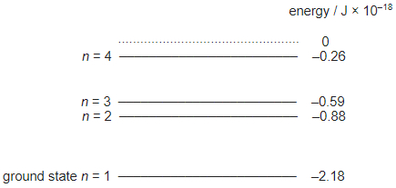
(i) Calculate the frequency of an emitted photon due to the transition level n = 4 to level n = 3.

answer = ____________________ Hz
(3)
(ii) Draw an arrow on the diagram above to show a transition which emits a photon of a longer wavelength than that emitted in the transition from level n = 4 to level n = 3.
(2)
(Total 12 marks)

De Broglie
Wave-particle duality
In 1923 Louis de Broglie put forward the idea that ‘all particles have a wave nature’ meaning that particles can behave like waves.
This doesn’t sound too far fetched after Einstein proved that a wave can behave like a particle.
De Broglie said that all particles could have a wavelength. A particle of mass, m, that is travelling at velocity, v, would have a wavelength given by:
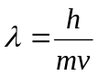 which is sometime written as 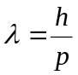 where p is momentum
This wavelength is called the de Broglie wavelength. The modern view is that the de Broglie wavelength is linked to the probability of finding the particle at a certain point in space.
De Broglie wavelength is measured in metres, m

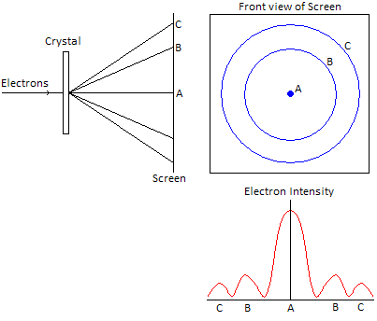
Electron Diffraction
Two years after de Broglie came up with his
particle wavelengths and idea that electrons
could diffract, Davisson and Germer proved
this to happen.
They fired electrons into a crystal structure
which acted as a diffraction grating. This
produced areas of electrons and no electrons
on the screen behind it, just like the pattern
you get when light diffracts.

Electron Wavelength
We can calculate the de Broglie wavelength
of an electron from the potential difference, V, that accelerated it.
Change in electric potential energy gained = eV
This is equal to the kinetic energy of the electron 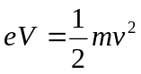
The velocity is therefore given by: 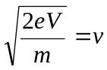
We can substitute this into to get: 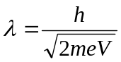

Sand Analogy
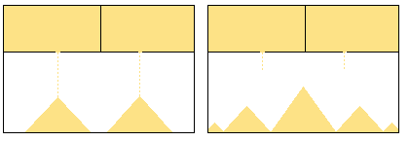
If we compare a double slit electron diffraction to sand falling from containers we can see how crazy electron diffraction is. Imagine two holes about 30cm apart that sand is dropping from. We would expect to find a maximum amount of sand under each hole, right? This is not what we find! We find a maximum in between the two holes. The electrons are acting like a wave.

Wave-Particle Duality
Wave-particle duality means that waves sometimes behave like particles and particles sometimes behave like waves. Some examples of these are shown below:

Light as a Wave
Diffraction, interference, polarisation and refraction all prove that light is a wave.

Light as a Particle
We have seen that the photoelectric effect shows that light can behave as a particle called a photon.

Electron as a Particle
The deflection by an electromagnetic field and collisions with other particles show its particle nature.

Electron as a Wave
Electron diffraction proves that a particle can show wave behaviour .

Derivation of de Broglie wavelength.

1. De Broglie first used Einstein's famous equation relating matter and energy:
[1]
E = energy,
m = mass,
c = speed of light

2. Using Planck's theory which states every quantum of a wave has a discrete amount of energy given by Planck's equation:
[2]

E = energy,
h = Plank's constant (6.63 x 10⁻³⁴ J s),
f= frequency

3. Since de Broglie believed particles and waves have the same traits, he hypothesised that the two energies would be equal:
[3]

4. Because massive particles do not travel at the speed of light, De Broglie substituted velocity (v) for the speed of light (c).

[4]

5. De Broglie substituted f = v/λ and arrived at the final expression that relates wavelength and particle with speed.

[5]

Hence:

Wave Particle Duality
1. Calculate the speed of a carbon atom of mass 2.0 × 10–26 kg travelling in space with a de Broglie wavelength of 6.8 × 10–11 m.
speed = .......................... m s–1 [3]
2. Lithium ions are accelerated to a speed v. Below is a graph of the de Broglie wavelength  of the ions against 1 
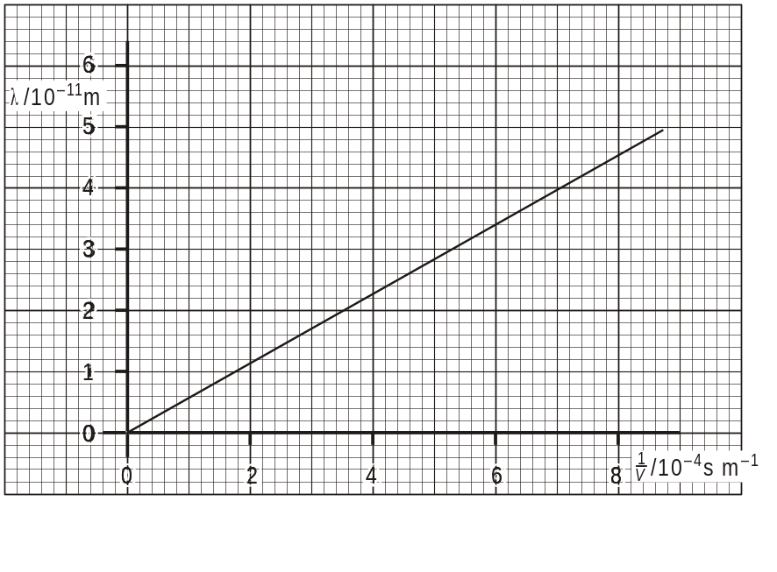
Determine the gradient of the graph and hence calculate the mass m of a single ion of lithium.

m = .................................................... kg
[Total 3 marks]
3. In 1927 it was shown by experiment that electrons can produce a diffraction pattern.
(a) (i) Explain the meaning of the term diffraction.
..............................................................................................................
..............................................................................................................
..........................................................................................................[1]
(ii) State the condition necessary for electrons to produce observable diffraction when passing through matter, e.g. a thin sheet of graphite in an evacuated chamber.
..............................................................................................................
..............................................................................................................
..............................................................................................................
..........................................................................................................[2]
(b) Show that the speed of an electron with a de Broglie wavelength of 1.2 × 10–10 m is 6.0 × 106 m s–1.

[3]
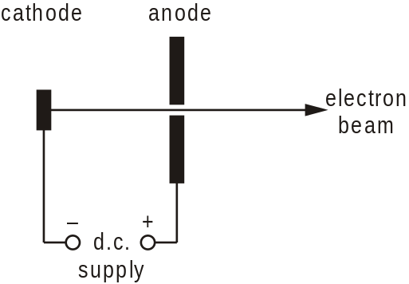
(c) The electrons in (b) are accelerated to a speed of 6.0 × 106 m s–1 using an electron gun shown diagrammatically in the figure below.

(i) Calculate the potential difference V across the d.c. supply between the cathode and the anode.

V = ..................................... V
[3]
(ii) Suggest why, in an electron gun, the cathode is connected to the negative terminal of the supply rather than the positive terminal.
..............................................................................................................
..............................................................................................................
..........................................................................................................[1]
[Total 10 marks]
4. Write down the de Broglie equation and define the symbols. Explain how this important equation relates to both particle and wave-like properties of the electron.
.................................................................................................................................
.................................................................................................................................
.................................................................................................................................
.................................................................................................................................
.................................................................................................................................
...........................................................................................................................[4]

5. Two of the most important equations from quantum physics are listed below.
equation 1 E = hf
equation 2 λ = 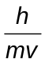
Complete the following sentences:
(i) Equation 1 describes the …………… behaviour of electromagnetic waves.
[1]
(ii) Equation 2 describes the …………… behaviour of a particle such as an electron.
[1]
[Total 2 marks]

6.
(a) J.J. Thompson investigated the nature of cathode rays in discharge tubes.
Suggest how he could have demonstrated that the cathode rays were negatively charged particles.
___________________________________________________________________
___________________________________________________________________
___________________________________________________________________
___________________________________________________________________
(2)
(b) In an experiment, electrons are incident on a thin piece of graphite. The electrons emerging from the graphite strike a fluorescent screen and produce the pattern shown in the figure below.

State and explain the evidence this provides about the nature of moving electrons.
___________________________________________________________________
___________________________________________________________________
___________________________________________________________________
___________________________________________________________________
(2)
(c) High energy electrons may be used to investigate the nature of protons of diameter
2.4 × 10^{–15} m.
(i) Calculate the lowest value of the momentum of the high energy electrons that would be suitable for this investigation.
State an appropriate unit for your answer.

momentum ____________________ unit __________
(3)
(ii) Calculate the kinetic energy of the electrons.

kinetic energy ____________________ J
(2)
(Total 9 marks)

Acknowledgements:
The notes in this booklet come from TES user dwyernathaniel. The original notes can be found here:
https://www.tes.com/teaching-resource/a-level-physics-notes-6337841
Questions on specific charge and isotopes come from TES user quentus75. The original questions can be found here:
https://www.tes.com/teaching-resource/specific-charge-and-isotopes-worksheet-aqa-a-level-physics-11969305
Questions in the particles and antiparticles section comes from the IoP TAP project. The original questions can be found here:
https://spark.iop.org/episode-535-particle-reactions#gref
Questions in the quarks and hadrons sections come from the IoP TAP project. The original questions can be found here:
https://spark.iop.org/episode-540-quarks-and-standard-model
Questions in the leptons section comes from TES user Cnut_Hardresen. The original resources can be found here:
https://www.tes.com/teaching-resource/conservation-rules-6447074
Questions in the photoelectric effect section come from the IoP TAP project. The original resources can be found here:
https://spark.iop.org/episode-502-photoelectric-effect
Questions in the wave particle duality section come from Bernard Rand’s resources. The original resources can be found here:
https://drive.google.com/drive/folders/1-2qNVLwGzJ_7AjQK9N0z4BQBIRmSHAwG

