Basic:
- Draw the symbols for:
- A bulb
- A cell
- A battery
- A voltmeter
- An ammeter
- A fuse
- An LDR
- A thermistor
- A resistor
- A variable resistor
- An LED
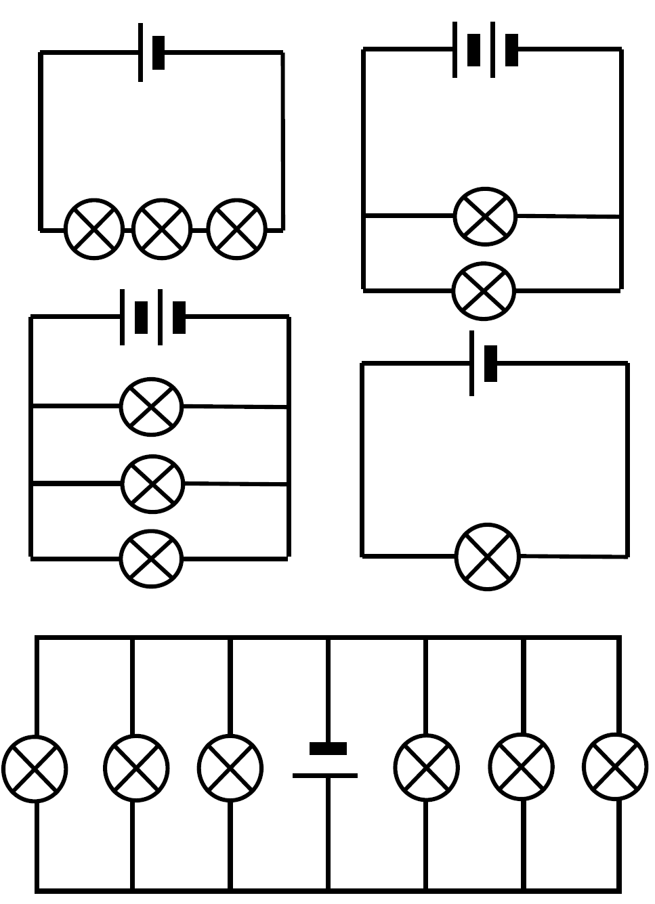
- A switch
- Look at each of the circuit diagrams to the right. Label each one as either a series or parallel circuit. If the circuit is parallel, write how many different routes there are around the circuit.

Medium:
- Draw a series circuit with two cells, a bulb and an ammeter.
- Draw a series circuit with a cell an open switch and a motor.
- Draw a series circuit with a cell, a closed switch, a motor and a bulb.
- Draw a circuit with two cells, and three bulbs in parallel with the cells.
- Draw a circuit with one cell, and with a bulb and voltmeter in parallel with each other.
Parts of a circuit will only work if there is a complete circuit for the current to flow. If there is a break in the circuit then it’s not complete.
Current also prefers to take the path of least resistance.
Hard:
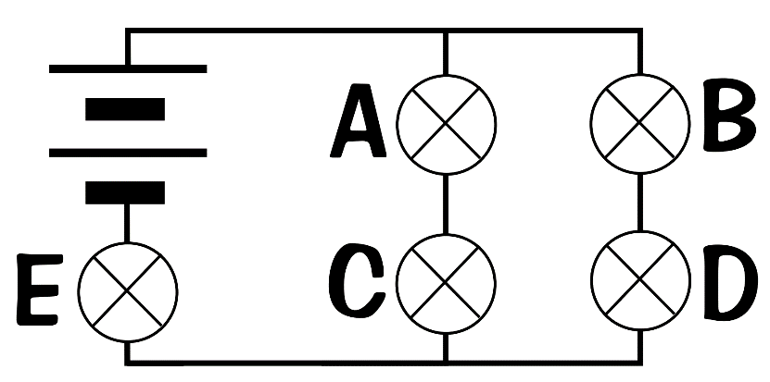
- Bulb A is unscrewed. Which bulbs are on and which bulbs are off? Explain why.
- Bulb D is unscrewed. Which bulbs are on and which bulbs are off? Explain why.
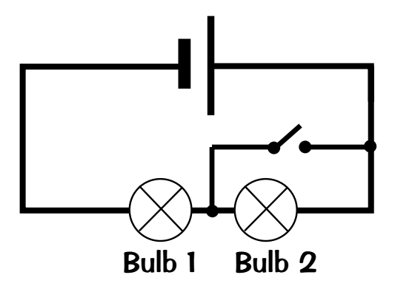
- Bulb E is unscrewed. Which bulbs are on and which bulbs are off? Explain why.
- Would bulb 2 be lit when the switch is open? Explain why.
- Would bulb 1 be lit when the switch is open? Explain why.
- Would bulb 1 be lit when the switch is closed? Explain why.

