Practical:
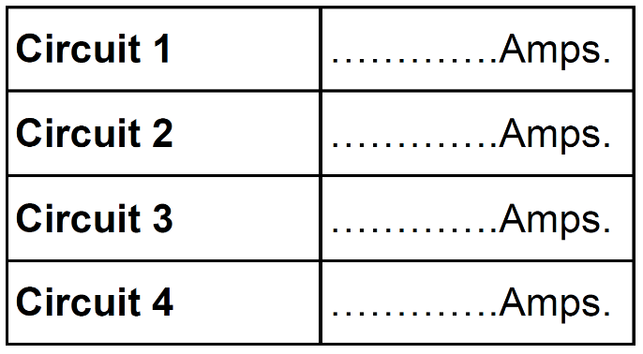
Set up each of the circuits shown and record the results in the table provided.
Equipment you will need:
-Battery x2
-Bulb x2
-Ammeter x1
-Connecting wires x5
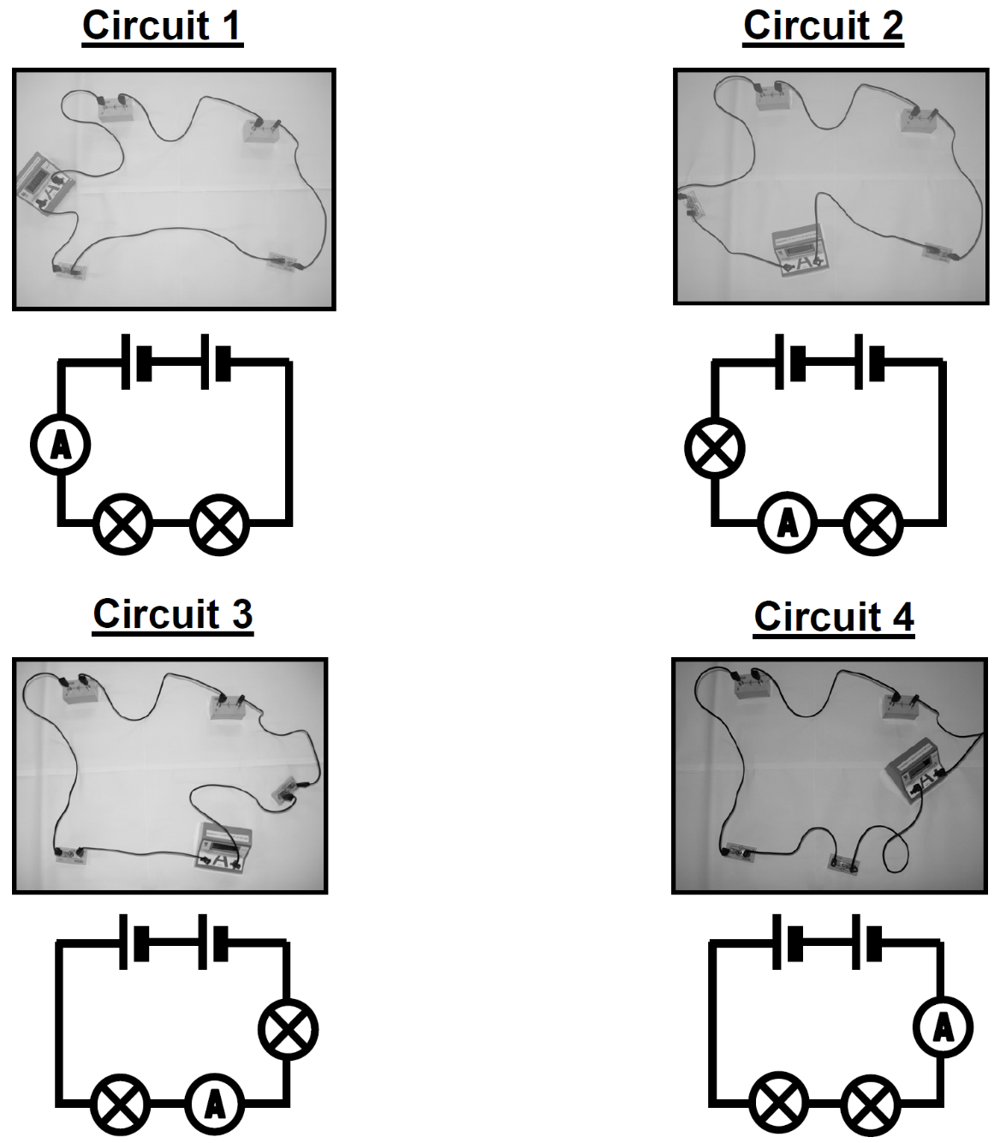
Conclusion: _______________________________________________________
_________________________________________________________________
_________________________________________________________________
Stretch: Unscrew one of the bulbs. What do you notice? Why does this happen?
_________________________________________________________________
_________________________________________________________________
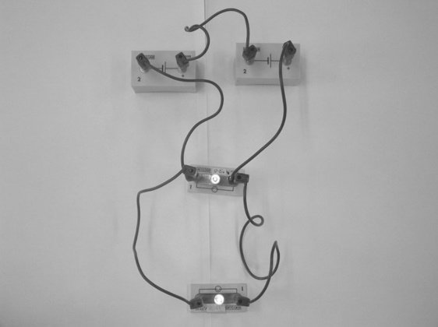
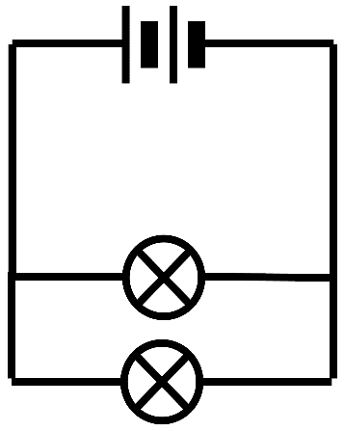
Now build the following circuit:
3
2
1

Place an ammeter in positions 1, 2 and 3 and note the currents down below.
Current in position 1: ___________
Current in position 2: ___________
Current in position 3: ___________
Conclusion: _______________________________________________________
_________________________________________________________________
Stretch: Unscrew one of the bulbs. What do you notice? Why does this happen?
_________________________________________________________________
_________________________________________________________________

