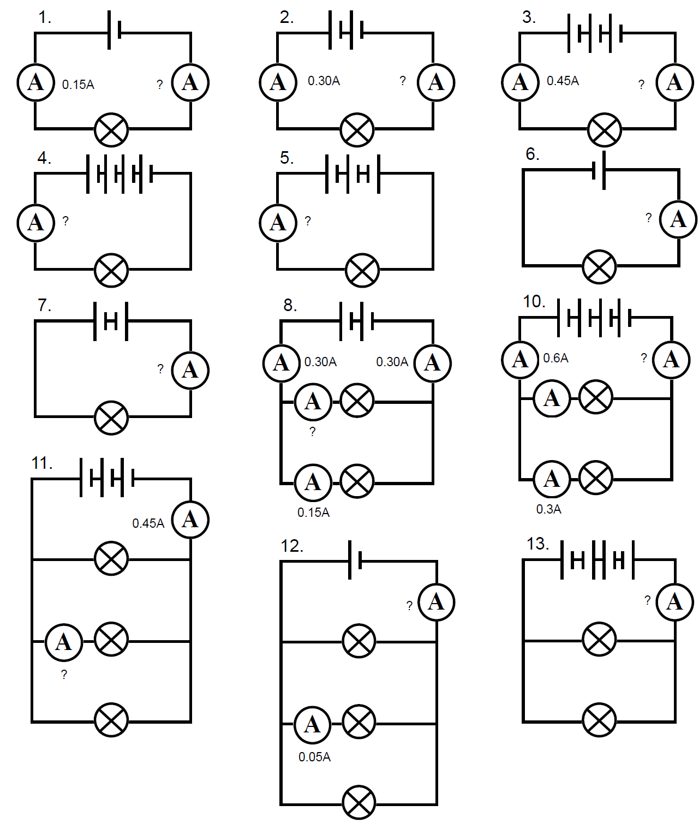
Basic: Write the currents on the following ammeters.

Medium:

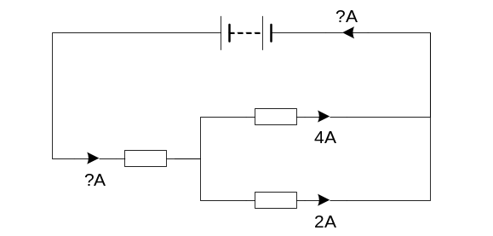Hard:
- The resistors in the circuit opposite are not of equal resistance. What is the current on the remaining ammeters? Explain why.
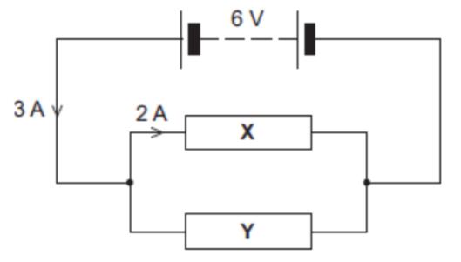
- What is the current through resistor Y? Explain why.

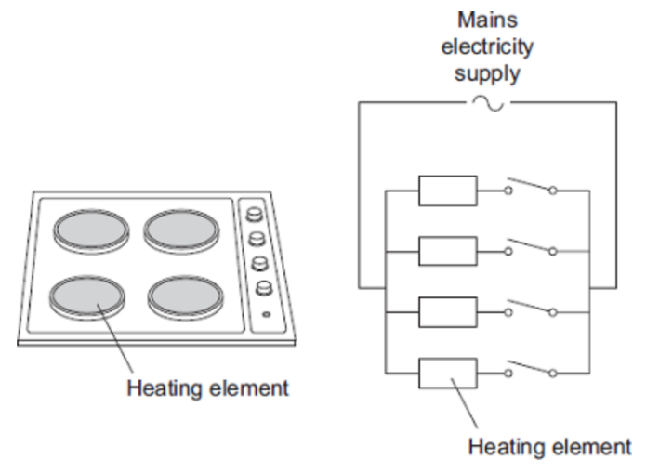

- The picture shows an electric cooker hob. The simplified circuit diagram shows how the four heating elements connect to the mains electricity supply. The heating elements are identical.

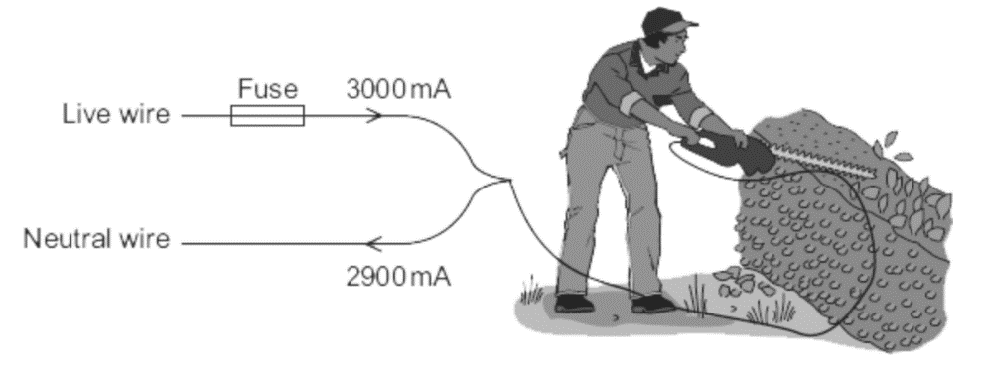
At full power the hob draws a current of 26 A. What is the current through each heating element?
- The diagram above shows how someone could get an electric shock from accidentally cutting into an electric cable. If this happens, the fuse can overheat and melt.
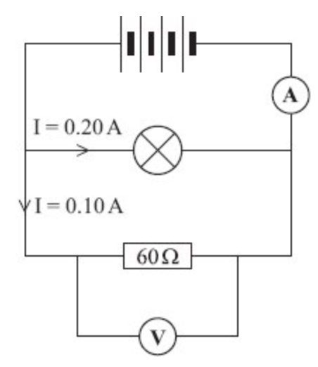
What is the current in the hedge trimmer above? Why?

- What is the current in the ammeter in the diagram to the left? Why?

