(a) Some people wear magnetic bracelets to relieve pain.
Figure 1 shows a magnetic bracelet.
There are magnetic poles at both A and B.
Part of the magnetic field pattern between A and B is shown.
Figure 1
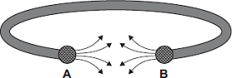
What is the pole at A? ______________________
What is the pole at B? ______________________
(1)
(b) Figure 2 shows two of the lines of the magnetic field pattern of a current-carrying wire.
Figure 2
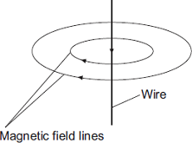
The direction of the current is reversed.
What happens to the direction of the lines in the magnetic field pattern?
___________________________________________________________________
(1)
(c) Fleming’s left-hand rule can be used to identify the direction of a force acting on a current-carrying wire in a magnetic field.
(i) Complete the labels in Figure 3.
Figure 3
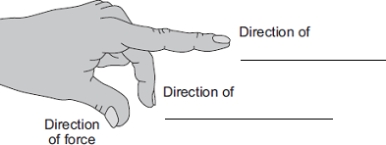
(2)
(ii) Figure 4 shows:
• the direction of the magnetic field between a pair of magnets
• the direction of the current in a wire in the magnetic field.
Figure 4
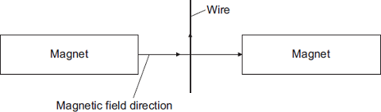

In which direction does the force on the wire act?
______________________________________________________________
(1)
(iii) Suggest three changes that would decrease the force acting on the wire.
1. ____________________________________________________________
2. ____________________________________________________________
3. ____________________________________________________________
(3)
(d) Figure 5 shows part of a moving-coil ammeter as drawn by a student.
The ammeter consists of a coil placed in a uniform magnetic field.
When there is a current in the coil, the force acting on the coil causes the coil to rotate and the pointer moves across the scale.
Figure 5
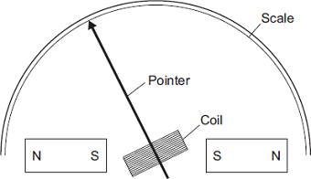
(i) The equipment has not been set up correctly.
What change would make it work?
______________________________________________________________
______________________________________________________________
(1)
(ii) Figure 6 shows the pointer in an ammeter when there is no current.
Figure 6
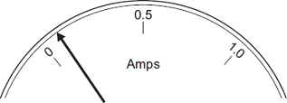
What type of error does the ammeter have?
______________________________________________________________
(1)
(Total 10 marks)

Mark schemes
Q1.
(a) north (pole)
accept N
north (pole)
both needed for mark
1
(b) reverses
accept changes direction
1
(c) (i) first finger:
(direction of) (magnetic) field
1
second finger:
(direction of) (conventional) current
1
(ii) into (plane of the) paper
1
(iii) less current in wire
accept less current / voltage / more resistance / thinner wire
1
weaker field
allow weaker magnets / magnets further apart
do not accept smaller magnets
1
rotation of magnets (so) field is no longer perpendicular to wire
1
(d) (i) reverse one of the magnets
do not accept there are no numbers on the scale
1
(ii) systematic or zero error
accept all current values will be too big
accept it does not return to zero
accept it does not start at zero
1
[10]

