Q1.
Scientists have used a satellite system to investigate the idea of generating electricity in space.
As the system orbited the Earth a 20 km copper wire was reeled out.
Before the wire snapped a current of 1 amp was induced in the wire.
Figure 1
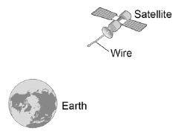
(a) What provides the force needed to keep a satellite in orbit around the Earth?
___________________________________________________________________
(1)
(b) Explain how a current is induced in the wire.
___________________________________________________________________
___________________________________________________________________
___________________________________________________________________
___________________________________________________________________
___________________________________________________________________
___________________________________________________________________
___________________________________________________________________
___________________________________________________________________
(3)
An alternator is connected to a data logger.
The data logger is connected to a computer.
Figure 2 shows how the output potential difference of the alternator varies with time.
Figure 2
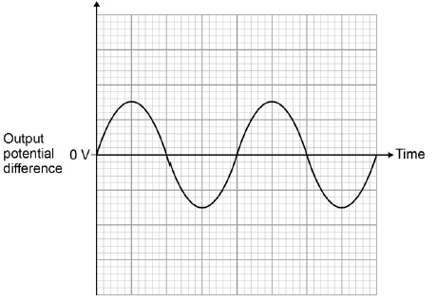
(c) The coil inside the alternator now rotates at twice the frequency.
Draw on Figure 2 to show how the output potential difference varies with time at this new frequency.
(2)
Another type of generator is now connected to the data logger and computer.
Figure 3 shows how the output potential difference varies with time for this generator.
Figure 3
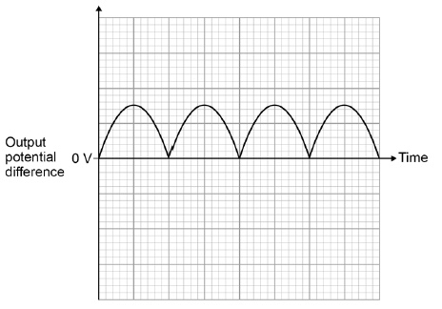
(d) What name is given to this second type of generator?
___________________________________________________________________
(1)
(e) Look at Figure 2 and Figure 3.
Give one difference between the outputs from the two types of generator.
___________________________________________________________________
___________________________________________________________________
___________________________________________________________________
(1)
(f) The charger used to charge the battery inside a laptop computer contains a small transformer.
The charger plugs into the mains electricity supply.
mains electricity supply = 230 V
number of turns on the primary coil of the transformer = 690
number of turns on the secondary coil of the transformer = 57
Calculate the potential difference applied by the charger across the battery inside the computer.
___________________________________________________________________
___________________________________________________________________
___________________________________________________________________
___________________________________________________________________
___________________________________________________________________
___________________________________________________________________
Potential difference = ____________________ V
(3)
(Total 11 marks)

Mark schemes
Q1.
(a) gravity
1
(b) as the wire moves through the Earth’s magnetic field
1
a potential difference is induced between the ends of the wire
1
the wire must be part of a complete circuit
1
(c) new trace shows:
twice the frequency
1
twice the amplitude
1
(d) dynamo
dc generator is insufficient
1
(e) the alternator pd changes polarity, the 2nd type of generator does not
1
(f) 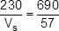
1
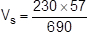
1
V_{s} = 19 (V)
an answer of 19 (V) scores 3 marks
1
[11]

