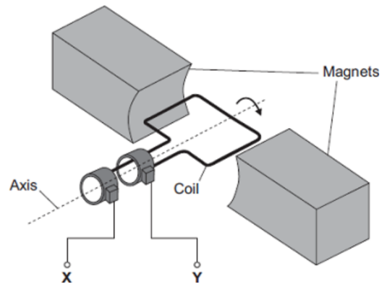
Alternators and dynamos
Basic
Q1. What type of generator is in the diagram opposite?
Q2. What type of current does this generator create?
Q3. In the diagram opposite, a potential difference is induced between X and Y. This effect is called the ___________________ effect.
Q4. What do the letters AC stand for?
Q5. Name what instrument could be used to measure the potential difference between X and Y.
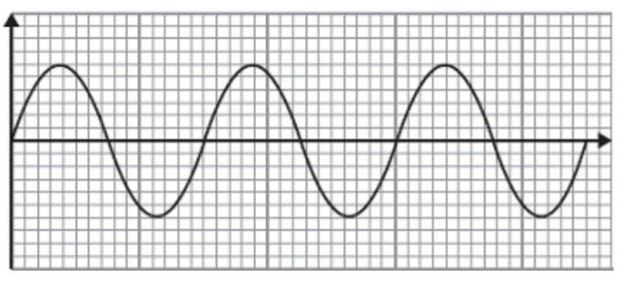
Q6. The graph opposite shows the output from this generator. Label the axes of the graph.
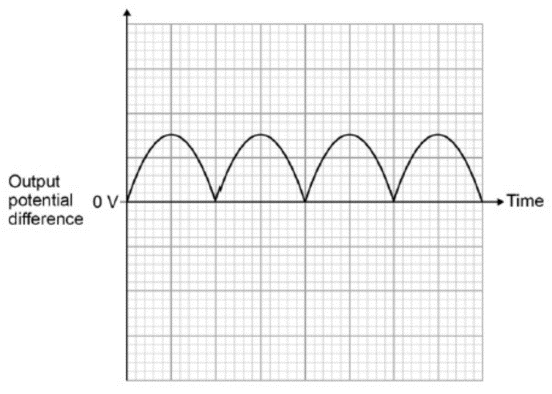
Q7. The direction of the magnetic field is reversed, draw the output from the generator if everything else remains the same.
Q8. What type of generator would produce the output potential difference displayed in the graph opposite?
Q9. Give one difference between the outputs of the diagram above and the graph opposite.
Medium
Q10. The coil inside this generator now rotates at half the frequency. Draw on the graph opposite how the output potential difference varies with time at this new frequency.
Q11. The direction of the magnetic field is now reversed and the coil is rotated at twice its original frequency. Draw on the graph above how the output potential difference now varies with time.
Q12. Name two devices we use generators in. Describe how they work.
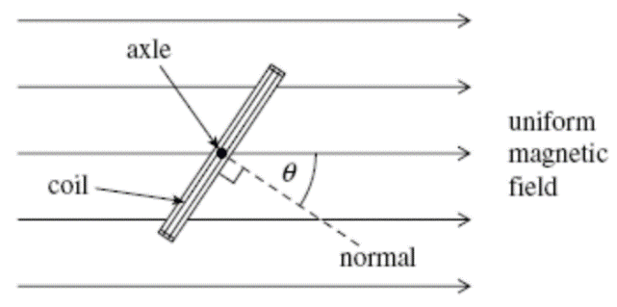
Hard
The diagram to the left shows an end view of a simple electrical generator. When in the position shown in the diagram the angle between the direction of the magnetic field and the normal to the plane of the coil is θ.
Q13. At what angle is the induced potential difference zero? At what angle is it maximum?
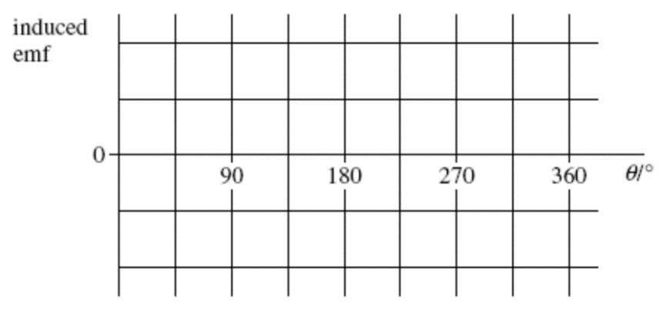
Q14. The coil is rotated at a constant speed, causing a potential difference to be induced. Sketch a graph on the axes to show how the induced potential difference varies with angle θ during one complete rotation of the coil, starting when θ = 0.

