
Synoptic Task: Lewis Latimer & the filament light bulb.
The filament light bulb operates in a fairly simple way. An electric current flows through a thin filament wire. Because the wire is thin, its resistance is high and this then means that the filament gets hot.

All objects naturally emit infra-red radiation (otherwise called thermal radiation). As the temperature of an object increases, the wavelength of the emitted radiation reduces until visible light is given out. The higher the temperature, the more intense the glow, and the more "white" the light that comes out, so if you get the filament hot enough, you get a bright source of light at wavelengths through the whole visible region of the spectrum. In air, the high temperatures would cause chemical reactions that quickly destroy the filament. This can be avoided by putting the filament in a glass bulb with the air either pumped away or replaced with an inert gas like argon.

Most people think of the filament light bulb as being invented by Thomas Edison, but its history is more complicated than that. In 1850, Joseph Swan began working on early prototypes of commercialised bulbs with paper filaments in evacuated glass. These filaments worked, but had a short operating lifetime. In 1878, Thomas Edison made improvements to the design by using a carbon filament.

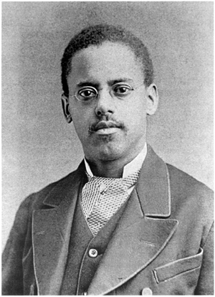
Four years later, this design was improved by Lewis Howard Latimer who patented a method for heat-treating carbon filaments. This increased their durability & allowed the filaments to be moulded into different shapes. Latimer had a remarkable life, and his inventions have impacted our lives in more ways than we know. Four years prior to his birth, his parents had been slaves in Virginia & they managed to escape and sought freedom in neighbouring Boston.

After the end of the civil war (during which Latimer served in the Union Navy), Latimer obtained a job at a patent law firm. During this time, Latimer taught himself mechanical drawing. It was these skills that attracted the attention of Alexander Graham Bell. Latimer’s expertise & contributions meant that Bell’s telephone patent was filed just a few hours earlier than rival inventor Elisha Gray. Latimer also worked with Maxim (where he registered a patent for the carbon filament) and eventually worked closely with Edison (protecting Edison’s patents).

- What happens to the temperature of a filament as a current flows through it?
- What type of radiation do all objects naturally emit?
- What happens to this radiation as the temperature of the object increases?
- How do we lengthen the operating lifetime of a filament?
- Draw the circuit symbol for the filament light bulb.
- Draw the I-V curve for a filament light bulb.
- Explain the shape of this I-V curve (3 marks).
- Draw a circuit diagram for how we could investigate the I-V curve of a filament light bulb.
- Describe how we could carry out an experiment to determine the I-V curve of a filament light bulb (6 marks).
- A typical filament light bulb has a total power input of 40W, and creates a useful power output of 1W. Calculate the efficiency of this bulb.
- A current of 100 mA flows through a filament light bulb and there is a potential difference of 230 V across the bulb. Calculate the power of the bulb.
- Calculate the resistance of the bulb in Q11.
- Two of these bulbs (with the same resistance as calculated in Q12) are in series in a circuit. The circuit is powered by a 12V battery. Calculate a) The current in the circuit b) The power of the circuit.
- The circuit in Q13 is on for a time for 5 minutes. Calculate:
- The amount of charge that has flowed in the circuit.
- The amount of energy transferred in the circuit.
- These days, LEDs are more frequently used due to their higher efficiency (up to 50%). Draw the circuit symbol for an LED.
- Draw the I-V curve for an LED.

